**CS 260 – Homework #7**

**Chris Kasper**

**February 23, 2018**

**Problem 1 (5.20 from text)**

A *finite automaton* consists of a set of states, which we shall take to be the integers 1..*n* and a table *transitions*[*state*, *input*] giving a *next state* for each *state* and each *input* character. For our purposes, we shall assume that the input is always either 0 or 1. Further, certain of the states are designated *accepting states*. For our purposes, we shall assume that all and only the even numbered states are accepting. Two states *p* and *q* are *equivalent* if either they are the same state, or (i) they are both accepting or both nonaccepting, (ii) on input 0 they transfer to equivalent states, and (iii) on input 1 they transfer to equivalent states. Intuitively, equivalent states behave the same on all sequences of inputs; either both or neither lead to accepting states. Write a program using the MFSET operations that computes the sets of equivalent states of a given finite automaton.

**Solution**

Function equivalent(p,q,transitions):

if p == q:

return true

else:

if (p%2 == q%2) || ((p%2 > 0) && (q%2 > 0))

if (transitions[p,0] == transitions[q,0]) && (transitions[p,1] == transitions[q,1])

return true

else

return false

Function equivalent_states(states, transitions):

eq_states = Initial(states)

for i in states:

for j in states:

if (equivalent(i, j):

eq_states.Merge(i,j)

return eq_states

**Problem 2**

Consider an undirected graph *G* = (*V*,*E*) with *n* = |*V*| and *m* = |*E*|. The degree of a vertex is the number of edges incident on that vertex. Let *di* be the degree of vertex *vi*, Show that:

SUM[1..*n*]( *di* ) = 2*m*

**Solution**

Consider the following graph:

The nodes have the following degrees: a = 1, b=2, c=2, d=1;

In this instance, n = 4 because it is the number of vertices, and m = 3 because it is the number of edges.

The left-hand side of the equation is just sum of all the degrees, therefore…

1+2+2+1 = 2*3

6 = 6

**Problem 3**

In a directed graph, we can talk about in-degree and out-degree, the number of edges, respectively, arriving and leaving a given vertex. Show that the sum of the in-degrees of a graph is equal to the sum of the out-degrees.

**Solution**

Consider the following graph:

As you can see, every directed edge is coming from one node, into another. Essentially if you were keeping track of the edges, every directed edge would add +1 to both the sum of the in-degrees and out-degrees, which makes both sums equal. For the given graph, this can be seen as each node has each 1 edge directed in and out.

**Problem 4 (6.1 from text)**

Represent the digraph of Fig. 6.38:

1. By an adjacency matrix give arc costs
2. By a linked adjacency list with arc costs indicated

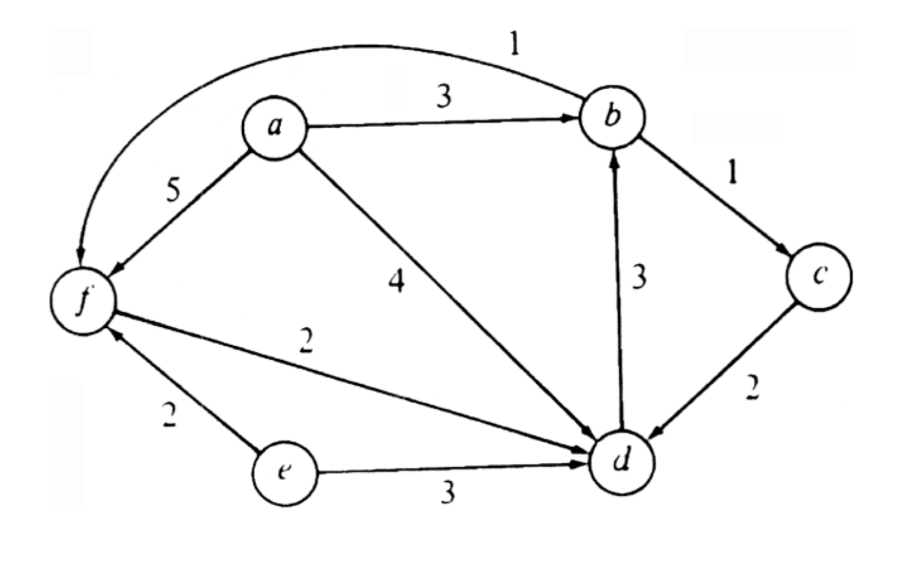

**Solution**

|  |  |  |  |  |  |  |
| --- | --- | --- | --- | --- | --- | --- |
|  | a | b | c | d | e | f |
| a | 0 | 3 | 0 | 4 | 0 | 5 |
| b |  | 0 | 1 | 3 | 0 | 1 |
| c |  |  | 0 | 2 | 0 | 0 |
| d |  |  |  | 0 | 3 | 2 |
| e |  |  |  |  | 0 | 2 |
| f |  |  |  |  |  | 0 |

a (5)

b (1)

d (2)

e (2)

f (2)

d (3)

f (2)

e (3)

c (2)

b (3)

a (4)

d (2)

b (1)

f (1)

d (3)

c (1)

a (3)

f (5)

d (4)

b (3)