**CS 260 – Homework #8**

**Chris Kasper**

**March 2, 2018**

**Problem 1 (6.6 from text)**

Show that the program Dijkstra does not work correctly if arc costs can be negative.

**Solution**

Consider the following graph:

5

0

8

-6

1

Running Dijkstra on this graph with A being the starting node to D, the algorithm will result in the shortest path being 5. However, the shortest path to D is in fact -5 (A to C to D).

**Problem 2 (7.1 from text)**

Describe an algorithm to insert and delete edges in the adjacency list representation for an undirected graph. Remember that an edge (*i*, *j*)  appears on the adjacency list for both vertex *i* and vertex *j*.

**Solution**

Insert_Edge(G,v1,v2){

New_edge = {}

If {v1,v2} in adj_list:

Return

Else:

New_edge = Insert(v1)

New_edge = Insert(v2)

G.append(New_edge)

}

Delete_Edge(G,v1,v2){

If {v1,v2} in G:

For edges in G:

If edge == {v1,v1}:

G.remove(edge)

Else:

Return

}

**Problem 3 (7.2 from text)**

Modify the adjacency list representation for an undirected graph so that  the first edge on the adjacency list for a vertex can be deleted in constant time. Write an algorithm to delete the first edge at a vertex using your new representation. *Hint*. How do you arrange that the two cells representing edge (*i*, *j*) can be found quickly from one another?

**Solution**

Consider if the adjacency list was modified to contain dictionaries (hash map) of edges [values] for each vertex [key]. This would make deleting the first edge of each vertex much easier. You’d just have the index for a specific vertex’s edge list, and then delete the first one.

Delete_First_Edge(G, v1){

if not G:

Return

else if v1 not in G:

Return

else:

G[v1].remove(0)

Return G

}

**Problem 4 (7.3 a, b, d from text)**

Consider the graph of Fig. 7.20.

1. Find a minimum-cost spanning tree by Prim's algorithm.
2. Find a minimum-cost spanning tree by Kruskal's algorithm.
3. Find a breadth-first spanning tree starting at *a* and at *d*.

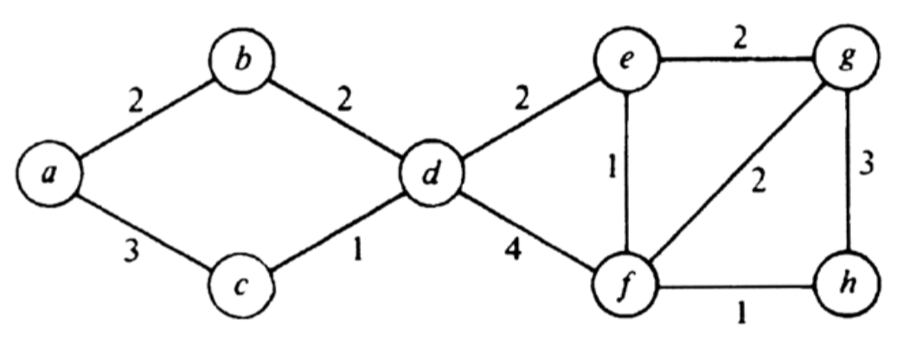

**Solution**

1. Find a minimum-cost spanning tree by Prim's algorithm.

1

1

2

2

1

2

2

1. Find a minimum-cost spanning tree by Kruskal's algorithm.

2

2

2

2

1

1

1

1. Find a breadth-first spanning tree starting at *a* and at *d*.

At a:

Result: a, b, c, d, e, f, g, h

At d:

Result: d, b, c, e, f, a, g, h