Chris Kasper

CS 383-002

Homework #1

Theory Questions

1a.   
Group data together

$$=\left[\begin{matrix}-2 & 1 \\ -5 & -4 \\ -3 & 1 \\ 0 & 3 \\ -8 & 11 \\ -2 & 5 \\ 1 & 0 \\ 5 & -1 \\ -1 & -3 \\ 6 & 1\end{matrix}\right] \left[\begin{matrix}1 \\ 1 \\ 1 \\ 1 \\ 1 \\ 0 \\ 0 \\ 0 \\ 0 \\ 0\end{matrix}\right]$$

Compute information gain for feature 1

Split into subsets $$f_{1}=\{-2,-5,-3,0,-8,1,5,-1,6\}$$

$s_{1}=\left[\begin{matrix}-2 & 1 \\ -2 & 5\end{matrix}\right]\left[\begin{matrix}1 \\ 0\end{matrix}\right]$ $s_{2}=\left[\begin{matrix}-5 & 4\end{matrix}\right] \left[\begin{matrix}1\end{matrix}\right]$ ${ s}_{3}=\left[\begin{matrix}-3 & 1\end{matrix}\right] \left[\begin{matrix}1\end{matrix}\right]$ $s_{4}=\left[\begin{matrix}0 & 3\end{matrix}\right] \left[\begin{matrix}1\end{matrix}\right]$

$s_{5}=\left[\begin{matrix}-8 & 11\end{matrix}\right] \left[\begin{matrix}1\end{matrix}\right]$ $s_{6}=\left[\begin{matrix}1 & 0\end{matrix}\right] \left[0\right]$ $s_{7}=\left[\begin{matrix}-5 & 4\end{matrix}\right] \left[0\right]$ $s_{8}=\left[\begin{matrix}-1 & -3\end{matrix}\right] \left[\begin{matrix}0\end{matrix}\right]$

$$s_{9}=\left[\begin{matrix}6 & 1\end{matrix}\right] \left[\begin{matrix}0\end{matrix}\right]$$

Entropy of Initial System

$$H\left(\frac{1}{2},\frac{1}{2}\right)= -\frac{5}{10}*\log_{2}\left(\frac{5}{10}\right)+ -\frac{5}{10}*\log_{2}\left(\frac{5}{10}\right)=1$$

Entropy of subsets

$$H\left(s_{1}\right)=H\left(\frac{1}{2},\frac{1}{2}\right)= -\frac{1}{2}*\log_{2}\left(\frac{1}{2}\right)+ -\frac{1}{2}*\log_{2}\left(\frac{1}{2}\right)=1$$

$$H\left(s_{2}\right)=H\left(s_{3}\right)…=H\left(s_{9}\right)=H\left(0,1\right)= -0*\log_{2}\left(1\right)+ -1*\log_{2}\left(1\right)=0$$

$$s_{2}-s_{9} have entropy of 0 (all deterministic), each with weight of\frac{1}{10}$$

$$s_{1} has entropy of 1 (equally random), with a weight of\frac{2}{10}$$

$$E\left(H\left(f_{1}\right)\right)=\frac{2}{10}*1+\frac{1}{10}*0+\frac{1}{10}*0+\frac{1}{10}*0+\frac{1}{10}*0+\frac{1}{10}*0+\frac{1}{10}*0+\frac{1}{10}*0 +\frac{1}{10}*0 \\ E\left(H\left(f_{1}\right)\right)=0.2$$

$$IG\left(f_{1}\right)=1-0.2=0.8$$

Compute information gain for feature 2

Split into subsets $$f_{2}=\{1,-4,3,11,5,0,-1,-3\}$$

$s_{1}=\left[\begin{matrix}-2 & 1 \\ -3 & 1 \\ 6 & 1\end{matrix}\right]\left[\begin{matrix}1 \\ 1 \\ 0\end{matrix}\right]$ $s_{2}=\left[\begin{matrix}-5 & 4\end{matrix}\right] \left[\begin{matrix}1\end{matrix}\right]$ ${ s}_{3}=\left[\begin{matrix}0 & 3\end{matrix}\right] \left[\begin{matrix}1\end{matrix}\right]$ $s_{4}=\left[\begin{matrix}-8 & 11\end{matrix}\right] \left[\begin{matrix}1\end{matrix}\right]$

$s_{5}=\left[\begin{matrix}-2 & 5\end{matrix}\right] \left[0\right]$ $s_{6}=\left[\begin{matrix}1 & 0\end{matrix}\right] \left[0\right]$ $s_{7}=\left[\begin{matrix}5 & -1\end{matrix}\right] \left[0\right]$ $s_{8}=\left[\begin{matrix}-1 & -3\end{matrix}\right] \left[\begin{matrix}0\end{matrix}\right]$

Entropy of Initial System

$$H\left(\frac{1}{2},\frac{1}{2}\right)= -\frac{5}{10}*\log_{2}\left(\frac{5}{10}\right)+ -\frac{5}{10}*\log_{2}\left(\frac{5}{10}\right)=1$$

Entropy of subsets

$$H\left(s_{1}\right)=H\left(\frac{2}{3},\frac{1}{3}\right)= -\frac{2}{3}*\log_{2}\left(\frac{2}{3}\right)+ -\frac{1}{3}*\log_{2}\left(\frac{1}{3}\right)=0.9182$$

$$H\left(s_{2}\right)=H\left(s_{3}\right)…=H\left(s_{8}\right)=H\left(0,1\right)= -0*\log_{2}\left(1\right)+ -1*\log_{2}\left(1\right)=0$$

$$s_{2}-s_{8} have entropy of 0 (all deterministic), each with weight of\frac{1}{10}$$

$$s_{1} has entropy of 0.9182, with a weight of\frac{3}{10}$$

$$E\left(H\left(f_{2}\right)\right)=\frac{3}{10}*0.9182+\frac{1}{10}*0+\frac{1}{10}*0+\frac{1}{10}*0+\frac{1}{10}*0+\frac{1}{10}*0+\frac{1}{10}*0+\frac{1}{10}*0$$

$$E\left(H\left(f_{2}\right)\right)=0.2754$$

$$IG\left(f_{2}\right)=1-0.2754=0.7246$$

1b. Feature 1 is more discriminating then Feature 2 because Feature 1 has more information gain.

2. Using equation:

$$w^{T}{\left(μ_{1}-μ_{2}\right)}^{T}\left(μ_{1}-μ_{2}\right)w- λ( w^{T}\left(σ_{1}^{T}σ_{1}+σ_{2}^{T}σ_{2}\right)w)$$

Take derivative with respect to w

Use rule: $\frac{d}{dw}\left(X^{T}A^{T}AX\right)=2A^{T}AX$

Split into 2 sections

Left section:

$$\frac{d}{dw}\left(w^{T}{\left(μ_{1}-μ_{2}\right)}^{T}\left(μ_{1}-μ_{2}\right)w\right)=>2{\left(μ_{1}-μ_{2}\right)}^{T}\left(μ_{1}-μ_{2}\right)w$$

Right section:

$$\frac{d}{dw}\left( λ\left( w^{T}\left(σ_{1}^{T}σ_{1}+σ_{2}^{T}σ_{2}\right)w\right)\right)$$

$$=λ\frac{d}{dw}\left( w^{T}\left(σ_{1}^{T}σ_{1}+σ_{2}^{T}σ_{2}\right)w\right)$$

$=λ\frac{d}{dw}\left(w^{T}σ_{1}^{T}σ_{1}w+{w^{T}σ}_{2}^{T}σ_{2}w\right)$

$=λ(2σ_{1}^{T}σ_{1}w+2σ_{2}^{T}σ_{2}w)$

Combine both:

$2{\left(μ_{1}-μ_{2}\right)}^{T}\left(μ_{1}-μ_{2}\right)w- λ(2σ_{1}^{T}σ_{1}w+2σ_{2}^{T}σ_{2}w)$

$$2{\left(μ_{1}-μ_{2}\right)}^{T}\left(μ_{1}-μ_{2}\right)w= λ(2σ_{1}^{T}σ_{1}w+2σ_{2}^{T}σ_{2}w)$$

$$2{\left(μ_{1}-μ_{2}\right)}^{T}\left(μ_{1}-μ_{2}\right)w= (λ*σ_{1}^{T}σ_{1}+λ*σ_{2}^{T}σ_{2})2w$$

$${\left(μ_{1}-μ_{2}\right)}^{T}\left(μ_{1}-μ_{2}\right)w= (λ*σ_{1}^{T}σ_{1}+λ*σ_{2}^{T}σ_{2})w$$

Which is in the form of... $Aw=bw$

Part 2: Dimensionality Reduction via PCA

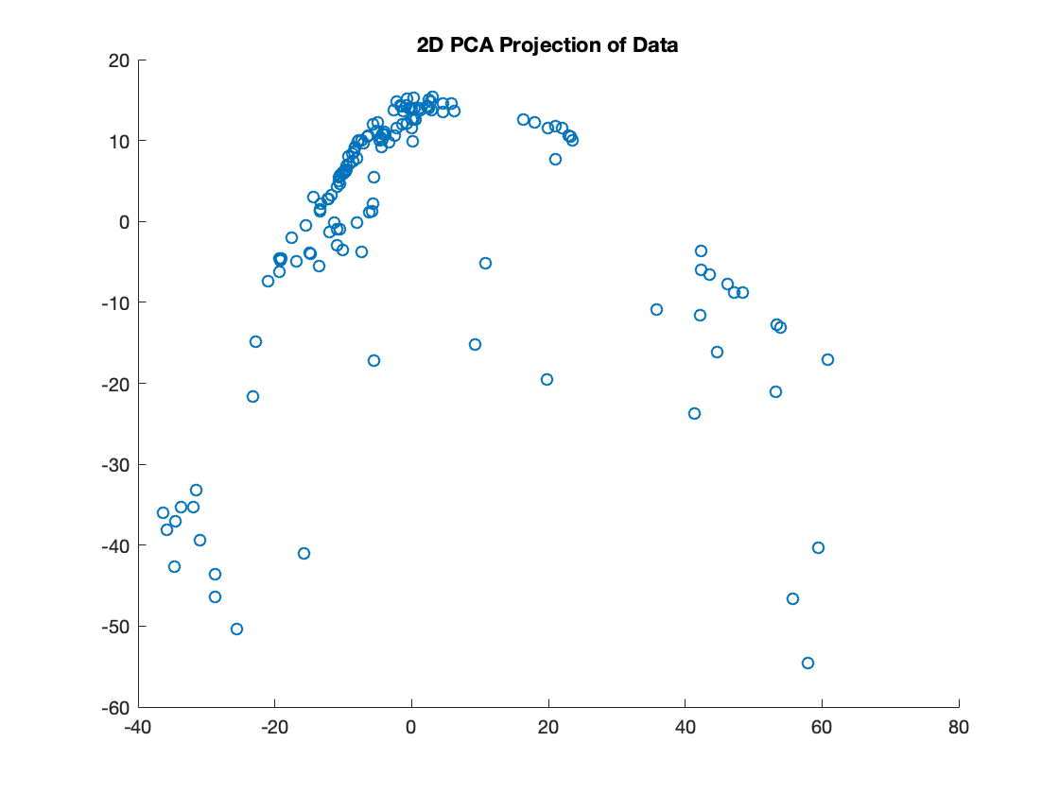

Part 3: Eigenfaces

Number of principle components needed to represent 95% of information, k = 37

