Chris Kasper

CS 383-002

Homework #3

**1. Theory**

1. Linear regression using least squares estimate (LSE).

$$X=\left[\begin{matrix}-2 & 1 \\ -5 & -4 \\ -3 & 1 \\ 0 & 3 \\ -8 & 11 \\ -2 & 5 \\ 1 & 0 \\ 5 & -1 \\ -1 & -3 \\ 6 & 1\end{matrix}\right]$$

Column 1 contains the sole feature, column 2 contains the value to be predicted

std of feature = 4.2282

mean of feature = -0.9

Standardized data with bias feature:

$X=\left[\begin{matrix}1 & -0.2602 \\ 1 & -0.9697 \\ 1 & -0.4967 \\ 1 & 0.2129 \\ 1 & -1.6792 \\ 1 & -0.2602 \\ 1 & 0.4494 \\ 1 & 1.3954 \\ 1 & -0.0237 \\ 1 & 1.6319\end{matrix}\right]$ $Y=\left[\begin{matrix}1 \\ -4 \\ 1 \\ 3 \\ 11 \\ 5 \\ 0 \\ -1 \\ -3 \\ 1\end{matrix}\right]$

Calculate coefficients using:

2. Function $g\left(x\right)={\left(x-1\right)}^{4}, where x is a single value$

1. Gradient with respect to x:
$$\frac{dg}{dx}=4*{\left(x-1\right)}^{4-1}*\left(1\right)=4{\left(x-1\right)}^{3}$$

2. Finding global minimum:

$$0=4{\left(x-1\right)}^{3}$$

$$0=4\left(x^{3}-3x^{2}+3x-1\right)$$

$$0=4x^{3}-12x^{2}+12x-4$$

$$4=4x^{3}-12x^{2}+12x$$

$$4=4x\left(x^{2}-3x+3\right)$$

$$4=4x=>x=1 is the global minimum$$

1. Plot x vs g(x) using MATLAB

x = -5 to 5 (in steps of 0.1)

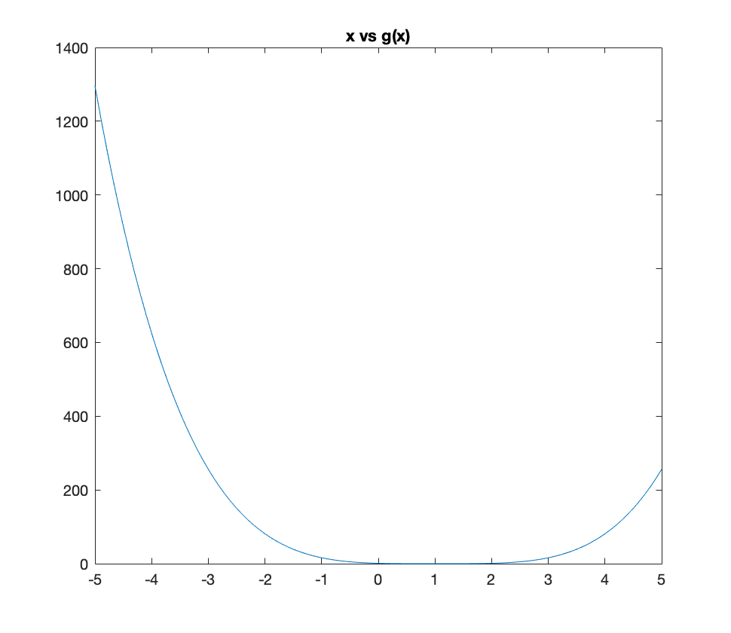

**2. Gradient Descent**

Fixed Learning Rate

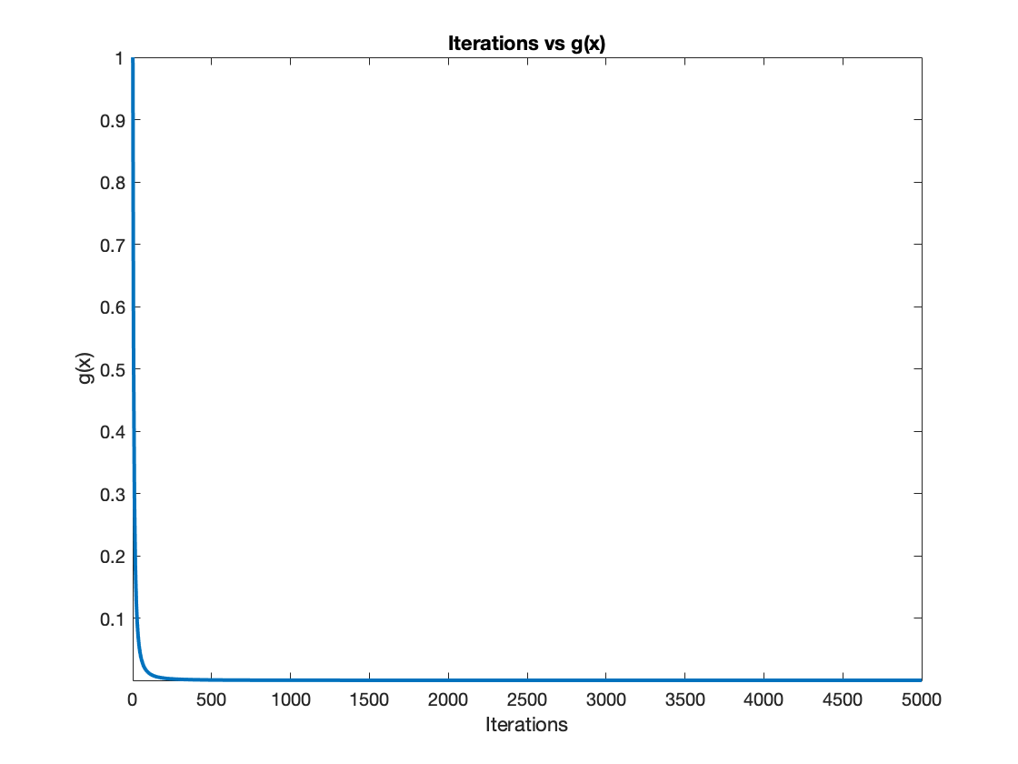

Iterations vs g(x)  
Note: X axis adjusted

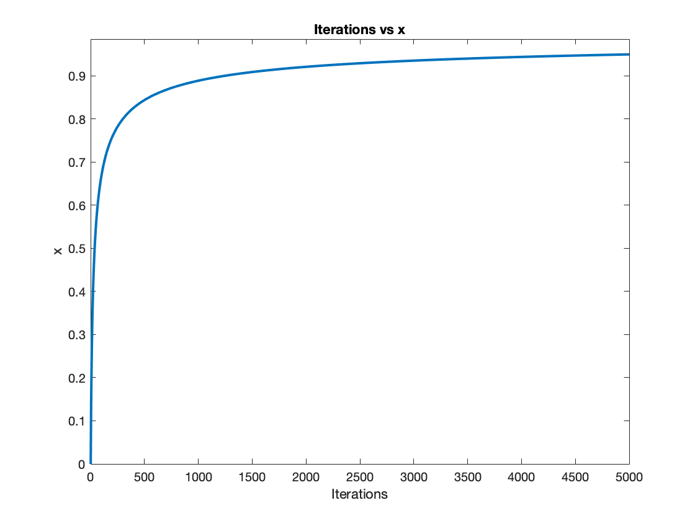

Iterations vs x

Note: X axis adjusted

Chosen value of n (learning rate) was 0.23

Adaptive Learning Rate

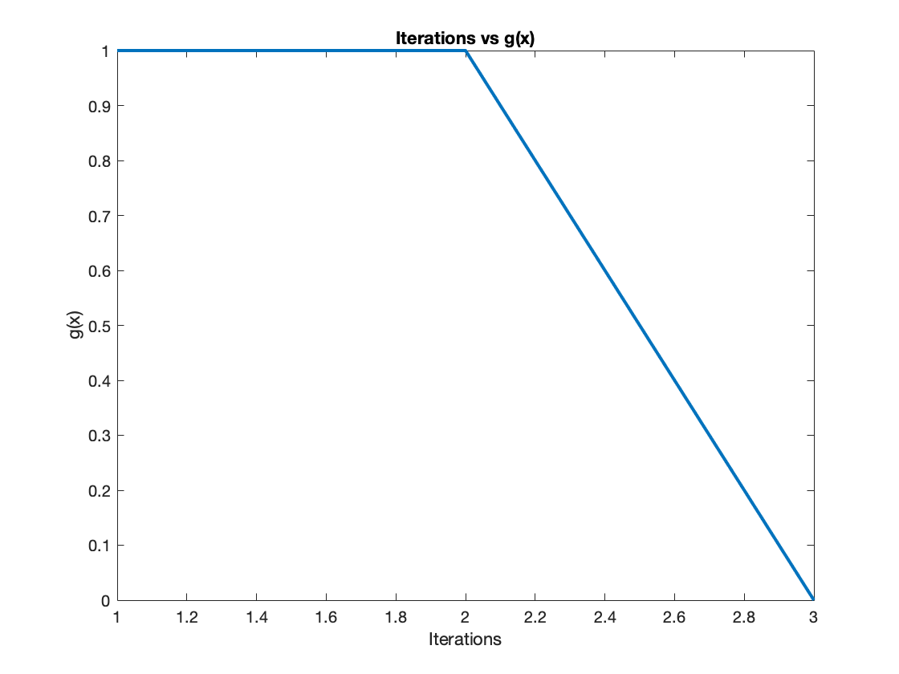

Iterations vs g(x)

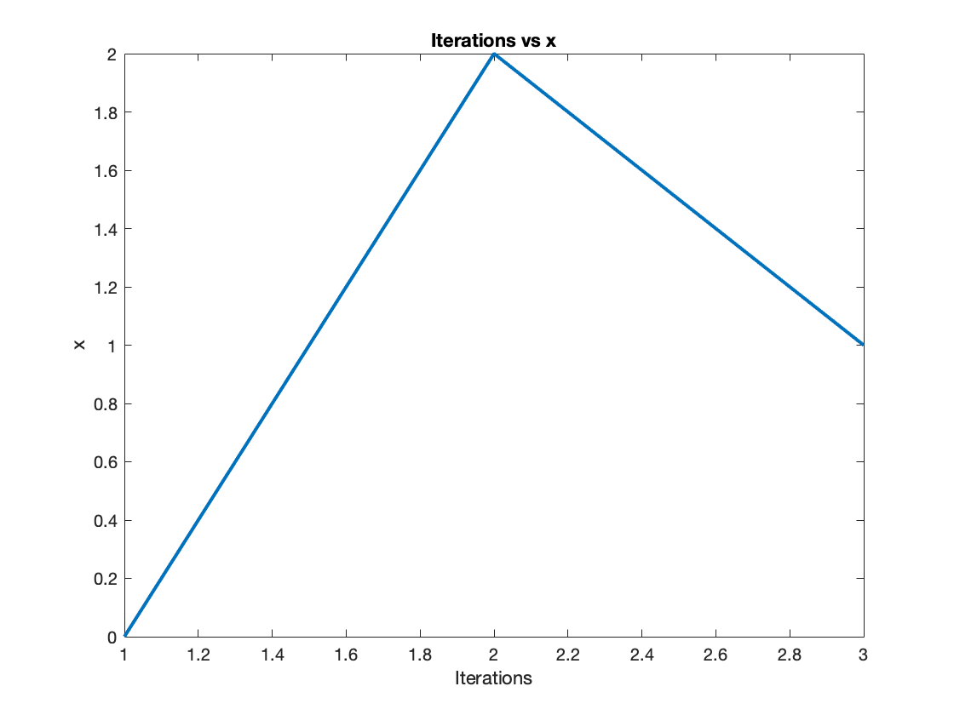

Iterations vs x

**3. Closed Form Linear Regression**

Model: $y=5404.3105+890.5098x_{1}-315.4464x_{2}$

|  |  |
| --- | --- |
| RMSE | 813.2411 |

**4. S-Folds Cross-Validation**

|  |  |  |
| --- | --- | --- |
| **S** | **Average RMSE** | **Std of RMSE** |
| 3 | 655.9816 | 45.5404 |
| 5 | 634.3463 | 23.6618 |
| 20 | 627.0605 | 12.6290 |
| N (= 44) | 623.4051 | 0 |