Chris Kasper

CS 383-002

Homework #4

**1. Theory**

1.

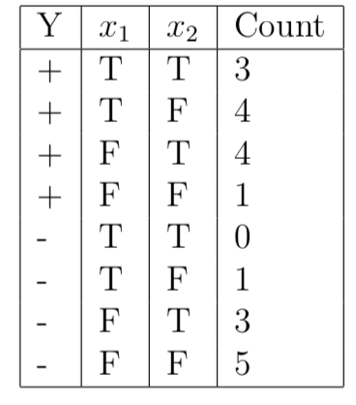

1. Entropy of system:
$$H\left(Y\right)=H\left(\frac{12}{21},\frac{9}{21}\right)=-\frac{12}{21}*\log_{2}{(\frac{12}{21})}-\frac{9}{21}*\log_{2}\left(\frac{9}{21}\right)=0.9852$$

2. Information Gains for x1 and x2:

For x1:

T – (7/8, +), (1/8, -)

F – (5/13, +), (8/13, -)

For x2:

T – (7/10, +), (3/10, -)

F – (5/11, +), (6/11, -)

$$H\left(x_{2}(T)\right)=H\left(\frac{7}{10},\frac{3}{10}\right)=-\frac{7}{10}*\log_{2}{(\frac{7}{10})}-\frac{3}{10}*\log_{2}\left(\frac{3}{10}\right)=0.8813$$

$$H\left(x_{2}(F)\right)=H\left(\frac{5}{11},\frac{6}{11}\right)=-\frac{5}{11}*\log_{2}{(\frac{5}{11})}-\frac{6}{11}*\log_{2}\left(\frac{6}{11}\right)=0.9940$$

$$E\left(x_{2}\right)=\frac{10}{21}*0.8813+\frac{11}{21}*0.9940=0.9403$$

$$IG\left(x_{2}\right)=0.9852-0.9403=0.0449$$

1. Decision tree using ID3 algorithm:

X1

F

T

X2

X2

T

F

-

+

F

T

+

+

Note: x2 nodes, when x1 is T, could be collapsed to just “+”

2.

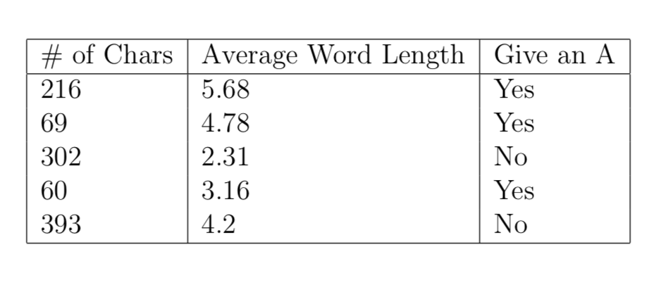

1. Class priors:
$$P\left(A=Y\right)=3/5 \\ P\left(A=N\right)=2/5$$

2. Finding Gaussian parameters to do Gaussian Naïve Bayes classification on the decision to give an A or not:

$data_{standardized}=\left[\begin{matrix}0.0551 & 1.2477 \\ -0.9572 & 0.5688 \\ 0.6473 & -1.2945 \\ -1.0192 & -0.6533 \\ 1.2740 & 0.1313\end{matrix}\right]$, $Y=\left[\begin{matrix}1 \\ 1 \\ 0 \\ 1 \\ 0\end{matrix}\right]$

$$mean=[208, 4.0260]$$

$$std=[145.2154, 1.3256]$$

Gaussian Parameters for A=Y models:

$data(A=Y)=\left[\begin{matrix}0.0551 & 1.2477 \\ -0.9572 & 0.5688 \\ -1.0192 & -0.6533\end{matrix}\right]$

$\begin{matrix}mean & std\end{matrix}$

$$\left[\begin{matrix}-0.6404 & 0.6031 \\ 0.3877 & 0.9633\end{matrix}\right] \begin{matrix}\#chars \\ avg word length\end{matrix}$$

Gaussian Parameters for A=N models:

$$data(A=N)=\left[\begin{matrix}0.6473 & -1.2945 \\ 1.2740 & 0.1313\end{matrix}\right]$$

$\begin{matrix}mean & std\end{matrix}$

$$\left[\begin{matrix}0.9606 & 0.4431 \\ -0.5816 & 1.0082\end{matrix}\right] \begin{matrix}\#chars \\ avg word length\end{matrix}$$

1. Given an essay with 242 characters and an average word length of 4.56, determine whether or not it would get an A.

$$P\left(f_{k}=x_{k} \right| y=i)=\frac{1}{σ_{i}\sqrt{2π}}*e^{-\frac{{\left(x_{k}-μ_{i}\right)}^{2}}{2σ_{i}^{2}}}$$

$$x=\left(242, 4.56\right)=>x_{standardized}=(0.2341, 0.4028)$$

$P\left(A=Yes \right|f=x)=P\left(A=Yes\right)*P\left(f_{1}=x_{1} \right| A=Yes)* P\left(f_{2}=x_{2} \right| A=Yes)$

$$P\left(f_{1}=x_{1} \right| A=Yes)=\frac{1}{0.6031*\sqrt{2π}}*e^{-\frac{{\left(0.2341--0.6404\right)}^{2}}{2*{0.6031}^{2}}}=0.2312$$

$$P\left(f_{2}=x_{2} \right| A=Yes)=\frac{1}{0.9633*\sqrt{2π}}*e^{-\frac{{\left(0.4028-0.3877\right)}^{2}}{2*{0.9633}^{2}}}=0.4141$$

$$P\left(A=Yes \right|f=x)=\frac{3}{5}* 0.2312* 0.4141=0.0574$$

-------

$$P\left(A=No \right|f=x)=P\left(A=No\right)*P\left(f_{1}=x_{1} \right| A=No)* P\left(f_{2}=x_{2} \right| A=No)$$

$$P\left(f_{1}=x_{1} \right| A=No)=\frac{1}{0.4431*\sqrt{2π}}*e^{-\frac{{\left(0.2341-0.9606\right)}^{2}}{2*{0.4431}^{2}}}=0.2348$$

$$P\left(f_{2}=x_{2} \right| A=No)=\frac{1}{1.0082*\sqrt{2π}}*e^{-\frac{{\left(0.4028--0.5816\right)}^{2}}{2*{1.0083}^{2}}}=0.4141$$

$$P\left(A=No \right|f=x)=\frac{2}{5}* 0.2348* 0.2457=0.0231$$

$$Since P\left(A=Yes \right|f=x)>P\left(A=No\right| f=x), this essay gets an A$$

3. $$\tanh\left(z\right)=\frac{e^{z}-e^{-z}}{e^{z}+e^{-z}}$$

$$g(x,θ)=\frac{e^{xθ}-e^{-xθ}}{e^{xθ}+e^{-xθ}}$$

1. Augment log likelihood objective function to deal with the range of -1 <= tanh(z) <= 1

For $P\left(y=1\right|x,θ)$: we need to account for the negative values that could be returned from $g(x,θ)$ because the equation is bound from -1 to 1. When $g\left(x,θ\right)≈1$, we want the probability to 1. When $g\left(x,θ\right)≈-1$, we want the probability to 0. When $g\left(x,θ\right)≈0$, we want the probability to 0.5, hence why I add 1 to $g\left(x,θ\right)$ and then divide by 2. The exponent accounts for the two binary outcomes, 1 and -1. When y=1, the exponent = 1, and when y= -1, the exponent = 0.

$$P\left(y=1\right|x,θ)={\left(\frac{g\left(x,θ\right)+1}{2}\right)}^{\frac{1+y}{2}}$$

For $P\left(y=0\right|x,θ)$: We just need to subtract 1 by $P\left(y=1\right|x,θ)$. The exponent accounts for the two binary outcomes, 1 and -1. When y=1, the exponent = 0, and when y= -1, the exponent = 1.

$$P\left(y=0\right|x,θ)={\left(1-\frac{g\left(x,θ\right)+1}{2}\right)}^{\frac{1-y}{2}}$$

Therefore, the new log likelihood objective function is …

$$l\left(y | x,θ\right)={\left(\frac{g\left(x,θ\right)+1}{2}\right)}^{\frac{1+y}{2}}{\left(1-\frac{g\left(x,θ\right)+1}{2}\right)}^{\frac{1-y}{2}}$$

1. Show that:

$$\frac{d}{dθ_{j}}(\tanh\left(x,θ\right))=x_{j}(1-{\tanh\left(xθ\right)}^{2})$$

$$\frac{d}{dθ_{j}}\left(\tanh\left(x,θ\right)\right)=\frac{e^{xθ}-e^{-xθ}}{e^{xθ}+e^{-xθ}}$$

Using quotient rule…

$$\frac{d}{dθ_{j}}\left(\tanh\left(x,θ\right)\right)=\frac{{\left(e^{xθ}-e^{-xθ}\right)}^{'}{(e}^{xθ}+e^{-xθ})-\left(e^{xθ}-e^{-xθ}\right){\left(e^{xθ}+e^{-xθ}\right)}^{'}}{{\left(e^{xθ}+e^{-xθ}\right)}^{2}}$$

$$\frac{d}{dθ_{j}}\left(\tanh\left(x,θ\right)\right)=\frac{\left({xe}^{xθ}+{xe}^{-xθ}\right){(e}^{xθ}+e^{-xθ})-\left(e^{xθ}-e^{-xθ}\right)\left({xe}^{xθ}-xe^{-xθ}\right)}{{\left(e^{xθ}+e^{-xθ}\right)}^{2}}$$

$$\frac{d}{dθ_{j}}\left(\tanh\left(x,θ\right)\right)=\frac{\left({xe}^{xθ}+{xe}^{-xθ}\right){(e}^{xθ}+e^{-xθ})-{x\left(e^{xθ}-e^{-xθ}\right)}^{2}}{{\left(e^{xθ}+e^{-xθ}\right)}^{2}}$$

$$\frac{d}{dθ_{j}}\left(\tanh\left(x,θ\right)\right)=\frac{\left({xe}^{xθ}+{xe}^{-xθ}\right){(e}^{xθ}+e^{-xθ})}{{\left(e^{xθ}+e^{-xθ}\right)}^{2}}-\frac{{x\left(e^{xθ}-e^{-xθ}\right)}^{2}}{{\left(e^{xθ}+e^{-xθ}\right)}^{2}}$$

$$\frac{d}{dθ_{j}}\left(\tanh\left(x,θ\right)\right)=\frac{x_{j}\left(e^{xθ}+e^{-xθ}\right){(e}^{xθ}+e^{-xθ})}{{\left(e^{xθ}+e^{-xθ}\right)}^{2}}-x_{j}{\tanh\left(x,θ\right)}^{2}$$

$$\frac{d}{dθ_{j}}\left(\tanh\left(x,θ\right)\right)=x_{j}-x_{j}*{\tanh\left(x,θ\right)}^{2}$$

$$\frac{d}{dθ_{j}}\left(\tanh\left(x,θ\right)\right)=x_{j}(1-{\tanh\left(x,θ\right)}^{2})$$

1. Derivative of log likelihood function

$$\frac{d}{dθ}(l\left(y | x,θ\right))={\left(\frac{g\left(x,θ\right)+1}{2}\right)}^{\frac{1+y}{2}}{\left(1-\frac{g\left(x,θ\right)+1}{2}\right)}^{\frac{1-y}{2}}$$

$$\frac{d}{dθ}\left(l\left(y | x,θ\right)\right)={\left(\frac{g\left(x,θ\right)+1}{2}\right)}^{\frac{1+y}{2}}\left(1^{\frac{1-y}{2}}-{\left(\frac{g\left(x,θ\right)+1}{2}\right)}^{\frac{1-y}{2}}\right)$$

$$\frac{d}{dθ}\left(l\left(y | x,θ\right)\right)={\left(\frac{g\left(x,θ\right)+1}{2}\right)}^{\frac{1+y}{2}}*1^{\frac{1-y}{2}}-{\left(\frac{g\left(x,θ\right)+1}{2}\right)}^{\frac{1+y}{2}}*{\left(\frac{g\left(x,θ\right)+1}{2}\right)}^{\frac{1-y}{2}}$$

$$\frac{d}{dθ}\left(l\left(y | x,θ\right)\right)=\frac{g\left(x,θ\right)+1}{2}-{\left(\frac{g\left(x,θ\right)+1}{2}\right)}^{2}$$

$$\frac{d}{dθ}\left(l\left(y | x,θ\right)\right)=\frac{g\left(x,θ\right)+1}{2}-\frac{g{\left(x,θ\right)}^{2}+2g(x,θ)+1}{4}$$

$$\frac{d}{dθ}\left(l\left(y | x,θ\right)\right)=\frac{g\left(x,θ\right)+1}{2}-\frac{g{\left(x,θ\right)}^{2}+2g(x,θ)+1}{4}$$

$$\frac{d}{dθ}\left(l\left(y | x,θ\right)\right)=\frac{1}{2}*\frac{d}{dθ}\left(g\left(x,θ\right)+1\right)-\frac{1}{4}*\frac{d}{dθ}\left(g{\left(x,θ\right)}^{2}+2g\left(x,θ\right)+1\right)$$

$$LHS:\frac{d}{dθ}\left(l\left(y | x,θ\right)\right)=\frac{1}{2}*\left(x_{j}\left(1-\tanh\left(xθ\right)\right)\right)$$

$$RHS: \frac{d}{dθ}\left(l\left(y | x,θ\right)\right)=\frac{1}{4}*\left({2\left(\tanh\left(xθ\right)\right)*x}_{j}(1-\tanh\left(xθ\right))+2(x_{j}(1-tanh⁡(xθ))+1\right)$$

$$RHS: \frac{d}{dθ}\left(l\left(y | x,θ\right)\right)=\frac{1}{2}*\left({\tanh\left(xθ\right)*x}_{j}(1-\tanh\left(xθ\right))+(x_{j}(1-tanh⁡(xθ))+1\right)$$

$$\frac{d}{dθ}\left(l\left(y | x,θ\right)\right)= \frac{1}{2}*\left(x_{j}\left(1-\tanh\left(xθ_{j}\right)\right)\right) \\ -\frac{1}{2}*\left({\tanh\left(xθ_{j}\right)*x}_{j}(1-\tanh\left(xθ_{j}\right))+(x_{j}(1-tanh⁡(xθ_{j}))+1\right)$$

**2. Naïve Bayes Classifier**

|  |  |
| --- | --- |
| Precision: | 68.16% |
| Recall: | 95.75% |
| F-Measure: | 79.63% |
| Accuracy: | 81.23% |