

Drexel University

Electrical and Computer Engineering Dept.

ECEC-413

**Numerical Integration with OpenMP**

**Chris Kasper**

**Prof. Naga Kandasamy**

**DATE: 05/2/19**

**Multi-threaded Design (OpenMP)**

To extend the design of the numerical integration (using the trapezoid rule) to a multi-threaded design, the work has to be divided among the number of threads. This was done as such:

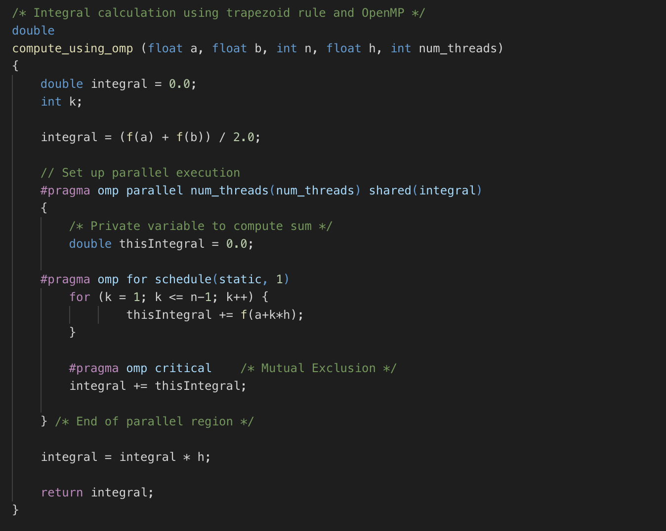

The first thing that is done before splitting the work up, is to calculate the values for the start and end point of our total area. Then, each thread gets allocated a certain number of trapezoids being used to calculate the rest of the integral of the equation. Utilizing OpenMP, we set the computation to be done in parallel, split up given the number of threads, and set our “integral” variable to be shared amongst all threads. However, each thread has a private variable, “thisIntegral”, where they can store their result for the computations it performed. Once the trapezoid computations for a thread are finished, each thread adds on their result to the shared variable “integral”, using mutual exclusion. Finally, once all the threads finish, the “integral” variable is multiplied by the trapezoid base value to give us our final estimation.

**Speedup**

**Table 1: Speedup of integration on xunil-05**

|  |  |  |  |  |  |  |  |
| --- | --- | --- | --- | --- | --- | --- | --- |
| **Number of Trapezoids** | **Lower Limit** | **Upper Limit** | Single Thread | 2 Threads | 4 Threads | 8 Threads | 16 Threads |
| 100000 | 0 | 10 | 0.0052s | 0.0028s | 0.0017s | 0.0010s | 0.0012s |
| 100000 | 0 | 100 | 0.0052s | 0.0030s | 0.0017s | 0.0011s | 0.0010s |
| 1000000 | 0 | 10 | 0.0455s | 0.0250s | 0.0134s | 0.0077s | 0.0056s |
| 1000000 | 0 | 100 | 0.0455s | 0.0250s | 0.0133s | 0.0070s | 0.0045s |