Credit-Risk Segmentation and Predictive Modeling: Module B Capstone Proposal
Calvin Baker | DX699O2 | Summer 2026

1. Problem statement/description
Consumer lenders need to identify loans that merit additional review before losses materialize, while avoiding the opposite error of treating creditworthy borrowers as high risk. This project asks whether routinely available application and loan features can rank adverse outcomes well enough to support a transparent, capacity-limited human review process. The business value is earlier monitoring and better allocation of underwriting attention; the public value is a more consistent process with explicit limits on automated decision-making.
The analysis compares two distinct populations. The mortgage Loan Default dataset has 148,670 records and a binary Status outcome with a 24.6% overall adverse rate. The Accepted Lending Club file contains 2,260,701 issued-loan records; the modeling sample uses 61,100 evenly spaced rows and defines a bad loan from completed adverse statuses, yielding a 13.0% adverse rate. Because the targets are related but not identical, performance is interpreted within each dataset rather than as a lender-to-lender scorecard.
Weeks 1–7 established data quality, skew, class imbalance, and pairwise relationships. Weeks 8–12 added interactions, PCA, logistic baselines, and tuned random forests. The models offer useful ranking but not automatic approval or denial: mortgage missingness is outcome-linked, Lending Club includes only accepted applicants, and neither result is an out-of-time production validation.

2. Exploratory data analysis

a. Multivariate analysis
Binned heatmaps expose interactions without imposing a linear trend. Mortgage default is elevated in the 100%+ loan-to-value (LTV) tier across debt-to-income (DTI) bands, although DTI is nonlinear and edge cells are smaller. In Lending Club, bad-loan rates generally rise from grade A through G across purposes; purpose is secondary and sparse cells require caution.
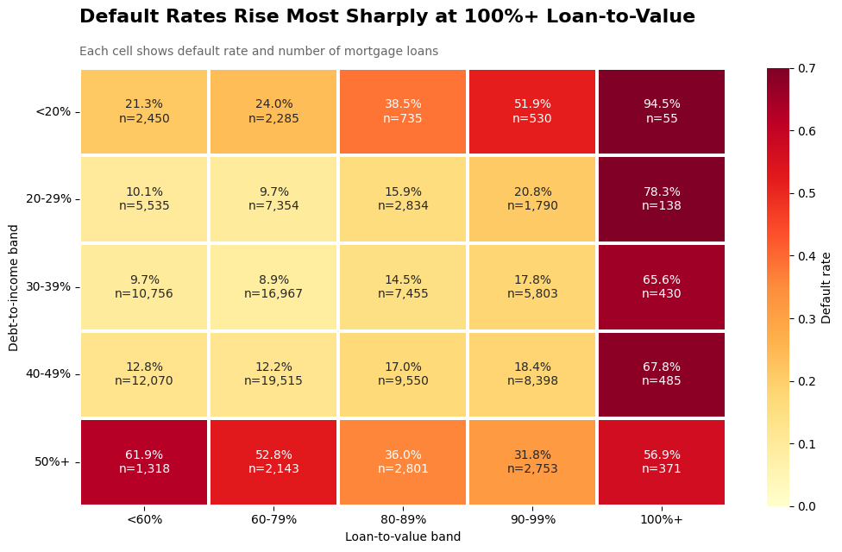  Figure 1. Mortgage default rate by LTV and DTI tier; cell labels include rates and counts. | 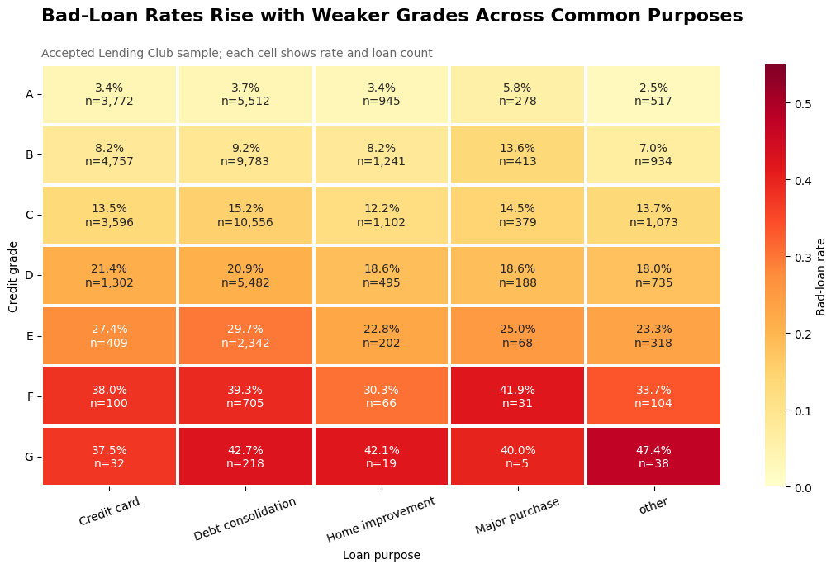  Figure 2. Accepted Lending Club bad-loan rate by grade and purpose.

Multivariate evidence: redundancy and dimensionality
The mortgage bubble plot confirms that loan amount closely tracks property value and that defaults overlap nondefaults, so two variables do not form a clean boundary. PCA reaches 86.3% variance with four mortgage components and 84.1% with five Lending Club components; the first two retain only 52.8% and 46.8%. Logistic ROC AUCs of 0.586 and 0.680 likewise leave room for nonlinear models without guaranteeing improvement.
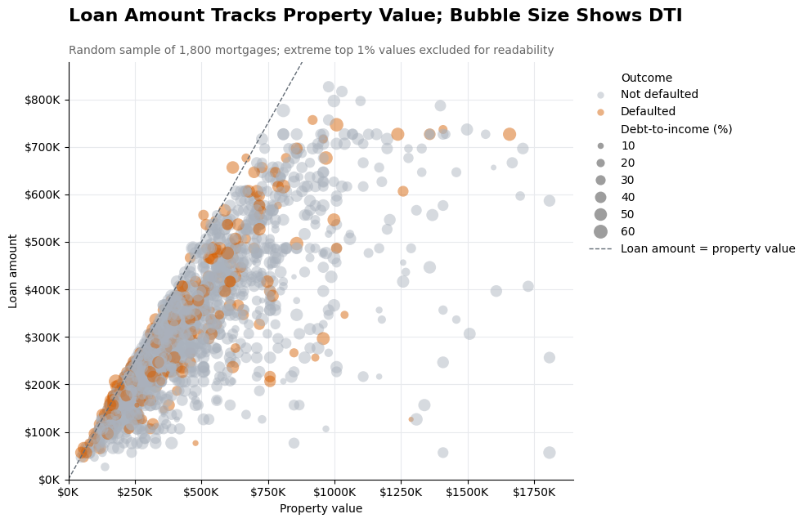  Figure 3. Mortgage loan amount versus property value; bubble size is DTI and color is Status. | 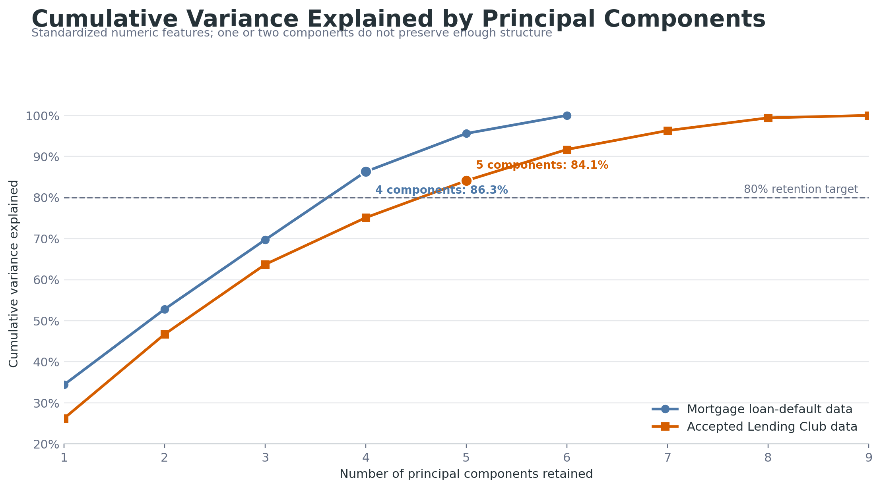  Figure 4. PCA cumulative variance; four mortgage and five Lending components exceed 80%.

b. Random forest analysis
A stratified 80/20 train-test split was held fixed for evaluation. RandomizedSearchCV tuned each RandomForestClassifier with three stratified folds and ROC AUC as the scoring rule. Class-weight balancing addressed unequal outcomes. For Lending Club, median imputation was fitted inside each cross-validation fold. For mortgage, rate_of_interest was excluded because its missingness nearly identifies Status; modeling used 124,437 complete cases on six pre-outcome numeric features. The best mortgage forest used 208 trees, depth 12, sqrt feature sampling, and minimum leaf size 13. The Lending Club forest used 289 trees, depth 8, all features per split, and minimum leaf size 12.
Table 1. Validated random-forest performance on held-out test sets.
Dataset | n; adverse rate | CV / test AUC | Accuracy | Precision | Recall
Mortgage | 124,437; 16.3% | 0.730 / 0.723 | 0.760 | 0.345 | 0.525
Lending Club | 61,100; 13.0% | 0.695 / 0.698 | 0.648 | 0.215 | 0.643
AUC measures ranking across thresholds, whereas precision and recall describe the specific 0.50 cutoff. The mortgage confusion matrix contains 20,974 true negatives, 5,056 false positives, 2,413 false negatives, and 2,667 true positives. Lending Club contains 8,621, 4,662, 712, and 1,280, respectively. The lower Lending precision shows why the threshold must be selected from review capacity and error cost—not inherited from a software default.

Random forest interpretation: which variables the models used
Impurity-based importance indicates how often a feature improved forest splits; it is not a causal effect. Mortgage importance is led by DTI (0.317), income (0.224), and LTV (0.207). Lending Club is concentrated in interest rate (0.623); DTI, annual income, revolving utilization, installment, FICO, and total accounts each contribute 0.069 or less.
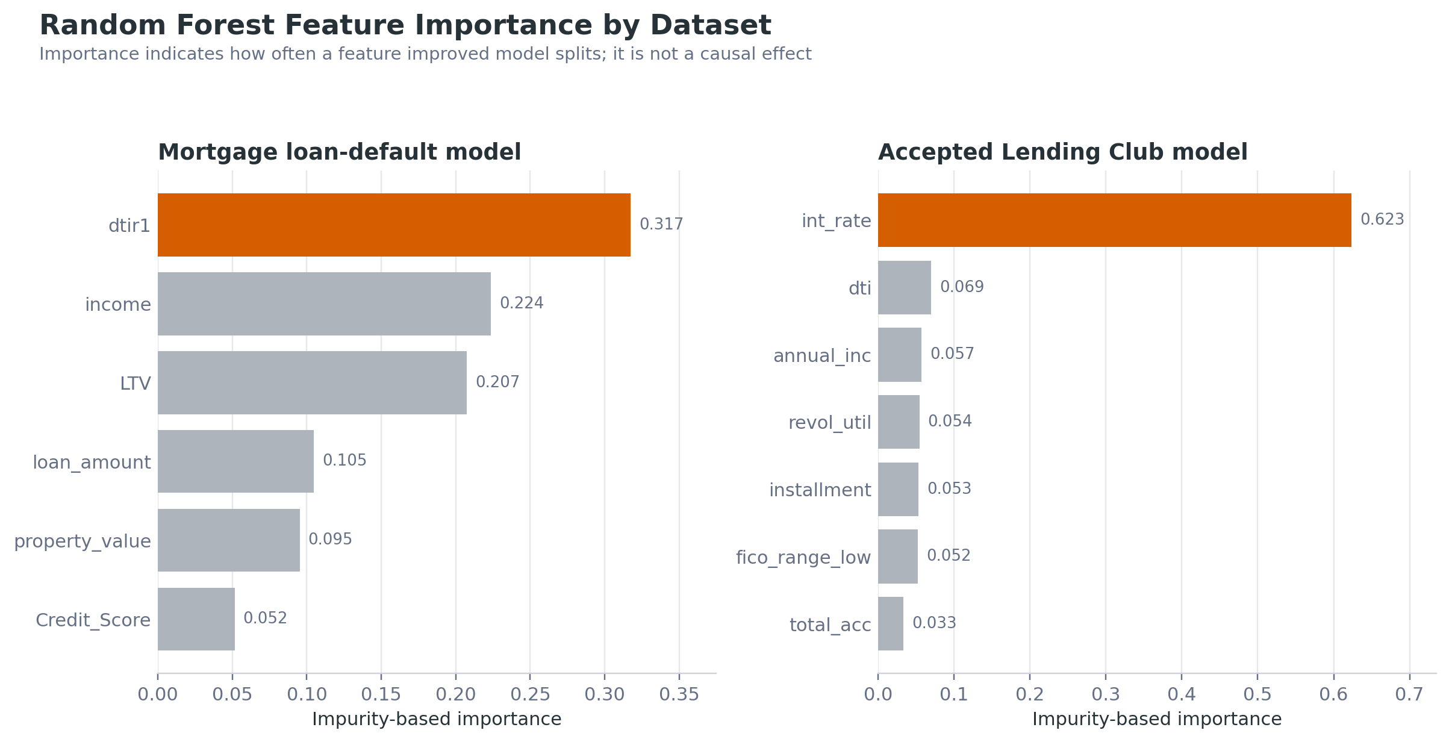
Figure 5. Random-forest impurity importance by dataset. Values describe model use, not causation.
Affordability dominates mortgage risk, while an interest rate already shaped by underwriting dominates Lending Club. Module C will add held-out permutation importance and time-stability checks so a single fitted forest does not determine the narrative.

Random forest interpretation: operational separation
Risk deciles translate AUC into reviewer capacity. On held-out data, mortgage default rises from 6% in the lowest-risk decile to 52% in the highest, 3.2 times the complete-case average. Lending Club rises from 3% to 30%, 2.3 times average. Both sequences are ordered.
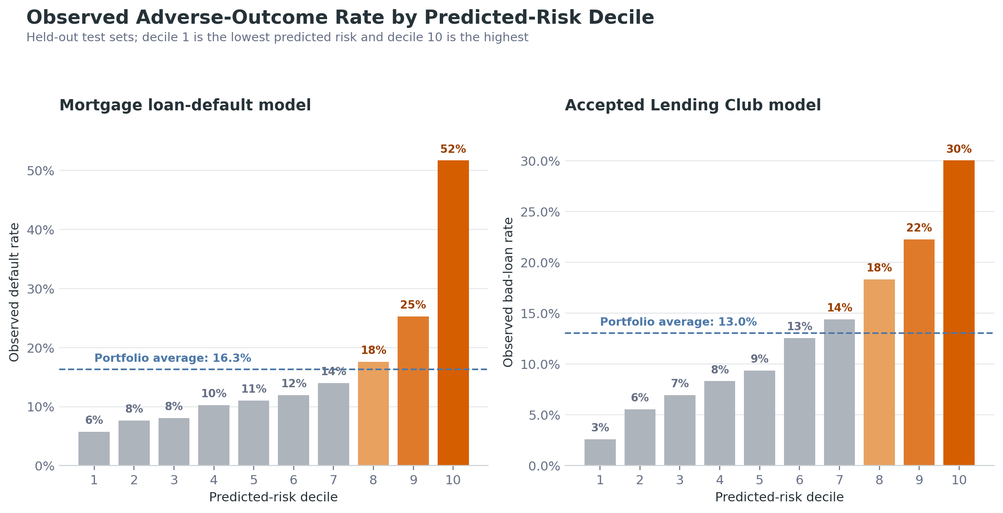
Figure 6. Held-out adverse-outcome rate by predicted-risk decile; decile 10 is highest risk.
The result supports prioritized human review, not automatic denial: the top decile still contains many nondefaults and the model misses defaults below it. Calibration, time stability, reason codes, and subgroup errors remain gating tests because complex models do not remove the duty to give accurate, specific adverse-action reasons (CFPB, 2022).

c. Relationship to analysis from Week 1-7
Week 2 documented scale, missingness, outcome definitions, and the planned model comparison. Week 4 found right-skewed amounts and class imbalance. Week 6 found weak mortgage pairwise correlations (DTI 0.078; income −0.065), while Lending Club interest rate was strongest at 0.206 and risk rose from grade A to G. Week 7 framed the 100%+ LTV risk jump.
Weeks 8–12 add nonlinear interactions, multidimensionality, and model comparisons. The mortgage forest improves logistic AUC from 0.586 to 0.723, but the population changes: complete cases default at 16.3% versus 24.6% overall because property value and LTV are missing for 15,098 records, 99.99% with Status = 1. This is selection, not model progress.

3. Data conclusions
Expected findings were the grade gradient and the importance of interest rate, income, DTI, and LTV. Unexpected findings were weak standalone mortgage credit score, nonlinear DTI, the number of PCA components needed, and near-deterministic missingness. The evidence is shareable for exploration because imbalance and limitations are explicit and metrics were reproduced. It is not production evidence: Lending Club is accepted-only, mortgage lacks time validation, outcomes may mature differently, and current data cannot establish protected-class fairness.

4. Proposal
Module C will develop an auditable early-risk ranking system for consumer lending. The primary population will be Accepted Lending Club loans because the file is large and has issue dates for out-of-time evaluation; mortgage will be a robustness benchmark, not pooled training data. The system will prioritize monitoring or human review, not issue an automatic adverse decision.
Research question 1. Do models using only pre-outcome, operationally available features improve out-of-time discrimination over the current logistic baseline and Week 11 random forest?
Research question 2. Can predicted probabilities reliably concentrate adverse outcomes in the highest-risk deciles while remaining calibrated enough to compare risk across months?
Research question 3. Are ranking, calibration, and threshold errors stable over time and across available, legally reviewable borrower or loan segments?
Lending Club grade and interest rate contain signal, but test AUC 0.698 leaves room to improve; the top-decile adverse rate is already 2.3 times average. Accepted-only records cannot estimate rejected-applicant outcomes, so rejected data will describe selection, not create counterfactual labels. Industry value is focused review. Public value is documented limits, errors, and explanations aligned with CFPB expectations (CFPB, 2022).

Proposed modeling and validation process
First, a data dictionary will tag every candidate variable as application-time, post-origination, outcome-derived, sensitive, or unavailable at decision time. Leakage checks will compare missingness and timing with the target. Duplicates, impossible values, target maturity, and monthly shifts will be reported. Imputation, transforms, and categorical encoding will be fitted only within training folds.
A regularized logistic regression will remain the interpretable baseline. Random forest and histogram gradient boosting will test nonlinearities. Randomized search will operate inside expanding-window validation; the latest period remains untouched for the final test. Mortgage will test broad robustness, with no averaging across different targets.
ROC AUC and precision-recall AUC will measure ranking; log loss, Brier score, and reliability plots will measure calibration. Precision, recall, F1, confusion matrices, recall at a fixed review rate, and top-decile lift will test operating value. Bootstrap intervals and fold-to-holdout gaps will quantify uncertainty; permutation importance and reason-code review will test explanation stability.
Where lawful and supported, audit slices will compare AUC, calibration, false-positive rate, and recall across time and available groups. Small groups will carry intervals or be suppressed. Gains that depend on leakage, unstable subgroups, or unusable reason codes will be rejected.

Success criteria and deliverables
The primary success threshold is out-of-time Lending Club ROC AUC of at least 0.73, with an improvement of at least 0.02 over the same-split logistic baseline and no more than 0.03 deterioration from cross-validation to holdout. The top decile should reach 2.5 times the adverse rate, Brier score should improve 10%, and capacity-based precision and recall must beat random selection and Week 11. Recall or false-positive-rate gaps above 0.05 will trigger investigation and mitigation or documented rejection.
Deliverables are a reproducible pipeline, data dictionary, model card, validation report, threshold-capacity table, explanation review, and decision brief. Checkpoints are (1) data/leakage audit, (2) baseline/time split, (3) tuning/calibration/error analysis, and (4) robustness and recommendation: controlled pilot, revise/retest, or stop.

5. Teamwork
The supplied files identify an individual submission and contain no teammate, contract, or team-communication record. No other member can be scored without fabrication.
Member | Score (1–5) | Comment
Calvin Baker (self) | 5 | Completed weekly analyses, integrated milestones, reproduced final models, and documented limitations. Individual submission; team criteria are not applicable.

Appendices

6. Citations/bibliography
Baker, C. (2026). DX699O2 weekly analysis notebooks, Weeks 1–12 [Unpublished course work].
Consumer Financial Protection Bureau. (2022, May 26). Circular 2022-03: Adverse action notification requirements in connection with credit decisions based on complex algorithms. CFPB circular
Knaflic, C. N. (2015). Storytelling with data: A data visualization guide for business professionals. Wiley.
Pedregosa, F., Varoquaux, G., Gramfort, A., Michel, V., Thirion, B., Grisel, O., Blondel, M., Prettenhofer, P., Weiss, R., Dubourg, V., Vanderplas, J., Passos, A., Cournapeau, D., Brucher, M., Perrot, M., & Duchesnay, É. (2011). Scikit-learn: Machine learning in Python. Journal of Machine Learning Research, 12, 2825–2830.
Scikit-learn developers. (2026). RandomForestClassifier, RandomizedSearchCV, and roc_auc_score [Documentation].Random forest documentation
Kaggle. (n.d.). Loan default dataset [Data set].Dataset page
Kaggle. (n.d.). All Lending Club loan data [Data set].Dataset page
Kaggle. (n.d.). Home Credit default risk [Data set].Competition page

7. AI Appendix

Prompt supplied to the AI
“Can you now take what I have from weeks 1–7 and compile it into a Word doc according to this document? Make sure that I receive the highest grade you can and hit all rubric points.”

Representative AI output
The AI mapped the paper to the rubric's required section labels, summarized the Week 1–7 progression, incorporated the existing Week 8–12 multivariate and random-forest work required by the final-project guidelines, generated publication-ready PCA, feature-importance, and risk-decile figures, and produced the formatted Word draft. It also reported the independently reproduced model results: mortgage test ROC AUC 0.723 and Lending Club test ROC AUC 0.698.

How the AI output was used
AI assistance was used for rubric extraction, notebook inventory, structural editing, figure layout, code-based metric reproduction, citation organization, and Word formatting. The report does not treat AI prose as evidence. Numeric claims were checked against notebook outputs and re-fitted source-data models; discrepancies and limitations were retained, including the mortgage missingness/target coupling. The author remains responsible for verifying the submission, confirming individual-versus-team status, and ensuring that the disclosed use follows course policy.

Validation record
- Mortgage source: 148,670 rows; 24.6% overall default; 124,437 complete cases; 16.3% complete-case default.
- Mortgage missingness audit: property value and LTV are missing in 15,098 rows, and 99.99% of those rows have Status = 1; rate_of_interest missingness is perfectly coupled with Status = 1 in the supplied file.
- Held-out refit metrics matched Week 11 after rounding: mortgage AUC 0.723, accuracy 0.760, precision 0.345, recall 0.525; Lending AUC 0.698, accuracy 0.648, precision 0.215, recall 0.643.

8. Weekly graphs and homework assignments
The following notebooks are companion deliverables and should be submitted with this paper. They contain the required graphs, calculations, model outputs, and written interpretations. The original notebooks remain in the project directory; the completed Week 12 submission copy preserves the original Week12.ipynb.
Week 8 — Week8.ipynb. Heatmaps, bubble plots, PCA, and multivariate exercises; completed outputs embedded.
Week 9 — Week9CalvinBakerSubmission.ipynb. Dataset heatmaps, bubbles, PCA, logistic comparisons, and story plots; completed.
Week 10 — Week10.ipynb. Cross-validation, model comparison, and fixed random forests; completed outputs embedded.
Week 11 — Week11.ipynb. Randomized tuning, held-out metrics, importances, and risk deciles; completed.
Week 12 — Week12CalvinBakerSubmission.ipynb. Graph comparison and Chapter 8 storytelling recreation; executed, original preserved.

Weeks 1–7 evidence carried into the final analysis
Week | Contribution
Week 1 | Data cleaning, missingness, duplicates, encoding, and outlier checks
Week 2 | Dataset selection, scale, outcome definitions, audience, and model plan
Week 3 | Descriptive statistics and visualization practice
Week 4 | Univariate distributions, skew, class imbalance, and outlier interpretation
Week 5 | Visualization and analytic exercises supporting the project workflow
Week 6 | Bivariate correlations, grouped default rates, redundancy, and time patterns
Week 7 | Action-oriented LTV story graph: default risk jumps at 100%+ LTV

