**Introduction:**

* Now that we have learnt how to use floats, we'll use that knowledge along with what we've learnt in previous lessons to make a newspaper page that we shall call SPOC DAILY.
* Below is a screenshot of how the complete page should look like:

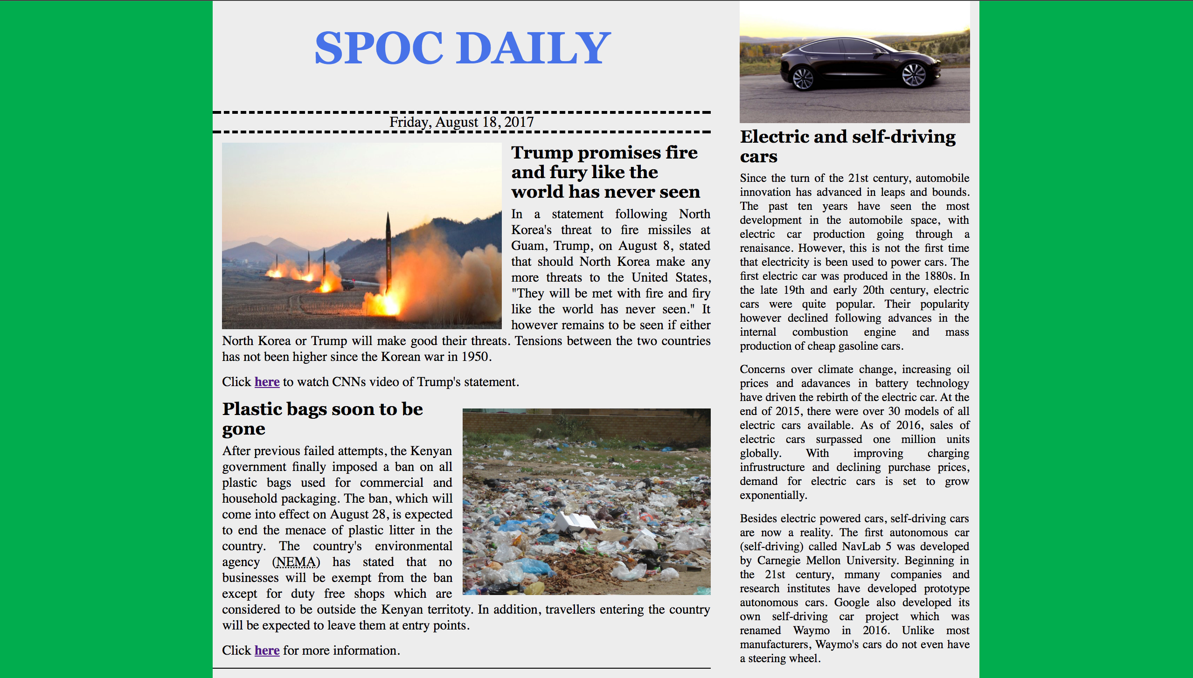

* We've provided you with all the html that you need. Feel free to run the code and see how our unstyled page looks like.
* Below is a review of the **page's structure**:

1. The entire page is wrapped inside a <main> element.
2. The left side of the document containing the header, date and news content is wrapped inside a <div> element with the class "news".
3. The right column of the page is wrapped inside a <div> element with a class "column".

* Below is a review of the **page's style**:

1. The background color of the entire page (<html>) is rgb(1, 173, 78)
2. The main container (<main>) is styled as follows:

a) background-color is rgb(237, 237, 237)

b) overflow property is scroll

c) width is 65%

3. The section containing the news items has the class news. It is floated left and its width is 65%.

4. The column to the right has class column and is styled as follows:

a) float: right

b) width: 30%

c) padding: 10px

5) All the images have individual id's. The first image (the one on Trump) has id one and is styled as follows:

a) float: left

b) height: 200 px, width: 300px

c) margin: 0 10px 0 0

* The second (with plastic bags) has id two and is styles as follows:

a) float: right

b) margin: 10px 0 0 10px

* The third image has id three and has a width of 100%

6) All paragraphs have the following CSS applied:

a) margin-top: 5px

b) margin-bottom: 10px

c) font-size: 0.9em

d) text-align: justify (this property aligns the text so that paragraphs are aligned along a straight line to the right and left.

7) The rest of the CSS is provided for you in the *index.css* file. Feel free to have a look at it.

The following elements have been styled for you:

a) header

b) time (this is the day and date below the title

c) All headings (h1 and h3)

d) Anchor elements (<a>)

**Instructions:**

1. Take time to look at the index.html file and make sure you understand the structure of the page.
2. Add all your CSS to the style.css file and remember to link it to the index.html file.
3. Refer to the above information the CSS used to style the page when adding your CSS.
4. Take a look at the index.css file and try to understand what the provided CSS does.
5. Drag the border separating this border to expand and contract the rendered page and see how it adjusts.

*{

background-color:#508AA8;

}

body > h2{

text-align:center;

color:#FAA916;

}

#first,#second{

display:flex;

justify-content:space-around;

}

#first > div, #second > div {

height:20px;

width:20%;

display:flex;

justify-content:center;

align-items:center;

border-bottom:15px solid #FAA916;

}

#first>div:first-child:hover{

color:#FAA916;

border-bottom:15px solid black;

}

#second > div:first-child:hover{

color:#FAA916;

border-bottom:15px solid black;

text-shadow:none;

}

div>#second:hover{

text-shadow:5px 5px 1px #FAA916;

}