**HD in Computer Systems Administration (IT124106)**

**Contemporary Topics in CSA (ITP4605)**

**Assignment Report**

|  |  |
| --- | --- |
| **Name** | **Student ID** |
| **CHAN Ka Chun** | **140154313** |
| **Ho Tsz Cheung** | **140111325** |

Content

Assumptions regarding the problem context 3

Application design with class diagram 4

Design patterns applied 5

User Guide 6

Test Plan and Test Cases 7

Well documented Source Code 8

# Assumptions regarding the problem context

X Membership handling Corporation is a large membership management company. The company manages different subsidy companies’ membership programs that let the user to create, search, renew, and close accounts in different membership programs. There are two subsidy companies, which are Africa Java Coffee Series shop (AJCS), and Wo-long Tea Series shop (WLTS).

Developing a X Membership management System for handing two existing membership system classes which is including client care, client, vip, vipfamily and advancedmem , member , Primary Member , Company Member. The X Membership management system need to handle the exist classes and create new classes that able previous classes reserved and able to create new member.

# Design patterns applied

Adapter pattern

Factory Pattern

Command pattern

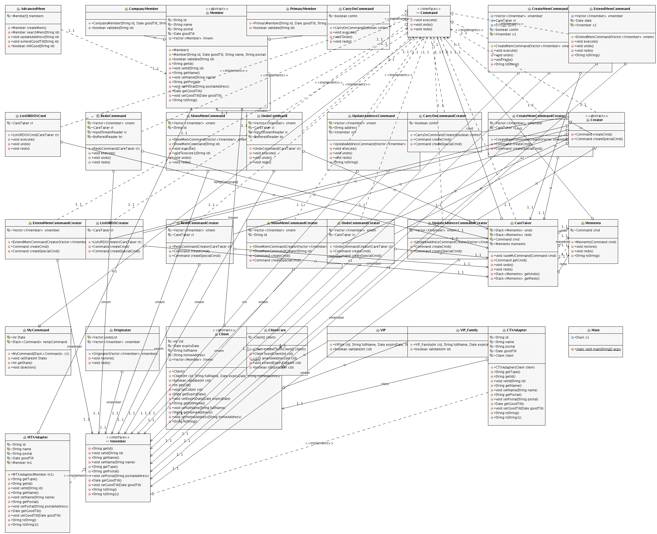

# User Guide

When you enter the system, just type the following character to do maintain the member action:

|  |  |
| --- | --- |
| **To** | **Press** |
| Create membership | **c** |
| Show membership details | **s** |
| Update address | **a** |
| Extend membership | **e** |
| undo | **u** |
| redo | **r** |
| list undo/redo | **l** |
| Exit system | **x** |

**The above commands are case insensitive.**

# Test Plan and Test Cases

**1a. Create Member Information (c)**

**c**

**wlts**

**312345675;VIP;Chan Tai;Flat 1, Tower A, 1 Tai Rd.**

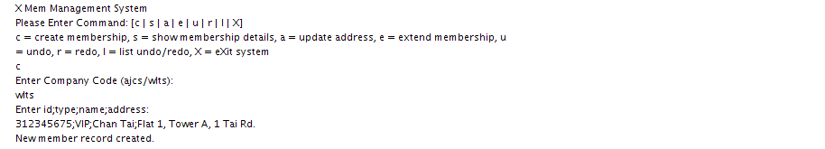

**1b. Create family member**

**C**

**wlts**

**303345675; VIPF; TANG Chi; Room B,Tower 2, 3 Mansion Rd.**

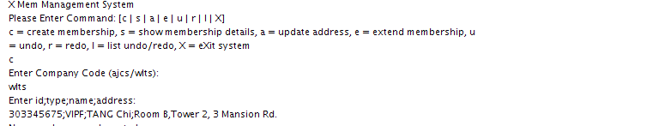

**1c. Show one member information (s)**

**s**

**303345675**

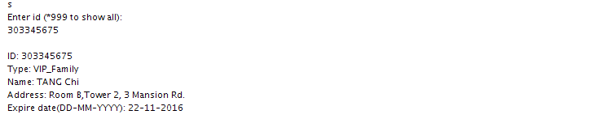

**1d.Show all records**

**s**

**\*999**

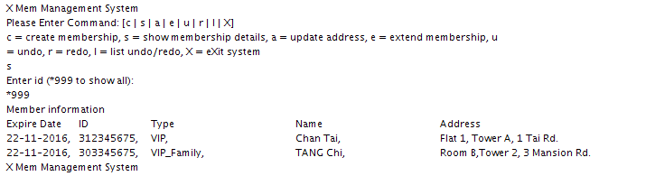

**2a.Create 2 members (1 primary member, and 1company member)**

**C**

**ajcs**

**21234561;Pri;Chan Siu;Flat 3, Tower C, 21 Tai Rd.**

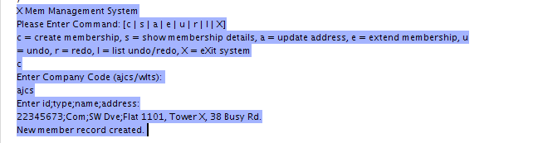

**c**

**ajcs**

**22345673;Com;SW Dve;Flat 1101, Tower X, 38 Busy Rd.**

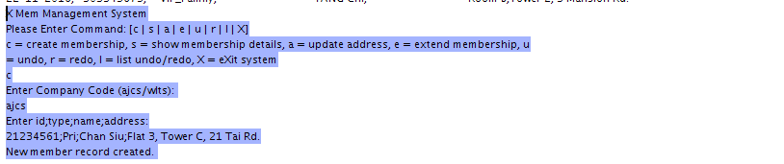

**2b. Show all records**

**s**

**\*999**

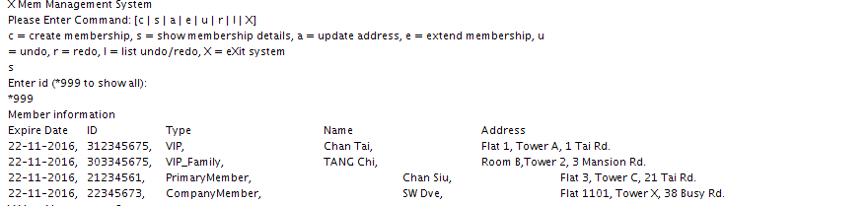

**3.** **Update address (a)**

**a**

**303345675**

**Room D, Tower 2, 3 Mansion Rd.**

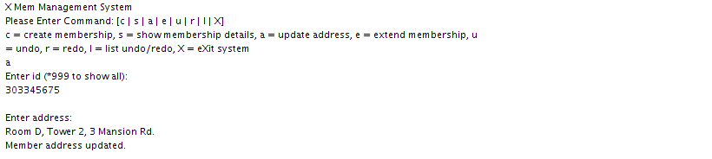

**s**

**303345675**

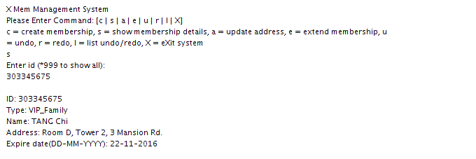

**4. Extend membership (e)**

e

22345673

Membership extended: 12-10-2017, 22345673, Com, SW Dve, Flat 1101, Tower X, 38 Busy Rd.

s

*999

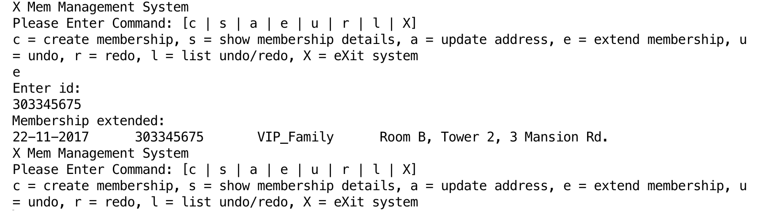

**5. Display the Undo/Redo List (l)**

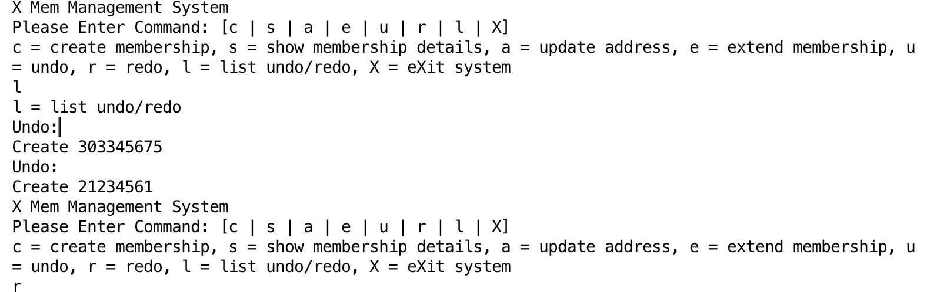

**6. Undo Last Command in the Undo List (u)**

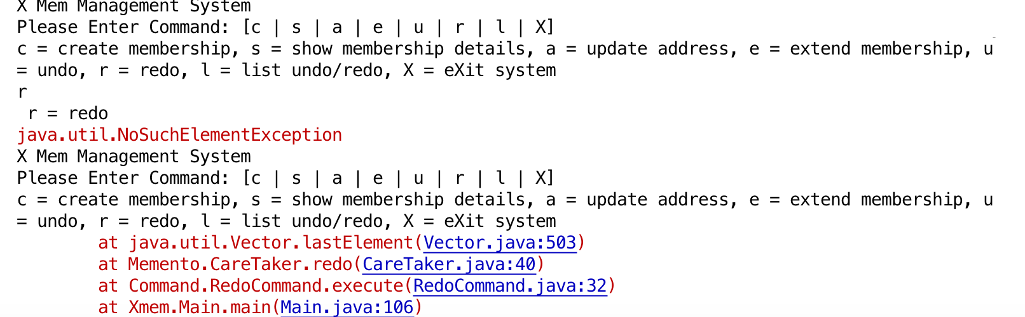

**7. Redo the last undo command (r)**

N/A

# Well documented Source Code

As our XSystem mamagnment membership system have existing classes

So the XSystem mamagnment membership system separate to 5 files.

