DEPARTMENT OF INFORMATION TECHNOLOGY
(TSING YI)

ITP4603 Programming techniques for Systems Integration
Assignment

Name | CHAN Ka Chun
Student ID | 140154313
Course | HDCSA(IT124106)

Contents

DEPARTMENT OF INFORMATION TECHNOLOGY 1
Description 3
User Guide 6
Using Framework 8

Description
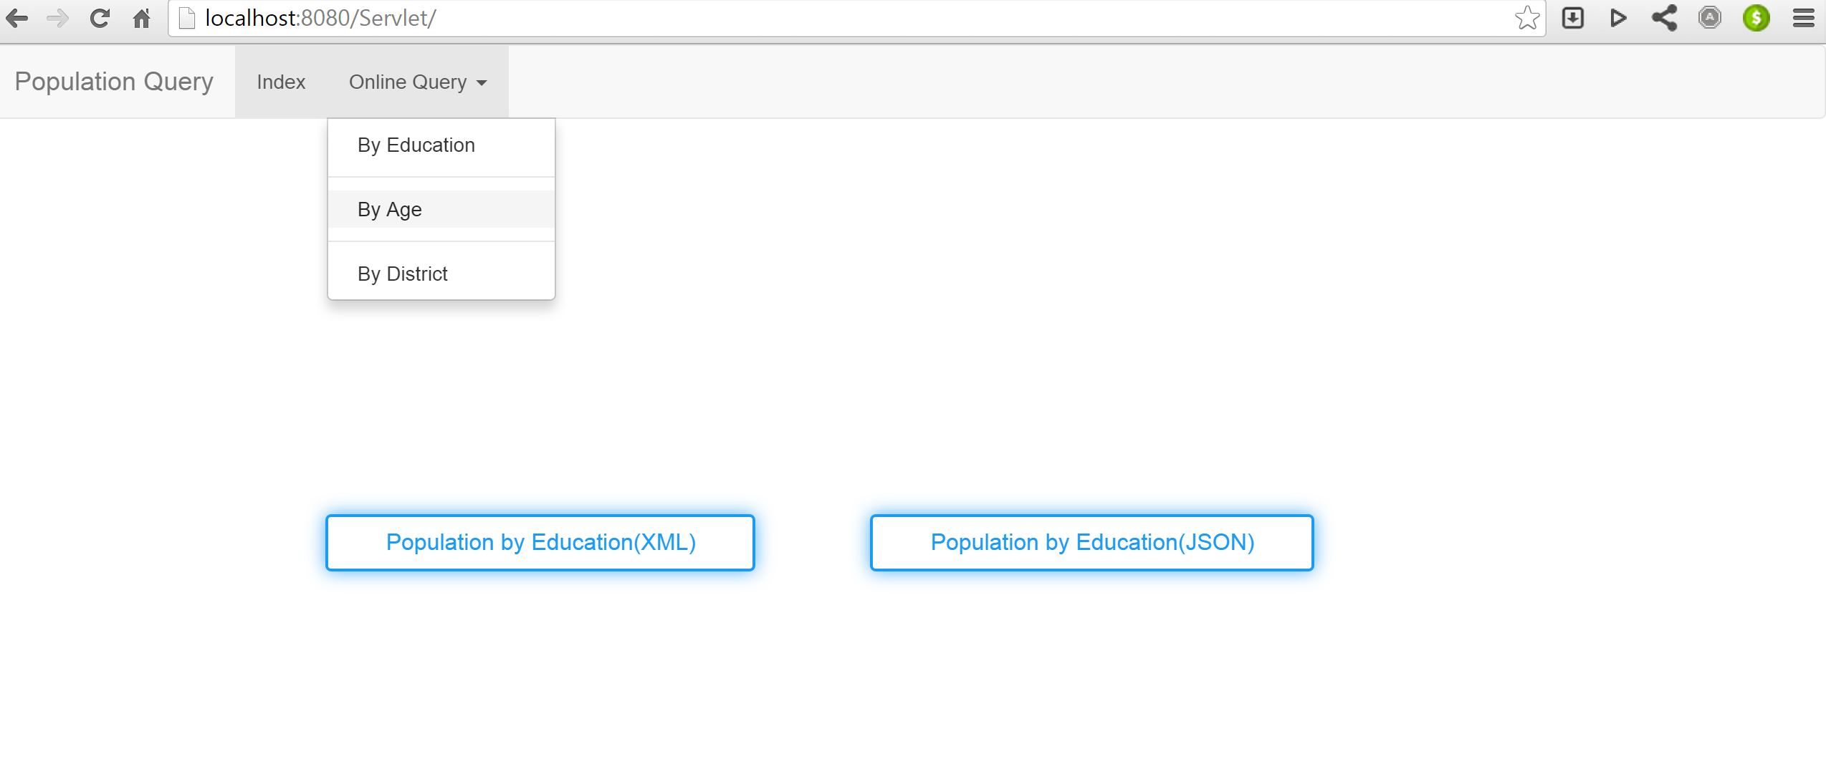
Main page

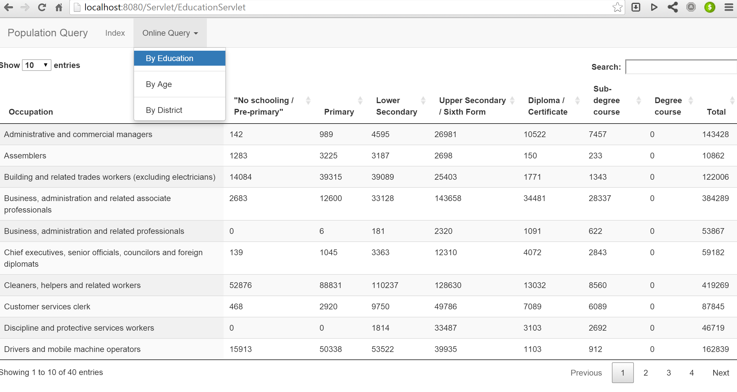

Education Web Page Query
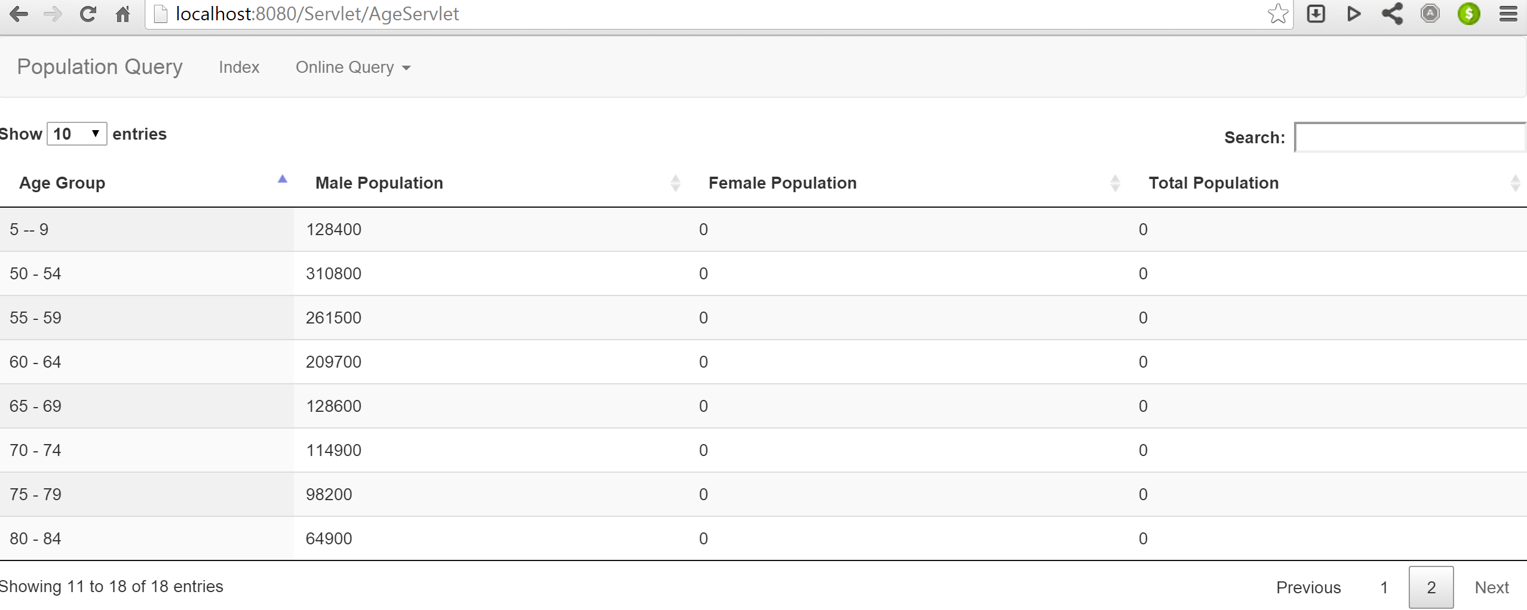
Age Group Web page Query

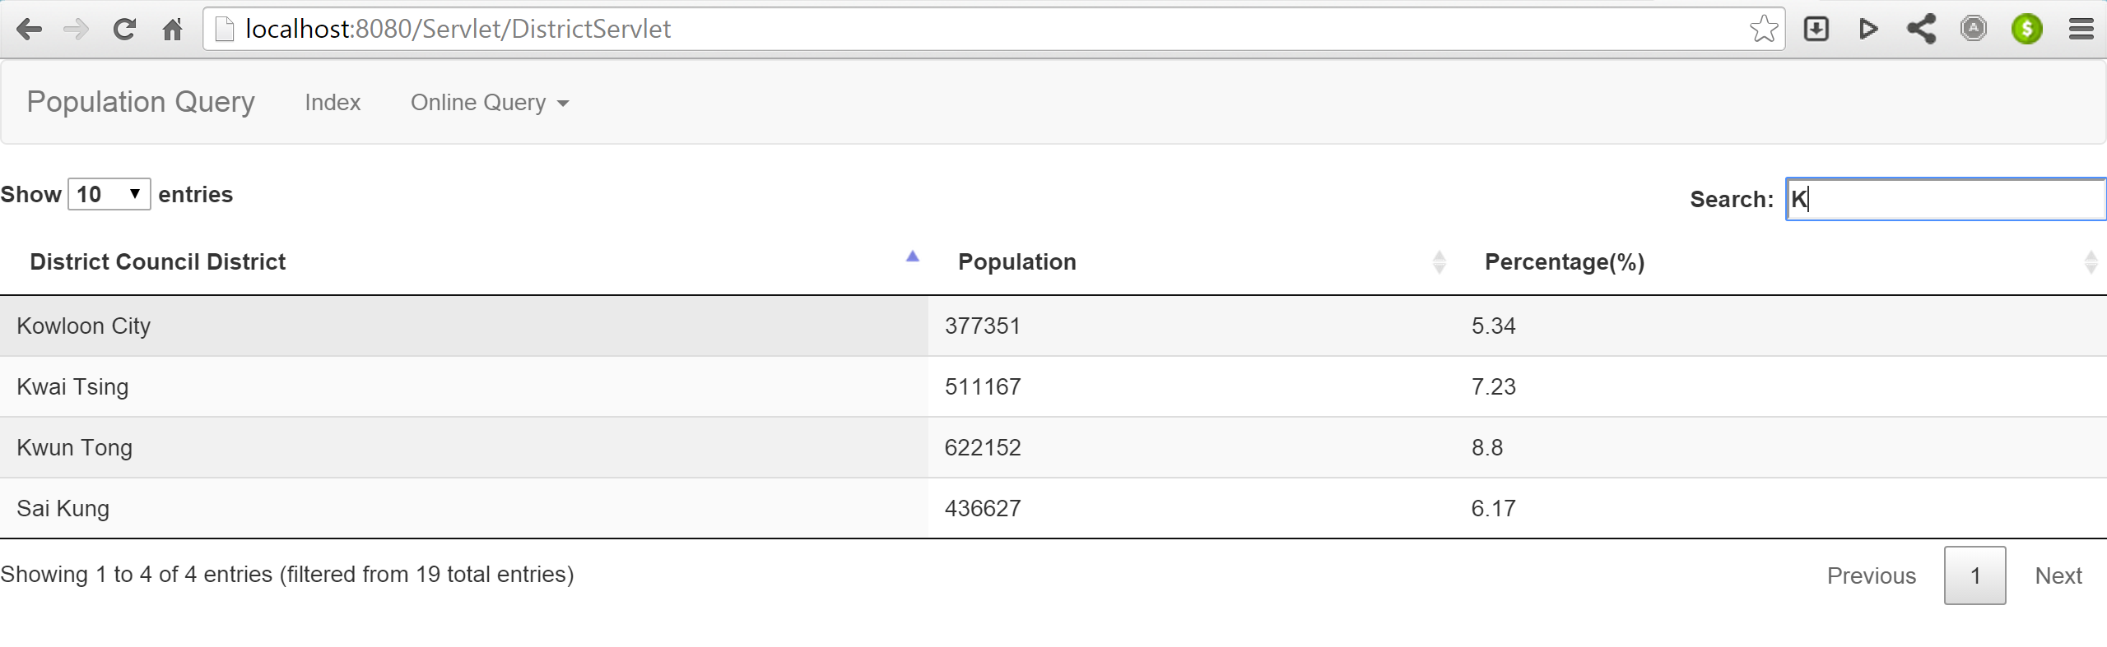
District Web page Query

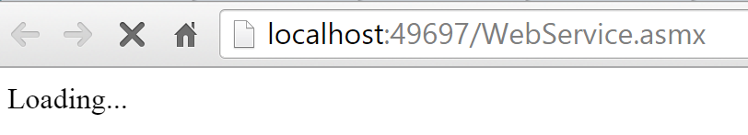
It will redirect to web service discription page when Start-up
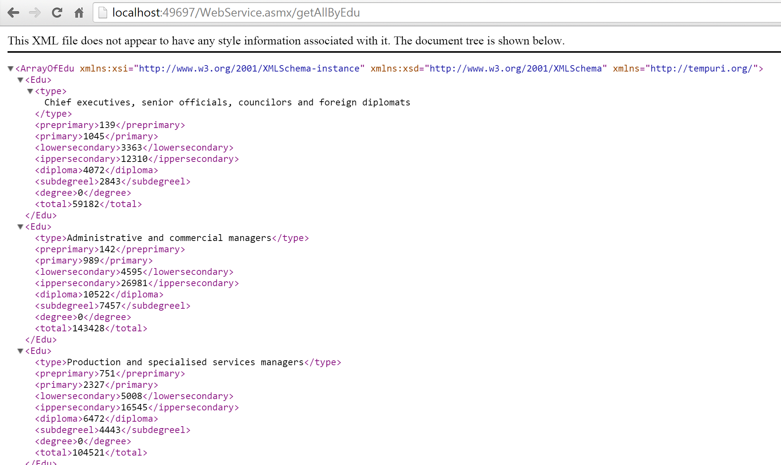
Education sheet XML output via HTTP Request

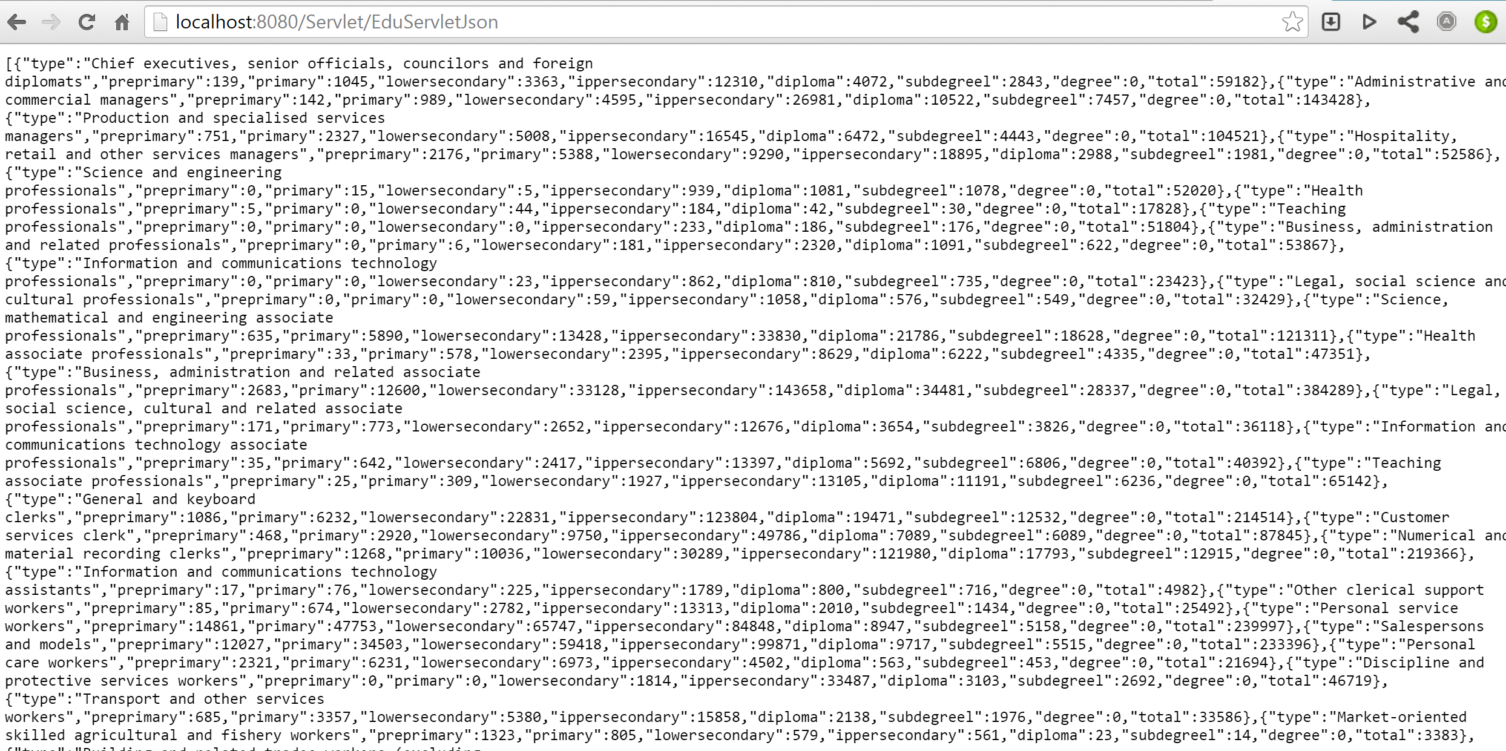
Education sheet JSON output

User Guide

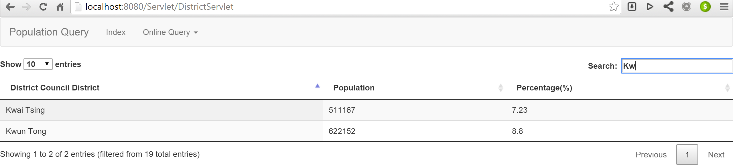
Key-in any keyword in data, it’ll be filtering.(Such as District)

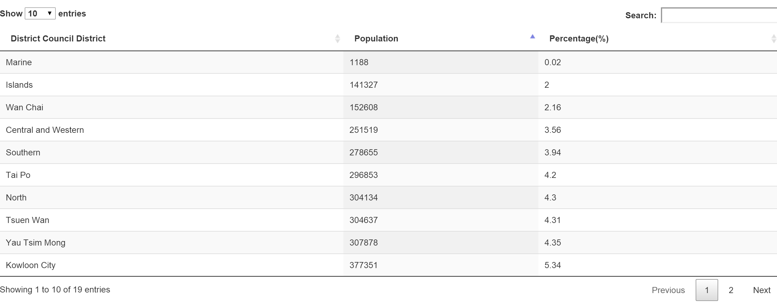
And sorting by Population or other colums

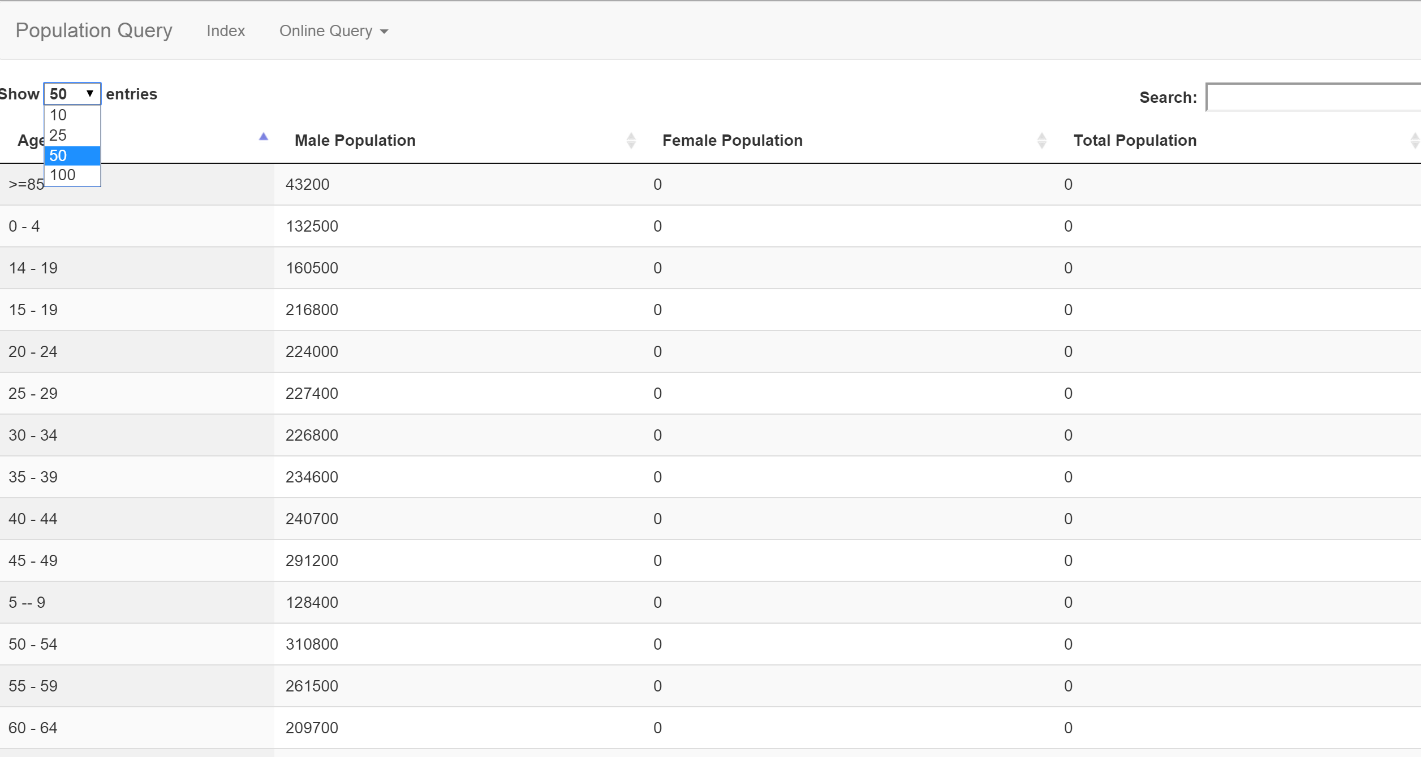
It’s also filtering the number of rows record display

Using Framework

- BootStrap
- jQuery
- DataTables Table plug-in for jQuery

