A Report

On

**Generators, Motors and Alternators in Electric Vehicles**



Prepared by-

CHAITANYA KRISHNA CHAUHAN 2020A4PS1869P

ALOK NARAYAN 2020A4PS0501P

PREM SHANKAR 2021A7PS0557P

A Report submitted in partial fulfillment of the requirements of ME F441 Automotive Vehicles to

**Professor Saket Verma**

Birla Institute of Technology and Science,

Pilani December 2022

**ACKNOWLEDGEMENT**

Our team GROUP 5, ME F441, would like to thank Dr. Saket Verma, Assistant professor, Mechanical Engineering, BITS Pilani who gave us this opportunity to make an assignment on Electrical Vehicles.

**INDIVIDUAL CONTRIBUTIONS**

|  |  |  |  |
| --- | --- | --- | --- |
| 1 | CHAITANYA KRISHNA CHAUHAN | Title page, alternators, conclusion, references APA formatting. | . |
| 2 | ALOK NARAYAN |  |  |
| 3 | PREM SHANKAR |  |  |

**3.1 What is an Alternator?**

An alternator is a type of electric generator that converts mechanical energy to electrical energy in the form of alternating current. They are commonly used in various applications where a source of electricity is needed, such as in automobiles, aircraft, and power plants. The use of alternators has increased manifold due to its high efficiency and reliability. They are capable of producing a higher output of electrical energy. This makes them ideal for use in modern vehicles that require a lot of electrical power to operate various systems such as lights, air conditioning, and sound systems.

**3.2 Technical details**

**3.2.1 Components**: An alternator mainly consists of a rotor, stator, and rectifier. The stator is a stationary component of the alternator that is located around the rotor and it contains a set of copper wire coils that generate an electrical current as the rotor spins.

The rotor is a rotating part of the alternator. It is also known as the rotating magnetic core which has a set of permanent magnets mounted on a shaft and is connected to the engine through a pulley system. 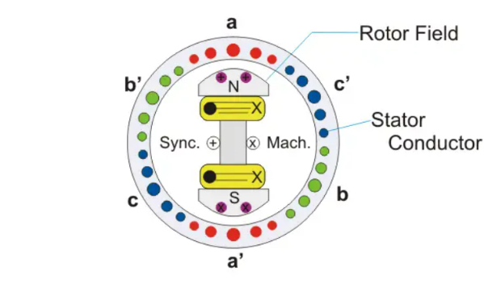

The rectifier is a device that converts the AC current generated by the stator into DC current that is usable by the vehicle's electrical system. There are other components in alternator such as regulator, slip rings, end bearings, pulley.

**3.2.2 Working principle**: An alternator works on the principle of electromagnetic induction. A magnetic field is generated due to the rotatory motion of rotor that passes through the stationary conductors in the stator. The moving magnetic field induces an electric current in the conductors, which is then transmitted to the electrical load.

**3.2.3 Power rating**: Power rating of an alternator is defined as the power which can be delivered by an alternator safely and efficiently under some specific conditions. Increasing load increases losses in the alternator, which leads to a temperature rise of the machine. It can range from a few watts for small portable generators to several megawatts for large power plants.

**3.2.4 Cooling system:** Alternators generate heat during operation, and therefore, they require a cooling system to dissipate the heat. The cooling system can be air-cooled or water-cooled, depending on the application and operating conditions. There are many methods of cooling for alternators namely Open Circuit Cooling, Closed Circuit Cooling, Radial, Axial and Circumferential Flow Ventilation System.

**3.2.5 Voltage regulation:** It is defined as the rise in the terminal voltage when the load is decreased from full-load rated value to zero. Alternators have a voltage regulator that controls the output voltage of the alternator. The speed and field current of the alternator remain constant. The voltage regulator monitors the electrical load and adjusts the field current in the rotor to maintain a constant output voltage.

Percentage voltage regulation = $\frac{\left|Ea\right|-|V|}{|V|}$ ×100%

**3.2.6 Efficiency:** The efficiency of an alternator is the ratio of the electrical power output to the mechanical power input. The efficiency of alternators can vary depending on their design, size, and operating conditions. The efficiency can be improved by using high-quality materials, optimizing the design, and improving the cooling system.

Alternators in electric vehicles are usually designed to be more efficient than those in conventional gasoline-powered vehicles. They are also designed to operate at a higher voltage, typically 400V and a battery voltage of 14V to provide sufficient power for the electric drivetrain and other electrical systems with a regulating system to modulate the amount of current entering the electromagnet.

**3.3 Classifications**

Alternators can be classified based on various factors, including their design, number of phases, operating principle, and application. Here are some common classifications of alternators:

**3.3.1 Design:** Alternators can be classified based on their design, such as:

**3.3.1.1 Salient-pole alternators:** These alternators have a large number of projecting poles with a large air gap between the stator and rotor. They are commonly used in low speed turbine such as hydroelectric power plants.

**3.3.1.2 Cylindrical-rotor alternators:** These alternators have a smooth cylindrical rotor and a stator with a distributed winding for accommodating coils. They are commonly used in high speed turbine such as gas turbine power plants.

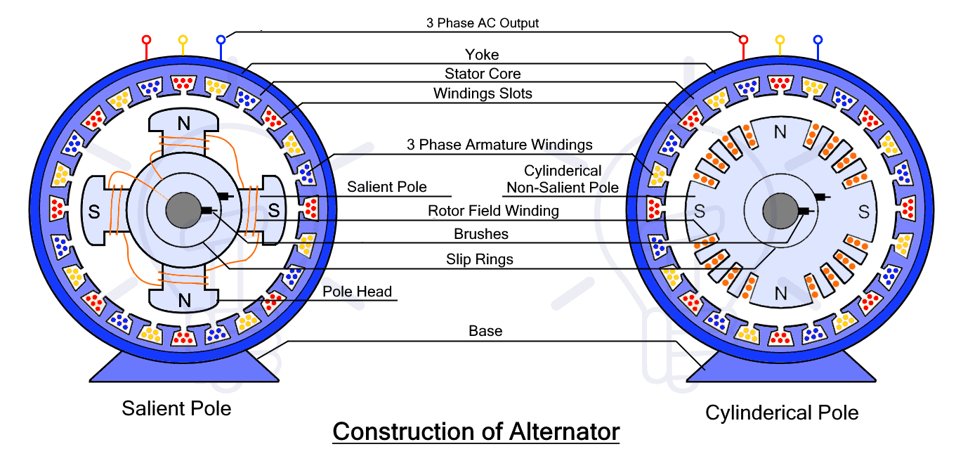

**3.3.2 Phases :** Alternators can be classified on the basis of the number of phases :

**Single phase alternator :** Generating one alternating voltage continuously.

**Two-phase alternator :** Alternative maximum and zero flux generation.

**Three-phase alternator :** Each winding voltage is 120 ° from one stage to another.

**3.3.3 Operating principle:** Alternators can also be classified based on their operating principle, such as:

**3.3.3.1 Induction alternators:** These alternators uses an air gap rotating magnetic field between stator and rotor to produce an induced current in rotor winding, commonly used in wind turbines and hydroelectric power plants. They are also known as Asynchronous alternators.

**3.3.3.2 Synchronous alternators:** These alternators have a rotor that rotates at the same speed as the frequency of the alternating current, and they are widely used in hydropower, thermal power, nuclear power, and diesel power generation.

**3.3.4 Application:** Alternators can also be classified based on their application, such as:

**Automotive alternators:** These alternators are used in gasoline or diesel-powered vehicles to charge the battery and power the electrical components.

**Marine alternators:** These alternators are designed to withstand the harsh marine environment and are commonly used in marine and navy boats.

**Brushless alternators:** In these alternators, the rotor’s slip rings and brushes are replaced by a separate alternator called an excitation alternator. It is also used in thermal and nuclear plants.

**Radio alternators:** It is a high frequency alternator used for generating radio frequency current in radio transmitters. It is also known as Goldschmidt alternator.

**3.4 Mode of operation**

Alternators operate on the principle of electromagnetic induction, which is the process of generating an electric current in a conductor by varying the magnetic field around it. The mode of operation of an alternator can be divided into two phases: the excitation phase and the generation phase.

**3.4.1 Excitation phase:** In this phase, the rotor is magnetized by an external source of energy, such as a battery or a rectifier. The magnetic field produced by the rotor induces an electromotive force (EMF) in the stator windings as it rotates. The EMF in the stator windings is alternating and has a sinusoidal waveform.

**3.4.2 Generation phase:** In this phase, the EMF induced in the stator windings is transformed into an electrical current that can be used to power electrical loads. This is achieved by connecting the stator windings to a load through a rectifier, which converts the alternating current (AC) to direct current (DC).

**3.5 Benefits of Alternators in Electric Vehicles:**

**Efficient Charging:** Alternators in electric vehicles are designed to be more efficient than those in conventional gasoline-powered vehicles. Since electric vehicles don’t have an engine, we can connect the alternators to the spinning wheels or driving shaft to run it.

**Extended Driving Range:** Alternators in electric vehicles can help to extend the vehicle's driving range by providing a constant source of electrical power to the battery. This means that the vehicle can travel further on a single charge, reducing the need for frequent recharging.

**Regenerative Braking:** Alternators can be used to capture energy during regenerative braking in electric vehicles. This energy can be stored in the battery and used later to power the electric motor and other systems.

**Reduced Energy Consumption:** Alternators in electric vehicles can reduce the energy consumption of the vehicle's electrical systems, as they can generate power more efficiently. This means that the vehicle's battery will last longer, reducing the need for frequent charging.

**Reduced Emissions:** Alternators in electric vehicles can help to reduce the emissions produced by the vehicle, as they do not rely on fossil fuels to generate electricity. This means that electric vehicles powered by alternators produce fewer emissions than gasoline-powered vehicles.

**3.6 Drawbacks of Alternators in Electric Vehicles:**

**Power source:** Alternators need a mechanical source to function, since electrical vehicles don’t have an engine, it’s not feasible to use an alternator in EVs.

**Cost:** Alternators in electric vehicles can be expensive, as they require specialized components and materials to operate effectively. This can make electric vehicles more expensive to produce, reducing their appeal to consumers.

**Limited power output:** Alternators are typically designed to provide a limited amount of power, which may not be sufficient for an electric vehicle.

**Better alternatives:** We can use a DC to DC converted in place of alternators which is more efficient and simpler way for conversion of voltages. Alternators will overheat if the current is high which is not a problem in case of DC/DC converters.

**Weight:** Alternators are heavy and bulky, which can reduce the efficiency and performance of the electric vehicle by increasing the weight of the vehicle. In contrast, DC/DC converters and compact and light in weight.

**Maintenance:** Alternators in electric vehicles require regular maintenance to ensure that they are operating effectively. This can be time-consuming and expensive, particularly if the alternator requires repairs or replacement.

**Efficiency:** Using an alternator might increase the driving range but on the cost of reduced efficiency.

**3.7 Comparison**

Alternators, generators, and motors are all electrical machines that can be used in different applications, including electric vehicles. However, they have different designs, functionalities, and advantages and disadvantages when used in electric vehicles.

In electric vehicles, motors are widely used as compared to alternators and generators. First of all, we don’t have an engine in EVs. The power source in EVs comes exclusively from the batteries. Adding a generator or alternator in EVs would just reduce the torque of wheels as some energy would be used to drive the generator. Moreover, charging the batteries using energy of battery won’t be advantageous and only add to the overall weight of car reducing it’s performance. Hence, we generally don’t prefer a generator or motor when it comes to EVs. A motor may act as a generator during regenerative breaking and the power generated is sent back to battery. Dc motors are used due to their robust construction and simple control.

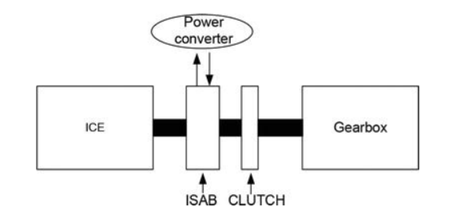

If we talk about HEVs, they are equipped with integrated starter-alternator (ISA) systems(Mike Ruff, 2021). Their function is to recover energy during working. The HEVs will also have a generator to charge the HV battery while driving. This replaces the alternator and can act as both generator and motor (Jo, 2022). A generator can convert to both AC and DC electrical energy but is less efficient due to it’s lower output. Combining the function of both the starter motor and generator or alternator, the product will ensue in fuel savings of 7-15 percent in a hybrid vehicle depending on the mode of driving.

Among the different types of alternators, three-phase alternators are most widely used. They have 3 sets of windings which produce three currents that make up the three phases. Salient pole alternators have a lower rating than cylindrical type. Cylindrical ones are used for high-speed applications and are simpler to design.

**3.8 Future trend**

The trend in electric vehicles is moving towards more efficient and sustainable technologies that maximize the range and performance of the vehicle while minimizing the environmental impact. Therefore, it is unlikely that there will be a significant increase in the use of alternators in electric vehicles in the future.

However, there may be some niche applications where alternators could be used in electric vehicles, such as in hybrid electric vehicles (HEVs) or plug-in hybrid electric vehicles (PHEVs) that use a combustion engine in addition to an electric motor. In these vehicles, the alternator could be used to charge the battery and provide auxiliary power to the electrical components.

Additionally, there may be some advancements in alternator technology that make them more efficient and suitable for use in electric vehicles. For example, the development of high-efficiency alternators, lightweight materials, and improved control systems could make alternators more attractive for use in electric vehicles. Moreover, there is a possibility that the alternators could be installed in other rotating parts of EVs such as wheels or driving shaft but that is a speculation and is subject to changes in future. The most recent developments have focussed on ‘Smart Charging’.

Overall, while there may be some limited applications for alternators in electric vehicles, the trend is moving towards more efficient and sustainable technologies such as electric motors and advanced battery systems.

**3.9 Applications with Examples**

Alternators are not commonly used in electric vehicles as it’s purpose is self-defeating because in cases of EVs, it consumes more energy than it adds. However, there may be some limited applications for alternators in electric vehicles. One possible application for alternators in electric vehicles is in hybrid electric vehicles (HEVs) or plug-in hybrid electric vehicles (PHEVs) that use a combustion engine in addition to an electric motor. In these vehicles, the alternator can be used to charge the battery and provide auxiliary power to the electrical components when the combustion engine is running.

Another possible application for alternators in electric vehicles is in range extender systems. Range extenders are small combustion engines that are used to generate electricity and recharge the battery while the electric motor powers the vehicle. In these systems, the alternator can be used to convert the mechanical energy from the combustion engine into electrical energy to recharge the battery and provide auxiliary power to the electrical components.

For example, the Toyota Prius uses an alternator to charge the battery and power the electrical components when the engine is running. However, it should be noted that the alternator is only used in conjunction with the combustion engine and not during electric-only operation.

Another example is the Chevrolet Volt, which is also a plug-in hybrid electric vehicle (PHEV) with a gasoline range extender. The Volt's gasoline engine powers a generator that provides electricity to the electric motor when the battery is depleted.

An example of range extender is the BMW i3. The i3 has an optional two-cylinder gasoline engine that acts as a generator to recharge the battery when it runs low, increasing the vehicle's total range.

**3.10.1 Case Study 1. Performance Analysis of an Integrated Starter-Alternator**

This case study focuses on increasing the autonomy of vehicles due to the accumulation of electricity using ISA in EVs. It is (Ruba, 2016). In this case, the integrated starter-alternator-booster (ISAB) system will be able initially to start the ICE, then, when it is turned on, it will reverse to generator mode and will supply electricity to consumers and the storage system. In order to study the electrical machines with ISAB applications, a model was created and simulated using AMESim. The parameters considered for ISAB(SynRM) and BSAB (PMSMOR) applications are presented in the below table:

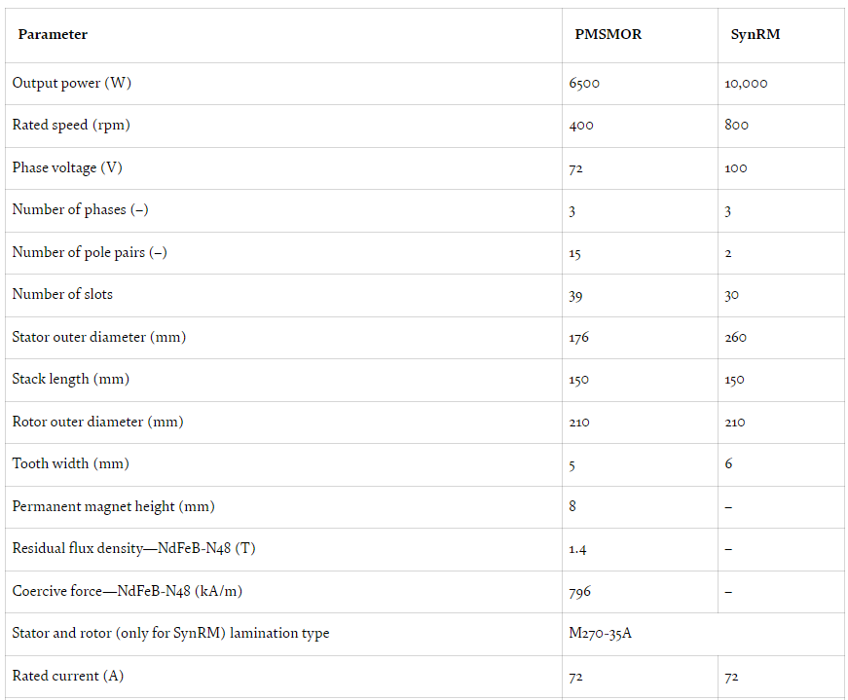

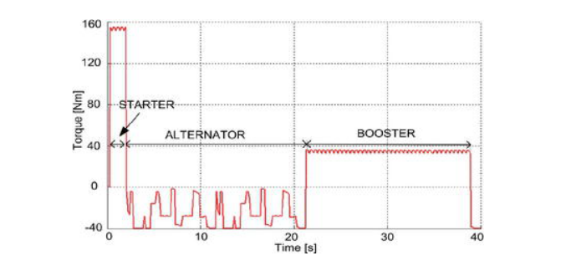The below figure shows the ISAB torque profile for starter, alternator and the booster.

**3.10.2 Case Study 2. Experimental study on the effect of alternator to the car charging system**

Table 1 shows the available electrical devices in Proton Preve 1.6 Manual. All the electrical devices were turned on and act as load to the alternator. The sequence has been set to ensure accuracy and consistency of the result. Table 1 is the measured speed of alternator and crankshaft. Table 2 shows the voltage reading of the battery after all the electrical components had been turned off for 5 minutes. The purpose is to study the relationship between current and charging rate of the battery.

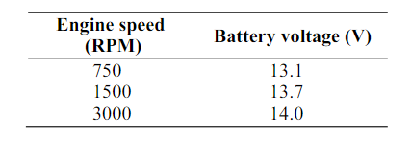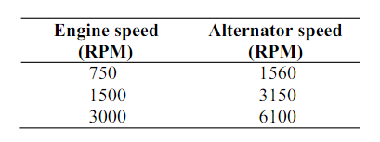

Table 1 Table 2

The results of the experiment is shown in the graph:

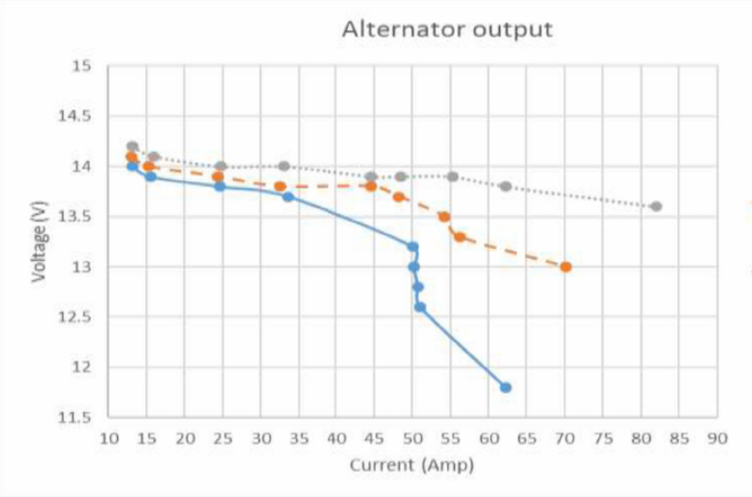

In this paper, the experiment was done to prove the theories, and to find the relationship

between alternator speed and the charging system. The experiment was aimed to gain better

understanding and better knowledge about charging system. The result shows that the faster

the alternator, the more power it can produce. But when alternator output current is low at low speed, the battery voltage is high as the battery get enough power for recharging. The Proton Preve used in the experiment has a crankshaft-alternator speed ratio of 1:2.

# References

Jo, J. (2022). *Do hybrid cars use alternators.* Retrieved from Quora: https://www.quora.com/Do-hybrid-cars-have-an-alternator

Mike Ruff, G. e. (2021, May 27). *Hybrid Vehicles.* Retrieved from Garagewire: https://garagewire.co.uk/news/company/asp/everything-you-need-to-know-about-hybrid-vehicle-alternators-and-starters/

Ruba, F.-N. J. (2016, October 26). *Perfomance Analysis of an Integrated Starter-Alternator.* Retrieved from Intechopen: https://www.intechopen.com/chapters/55341