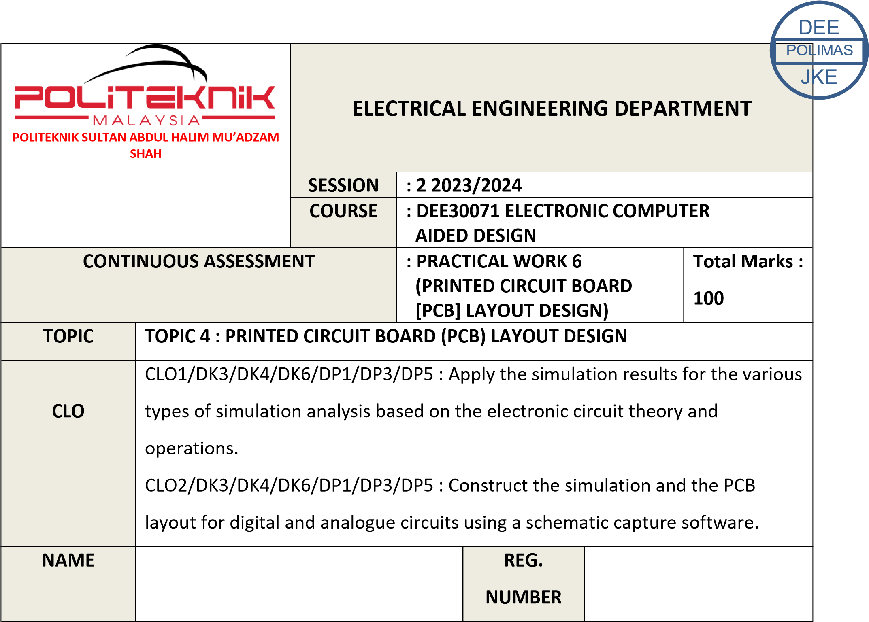

03DET22F1043

CHONG KHENG CHEN

|  |  |  |
| --- | --- | --- |
| CLO1 (C3, PLO1) | COGNITIVE ASSESSMENT  (20 %) |  |
| CLO2 (P4, PLO5) | PSYCHOMOTOR ASSESMENT  (80 %) |  |
|  | TOTAL MARKS  (100%) |  |

**\*Refer to Rubric**

|  |  |
| --- | --- |
| **1** | **LEARNING OUTCOMES (LO):**  2 : Construct the simulation and the PCB layout for digital and analogue circuits using a schematic capture software (P4, PLO5) |
| **2** | **OBJECTIVE :**    Upon completion of this practical work, students should be able to:   1. Apply PCB editor 2. Transfer components from schematic editor to PCB editor automatically 3. Organize components manually and automatically 4. Edit track width and component 5. Edit component footprints and pad size 6. Use Automatic updating component designators and footprints between PCB editor and schematic editor 7. Use Manual/Automatic Router to produce the PCB design layout for the circuits simulated in Topic 2 and Topic 3. |
| **3** | **THEORY :**    Printed circuit board (PCB) consist a conductive tracks, pads and other feature that build from copper sheet laminated onto non-conductive substrate. There are several types of PCB such as single sided (one copper layer), double sided (two copper layers) or multi-layer (outer and inner layers). |
| **4** | **EQUIPMENT / TOOLS / SOFTWARE :**   1. PC workstation 2. Related software |

**5**

**PROCEDURE**

**:**

**PART A : DRAWING SCHEMATIC AND SIMULATE**

.

1

Draw the circuit in Figure 6.1 as shown below using related software. Prior to

circuit construction, user must first identify the necessary components required

in the

circuit.

Figure 6.1:

Timer LED

555

Flasher S

chematic

Circuit

2

. S

imulate the circuit

in Figure 6.1

a

fter completing the circuit assembly and

configuration

to verify whether the source code compiled is virtually accurate or

not.

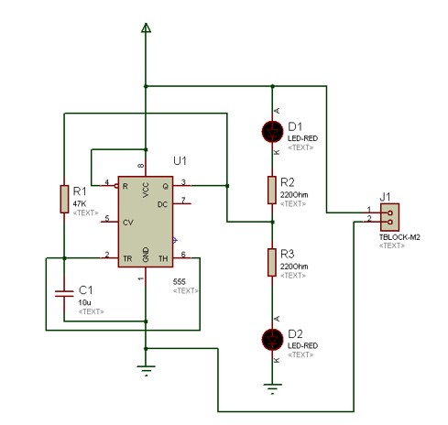

|  |  |
| --- | --- |
|  | **PART B : TRANSFORM ONTO PCB LAYOUT DESIGN**     1. Transfer components from schematic editor edit in question Part A to PCB editor automatically. 2. Arrange component manually and automatically. 3. Produce the PCB by manual and automatic router. |
| **6** | **RESULT :**    **PART A**  Convert the schematic circuit in Figure 6.1 into PCB.    **PART B**  Capture the screen layout for schematic and PCB that you have construct. Submit together with your lab sheet. |
| **7** | **DISCUSSION :**  In the discussion portion, students could analyse the effectiveness of different design choices, discuss challenges encountered during the design process, and explore strategies for optimizing PCB layout for performance, manufacturability, and cost-effectiveness. They could also reflect on the importance of proper communication between schematic and PCB editors and the implications of design decisions on the overall functionality and reliability of the circuit. |

|  |  |
| --- | --- |
| **8** | **CONCLUSION :**  Through this practical work, students will develop a comprehensive understanding of PCB design by mastering essential skills such as utilizing PCB editor software, transferring components seamlessly between schematic and PCB editors, both manually and automatically organizing components, adjusting track widths and component properties, modifying component footprints and pad sizes, ensuring automatic updating of designators and footprints, and employing manual or automatic routing techniques to create PCB layouts for simulated circuits. By applying these skills, students will gain the proficiency needed to produce efficient and optimized PCB designs while ensuring signal integrity, manufacturability, and adherence to design specifications.  . |

|  |  |  |  |  |  |  |  |  |  |
| --- | --- | --- | --- | --- | --- | --- | --- | --- | --- |
| **PRACTICAL WORK 6:**  **PRINTED CIRCUIT BOARD (PCB) LAYOUT DESIGN** | | | | | | | | A | B |
|  | **MATRIX NUMBER** | | | **NAME** | | | |
|  |  | | |  | | | |
| **A** |  | | |  | | | |  |  |
| **B** |  | | |  | | | |
| Course Learning  Outcomes(CLO)/  Learning Domain Cluster (CLS) | | Circuit | Skills / Aspects | | Very Poor | Satisfactory | Very Good | Marks | |
| 1 | 2 | 3 |
| CLO 1 : Apply the simulation results for the various types of simulation analysis based on the electronic circuit theory and operations.    CLO 2: Construct the simulation and the PCB layout for digital and analogue circuits using a schematic capture software.    CLS 1:  Knowledge &  Understanding    CLS3a :  Practical skill | | PART  A    6.1 | **Draw schematic circuit:** Student able to draw the schematic circuit same as given. | | Able to draw the schematic circuit with assistance. | Good to draw the schematic circuit  moderately with minimum assistance. | Excellent to draw the schematic circuit effectively. | /3 | /3 |
| **Simulation setting:** Student able to set simulation settings correctly. | | Able to set all the simulation settings correctly with assistance. | Good to set all the simulation settings  correctly with minimum assistance. | Excellent to set all the simulation settings correctly and effectively. | /3 | /3 |
|  | | | | | | /6 | /6 |
| PART  B    6.1 | **Transfer to PCB :** Students able to transfer  components from Schematic Editor to PCB editor automatically | | Able to automatically transfer components from  Schematic Editor to  PCB  editor independantly | Able to automatically transfer  components from Schematic  Editor to PCB editor with  some supervision  from the lecturer | Unable to automatically transfer  components from Schematic  Editor to PCB editor independantly and needs  supervision from the lecturer all the time | /3 | /3 |
| **Arrange components :** Students able to arrange components and tracks manually / automatically | | Able to arrange components and tracks manually without any supervision from the lecturer | Able to arrange  components and tracks manually with some supervision from the lecturer | Unable to arrange components and tracks  manually even with supervision from the lecturer all the time | /3 | /3 |
| **Produce PCB :** Students able to use the Automatic /  Manual  Component  Updater and Router to produce the PCB layout design. | | Able to update and route their PCB design independantly | Able to update and route their PCB design with some supervision from the lecturer | Unable to update  and route their PCB design even with supervision from the lecturer all the time | /3 | /3 |
|  | | | | | | /9 | /9 |

# PRACTICAL SKILLS PSYCHOMOTOR ASSESMENT - (80%)

|  |  |  |  |  |  |
| --- | --- | --- | --- | --- | --- |
| **NO.** | **STUDENT’S NAME** | **PART A**  **(6.1)** | **PART B**  **(6.1)** | **Total:** | **80%** |
|  |
|  |  |  |  | **(15 marks)** |  |
| **A** |  | /6 | /9 | /15 | /80 |
| **B** |  | /6 | /9 | /15 | /80 |

# PRACTICAL WORK COGNITIVE ASSESSMENT - (REPORT 20%)

|  |  |  |  |
| --- | --- | --- | --- |
| **Discussion** | **Conclusion** | **TOTAL** | **20**  **%** |
| /10 | /10 | /20 | /20 |

# TOTAL MARKS

|  |  |  |  |  |
| --- | --- | --- | --- | --- |
| **NO.** | **STUDENT’S NAME** | **COGNITIVE**  **ASSESSMENT**  **(20 %)** | **PSYCHOMOTOR**  **ASSESMENT**  **(80 %)** | **Total:** |
| **(100 %)** |
| **A** |  | /20 | /80 | /100 |
| **B** |  | /20 | /80 | /100 |