Department of Electrical Engineering

DEC50132 – **Internet Based Controller**

PRACTICAL WORK NO : 5

TITLE : Message Queuing Telemetry Transport (MQTT) -Controlling DATE : ESP32 output using MQTT.

:

LECTURER’S NAME : 1)

2)

|  |  |  |  |  |  |  |  |  |
| --- | --- | --- | --- | --- | --- | --- | --- | --- |
| PRACTICAL SKILL  ASSESSMENT  *(PLO5, LD2,CLO 3)* | |  | ATTAINMENT | LAB REPORT ASSESSMENT | | ATTAINMENT | | |
| Able to understand the node without supervision | | S1 |      | Result | |      | | |
| S2 |      |
| S3 |      |
| S4 |      |
| Able to establish connection to the broker from MQTTbox/ IOT MQTT panel | | S1 |      | Discussion | |      | | |
| S2 |      |
| S3 |      |
| S4 |      |
| Able to deploy the node-red and broker | | S1 |      | Conclusion | |      | | |
| S2 |      |
| S3 |      |
| S4 |      |
| Able to get the PBL output (weightage x 2) | | S1 |      | Score (30) | |  | | |
| S2 |      |
| S3 |      |
| S4 |      |
| Score (50) | | S1 |  | Percentage (30%) | |  | | |
| S2 |  |
| S3 |  | Total CA Marks (100%) | | S1 |  | |
| S4 |  | S2 |  | |
| Percentage (70%) | | S1 |  | S3 |  | |
| S2 |  |
| S3 |  | S4 |  | |
| S4 |  |
| BIL. | GROUP MEMBERS | | | | REGISTRATION NO. | | |
| 1 |  | | | |  | | |
| 2 |  | | | |  | | |
| 3 |  | | | |  | | |
| 4 |  | | | |  | | |

**LABORATORY RUBRIC TABLE**

**PRACTICAL SKILL ASSESSMENT**  **(PLO5, CLO[1])**

|  |  |
| --- | --- |
| Score | Description |
| 10 | Student can complete all tasks assigned WITHOUT errors |
| 8 | Student can complete all tasks assigned with A FEW errors |
| 6 | Student can complete all tasks assigned with MORE errors |
| 4 | Student can complete partial tasks assigned WITHOUT errors |
| 2 | Student can complete partial tasks assigned with A FEW errors |
| 0 | Student shows no response/task not attempted |

**LAB REPORT ASSESSMENT** **(PLO5, CLO2)**

|  |  |  |  |  |  |
| --- | --- | --- | --- | --- | --- |
| Report Component | Excellent | Very Good | Good | Fair | Unsatisfactory |
| 10 | 8 | 6 | 4 | 2 |
| Result  Ability to record result correctly | Record the result correctly Attached approved result that has been verify in the report. | Record result with less error. Attached approved result that has been verify in the report. | Record result with few errors. Attached result in the report. | Record result with error.  Attached result in the report. | result recorded partially  Result not verify by lecturer. |
| Discussion  Ability to present, interpret and analyze result. | All point of discussion on the results obtained covered and elaborated. | Most points of discussion on results obtained covered and elaborated. | Some points of discussion on results obtained covered and elaborated. | Some points of discussion on results obtained covered and but not properly elaborated. | Very few points of discussion, not properly elaborated. |
| Conclusion  Provide answers to objectives stated earlier.    Ability to learn something from the experiment. | Conclusion includes whether the findings supported the hypothesis/objectives, possible sources of error, and what was learned from the experiment. | The closing paragraph summarizes and draws a sufficient conclusion. | The closing paragraph attempts to summarize but draws a weak conclusion. | The closing paragraph do not attempts to summarize the  experiment OR shows  little effort and reflection. | No conclusion was included in the report. |

The objectives outlined aim to equip students with essential skills in IoT development using MQTT. They start by teaching students how to establish an internet connection using MQTT clients, laying the groundwork for communication. Subsequently, students learn to publish and subscribe to MQTT messages, enabling bidirectional communication between devices and a broker. These skills are then applied to create a basic IoT application, where students control LEDs and monitor sensor readings. Integration with Node-RED dashboarding adds a user-friendly interface for visualization and interaction, enhancing the practicality and accessibility of the developed IoT solution. Overall, these objectives provide a comprehensive foundation for students to understand and implement MQTT-based IoT solutions effectively.

Problem Based Learning

Based on all the steps above, use your understanding to get the output in your node

-

red

dashboard

and Android

or IOS

IOT MQTT Panel

to control two LEDs at dining hall and kitchen

in

your house.

Discussion:

.

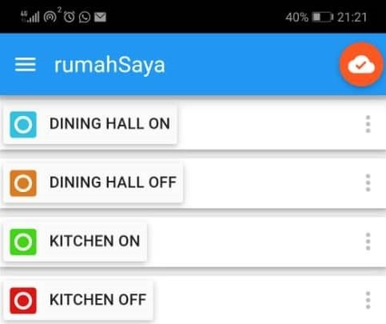

Conclusion:

In conclusion, through this practical course, students have achieved the fundamental objectives of writing code to establish MQTT internet connections, publishing and subscribing to MQTT topics, and developing simple IoT applications for LED control and sensor monitoring using Node-Red dashboard. This comprehensive learning experience has equipped them with essential skills in MQTT communication protocols and IoT application development, empowering them to navigate and contribute to the evolving landscape of interconnected devices and systems with confidence and proficiency.

Result :

1. /17 | P a g