文件說明 | 台灣國際住商_接待申請逾時通知批次
版本 | □SP6 □SP7 □7.X □2.X ■3.X |  |  | 發行範圍 | ■對內 □對外
行業別 | □____________ □通用 |  |  | 客戶名稱 | (必填)
撰寫人 | 胡靜涵 | 撰寫日期 | 2015.07 | 修改人 |  | 修改日期
相關程式 | 表單代號:EFNET0143_RESAB02
目的:針對簽核中的接待申請單及接待申請變更單若系統日等於表單內容的預訂時間，發出簽核即將逾期通知mail

結果:
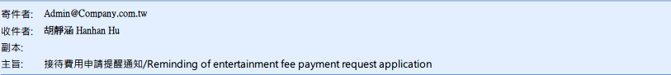
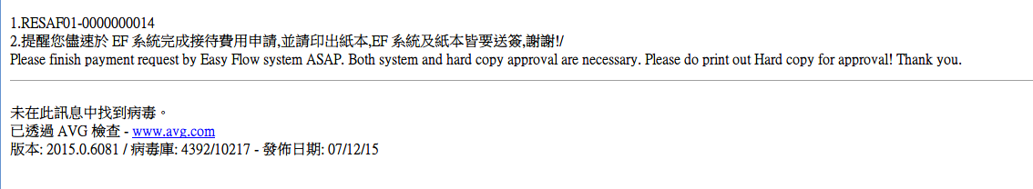
public void Run()//針對簽核中的接待申請單及接待申請變更單若系統日等於表單內容的預定日期，發出簽核即將逾期通知mail。
{
DBCommand db = DscDBData.GetDataDBCommand();
DataTable dt = new DataTable();
string sql = "";
string sql2 = "";
int nowDate = int.Parse(DateTime.Now.ToString("yyyyMMdd"));//取得目前系統日期
string nowTime = DateTime.Now.ToString("HH:mm");//取得目前系統時間
int receptionDate = 0; //預定接待日
string applicant = "";//申請人
string applicantEmail = "";//申請人mail
string mailSubject = "";//mail主旨
string mailContent = "";//mail 內容
int count = 0; //資料筆數
string formNum = "";//表單單號
string AdminMailbox = objEFPara.EF_getCompanyParameterData("AdminMailbox");//取得單一寄件者
UTL_PublicProcess oo = new UTL_PublicProcess(m_processor);//Mail
string logMsg = "";

try
{ //撈出 以resdd為主 RESAF01接待申請單為輔 狀態碼為1[未簽核] 的 表單單號 、接待申請編號、收件人、預定接待日、收件人mail、狀態碼:1
sql = string.Format(@"select resaf01001,resaf01002 as formNum,left (resaf01008,8)as receptiondate,resdd007 ,resdd015,resak005
from {0}..resdd
left join {0}..resaf01 on resdd001 = resaf01001 AND resdd002 = resaf01002
left join {0}..resak on resdd007 = resak001
where resdd015 = '1' and resdd001 = 'RESAF01' ", gCompany);
//撈出以resdd為主 RESAF02 接待申請單為輔 狀態碼為1[未簽核] 的 表單單號 、接待申請編號、收件人、預定接待日、收件人mail、狀態碼:1
sql2 = string.Format(@"select resaf02001,resaf02002 as formNum,left (resaf02010,8)as receptiondate,resdd007 ,resdd015,resak005
from {0}..resdd
left join {0}..resaf02 on resdd001 = resaf02001 AND resdd002 = resaf02002
left join {0}..resak on resdd007 = resak001
where resdd015 = '1' and resdd001 = 'RESAF02' and resaf02003 <> '作廢'", gCompany);

string[] sqlArray = new string[] { sql, sql2 };
for (int i = 0; i < sqlArray.Length; i++)
{
dt = db.Query(sqlArray[i]);
count = dt.Rows.Count;
if (count == 0)
{
// tLog.Append("無資料，不處理");
continue;

}
for (int j = 0; j < count; j++)
{
formNum = dt.Rows[j]["formNum"].ToString();//表單單號
receptionDate = int.Parse(dt.Rows[j]["receptiondate"].ToString());//預計接待日
applicant = dt.Rows[j]["resdd007"].ToString();//收件人
applicantEmail = dt.Rows[j]["resak005"].ToString();//收件人mail

if (nowDate == receptionDate)
{
mailSubject = "注意！接待申請單簽核即將逾期通知！Attention! Entertainment application/authorization is due today!!";
mailContent = "今日為接待申請單的預計實施日前的最後簽核日，請於今日下班前盡速至EasyFlow簽核。謝謝！" + "<br>" + "Today is the deadline for your entertainment application/authorization! Please do follow up EasyFlow undo list! Thank you." + "<br>" + "表單單號/SheetNo:" + formNum;
oo.m_SendEMail(AdminMailbox, applicantEmail, mailSubject, mailContent, m_strProcID);
logMsg = "系統時間:" + nowDate + " " + nowTime + Environment.NewLine + "單號:" + formNum + " " + "收件人:" + applicant + " " + "郵件地址:" + applicantEmail; ;
tLog.Append("預計接待日與系統時間相符" + " " + logMsg);
}

}

}

}
catch (Exception ex)
{

tLog.Append("錯誤" + ex.Message);

}
finally
{
//寫 Log範例 iisMag.WriteLog(glogFileName,"LOG內容");
if (tLog.ToString().Length != 0)
{
iisMag.WriteLog(glogFileName, tLog.ToString());
}

}

}

#endregion
}

