UNIT 2.
PRACTICAL EXERCISES WITH AWS.

Index
1 AWS Basics 2
2 AWS Installation of specific services 2
2.1 Webmin installation 3
2.2 Deployment of a NodeJS server 3
2.2.1 Deployment of a simple server 3
2.2.2 Deployment of a REST Server 4
2.3 Connection to the AWS instance through SSH 5
2.4 Setting up a FTP server at AWS 5
2.4.1 Connection to a FTP server 5
3 AWS practice 5
3.1 Creation of Server001 6
3.2 DNS Configuration 7
3.3 Creation of AMIs and DNS configuration 7
3.4 HTTPS server 7
3.5 FTP server 7
3.6 SFTP server 8
3.7 DNS configuration for VPC (local network) 8
3.8 LDAP 9
3.8.1 LDAPD Installation 9
3.8.2 LDAPD Management 10
3.8.3 LDAPD Use 13

Changes
Publication date | New sections
09/10/2023 | All
16/10/2023 | 3.5, 3.6,3.7 and 3.8

For the resolution of this practice, you should create a report with a cover page indicating your personal information. For each section, you should capture a screenshot of the requested execution on your computer(s), as well as some screenshots of the intermediate steps and the answer to any of the proposed questions.

AWS Basics
At the AWS Academy, find the course AWS CF DAW Mor (Cloud Foundations Mor)
Within that course, do the learner labs:
- Lab 2 - Build your VPC and Launch a Web Server
- Lab 3 - Introduction to Amazon EC2

AWS Installation of specific services
For these activities, you must use at least one virtual machine. You can use the environment of an existing learning lab (e.g. Lab3).
Note: If you are actively working and you need more time, you can reset your session timer by pressing “Start Lab”
- Access to : Lab 3 - Introduction to Amazon EC2
- Click on “Start Lab”
- Wait until “Lab status: ready” is shown
- Click on “AWS”
- Access to EC2 Service
- Launch instances
  - Name: My Server 001
  - OS Image Ubuntu
  - Key pair login → Create new key pair (RSA, pem) . Create key pair (myserver001keypair), it will be downloaded automatically
  - Network settings. Click on
  - Allow HTTPS traffic from the internet
  - Allow HTTP traffic from the internet
  - Wait until the instance is launched (instance state = Running)

Webmin installation
- Connect to the EC2 Instance (user ubuntu, no pass)
- Download and install webmin
curl -o setup-repos.sh https://raw.githubusercontent.com/webmin/webmin/master/setup-repos.sh
sudo sh setup-repos.sh
sudo apt-get install --install-recommends webmin
- Create an inbound rule to allow traffic through port 10000 (Security Groups, access to the launch-wizard-1 group, inbound rules, create new rule for TCP, anywhereIP, port 10000 for webmin)
- Create a user to connect to WEBMIN (default is root but no_password is not allowed)
sudo /usr/share/webmin/changepass.pl /etc/webmin root rootpass
- Connect to the remote webmin from your local machine (http://DNS_of_newly_created_machine:10000)

Deployment of a NodeJS server

Deployment of a simple server
- Install nodejs, npm and the corresponding libraries
sudo apt update
sudo apt install nodejs
sudo apt install npm
sudo npm install jquery
sudo npm install typescript -g

- Create a file simpleserver.js (you can use the nano editor)
// DAW2

// Simple server.js

const http = require('http');

const hostname = '0.0.0.0';

const port = 3000;

const server = http.createServer((req, res) => {

res.statusCode = 200;

res.setHeader('Content-Type', 'text/plain');

res.end('Hello Your name! Welcome to the IES José Mor de Fuentes Course');

});

server.listen(port, hostname, () => {

console.log(`Server running at http://${hostname}:${port}/`);

});

- Launch it in background (revise the pid)

node simpleserver.js &

- Check that it is working properly

curl http://localhost:3000

- Kill the process

kill -9 pid_of _process

- Create a file simpleserver.js (you can use the nano editor)

Deployment of a REST Server

- Install express library

sudo npm install express

- Create a file with nano/vi/vim named “expressRESTserver.js” with the following content(change your data in the file with your real data)

const express = require('express');
const app = express();
const port = 3000;
// Route 1: Respond with your full name at the root URL
app.get('/', (req, res) => {
res.send('Heollo, I am YourName YourSurname');
});
// Route 2: Respond with a custom message
app.get('/name', (req, res) => {
res.send('My name is : Yourname');
});
// Route 3: Respond with another custom message
app.get('/surname', (req, res) => {
res.send('My surname is: Yoursurname');
});
app.listen(port, () => {
console.log(`Server is listening at http://localhost:${port}`);
});

- Launch the server from the command line

node expressRESTserver.js &

- Check the correct behaviour of the server from the command line (curl)

- Check that you cann not access the server from your local machine.

- Open port 3000 in AWS

- Check that you can access the server from your local machine

  - http://server-name:3000/
  - http://server-name:3000/name/
  - http://server-name:3000/surname/
  - http://server-name:3000/anything/

Connection to the AWS instance through SSH
https://www.clickittech.com/aws/connect-ec2-instance-using-ssh/

Setting up a FTP server at AWS

Connection to a FTP server

https://medium.com/tensult/configure-ftp-on-aws-ec2-85b5b56b9c94

AWS practice

In this section we are going to perform a set of tasks oriented to create a small infrastructure that can be used during the whole course. We are going to work with:
- SCP in order to make secure copy of files to the server
- Creation of AMI (Amazon Machine Images) or images of instances that can be imported to create new ones
- Route 53 which is the name of the AWS DNS service
- HTTPS
All this work is going to be done in the new AWS module “AWS LL Lab Mor DAW B” that has an structure that allows the creation of services that stay also once the session has finished. Nevertheless, take into account that
- the session initial time is 2 hours (you can press start lab to reset timer)
- once the session is finished, the services remain but the EC2 instances are terminated
- once a new session starts, the EC2 instances are launched again but some information may change (e.g. IPs)
The idea of this session is to create three machines (servers). The first one will be called Server001, the second one Server002 and the third one Server003. Server002 and Server003 will be created as copies of Server001 at some step of this practical work.

Creation of Server001
- Access to : AWS LL Lab Mor DAW B
- Click on “AWS LL Lab Mor DAW B “
- Click on “Start Lab”
- Wait until “Lab status: ready” is shown and AWS has a green dot.
- Click on “AWS”
- Access to EC2 Service
- Launch instances
  - Name: Server001
  - OS Image Ubuntu
  - Key pair login → Create new key pair (RSA, pem) . Create key pair (server001kp), it will be downloaded automatically
  - Network settings. Settings by default. Click on
    - Allow HTTPS traffic from the internet
    - Allow HTTP traffic from the internet
  - Wait until the instance is launched (instance state = Running)
- Connect to the instance either through EC2 connect or through SSH

ssh -i "server001kp.pem" ubuntu@ec2-18-232-XX-24.compute-1.amazonaws.com

- Create a folder “DAW” in the /home/ubuntu folder mkdir DAW

- Go to the folder you have just created, it will be your working dir (check the scp syntax and write down in this secion with is the meaning of each argument in the command)

scp -i server001kp.pem awsdawfiles.zip ubuntu@18.232.SS.XX:/home/ubuntu/DAW

- Copy file awsdawfiles.zip (from Aramoodle) to the new instance. Unzip it. (the new file contains two .js files, a zip file with a SSL certificate)

- Install the nodeJS server

sudo apt update
sudo apt install nodejs
sudo apt install npm
sudo npm install jquery
sudo npm install typescript -g
sudo npm install express
sudo npm install fs
sudo npm install https

- Change the file simpleserver.js so it shows your name on it (you can do it with nano)

- Test the simple server with the IP
  - node simpleserver.js & (you will have to do it with root privileges)
  - Connect from a web browser to http://IP
  - Check that server is working properly (you get the expected web page at the browser)

DNS Configuration

DNS service in AWS is called ROUTE 53. We are going to create a domain for our web pages. The domain will be a subdomain of an existing domain managed by the module teacher.

- Go to the Route 53 Service and press “DNS Management”, “Create hosted zone”
- In the domain name, enter the domain name. You must select name_surname.msierra.cloud (e.g. jimmy_hendrix.msierra.cloud), it will be a public hosted zone, “Create hosted zone”
- Check the record “NS” NameServer / Name Servers for a hosted zone and copy the name of the servers in a .txt file. You must also include the domain name in that file and you must send it to the teacher course. The teacher will add a new NS record in the server domain in order to register that subdomain
- Now you have the “control” of the subdomain, you must create a new entry in the hosted zone. Type A, including the subdomain server001.name_surname.msierra.cloud (select a TTL of 60)
- Once the change has been made, you should be able to access the server through its DNS

Creation of AMIs and DNS configuration

- At the images list, select the WebServer001 instance, press Actions and select Create Image. You can call it ServerImageForDAW. Create image
- At the Images/AMIs menu, you can check whether the AMI has been finished or not
- Create two instances by selecting the image you have just created. They will be WebServer002 and WebServer003
- Modify the corresponding simpleserver.js files for each server so they show the right name for each of them
- Add new entries to the Route 53 service to point to the new machines though their names server002.name_surname.msierra.cloud and server003.name_surname.msierra.cloud. You can select the same keys and security group as for the first server.
- Check that you are able to connect to each of the servers from the web browser

HTTPS server

- Modify simplesecureserver.js at the server001 to show the important info about the server. Verify the code. Unzip the msierra.cloud file so the certificate files are uncompressed. Launch the simplesecureserver and try to access to it.

FTP server

If you haven’t finished task 2.4 , do it in server001
Take into account that the vsftpd.conf file is at /etc/vsftpd.conf.
https://medium.com/tensult/configure-ftp-on-aws-ec2-85b5b56b9c94
Remember restart the service once the configuration is finished
sudo /etc/init.d/vsftpd restart
You can also follow the steps at
https://hostadvice.com/how-to/web-hosting/ubuntu/how-to-install-and-configure-vsftpd-on-ubuntu-18-04/
In step 3, select as pasv_min_port 1024 and as pasv_max_port 1048
Open ports 20-21 and 1024-1048 at the server machine for both connections from any IP4 and any IP6 addresses.

SFTP server
Configure server001 so it can become an SFTP server
Instructions at: https://hostadvice.com/how-to/web-hosting/ubuntu/how-to-install-and-configure-vsftpd-on-ubuntu-18-04/
For connection from Filezilla, follow instructions at
https://www.hostinger.com/tutorials/how-to-setup-ftp-server-on-ubuntu-vps/

DNS configuration for VPC (local network)

- Install webmin at the server001.
- Install BindDNS server at server001.
- Configure a domain dawlocal.net
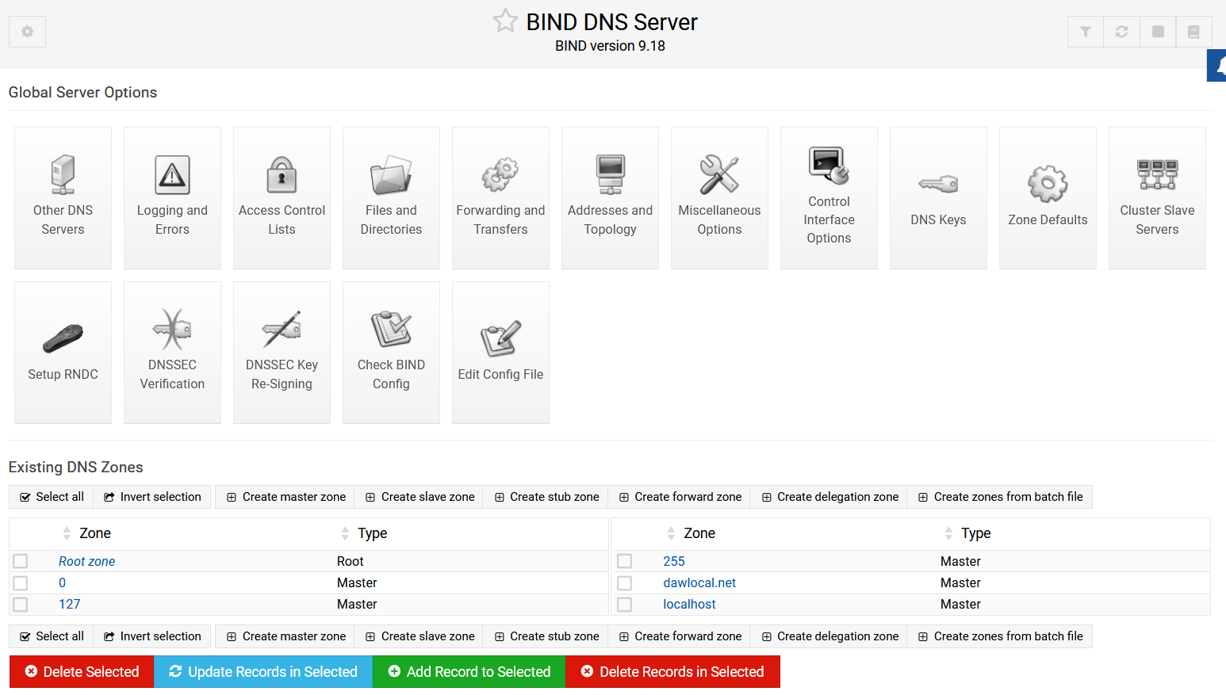
- Configure the DNS service so each machine has a different DNS in the new domain inside the VPC (with their local IP addresses). The image is just an example
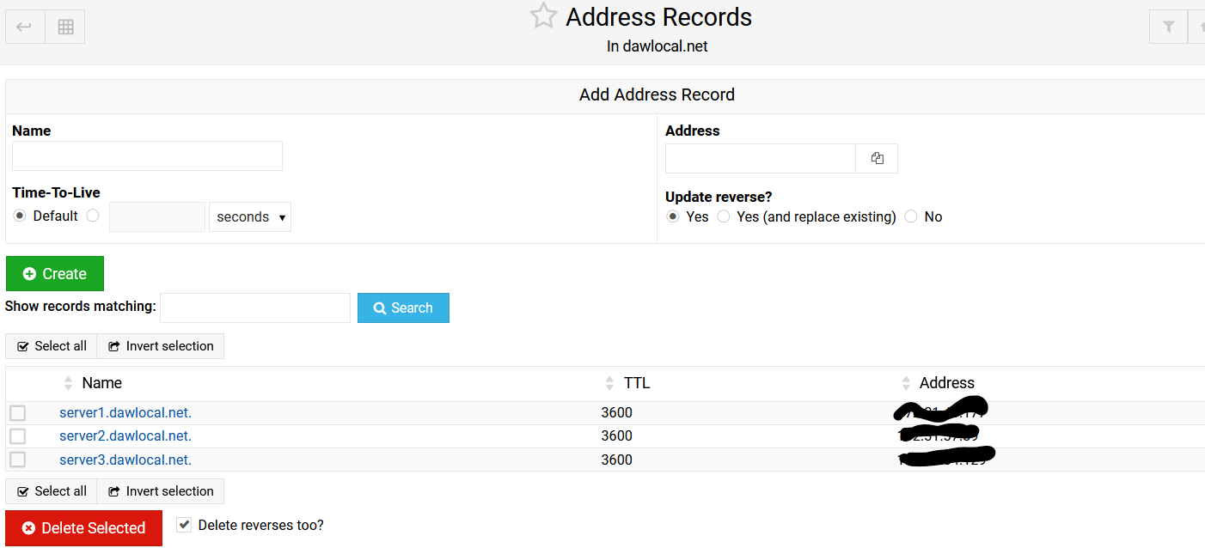

- What changes are needed in the server so the DNS service can be accessed from an external machine?
- From server2, Check with dig & nslookup before making any other change
  - the local addresses and URLS of the server1 and server3 machines
  - the global addresses and URLS of the server1 and server3 machines
- From server2, Check with dig & nslookup before making any other change using the dig@dnsserver urltoberesolved
  - the local addresses and URLS of the server1 and server3 machines
  - the global addresses and URLS of the server1 and server3 machines
Explain the changes you have obtained from the previous configuration
- Configure the DNS of server2 to resolve through the DNS of server1 (be careful because the default configuration does not allow the direct change of the DNS server, you will have to work with the resolvconf service, check through the internet for solutions) . You can follow the steps at
https://www.ionos.com/digitalguide/server/configuration/change-dns-server-on-ubuntu/

LDAP
OpenLDAP is an open source implementation for LDAP.
https://www.okta.com/identity-101/what-is-ldap/

LDAPD Installation
We are going to configure a LDAP server at the server machine server001.
Slapd is the OpenLDAP server001
We will do the installation of the packages slapd and ldap-utils.
sudo apt-get install slapd ldap-utils
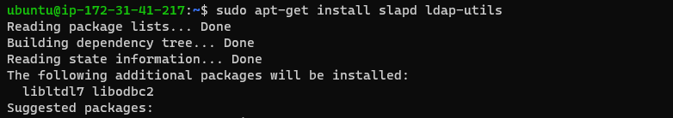
During the installation, a password setup is needed. Remember to keep the password safe and do not forget it. (i.e. we can use slapdpass)
Once the installation is finished, we will do the configuration through the command:
sudo dpkg-reconfigure slapd
- We will be asked if we want to avoid the configuration, we will press NO (we want to do the configuration)
- In the domain name, we can use the same name as the one we used for DNS (dawlocal.net)
- We can use an organisation name (e.g. dawmor)
- We will be asked if we want to delete the database once slapd package is purged → answer YES
- We will be asked if we want to move the old database files before creating a new one → answer YES
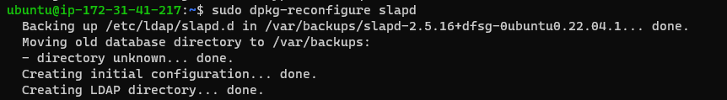
Once these steps are finished, service will be installed (ports TCP/UDP 389 and 636 for SSL).
Now you can run the following commands (execute them and check the result)
- sudo service slapd start (launches service)
- service slapd stop (stops service)
- service slapd status (provides a report about the service status)
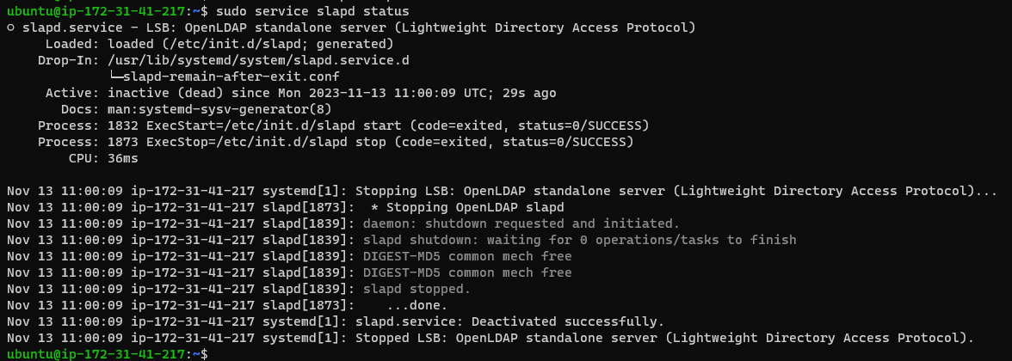
- service slapd reload (allows loading the service configuration without restarting it)
- service slapd restart (restarts service)
- service slapd force-reload (forces reload of service configuration)
- slapcat (it shows the information stored in our server). For this command, check the information that you have stored in our server.
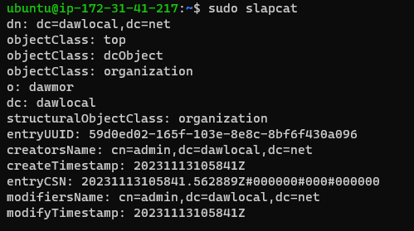

LDAPD Management
LDAP management can be done in several ways. We can do it through command line, through LDIF files or with an external tool as JXPlorer

JXPlorer
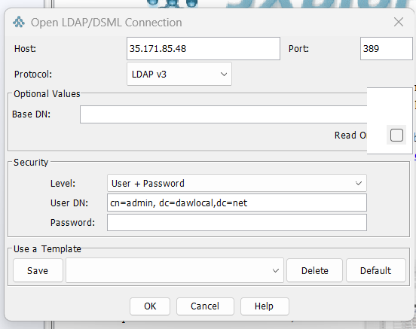
We can install JXPlorer at the user PC. Once installed, we can try to connect to the server with the corresponding options (be sure that the specific ports at the server machine have been configured correctly)

Once the connection is finished, we are ready to operate with the service.
Create the following structure (steps are detailed below in this document):
- two organizational units: users and groups
- two groups: students and teachers
- four users: student1, student2, teacher1 and teacher2. Each user belongs to its corresponding group. Instead of student2 and student2, you will create a your_name and your surname users.
For the creation of organizational units
- “users”
  - Select “dawlocal” in the left window and click on “Create new”
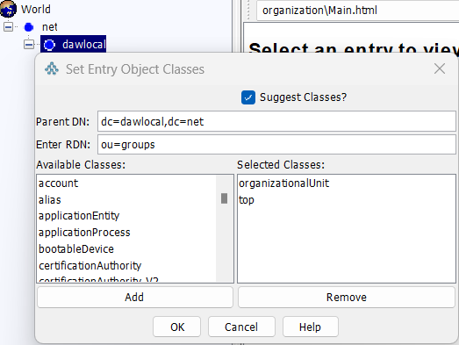
  - Enter RDN : ou=students, Selet classes “organizationalUnit” and “top”. Press “ok” and then “submit”.
- Same for “groups”

Creation of groups
- Select “groups” at the left window and click on “New”. Select classes “possixGroup” and “top”. RDN cn=”students”. Assign the gidNumber a value 2001 before clicking “Submit”
- Same for group “teachers”, gidNumber 2002
Creation of users
- Select “users” at the left window and click on “New”. Select classes s “posixAccount”, “person”, “organizationalPerson” y “top”. RDN cn= “student1”. Press ok. Fill in the attributes that are specified in the following image. You must assign a password (remember it).
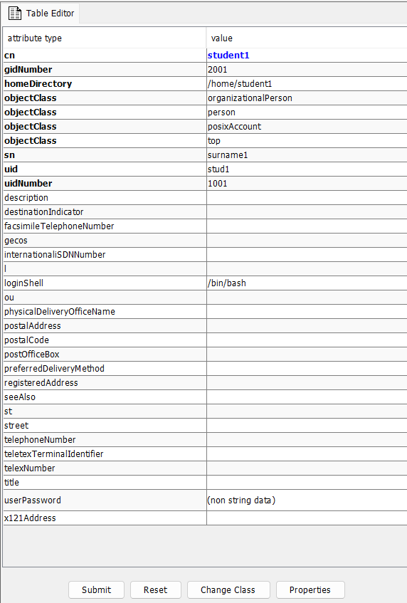

Now we are going to provide multiple values to an attribute. We are going to add a fer members to the students group. We select “groups” and “students” at the left window and then we add values for the “memberUid” attribute type and value. For adding several values, we must press “add another value”.
Check with slapcat how this information has been updated in the server machine
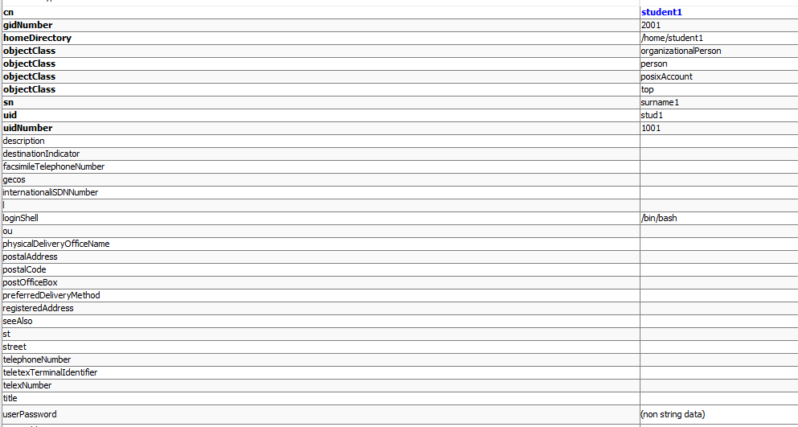

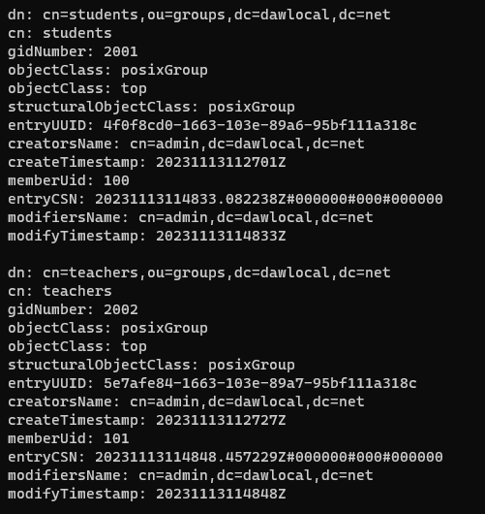

LDIF File
- We can export the information of the server in LDIF Format in the Jxplorer menu LDIF “Export”
- Have a look at the LDIF file syntax. Create a new LDIF file to include a new group called “administration” and two new users that belong to that group (admin1 and admin2). Import the file and check that the information can be accessed from Jxplorer and thorugh slapcat at the server001
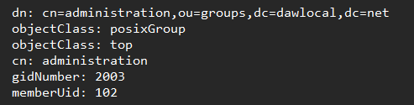

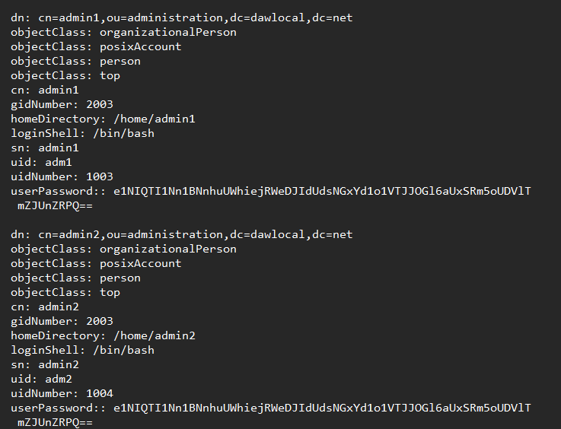
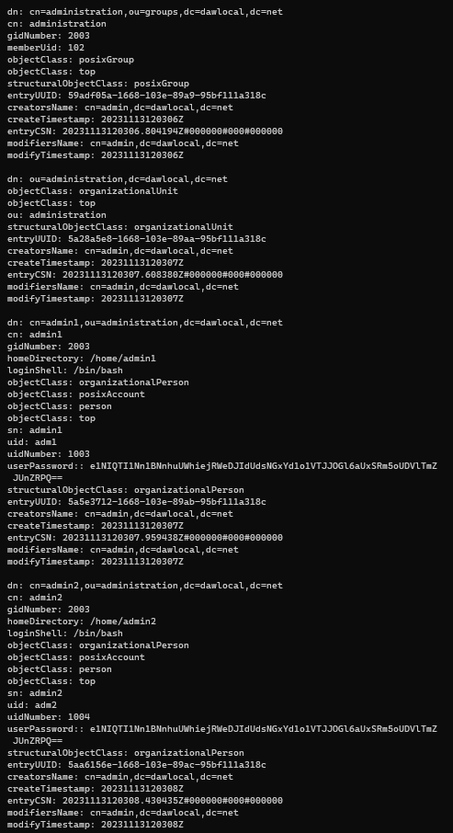
RESULT ON JXPLORER AND SLAPCAT

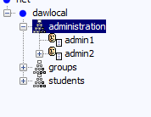

FILE IMPORTED
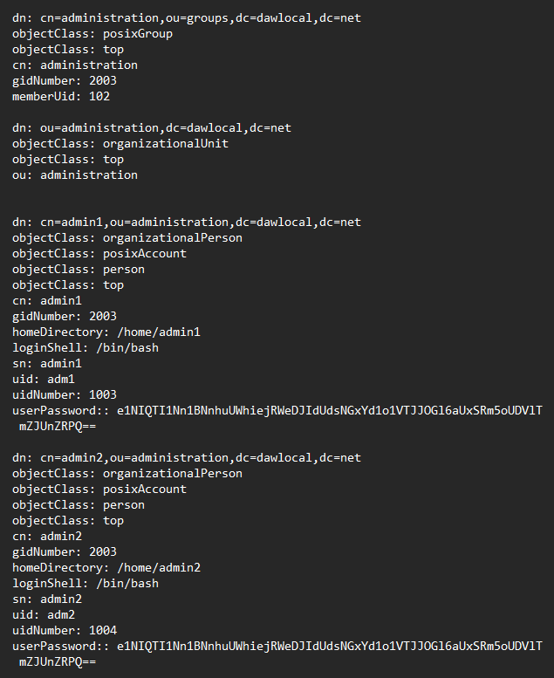

LDAP Search
We can look for information from JXPlorer. Execute the following search and show the result.
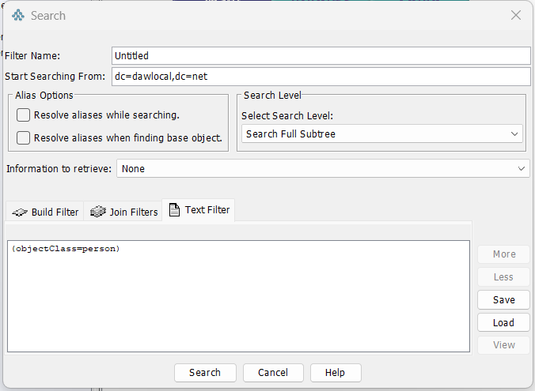

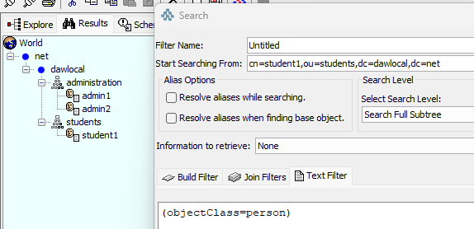

LDAPD Use

Connection from a PHP Program.
We are going to test an authentication app based on LDAP Deploy the following file in your XAMPP, make the changes you think are needed and show the result.
<?php
$ldapconfig['host'] = "192.168.1.140";
$ldapconfig['port'] = 389;
$ldapconfig['basedn'] = "dc=dawmor,dc=net";
$ldapconfig['binddn'] = "cn=admin,dc=dawmor,dc=net";
$ldapconfig['bindpw'] = "dawpass";
$ldapconn=ldap_connect($ldapconfig['host'],$ldapconfig['port']);
if ($ldapconn) {
ldap_set_option($ldapconn, LDAP_OPT_PROTOCOL_VERSION, 3);
echo "Estoy dentro<br>";
$ldapbind = @ldap_bind($ldapconn, $ldapconfig['binddn'], $ldapconfig['bindpw']);
if ($ldapbind) {
echo "User logged in";
} else {
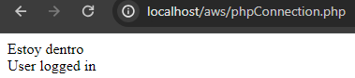
echo "User unknown";
}
}
?>

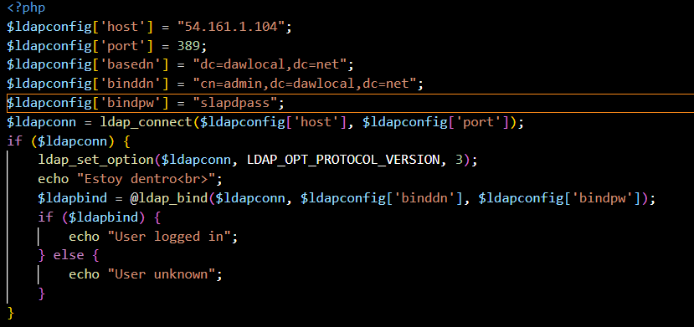

Connection from a NODEJS Program
We are going to test an authentication app based on LDAP . You can execute it from any machine (but be careful with the changes you make in order to make it work)
You must install the ldapjs library
sudo npm install ldapjs
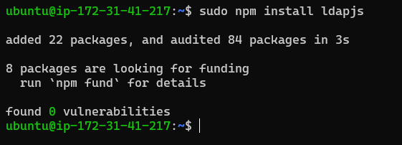
The code program is (rememeber to make the changes you think are needed in order to execute it)
const ldap = require('ldapjs');
const client = ldap.createClient({ url: 'ldap://127.0.0.1:339' });

// User credentials
let username = 'cn=admin,dc=dawlocal,dc=net';
let password = 'userPassword';

// Connect and bind to the server
client.bind(username, password, (err) => {
if (err) {
console.log('Authentication failed', err);
} else {
console.log('Authentication successful');
}
});

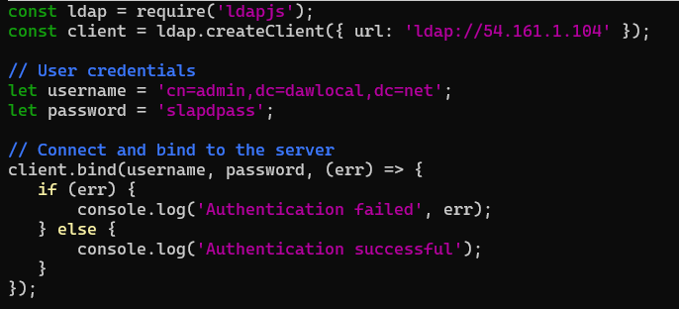
If you have problems related to the nodejs version, you can follow steps on:
https://github.com/nodesource/distributions/blob/master/README.md#installation-instructions
to solve them

