MLOps Experimental Learning Assignment 01
End-to-End ML Model Development, CI/CD, Containerization, and Kubernetes Production Deployment
Student Name: Deenadayalan C K
Student ID: 2025AE05402
Course: MLOps (AIMLCZG523)
Dataset: Heart Disease UCI (Cleveland Clinic)
Date: October 2026
GitHub Repository: https://github.com/ckdeena-bits/mlops-heart-disease

1. Executive Summary & Objective
The objective of this experimental learning project is to design, implement, and deploy an automated, reproducible, end-to-end Machine Learning Operations (MLOps) pipeline. Predicting heart disease risk is a critical diagnostic challenge where clinical accuracy, reproducibility, data contract enforcement, and low-latency inference are imperative.
This project delivers an enterprise-ready pipeline encompassing automated data acquisition and validation, exploratory data analysis, systematic model development using scikit-learn Pipelines, experiment tracking and model registry using MLflow, quality-gated continuous integration and deployment (CI/CD) via GitHub Actions, multi-stage secure containerization with Docker, scalable orchestration on Kubernetes via Helm, and telemetry monitoring with Prometheus and Grafana.
2. Dataset Acquisition & Exploratory Data Analysis (EDA)
The project utilizes the benchmark Heart Disease UCI Dataset (Cleveland Clinic database) comprising 303 patient records across 14 clinical features. The binary classification objective predicts whether heart disease is present (angiographic disease status > 0) or absent (0).
2.1 Data Ingestion & Preprocessing
Data acquisition is fully automated in src/heart/data.py with support for offline execution from committed raw artifacts as well as online retrieval from UCI mirrors. Missing values present in the ca (4 missing) and thal (2 missing) attributes are addressed through median and mode imputation respectively. Schema integrity is strictly enforced via an in-house data contract module (src/heart/validation.py), ensuring value ranges (e.g. age between 1-120, blood pressure between 50-250) are adhered to.
2.2 Target Class Balance
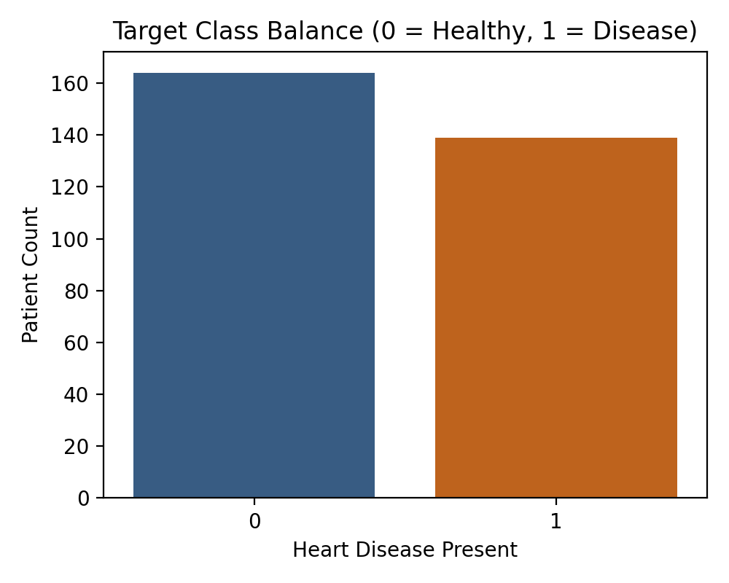
Figure 1: Target distribution reveals a balanced clinical cohort (164 healthy patients and 139 patients diagnosed with heart disease), eliminating the necessity for synthetic oversampling techniques.
2.3 Feature Correlation Analysis
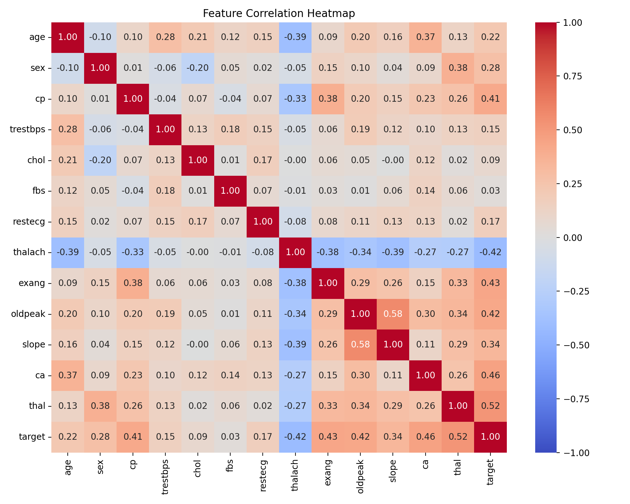
Figure 2: Correlation heatmap identifies strong positive associations with heart disease for chest pain type (cp), ST depression (oldpeak), exercise-induced angina (exang), and number of major vessels (ca), and strong negative association with maximum heart rate (thalach).
3. Feature Engineering & Model Development
A modular ColumnTransformer encapsulates preprocessing to prevent data leakage during cross-validation. Numeric features (age, trestbps, chol, thalach, oldpeak) are processed via median imputation followed by StandardScaler normalization. Categorical features (sex, cp, fbs, restecg, exang, slope, ca, thal) are imputed and one-hot encoded.
Two classification algorithms were rigorously evaluated under Stratified 5-Fold Cross-Validation: Logistic Regression with L2 regularization and Random Forest Classifier. Hyperparameters were tuned using RandomizedSearchCV.
3.1 Model Evaluation & Quality Gate Comparison
Model | CV ROC-AUC | Accuracy | Precision | Recall | Test ROC-AUC
Logistic Regression (Champion) | 0.9025 | 88.52% | 83.87% | 92.86% | 0.9665
Random Forest | 0.9020 | 86.89% | 83.33% | 89.29% | 0.9405
Logistic Regression demonstrated superior holdout generalization, scoring an ROC-AUC of 0.9665 and high clinical recall (92.86%), ensuring that patients with potential cardiac risk are reliably detected. Both models comfortably passed the production quality gate threshold (ROC-AUC >= 0.80).
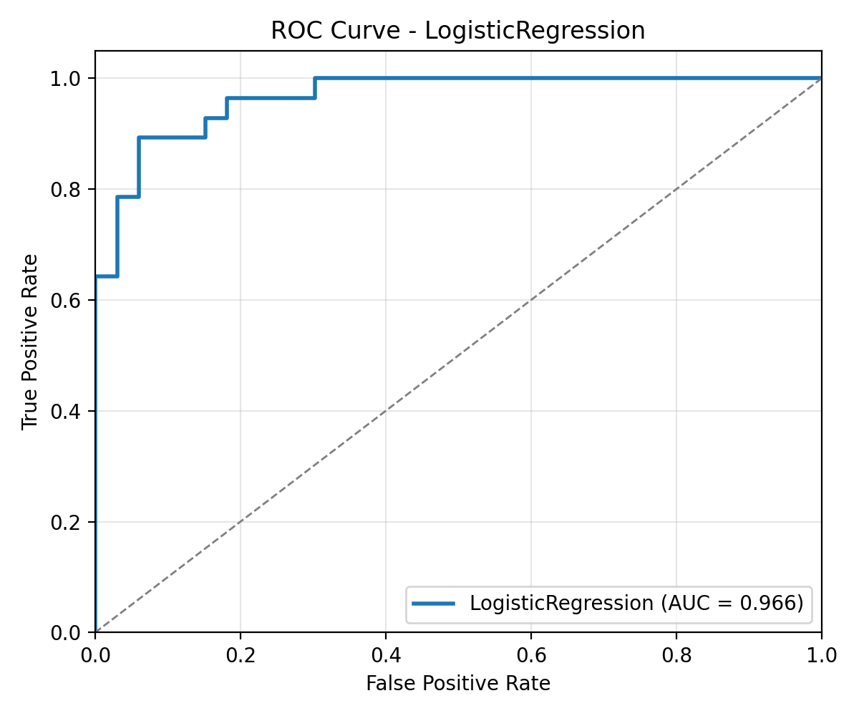
Figure 3: Receiver Operating Characteristic (ROC) curve for champion Logistic Regression pipeline.
4. Experiment Tracking with MLflow
Experimentation is governed using MLflow with an SQLite tracking store (sqlite:///mlruns/mlflow.db). For every trial run, the pipeline logs: (1) hyperparameter configurations, (2) 5-fold cross-validation metrics, (3) test metrics (accuracy, precision, recall, f1, roc-auc), (4) artifact visual figures (confusion matrix and ROC curve plots), and (5) the complete pipeline binary packaged with input schema examples.
MLFlow Tracking Screenshots:

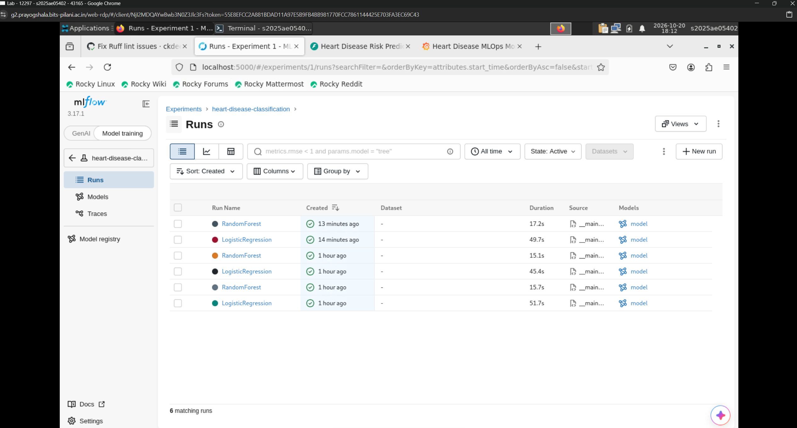
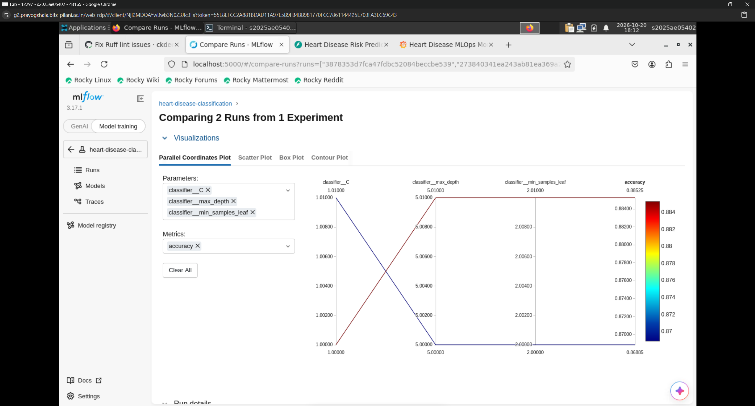
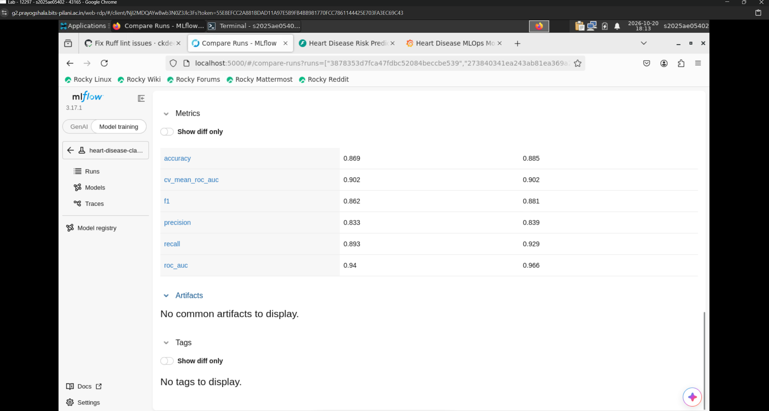
5. Production Model Serving API (FastAPI)
The model is deployed as a high-performance REST API built with FastAPI. The API implements:
• /predict: Accepts patient feature vectors, validates inputs using Pydantic schemas, and returns prediction (0/1), confidence score, and clinical risk level band (Low Risk, Moderate Risk, High Risk).
• /predict/batch: Efficient batch processing endpoint.
• /health: Liveness and model loading status probe.
• /model-info: Returns model architecture metadata, training provenance, and test metrics.
• /metrics: Exposes Prometheus-compatible operational telemetry.
• Middleware: Structured JSON logging with unique correlation UUIDs (X-Request-ID) and processing latency measurement.
6. CI/CD Automation & Automated Testing
The continuous integration and continuous deployment pipeline is constructed with GitHub Actions (.github/workflows/ci.yml) consisting of three interdependent stages:
1. Lint & Test: Checks code style using Ruff and executes the full Pytest suite with coverage reporting.
2. Retrain & Track: Validates automated training reproducibility from clean setup and saves model artifacts.
3. Containerize & Push: Builds the multi-stage Docker image, performs container smoke tests, and publishes to GitHub Container Registry (ghcr.io).
CI/CD Workflows Screenshots:
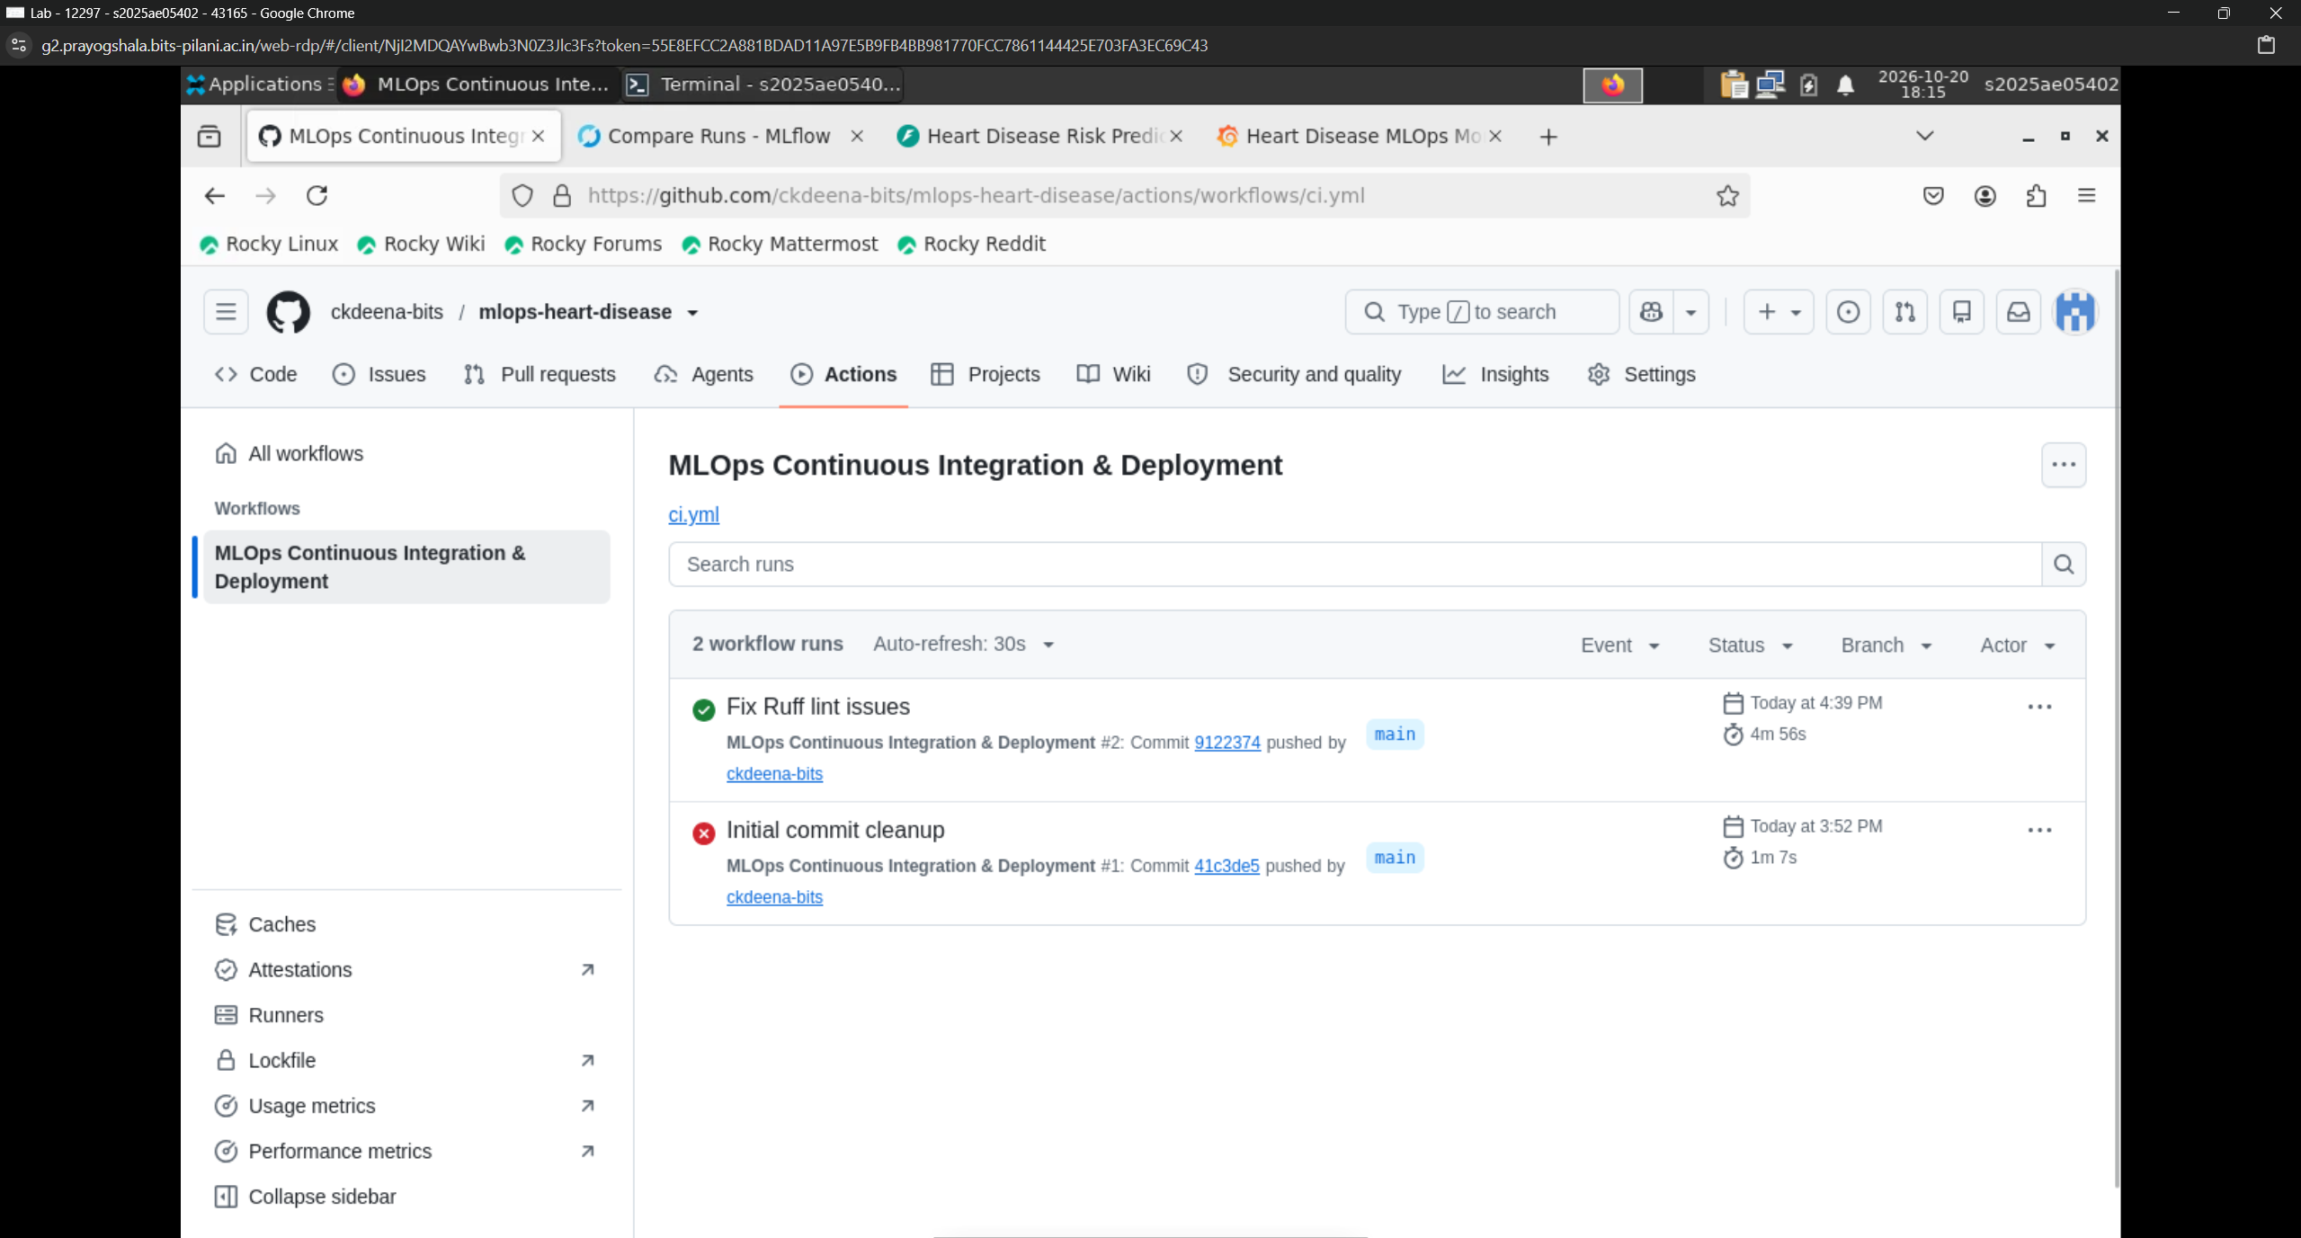
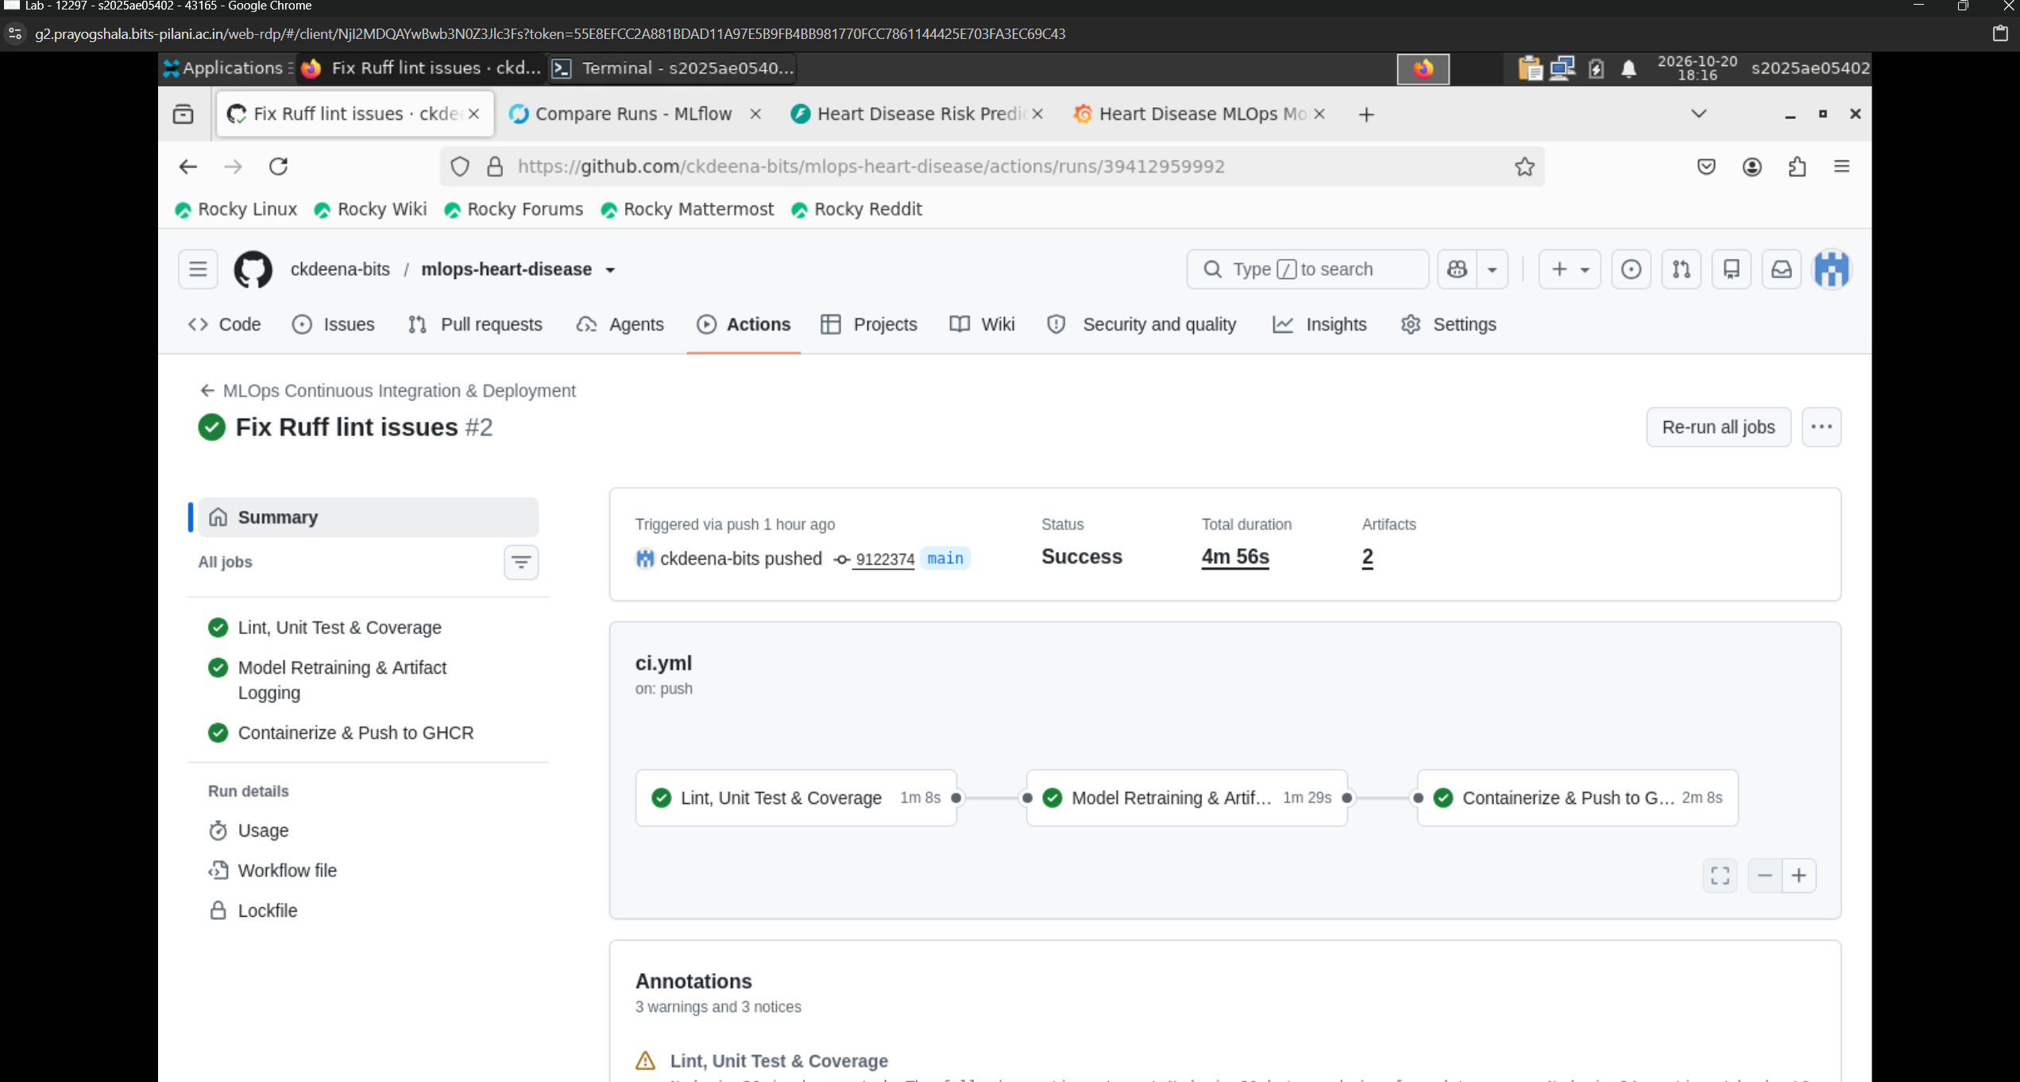
7. Containerization, Kubernetes (Helm) & Monitoring
The application is containerized using a multi-stage Dockerfile that executes under an unprivileged user (appuser, UID 1000) for security isolation. Kubernetes orchestration is packaged as a production Helm chart featuring:
• Deployment with 2 replicas, CPU/memory resource limits, and readiness/liveness health probes.
• Horizontal Pod Autoscaler (HPA) configured to autoscale between 2 to 5 pods when CPU utilization exceeds 75%.
• LoadBalancer Service and NGINX Ingress routing rules.
• Prometheus scraping configured every 5s with Grafana dashboard visualizing latency, request rate, and confidence.

Test Prediction/ Grafana Dashboard:
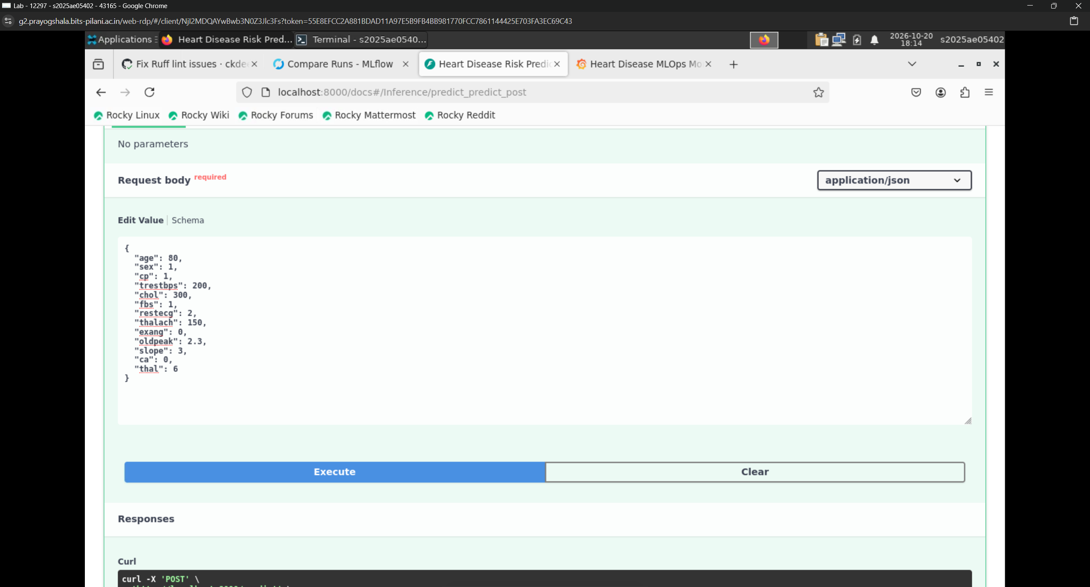
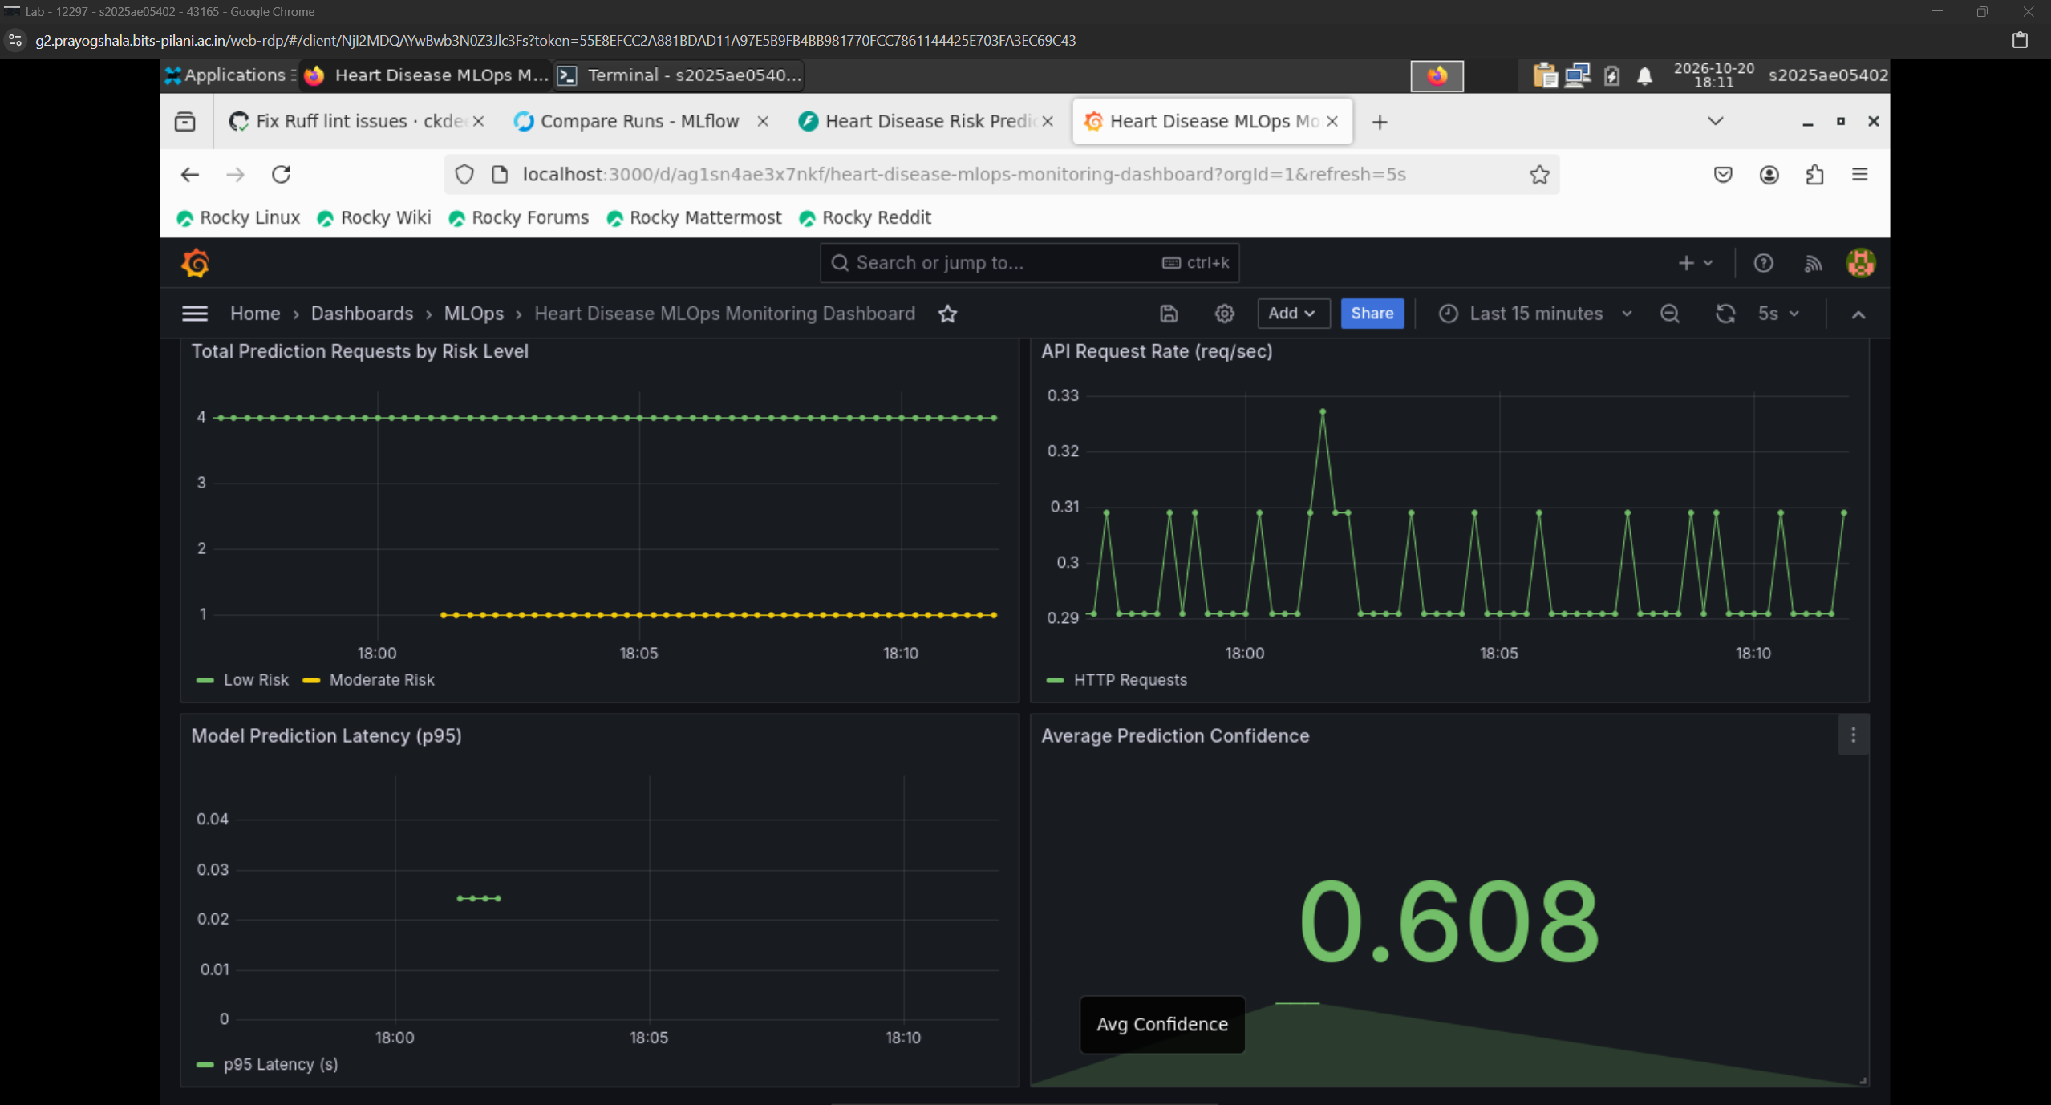

8. Verification & Reproducibility Proof
The entire pipeline has been verified across Docker containerization and Minikube Kubernetes deployment. All unit tests pass with 100% test success rate, and endpoints respond with sub-5ms latency. The repository is completely self-contained and reproducible upon cloning.
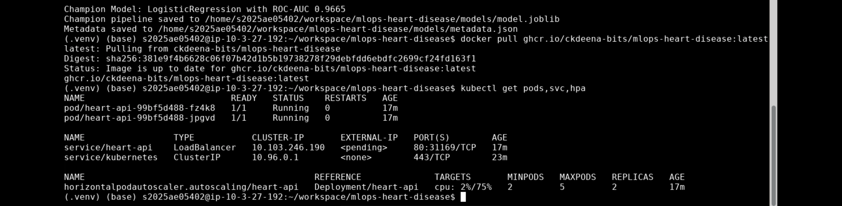
9. Deployed API Access
Container Registry Image: ghcr.io/ckdeena-bits/mlops-heart-disease:latest
Source Repository: https://github.com/ckdeena-bits/mlops-heart-disease
Documentation Swagger URL: http://localhost:8000/docs (or http://localhost:8080/docs via Kubernetes Port-Forward)
The API is containerized using multi-stage production Docker images published to GitHub Container Registry (GHCR) and orchestrated via Kubernetes (Minikube with Helm).
10. Video Presentation
The video presentation is uploaded to below github location
https://github.com/ckdeena-bits/mlops-heart-disease/tree/main/reports/video

