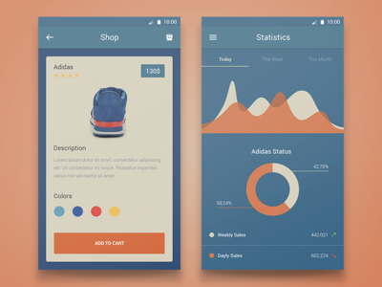
1. Peach: #F7845B;Deep Blue (body): #307695;
“white”: DBD6C0;
accent blue: #2E7695

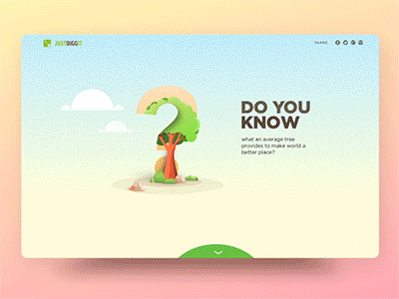
2. green: #AB3925; light peach: #FEEBAB – gradient to bottom pink/lavender: #FBD7CC

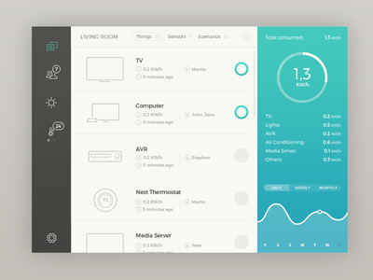
3. aqua: #00C9BC; white: #FAFAF5; dark gray: #4B4B47;light gray: #C9C7C1;
background gray/white: #CCCCC6


4. Midnight blue: #253759; black/blue: #1D2739, light accent blue: #314B60; white: #FFFFFF; raspberry-red: #E51D3B

