Kitty from internet: 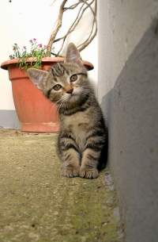
My drawing: hehehehe :D 

