Kitty from internet: 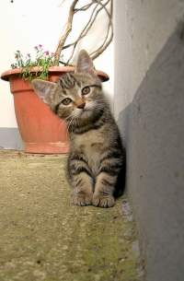
My drawing: hehehehe :D 
Additional shape made within Word is added here:

