Kitty from internet: 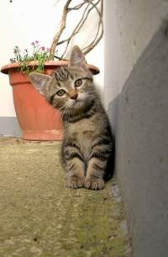

My drawing:  hehehehe :D 

Additional shape made within Word is added here: