Data Mining Census Information to Determine Relative Income
by Chris Poupore and Chad Kembel

The Dataset

The dataset we are working with is originally from the census bureau database. It was taken and processed by two individuals in order to predict whether or not a person would make over $50,000 a year given fourteen different attributes. These attributes are as follows:

- Age
- Workclass
- Fnlwgt
- Education
- Education-num
- Marital-status
- Occupation
- Relationship
- Race
- Sex
- Capital-gain
- Capital-loss
- Hours-per-week
- Native-country

The previous work done with this dataset included the use of many different classifiers in an attempt to gain a high prediction rate. However, the greatest accuracy any of these classifiers was able to achieve was an 86% prediction rate. We feel that this is too low of a prediction rate and a better classifier can be found.

Project Goal

The original miners of this dataset were only able to achieve an 86% prediction rate. We are attempting to utilize the right classifier or combination of classifiers that will allow us to obtain a prediction rate greater than 86%.

Data Exploration

To the human eye, summary stats were very helpful to determine what attributes contributed to a person making over $50,000 a year. From K means clustering as well as summary stat visualizations we were able to determine what gives a person the best chance at making over $50,000 a year. If you are a white, male, between the ages of 30 and 52 years old, married, with a bachelor's degree or higher, you stand the best chance of earning more than $50,000 a year. These conclusions came from the percentages of people making over $50,000 per attribute in the summary stat graphs as well as the obvious clusters/groupings that were found from the K means clustering visualizations. Also, according to our dataset, it is basically impossible for you to earn over $50,000 a year if you are any of the following: younger than 20, have less than a 6th grade education, or you are married but your spouse is absent. Some examples of these visualizations are on the following page.

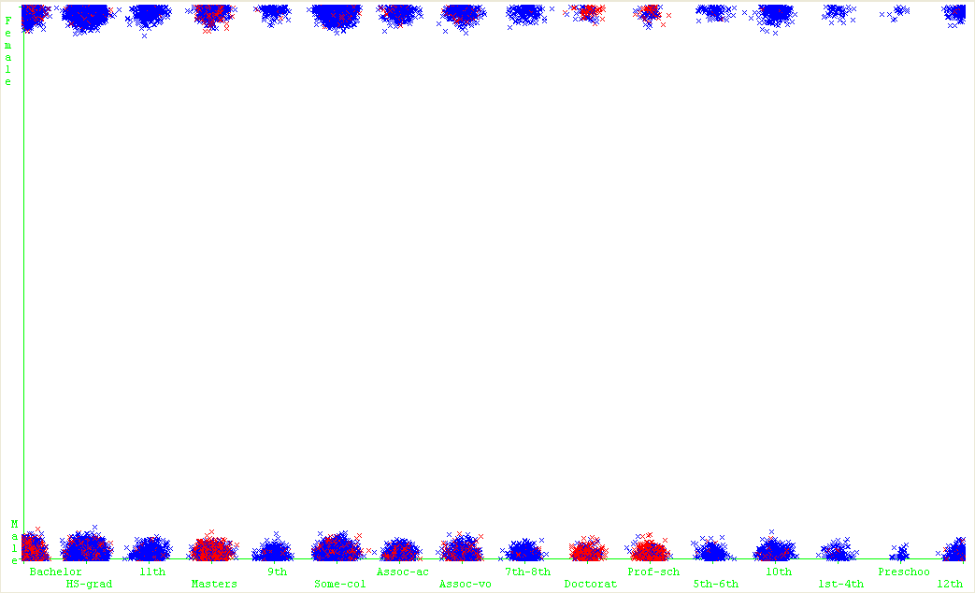

Education Level vs Sex
Red = (>= 50K)
Blue = (<50K)

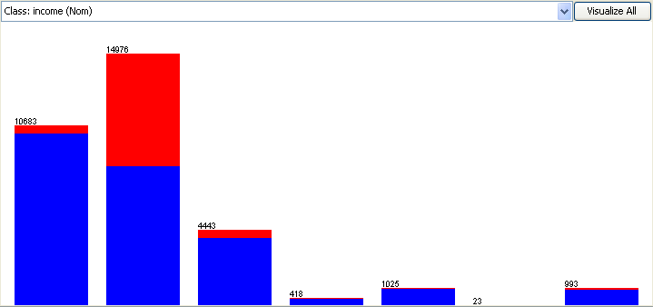
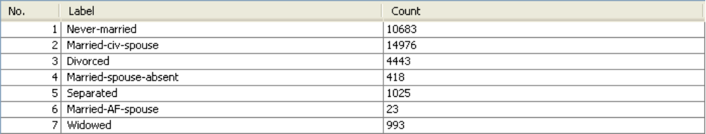

Marital Status
Red = (>= 50K)
Blue = (<50K)

Preprocessing

Since this dataset has been mined before, it has already undergone significant preprocessing to reach the state it was in when we came across it. It seems like the authors before us pruned a larger set down to reach the current fourteen attributes. These attributes seemed to be critical predictors of income level. We ran this dataset on the J48 tree classifier, removing a different attribute every time to see if we could improve accuracy. Instead of improving the accuracy, we either achieved the same accuracy or worse. We did look into the fnlwgt attribute, which the original miners apparently created using the original dataset's attributes about the demographic characteristics of the people being surveyed. Because it was not part of the original data collected, we decided to cut this attribute out for the majority of the tests. The biggest reason why we removed this attribute was because we didn't have a complete idea of what this attribute encompassed or how it was generated. Also, the attributes education and education-num seemed to be redundant and in turn, we decided to only use education-num for the majority of the experiments outside of the visualization.

Experimenting

Our first thought was to try a variety of classifiers with basic settings just to see if any particular classifier would stand out from the rest. Preliminary results were as follows:
- J48 – 86%
- Conjuctive Rules – 75%
- Decision Table – 85%
- One R – 80%
- Naïve Bayes – 83%
- Lazy Kstar – 78%

As none of these classifiers had outstanding results, we decided to take another approach to the mining process. After learning of the ensemble approach in class, we decided to create an ensemble of five relatively powerful classifiers using the Forward Selection Algorithm. The ensemble consisted of :
- BayesNet
- MultilayerPerceptron
- AdaBoostM1 with DecisionStump classifier
- Bagging with REPTree classifier
- RandomForest

Unfortunately, the performance of the ensemble was not much better than the previous attempts. It did however, result in a prediction rate of 86.26%, which beats the results from the original data miners. Though we had attained our goal, we were still unsatisfied with the results of our classifiers. We recalled hearing in class that boosting was another excellent technique for achieving optimal results. Though we had employed it already within the ensemble, we hoped that it would have better performance on its own. We were correct, as it ended up being the final algorithm we experimented with. However, our first results with the solo AdaBoostM1 classifier were relatively discouraging. Using the boosting algorithm on the DecisionStump classifier, we only achieved results comparable with all the previous algorithms. Discouraged, but realizing that the DecisionStump may not have been the best classifier to boost, we decided to run one more experiment with AdaBoostM1 in an attempt to meet our goal in a more respectable manner. This time, we ran the boosting algorithm using the Random Forest tree classifier.

Results

=== Run information ===
Scheme: weka.classifiers.meta.AdaBoostM1 -P 100 -S 1 -I 10 -W weka.classifiers.trees.RandomForest -- -I 10 -K 0 -S 1
Relation: income_data-weka.filters.unsupervised.attribute.Remove-R3-4
Instances: 32561
Attributes: 13
age
workclass
education-num
marital-status
occupation
relationship
race
sex
capital-gain
capital-loss
hours-per-week
native-country
income
Test mode: evaluate on training data
=== Classifier model (full training set) ===
AdaBoostM1: Base classifiers and their weights:
Random forest of 10 trees, each constructed while considering 4 random features.
Out of bag error: 0.1757
Weight: 3.63
Random forest of 10 trees, each constructed while considering 4 random features.
Out of bag error: 0.383
Weight: 3.21
Random forest of 10 trees, each constructed while considering 4 random features.
Out of bag error: 0.4545
Weight: 1.32
Random forest of 10 trees, each constructed while considering 4 random features.
Out of bag error: 0.5159
Weight: 1.3
Random forest of 10 trees, each constructed while considering 4 random features.
Out of bag error: 0.4848
Weight: 0.79
Random forest of 10 trees, each constructed while considering 4 random features.
Out of bag error: 0.5124
Weight: 0.66
Random forest of 10 trees, each constructed while considering 4 random features.
Out of bag error: 0.4963
Weight: 0.48
Random forest of 10 trees, each constructed while considering 4 random features.
Out of bag error: 0.509
Weight: 0.41
Random forest of 10 trees, each constructed while considering 4 random features.
Out of bag error: 0.5036
Weight: 0.34
Random forest of 10 trees, each constructed while considering 4 random features.
Out of bag error: 0.5048
Weight: 0.3
Number of performed Iterations: 10
Time taken to build model: 146.19 seconds
=== Evaluation on training set ===
=== Summary ===
Correctly Classified Instances 31793 97.6414 %
Incorrectly Classified Instances 768 2.3586 %
Kappa statistic 0.9351
Mean absolute error 0.0282
Root mean squared error 0.1187
Relative absolute error 7.7233 %
Root relative squared error 27.7529 %
Total Number of Instances 32561
=== Detailed Accuracy By Class ===
TP Rate FP Rate Precision Recall F-Measure ROC Area Class
0.987 0.057 0.982 0.987 0.985 0.998 <=50K
0.943 0.013 0.958 0.943 0.951 0.998 >50K
Weighted Avg. 0.976 0.046 0.976 0.976 0.976 0.998
=== Confusion Matrix ===
a b <-- classified as
24397 323 | a = <=50K
445 7396 | b = >50K
Conclusion

97.64% correctly classified instances is over 10% better than any other classifier we tried. We outdid even our best expectations for any classifier. With less than 3% of instances being classified incorrectly, we feel confident that our classifier can provide an accurate prediction of a person's income. The best part about this classifier, is that it only needed to work on 13 attributes that are easy to gather, especially by the national census bureau. After this success, we decided that any better results would probably mean that the classifier was over-fitting based on the data. With this in mind, we concluded our search for the highest prediction rate.

