Project Debbie
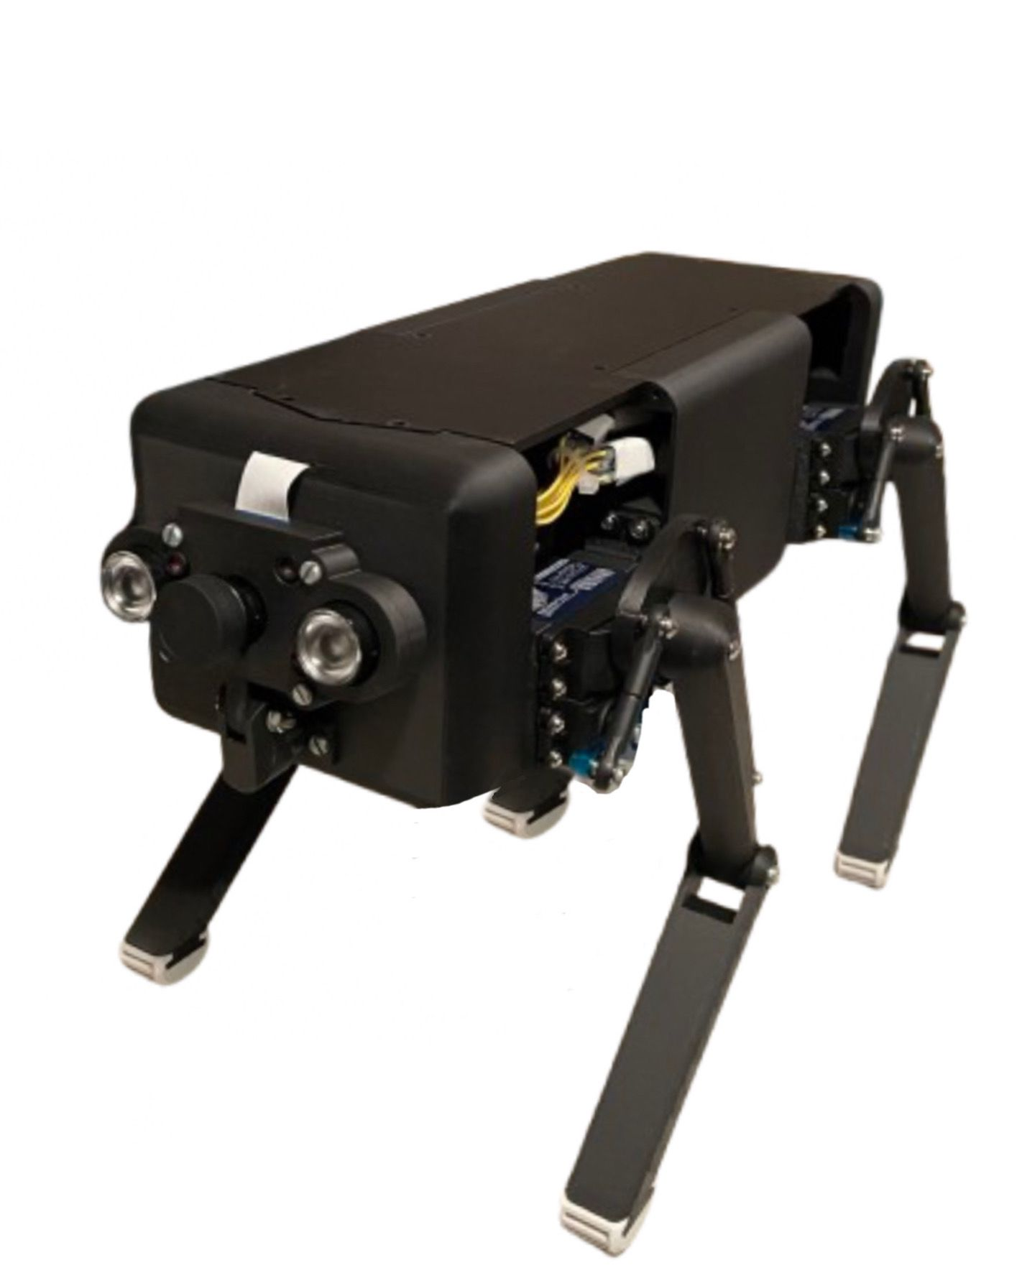

Cesario Kufner
Momen Louati
AJ Holzer
Prof. Ing. Michael Wagner

15.01.2025

table of contents
Parts and Assembly 3
Production of Parts 3
3d-printed Parts 3
Laser-cut Parts 4
Assembly 5

Parts and Assembly

Production of Parts

3d-printed Parts

The parts of Debbie are mainly 3D printed. There are 3 parts that are laser cut, which are the bottom plate, midde plate and upper plate.
Below is the name of the STL file to be 3d printed, the amount of parts that has to be printed and their infill density.
We strongly recommend these parts to be printed with carbon filament.
All of these parts are found within the respective Folder inside the „Hardware“-folder
Battery:
Name | Amount | Infill
case.stl | x3 | 70%
cover.stl | x2 | 100%
cover_closed.stl | x1 | 100%

Body:
Name | Amount | Infill
back.stl | x1 | 70%
bolt.stl | x4 | 100%
front.stl | x1 | 70%
lower_back_plate_switch_charger.stl | x1 | 100%
side.stl | x2 | 70%
upper_back_plate_usb_hdmi.stl | x1 | 100%
Camera:
Name | Amount | Infill
holder.stl | x1 | 100%
holder_base.stl | x1 | 100%
holder_top.stl | x1 | 100%

Legs:
Name | Amount | Infill
lower_leg_left.stl | x2 | 70%
lower_leg_right.stl | x2 | 70%
rubber_tip.stl | x4 | 40%
thigh.stl | x4 | 50%

Mounts:
Name | Amount | Infill
distance_rod.stl | x4 | 100%
servoarm_left.stl | x2 | 100%
servoarm_right.stl | x2 | 100%
servoholder_left.stl | x2 | 100%
servoholder_left_B.stl | x2 | 100%
servoholder_right.stl | x2 | 100%
servoholder_right_B.stl | x2 | 100%

Laser-cut Parts
As mentioned before, there are 3 laser-cut parts. These are the following: bottom plate, midde plate and upper plate.
All of these parts are to be lasered with 3mm plastic. Whatever color you use depends on your personal preference.

Assembly

