Get Started
Appota Game SDK is the simplest way to integrate user and payment for your game in Appota system. This SDK provides solutions for payment methods such as: SMS, Card. Internet Banking, Paypal and Apple Payment.
Steps to integrate SDK:
1. Setup Appota SDK
2. Config SDK
3. Run SDK samples

1. Setup Appota SDK
Import Appota.framework into project
Drag and drop AppotaSDK.framework and AppotaBundle.bundle into your project.
Tick on checkbox: “Copy items into destination group's folder (if needed)”.
In Project app’s target settings section, find [Build phases] and open Link Binary with Libraries. Click on ‘+’ button and add these frameworks:
AppotaSDK CoreText StoreKit AudioToolBox MobileCoreServices AVFoudation CoreVideo MessageUI Security SystemConfiguration CFNetwork OpenGLES CoreMedia libxml2.dylib libsqlite3.dylib
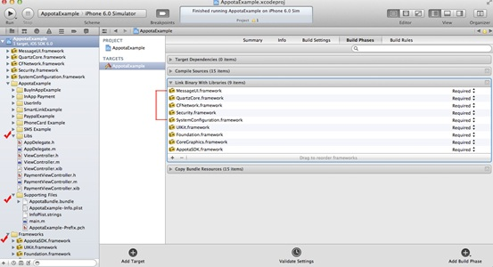
In project build settings section, find Other Linker Flags, add 3 values: -lc++, -ObjC and -all_load.
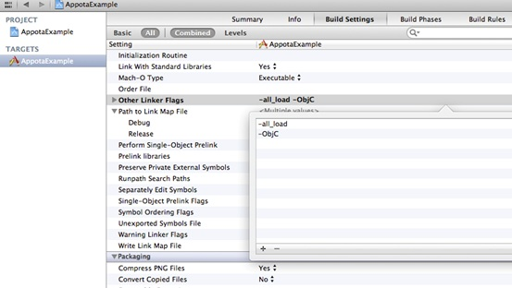
Import header file to source file where do you want to use SDK:
#import <AppotaSDK/AppotaSDK.h>
Facebook, Google and Twitter login
If you want to user Social login. Please drag suitable framework : FacebookSDK.framework, GooglePlus.framework, Twitter.framework to use.
Reference: https://github.com/facebook/facebook-ios-sdk
https://developers.google.com/+/mobile/ios/
https://dev.twitter.com/docs/ios
2. Config SDK
Config SDK in Appdelegate:
+AppDelegate.h
Add protocol AppotaGameSDKConfigureDelegate to AppDelegate
+AppDelegate.m
Config AppotaGameSDK after setting up window in Appdelegate (reference AppotaGameTest/AppDelegate.m) by AppotaGameSDKConfigure class.
- Init payment list (AppotaPayment class represents payment item)
- Init AppotaGameSDKConfigure with
CLIENT_ID - Config on dev.appota.com
CLIENT_SECRET - Config on dev.appota.com
INAPP_API_KEY - Config on dev.appota.com
noticeUrl - URL for payment notification
enableFacebookLogin – Enable to use facebook login
enableGoogleLogin – Enable to use google login
enableTwitterLogin – Enable to use twitter login

checkUpdate option - Enable this option for automatic update by AppotaGameSDK
autoShowPaymentButton option:
- YES: Enable this option for automatic show a payment button floating on game screen after login
- NO: Don't show the floating payment button (Payment view can be shown via function [AppotaGameSDKConfigre showPaymentView] or show or hide payment button via [AppotaGameSDK showPaymentButton])
- Set delegate for AppotaGameSDKConfigure (should use AppDelegate for delegate)
- Handle login status by protocol function - (void) didFinishLogin:(NSDictionary *)userInfoDict (UserInfo dict can be used for verification process)
- Handle OpenURL by adding handleOpenURL in - (BOOL) application:(UIApplication *)application openURL:(NSURL *)url sourceApplication:(NSString *)sourceApplication annotation:(id)annotation
Example:
- (BOOL) application:(UIApplication *)application openURL:(NSURL *)url sourceApplication:(NSString *)sourceApplication annotation:(id)annotation {
return [AppotaGameSDKConfigure handleOpenURL:url sourceApplication:sourceApplication annotation:annotation];
}
3. Run SDK samples
Reference example for more detail: AppotaGameTest.

