Data Analysis of

Canada Car Accidents: 1999 - 2014

Term Project Report

SCS 3250-015, Group 3

**Boris Korotkov**

**Chaewon Kim**

**Patricia Luo**

**Ryan He**

April 2018

Table of Contents

Project Overview 2

Data Preparation 2

What was the data source? 2

How good was the data quality? 2

How did we procure the data? 3

What tools/code did we use to prepare for our analysis? 3

What challenges did we face? 3

Analysis 5

What trends, correlations and/or patterns we saw in the data? 5

Individual analysis and the result we discovered: 5

Conclusions 25

What we learned from the data set? 25

What …. 27

Appendices 28

A-1 sample dataset 28

A-2 Sample Codes 28

# Project Overview

We analyzed the dataset containing collision data for car accidents in Canada from 1999 to 2014. Given various information pertaining to collision, vehicle and person, we conducted analyses to understand the trends and patterns of collisions and discover conditions that are more prone to accidents.

We created an open repository on [GitHub](https://github.com/rynho/3250-G3) containing background information, codes (via Jupyter Notebook) and reports to allow members to easily collaborate and track changes.

# Data Preparation

## What was the data source?

We selected the [Canadian Car Accidents 1999-2014](https://www.kaggle.com/tbsteal/canadian-car-accidents-19942014/data) dataset (provided by Transport Canada) from Kaggle: an open platform for predictive modeling and analytics competition using real life datasets provided by companies and users.

## How good was the data quality?

The overall quality of the dataset was decent except there were several missing values, unknown/inapplicable values and different data types. For example, besides the 17 vehicle types defined in ***vehicle type*** (numbers in ‘str’), there were four nonnumeric values:

* ‘NN’ not applicable, e.g., “dummy” vehicle record created for the pedestrian;
* ‘QQ’ choice other than defined vehicle types;
* ‘UU’ unknown values; and
* ‘XX’ jurisdiction does not provide the data.

Since every column contained some nonnumeric values, Pandas treated them as strings, which required manipulation of data when trying to utilize numeric-only features (e.g. scatterplots).

Moreover, the values in the **c_wday (Day of week)** column represented specific days of the week (e.g. 1 = Monday, 7 = Sunday) instead of representing days of month, which created some difficulty when trying to use time series index for our analysis (detail in below sections).

## How did we procure our data?

The full dataset, in **csv** format (including header), included around 6 million records of car accidents in Canada over the period of 15 years from 1999 to 2014 and the pdf file was the data dictionary. Each row of the dataset represented registered records for each person involved in those specific collisions, and there were 22 columns presenting information pertaining to collision, vehicle and person level data elements of each collisions.

We downloaded the dataset (.csv) from the URL mentioned above, used system command to perform some sense check, then used *pandas.read_csv* method to load the full dataset into a *DataFrame*. See Appendix **[A-2.R1]**.

## What tools/code did we use to prepare for our analysis?

We utilized Python (Pandas, NumPy) for data cleaning and preparing. Some of our data cleaning include the following but are not limited to:

* Converted data type from ‘str’ to ‘int’ for certain numeric columns;
* Converted non-numeric values to NaN and used drop.na() as they do not present significant insights; and
* Composed a ***date*** column combining ***year*** and ***month*** for possible usage in the analysis. See **[A-2.R2]** for the sample code.

## What challenges did we face?

Some of the challenges we faced while preparing the data for analysis include the following but are not limited to:

* The dataset did not include ‘day’ portion of (YY/MM/DD) but a column ***day of week (c_wday)*** representing specific days of the week (e.g. 1 = Monday, 7 = Sunday). We decided to combine ***year*** and ***month*** column to create a time series and kept the ***day of week*** for certain analyses.
* We experimented two different ways to engineer the **date** column and noted their advantages and disadvantages. We discovered that *pandas.DatetimeIndex* method is faster, but the result included ‘day’ part (YY/MM/DD e.g. 1999/01/01) when it actually represents *1999 January, Monday*. On the contrary, while the *pandas.PeriodIndex* with ‘M’ frequency accurately shows only the year and month, the method is about 10 times slower given the huge dataset. We decided to use one or the other in our individual analyses to compare the difference.
* All values in the dataset were ‘str’ type. We decided to change the data type when we created a duplicate of the dataset/sliced data to proceed with further analysis accordingly.
* Considering that some unknown values may present significant insights into our analysis, we decided to keep them in the general dataset but treat them differently in individual analyses. However, the unknown values in date/time columns are dropped as they not only represent tiny portion of the data and are insignificant, but also complicate the analysis.

# Analysis

## What trends, correlations and/or patterns did we see?

In the following section, we addressed the most interesting findings. However, refer to the attached Jupyter Notebooks for all details, and the analyses not mentioned here. We analyzed the nature of the collision records by considering different factors/conditions, as well as the relationships/correlations between those factors/conditions to identify trends and patterns. Before doing each analysis, we sliced the dataset pertaining to only the columns needed in order to maintain original data integrity, make debugging easier, and avoid reloading the huge dataset which takes longer.

## Individual analysis and the result we discovered:

1. **Collision trend, correlation and seasonality**

To analyze the collision trend over the time, we created a ‘date’ column using the pd.*PeriodIndex* function (collision year and month as arguments) and set it as the index of our dataset (see sample code in **[A-2.B1]**).

* 1. Overall collision diagram

In order to examine the trend for both fatal and non-fatal collisions, we created two more corresponding columns by using the collision severity (**c_sev = 1 fatal , c_sev =2 non-fatal)** column. (see sample code in **[A-2.B2]**). Then we grouped the *‘fatal’* and ‘*non-fatal’* columns by date and summed the number of collisions (see sample code in **[A-2.B3]**).

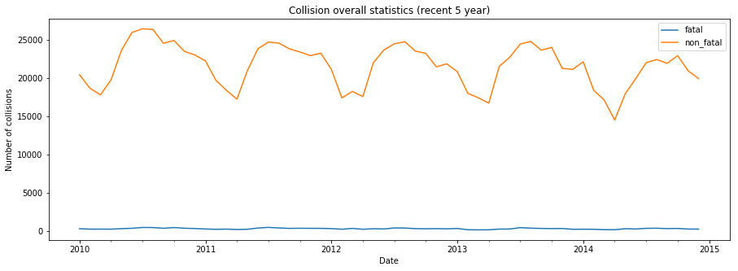

When we plotted the result we noticed that collisions have a seasonal pattern, but it was difficult to identify the exact pattern since the time period was a 15-year scale. Thus, we created another plot with a smaller range (most recent 5 years). From the graph above, we identified a seasonality for non-fatal collisions as 12 months; the number of collision peaks is in mid-year and decreases in the first quarter (Q1).and off-peak is in the first quarter (Q1).

While we were able to see a seasonality pattern for non-fatal collisions, the fatal collision line resembled that of a straight line. We assumed that this is due to the very small number of the fatal collisions in comparison to non-fatal ones, so we created a plot for fatal collisions only for the most recent 5 years of data.

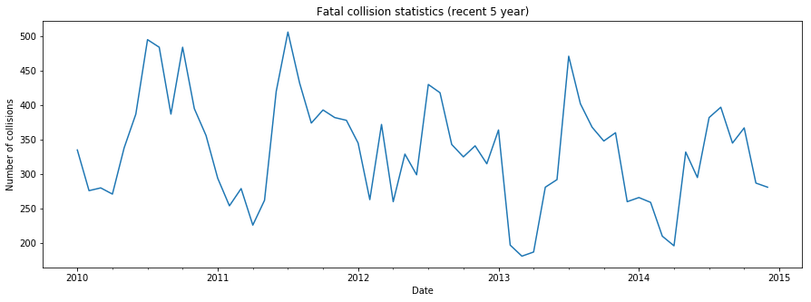

The graph above confirmed our assumption that fatal collisions have the seasonal pattern as non-fatal collisions e.g. Increases and peaks mid-year and starts to decrease and reaches off-peak in Q1.

* 1. Fatal vs. Non-fatal collisions: Autocorrelation & Correlation

To further confirm our seasonality assumption of fatal and non-fatal collisions, we examined the autocorrelation of fatal and non-fatal collisions for the most recent 5 years (see sample code in **[A-2.B4]**).

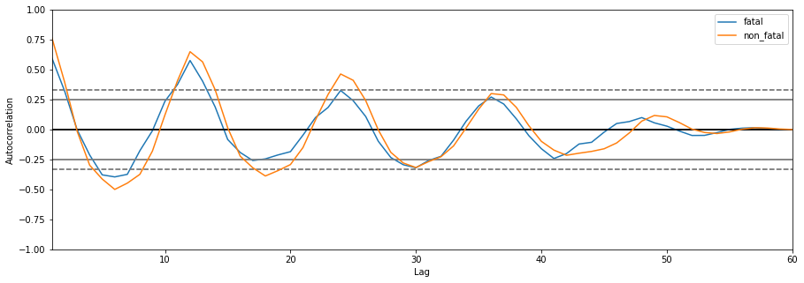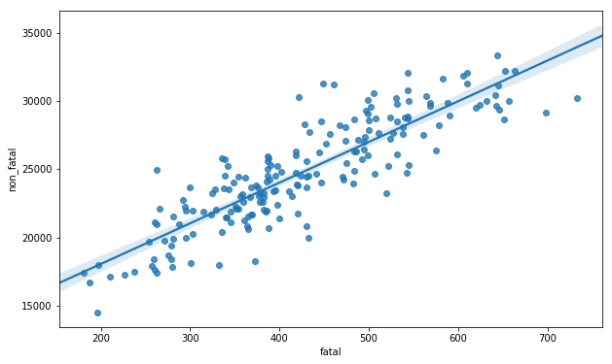

By looking at the autocorrelation diagram (left), we noticed that fatal and non-fatal collisions have a strong autocorrelation with a 12-month lag thus solidifying our assumption. Furthermore, we used the df.corr() to find out how strongly they were correlated. The correlation diagram (right) with the regression line shows that they are strongly correlated; in fact, the correlation coefficient was determined as 0.87. (see sample code in **[A-2.B5]**)

1. Number of vehicles involved in collision **(c_vehs)** by Week Day (c_wday) and Hour (c_hour)

To gain better understanding, we counted the records for certain values in *c_vehs*, and confirmed that every vehicle involved in that specific accident had its own record (e.g., there are 58 records in the dataset have 57 vehicles involved, the outstanding one could be a pedestrian.

We wanted to observe the pattern of number of vehicles involved in collision over **(c_vehs)** over *Week Day* ***(c_wday)***and *Hour* ***(c_hour)****.* We grouped the **c_vehs** by **c_wday** and the results are shown below (left). In a span of a week, number of collisions increase towards Friday (peak) and starts decreasing towards Sunday. (see sample code in **[A-2.B6]**).

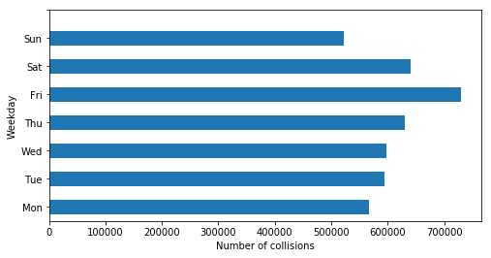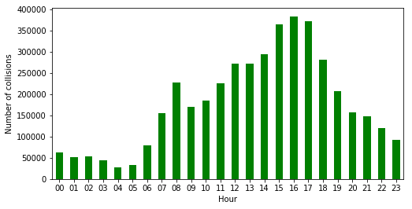

To observe the trend in regard to hours, we grouped the **c_vehs** records by **c_hour**. From the graph above (right), we saw that there are two local maxima: one at 8:00-8:59AM and the second at 16:00-16:59pm. These peaks reflect morning and afternoon rush hours (see sample code in **[A-2.B7]**).

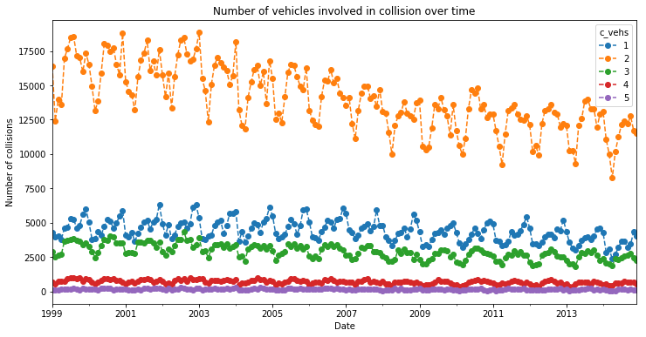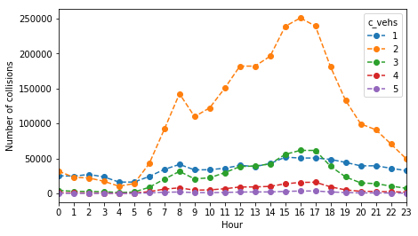

The graph on the left shows the trend of number of vehicles involved in collision over time. The maximum number of vehicles involved in a single accident was 77 but since it was hard to observe a pattern, so we selected the top 5 frequent number of vehicles involved in collision to do our analysis. We can see that the overall number of vehicles involved in collision decreased over time and that 2 vehicles were most likely to be involved in a collision followed by 1 and 3 vehicles. The graph on the right shows the trend of number of vehicles involved in collision at different hours. The two peaks are prominent at Hour 8 and Hour 16 which resembles the exact same pattern for the total number of vehicles involved in collision at different hours.

1. **Road configuration, weather, road surface and traffic control**

The further analysis is similar in nature and will demonstrate the impact of four different collision factors to collision and fatality rate.

* 1. Road configuration **(c_rcfg)**

In addition to generating a bar plot showing the relation between collision severity and road configuration, we also plotted a second axis using the *twinx()* method of a subplot to show the fatal percentage for collisions happened in different road configuration (the blue curve below with the y axis on right).

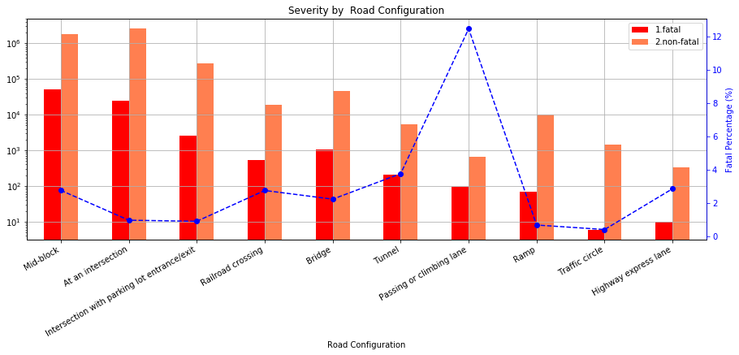

While mid-block and intersection collisions represent the biggest portion of collisions, the passing or climbing lane collisions have the highest fatality rate (~12%). A possible reason could be the different speed between vehicles during collision contact and the vulnerable position of the vehicle changing the lane.

* 1. Weather **(c_wthr)** & Road Surface **(c_rsur)**

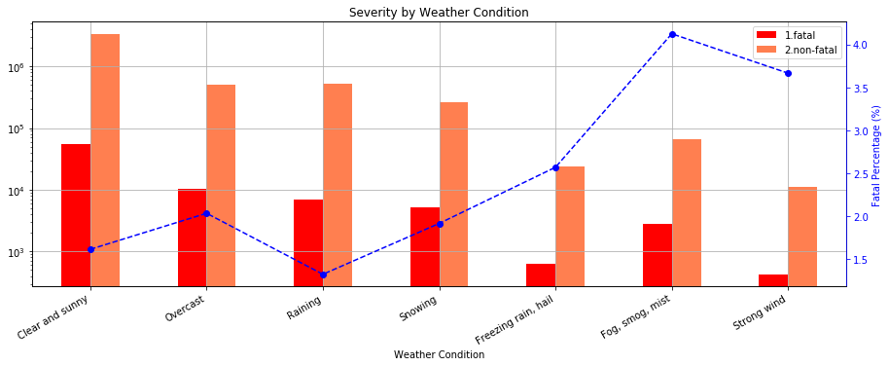

From the graph above we can see that surprisingly, neither snow nor rain contributed to more collisions and fatality rate. In fact, the majority of collisions actually took place in clear and sunny days. The most dangerous weather for drivers was weather with limited visibility like as fog, smog and mist and weather with strong wind. The fatality rate in such weather condition was about 4%.

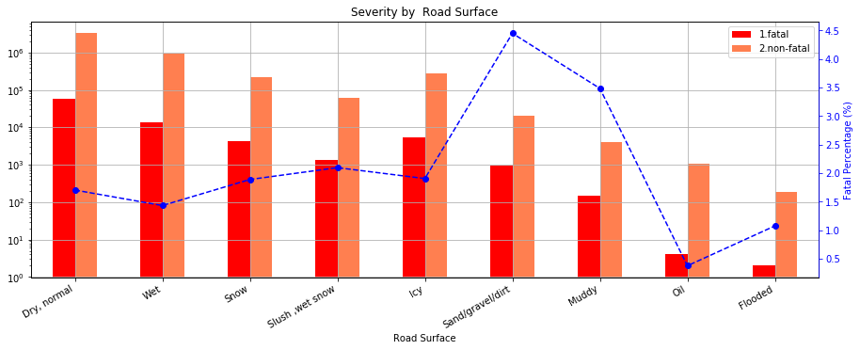

The analysis done for road surface above brought to our attention that dry and normal road surface does not guarantee a safe trip. Dry road leads in the statistics while fatality rate is not significant (~1.5%). The most life-threatening collisions happen on sandy, dirty and muddy roads with fatality rate 3.5% and 4.5% respectively.

* 1. Traffic Control **(c_traf)**

Traffic controls are designed to inform, guide and control traffic to enhance the safety of motorists and pedestrians. As we can see from the graph below, most number of collisions happened when traffic signals were fully operated, and no traffic control was present. The highest fatality rate occurred when collisions happened in reduced speed zone and railway crossing with signs only, around 7% and 8% respectively. While high fatality rate near railway signs can be explained by collision with trains, the high collision rate in reduced speed zone was not easy to comprehend. One possible explanation could be collision involving minors: since the reduced speed zone signs are usually present near schools and day care services.

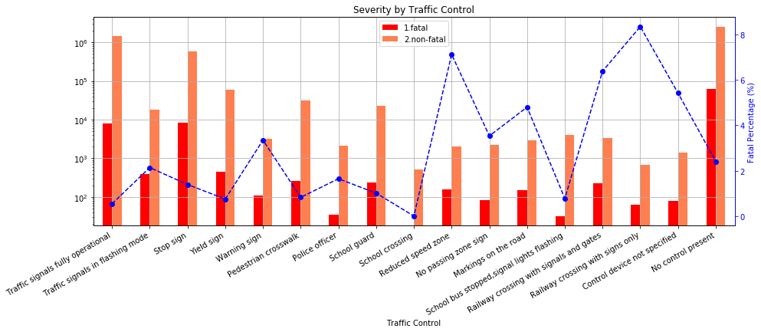

1. **Road Alignment (c_raln)**
   1. Road Alignment & Time relation

We sliced and grouped the data by *time* and *road alignment*, used the *size* method to aggregate the sum for each possible (*date, c_raln*) pair into a two-level indexed *pandas.Series* and used the *unstack* method to transform into a new *Dataframe* (sample code in **[A-2.R4]**).

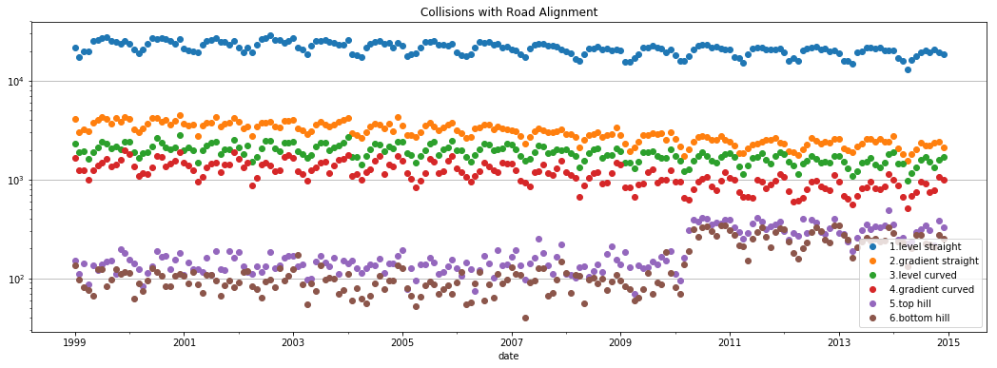

From the graph above, we saw that most collisions happened on *Straight and level* road alignment. A possible reasoning could be that drivers were not cautious enough and drove at a high speed given the easy road.

* 1. Road Alignment **(c_raln)** & Collision Severity **(c_sev)**

The graph below shows the relationship between collision severity and road alignment and presents the fatality rate at each road alignment.

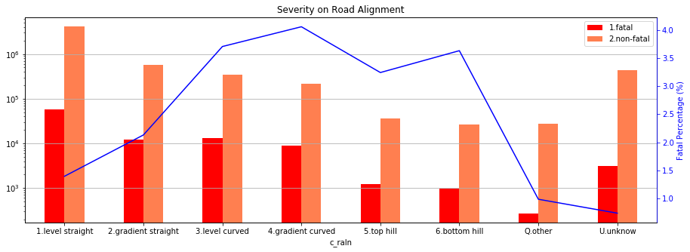

Generally, there were less fatal accidents compared to non-fatal accidents (less than 4% in any given cases) and to no surprise, the Straight-level road alignment had a lower fatality rate, even though the total number of collisions was much higher than other cases. On the other hand, the curved alignment led to more severe accidents; this could be caused by limited sight.

* 1. Road Alignment & Collision Configuration

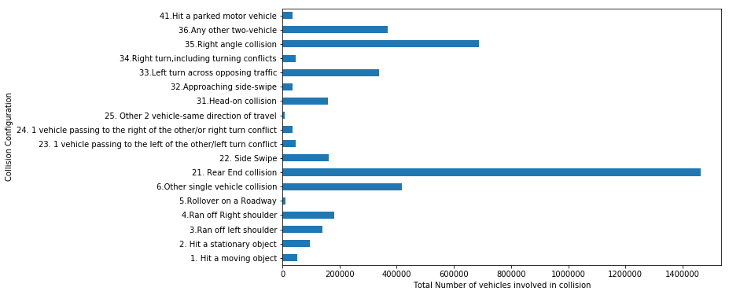

*Collision configuration* **(*c_conf*)** column indicates one or two vehicles involved in collision, their motion, direction and relative position during a collision. From the graph above, we can see that the most common collision configuration was read end collision, followed by right angle collision.

Considering the complexity of collision configurations, we grouped them into four categories by number of vehicles and their directions and plotted them into four subplots.

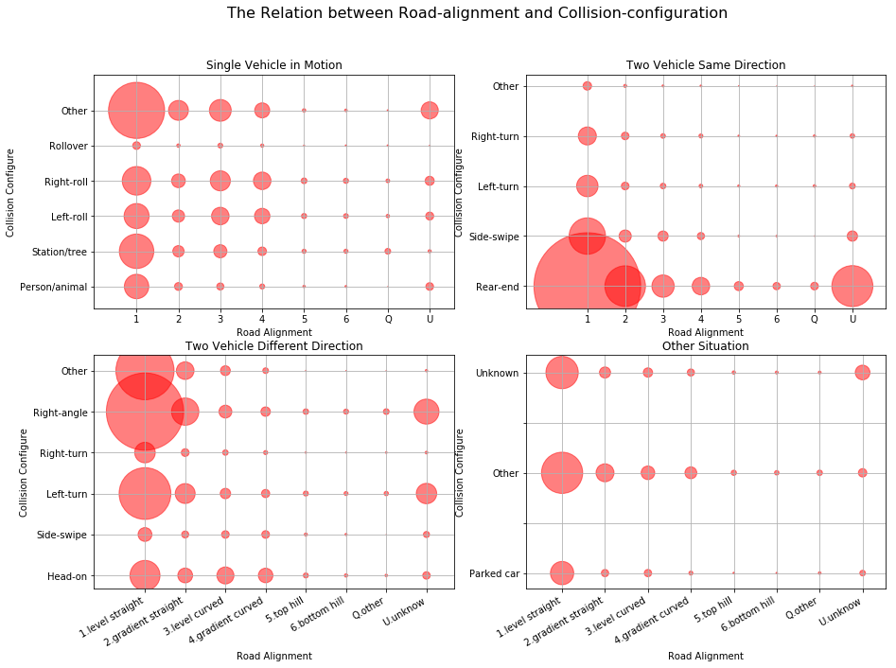

The size of each bubble indicates the number of collisions in each setting and the scale for all subplots were equal, which makes the results comparable. In all cases, there was a clear trend that as road-alignment improved, the collision chances increased due to higher speed and less caution. Disregarding the unknown or "other" conditions, we can see from each case that:

* Most collision for one car accident occurs from hitting a static object, followed closely by right and left roll on to shoulder.
* For two cars in same direction, most accident situations are rear-end collision, which clearly increases along road-alignment.
* For two cars in different direction, right-angle collision is the most frequent, probably in an intersection. While left turn is also risky, right turn shows very low risk: a result of the inherent complexity of left turn.

1. **Collision configuration**
2. **Vehicle Type**

***Vehicle type*** (*v_type*) indicates the vehicle types involved in accidents. e.g., truck, school bus, bicycle, etc.

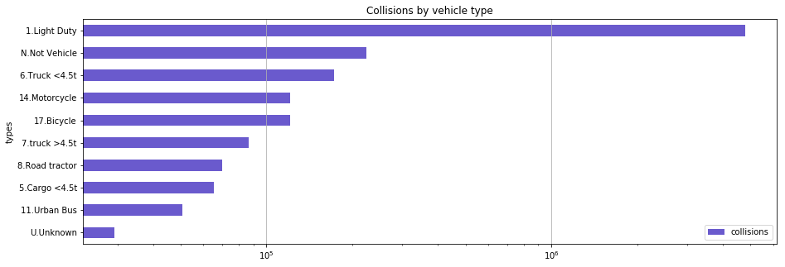

From the graph above, we can see that vast majority of collisions were caused by light duty vehicles, followed by light truck, motorcycle and bicycle.

* 1. Vehicle Type & Time Relation

Because there were around 20 different types of vehicles in the dataset, we grouped similar types, and plotted them into a set of graphs, which focused mostly on the seasonal pattern observed for each vehicle types.

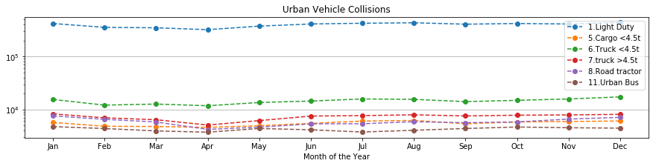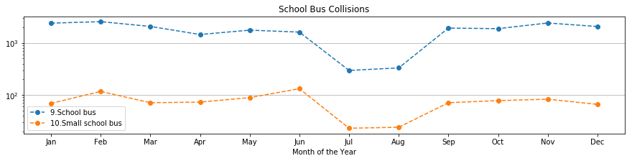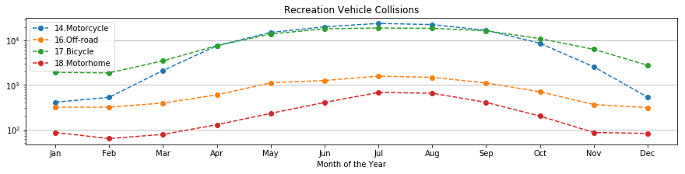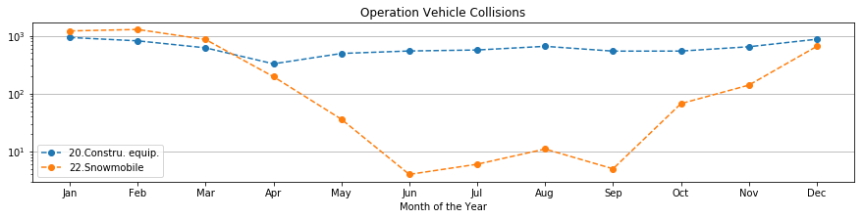

By looking at the plots above, different vehicle types showed different observations:

* The number of collisions for urban vehicles (light duty, trucks, road tractor, and bus) is flat across all seasons, indicating that urban vehicles are in duty all throughout the season.
* School bus collisions decreased in July and August due to summer vacation.
* More accidents related to bicycle, motorcycle, off-road vehicle and motorhome occurred from April to October, as they are used for outdoor activities during warmer temperature, whereas more snow-mobile collisions were prevalent from October to April.
  1. Vehicle Type & Severity

Similar to the analysis for ***road alignment*** and ***severity***, we plotted the results for fatal and non-fatal collisions by different vehicle types with their corresponding fatality rates with a blue dotted line.

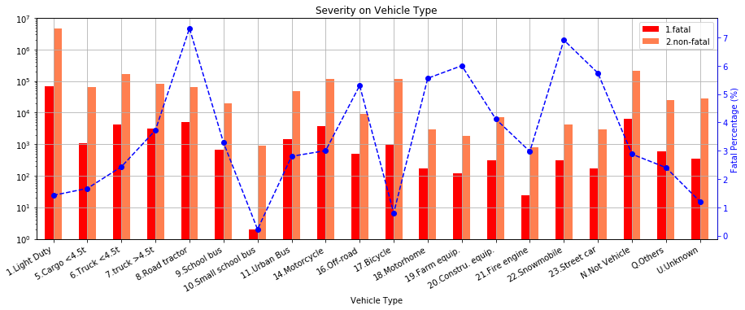

From the figure above we see most fatal collisions are caused by light-duty vehicles, followed by motorcycle, road tractor, and trucks. However, the highest percentage of fatal accidents is caused by road tractor and Snowmobile (about 7%), and followed by street car, farm equipment and motorhome (around 6%). Also noticed that small school bus produces least fatal collisions, and bicycle number is also non-surprisingly low.

Apart from some external environment factors, individual’s characteristics also are a significant factor to influence the likelihood of a crash. Therefore, the following analysis will pay more attention to some person-level data elements, separately focusing on person sex, age, and road user class.

1. **Person sex**

***Person sex*** (*p_sex*) is a column shows the sex of the individual who is involved in a traffic accident. For convenience, all unknown and missing information variables (which include not applicable elements and those are not provided by jurisdiction) will be dropped.

In this section, we will analysis three factors to person sex: collision hour; medical treatment required; collision configuration.

* 1. Person Sex & Collision Hour

***Collision Hour*** (*c_hour*) is a column simply shows when the collision happened. Number from 0 to 23 correspond to 24 hours. For example, 0 indicates form midnight to 0:59; 14 represents from 14:00 to 14:59.

In the whole sample, we grouped the data by sex (*p_sex*), and then using *count* method to account the number for each sex. So, data includes 2, 608, 529 men and 2,116, 502 women. Therefore, we might expect that man will more likely to involve in a collision.

In order to analyze the relation with collision hour, we need slice and group the data by sex (*p_sex*) and collision hour column (*c_hour*). Then using *size* and *unstack* method to aggregate the result. In the end, we plot a line chart with grid line for data visualization purpose:

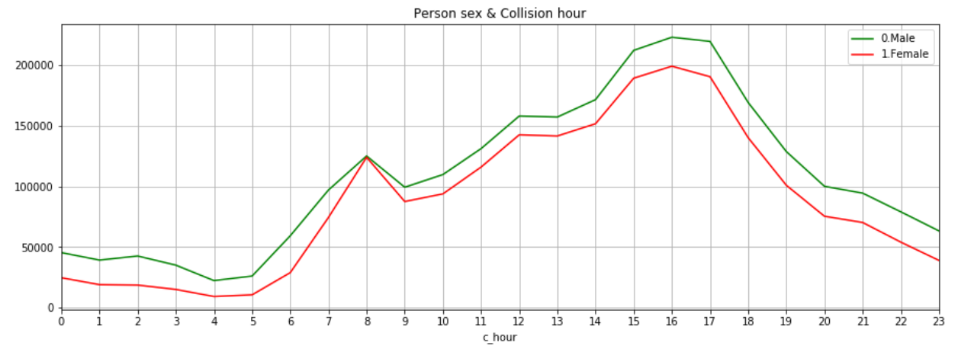

Our expectation is confirmed by the line chart, men are more likely to involve in a collision accident at all times. However, the collision times of male and female are very close to each other at 8 am, around 125047 and 123961 times. Also, for both male and female, the riskiest time period is form 3 pm to 5 pm, and then the risk has a monotonically decreasing trend.

* 1. Person Sex & Medical Treatment Required

***Medical Treatment Required*** (*p_isev*) is a column indicating the degree of casualty. After dropping all unknown and missing information elements, dataset indicated three levels: *No injury*, *Injury* and *Fatality*.

By using the same method as before, we can easily aggregate the result into a two-level index table (*p_sex* and *p_isev*), and then plotting a bar chart.

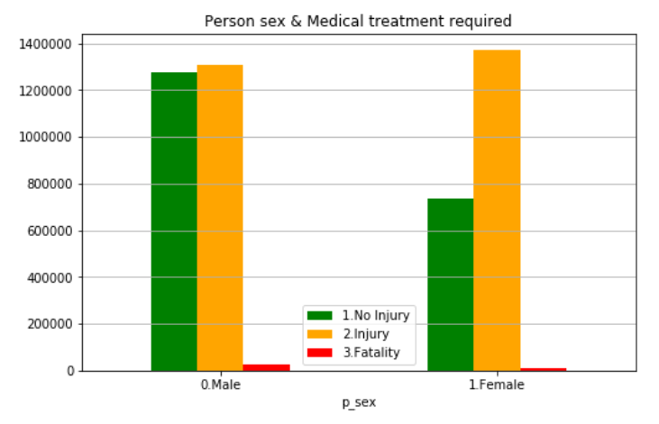

If we focus on No injure and Injure now, we can conclude that female is more likely to injure in an accident, compared to male. In another word, women are more likely to have a serious accident. Plotted in this scale, it is hard to get information about fatality. Therefore, we will plot these same data on a log scale:

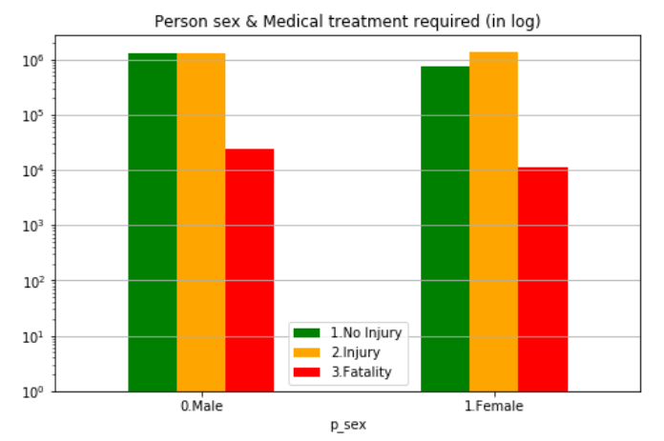

By comparing the red bars, we can see that men have greater likelihood to die in an accident. Numerically, men are twice as likely to die as woman.

* 1. Person Sex & Collision Configuration

***Collision Configuration*** (*c_conf*) is a variable to describe the type of a traffic accident. Dataset includes 4 major categories, which are single vehicle in motion, two vehicles in motion with the same direction, two vehicles in motion with the different direction, and one vehicle hits a parked motor vehicle. Also, the specific type of collision is indicated within each major category. Therefore, more details of each of them will be provided as following.

There are six types of collision when only one vehicle is involved. The first type is hitting a moving object, such as an animal. The second type is hitting a stationary object, like a tree. The third one is vehicle ran off left shoulder, including rollover in the left ditch. Corresponding with the previous one, the fourth one is it ran off right shoulder, which include rollover in the right ditch. Rollover on roadway is the fifth type, and the last one is others.

When two vehicles are moving in the same direction, five types of collision might occur. The first one is rear-end collision. The second one is side swipe, which means the sides of vehicles hit one another. The third type is one vehicle passing to the left of the other, or left turn conflict. The fourth one is exactly the opposite of the previous one. The last one is other types.

Six kinds of crashes might happen when two vehicles are moving in the different direction. The first one is head-on collision. The second type is approaching side-swipe. The third and fourth types are left turn or right turn across opposing traffic. The fifth one is right-angle collision. The last one is other types.

The final category only includes one type which two vehicles are involved in, but one hits a parked motor vehicle.

Now, the similar method will be used to analyze the relation between sex and collision configuration, which is shown as below.

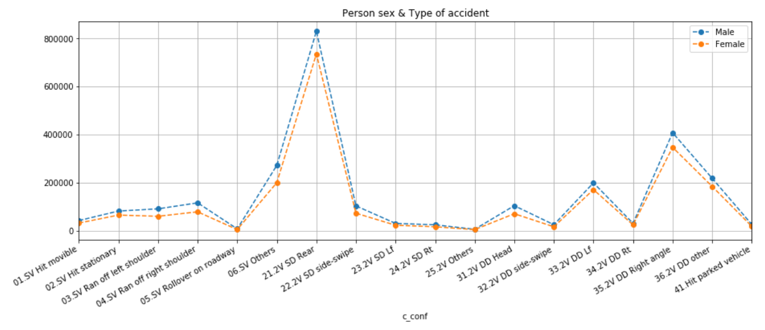

It is obvious that male always has higher collision risk than female. Basically, male and female have a similar pattern among all kinds of collision configurations. Which means accident types do not have a significant sexual differentiation. Rear-end collision is the most frequent type of the traffic accidents for both man and woman, and Right-angle side collision is ranked as the second. Additionally, Rollover on roadway is the least common type of accident.

1. **Person age**

***Person age*** (*p_age*) is numerical column, the age is from 0 to 99 years old. It is noteworthy that 0 means less then 1 years old and 99 represents 99 years or older. All other numbers, between 1 and 98, correspond to 1 to 98 years old. In doer to focus on generation differentiation instead of each age, we binned person age into 10 bins. For example, 10 represents the age from 11 to 20; 20 represents the age from 21 to 30 and so on. For analysis purpose, we still choose to drop all unknown and missing information data.

* 1. Person Age & Collision Hour

Like in “Person Sex & Collision Hour” analyze, we defined x-axis as collision hour in one day. Also, 10 different-color lines represent 10 age-groups.

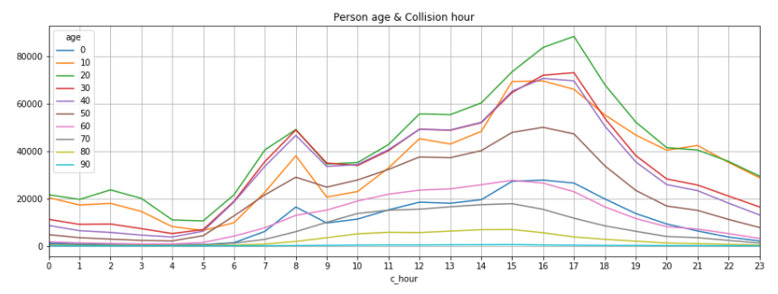

The graph shows that the most dangerous population is from 21 to 30 years old. Also, the youth whose age is from 11 to 20 are more likely to involve in a collision at night, especially from 9 pm to 1 am. At morning (8 am to 11 am), three age-groups (21 to 30; 31 to 40; 41 to 50) has the similar number of accident. In the end, graph shows the working people share the same pattern, which is the rush hour are more likely to collide.

* 1. Person Age & Day of week

***Day of week*** (*c_wday*) is a variable, which contains a series of numbers from 1 to 7. Therefore, 1 to 7 means Monday to Sunday.

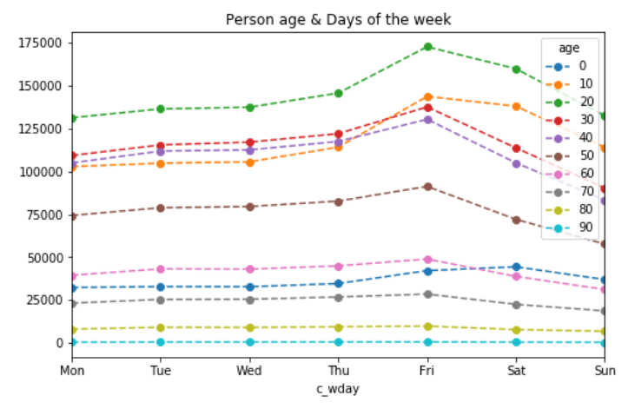

The plot shows that during the whole week, young adults (from 21 to 31) are the riskiest population. Risk decrease with age increases, for example the age from 41 to 50 are less likely to involve in an accident, and compared with whose age is from 31 to 40. Also, in-accident probabilities of the youth are significantly increasing over the weekend. Which is realistic, because the most of teenagers or young drivers are still in school.

In addition, the most of age-groups, like the teenager, young adult and adult, point out most collisions happened on Friday. Also, teenagers and young adults involved collisions happened much less on Monday. In contrast, adults are less likely being involved in an accident on Sunday.

* 1. Person Age & Medical Treatment Required

Considering the normal scale first.

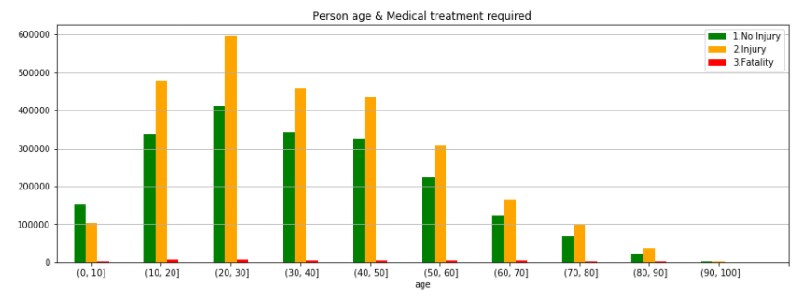

Except for whose age below 10, other age groups get the similar conclusion that people are more likely to injure in collision, and the likelihood decreases with age. Same as before, the graph shows the youth are the most dangerous group. The injuries of young adults are around twice of those of whose age between 51 and 60.

Now, changing to a log scale with the same data.

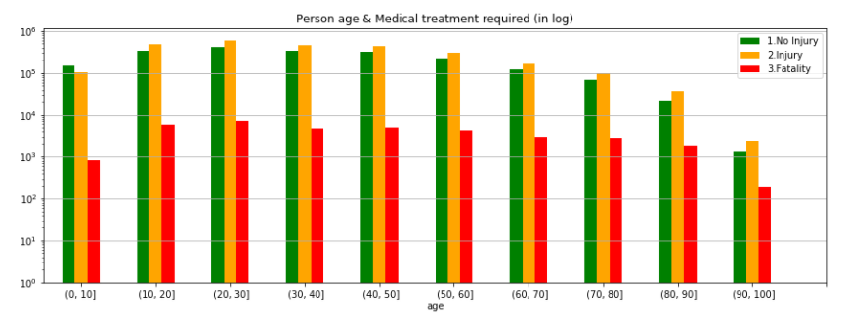

In contrast with the huge gap in injuries, young adults’ deaths are not outstanding, although it is the maximum. Additionally, people who above 90 are less likely to die in traffic casualty then all other age groups. Numerically, from 1999 to 2014, only 185 old people (above 90) died in an accident, compared with 7064 young adults died.

1. **Road user class**

***Road user class*** (*p_user*) shows when accident happened who is involved. Dataset provides 5 road users, with codes from 1 to 6. Thus, 1 is motor vehicle driver; 2 is motor vehicle passenger, 3 is pedestrian; 4 is Bicyclist; 5 is Motorcyclist; and the last one includes others and unknown. For consistency, the last elements will be dropped.

* 1. Road User & Medical Treatment Required

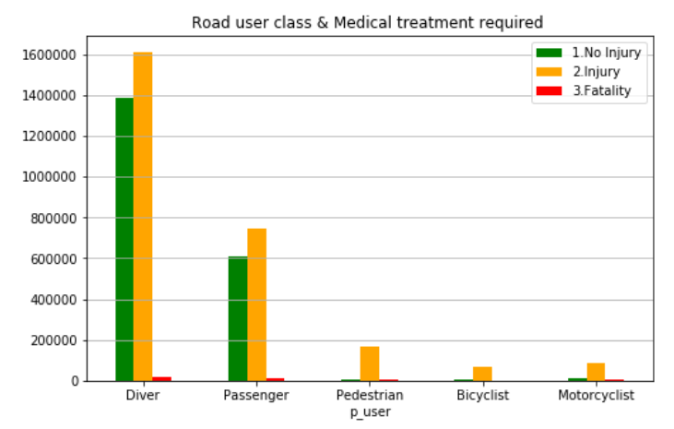

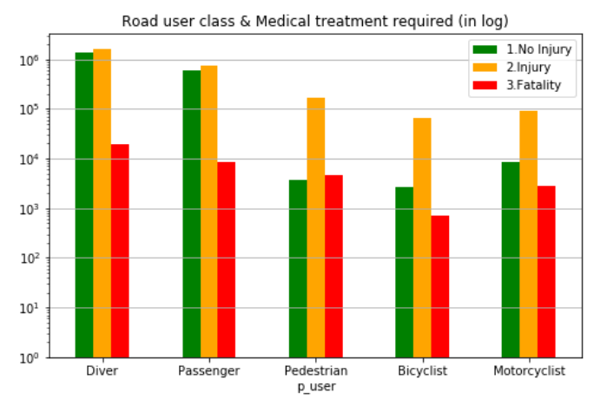

The major class involved in an accident is drivers, they are twice likely to get hurt or die than passengers. In particular, for each three degrees of casualty, the cases of driver are more than the sum of the rest of road users. Also, among all 5 categories, bicyclists are the safest, because of the lowest injuries and deaths.

Additionally, as far as drivers and passengers is concerned, not injury and injury separately account for half of total cases since fatality only accounts for about 0.06% in both road users. Whereas, a collision has above 85% possibility to cause injury when either pedestrians, bicyclists or motorcyclists are involved in.

* 1. Road User & Collision Configuration

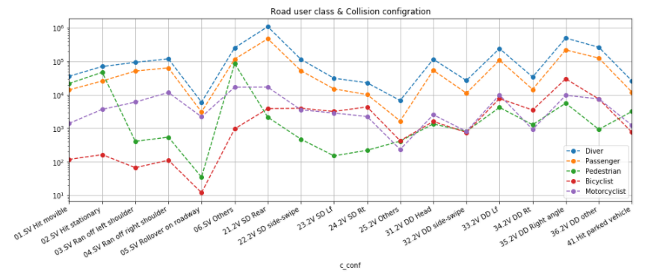

In the end, it is no surprise that driver and passenger have the identical pattern, both of them are more likely to involve in a rear-end collision, and the second common type is right-angle collision. Single vehicle rollover on roadway causes pedestrian or bicyclists to injure or die is infrequent. However, pedestrians are more likely to involve in any other single vehicle collision configuration; for bicyclists, they are more likely to get hurt in a right-angle collision. Among all types of accidents, Motorcyclists get a middling ranking.

# Conclusions

## What ….

Sample sample sample sample sample

* List
* List
* List

Sample sample sample sample sample

# Appendices

## A-1 sample dataset

* Data dictionary:



* Sample data:

|  |  |  |  |  |  |  |  |  |  |  |
| --- | --- | --- | --- | --- | --- | --- | --- | --- | --- | --- |
| **C_YEAR** | **C_MNTH** | **C_WDAY** | **C_HOUR** | **C_SEV** | **C_VEHS** | **C_CONF** | **C_RCFG** | **C_WTHR** | **C_RSUR** | **C_RALN** |
| 1999 | 1 | 1 | 20 | 2 | 2 | 34 | UU | 1 | 5 | 3 |

|  |  |  |  |  |  |  |  |  |  |  |
| --- | --- | --- | --- | --- | --- | --- | --- | --- | --- | --- |
| **C_TRAF** | **V_ID** | **V_TYPE** | **V_YEAR** | **P_ID** | **P_SEX** | **P_AGE** | **P_PSN** | **P_ISEV** | **P_SAFE** | **P_USER** |
| 3 | 1 | 6 | 1990 | 1 | M | 41 | 11 | 1 | UU | 1 |

## A-2 Sample Codes

1. **[A-2.B1]** create new column ‘date’ with data type as ‘period[M]’ and set this column as an index (in “G3_Project_Boris.ipynb”).

|  |
| --- |
| df['date'] = pd.PeriodIndex(df['c_year'].map(str) + '-' + df['c_mnth'], freq='M')  df=df.set_index('date') |

1. **[A-2.B2]** create ‘fatal’ and ‘non_fatal’ columns based on c_sev column value (in “G3_Project_Boris.ipynb”).

|  |
| --- |
| df['fatal']=np.where(df['c_sev']==1,1,0)  df['non_fatal']=np.where(df['c_sev']==2,1,0) |

1. **[A-2.B3]** group ‘fatal’ and ‘non_fatal’ columns by date (in “G3_Project_Boris.ipynb”).

|  |
| --- |
| df_1=df.groupby('date')['fatal','non_fatal'].sum() |

1. **[A-2.B4]** Autocorrelation plot (see line 15 in “G3_Project_Boris.ipynb”).

|  |
| --- |
| plt.figure(figsize=(15,5))  for c in df_1.columns:  autocorrelation_plot(df_1[c][-60:],label=c) |

1. **[A-2.B5]** correlation plot andcorrelation coefficientdetermination (in “G3_Project_Boris.ipynb”).

|  |
| --- |
| sns.regplot('fatal', 'non_fatal', data=df_1)  corr = df_1.corr() |

1. **[A-2.B6]** group collisions by week day and create a bar plot (in “G3_Project_Boris.ipynb”).

|  |
| --- |
| by_weekday = df.groupby('c_wday')['c_sev'].count()  by_weekday.index = ['Mon', 'Tue', 'Wed', 'Thu', 'Fri', 'Sat', 'Sun']  plot2 = by_weekday.plot(kind='bar',title='Collisions by week day') |

1. **[A-2.B7]** group collisions by day hour day and create a bar plot (in “G3_Project_Boris.ipynb”).

|  |
| --- |
| plt.figure(figsize=(15,5))  by_hour = df.groupby('c_hour')['c_sev'].count()  plot3 = by_hour.plot(kind='bar',title='Collisions by week hour',color='G') |

1. **[A-2.R1]** load the data into a *pandas.DataFrame* (in “G3_Project_Ryan.ipynb”).

|  |
| --- |
| accident = pd.read_csv('NCDB_1999_to_2014.csv', engine = 'python')  *#replace header to lower case*  accident.columns = accident.columns.map(lambda x: x[:].lower()) |

1. **[A-2.R2]** clean and prepare the data for analysis (in “G3_Project_Ryan.ipynb”).

|  |
| --- |
| *#Check the non-numeric values in date-time columns*  accident[accident['c_mnth'].str.contains('[^0-9]')|  accident['c_wday'].str.contains('[^0-9]')|  accident['c_hour'].str.contains('[^0-9]')]  *#Make a copy "df" for further analysis, avoid mess up the original data "accident".*  *#Remove all special values (unknown to us) in date-time columns, prepare for using*  *# time series as index.*  df = accident[:]  df[['c_mnth','c_wday','c_hour']]=df[['c_mnth','c_wday','c_hour']].\  replace('[^0-9]+',np.nan,regex=True)replace('[^0-9]+',np.nan,regex=True)  df.dropna(axis=0,subset=['c_mnth','c_wday','c_hour'],inplace=True) |

1. **[A-2.R3]** make a copy of the dataset for easy debugging and faster processing (in “G3_Project_Ryan.ipynb”).

|  |
| --- |
| *#Slice the columns I would analyse from original dataset.*  dfa = df.loc[:,['date','c_year','c_mnth','c_wday','c_hour',  'c_sev','c_vehs','c_conf','c_wthr','c_raln',  'v_type','v_year']]  *# Make a slice only focusing on c_raln: road alignment.*  df1 = dfa.loc[:,['date','c_raln']] |

1. **[A-2.R4]** aggregate by a pair, and reform into a *DataFrame* (in “G3_Project_Ryan.ipynb”).

|  |
| --- |
| *#Aggregate the events by month into a summarized dataframe.*  df2 = df1.groupby(['date','c_raln']).size().unstack() |

1. **[A-2.R5]** calculate accident portion for each collision, and bin the numbers of vehicle involved in each collision (in “G3_Project_Ryan.ipynb”).

|  |
| --- |
| *#Calculate accident portion of each event, considering 58 records that have 57 vehicle*  *# involved, that should be just one accident, every relevant record should be only about 1/57.*  df1['acc']= 1/df1.c_vehs  *#Categorize number of involved vehicles into bins.*  bins = [0,5,10,20,40,60]  df1['cats'] = pd.cut(df1.c_vehs,bins) |