Colin Kincaid Section #1

CS 106A June 27, 2018

Section Handout #1—Karel the Robot

Based on handouts by Eric Roberts and Marty Stepp

This week in section, your first priority is to meet your section leader and discover what sections in CS 106A are all about. Your section leader will therefore spend the first part of this week’s session on introductions and telling you the logistic things you need to know. After the introduction, the section will move on to cover some of the important material from class in a setting that is small enough for you to go over practice problems and ask questions. This week, your goal is to solve Karel problems that involve stepwise refinement, also known as top-down design.

1. United Nations Karel

As part of its plans to help reconstruct infrastructure worldwide, the United Nations—that’s right, the UN is using Karel—established a new program whose mission is to dispatch house-building robots to repair flood-damaged areas. Your job is to program those robots.

Each robot begins at the west end of a street that might look like this:

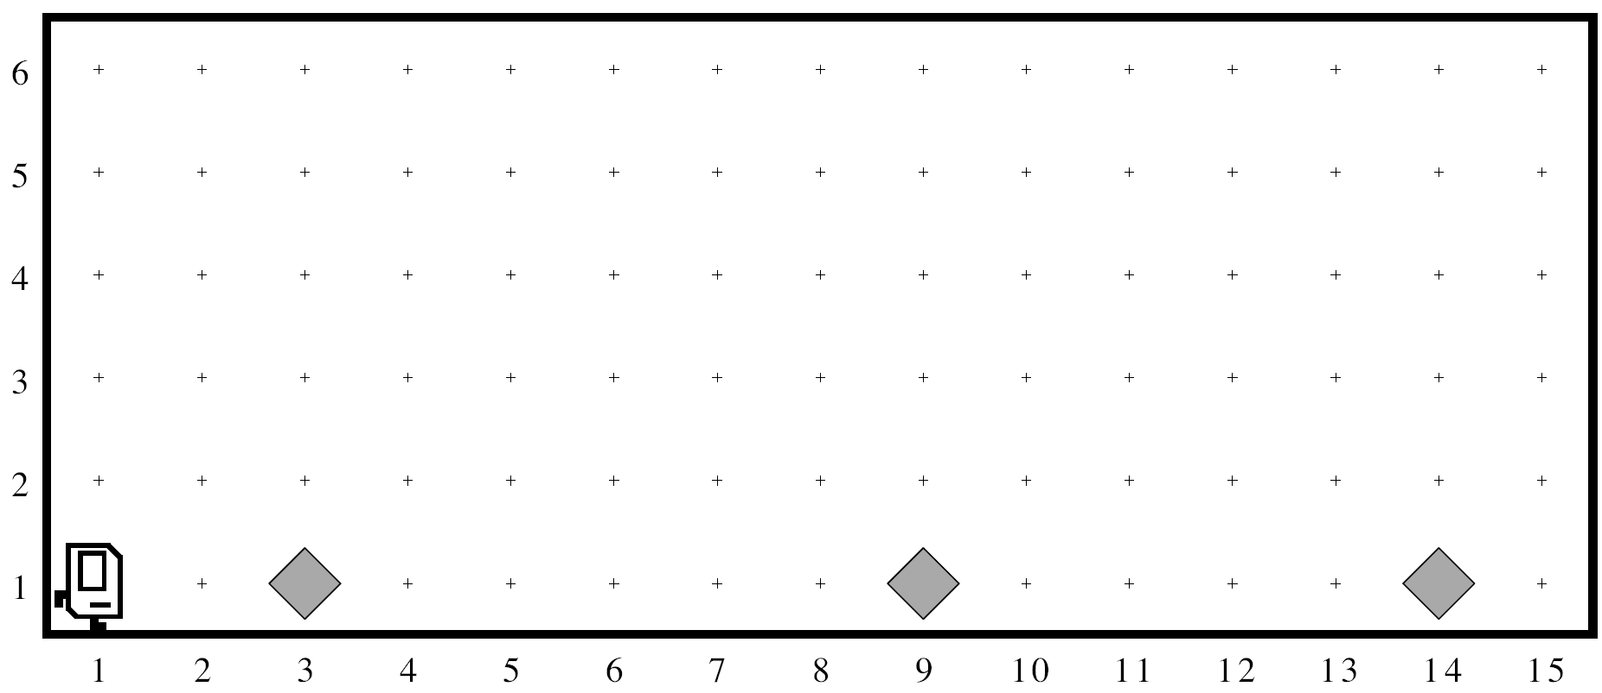

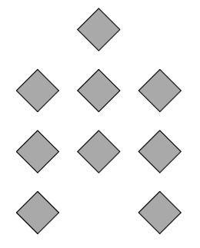

Each beeper in the figure represents a pile of debris. Karel’s job is to walk along the street and build a new house in the place marked by each beeper. Those houses, moreover, need to be raised on stilts to avoid damage from the next flood. Each house, in fact, should look exactly like the picture at right.

The new house should be centered at the point at which the bit of debris was left, which

means that the first house in the diagram above will be constructed with its left edge

along 2nd Avenue. At the end of the run, Karel should be at the east end of the street having created a set of houses that look like this for the initial conditions shown:

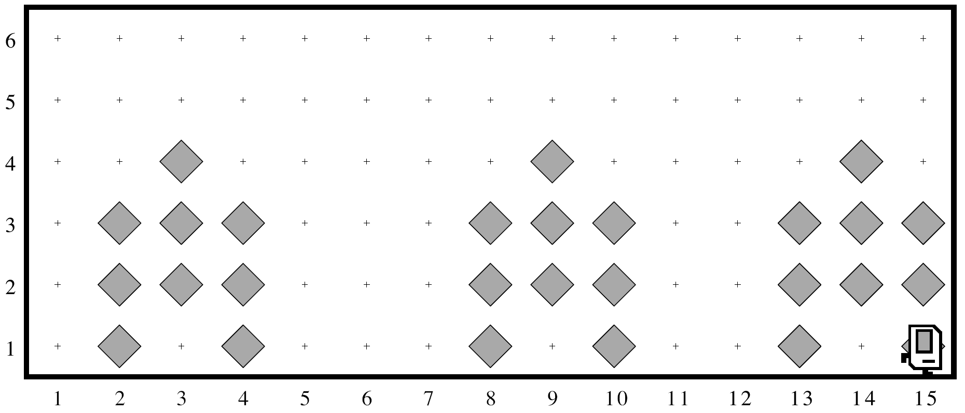

Karel may count on the following facts about the world:

* Karel starts facing east at (1, 1) with an infinite number of beepers in its beeper bag.
* The beepers indicating the positions at which houses should be built will be spaced so that there is room to build the houses without overlapping or hitting walls.
* Karel must end up facing east at the southeast corner of the world. Moreover, Karel should not run into a wall if it builds a house that extends into that final corner.

Write a program to implement the United Nations Karel project. Remember that your program should work for any world that meets the above conditions.

1. Karel Defends Democracy

The 2000 Presidential Elections were plagued by the hanging-chad problem. To vote, voters punched columns out of a paper ballot; but if they only punched partially, the column was left hanging. Luckily, Karel is here to save the day!

In Karel’s world, a ballot consists of a series of columns that a voter can “punch out”. Karel starts on the left of a ballot and should progress through each column. If a column contains a beeper in the center row, the voter did not intend to vote on that column, and Karel should move to the next column. However, if a column contains **no** beeper in the center row, Karel must make sure that there is no hanging chad. In other words, Karel should check the corners above and below and remove any beepers. A corner may contain any number of beepers. Karel must finish facing east at the rightmost edge of the ballot.

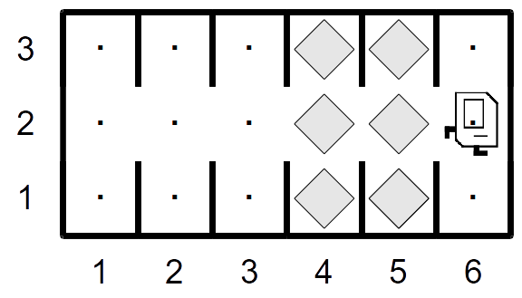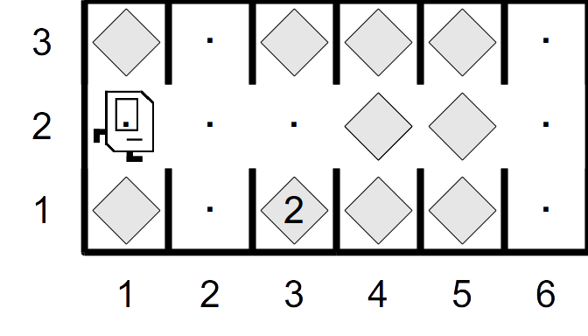

In this world, Karel may assume the following: the world consists entirely of 3-height columns, of which there can be any number. Karel starts facing east on the leftmost column in row 2, and Karel can travel along this row without hitting a wall. Your program should work for a ballot with any number of columns.