Chris Piech Handout #45
CS 106A November 22, 2013

Assignment #7—FacePamphlet
Due: 3:15pm on Friday, December 6th
Note: No late days (free or otherwise) may be used on Assignment #7
Your Early Assignment Help (YEAH) hours: 7:00pm-8:00pm, Friday, Nov. 22nd in Hewlett 200

Based on an assignment (with the same name) by Mehran Sahami.

Social networking applications (such as Facebook, LinkedIn, and Snapchat) are used by billions of people. They are immensely popular particularly because of the power of the internet to connect people. In this vein, your job for this assignment is to create a application that keeps track of a simple, internet based, social network: FacePamphlet.

Web Application
Applications like FacePamphlet, that interact over the internet, are actually two separate programs: the “server” (aka the cloud, aka the backend) and the “client” (or frontend). The server is the program that runs on a datacenter. It will store all of the data of your social network. The client is the program that runs on a user’s computer or phone (did you know Facebook’s datacenters and android phones both run Java?).

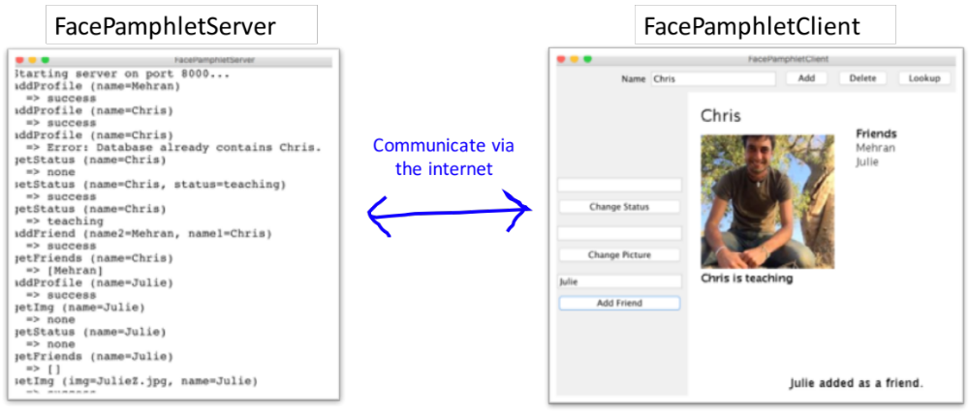

The client and the server work as a team to provide a persistent internet experience. They are constantly sending messages back and forth to each other. The client sends requests to the server (such as setStatus or getStatus) and the server updates its state and returns a string back to the client. All of these communications are sent over the internet.

As a note: this is the first time ever that CS106A students are writing a server that interfaces with a client over the internet (Previous versions of FacePamphlet were quite different). Woot. We have done everything we can to make this an experience that maximizes education while minimizing time spent. We get that it’s the end of the quarter. In this assignment you are going to write the server (or backend) of the FacePamphlet application. You will practice the essential concepts that we have learned in the second half of the course, and in addition learn the crucial parts of how to code for the internet. You can, optionally, write the client as extra credit and we encourage you to do so :-).

Before you read any further, if you haven’t seen the lecture from Wed March 8th, first go check it out.

The Assignment
For this assignment, you will create a server program that keeps tracks of the information in the simple social network called FacePamphlet. Your server will manage all user’s profiles. A profile includes: the person's name associated with that profile, an optional image file name for a profile picture, an optional "current status" for the profile (which is basically just a String indicating what activity the owner of that profile is currently engaged in), and a list of friends for each profile.

A Walkthrough of the Client Program
Your job in this assignment is to write the server (writing the client is optional). However, in order to understand why the server is important it is useful to first walkthrough how humans will interact with the client program. Initially, let assume the social network starts out empty (i.e., it contains no profiles). When the client application starts it shows a blanks screen with a few interactors.

To create a new profile, the user would enter a name in a Name text field and click an Add button. For example, say we entered Mehran Sahami in the text field and clicked Add. Since there is not already a profile with the name "Mehran Sahami" in the network, we would create a new profile for Mehran which is then displayed on the client. Importantly, the FacePamphlet data lives on the server – so the client will be communicating to your program that a new user has just been created:

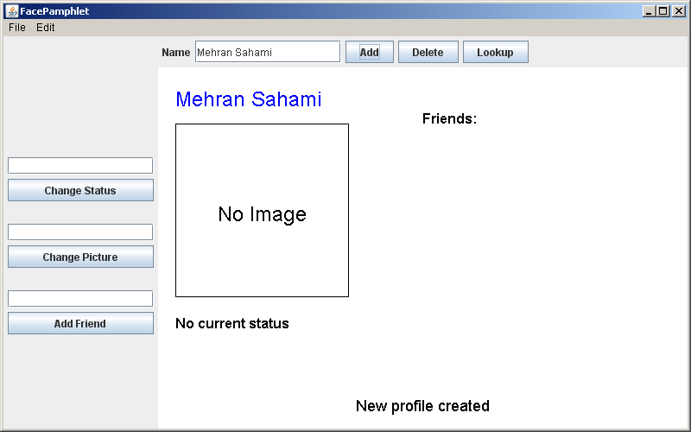

In this profile displayed above, we note five display elements of interest:

- Name: The name associated with the profile ("Mehran Sahami") is displayed prominently in the top left corner of the display canvas.
- Image: Although there is currently no image associated with this profile, there is space available to display a picture immediately under the name of the profile.
- Status: Under the area for the image, the current status of the person with this profile is displayed. Since a newly created profile does not have a status yet set, the display simply shows the text "No current status".
- Friends: To the right of the profile's name, there is the header text "Friends:", and space available under this text to list the friends of this profile. Again, since we have just created a new profile, there are no friends yet associated with it, so there are no entries listed under the "Friends:" header.
- Application Message: Centered near the bottom of the display canvas is a message from the application ("New profile created") letting us know that a new profile was just created (which is the profile currently being displayed).

Updating the Profile
Both the user’s status and profile picture can be updated using the client interactors. Here is a version of Mehran’s profile after (1) setting his picture to MehranS.jpg (2) setting his status to “coding like a fiend” and (3) having him become friends with Julie Zelinski (another intrepid lecturer in the CS department):

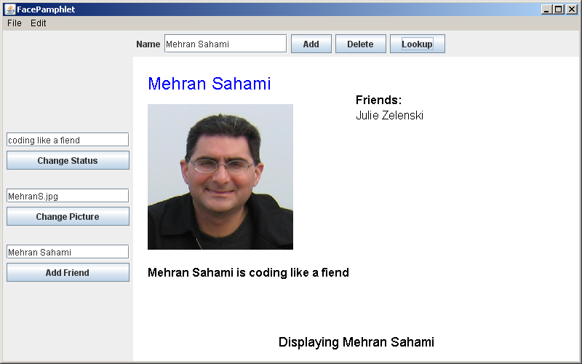

With the client you can continue building the social network. You can add more users, lookup a user (and go to their profile) and edit their status, pictures or add friends.

A Walkthrough of the Server Program
The heart and soul of this application is a program called a “server”. In theory you could execute this program on a computer very far away, though while testing you will be running it on your own laptop.

To explain why we need a server first think: How would you feel if you went to facebook.com, created a profile, but then nobody in the world could see it, and moreover the next time you open up the website your profile was gone? In order for data to be visible across the internet, and to persist it is stored and managed by a server.

The server stores all of the data and contains the logic for creating, deleting profiles and getting and setting profile properties. It doesn’t display the data to a user. That is the job of a client. The server receives requests (which we assume come from the client), updates it’s internal data, and sends back a string. Here is an example of a server that has received many requests (eg addProfile) and its corresponding responses:

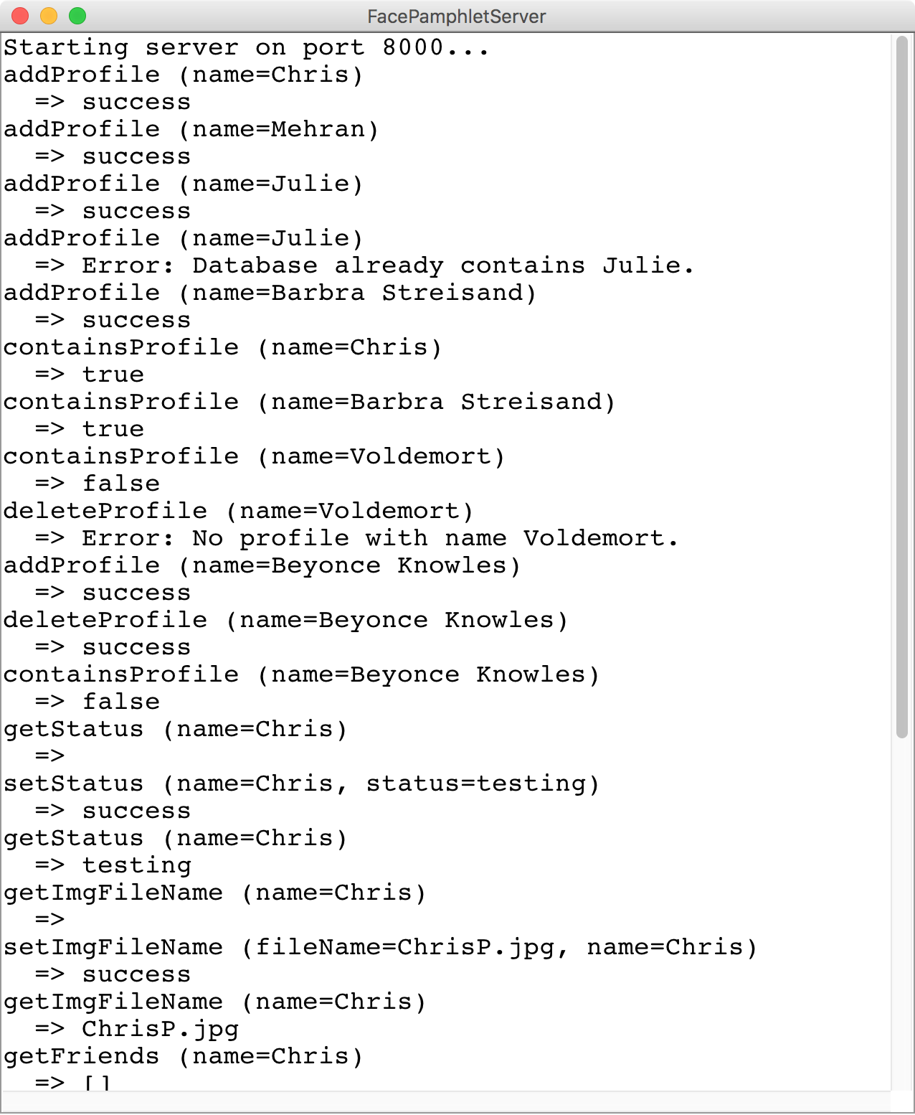

Eventually, in order to support a FacePamphlet application, your server is going to need to handle nine different request commands.

Command | Parameters | Response
addProfile | name | Creates a profile with the given name. Return “success” or, if the profile already exists, returns an error message.
containsProfile | name | Checks if a profile with the given name exists. Returns “true” or “false.”
deleteProfile | name | Removes a profile from the database. Returns “success” or, if the profile doesn’t exist, returns an error message.
getStatus | name | Returns the status of the user with the given name (or “”). Returns an error message if the profile doesn’t exist.
getImgFileName | name | Returns the image fileName of the user with the given name (or “”). Returns an error message if the profile doesn’t exist.
getFriends | name | Returns the list of friends, as a string, for the user with the given name. Returns an error message if the profile doesn’t exist.
setStatus | name, status | Sets the status of the user with the given name. No error checking. Return “success” or, if the profile doesn’t exist, returns an error message.
setImgFileName | name, fileName | Sets the image fileName for the user with the given name. Return “success” or, if the profile doesn’t exist, returns an error message.
addFriend | name1, name2 | Makes user with name1 friends with user with name2 and vice versa. Return “success”, or an error message if either user does not exist, or if they are already friends.

The Details
Similar to the NameSurfer assignment, the FacePamphlet program is broken down into several separate class files, as follows:

• FacePamphletServer—This is the main program class that runs the server. It is a ConsoleProgram and it is responsible for responding to requests from the client.
• FacePamphletProfile—This class should encapsulate all the information for a single profile in the social network. Given a FacePamphletProfile object, you can find out that profile's name, associated image (or lack thereof), associated status (or lack thereof), and the list of names of friends for that profile.
• ServerTester —This program is already written for you. If you run your server, and then run this program, it will send test requests at your server and let you know what is working and what is not.

To help you with regard to developing your program in stages, we outline some development milestones below, along with more details regarding implementing the functionality provided in the program.

Milestone 1: Implement Ping

Before we program requests that will support the FacePamphlet client, let’s start out with a simple task: write code such that if your server receives a request with command “ping” you simply return the string “hello, internet”. Open FacePamphletServer to get started.

The starter code is already set up with a SimpleServer instance variable. In the run, method when we call start() on the instance variable your program opens up to receiving requests. Every time a request is sent to your computer the method requestMade will be called with the details of the request. As we talked about in class there are two methods that you can call on the request class: getCommand() and getParam(key). Update the requestMade method to check if a given request has command equals “ping” and if so return “hello, internet.”

Eventually, the server is going to receive requests from the client. For now, we can test out our ping response by making a request to your server from a web browser (eg Chrome or Firefox). Start your server and navigate to http://localhost:8000/ping to send a request to the server with the command “ping”. Your browser will display the string that your server sends back;

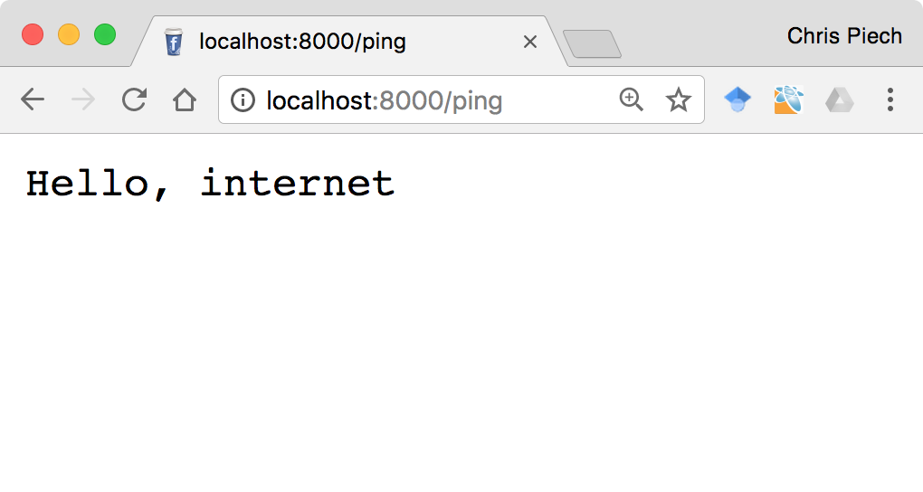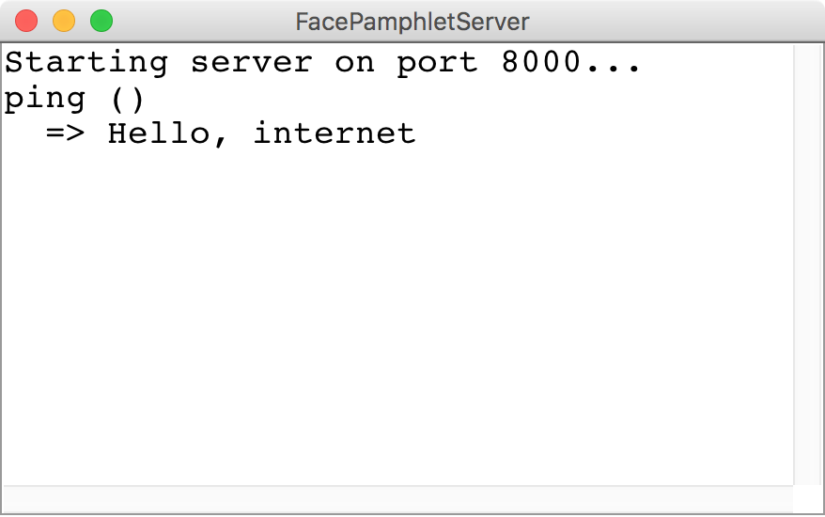
The browser sends a request to the server with command “ping”
1
The server response with the string “Hello, internet” which the browser displays
2
Browser
Server

The server that we show you prints out the received request and the response returned. You do not have to imitate this functionality—all that matters is that you return the appropriate string. Having said that, it is very useful for debugging.

Call your loved ones! You now have a program that is getting (and responding to) an internet request. Next up, let’s make our server process commands relevant to FacePamphlet.

Milestone 2: Implement the FacePamphletProfile class

The server is responsible for storing all of FacePamphlet’s data so that it can respond to requests from the client. We are not going to explicitly tell you how to structure your data. Instead, on a high level, it is useful to think of the server keeping track of many profiles, each of which the server can look up based on the user’s name:

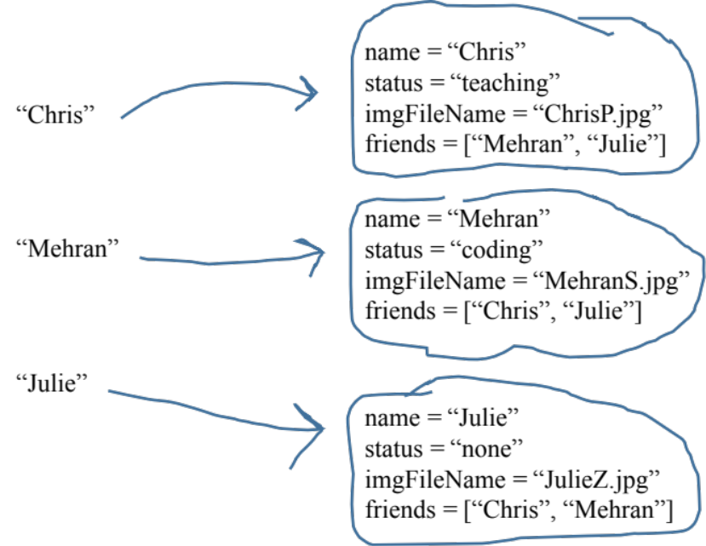

We have provided the shell of a class FacePamphletProfile which defines a new variable type which is incredibly useful. The starter file for the FacePamphletProfile class includes definitions for all of the public methods we expect you to define. The method definitions in the starter files, however, do nothing useful (they are just stubs), although they occasionally include a return statement that gives back a default value of the required type. In Figure 2, for example, the getName method always returns the empty string ("") to satisfy the requirement that the method returns an String as defined in its header line.

The FacePamphletProfile class encapsulates the information pertaining to one profile in the social network. That information consists of four parts:
- The name of the person with this profile, such as "Mehran Sahami" or "Julie Zelenski"
- The status associated with this profile. This is just a String indicating what the person associated with the profile is currently doing. Until it is explicitly set, the status should initially be the empty string.
- The image fileName associated with that profile. This is a String. Until it is explicitly set, this field should initially be the empty string.
- The list of friends of this profile. The list of friends is simply a list of the names (i.e., list of Strings) that are friends with this profile. This list starts empty. The data structure you use to keep track of this list is left up to you.

Note that the FacePamphletProfile class is a suggestion to help you design how to store the data on the server. You may define additional classes, and can modify the FacePamphletProfile as you see fit.

Now that you have a new variable type (FacePamphletProfile) what data structure can you use that will enable you to look up a user’s profile based on their name?

Milestone 3: Implement addProfile, containsProfile and deleteProfile
The first set of commands to implement are ones that tell the server to create or delete a profile, and to return whether or not a profile exists. The commands, which were listed above, are repeated here for convenience.

Command | Parameters | Response
addProfile | name | Creates a profile with the given name. Return “success” or, if the profile already exists, returns an error message.
containsProfile | name | Checks if a profile with the given name exists. Returns “true” or “false.”
deleteProfile | name | Removes a profile from the database. Returns “success” or, if the profile doesn’t exist, returns an error message.

Start by modifying the requestMade method so that it can handle the addProfile method. When your server receives a request whose command is addProfile, the server should prepare to generate a new profile for a new user.
A request is a lot like a remote computer trying to execute a method on your server. The command is like the method name, and just like a method call, requests can contain parameters.
Every request to addProfile should include a parameter with key name. You can get the value of this parameter by calling:
request.getParam(“name”); // the name associated with this request.
If your FacePamphlet server does not already have a profile with the given name, create a new profile, store it, and return the string “success”.
If your FacePamphlet server already has a profile with the given name, you should return an error message. An error message is a string which starts with “Error:” where the remainder of the string describes what went wrong. We don’t mind what description you send, as long as the string you return is an error message.
Similarly, you should implement containsProfile and deleteProfile to match the specifications in the table. If you are having trouble, look at the example ChatServer from class on March 8th.
Servers need to be tested thoroughly. In your project we provide a Program called ServerTester. This program will send test requests at your server and let you know what is working and what is not. First, launch your FacePamphletServer program, then launch the ServerTester. You should pass all of the tests with the commands you just implemented.

Milestone 3: Make the Client Interactors
The FacePamphletClient program is driven by interactors. Set up the interactors so that your clinet program looks like the pictures in the walkthrough.
Milestone 4: Implement Create profile
The FacePamphletClient program is driven by interactors. Set up the interactors so that your clinet program looks like the pictures in the walkthrough.

Milestone 5: Implement Set Status
The FacePamphletClient program is driven by interactors. Set up the interactors so that your clinet program looks like the pictures in the walkthrough.

