Mehran Sahami Handout #15
CS 106A October 5, 2015
Section Handout #2—Simple Java
Portions of this handout by Eric Roberts

1. The Fibonacci sequence
In the 13th century, the Italian mathematician Leonardo Fibonacci—as a way to explain the geometric growth of a population of rabbits—devised a mathematical sequence that now bears his name. The first two terms in this sequence, Fib(0) and Fib(1), are 0 and 1, and every subsequent term is the sum of the preceding two. Thus, the first several terms in the Fibonacci sequence look like this:

Fib(0) = 0
Fib(1) = 1
Fib(2) = 1 (0 + 1)
Fib(3) = 2 (1 + 1)
Fib(4) = 3 (1 + 2)
Fib(5) = 5 (2 + 3)

Write a program that displays the terms in the Fibonacci sequence, starting with Fib(0) and continuing as long as the terms are less than 10,000. Thus, your program should produce the following sample run:

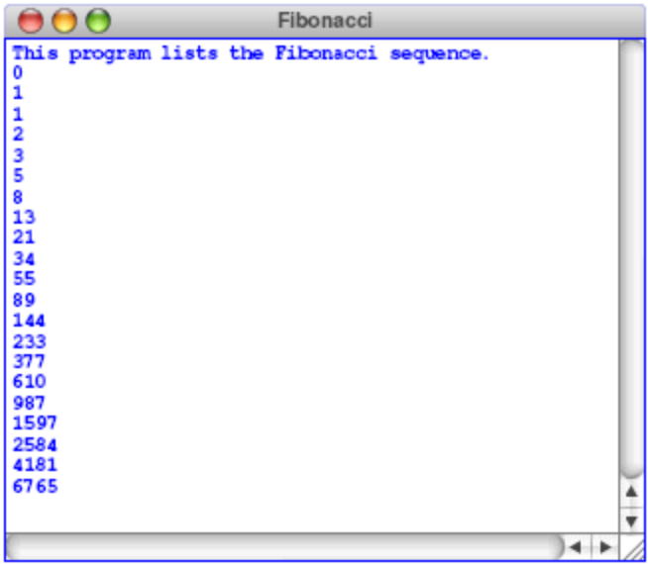

This program should continue as long as the value of the term is less than the maximum value. To do this, you should use a while loop, presumably with a header line that looks like this:

while (term < MAX_TERM_VALUE)

Note that the maximum term value is specified using a named constant.
2. Drawing centered text
Your job is to write a GraphicsProgram that displays the text message (i.e., GLabel):

CS106A rocks my socks!

The text should be displayed in SansSerif 28-point font, and centered horizontally and vertically in the middle of the graphics window, looking something like this:

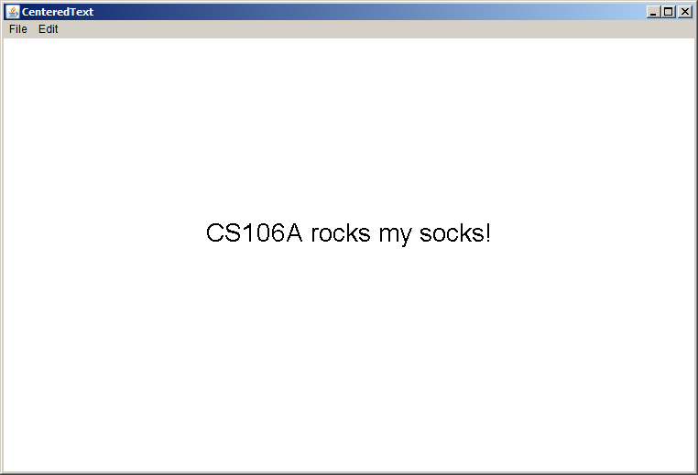

You can find the width of a label by calling label.getWidth() and the height it extends above the baseline by calling label.getAscent(). If you want to center a label, you need to shift its origin by half of these distances in each direction.
3. Drawing a face
Your job is to draw a robot-looking face like the one shown in the following sample run:

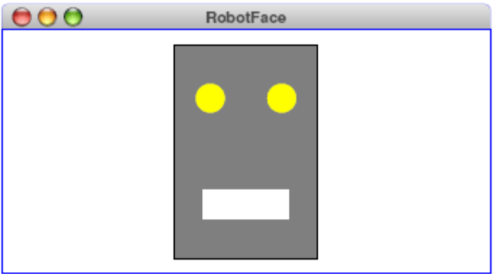

This simple face consists of four parts—a head, two eyes, and a mouth—which are arranged as follows:

• The head. The head is a big rectangle whose dimensions are given by the named constants HEAD_WIDTH and HEAD_HEIGHT. The interior of the head is gray, although it should be framed in black.
• The eyes. The eyes should be circles whose radius in pixels is given by the named constant EYE_RADIUS. The centers of the eyes should be set horizontally a quarter of the width of the head in from either edge, and one quarter of the distance down from the top of the head. The eyes are yellow.
• The mouth. The mouth should be centered with respect to the head in the x-dimension and one quarter of the distance up from the bottom of the head in the y-dimension. The dimensions of the mouth are given by the named constants MOUTH_WIDTH and MOUTH_HEIGHT. The mouth is white.

Finally, the robot face should be centered in the graphics window.

