Chris Piech Handout #29
CS 106A February 17, 2017
Assignment #5 — Yahtzee!™
Due: 10:30am on Monday, February 27
This assignment may be done in pairs (which is optional, not required)
Your Early Assignment Help (YEAH) Hours: Tues. Feb 21st, 7:30-9PM in Bishop Auditorium
Based on a handout written by Eric Roberts and Julie Zelenski.

Note: Yahtzee™ is the trademarked name of a game produced by Hasbro. We refer to this game for educational purposes only. Okay, we also like to have fun playing the game. But then again, something can be both "educational" and "fun" (hopefully, like CS106A), so we shouldn't run into any problems there. Thanks for listening. We now return to our previously scheduled assignment.

Arrays, arrays, everywhere...
Now that you have have arrays at your disposal, your ability to write interesting programs takes a dramatic leap forward. To solidify your understanding, Assignment #5 uses arrays in a variety of contexts to implement a popular multiplayer dice game. There are arrays for the dice, arrays for the dice to reroll, arrays for the player names, arrays for a player’s score, and even an array of arrays (that is, a 2-dimensional array) to handle the entire scorecard. By the time you’re done, you will be well on your way to mastering the concept of arrays.

The goal
Your task is to create a computer version of the game Yahtzee™. Some of you may have already played the game, but for those who haven’t, it’s simple to learn. There are five dice and one to four players. A round of the game consists of each player taking a turn. On each turn, a player rolls the five dice with the hope of getting them into a configuration that corresponds to one of 13 categories (see the following section on “Dice Categories”). If the first roll doesn’t get there, the player may choose to roll any or all of the dice again. If the second roll is still unsuccessful, the player may roll any or all of the dice once more. By the end of the third roll, however, the player must assign the final dice configuration to one of the thirteen categories on the scorecard. If the dice configuration meets the criteria for that category, the player receives the appropriate score for that category; otherwise the score for that category is 0. Since there are thirteen categories and each category is used exactly once, a game consists of thirteen rounds. After the thirteenth round, all players will have received scores for all categories. The player with the total highest score is declared the winner.

Dice categories
The thirteen categories of dice configurations and their scores are:

1. Ones. Any dice configuration is valid for this category. The score is equal to the sum of all of the 1’s showing on the dice, which is 0 if there are no 1’s showing.
2–6. Twos, Threes, Fours, Fives, and Sixes. (same as above but for different values). Any dice configuration is valid for these categories. The score is equal to the sum of the 2’s, 3’s, 4’s, and so on, showing on the dice.
7. Three of a Kind. At least three of the dice must show the same value. The score is equal to the sum of all of the values showing on the dice.
8. Four of a Kind. At least four of the dice must show the same value. The score is equal to the sum of all of the values showing on the dice.
9. Full House. The dice must show three of one value and two of another value. The score is 25 points.
10. Small Straight. The dice must contain at least four consecutive values, such as the sequence 2-3-4-5. The score is 30 points.
11. Large Straight. The dice must contain five consecutive values, such as the sequence 1-2-3-4-5. The score is 40 points.
12. Yahtzee! All of the dice must show the same value.. The score is 50 points.
13. Chance. Any dice configuration is valid for this category. The score is equal to the sum of all of the values showing on the dice.

Running the executable YahtzeeDemo program
In the folder for the starter project for Assignment #5 on the CS106A web site, you will find an exectuable demo program named “YahtzeeDemo” that you can use as a model. To run the applet, just double-click on the “YahtzeeDemo” file. As outlined in the section entitled “What is provided,” all the methods to implement the graphics and mouse interaction have been written for you. This section describes the way the program works as a whole.

When the program begins, it displays a welcome message and asks the user to enter the number of players. It then asks the user to enter the names of the players, one at a time. Suppose that there are two players—Eric and Julie—locked in a cutthroat, head-to-head, winner-take-all showdown. After you use the pop-up dialog boxes to enter the names Eric and Julie, the applet displays the starting Yahtzee scorecard and dice in the graphics window, as shown in Figure 1 on the next page.

Figure 1 (After configuring a new two-player game with players "Eric" and "Julie")
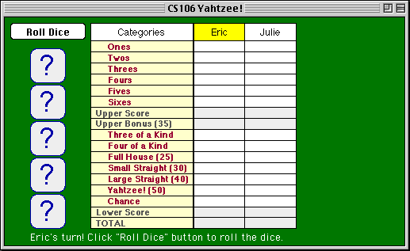

The Yahtzee scoreboard
It’s worth taking a minute to two to look at the Yahtzee scoreboard. The 13 categories that make up the game are divided into two sections. The upper section contains the categories Ones, Twos, Threes, and so forth. At the end of the game, the values in these categories are added to generated the value in the entry labeled Upper Score. Moreover, if a player’s score for the upper section ends up totaling 63 or more, that player is awarded a 35-point bonus on the next line. The scores in the lower section of the scorecard are also added together to generate the entry labeled Lower Score. The total score for each player is then computed by adding together the upper score, the bonus (if any), and the lower score. Note that the total score is updated everytime any category score is updated (i.e., after each player's turn).

Playing a sample game
The game shown in Figure 1 is now ready to begin. Eric is first, so his name is highlighted in the scorecard, which also displays the following message:

Eric's turn. Click "Roll Dice" button to roll the dice.

When Eric clicks the Roll Dice button, the dice are randomly rolled, resulting in a display that looks like the diagram shown in Figure 2 at the top of the next page.
Figure 2 (After Eric’s first roll)
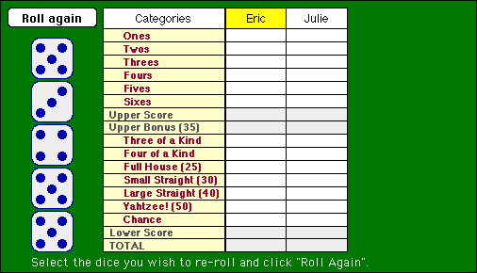

At first glance, these numbers look wonderful, with three 5’s already! Thinking that he has a chance for the Yahtzee category, Eric wants to reroll the 3 and the 4. To indicate this choice, all Eric has to do is click on these two dice. Doing so highlights these dice as follows:

Figure 3 (Eric has selected the 3 and 4 and is ready to reroll)
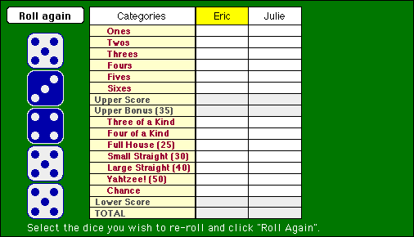

To reroll the selected dice, all the player has to do is click on the Roll again button. Until this button is clicked, the player can select or deselect any particular die by clicking on it. For example, if Eric decided instead to try for some kind of straight, he could deselect the 3 and the 4 by clicking on them and then selecting new dice—presumably two of the 5’s—by clicking on these.

Always overconfident, Eric decides to go for the Yahtzee and rerolls just the 3 and 4. Unfortunately, Eric doesn’t get any more 5’s on his second roll, so he selects those same two dice for his final roll, but is again unsuccessful in his quest for more 5’s. Eric ends up with the three 5’s, a 6, and a 3, as shown in Figure 4.

Figure 4 (After Eric’s final roll of his first turn, choosing category Three of a Kind)
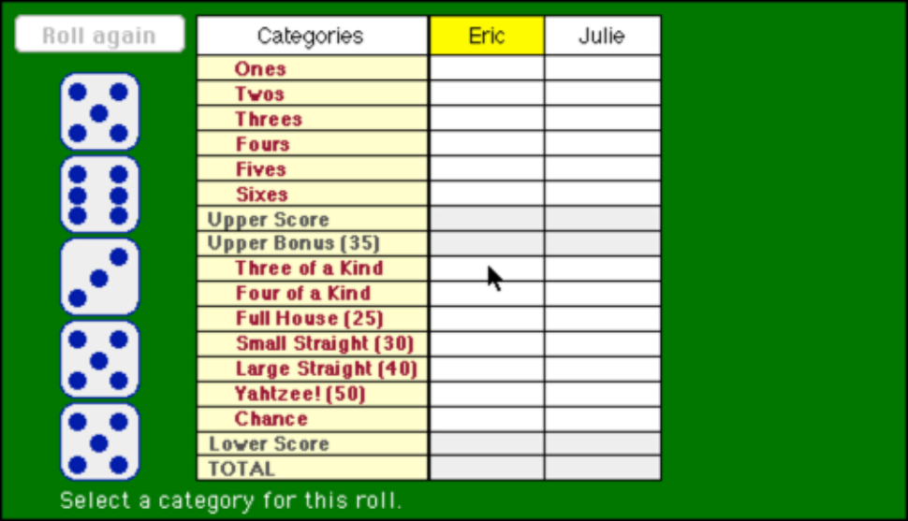

While Eric didn’t manage to secure a Yahtzee, he did come up with a reasonably decent Three of a Kind. When asked to choose a category, Eric clicks Three of a Kind, and a score of 24 points will be recorded in the column. Note that Eric's TOTAL score is also updated at this point to reflect his updated total points.

Now it’s Julie’s turn. Julie has better karma than Eric, but we won't talk about that right now. Anyway, Figure 5 shows the configuration of the dice at the end of her three rolls: three 2’s and two 3’s. Julie is quite pleased and plans to use this configuration for a Full House, which is worth 25 points and gives her the early lead.

Figure 5 (After Julie’s final roll of her first turn, as she is choosing her category)
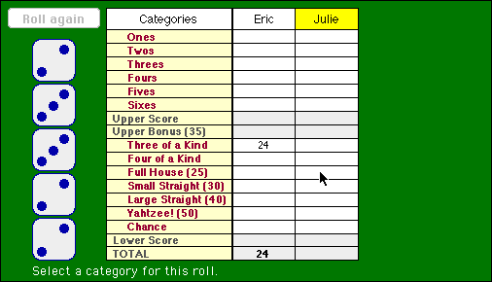

Now it’s Round #2. Eric is behind by one point and wants to seize the lead. His first roll is 3, 5, 5, 4, 1. Eric sees that if he could just turn one of those 5’s into a 2 he would have a large straight. He rolls the single die again and gets . . . a 2! He made it! Of course, Eric doesn’t want to roll the dice again, so he simply clicks the Roll again button without selecting any more dice and then selects the Large Straight category to end his turn, as shown in Figure 6.

Figure 6 (Eric getting ready to take the lead with his large straight)
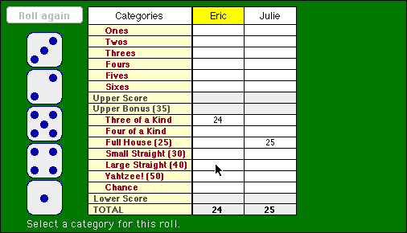

Julie’s not at all worried. She rolls the dice and gets three 3’s, a 6, and a 1. She keeps the 3’s and rerolls to get a 3 and 4. So close! She holds her breath and prays for another 3! She rolls the single die and gets . . . a 1. Dejectedly, she uses the result for Threes; which earns 12 points for her efforts. Eric goes into the third round with the commanding lead shown in Figure 7.

Figure 7 (State of the scorecard at the beginning of the third round)
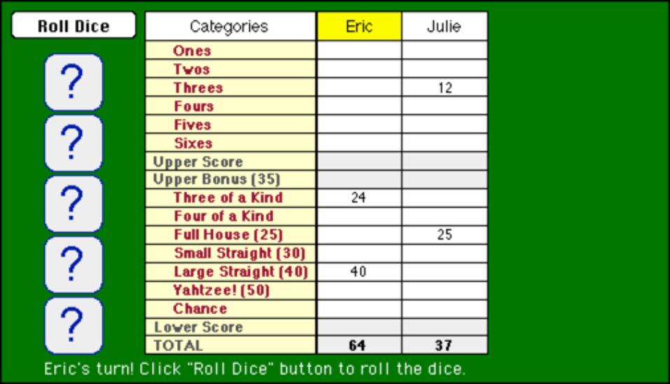

The game continues in a similar fashion. On each turn, players must

1. Click on the Roll Dice button to set up the initial roll of all five dice.
2. Select a set of dice and then click the Roll again button to reroll the selected dice.
3. Repeat step 2 to generate the final dice configuration after the third roll.
4. Click on a category to store the score in the appropriate box.

Note that a player will sometimes have to choose a category that doesn’t match the configuration of the dice, because there are no appropriate categories left. In such cases, the player simply scores 0 in the selected box. Also note that each player's TOTAL score is updated after every turn to reflect their running total score so far in the game.

Let’s fast-forward to Round #13—the final round—where we find the tide has turned:

Figure 8 (At the beginning of the final round—Eric’s up but has not yet rolled)
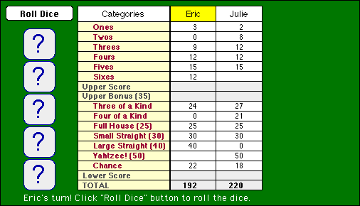

Eric is in trouble. Julie has already gotten her Yahtzee, and Eric desperately needs his. He rolls the dice and gets a 1, 3, 4, and two 2’s. Uggh! He keeps the 2’s and rerolls the 1, 3, and 4. Now he gets a 5, 6, and 3. He rolls these same dice yet another time. Nothing much comes of it—just a 2, 4, and 6. Eric is forced to use this motley collection in the Yahtzee category, which gets him a big, fat 0 (since it does not satisfy the criteria for an actual Yahtzee). Too bad Eric — sometimes that's just how life turns out.

It’s Julie’s turn; all she has left is Sixes. She is already headed for victory, but she plows ahead to rub it in. Julie’s first roll gives her one 6 along with four useless numbers. She discards the junk and gathers two more 6’s during her two rerolls, earning a 18 in Sixes.

Since the game is now over, the upper and lower scores are computed and if applicable, the upper bonus is awarded. Julie earned her upper bonus, since those last 6’s pushed her upper score over 63. Eric, however, fell short. Julie shows Eric who’s boss with a final score of 273 to 192 (shown on the next page)!

Figure 9 (At the end of the game)
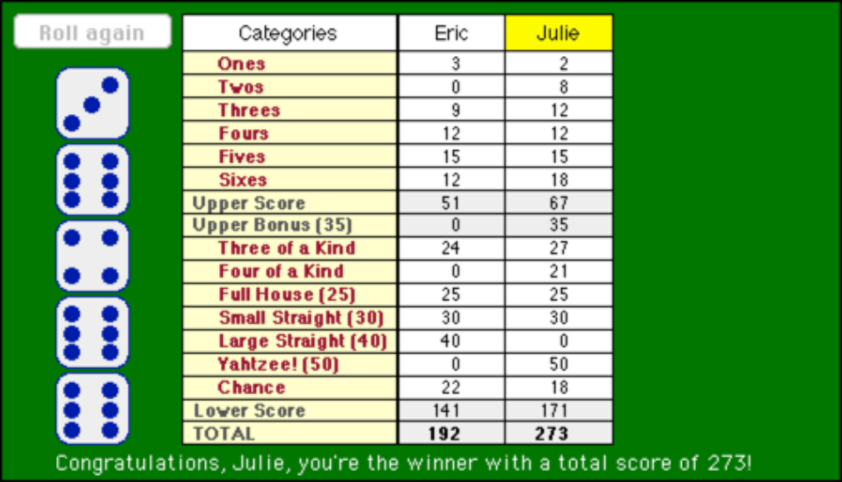

What is provided in the starter project
The starter project provides the following:

• A Yahtzee.java file that you need to expand to play the game. The initialization code, however, is already provided.
• A YahtzeeConstants.java file that defines several constants used in the game. The contents of this file appear in Figure 10 on the next page. Some of these are simple conveniences, such as defining the number of dice to be the named constant N_DICE. The most important entries, for you to understand are the category constants at the end of the file. These constants form an enumeration that allows you to refer to constants on the score sheet. These constants are available to the Yahtzee class because it declares itself as implementing the YahtzeeConstants interface.
• A precompiled class called YahtzeeDisplay (which is embedded in the file yahzeelib) that manages all the graphics and event handling. You’ve already shown your mettle with the graphics library on Assignments 3 and 4, so this time we’ll take the graphics off your plate. This class is discussed in more detail in the section that follows.
• A precompiled class called YahtzeeMagicStub (which is also embedded in the file yahzeelib) that exports a method checkCategory that will allow you to get your program working a little sooner. You have to write your own version of this method before you submit your assignment, but having a working implementation available means that you can test your scoring methods without having to work out the details of this method as well.

Figure 10. The YahtzeeConstants interface
/*
* File: YahtzeeConstants.java
* ---------------------------
* This file declares several constants that are shared by the
* different modules in the Yahtzee game.
*/

public interface YahtzeeConstants {

/** The width of the application window */
public static final int APPLICATION_WIDTH = 600;

/** The height of the application window */
public static final int APPLICATION_HEIGHT = 350;

/** The number of dice in the game */
public static final int N_DICE = 5;

/** The maximum number of players */
public static final int MAX_PLAYERS = 4;

/** The total number of categories */
public static final int N_CATEGORIES = 17;

/** The number of categories in which the player can score */
public static final int N_SCORING_CATEGORIES = 13;

/* The constants that specify categories on the scoresheet */
public static final int ONES = 1;
public static final int TWOS = 2;
public static final int THREES = 3;
public static final int FOURS = 4;
public static final int FIVES = 5;
public static final int SIXES = 6;
public static final int UPPER_SCORE = 7;
public static final int UPPER_BONUS = 8;
public static final int THREE_OF_A_KIND = 9;
public static final int FOUR_OF_A_KIND = 10;
public static final int FULL_HOUSE = 11;
public static final int SMALL_STRAIGHT = 12;
public static final int LARGE_STRAIGHT = 13;
public static final int YAHTZEE = 14;
public static final int CHANCE = 15;
public static final int LOWER_SCORE = 16;
public static final int TOTAL = 17;

}

The YahtzeeDisplay class
As noted in the preceding section, the starter project contains a precompiled class called YahtzeeDisplay that manages the drawing and event-handling. This section of the handout offers a brief overview of the methods, which should be enough to get you started. The assignments area of the CS 106A web site contains a javadoc file for YahtzeeDisplay that displays the full story, the important parts of which are reproduced as Figure 11 on the next two pages.

• There is a constructor method YahtzeeDisplay that creates the initial display. It takes as parameters the GCanvas for the Yahtzee program and an array containing the names of each player. The call to this method is included in the Yahtzee.java starter file we’ve provided to you.
• The waitForPlayerToClickRoll method is used at the beginning of each player’s turn. It waits for the player to click the Roll Dice button indicating they are ready to take their chances.
• The displayDice method draws the dice on the board. It takes an array of N_DICE values. You call this method to draw the random dice results you generated on each roll or reroll. Calling this method causes all dice displayed to be unselected.
• The waitForPlayerToSelectDice method allows the player to click on the dice to select and deselect which ones should be rerolled. You call this method on the second and third rolls of the player’s turn to find out which dice they wish to reroll.
• The isDieSelected method allows you to check whether the player has chosen to reroll a particular die. You call this method after waitForPlayerToSelectDice returns to determine which dice you need to reroll and which you can leave alone.
• The waitForPlayerToSelectCategory method allows the player to click on the scorecard to select a category. You call this method at the end of the player’s turn when they need to choose the category to assign the current dice configuration. The method returns the number of a category, as defined in YahtzeeConstants.
• The updateScorecard method updates a score entry on the scorecard. You call this method at the end of the player’s turn to report the latest score. It takes a player number, a category, and a value, and updates the scorecard to display that value in the proper row and column.
• The printMessage method allows you to display a message at the bottom of the graphics window. This method works exactly like println and allows you to include values in exactly the same way. For example, if you want to display the message
Eric's turn.
with the name Eric replaced by the contents of the string variable name, you could use the following call to printMessage:
display.printMessage(name + "'s turn.");
As this last example illustrates, any calls to the methods in the YahtzeeDisplay class must include the variable display as the receiver. You are asking the display to print a message and therefore must use the receiver-based style of method call.
Figure 11. Entries in the YahtzeeDisplay class
public YahtzeeDisplay(GCanvas gc, String[] playerNames)
Creates a new YahtzeeDisplay object that adds its objects to the GCanvas specified by gc. The playerNames parameter is an array consisting of the names of the players.

Usage: YahtzeeDisplay display = new YahtzeeDisplay(gc, playerNames);
Parameters: gc The GCanvas on which the board is displayed
playerNames An array containing the names of the players, indexed from 0.
public void waitForPlayerToClickRoll(int player)
Waits for the player to click the "Roll Dice" button to start the first dice roll. You will call this method once at the beginning of each player's turn. The parameter is the index number of the player, which ranges from 1 to nPlayers, where nPlayers is the number of players in the game. The method highlights the player's name in the scorecard, erases any dice displayed from previous rolls, draws the "Roll Dice" button, and then waits for the player to click the button. This method returns when the button is pressed. At that point, it is your job to randomly roll the dice and call the displayDice method.

Usage: display.waitForPlayerToClickRoll(player);
Parameter: player The index of the player, ranging from 1 to nPlayers
public void displayDice(int[] dice)
Draws the pictures of the dice on the screen. You pass one parameter, a zero-based integer array with N_DICE entries, that contains the values to draw on the dice. Each value in the array must be a valid die roll between 1 and 6; if not, displayDice will throw an ErrorException. You will need to call this method after each roll or reroll of the dice to display the new random values.

Usage: display.displayDice(dice);
Parameter: dice An array of dice values, whose indices range from 0 to N_DICE - 1
public void waitForPlayerToSelectDice()
Allows the player to select which dice to reroll by clicking on the dice with the mouse. You will call this method twice each player turn, giving them two additional chances to improve their roll. This method draws the "Roll Again" button, and waits for the player to click on the dice to select and deselect which ones they would like to reroll. The method returns only after the player has made a selection and clicks the "Roll Again" button. Once the method returns, you can use the isDieSelected method to determine whether the die should be rerolled.

Usage: display.waitForPlayerToSelectDice();
public boolean isDieSelected(int index)
Checks to see whether the die specified by index is selected. You call this method before each reroll to determine whether this die needs to be updated.

Usage: if (display.isDieSelected(index)) . . .
Parameter: index The index number of the die, which ranges from 0 to N_DICE - 1
Returns: true if the die is selected, and false otherwise
public int waitForPlayerToSelectCategory()
Allows the user to select a category in which to place the score for this roll. You will call this method once each turn after the player finishes rolling the dice. As its name suggests, the method waits for the player to click on one of the categories and returns the index of the category, which will be one of the constants defined in YahtzeeConstants. Note that this method does not check to see whether the category is valid for the dice values or whether this category has already been used by this player. Thus, you will need to include some error-checking in your program to test the result of waitForPlayerToSelectCategory before you try to update the scorecard.

Usage: int category = display.waitForPlayerToSelectCategory();
Returns: The category number selected by the player
Figure 11. Entries in the YahtzeeDisplay class (continued)
public void updateScorecard(int category, int player, int score)
Updates a value on the Yahtzee scorecard. You must call this method once each turn after the player has finished rolling and has chosen the category in which to score the result. The parameters to the method are the index of the category (which will be one of the constants defined in YahtzeeConstants), the player number, and the score to be displayed in that cell of the scorecard.

Usage: display.updateScorecard(category, player, score);
Parameters: category The category number to update
player The player number (between 1 and nPlayers)
score The score to display in that box
public void printMessage(String message)
Prints a message on the bottom of the Yahtzee scorepad. The old message is cleared whenever any YahtzeeDisplay method is called.

Usage: display.printMessage(message);
Parameter: message The message string to display

Another point to which you should pay attention is that the methods in the YahtzeeDisplay class take player numbers that run from 1 to the number of players, and not from 0 to the number of players minus one. The latter is what you need for array selection, but the former makes more sense to humans, who are unaccustomed to thinking about a player 0. You might want to look at the section of Chapter 8 entitled “Changing the index range” for some guidance as to how to think about this small wrinkle in the design, although it should be rather straightforward to deal with.

Some strategies to consider
As always, we recommend first spending time thinking about the program before you jump in and start coding. Consider what types of variables will be needed to store the various information. How will you arrange the data and how will you pass it around in the program? Sketching out a decomposition tree will be helpful here. Take time to identify the parameters going into each method and the return value coming out. Also consider how you plan to use the library routines in your solution. Be sure to read the javadoc for YahtzeeDisplay (available from the "Yahtzee" page of the CS106A web site) very carefully so that you thoroughly understand how the methods behave and the kinds of parameters they require.

One of the most interesting (and challenging) array tasks you will be faced with is determining whether a dice configuration meets the requirements for a given category, and is therefore valid. For example, Three of a Kind requires a dice configuration in which at least three of the dice show the same value, Small Straight requires at least four of the dice values to be consecutive, and so forth. If a player assigns an invalid dice configuration to a category, they receive 0 points for it.

To make it easier for you to get your program working, we have provided a method called YahtzeeMagicStub.checkCategory, which tests to see whether an array of dice values matches a particular category. If you call this method with the array of dice and the index of the category you’re checking for, checkCategory returns true if the values of the dice stored in the array are valid for the category and false otherwise. Note some categories (namely, Chance and Ones, Twos, etc.) accept any dice configuration; for these categories checkCategory always returns true. The javadoc describing the class YahtzeeMagicStub is available from the "Assignments" page of the CS106A web site, but for your convenience, we note that the static method YahtzeeMagicStub.checkCategory can be called as follows (assuming we have an array of ints named dice that we want to check to see if it matches the Full House category):

boolean p = YahtzeeMagicStub.checkCategory(dice, FULL_HOUSE);

In the early stages of your development, you can use our checkCategory method to help you get up and running. Ultimately, however, you need to write this method yourself. As you develop your own version of this method, you’ll probably want to test it in stages. You could, for example, write a method that tests the validity of, say, Three of a Kind, but uses the implementation from YahtzeeMagicStub for everything else. When that works, you could move on to take care of Four of a Kind, and then Yahtzee and Full House. Once you have your own methods for checking the validity of these categories, move on to tackling Small Straight and Large Straight.

For full credit, you should not use YahtzeeMagicStub.checkCategory anywhere in the final version of your program. If you find determining the validity of a certain category or categories too difficult, you may use our method, but you will lose points for each category whose validity you do not check with your own implementation.

In a similar vein, look for other intermediate milestones you can aim for instead of heading straight for the final goal and letting it overwhelm you. For example, it is easier to get a single-player game working than a multi-player game. If there is only one player, you can work with a single array of scores. After you can reliably play a single-person game, you can move on to support an array of players’ scores where a multidimensional array will be needed.

You also might find it worthwhile to create a “cheat” mode during development. If you are running in cheat mode, you can prompt the user to specify the values by typing them in instead of choosing the dice randomly. Implementing this feature will make it easier for you to check the various situations that can come up during the game, rather than waiting and hoping for them to come up randomly at some point during your testing.

Hints and other random details
• Just like the demo YahtzeeDemo, you do not need to do error checking on the number of players entered at the beginning of the game.
• There’s not a great deal difference between determining the validity for Three of a Kind, Four of a Kind, Yahtzee, and Full House.
• There’s not a great deal of difference between determining the validity for Small Straight and Large Straight.
• Any dice configuration is valid for Ones, Twos, Threes, Fours, Fives, Sixes, and Chance.
• A dice configuration assigned to a category where it doesn’t meet the requirements receives a score of 0.
• Make sure to update each player's TOTAL score after each of their turns to keep track of their running total score in the game so far.
• You should print text messages along the way to inform the players what to do next (whose turn it is, when the player should roll, when to select dice for rerolling, when to choose a category, who the winner is, etc.). You can use the demo applet provided on the CS106A website as a guide to the sorts of messages you should give the players.
• Be sure to check for errors when the player selects the category to assign a dice configuration. The user cannot re-use any previous category. Print a message if you cannot honor their choice and have them select another.
• On each turn, a player will roll the dice three times. If a player doesn’t want to change anything on a subsequent roll, that player should click the Roll again button without selecting any dice.
• At the end of the game, don’t forget to compute and assign the upper bonus (35 points if their upper score is 63 or over), upper score, lower score, and final total.
• Be sure to mark all methods as private unless you explicitly plan for them to be used outside the module. The grading criteria that we will use for the assignment will include a deduction along these lines.

Extensions
Since the standard assignment is pretty much a full implementation of the Yahtzee game, it is hard to come up with ideas for extensions, but don’t let our lack of creativity stop you from exploring things that you would find interesting. Here’s at least a few ideas that occurred to us:

• Add a high score feature. Save the top ten highest scores and names to a file and make it persistent between runs of the program. Read the file when you start and print out the hall of fame. If a player gets a score that preempts one of the early high scores, congratulate them and update the file before you quit so it is recorded for next time.
• Incorporate the bonus scores for multiple Yahtzees in a game. As long as you have not entered a 0 in the Yahtzee box, the rules of the game give you a bonus chip worth 100 points for each additional Yahtzee you roll during the same game.

As always, you should only tackle extensions after you have completed and thoroughly tested all the basic requirements. If you do create an extended version, please turn in both a basic and an extended version to make it easier for us to verify the base functionality. Small extensions that don’t disrupt the basic functionality are fine to include in one version. Be sure to describe in your comments where we should look for your fun additions!

(Note: to create another file, right click on default package in the project sidebar, select New -> Class, and name your new class, e.g. YahtzeeExtension. Then, click Finish and copy your code over from your unextended program. Remember to change two things in this code:
- Change the class name (“Yahtzee”) to match the name you chose for your file.
- Change the code in the main method to be new CLASS_NAME().start(args), where CLASS_NAME is then name of your file.

