Nemesis: An Exploitative Poker Simulator for Android
Clark Kirby · Project Update 5 · 11/02/2026
Overview—Nemesis is an Android app that shows a live low-stakes poker player which starting hands make money at their specific table. The user describes the table in plain English, the app turns that into a parameterized opponent model, and a Monte Carlo simulator estimates the expected value of opening all 169 starting hands from each selected position. Update 4 delivered the finished app. This update covers a full audit of it: I read every source file, ran the test suites and Android lint, and compared the engine against the original Python code. The audit found six bugs. The most important was that simulated opponents were dealt hand types uniformly instead of by real card combinations, so they held suited hands about twice as often as a real deck deals them. The others were an offline parser that counted some reads twice, ranked lists that could show losing hands as “best opens,” a results notification that could be lost on long runs, an offline report with hard-coded verdicts, and an advisor that ignored every position but the first. All six are fixed and covered by new tests, lint now runs in CI, and the fixes shipped as release v1.1. Because the dealing fix changes the numbers, I then re-measured how EV grows with position across five opponent pools and retuned the advisor’s thresholds to match. The app now has 50 unit tests and 25 instrumented tests, and both suites pass on every push.

Introduction
S
ince Update 4, the app has been feature complete: it reads a table description, simulates every starting hand, and turns the results into a report. In that update’s Future Work I noted one problem I already knew about, that a villain’s hand was drawn uniformly from the 169 hand classes, and there were likely others I had not found. This update is about finding and fixing them.
The whole point of Nemesis is telling a player which hands to open, so a quiet bug in the numbers is worse than a crash, because nothing tells you it is there. Instead of adding features, I audited the whole project: every Kotlin file, the build setup, the manifest and CI. I kept a list of everything that could give a wrong answer, a misleading message or lost work, and fixed those first. Features I would like to add went into Future Work.

Audit Method
I read the code layer by layer, engine, parsing, advisor, data, the simulation service and each screen, and checked each part against what the app tells the user it does. The 44 unit tests passed and Android lint reported no issues, so none of these bugs showed up as a failing test. For anything inherited from the Python version, I checked the original engine [1] to see whether a behavior was a porting mistake or a choice. The uniform dealing turned out to be a deliberate shortcut there, marked in the code as a “cheap approx.”
Each fix followed the same pattern: change the code, add a unit test that fails without the fix, then rerun the unit tests, lint and the instrumented tests on an emulator before committing. Everything is on GitHub [2].

Application Design Changes

Dealing real cards
Simulator.simulateHand() used to choose each opponent’s hand type at random from the 169 classes and then pick cards for it. Every class was equally likely, but a deck is not: a pair has 6 combinations, a suited hand 4 and an offsuit hand 12. Opponents therefore held suited hands 46% of the time instead of 23.5% and offsuit hands 46% instead of 71%, so they made flushes and draws far too often after the flop.
Now each seat is dealt two real cards from what is left of the deck, and those cards stay out of the deck even when the player folds. Opponent ranges are written as “top X% of hands,” so I also changed Ranking to weight each hand by its combinations: “opens 15%” now means 15% of the hands actually dealt, not 15% of the 169 classes. Together these keep how often opponents open, call and 3-bet the same and change only which hands they hold.

Parsing seat notes
Offline, a note like “the CO is a calling station” matched both the station archetype and the “station” keyword, so the seat got the preset plus another +0.25 on top. “Tight aggressive” got the TAG preset and then the “tight” adjustments as well. The parser now removes the words that named the archetype before looking for behavior cues, so presets apply once while other cues still add up (“a nit who bluffs rivers” is a nit who bluffs more). This matches what the Claude prompt already asked for.

Results and notifications
The Best opens list only skipped hands whose confidence interval crossed zero, so when only a few hands were clearly profitable it filled up with clearly losing ones. Best opens now requires the whole interval above zero, and Worst opens the whole interval below.
The foreground service uses Android’s shortService type, which the system stops after about three minutes [3]. When that happened the service also stopped watching the run, so a long run that finished in the background never posted “Results ready.” That notification now comes from the AppContainer, which watches SimulationRunner for the life of the process, and the service only shows progress.

Advisor
The offline report always called trash hands “clear folds” and always praised premiums, whatever the simulation said. It also always suggested isolating limpers even though the simulator has no limpers, and it calculated the offsuit marginal group without ever showing it. Those lines now come from the numbers, and the limper tip only appears when retrieval picks that principle. The advisor also only profiled the first selected position. TableProfile now carries every simulated seat, so Claude’s prompt includes them all and the offline report adds an Other positions section.

Continuous integration
GitHub Actions now runs Android lint [4] on every push alongside the unit tests and builds, and uploads the lint report so warnings are easy to review.

Retuning the Thresholds
Since the dealing fix changed the numbers, I had to check the advisor thresholds from Update 4. They are written in button units and scaled by how many players are left to act, using the square root of players behind divided by two. A quick first check with four positions suggested the curve had become steeper, but that sample was too small to trust, so before changing anything I ran a full calibration: every opening seat against five opponent pools (default, loose-sticky, nit, maniac and station) at 3,000 simulations per hand.
Across all hand classes the fitted exponent was 0.54, so the square root still fits, and the button-unit thresholds stay as they were since button EVs barely moved with the fix. Two groups did not fit (Fig. 1). Premiums grow faster, close to (players behind ÷ 2)^{0.7}: from UTG they earn 2.4 to 3.0 times their button value in four of the five pools, where the square root predicts 2.0. The nit pool is the exception, since nits rarely pay off big hands. The small blind earns about 0.6 of the button rather than the predicted 0.71, probably because it plays every flop out of position against the big blind. Positions.evScale() now takes a premium flag and uses 0.6 for the small blind, and the advisor’s premium threshold and the verdicts for premium hands on the Results screen use the steeper curve.
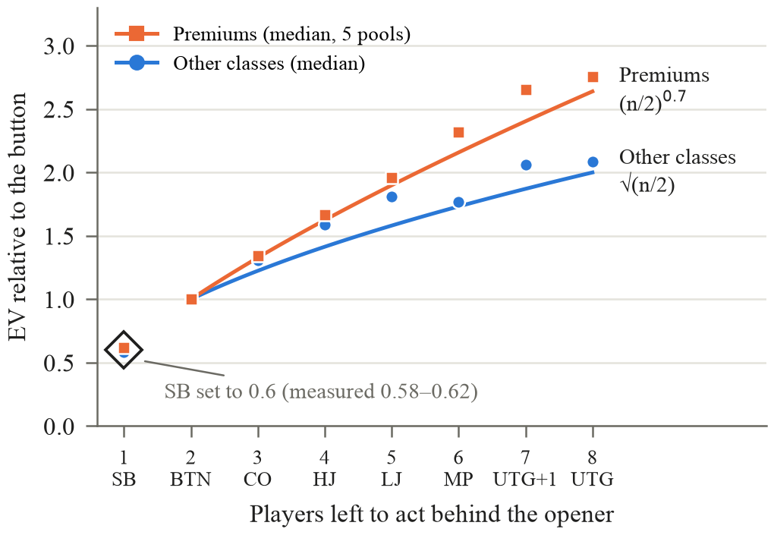
Fig. 1. EV relative to the button by seat (median across five opponent pools) with the retuned scaling: the square root for most hands, a steeper curve for premiums, and 0.6 for the small blind.

Results
All six fixes shipped in release v1.1, which installs over v1.0 and keeps saved runs and settings; the threshold retune followed on the main branch. Fig. 2 shows the same loose, sticky description as Update 4 after the changes. On the button the ranking and the numbers are close to before, with premiums and strong aces on top; most of the change is in early positions, where hands like broadways gained the most. The offline report now gives offsuit marginal hands their own line, takes the trash verdict from the numbers (−8.4 bb per open, a leak), and summarizes the cutoff, the second position in this run, under Other positions.
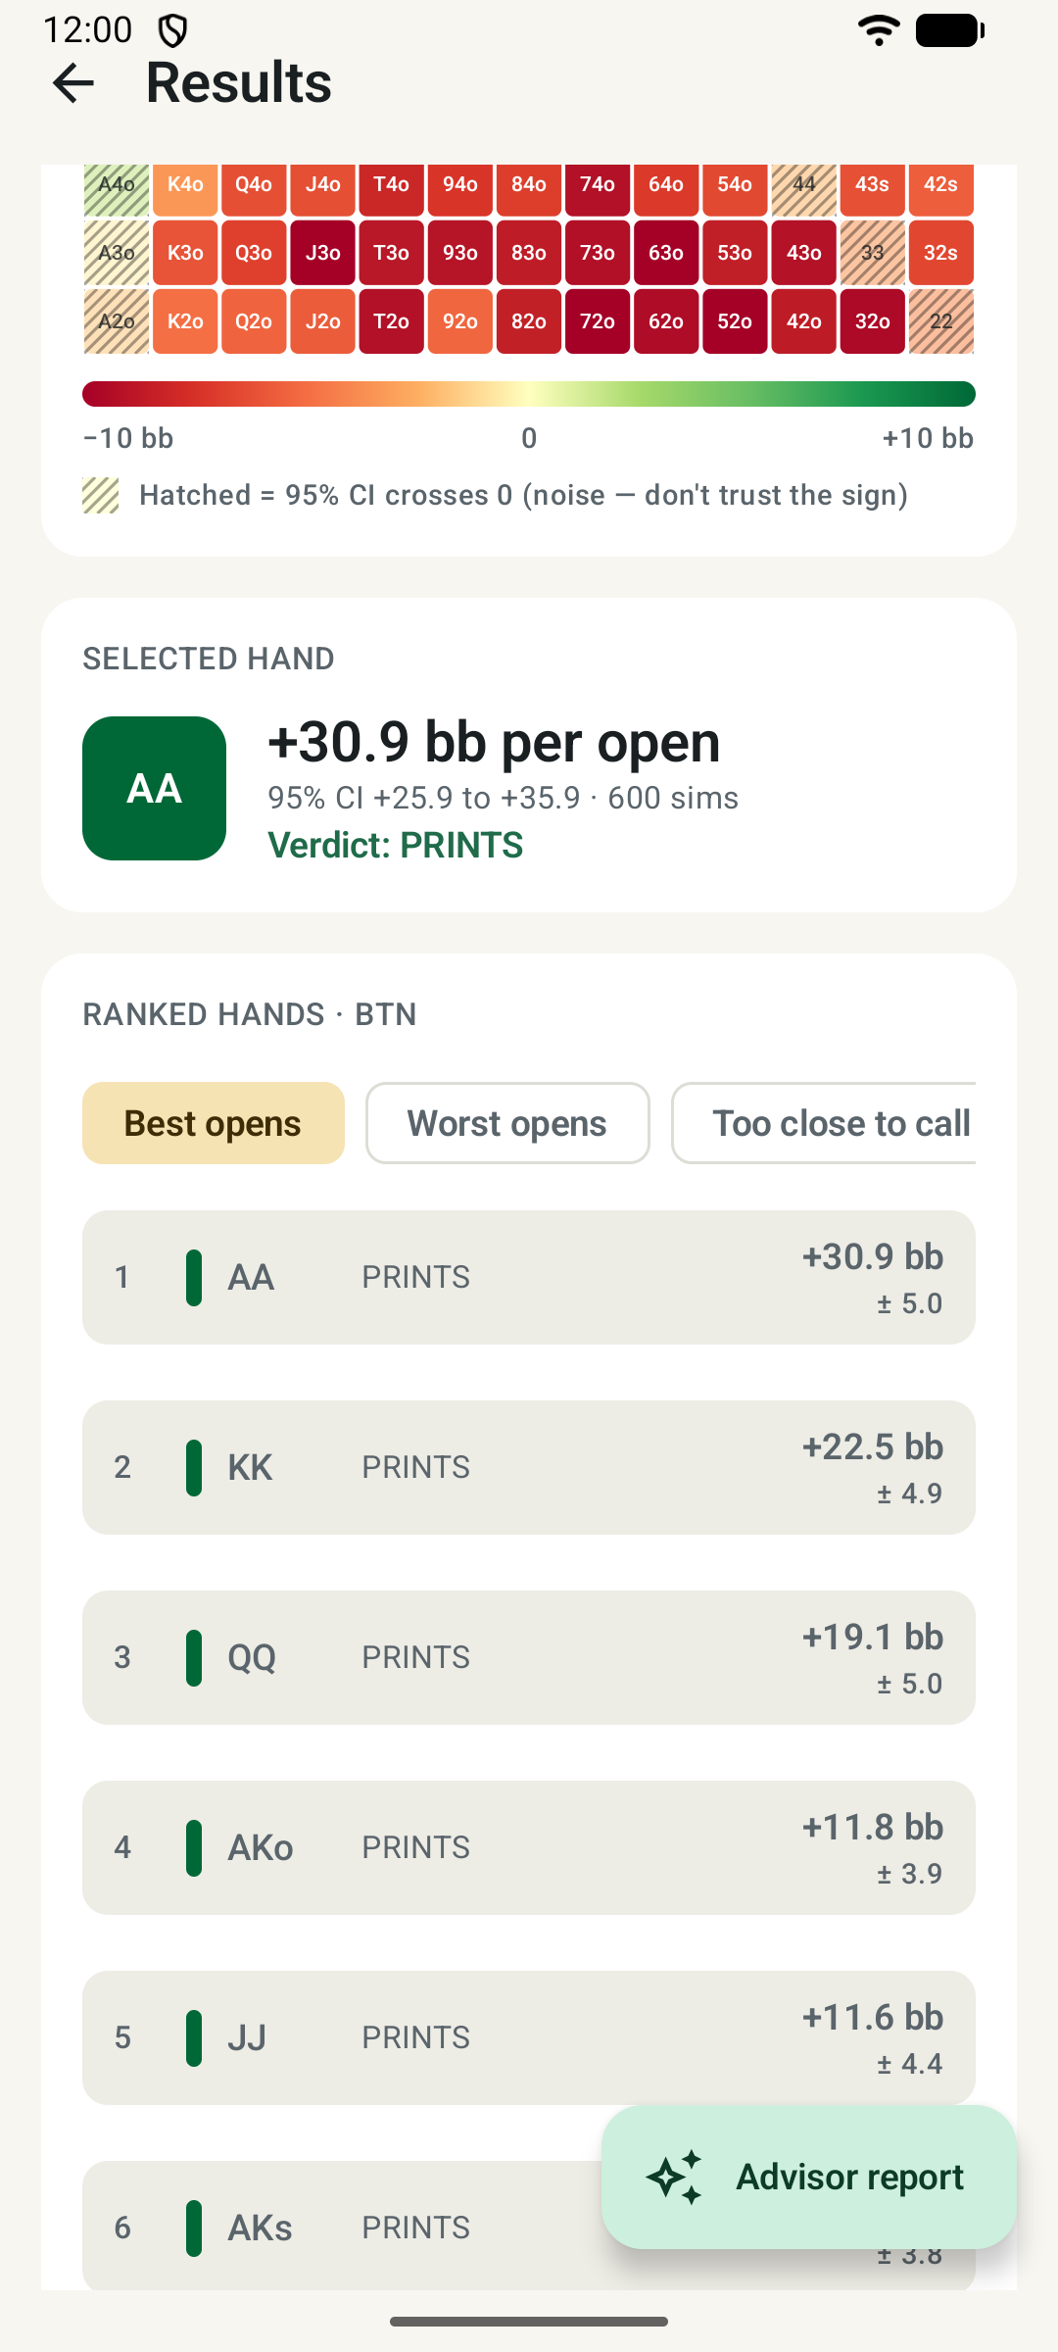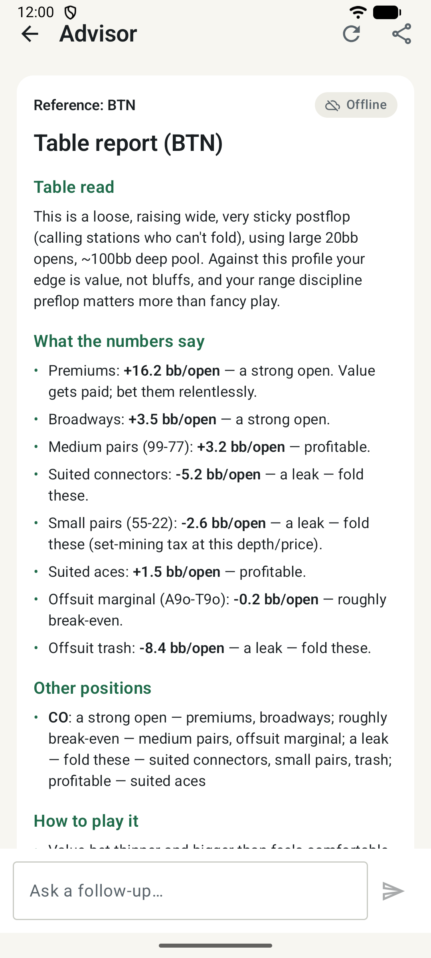
Fig. 2. Results against a loose, sticky table after the dealing fix (left); offline report with data-driven verdicts and the new Other positions section (right).
There are now 50 unit tests, up from 44. The new ones check that Ranking selects the right share of real hands, that archetype words are not also counted as behavior cues, that the offline report’s verdicts follow the data and cover every position, and that premiums use the steeper scale. All 25 instrumented tests still pass, including the two that check the foreground service, and lint reports no errors.

Future Work
The fixes made the model more honest but not exact. Villains still play a fixed strategy and the hero still plays one open-and-value-bet line. Seats that fold before the hero also keep their cards in the deck, a small card-removal effect I left alone. Android can still kill the app during a long run in the background if it needs memory; avoiding that would take a different kind of foreground service. The Other positions line also lists verdicts in the order they first appear rather than from best to worst, which reads awkwardly.
The audit turned up smaller hardening items I have not done yet: a migration plan for the Room database before its schema changes, a fallback for a corrupted saved run, unit tests for CoachRepository and SimulationRunner, and encrypting the stored API key. For features, I would most like a suggested opening range per position built from the clearly profitable hands, a side-by-side comparison of two runs, streaming Claude’s reports, and making the heatmap readable with TalkBack.

Discussion
The biggest lesson was that a passing test suite and a clean lint report did not mean the app was right. All six bugs passed every existing test, because the tests checked what the code did, not whether the model matched a real game; reading the code against what the screens promise is what found them. The calibration taught me something too: my first quick measurement pointed to a bigger change than the full run supported, and I would have retuned the wrong thing if I had trusted it. Source, README and the v1.1 APK are on GitHub [2].

References
- C. Kirby. (2026). Nemesis: exploitative poker EV simulator [Online]. Available: https://github.com/ckirby04/Nemesis
- C. Kirby. (2026). Nemesis (Android) [Online]. Available: https://github.com/ckirby04/nemesis-android-application
- Google. Foreground service types [Online]. Available: https://developer.android.com/develop/background-work/services/fgs/service-types
- Google. Improve your code with lint checks [Online]. Available: https://developer.android.com/studio/write/lint

