The Air Quality Dataset

Christian Julca

3 de febrero de 2019

## Summary of Air Quality Dataset

In this paragraph, provide the syntax to: show “air quality” in non-proportional font using backticks; create a non-numbered bulleted list for the 6 variables in the dataset; put each variable name in bold using double asterisks; put everything in parentheses in italics by placing a single underscore immediately before and after the opening and closing parentheses; notice that the 1st sentence contains an inline footnote which should appear at the bottom of your document when compiled. This exercise will be working with the built-in air quality dataset.[1] This dataset contains 154 daily air quality measurements in New York from May 1, 1973 (a Tuesday) to September 30, 1973. The dataset contains 6 variables:

* **Ozone**: Mean ozone in parts per billion (ppb) from 1300 to 1500 hours at Roosevelt Island;
* **Solar.R**: Solar radiation in Langleys (lang) in the frequency band 4000–7700 Angstroms from 0800 to 1200 hours at Central Park;
* **Wind**: Average wind speed in miles per hour (mph) at 0700 and 1000 hours at LaGuardia Airport;
* **Temp**: Maximum daily temperature in degrees Fahrenheit (oF) at LaGuardia Airport;
* **Month**: numeric month (1-12)
* **Day**: numeric Day of the month (1-31)

### Table of Top of the Air Quality Dataset

knitr::kable(head(airquality),   
 caption = "Top of the Air Quality Dataset")

Top of the Air Quality Dataset

|  |  |  |  |  |  |
| --- | --- | --- | --- | --- | --- |
| Ozone | Solar.R | Wind | Temp | Month | Day |
| 41 | 190 | 7.4 | 67 | 5 | 1 |
| 36 | 118 | 8.0 | 72 | 5 | 2 |
| 12 | 149 | 12.6 | 74 | 5 | 3 |
| 18 | 313 | 11.5 | 62 | 5 | 4 |
| NA | NA | 14.3 | 56 | 5 | 5 |
| 28 | NA | 14.9 | 66 | 5 | 6 |

### Plot of Ozone by Temperature –Air Quality Dataset

code chunk with the following code:

plot(airquality$Temp, airquality$Ozone,   
 main="Airquality: Ozone by Temperature")

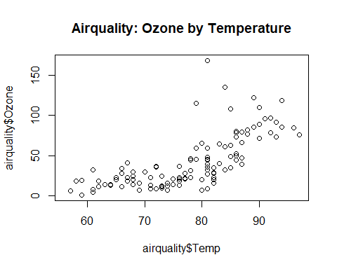

1. Chambers, J. M., Cleveland, W. S., Kleiner, B. and Tukey, P. A. (1983) Graphical Methods for Data Analysis. Belmont, CA: Wadsworth.