1. 利潤報表：每日寄送2015/12/1後「訂單與專案標號不一致清單」。

※ 訂單編號的開頭是"R","P","D"不寄，ken、claire、joe、sam、bruce@cip.com.tw

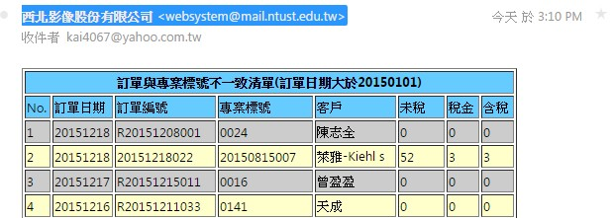

1. 利潤報表：專案編號的查詢改為關鍵字查詢，即可統計"R","P","D"開同的訂單。

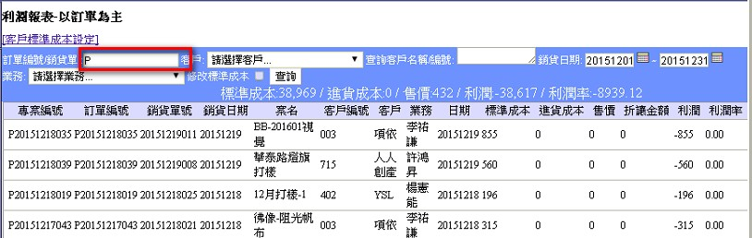

1. 利潤報表：銷貨單與訂購單的連結是透過訂單編號，而採購單號與訂購單的連結一樣是透過訂單編號 ， 所以目前改由訂購編號去串連

※ (因為有可能也沒有專案編號但訂購單編號一定會有，因為是系統產生的)

|  |  |  |
| --- | --- | --- |
| 訂單日期 | 訂單編號 | 專案編號 |
| 20150909 | 20150909054 |  |
| 20150826 | 20150826029 | 20150826030 |
| 20150807 | 20150807005 | 20150807004 |
| 20150723 | 20150723034 | 20150725034 |
| 20150824 | 20150824085 | 20150824077 |
| 20150106 | 20150106037 | 20150106001 |
| 20150924 | 20150924040 | 201509240404 |
| 20150522 | 20150522007 | 20150522005 |
| 20150131 | 20150131004 | 20140131004 |
| 20151026 | 20151026060 | 20151126060 |
| 20150414 | 20150414030 | 20150414031 |
| 20150515 | 20150515006 | 20150505006 |
| 20150925 | 20150925006 |  |
| 20150909 | 20150909030 | 201510909030 |
| 20150611 | 20150611028 | 20150506020 |
| 20150826 | 20150826028 | 20150826029 |
| 20150108 | 20150108042 | 2015010842 |
| 20150702 | 20150702035 | 20140304039 |
| 20150625 | 20150625056 |  |
| 20150225 | 20150225047 |  |

1. 類別三報價：新增批次報價及可獨立設定數量

