Article | UREP version
Biomass and daily growth rate (W)
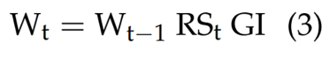 | 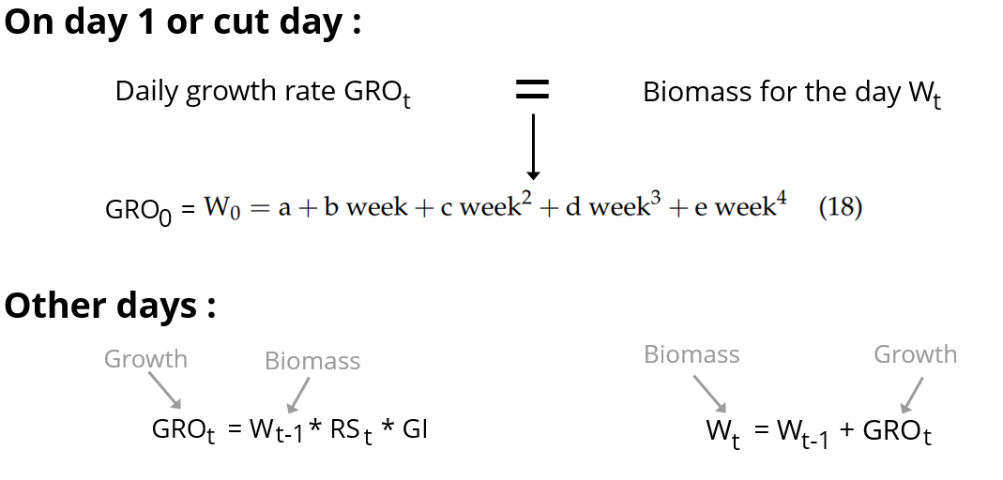
There can be a confusion between the biomass W and the daily growth rate W_{t} (in kg DM ha⁻¹ day⁻¹) because the biomass on day _{t} is referred also as W_{t} (kg/ha) (equation 3).We choose to change the name of the daily growth rate by GRO_{t}

Leaf Area Index (LAI)
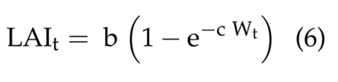 | 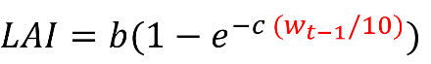
In the LAI equation (equation 6), W_{t}​ is also used but it is unclear whether this refers to cumulative biomass or the daily growth rate. In our code, we used the biomass from the previous day (W_{t−1}​), which must be expressed in g/m². Since it is originally calculated in kg/ha, we convert it by dividing it by 10.

Potential evapotranspiration (ETp)
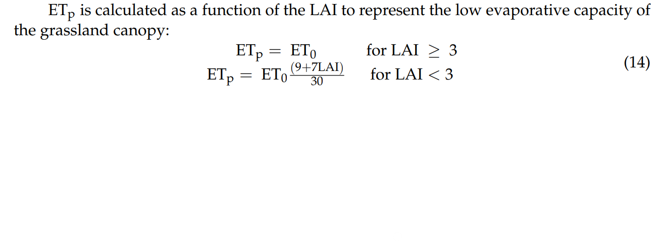  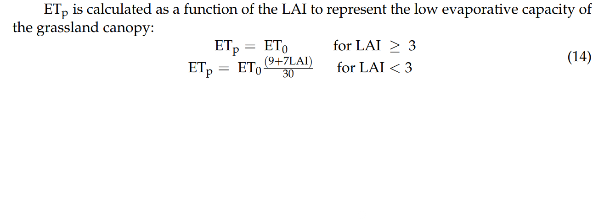 | 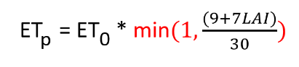
To ensure that it is never negative.

Soil Water Content (SW)
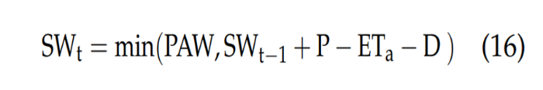

Same thing.

Circularity in equations

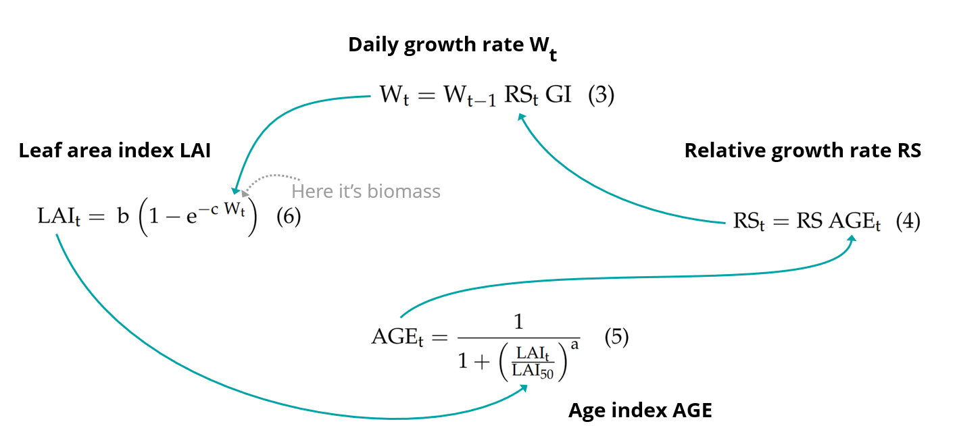
We observe a circular dependency between four equations 3, 4, 5 and 6, as each variable relies on the others for the same day _{t}.

Our results with our data

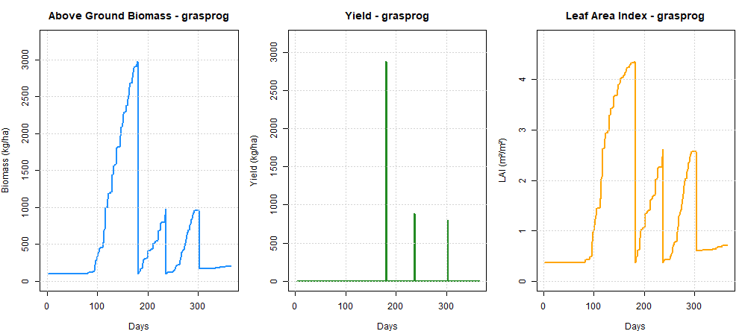
Growing period start when the sum of temperature is above 250°C/day.
Simulation of one year with three cuts on days 181, 237 and 303.

