Telepathy
A cooperative microgame of wordless communication.
You and your partner are part of an experimental trial to determine the existence of extrasensory perception (ESP) in human subjects. Participation in this trial is voluntary and confidential. If you demonstrate results that are more significant than random chance, the government will fly you to fabulous destinations all over the globe! Regardless of the results, the university will compensate you as indicated in the research subject consent form.
Reminder: Your participation in this trial is a matter of national security. As the waiver indicated, if you disclose your participation in this trial, the university and the government will disavow all knowledge of the event, and you may be subject to fines, expulsion, or prosecution.

Overview
Cooperative. Two players. 15 minutes. No speaking.
You each have one secret win condition and one secret lose condition. You must arrange a grid of cards so that it simultaneously matches both players’ win conditions. When you believe you have done so, you must each announce the other’s win condition.
You lose immediately if the grid matches either player’s lose condition.
You also lose if either of you announce the wrong win condition.

Components
- 16 square grid cards, each in a unique combination of shape and color
- 4 shape condition cards, depicting each shape in black
- 2 shape condition markers, with a green checkmark for win and a red X for lose
- 4 color condition cards, depicting each color in a square
- 2 color condition markers, with a green checkmark for win and a red X for lose
- 10 action cards, with a compass rose depicted on the backs
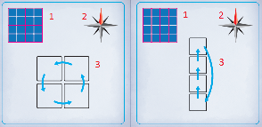
Each action card displays the following:
- The sections of the grid where the action can be applied, separated by the red lines.
- The orientation of the card.
- How the action rearranges the cards within the selected grid section.

Setup
Do not speak.
Draw one color condition card as your win condition, and then a second as your lose condition. Look at your condition cards, but do not show them to your partner. Keep them face-down on the table in front of you. Place the win condition marker (green checkmark) on your win condition card and your lose condition marker (red X) on your lose condition card. Return the remaining condition cards to the box.
Your partner performs the same process with the shape condition cards.
Arrange the grid cards randomly into a 4x4 grid. If any shape or color appears three times in a continuous line, scramble the grid cards and try again.
For your first game, select the action cards that have a numeral “1” in the lower right corner. Arrange them face-up in a row next to the grid, so that the compass rose points north. Return the other cards to the box.
For the standard game, orient all the cards in the action deck in the same direction. Shuffle the action cards. Place them face-down next to the grid so that the compass rose on the back points north. Draw the top four action cards and lay them face-up next to the grid.
For a greater challenge, after setting up for the standard game, discard one or more cards from the top of the action deck back to the box.
The player with the color conditions plays first.
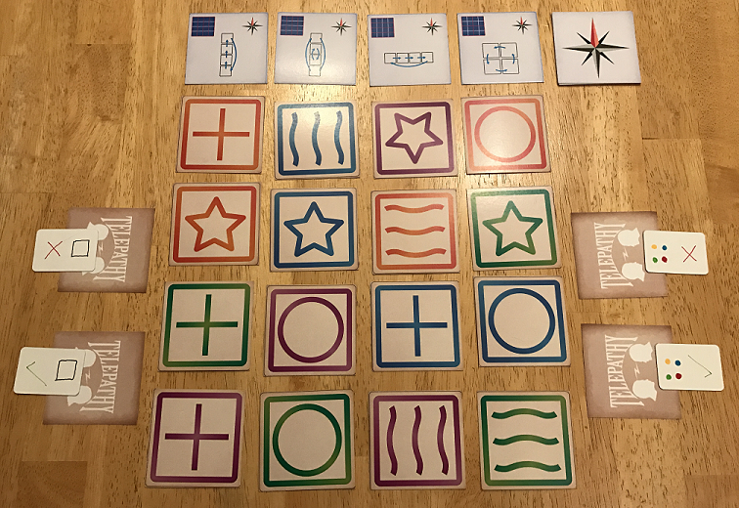

Conditions
A condition is met if there are three grid cards in a continuous line that match a win or lose condition card.
Lines can be east-west (horizontal) or north-south (vertical). Diagonal lines do not count. Lines do not “wrap around” the edge of the grid.

Play
Do not speak.
On your turn:
- Hand your partner an action card. If no action cards remain, one of you must make the Announcement (see below).
- Your partner performs the action.
- If either of your lose conditions is now met, you both lose.
- For your first game, your partner returns the used action card to its row.
For the standard game, your partner places the used action card in the discard pile. If cards remain in the action deck, they draw the next action card and add it to the row.
- Your partner begins their turn.
Announcement: After any turn is complete, either of you may announce your partner's win condition. Your partner responds by announcing your win condition. If you are both correct, and both win conditions are met in the grid, you both win. If either of you are incorrect, you both lose.

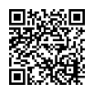
Examples of Play
See << http://bit.ly/2gmF72y >> or scan here for videos of the game in play.

Multiplayer Variants

With Three Or More Players
Set up two players as partners, as in the standard game. The remaining player(s) are observers. Observers may talk to each other as long as the partners cannot hear them.
The observers take all the turns, acting as a single player. They alternate handing action cards to each partner. Instead of selecting an action card, they may announce both win conditions.

With Four Players
Set up the grid and action cards as in the standard game.
Randomly select the first player. That player privately draws a lose condition from the color condition cards. The remaining players in clockwise order draw the color win condition, the shape lose condition, and the shape win condition. Place the appropriate condition marker on each player’s condition card.
Starting with the first player, players take turns in clockwise order. On your turn, either hand an action card to the player on your right, or announce both win conditions.
The first time the action deck is empty when you would draw from it, turn over the action card discard pile to form a new deck.

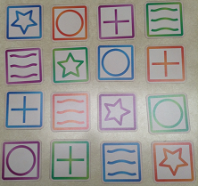
Four Player Variant: Opposed Teams
Organize the grid as shown to the left. Set up the action cards as per the standard game.
Players on opposite sides of the play area are partners on the same team. One partner on each team privately draws a color win condition. The other partners privately draw shape win conditions. There are no lose conditions.
Players take turns in clockwise order, starting with the leftmost color condition player.
Immediately after your partner performs an action you selected, they may announce your win condition. You must reply with their win condition. If you are both correct, and both win conditions are met in the grid, your team wins. Otherwise, the other team wins.
Whenever the action deck runs out, turn over the action card discard pile to form a new deck.

Credits
Game Design: Carl Klutzke (carl@phos.net)
Graphic Design: Brian Lee
Playtesters: Alex Yeager, Andy Arenson, Andy Kluessendorf, Andrew Hanson, Andrew Voigt, Barbara Meihls, Brandon Klutzke, Brett Myers, Brian Lee, Carl Sommers, Cecilia Hyland, Chris Hamm, Chris Sellers, Christine Setze, Clark Rodeffer, Colin Degnan, Cyrus Kirby, Daniel Alejos, David Whitcher, Dustin Oakley, Eric Hyland, Eric Jome, Evan Davis, Francois Valentyne, George Jaros, Heather Newton, Isaac Childres, Jack Spoerner, Jackson Richey, James DuMond, Jazz Eisinger, Jeff Tidball, John Lechner, John Shulters, Jonathan Chaffer, JT Smith, Kane Klenko, Karen Alfrey, Karen Klutzke, Kevin Klutzke, Kevin Nunn, Lee Richey, Liam Kirby, Lily Starkey, Marcin Zarycki, Maxine Ekl, Michele Luzetski, Monica Degnan, Morgan Klutzke, Nathaniel Tact, Nick Little, Paul Anshus, Peter Dast, Richard Frederick Baltzell, Robert Johnson, Rod Curie, Russ Luzetski, Sarah Graybill, Scotto Starkey, Shannon McDowell, Stacey Gibbens, Steven Dast, Timmy Clark, Vicki Dickson, Will Newton

