# Singapore-Resale-HDB-Price-Prediction

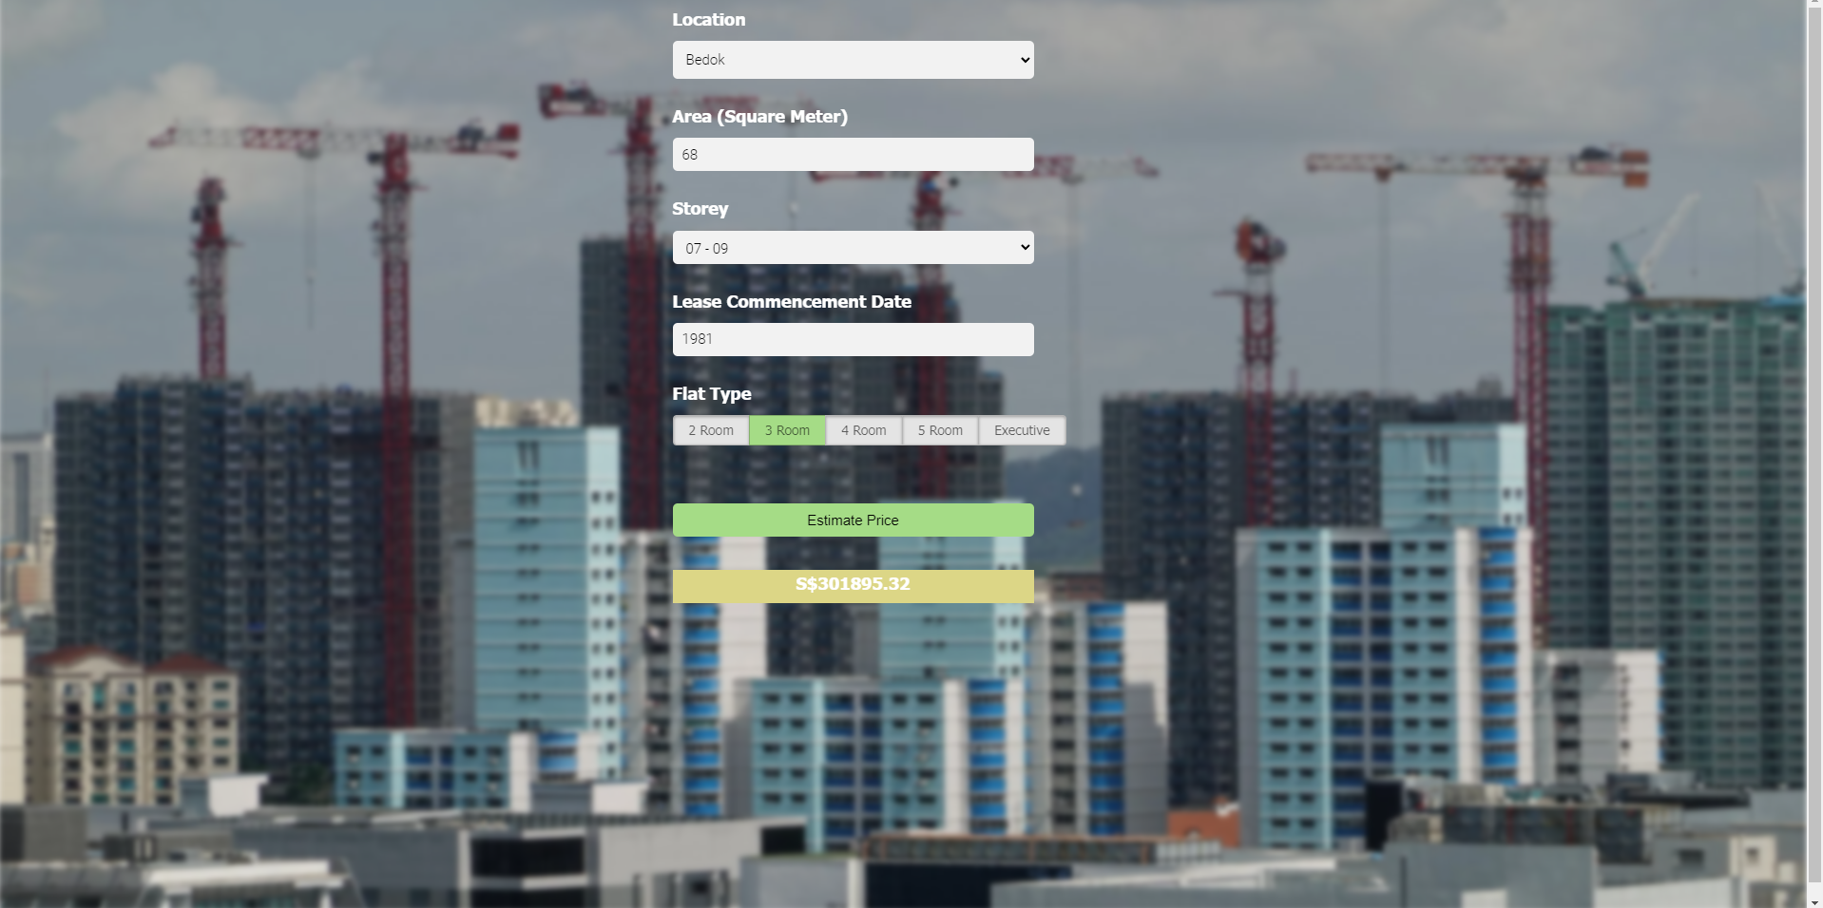

Dataset is took from https://data.gov.sg/dataset/resale-flat-prices, i will be exploring 2017 - Present data and have implemented a price prediction program using Random Forest Regressor.

Here is the folder structure,

* client : This contains client website code
* server: Python flask server
* model: Contains python notebook for model building
* dataset: Contains csv file of the data that I used

Technology used:

* Python
* Numpy for data cleaning
* Scikit-Learn for data visualization
* Matplotlib & Seaborn for data visualization
* Jupyter Notebook, visual studio code and PyCharm as IDE
* Flask for http server
* HTML/CSS/Javascript for UI
* JavaScript