PERSUASIVE LANGUAGE IN CALL-TO-ACTION PHRASES OF FACEBOOK SKINCARE PRODUCT ADVERTISEMENTS

A Thesis
Presented to the faculty
of the Department of English
College of Arts and Sciences
Pampanga State Agricultural University
Magalang, Pampanga

In partial fulfillment
Of the Requirement for the Degree
BACHELOR OF ARTS IN ENGLISH LANGUAGE STUDIES

by

AHLAI JEHZIEL M. VELASQUEZ
October, 2026

INTRODUCTION

Background of the Study
The shortest line in an advertisement is often the one that asks the most of the reader. Persuasion does not always need a long argument. Sometimes it needs only a clear instruction. A few words can do more work than a full product description when the goal is not only to inform but to prompt a next step.
On Facebook, those short lines appear at the end of many skincare captions. In the Philippines, Facebook reached about 95.8 million users in late 2025, equivalent to roughly 82 percent of the population (Kemp, 2025). In this setting, the beauty industry relies heavily on caption-based advertising. The call-to-action (CTA) phrase is one of the most direct linguistic tools in those captions: brief, yet the part of the text that most clearly directs the reader toward an action.
The beauty and personal care market in the Philippines continues to grow. The Chamber of Cosmetics Industry of the Philippines reported that retail sales rose by about 10 percent in the previous year and projected similar growth of 9 to 10 percent (Desiderio, 2026). Skincare is a central part of that market, which makes Facebook skincare captions a useful site for studying how short promotional English is worded.

Facebook and social-media advertising language as a short promotional genre

Facebook advertising language tends toward a transactional style. Comparative work on social-media ads reports that Facebook posts often rely on imperatives, urgency lexicon, and direct calls to action, while Instagram more often favors aspirational imagery and implicature (Ul Islam, 2025). That platform pattern matters here because the present corpus is drawn from Facebook captions. The CTA line is not an incidental closer but a conventional slot where the text most clearly asks for a response.
Studies of social-media advertising metadiscourse likewise find that directives and engagement markers rank among the most frequent linguistic devices used to structure the message and address the reader (Al-Subhi, 2022). In short promotional posts, then, directive wording is not rare background noise. It is part of how the genre organizes persuasion in limited space.

Call-to-action phrases as persuasive linguistic units

A call to action is a short directive expression that tells or invites the audience to take a specific next step. It can appear as a simple prompt such as "Shop now" or as a longer line that still asks the reader to act. In advertising discourse, CTA phrases matter for linguistic analysis because they are the point in the caption where the text most clearly performs a directive function.
Arakelyan and Aleksanyan (2025) examined CTA phrases across commercial websites through discourse and linguistic analysis. Effective CTAs, they found, tend to use direct action verbs, short structures, and urgency markers such as "buy now" or "limited time offer." Their work supplies a clear list of linguistic features that can be checked in the Facebook skincare captions of the present study. These include action verbs, length, urgency markers, and signs of audience tailoring.
Directness itself can take different forms. Nguyen (2025) looked at creative CTA messages through requestive strategies drawn from speech-act theory. Analyzing campaigns from major global brands, the study distinguished direct requests such as "Buy today" and "Sign up now" from indirect ones such as "Why not try this?" Direct forms give clarity and immediacy. Indirect forms reduce pressure. This distinction is useful here because Facebook skincare captions also move between blunt instructions and softer invitations.
A broader view of promotional writing supports the same focus on directive form. Simon and Dejica-Cartis (2015) analyzed eighty-four written advertisements from newspapers and magazines and identified the speech acts that recur in that genre. Directions, meaning requests for an action or information, appeared in a large share of the ads, alongside information and assertion. Their quantitative profile shows that written advertising regularly organizes language around getting the reader to do something. That makes the short CTA line a natural unit for closer linguistic description.
These studies show that CTA phrases function as compact communicative acts that combine linguistic form with directive intent. What remains open is a focused analysis of how such features appear in the short CTA phrases of Facebook skincare advertisements in the Philippine context.

Rhetorical appeals in advertising discourse

Aristotle's three appeals, ethos, pathos, and logos, remain a practical way to examine how advertising language is organized to address an audience. Ethos relates to credibility. Pathos relates to emotion. Logos relates to reason or product information. In short captions the same three resources appear, often mixed, and they help describe why certain wordings lean on product information, feeling, or trust.
Talaue (2022) found that audience factors can affect which appeal is judged most effective. That finding is a reminder that the ranking of appeals may shift with audience and culture. The observation is worth keeping in view when captions aimed at Filipino Facebook users are examined.
Closer to the local setting, De Castro and Martinez (2025) analyzed rhetorical appeals in picture advertisements from five Philippine banks on Facebook. Their content analysis found that the combination of ethos and logos was the most frequent strategy. Their work is useful because it shares both national context and platform with the present corpus. It also shows that Philippine Facebook advertising does use Aristotle's appeals, often in combination.
Beauty and skincare materials have been studied through the same lens. Dwiyanti (2024) examined persuasive techniques in makeup and skincare video advertisements and found that pathos appeared most frequently among the rhetorical appeals. That concentration of emotional language in the beauty category is directly relevant when Facebook skincare captions are coded for the same three appeals.
Firdous, Li, and Saleh (2023) applied Aristotle's rhetorical theory to Pakistani beauty-product commercials and found consistent use of all three appeals. The cross-media persistence of the framework supports applying it to Facebook captions as well.
These studies confirm that ethos, pathos, and logos function as active tools in advertising language, including beauty discourse and Philippine Facebook posts. The dominant appeal can change with product type, platform, brand, and audience. A focused examination of how these three appeals appear in the short CTA phrases of Facebook skincare advertisements remains limited.

Directive speech acts in promotional language

Speech Act Theory treats utterances as actions, not only as statements about the world. Searle (1975) classifies illocutionary acts into several types. Among them is the directive, the act in which the speaker attempts to get the hearer to do something. That definition maps directly onto the call-to-action phrase. When a skincare caption ends with "try it," "shop now," or "add to cart," the language is not merely describing a product. It is performing an act whose point is to direct the reader toward a response.
Yule (1996) further distinguishes four common subtypes of directive: command, order, request, and suggestion. The present study adopts these four categories. Working definitions follow Anggraini and Afriana (2023), who applied Yule's framework and clarified the practical differences among the subtypes. A command typically rests on an assumed power difference. An order directs action without that strong hierarchical assumption. A request softens the force and leaves room for refusal. A suggestion offers a course of action that the hearer may accept or set aside. These distinctions give a usable scale of force for coding the short CTA lines that close Facebook skincare captions.
Recent work on beauty and social-media advertising shows that directive language is not incidental. Studies of skincare brands on Instagram report that directive utterances predominate in captions. Kencana (2025) found directives realized as commands, suggestions, invitations, and advice in NIVEA Indonesia posts. Nurjannah (2025) reported a similar preference for imperatives and related forms in Some By Me captions. Mahdiati, Azizah, Hadi, and Jumadi (2025) observed suggestions, commands, and invitations packaged to prompt consumer action in Wardah Beauty posts. Together these studies show that directive speech acts are a regular feature of skincare advertising on visual social platforms.
The same pattern appears in online cosmetics marketing more broadly. Septianasari, Baihaqi, Abqoriyyah, and Syaputri (2021) examined the language of cosmetics sellers on Facebook and Instagram through a netnographic, pragmatic lens. Across their corpus, directive speech acts dominated the sellers' posts, followed by expressive forms. Commissive acts were rare. Their finding strengthens the claim that directives are a central resource when beauty products are promoted in social-media commerce, including on the same platforms used by the brands in the present study.
Not every imperative in advertising carries the force of a command. Pennock-Speck and Fuster-Marquez (2014) analyzed nearly eight hundred voice-overs in British television commercials and found that imperatives were common, yet their directive force was closer to advice or recommendation than to orders issued from a position of power. Viewers retain high optionality. They need not comply. That observation is useful for coding Facebook skincare CTAs, where forms that look like commands may function more like suggestions or soft requests once the commercial context is taken into account.
The literature thus establishes that directive speech acts are a productive lens for short promotional lines. The four subtypes drawn from Yule (1996) and operationalized by Anggraini and Afriana (2023) offer a workable coding scheme. Skincare and cosmetics brands already rely on related forms to guide audience response. What varies is the force of the directive and how that force is realized in wording.

Philippine and beauty advertising language

Philippine advertising discourse has long favored relatively direct promotional structures. Dayag (2008), analyzing magazine ads for consumer nondurables including cosmetics and personal-care products, found preference for "reason" rather than "tickle" patterns and for moves that create a need and recommend a course of action. Fernandez (2013) focused specifically on Philippine print beauty advertisements and reported syntactic and semantic features that include imperatives, adjectives, time expressions, figurative language, and problem-solution structure, alongside appeals to emotion and image.
More recent online work points in a similar direction. Lanzarrote, Rallos, and Tan-de Ramos (2025) examined online Filipino beauty product advertisements and documented a blend of emotive language, pseudo-scientific terminology, and personalized messaging. While their study is framed in critical discourse terms, the textual features they describe are the same kinds of resources that can carry rhetorical appeals and directive force in short Facebook captions. These include personal address, emotion-laden wording, and product claims.
Together, these local and product-class studies justify treating Philippine Facebook skincare CTAs as a coherent site for linguistic analysis. The genre already favors direct promotional moves. Beauty ads in the Philippine context already use imperatives, emotional and credibility-oriented language, and personalized address.

Integrating rhetorical appeals and directive subtypes in CTA phrases

At the same time, social media advertising draws on more than one resource at once. Rhetorical appeals describe the basis of the message, whether the caption leans on product information, emotion, or credibility. Directive subtypes describe the force of the same short line, how it tries to get the reader to act. A small number of studies already move toward a joint view. Saad and Ismael (2025) examined cosmetics advertisements on Instagram and Facebook and showed that rhetorical appeals and speech-act patterns operate together. Rababah (2023), working with Jordanian print advertisements, likewise found that directive speech acts were among the most frequent categories and were regularly reinforced by rhetorical devices. Simon and Dejica-Cartis (2015) also noted that written ads often combine directions with persuasive macro-acts. What remains less examined is the specific pairing of Aristotle's three appeals with Yule's four directive subtypes when the unit of analysis is the CTA phrase itself in Facebook skincare captions.
This gap matters for English Language Studies. CTA phrases are authentic instances of language in use: short, public, and designed to act on readers in a commercial setting. Analyzing them with both a rhetorical lens and a speech-act lens can show how appeal and directive force are realized and patterned in everyday digital advertising English. It can also supply a transparent coding approach, dominant appeal plus directive subtype, that later studies of online promotional discourse may test or refine.
The present study therefore examines how rhetorical appeals and directive subtypes are realized in the CTA phrases of Facebook skincare advertisement captions. Aristotle's framework is used to identify the dominant rhetorical appeal (ethos, pathos, or logos) by reading the phrase together with its surrounding caption. Yule's (1996) classification of directive speech acts, operationalized through the definitions in Anggraini and Afriana (2023), is used to code each phrase as command, order, request, or suggestion. The analysis treats the CTA phrase as the primary unit, with the full caption supplying context when the rhetorical appeal is determined. In this way the study brings the two lenses together at the exact point where the caption most clearly directs the reader toward an action.
Statement of the Problem
Existing studies have examined various aspects of social media advertising, including linguistic features, stylistic analysis, and persuasive strategies. However, limited attention has been given to the integration of Aristotle’s rhetorical appeals and directive speech acts, particularly the directive subtypes embedded in call-to-action (CTA) phrases in Facebook skincare advertisement captions. In particular, short directive expressions, which function as key carriers of persuasive intent, remain underexplored as a distinct unit of analysis. Moreover, previous research has often treated advertising language as a whole, with less emphasis on CTA phrases as a specific linguistic component that directly prompts audience response. This gap suggests a need to examine how persuasion operates at the level of CTA expressions through both rhetorical appeals and directive subtypes.
In response to this gap, this study aims to examine the rhetorical appeals and directive subtypes of CTA phrases found in the captions of Facebook advertisements of selected skincare brands, namely Luxe Organix, Olay, The Ordinary, Pond’s, and Myra, and how these elements pattern together in the wording of those phrases.
This study generally aims to analyze how rhetorical appeals and directive subtypes are realized in the call-to-action (CTA) phrases of Facebook skincare advertisement captions.
Specifically, it seeks to answer the following:
- What rhetorical appeals are used in the CTA phrases of selected Facebook skincare advertisements?
- What directive subtypes are present in the CTA phrases of selected Facebook skincare advertisements?
- How do rhetorical appeals and directive subtypes pattern together in the CTA phrases of selected Facebook skincare advertisements?

Research Framework
This study is anchored in Aristotle’s rhetorical framework, specifically the three means of persuasion: ethos, pathos, and logos. As discussed in the Stanford Encyclopedia of Philosophy (2022), these means of persuasion operate through different aspects of persuasive communication: ethos refers to the speaker’s credibility or authority, pathos appeals to the emotions of the audience, and logos relies on logical reasoning or argument. In advertising discourse, these appeals are treated as persuasive strategies that shape audience perception and encourage responses. Within this framework, call-to-action (CTA) phrases in Facebook skincare advertisement captions are examined as the primary linguistic units through which advertisers encourage consumers to act. Although brief in form, CTA phrases such as “Shop now,” “Try it today,” and “Discover your glow” illustrate how concise expressions can convey persuasive intentions. In this study, rhetorical appeals are identified by examining each CTA phrase in the context of its original Facebook advertisement caption to determine how credibility, emotional engagement, and logical reasoning contribute to persuasive meaning.
In addition to Aristotle’s rhetorical framework, this study draws on Speech Act Theory, particularly Searle’s (1975) classification of illocutionary acts. Searle classifies illocutionary acts into five categories: assertives, directives, commissives, expressives, and declarations. This study focuses on directive speech acts because CTA phrases are intended to encourage consumers to perform particular actions in response to skincare advertisements.
For the classification of directive subtypes, this study follows Yule’s (1996) framework, which is applied to the four categories used in this research: command, order, request, and suggestion. The definitions and explanations of these subtypes are adopted from Anggraini and Afriana (2023), who apply Yule’s framework in their analysis of directive speech acts.
According to Anggraini and Afriana (2023), who apply Yule’s (1996) classification, command refers to a directive that is usually fulfilled when the speaker has authority or power over the hearer; order refers to a directive that tells someone to perform an action without necessarily involving a dominant power relationship; request refers to a polite directive that asks someone to perform an action; and suggestion refers to a directive that proposes an action while allowing the hearer to accept or reject it. These definitions serve as the basis for the operational criteria used to classify the CTA phrases according to their directive subtypes in this study.
Accordingly, Aristotle’s rhetorical framework is used to identify the dominant rhetorical appeal associated with each CTA phrase by examining the phrase alongside its original Facebook advertisement caption. Meanwhile, Yule’s (1996) directive framework, using the subtype definitions adopted from Anggraini and Afriana (2023), is used to classify each CTA phrase according to its directive function. The two frameworks provide complementary perspectives for examining the persuasive appeal of an advertisement and the way its CTA phrase encourages consumers to take action.
Overall, this study examines how rhetorical appeals and directive subtypes are realized in Facebook skincare advertisement captions. Aristotle’s rhetorical framework is used to identify the persuasive basis expressed in the wording of each CTA phrase in caption context, while Yule’s (1996) directive framework is used to classify how each phrase directs or invites action. The two perspectives are read together to describe how ethos, pathos, and logos, alongside command, order, request, and suggestion, appear in the CTA phrases under study.
Figure 1
Conceptual Framework
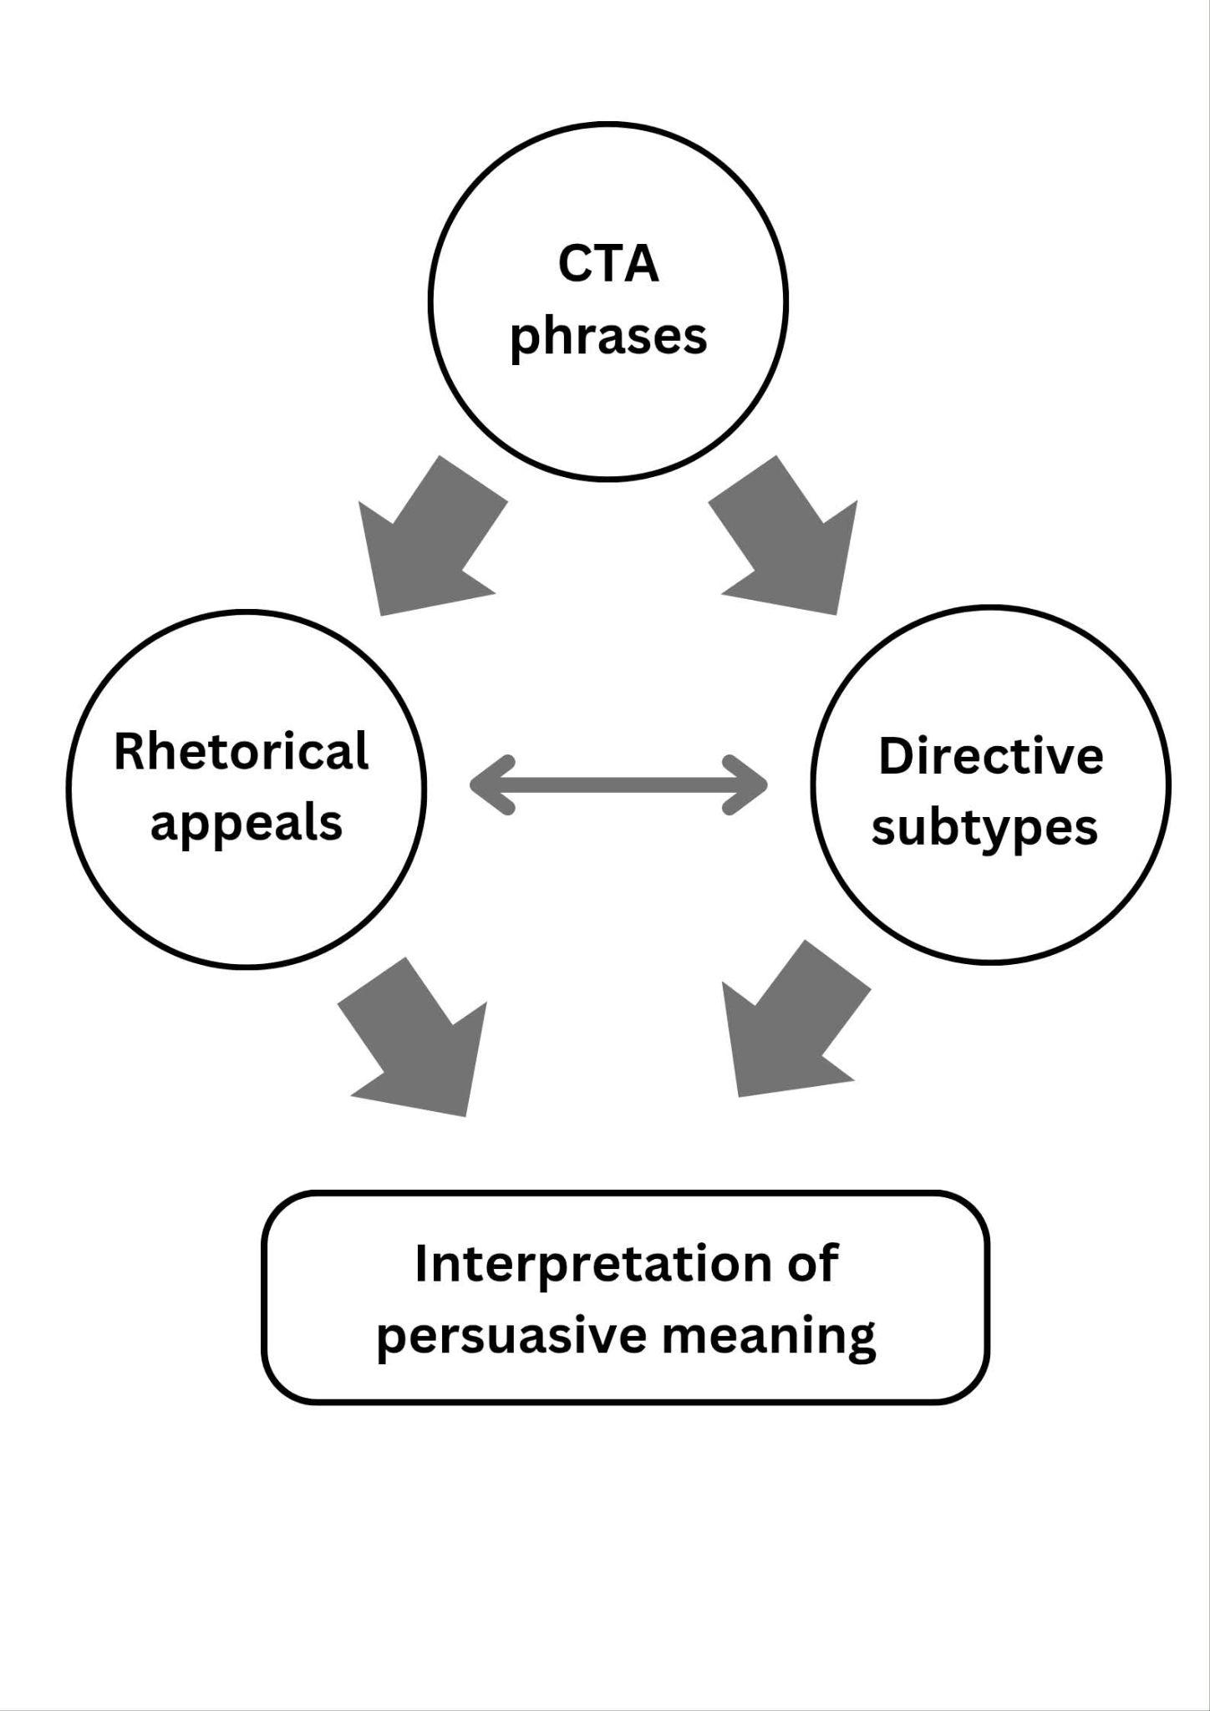
The conceptual framework of the study illustrates how persuasive meaning is constructed through the analysis of call-to-action (CTA) phrases in Facebook skincare advertisement captions. In this framework, CTA phrases are positioned at the top as the unit of analysis, serving as the primary source of data for the study. The CTA phrases are examined through two analytical lenses: Aristotle’s rhetorical appeals and directive subtypes based on Speech Act Theory.
The first analytical lens is Aristotle’s rhetorical framework, which explains persuasion through ethos, pathos, and logos. These rhetorical appeals are used to identify the persuasive strategies in the advertisement captions by examining how advertisers establish credibility, evoke emotions, and present logical reasoning to encourage consumers to take action.
The second analytical lens focuses on the directive subtypes of the CTA phrases. Within the perspective of Speech Act Theory, Searle (1975) provides the theoretical basis for directive speech acts, while Yule (1996) provides the classification of directive subtypes used in this study. Accordingly, the CTA phrases are classified into command, order, request, and suggestion. The operational definitions of these four directive subtypes are adopted from Anggraini and Afriana (2023). These subtypes are used to determine the different ways advertisers linguistically encourage consumers to perform a desired action.
The arrows from the CTA phrases toward the rhetorical appeals and directive subtypes indicate that the same CTA phrases are examined through both analytical lenses. The rhetorical appeals identify how persuasion is expressed, while the directive subtypes identify how the CTA phrases direct or encourage consumers to act.
At the bottom of the framework, interpretation represents the analysis of the combined findings from the rhetorical appeals and directive subtypes. Through this interpretation, the study explains how the persuasive appeal and directive function of a CTA phrase contribute to the construction of persuasive meaning. Thus, interpretation does not represent another category of analysis but serves as the resulting explanation based on the examination of the CTA phrases through both analytical lenses.
Overall, the conceptual framework illustrates that CTA phrases serve as the unit of analysis, rhetorical appeals and directive subtypes serve as the analytical lenses, and interpretation provides an explanation of how the findings contribute to the construction of persuasive meaning in Facebook skincare advertisement captions.

Significance of the Study
The findings of the study may be beneficial to the following: beauty product brands, students, Facebook advertiser and marketers, future researcher.
Beauty Product Brands. The findings may help beauty product brands understand how CTA phrases are constructed to convey persuasive meaning, allowing them to recognize the rhetorical and linguistic strategies used in skincare advertising discourse.
ELS Students. The findings may enhance English Language Studies (ELS) students’ understanding of how persuasive techniques are used in advertising language, particularly in call-to-action phrases. They may also help students develop their skills in discourse analysis and the critical interpretation of digital texts.
Facebook Advertisers and Marketers. The findings may provide insights into the use of persuasive language in beauty advertisement CTAs, particularly in terms of rhetorical appeals and directive subtypes. This may help advertisers and marketers better understand how these linguistic strategies are used in call-to-action phrases.
Future Researchers. The findings may serve as baseline data and a methodological reference for further studies on digital advertising discourse, particularly those examining persuasive language across different platforms and product categories.

Scope and Limitations
This study focuses on the analysis of call-to-action (CTA) phrases used in Facebook advertisement captions posted on the official Facebook pages of selected skincare brands. Specifically, the study examines CTA phrases from five skincare brands: Luxe Organix, Olay, The Ordinary, Pond’s, and Myra. These brands were selected based on their established presence, recognition, and relevance in the skincare industry, as supported by BusinessMirror (2022), Teehankee (2016), Mananquil (2009), Jamora-Garceau (2023), and Vogue Business Custom Insights Team (2023).
The study covers Facebook advertisement captions published from January 2023 to June 2026. For each selected brand, advertisements were selected from two periods within each year: January to June and July to December. One advertisement containing a CTA phrase was selected from each half-year period. Among the available advertisements within each period, the advertisement with the highest number of likes or reactions was prioritized for selection. This criterion was used to select advertisements with relatively higher audience engagement while maintaining the study’s focus on the linguistic analysis of CTA phrases rather than measuring advertising effectiveness. The CTA phrases identified from the selected advertisements served as the primary data for analysis. The final corpus consists of 34 CTA phrases instead of the expected 35 because no Pond’s advertisement post was available for the July–December 2024 period. The study examines how persuasive meaning is constructed through Aristotle’s rhetorical appeals (ethos, pathos, and logos) and directive speech acts, drawing on Searle’s (1975) Speech Act Theory and Yule’s (1996) classification of directive subtypes: command, order, request, and suggestion.
The study is limited to textual CTA phrases written in English or predominantly in English to ensure consistency in linguistic analysis. It focuses exclusively on CTA phrases found in Facebook advertisement captions. Although likes and reactions were considered when selecting advertisements, these engagement indicators were not included in the linguistic analysis. The study excludes visual elements such as images and videos, hashtags, emojis, comments, shares, and other engagement metrics. Consumer interpretations, purchasing behavior, and advertising effectiveness are likewise excluded, as the study is limited to the linguistic analysis of persuasive language.
Furthermore, advertisements published outside the January 2023 to June 2026 timeframe are excluded. Non-skincare advertisements, CTA phrases that are not written in English or predominantly in English, and captions that do not contain identifiable CTA phrases are also excluded from the analysis.
Definition of Terms
This section presents the operational definitions of the key terms used in the study. These definitions guide the identification, classification, and interpretation of call-to-action (CTA) phrases in Facebook skincare advertisement captions.
Call-to-Action (CTA) Phrases. These are short, directive expressions used in advertisements (e.g., "Buy Now," "Shop Today") that encourage an immediate response from the audience. In this study, CTA phrases are operationally defined as the primary linguistic units extracted from the Facebook advertisement captions of selected skincare brands. When an advertisement contains multiple CTA expressions, these are treated as one combined CTA phrase. They serve as the main data for analysis and are identified based on their persuasive function in encouraging product-related actions such as purchasing, trying, or exploring skincare products.
Command. This refers to a directive speech act that is usually fulfilled when the speaker has a dominating position or power over the hearer (Yule, 1996, as cited in Anggraini & Afriana, 2023). In this study, commands are identified when CTA phrases explicitly tell consumers to take an action related to a skincare product.
Directive Speech Acts. These refer to utterances used by speakers or writers to make the hearer perform a particular action. Based on Searle’s (1975) Speech Act Theory, directives are speech acts that express the speaker’s intention to get the hearer to do something. In this study, directive speech acts are operationally defined as the illocutionary acts performed by CTA phrases to encourage consumers to respond to skincare advertisements.
Directive Subtypes. These refer to the categories used to classify directive speech acts according to the intended action expected from the audience. Based on Searle’s (1975) concept of directive speech acts and Yule’s (1996) classification of directives, this study uses four directive subtypes: command, order, request, and suggestion. Following Anggraini and Afriana (2023), these subtypes are operationally defined as follows:
Ethos. This refers to an appeal based on the speaker’s or source’s credibility, character, or trustworthiness (Stanford Encyclopedia of Philosophy, 2022). In this study, ethos is identified when the advertisement presents the brand or product as trustworthy, reliable, or credible.
Logos. This refers to an appeal based on reasoning, evidence, or information that supports a claim (Stanford Encyclopedia of Philosophy, 2022). In this study, logos are identified when the advertisement provides specific product information, features, ingredients, benefits, or other details that give consumers a reason to consider the product.
Order. This refers to a directive speech act intended to ask someone to perform an action without a dominant power relationship between the speaker and the hearer (Yule, 1996, as cited in Anggraini & Afriana, 2023). In this study, orders are identified when CTA phrases present a direct instruction for consumers to take an action toward skincare products.
Pathos. This refers to an appeal that influences the audience by evoking emotions or feelings (Stanford Encyclopedia of Philosophy, 2022). In this study, pathos is identified when the advertisement uses emotional or desirable expressions that appeal to consumers’ feelings, wants, or aspirations.
Persuasive Language. This refers to the use of linguistic features intended to influence audience attitudes, perceptions, or actions. In this study, persuasive language is operationally defined as the use of rhetorical appeals and directive subtypes within CTA phrases to encourage consumer response in Facebook skincare advertisement captions.
Request. This refers to a polite directive speech act that asks someone to perform an action, which may or may not be carried out by the hearer (Yule, 1996, as cited in Anggraini & Afriana, 2023). In this study, requests are identified when CTA phrases encourage consumers to engage with skincare products through a polite or less direct expression.
Rhetorical Appeals. These refer to the persuasive strategies used in communication to influence an audience through credibility, emotion, and reasoning. Based on Aristotle’s rhetorical framework, the three rhetorical appeals are ethos, pathos, and logos (Stanford Encyclopedia of Philosophy, 2022). In this study, rhetorical appeals are used to identify the dominant persuasive basis expressed in the Facebook advertisement captions of selected skincare products.
Skincare Advertisements. These refer to promotional Facebook posts that advertise skincare products. In this study, skincare advertisements are operationally defined as the selected Facebook advertisement captions from Luxe Organix, Olay, The Ordinary, Pond’s, and Myra that contain CTA phrases and serve as the corpus of analysis.
Suggestion. This refers to a directive speech act that gives the hearer the option to accept or reject the proposed action (Yule, 1996, as cited in Anggraini & Afriana, 2023). In this study, suggestions are identified when CTA phrases encourage consumers to consider trying, exploring, or purchasing skincare products.

METHODOLOGY

This section explains the research design, where the study will be conducted, how the data will be collected, and how the data will be selected. These methods are based on the research questions and the limitations of the study.

Research Context
This study is situated within the context of digital advertising on Facebook, where skincare brands promote their products through advertisement captions. Facebook provides a platform for brands to communicate promotional messages to audiences through text-based content that encourages interest in their products.
Within this context, call-to-action (CTA) phrases are used in advertisement captions to encourage audience interaction and potential consumer action. These concise expressions guide audiences toward a desired response, such as purchasing, trying, or exploring a product. In skincare advertising, CTA phrases may communicate ideas related to beauty, self-improvement, product benefits, and urgency. These characteristics make CTA phrases relevant linguistic data for examining how persuasive meaning is constructed in advertising discourse.
The study focuses on CTA phrases collected from advertisement captions posted on the official Facebook pages of five selected skincare brands: Luxe Organix, Olay, The Ordinary, Pond’s, and Myra. These brands were selected based on their established presence, recognition, and relevance in the skincare industry, as supported by BusinessMirror (2022), Teehankee (2016), Mananquil (2009), Jamora-Garceau (2023), and Vogue Business Custom Insights Team (2023). The study covers advertisements published from January 2023 to June 2026. The advertisements were selected from two periods within each year: January to June and July to December. The final corpus consists of 34 CTA phrases because no Pond’s advertisement was available for the July–December 2024 period.
Within this context, the study examines how persuasive meaning is constructed through Aristotle’s rhetorical appeals (ethos, pathos, and logos) and directive speech acts. Searle’s (1975) Speech Act Theory provides the theoretical basis for examining directives, while Yule’s (1996) classification, with subtype definitions adopted from Anggraini and Afriana (2023), guides the classification of CTA phrases into command, order, request, and suggestion. By examining CTA phrases alongside their original advertisement captions, the study explores how rhetorical appeals and directive functions contribute to the construction of persuasive meaning in Facebook skincare advertising.

Research Design
This study employed a qualitative research design, specifically a discourse analysis approach, to examine how persuasive language is constructed in call-to-action (CTA) phrases used in Facebook skincare advertisement captions. Qualitative research was appropriate for this study because it focuses on interpreting language, meaning, and communicative function rather than numerical measurement, allowing for a deeper understanding of real-world communication (Tenny et al., 2022).
Discourse analysis was appropriate for this study because it examines language as it is used in real communicative contexts. Following Brown and Yule (1983), discourse is understood as language used for communication and interpreted within context, while Gee (2014) emphasizes discourse as language-in-use that performs social actions. From these perspectives, discourse is understood not by length or structure alone but also by its communicative function. Thus, even short linguistic units such as CTA phrases can be analyzed as discourse because they serve persuasive and communicative functions within Facebook advertising.
Within this framework, CTA phrases were treated as action-oriented components of advertising discourse intended to encourage audience interaction and potential consumer action. Since these phrases appear within a broader advertising context, the original Facebook advertisement captions were also considered when interpreting their persuasive meaning. Discourse analysis therefore enabled the study to examine the communicative functions of CTA phrases and how persuasive meaning was constructed within their advertising context.
The study was guided by two theoretical frameworks: Aristotle’s rhetorical appeals (ethos, pathos, and logos) and Speech Act Theory. Aristotle’s rhetorical framework was used to identify the dominant rhetorical appeal reflected in each CTA phrases, with the original advertisement caption providing context for the analysis. Speech Act Theory, particularly Searle’s (1975) concept of directive speech acts and Yule’s (1996) classification of directive subtypes, was used to classify the CTA phrases as commands, orders, requests, or suggestions. The definitions and explanations of these subtypes were adopted from Anggraini and Afriana (2023).
The data were collected from advertisement captions posted on the official Facebook pages of five selected skincare brands: Luxe Organix, Olay, The Ordinary, Pond’s, and Myra. These brands were selected based on their established presence, recognition, and relevance in the skincare industry, as supported by BusinessMirror (2022), Teehankee (2016), Mananquil (2009), Jamora-Garceau (2023), and Vogue Business Custom Insights Team (2023).
The study covered advertisements published from January 2023 to June 2026. For each brand, one advertisement was selected from the January–June period and another from the July–December period for each year from 2023 to 2025. For 2026, the selection was limited to advertisements published from January to June. Among the qualifying advertisements within each period, the advertisement with the highest number of likes or reactions was prioritized. The final corpus consisted of 34 CTA phrases instead of the expected 35 because no Pond’s advertisement was available for the July–December 2024 period. The selected CTA phrases served as the primary data for analysis, while their original advertisement captions provided context for identifying rhetorical appeals.

Research Process
The study followed a systematic qualitative procedure consisting of data collection, data preparation, data analysis, and presentation of findings. The process was guided by discourse analysis, which treats language as language-in-use within a specific social and communicative context rather than as isolated linguistic forms.
a. Data Collection
The data were collected from call-to-action (CTA) phrases found in advertisement captions posted on the official Facebook pages of five selected skincare brands: Luxe Organix, Olay, The Ordinary, Pond’s, and Myra.
The selected skincare brands were identified based on their established presence, recognition, and relevance in the skincare industry, as supported by BusinessMirror (2022), Teehankee (2016), Mananquil (2009), Jamora-Garceau (2023), and Vogue Business Custom Insights Team (2023). The study covered Facebook advertisements published from January 2023 to June 2026. For each brand, one advertisement was selected from the January–June period and another from the July–December period for each year from 2023 to 2025. For 2026, the selection was limited to advertisements published from January to June. Among the qualifying advertisements within each period, the advertisement with the highest number of likes or reactions was prioritized. This criterion was used only for selecting advertisements and not for measuring advertising effectiveness. The CTA phrases from the selected advertisements were extracted for analysis.
The inclusion criteria were as follows:
- CTA phrases were taken from advertisement captions posted on the official Facebook pages of the selected skincare brands.
- Advertisements were published within the January 2023 to June 2026 timeframe.
- Advertisements were selected from the January–June and July–December periods for each year from 2023 to 2025, while the 2026 selection covered January to June.
- CTA phrases were written in English or predominantly in English.
- CTA phrases functioned as directive expressions intended to encourage audience action and were examined according to the directive subtypes of command, order, request, and suggestion.

Screenshots and textual copies of the advertisement captions were collected to preserve the original advertisements and provide a record of the linguistic data and their advertising context. The CTA phrases served as the primary data for analysis, while the full captions provided context for identifying rhetorical appeals. The final corpus consisted of 34 CTA phrases instead of the expected 35 because no qualifying Pond’s advertisement was available for the July–December 2024 period.
b. Data Preparation
The extracted CTA phrases were organized into a structured corpus. Each data item was recorded according to its corresponding brand, year of publication, advertisement source, dominant rhetorical appeal, and directive subtype.
The collected data were reviewed to ensure that the CTA phrases met the established inclusion criteria. Advertisements outside the specified timeframe, non-skincare advertisements, captions without identifiable CTA phrases, and CTA phrases that were not written in English or predominantly in English were excluded from the analysis.
c. Data Analysis
The study employed qualitative discourse analysis to examine how persuasive meaning was constructed in the CTA phrases of Facebook skincare advertisement captions. CTA phrases were analyzed as functional communicative units that serve persuasive purposes within advertising discourse.
Each CTA data item was examined using two analytical frameworks.
1. Aristotle’s Rhetorical Appeals
Each CTA phrase was examined to determine its dominant rhetorical appeal. The full advertisement caption was considered when identifying the rhetorical appeal associated with the CTA phrase. Although the CTA phrase remained the primary unit of analysis, the information, claims, and wording in the caption provided contextual support for interpreting its dominant appeal.
- Ethos refers to persuasion through credibility, trustworthiness, or authority.
- Pathos refers to persuasion through emotions, desires, or feelings.
- Logos refers to persuasion through logic, reasoning, or factual information.
The identified rhetorical appeals were interpreted to explain how persuasive meaning was constructed through CTA phrases within the context of the advertisement captions.
2. Directive Subtypes Based on Speech Act Theory
Following Searle’s (1975) concept of directive speech acts and Yule’s (1996) classification of directive subtypes, each CTA phrase was classified according to its directive subtype. The classification was based on the communicative function of the CTA phrase within its advertising context rather than on the action verb alone.
The directive subtypes were defined as follows:
- Command refers to a directive speech act that is usually fulfilled when the speaker has a dominant position or power over the hearer (Yule, 1996, as cited in Anggraini & Afriana, 2023).
- Order refers to a directive speech act that asks someone to perform an action without necessarily involving a dominant power relationship between the speaker and the hearer (Yule, 1996, as cited in Anggraini & Afriana, 2023).
- Request refers to a polite directive speech act that asks someone to perform an action, which may or may not be carried out by the hearer (Yule, 1996, as cited in Anggraini & Afriana, 2023).
- Suggestion refers to a directive speech act that proposes an action while allowing the hearer to accept or reject it (Yule, 1996, as cited in Anggraini & Afriana, 2023).

These directive subtypes were used to identify how the CTA phrases expressed different communicative intentions and encouraged consumers to respond to skincare advertisements.
After identifying the dominant rhetorical appeal and directive subtype for each CTA phrase, the findings were interpreted to explain how these two analytical dimensions contributed to the construction of persuasive meaning in Facebook skincare advertisement captions.

d. Presentation of Results
The findings were presented according to the three research questions of the study.
Part I presented the rhetorical appeals identified in the 34 CTA data items, namely logos, pathos, and ethos. The full advertisement captions provided the context for identifying the dominant rhetorical appeal, while the CTA phrases served as the primary units of analysis. A table summarized the frequency and percentage distribution of the identified rhetorical appeals, followed by descriptive analysis and discussion supported by examples from the selected Facebook skincare advertisements.
Part II presented the directive subtypes examined in the 34 CTA data items: command, order, request, and suggestion. A table summarized the frequency and percentage distribution of these subtypes. The results showed that only order and suggestion were identified in the analyzed data, while command and request were not observed. The findings were followed by descriptive analysis and discussion of the linguistic expressions and communicative functions of the CTA phrases.
Part III examined how the rhetorical appeals and directive subtypes contributed to the construction of persuasive meaning in the CTA phrases. A table presented the frequency and percentage distribution of their combinations, followed by descriptive analysis and discussion supported by examples from the selected Facebook skincare advertisement captions.

Research Corpus
This study utilized a corpus of call-to-action (CTA) phrases extracted from the Facebook advertisement captions of five selected skincare brands: Luxe Organix, Olay, The Ordinary, Pond’s, and Myra. The data were collected from the official Facebook pages of these brands.
The selected skincare brands were chosen based on their established presence, recognition, and relevance in the skincare industry, as supported by BusinessMirror (2022), Teehankee (2016), Mananquil (2009), Jamora-Garceau (2023), and Vogue Business Custom Insights Team (2023). For each selected brand, Facebook advertisements published during two periods of each year—January to June and July to December—were considered. One advertisement containing CTA phrases was selected from each half-year period for 2023 to 2025, while advertisements published from January to June were considered for 2026. Among the qualifying advertisements within each period, the advertisement with the highest number of likes or reactions was prioritized. This criterion was used only to select the advertisements and not to measure advertising effectiveness. Since no qualifying Pond’s advertisement was available for July to December 2024, the final corpus consisted of 34 CTA phrases instead of the intended 35.
The corpus served as the primary linguistic data for qualitative discourse analysis. The collected CTA phrases were analyzed using Aristotle’s rhetorical appeals (ethos, pathos, and logos) and the directive subtypes of Speech Act Theory, following Searle’s (1975) concept of directive speech acts and Yule’s (1996) classification of directive subtypes: command, order, request, and suggestion. In analyzing rhetorical appeals, the CTA phrase served as the primary unit of analysis, while the full advertisement caption provided the context for identifying the dominant rhetorical appeal. Textual elements of the captions, such as product information, claims, benefits, emotional expressions, and statements related to credibility, were considered in determining the dominant appeal. The corpus was treated as discourse-in-use, recognizing that each CTA phrase performed a persuasive communicative function within the context of Facebook skincare advertising.
Inclusion Criteria
- The following criteria were used in selecting CTA phrases for the corpus:
- CTA phrases were extracted from Facebook advertisement captions posted on the official pages of the selected skincare brands.
- The advertisements were published from January 2023 to June 2026.
- For each selected brand, one advertisement from January to June and one from July to December were selected for each year from 2023 to 2025. For 2026, advertisements published from January to June were considered.
- Among the qualifying advertisements within each half-year period, the advertisement with the highest number of likes or reactions was prioritized.
- The CTA phrases were written in English or predominantly in English.
- The CTA phrases functioned as directive expressions intended to encourage audience action and were classified according to the directive subtypes used in the study: command, order, request, or suggestion.
Exclusion Criteria
The following were excluded from the corpus:
- Advertisements published outside the January 2023 to June 2026 timeframe.
- Advertisements that did not promote skincare products.
- CTA phrases that were not written in English or predominantly in English.
- Captions that did not contain identifiable CTA phrases.
- CTA phrases that did not function as directive expressions.

Ethical Considerations
This study analyzed CTA phrases extracted from publicly accessible Facebook advertisement captions of the selected skincare brands. Since the data consisted solely of publicly available advertising content, no human participants were involved, and no personal or private information was collected.
The study adhered to ethical research standards by using the collected data exclusively for academic purposes. The original wording of the CTA phrases was preserved, and no advertisement content was altered, fabricated, or misrepresented. Proper acknowledgment of sources and adherence to academic integrity were observed throughout data collection, analysis, and presentation of the findings.

RESULTS, ANALYSIS, AND DISCUSSION

This chapter presents the results, analysis, and discussion of the rhetorical appeals and directive subtypes identified in the call-to-action (CTA) phrases of Facebook skincare advertisement captions. It focuses on how these phrases use persuasive appeals and perform directive acts. The chapter is organized into three parts, each corresponding to a research question. Part I presents the rhetorical appeals identified in the CTA phrases. Part II examines the directive subtypes present in the CTA phrases. Part III discusses how rhetorical appeals and directive subtypes contribute to the construction of persuasive meaning in the analyzed CTA phrases.

Part I. Rhetorical Appeals used in the CTA Phrases
The coding identified three rhetorical appeals across the 34 call-to-action (CTA) phrases from the selected Facebook skincare advertisement captions. These appeals were classified as logos, pathos, and ethos based on Aristotle’s rhetorical framework, in which logos appeals to reason, pathos to emotion, and ethos to credibility (Stanford Encyclopedia of Philosophy, 2022). In identifying the dominant rhetorical appeal, the full advertisement caption was examined for textual evidence, while the CTA phrase remained the primary unit of analysis. Table 1 presents the distribution of rhetorical appeals across the five selected skincare brands.
Table 1
Frequency and Percentage Distribution of Rhetorical Appeals
Rhetorical Appeals Frequency Percentage
Logos 22 64.71%
Pathos 11 32.35%
Ethos 1 2.94%
Total 34 100%

Table 1 presents the frequency and percentage distribution of rhetorical appeals identified in the 34 analyzed call-to-action (CTA) phrases from Facebook skincare advertisement captions. The table shows that logos had the highest frequency, with 22 instances (64.71%), followed by pathos with 11 instances (32.35%). Ethos had the lowest frequency, with only one instance (2.94%). The total of 34 instances represents all the analyzed CTA phrases, with each phrase classified according to its dominant rhetorical appeal.
A closer examination of logos across the five selected skincare brands showed that The Ordinary had the highest frequency, with seven instances. Luxe Organix and Pond’s followed with five instances each, while Olay had three instances and Myra had two. The full advertisement captions associated with these CTA phrases commonly presented product ingredients, features, numerical information, stated benefits, and prices. For example, Olay used the phrase “Get the power of 5 serum benefits in just one bottle!” The number “5” and the reference to serum benefits provided specific product-related information. Similarly, Luxe Organix captions presented information about ingredients, sun protection, product functions, and prices. These textual elements served as the basis for classifying the corresponding CTA phrases under logos because they presented product-related information and stated benefits that could serve as reasons for considering the advertised products. This interpretation is consistent with the study’s theoretical framework, in which logos refers to persuasion through logical reasoning or argument (Rapp, 2022).
Pathos was identified in 11 CTA phrases. Olay and Myra had the highest frequencies, with four instances each, followed by Luxe Organix with two instances and Pond’s with one. No CTA phrase from The Ordinary was classified under pathos. The full captions containing these CTA phrases included expressions related to desirable skin conditions, emotional associations, promotional excitement, and urgency. For example, Olay used expressions such as “Wrap your skin in love,” “glowy, refreshed skin,” “win amazing prizes,” and “Don’t miss out!” Luxe Organix used the question “Want to achieve a youthful skin?” to present youthful-looking skin as a desirable outcome. Meanwhile, Myra used the phrase “Give her the gift of youthful radiance,” which associated the advertised product with affection and appreciation. These textual elements supported the classification of the corresponding CTA phrases under pathos because they appealed to the audience’s emotions, desires, and aspirations. This classification follows the study’s theoretical framework, which explains pathos as an appeal to the emotions of the audience (Rapp, 2022).
Ethos was identified in only one CTA phrase, which came from Myra. The phrase “Myra’s trusted skincare essentials” emphasized trustworthiness through the word “trusted.” This expression provided a basis for classifying the CTA phrase under ethos because it presented the brand’s skincare products as trustworthy. In contrast, the phrase “made by Myra” in another advertisement was not classified under ethos merely because it identified the brand. Instead, the associated words “Glow” and “Radiance” emphasized desirable skin appearance, which supported its classification under pathos. This distinction shows that the classification was based on the specific textual evidence in the advertisement captions rather than on brand identification alone. This interpretation is consistent with the theoretical definition of ethos as an appeal based on credibility and trustworthiness (Rapp, 2022).
The findings can be compared with Dwiyanti (2024), who examined persuasive techniques in makeup and skincare video advertisements. In that study, pathos was the most frequently identified rhetorical appeal, whereas logos and ethos occurred less frequently. This differs from the present study, in which logos were the dominant appeal. The difference may be related to the materials and units of analysis examined in the two studies, as the present research focused specifically on CTA phrases in Facebook advertisement captions, whereas Dwiyanti (2024) examined makeup and skincare video advertisements. However, this comparison does not establish that the platform itself caused the difference. Rather, it suggests that the distribution of rhetorical appeals may vary across the advertising materials and analytical approaches used.
Related work on Facebook advertising in the Philippines has also identified rhetorical appeals in other product sectors, including bank picture advertisements where ethos–logos combinations were common (De Castro & Martinez, 2025). Consumer-response research further suggests that audiences may give strong weight to credibility when judging advertisements (Talaue, 2022). Similar attention to product-based and fact-oriented language in social media advertising also appears in Nasir et al. (2025). Taken together, these studies support reading the present logos-dominant pattern as a finding about the captions under study, while showing that other materials and audiences may foreground pathos or ethos more strongly.
Overall, logos, pathos, and ethos were identified as the rhetorical appeals present in the selected Facebook skincare advertisement captions. Logos was the most frequently identified appeal, followed by pathos and ethos. This indicates that product-related information and stated benefits were the most prominent textual bases for constructing persuasive meaning in the analyzed CTA phrases.
Table 2
Sample Analysis of Rhetorical Appeals
Skincare Brands | Caption | Rhetorical Appeal | Interpretation
Olay | Don’t let the scorching heat dry your skin!  Check out our range of products with UV protection! Choose from Olay Regenerist Micro-sculpting Cream Moisturiser or Olay Regenerist Whip UV Cream! Both has SPF 30 that helps block DNA damaging rays to help protect skin  #OlayPhilippines | Logos | The caption uses logos by giving specific information about the products, particularly their SPF 30. It explains that the SPF 30 helps block DNA-damaging rays and protect the skin, giving a clear reason to consider the products.
Luxe Organix | Our newest serum sunscreen is also available in sachets! Handy and travel-friendly! Get yours now!  #LuxeOrganixxSerumSunscreen  #LuxeOrganixPH #serumsunscreen #sunscreen #fyp | Logos | The caption uses logos by providing practical information about the product’s availability in sachets and its portability. These features explain how the product may be convenient for consumers, giving them a practical reason to consider it.
The Ordinary | Want to reduce morning puffiness?  Massage Caffeine 3% + Escin 1% into your face for 1-3 minutes using gentle, upward strokes to support microcirculation and give skin a more energized, sculpted and defined look.  Grab your caffeine fix at theordinary.com | Logos | The caption uses logos by providing specific application instructions, including the duration and technique, along with the stated purpose of supporting microcirculation. These details explain how the product is intended to be used and what it is claimed to do.
Myra | This Mother's Day, let's all celebrate the ultimate queens of our hearts; our moms.  Give her the gift of youthful radiance with Myra Ultimate. | Pathos | The caption uses pathos by connecting the product with feelings of love and appreciation for mothers. Presenting the product as a gift associated with youthful radiance appeals to the audience’s emotions and desire to show care.
Pond’s | Struggling with acne marks, dark spots, or dullness? Try the Pond's Bright Miracle Serum with revolutionary new Niasorcinol. Get ultimately clearer skin from 3 days. | Logos | The caption uses logos by providing specific information about the product, particularly the “revolutionary new Niasorcinol” and the claim of achieving clearer skin from 3 days. These details present a specific ingredient and a time-based product claim.

The sample analysis in Table 2 illustrates how the rhetorical appeals were identified based on the textual evidence in the selected advertisement captions. Logos were evident in the examples from Olay, Luxe Organix, The Ordinary, and Pond’s through product information, stated benefits, and practical details. In contrast, Myra demonstrated pathos through its emotional appeal to love and appreciation for mothers. These examples show how different rhetorical appeals were used to construct persuasive meaning in the selected Facebook skincare advertisements.

PART II. Directive subtypes present in the CTA Phrases
The coding identified two directive subtypes across the 34 call-to-action (CTA) phrases from the selected Facebook skincare advertisement captions: order and suggestion. The analysis considered four directive subtypes—command, order, request, and suggestion—based on the operational categories used in the study, following Yule (1996, as cited in Anggraini & Afriana, 2023). On Fitch’s (2008) account of Searle’s taxonomy, directives are speech acts through which a speaker attempts to get a hearer to do something. Table 3 presents the distribution of directive subtypes across the five selected skincare brands.

Table 3
Frequency and Percentage Distribution of Directive Subtypes
Directive Subtypes Frequency Percentage
Command 0 0%
Order 22 64.71%
Suggestion 12 35.29%
Request 0 0%
Total 34 100%

Table 3 presents the frequency and percentage distribution of the directive subtypes identified in the 34 analyzed call-to-action (CTA) phrases from Facebook skincare advertisement captions. The table shows that order had the highest frequency, with 22 instances (64.71%), followed by suggestion with 12 instances (35.29%). No instances of command or request were identified in the analyzed CTA phrases. The total of 34 instances represents all the analyzed CTA phrases, with each phrase classified according to its identified directive subtype.
A closer examination of order showed that it appeared in 22 CTA phrases across the five brands. Olay had seven instances, followed by Luxe Organix with six, The Ordinary with five, and Myra and Pond’s with two each. These CTA phrases commonly directed consumers to perform actions such as checking out products, shopping, choosing from a product range, adding products to a cart, exploring a website, and obtaining advertised products. For example, Olay used “Shop now at Watsons, S&R, Robinsons Department Store, Landmark Department Store, Shopee and Lazada,” which directs consumers to shop for the advertised products. Similarly, The Ordinary used “Discover now via theordinary.com” to direct the audience to explore the product through its website. These expressions were classified as orders because they directly instruct the audience to perform a specific action related to the advertised products.
Suggestion was identified in 12 CTA phrases. Myra had five instances, followed by Pond’s with four, The Ordinary with two, and Luxe Organix with one. No suggestion was identified in Olay’s selected CTA phrases. These expressions encouraged consumers to consider trying products, incorporating them into their skincare routines, or using them to pursue desired results. For example, Luxe Organix used “Try this newest Niacinamide + Retinol cloudsoap!” to encourage consumers to consider trying the advertised product. The Ordinary used “Power Up Your P.M.” to suggest enhancing the audience’s nighttime skincare routine. Meanwhile, Myra used “Give her the gift of youthful radiance with Myra Ultimate,” connecting the product with the idea of giving a gift. These expressions were classified as suggestions because they encourage or recommend an action that the audience may consider (Anggraini & Afriana, 2023).
No instances of command or request were identified in the dataset. Although these subtypes were included in the classification framework, none of the selected CTA phrases was classified under either category based on the operational criteria applied in the analysis. The findings therefore show that the identified directive language was concentrated on orders and suggestions, with orders occurring more frequently.
Research on imperatives in advertising has noted that such forms often function more like advice or recommendation than strict commands (Pennock-Speck & Fuster-Márquez, 2014). The present findings are consistent with that observation in the sense that the CTA phrases clustered on order and suggestion rather than on command or request. Orders in the sample directed concrete commercial actions, while suggestions invited consideration. The absence of command and request does not mean those subtypes are impossible in advertising English; it means they were not observed under the operational criteria applied to this corpus.
Related work on beauty product captions has also identified directive language used to encourage purchase and engagement (Saad & Ismael, 2025). In that broader sense, the present study aligns with research that treats advertising language as action-oriented. What the present data specify is the distribution of Yule’s subtypes in these Facebook skincare CTAs: order as the main form, suggestion as secondary, and command and request as unused in the sample.
Overall, the findings showed that order was the dominant directive subtype, accounting for 22 of the 34 CTA phrases (64.71%), while suggestion accounted for 12 instances (35.29%). This distribution indicates that the selected Facebook skincare advertisements commonly used direct instructions to encourage consumers to take action toward the advertised products. Suggestions were also used to encourage consumers to consider trying products or incorporating them into their skincare routines. Thus, the findings answered the second research question by showing that order and suggestion were the directive subtypes identified in the analyzed CTA phrases, while command and request were not observed.
Table 4
Sample Analysis of Directive Subtypes
Skincare Brands | Caption | Directive Subtypes | Interpretation
Olay | Shop now at Watsons, S&R, Robinsons Department Store, Landmark Department Store, Shopee and Lazada. | Order | The CTA directly instructs consumers to shop for the product and provides the locations where they can purchase it.
Luxe Organix | Try this newest Niacinamide + Retinol cloudsoap! | Suggestion | The CTA suggests trying the new Niacinamide + Retinol cloudsoap as an option for consumers seeking youthful-looking skin.
The Ordinary | Apply Glycolic Acid 7% Exfoliating Toner in the evening after cleansing and before moisturizing | Order | The CTA directly instructs the audience to apply the toner in the evening, after cleansing and before moisturizing.
Myra | Shop now and embrace your healthiest, most radiant glow with exclusive Super Steal Deals.” / “Shop Myra | Order | The CTAs directly instruct consumers to shop for Myra products and take advantage of the available deals.
Pond’s | Live out your dream summer today with Pond’s UV Miracle. | Suggestion | The CTA presents Pond’s UV Miracle as an option for consumers who want to enjoy their desired summer experience.

The sample analysis in Table 4 illustrates how the directive subtypes were identified based on the wording and communicative function of the CTA phrases. The examples classified as orders directly instruct consumers to perform actions such as shopping for products or applying a skincare product. In contrast, the suggestions encourage consumers to consider trying a product or using it as part of their skincare routine. These examples show how orders and suggestions were used to encourage audience action in the selected Facebook skincare advertisements.

PART III: Constructing Persuasive Meaning
The analysis examined how rhetorical appeals and directive subtypes were combined in the 34 call-to-action (CTA) phrases from the selected Facebook skincare advertisement captions. The findings revealed different combinations of rhetorical appeals and directive subtypes, with some combinations occurring more frequently than others. Table 5 presents the frequency and percentage distribution of these combinations.
Table 5
Frequency and Percentage Distribution of Rhetorical Appeal and Directive Subtype Combinations
Rhetorical Appeal + Directive Subtype | Frequency | Percentage
Logos + Order | 15 | 44.12%
Pathos + Order | 6 | 17.65%
Ethos + Order | 1 | 2.94%
Logos + Suggestion | 7 | 20.59%
Pathos + Suggestion | 5 | 14.71%
Total | 34 | 100%

Table 5 shows that Logos + Order was the most frequent combination, occurring in 15 of the 34 CTA phrases (44.12%). This was followed by Logos + Suggestion, with seven occurrences (20.59%); Pathos + Order, with six occurrences (17.65%); Pathos + Suggestion, with five occurrences (14.71%); and Ethos + Order, with one occurrence (2.94%). These findings indicate that logos were commonly paired with both orders and suggestions, while pathos was also combined with both directive subtypes. Ethos appeared only with order in the final classifications.
The most frequent combination, Logos + Order, appeared in Olay, Luxe Organix, The Ordinary, and Pond’s. This combination presented product-related information alongside a direct instruction. For example, CTA phrases that mention product benefits and direct consumers to shop for or use a product connect information about the advertised product with a specific action. In this combination, logos provide the informational basis of the promotional message, while order directs consumers toward the intended action.
The second combination, Logos + Suggestion, occurred in The Ordinary, Myra, and Pond’s. This combination presented product-related information while inviting consumers to consider an action. Unlike an order, a suggestion allows consumers to consider the proposed action rather than presenting it as a direct instruction. By combining product information with a suggestion, the CTA provides a reason to consider the product while allowing consumers to decide whether to act on it.
Pathos + Order appeared in Olay, Luxe Organix, and Myra. This combination used emotional expressions or desirable outcomes alongside direct instructions. References to youthful radiance, glowing skin, or other desirable experiences may appeal to consumers’ feelings and aspirations. When paired with an order, these appeals connect a desirable outcome with a specific action, such as trying or purchasing a product. Pathos + Suggestion appeared in Luxe Organix, Myra, and Pond’s. This combination appealed to consumers’ feelings or desired appearance while inviting them to consider a product or action. Instead of directly instructing the audience, the CTA presents an action as an option.
Finally, Ethos + Order appeared once in Myra. This combination connected a credibility-related appeal with a direct instruction. The caption presented the brand in a way that emphasized credibility or trustworthiness, while the CTA directed consumers toward a specific action. In this combination, the credibility-related message supported the promotion, while the order encouraged consumers to act. However, the interpretation of ethos must be supported by the actual wording of the advertisement rather than by the brand name alone.
Related studies on cosmetics advertising in social media have examined how rhetorical appeals and speech acts work together in promotional messages (Saad & Ismael, 2025). The present findings are consistent with that line of work in showing that CTA phrases do more than name an appeal or issue an instruction alone. In this corpus, the most common pattern was Logos + Order, followed by Logos + Suggestion and the pathos-based pairings. The single Ethos + Order case further suggests that credibility-based wording was rare in the sample when the unit of analysis was the CTA phrase in context.
Overall, the findings show that persuasive meaning in the selected Facebook skincare advertisements was constructed through the combination of rhetorical appeals and directive subtypes. Logos presented product-related information, pathos appealed to consumers’ feelings and desired appearance, and ethos conveyed credibility when supported by the message. Meanwhile, orders directed consumers toward specific actions, while suggestions invited them to consider an action. However, this analysis focuses on the persuasive language used in the advertisements and does not establish whether consumers actually purchased or used the products.

CONCLUSION AND RECOMMENDATION

This study addressed a gap in advertising discourse research: limited attention to the combined analysis of rhetorical appeals and directive subtypes when call-to-action (CTA) phrases are treated as distinct linguistic units in Facebook skincare advertisement captions. From that gap, the inquiry identified the rhetorical appeals used in the selected CTA phrases, determined the directive subtypes present in those phrases, and explained how those appeals and subtypes contribute to the construction of persuasive meaning. The analysis drew on Aristotle’s rhetorical framework of ethos, pathos, and logos, together with a directive classification from Speech Act Theory. Command, order, request, and suggestion were defined operationally following Anggraini and Afriana (2023).
What follows states what that design allows the study to conclude about persuasive meaning in this corpus.

Conclusion
The findings establish that persuasive meaning in the selected Facebook skincare advertisement captions is constructed through the use of rhetorical appeals and directive subtypes in CTA phrases. The analysis demonstrates that these linguistic elements serve different but complementary functions: rhetorical appeals provide the persuasive basis of the advertising message, while directive subtypes express how the audience is encouraged to respond. The conclusions for each research question are presented below.
Regarding the rhetorical appeals used in the CTA phrases, the study identifies logos, pathos, and ethos, with logos occurring most frequently. This finding indicates that product-related information, stated benefits, ingredients, features, and other details are prominent in the persuasive messages of the selected advertisements. Pathos also contributes to persuasive meaning by connecting skincare products with emotions, aspirations, and desirable appearance-related outcomes. Ethos appears less frequently and is identified when the wording provides a basis for interpreting credibility or trustworthiness. Thus, the analysis shows that the persuasive basis of a CTA phrase is understood through its wording and the context of the full advertisement caption.
Regarding the directive subtypes present in the CTA phrases, the study identifies orders and suggestions. Orders occur more frequently than suggestions, showing that the selected advertisements commonly use direct instructions to encourage actions such as shopping for, exploring, or using skincare products. Suggestions, meanwhile, present actions that consumers may consider, such as trying a product or incorporating it into a skincare routine. Command and request are not identified in the analyzed data based on the operational criteria applied in the study. These findings indicate that orders and suggestions are the directive subtypes represented in the selected corpus.
Regarding how rhetorical appeals and directive subtypes contribute to the construction of persuasive meaning, the findings show that these elements can be combined in different ways. Logos + Order is the most frequent combination, followed by Logos + Suggestion. These combinations illustrate how product-related information may accompany either a direct instruction or a suggested action. Pathos also occurs with both orders and suggestions, connecting emotional or aspirational expressions with the actions presented in the CTA phrases. Ethos + Order appears only once, demonstrating that credibility-related language may accompany a direct instruction when supported by the advertisement’s wording. Overall, the combinations show how the persuasive basis of an advertising message and the communicative function of a CTA phrase contribute to its intended meaning.
In conclusion, the study demonstrates that persuasive meaning in the selected Facebook skincare advertisements is constructed through the relationship between rhetorical appeals and directive subtypes. Logos, pathos, and ethos provide different persuasive bases, while orders and suggestions express different ways of encouraging audience action. Their combination helps explain how CTA phrases communicate promotional messages within their advertising contexts. However, because the study focuses on textual analysis rather than consumer responses, the findings explain the construction of persuasive meaning and do not establish whether the advertisements lead to actual purchases or product use.

Recommendations
Based on the findings and conclusions of the study, the following recommendations are proposed.
First, skincare brands and Facebook advertisers may consider how rhetorical appeals and directive subtypes are used when developing CTA phrases. They may provide clear and relevant product information, use emotional or aspirational expressions appropriately, and ensure that claims about product benefits and credibility are supported by the advertisement’s content. They may also consider whether direct instructions or suggestions are more appropriate for the actions they intend to communicate.
Second, English Language Studies students may use the findings as a reference when examining persuasive language in digital advertising. They may analyze how short expressions function within broader texts and how rhetorical appeals and directive speech acts contribute to meaning. This may also help develop their skills in discourse analysis and the critical interpretation of online content.
Third, future researchers may examine CTA phrases from a wider range of skincare brands, social media platforms, or advertising periods. They may also compare skincare advertisements with advertisements for other product categories to explore similarities and differences in the use of rhetorical appeals and directive subtypes. Such studies may broaden the understanding of persuasive language across different advertising contexts.
Fourth, future researchers may explore other linguistic frameworks, such as politeness strategies or additional speech act categories, to examine features that are beyond the scope of the present study. These approaches may provide further insights into how advertisers formulate promotional messages and communicate with their audiences.
Finally, researchers interested in consumer responses may conduct a separate study using appropriate methods, such as interviews, surveys, or experiments, to investigate how audiences interpret CTA phrases. This may help determine how consumers understand persuasive messages and whether their interpretations relate to their attitudes or actions. Such research would complement the present study by examining audience responses rather than focusing solely on the linguistic construction of persuasive meaning.

REFERENCES
Yule, G. (1996). Pragmatics. Oxford University Press. https://books.google.com.ph/books?id=9trRnQEACAAJ&lpg=PP1&pg=PR4#v=onepage&q&f=fals
Vogue Business Custom Insights Team. (2023). The Vogue Business Beauty Index: The Ordinary, Charlotte Tilbury and Kiehl’s top the leaderboard. Vogue. https://www.vogue.com/article/the-vogue-business-beauty-index-the-ordinary-charlotte-tilbury-and-kiehls-top-the-leaderboard
Tenny, S., Brannan, J. M., & Brannan, G. D. (2022). Qualitative Study. StatPearls - NCBI Bookshelf. https://share.google/IFanouegVEjbWB3Fb
Teehankee, P. (2016). Be your ‘best beautiful.’ Philstar.com. https://www.philstar.com/other-sections/newsmakers/2016/11/11/1641397/be-your-best-beautiful
Talaue, G. M. (2022). Aristotle’s rhetorical triangle as applied to advertisements: it’s impact to Saudi Arabian college student consumers. International Journal of Applied Management Theory and Research, 4(1), 1–18. https://doi.org/10.4018/IJAMTR.300280
Sujinamol P. (2026). IMPACT OF SOCIAL MEDIA ADVERTISING ON CONSUMER BUYING DECISIONS. ShodhSamajik Journal of Social Studies, 3(1), 56–63. https://doi.org/10.29121/shodhsamajik.v3.i1.2026.76
Statista. (2026). Most used social networks 2025, by number of users. https://share.google/uNNWMR0oxQ6flNhQD
Stanford Encyclopedia of Philosophy. (2022). Aristotle’s rhetoric. https://share.google/ItMEB6Cu60yuw0QVd
Srivastava, N. (2026). Consumer attitude towards social media advertising and its impact on buying behaviour. International Journal of Innovations in Science Engineering and Management., 179–184. https://doi.org/10.69968/ijisem.2026v5i1179-184
Simon, S., & Dejica-Cartis, D. (2015). Speech acts in written advertisements: Identification, classification and analysis. Procedia – Social and Behavioral Sciences, 192, 234–239. https://doi.org/10.1016/j.sbspro.2015.06.033
Septianasari, L., Baihaqi, Y., Abqoriyyah, F. H., & Syaputri, W. (2021). Language of persuasion in online marketing of cosmetic products: A glance of netnography in pragmatics. Prasasti: Journal of Linguistics, 6(1), 74–85. https://doi.org/10.20961/prasasti.v6i1.44323
Searle, J. R. (1976). A classification of illocutionary acts. Language in Society, 5(1), 1–23. https://doi.org/10.1017/S0047404500006837
Searle, J. R. (1975). A taxonomy of illocutionary acts: Vol. VII (pp. 344–369). https://doi.org/10.1017/cbo9780511609213.003
Saad, I. T., & Ismael, A. A. (2025). The Art of Selling Beauty: Analyzing persuasive strategies and speech acts in social media cosmetics advertising. Tasnim International Journal for Human Social and Legal Sciences, 4(4), 483–509. https://doi.org/10.56924/tasnim.14.2025/23
Rapp, C. (2022). Aristotle’s rhetoric. In E. N. Zalta (Ed.), The Stanford Encyclopedia of Philosophy (Spring 2022 ed.). Stanford University. https://plato.stanford.edu/entries/aristotle-rhetoric/
Rababah, L. M. (2023). Examining speech acts in Jordanian advertising: Pragmatic functions, linguistic features, and rhetorical devices. Journal of Ethnic and Cultural Studies, 10(5), 212–223. https://doi.org/10.29333/ejecs/1722
Prasetya, D. A., & Ramdhani, I. S. (2023). Analysis of speech acts in the advertising language of yakult beverage products on television. AURELIA Jurnal Penelitian Dan Pengabdian Masyarakat Indonesia, 2(1), 552–554. https://doi.org/10.57235/aurelia.v2i1.218
Pond’s. (2026). Keeping it light with @bellemariano ( Facebook Post).https://www.facebook.com/share/r/1GRfEJBGB8/
Pond’s. (2025). Unlock the secret to stronger, plumper, radiant skin. ( Facebook Post). https://www.facebook.com/share/r/18kQA498vb/
Pond’s. (2025). Introducing the new Pond’s UV Miracle range – our new ultra-light sunscreens with 50x sun protection. ( Facebook Post).https://www.facebook.com/share/p/1EnnHAJa17/
Pond’s. (2024). Struggling with acne marks, dark spots, or dullness? ( Facebook Post). https://www.facebook.com/share/v/1DUhe1WukX/
Pond’s. (2023). Collagen loss is inevitable and your everyday stress doesn’t help! (Facebook Post). https://www.facebook.com/share/v/1CFSvPgtmo/
Pond’s. (2023). Get that bright, spot-less glow with POND’S Triple Glow Serum! ( Facebook Post).
Pennock-Speck, B., & Fuster-Márquez, M. (2014). Imperatives in voice-overs in British TV commercials: “Get this, buy that, taste the other.” Discourse & Communication, 8(4), 411–426. https://doi.org/10.1177/1750481314537578
Olay. (2026). Step into your #SuperEra with Olay Shopee Brand Day this Feb 24. (Facebook Post). https://www.facebook.com/share/p/1DjtRnQKEq/
Olay. (2025). Say hello to younger-looking skin with Olay Total Effects! (Facebook Post). https://www.facebook.com/share/p/1HMPTRCjss/
Olay. (2025). Feel SUPER with all-new OLAY SUPER SERUM. (Facebook Post). https://www.facebook.com/share/p/1EaKgLWF79/
Olay. (2024). Shop now and win amazing prizes with every minimum spend on your favorite Olay products! (Facebook Post). https://www.facebook.com/share/p/1LM7nRwDMh/
Olay. (2024). IT'S OUR BIGGEST SALE EVER! (Facebook Post). https://www.facebook.com/share/p/1KJPJUaZQV/
Olay. (2023). Wrap your skin in love this holiday! (Facebook Post). https://www.facebook.com/share/p/1GePGMfKJo/
Olay. (2023). Don’t let the scorching heat dry your skin! (Facebook Post).https://www.facebook.com/share/p/1GePGMfKJo/
Nurjannah. (2025). Analysis of directive utterances in “Some by Me” advertisement on Instagram. Social Science Research Journal, 2(2).
Nguyen, S. D. (2025). Interpreting creative call to action messages in advertising discourse using requestive strategies. Journal of Media & Management, Volume 7(4): 8-8, 8. https://doi.org/10.47363/JMM/2025(7)190
Nasir, M., Akhtar, N., Jamil, M., & Mazhar, M. (2025). Linguistic strategies through modes of persuasion: A textual analysis of Pakistani social media advertisements. Journal of Applied Linguistics and TESOL (JALT), 8(4), 937–951. https://doi.org/10.63878/jalt1428
Myra. (2026). Help reveal your powerful glow with regular use of Myra Glow Vitamin Lotion—NEW LOOK NA! (Facebook Post). https://www.facebook.com/share/p/1Qb8Eir7ka/
Myra. (2025). Experience the Gluta made by Myra (Facebook Post).https://www.facebook.com/share/p/1EJCE3Md2t/
Myra. (2025). Myra is now LIVE on the UL Skin Sciences Webstore! (Facebook Post). https://www.facebook.com/share/p/19XRxcdnGi/
Myra. (2024). Get Your Glow On This Holiday Season! (Facebook Post).https://www.facebook.com/share/p/1GenNeKNxS/
Myra. (2024). This Mother's Day, let's all celebrate the ultimate queens of our hearts; (Facebook Post).https://www.facebook.com/share/p/1DpbG8xzAS/
Myra. (2023). Get that confident glow with Kelsey and Myra Facial Wash! (Facebook Post).https://www.facebook.com/share/v/1dXVZy9vmK/
Myra. (2023). May i-go-glow ka pa, kaya ang inner queen mo, ilabas mo na! ​ (Facebook Post).https://www.facebook.com/share/p/1avkRdgMFb/
Moorthi, V., & Moorthi, V. (2025). What is Social Media Advertising? A Beginner’s Guide. Sprinklr. https://share.google/GZGUJ6XHUG2gJx1wl
McCormick, K., & McCormick, K. (2026). Social media advertising in 2026: Costs, types, tips & top channels. WordStream. https://share.google/fl9hXfbriNZC8D8oe
Mananquil, R. (2009). On Golden Pond’s. Philstar.com. https://www.philstar.com/lifestyle/fashion-and-beauty/2009/12/23/534716/golden-ponds?
Mahdiati, Azizah, Hadi, & Jumadi. (2025). Tindak tutur direktif dalam pembentukan citra produk pada digital kosmetik di Instagram @wardahbeauty [Directive speech acts in product image formation in digital cosmetics on Instagram @wardahbeauty].
Luxe Organix. (2026). Say hello to glowing, protected skin (Facebook Post). https://www.facebook.com/share/r/1Ny7w92hEp/
Luxe Organix. (2025). Start your routine with a skin-calming cleanse (Facebook Post). https://www.facebook.com/share/p/1Dk66gmjEA/
Luxe Organix. (2025). Your go-to for nourished, glossy lips with a hint of tint! (Facebook Post). https://www.facebook.com/share/r/14sphNJqpKJ/
Luxe Organix. (2024). Treat your skin to body care that will keep it glowing all day! (Facebook Post). https://www.facebook.com/share/v/19iKAX1GJZ/
Luxe Organix. (2024). The 1𝘴𝘵 𝘦𝘷𝘦𝘳 𝘴𝘶𝘯𝘴𝘤𝘳𝘦𝘦𝘯 𝘴𝘵𝘪𝘤𝘬 from Luxe Organix is finally out! (Facebook Post). https://www.facebook.com/share/p/1Mo11jqb6c/
Luxe Organix. (2023). Want to achieve a youthful skin? (Facebook Post). https://www.facebook.com/share/r/1M9Zzuom7W/
Luxe Organix. (2023). Our newest serum sunscreens are also available in sachets! (Facebook Post). https://www.facebook.com/share/r/1C3MBrSZ2H/
Kenton, W. (2025). What a call to action (CTA) is and how it works. https://share.google/s4l7LqDgUSalTgGvu
Kencana, D. S. S. (2025). An analysis of representative and directive speech acts in NIVEA’s advertising discourse on Instagram. Prasasti/UNS Journal of Language Studies, 10(2), 184. https://doi.org/10.20961/prasasti.v10i2.97398
Kemp, S. (2025). Digital 2025: The Philippines. DataReportal. https://datareportal.com/reports/digital-2025-philippines
Jamora-Garceau, T. (2023). Award-winning clean beauty brands under one roof. Philstar.com. https://www.philstar.com/lifestyle/2023/12/08/2317173/award-winning-clean-beauty-brands-under-one-roof
Giddings, A. (2025). The Role of Social Media in Beauty Marketing: Insights from Kidfluencers, Brand Withdrawal, and Consumers’ Attitudes. Scholars Archive - University at Albany (University at Albany, State University of New York). https://scholarsarchive.library.albany.edu/honorscollege_business/70
Gee, J. P. (2014). An introduction to discourse analysis. In Routledge eBooks. https://doi.org/10.4324/9781315819679
Fitch, K. (2008). Directives. The International Encyclopedia of Communication. https://doi.org/10.1002/9781405186407.wbiecd041
Firdous, T., Li, H. F., & Saleh, A.-N. Y. A. (2023). The Aristotelian rhetorical theory: A framework for analyzing Pakistani beauty products advertising. Indian Journal of Mass Communication and Journalism, 2(3). https://doi.org/10.54105/ijmcj.C1031.032323
Euromonitor International. (2025). Beauty and personal care in the Philippines. https://www.euromonitor.com/beauty-and-personal-care-in-the-philippines/report?id=421071&recid=1951822385765&utm_source=chatgpt.com
Dwiyanti, W. G. (2024). Persuasive techniques in makeup and skincare video advertisements. JLT Jurnal Linguistik Terapan, 14(1), 27–37. https://jurnal.polinema.ac.id/index.php/jlt/article/view/4558
Desiderio, L. (2026). Beauty industry sees up to 10% growth in sales. Philstar.com. https://www.philstar.com/business/2026/06/21/2536601/beauty-industry-sees-10-growth-sales
De Castro, G., & Martinez, S. M. (2025). Rhetorical Appeals across Selected Philippine Bank Advertising on Facebook. Southern Semiotic Review, 22. https://doi.org/10.33234/ssr.22.13
Darmawan, R., & Indah, R. N. (2025). STYLISTIC ANALYSIS OF PERSUASIVE TECHNIQUES IN MALE SKINCARE ADVERTISING ON INSTAGRAM. LINGUISTIK Jurnal Bahasa Dan Sastra, 10(4), 445–456. https://doi.org/10.31604/linguistik.v10i4.445-456
Business Mirror. (2022). Luxe Organix shares two important announcements to treat customers. BusinessMirror. https://businessmirror.com.ph/2022/11/02/luxe-organix-shares-two-important-announcements-to-treat-customers/
Brown, G., & Yule, G. (1983). DISCOURSE ANALYSIS. Cambridge University Press.https://carrerainglesuce.wordpress.com/wp-content/uploads/2019/05/discourse_analysis_by_gillian_brown_geor.pdf
Ardyanti, E., Duwila, S. A., & Astutik, A. (2025). CONSTRUCTING BEAUTY: A LINGUISTIC FEATURES ANALYSIS OF KOREAN SKINCARE ADVERTISEMENTS. Journal of Gender Equality and Social Inclusion (Gesi), 4(2), 57–68. https://doi.org/10.38156/gesi.v4i2.208
Arakelyan, H., & Aleksanyan, A. (2025). LINGUISTIC PECULIARITIES OF CALL-TO-ACTION PHRASES IN DIGITAL DISCOURSE. Foreign Languages in Higher Education, 29(2(39)), 5–20. https://doi.org/10.46991/flhe.2025.29.2.005
Anggraini, M., & Afriana. (2023). Types of directive speech acts in “Fall” Movie 2022. Journal of Language Teaching and Learning, Linguistics and Literature, Vol. 11, No. 2(2548–4192), 1132–1143. https://doi.org/10.24256/ideas.v11i2.4250
Abubakar, J., Ruqayya, R., & Bashir, A. S. (2023). Digital communication. ResearchGate. https://share.google/EC0fhobJadzjqEeAK

APPENDIX A: SCREENSHOTS OF THE SELECTED FACEBOOK SKINCARE ADVERTISEMENTS

Figure 1
Olay
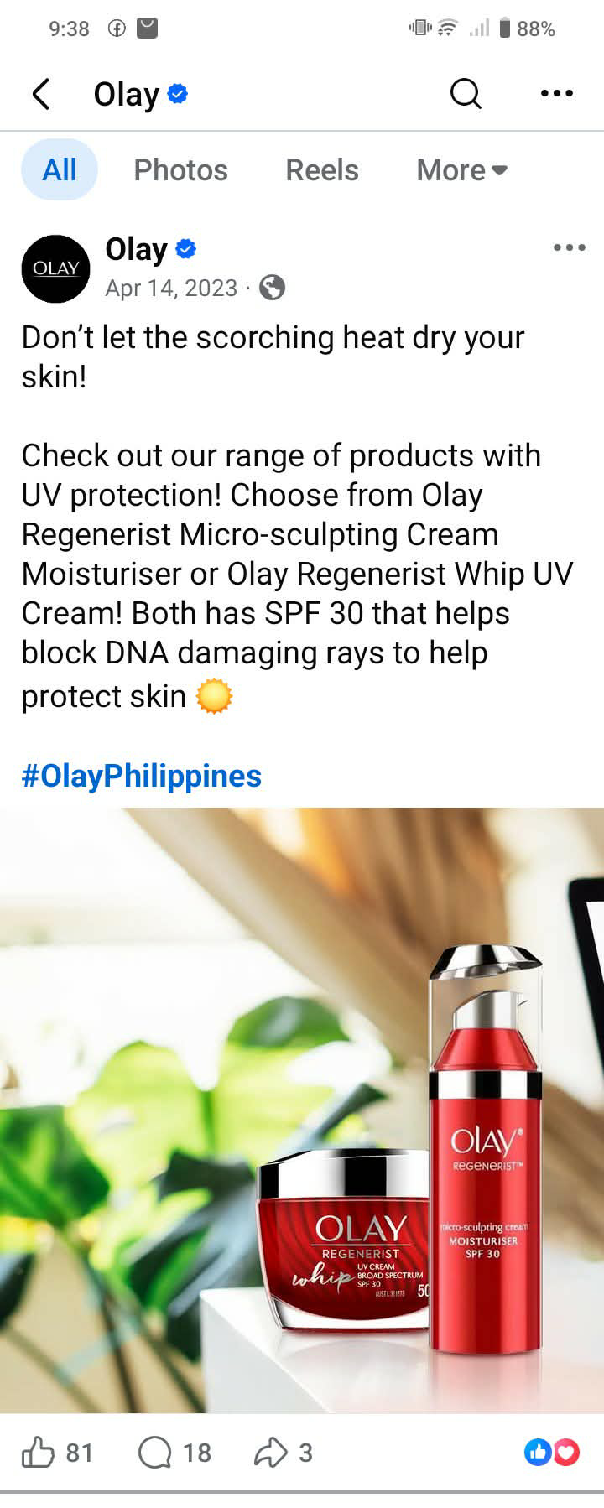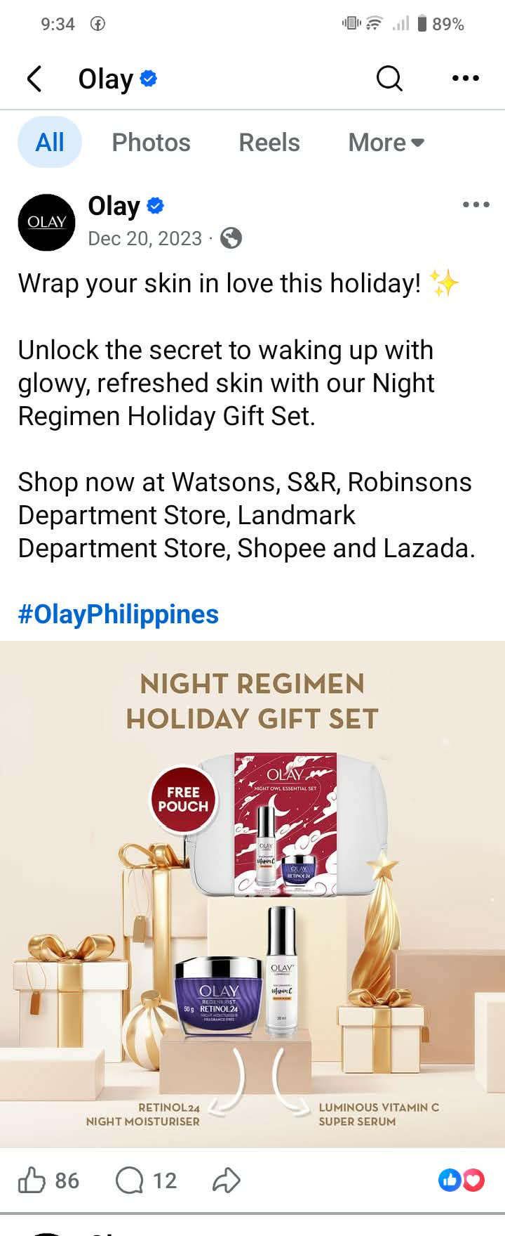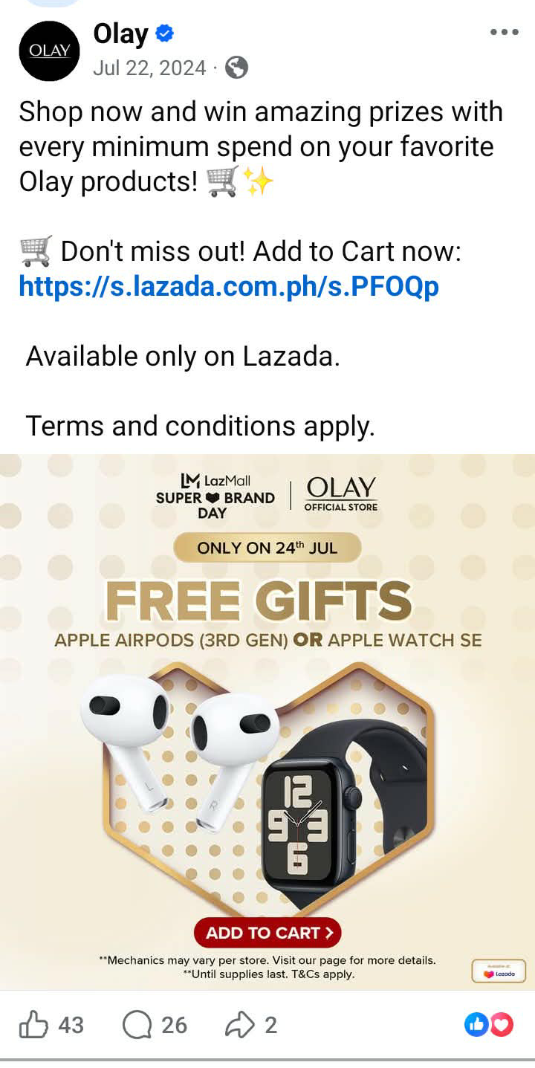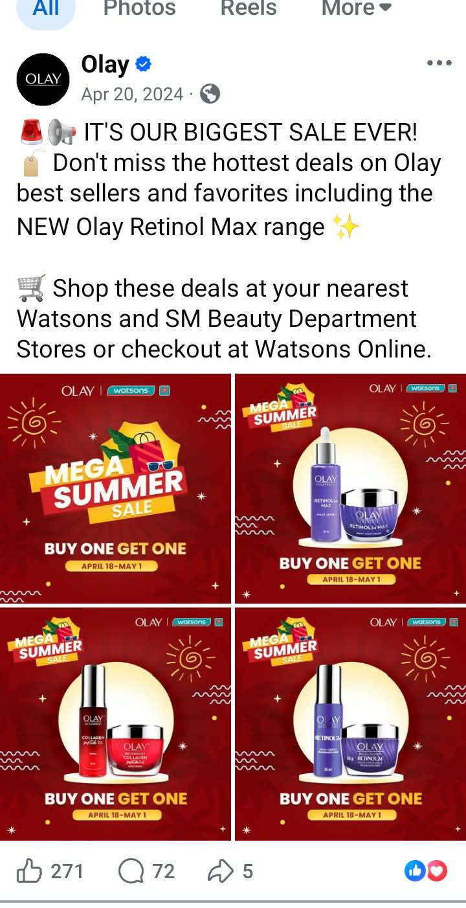
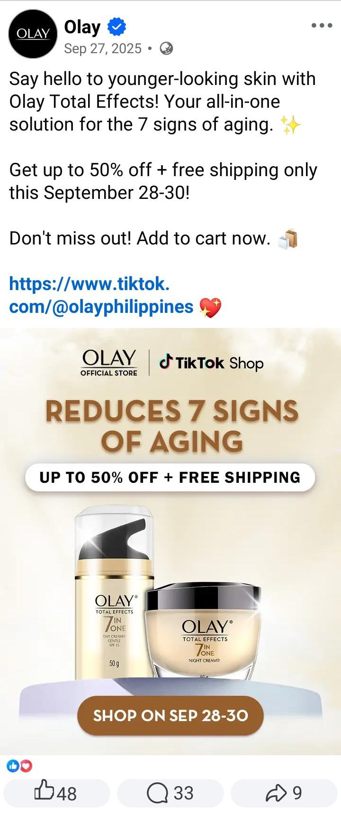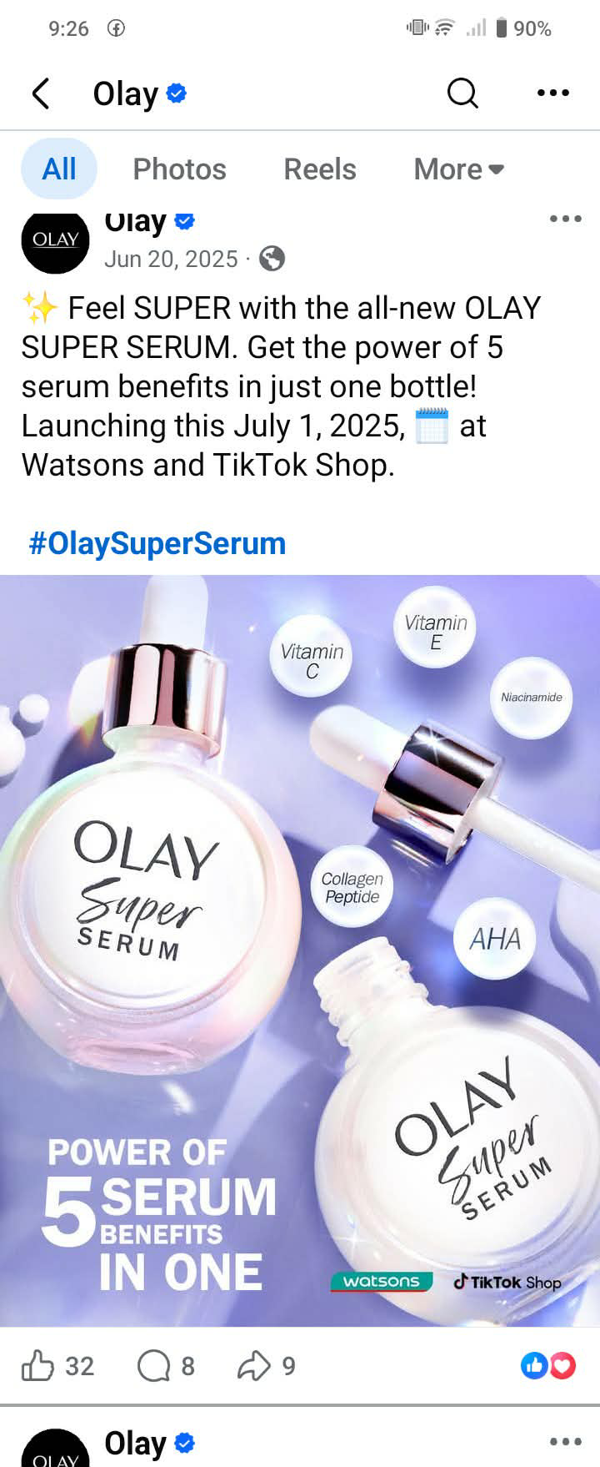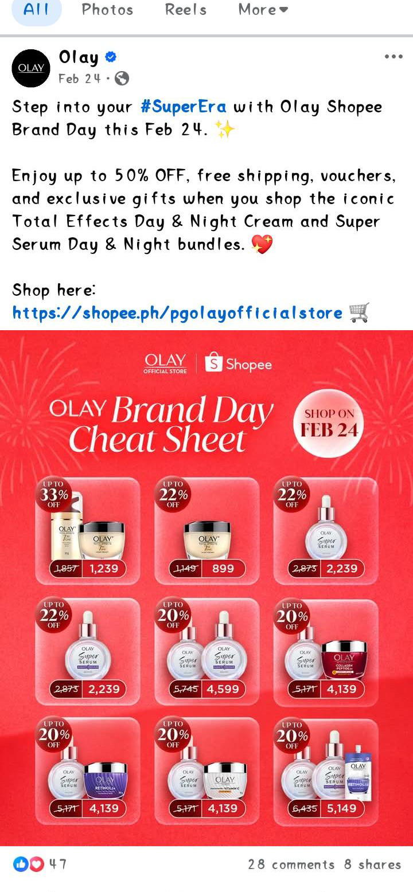
Figure 2
Luxe Organix
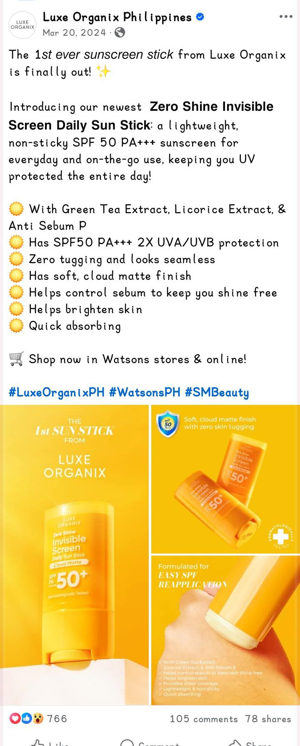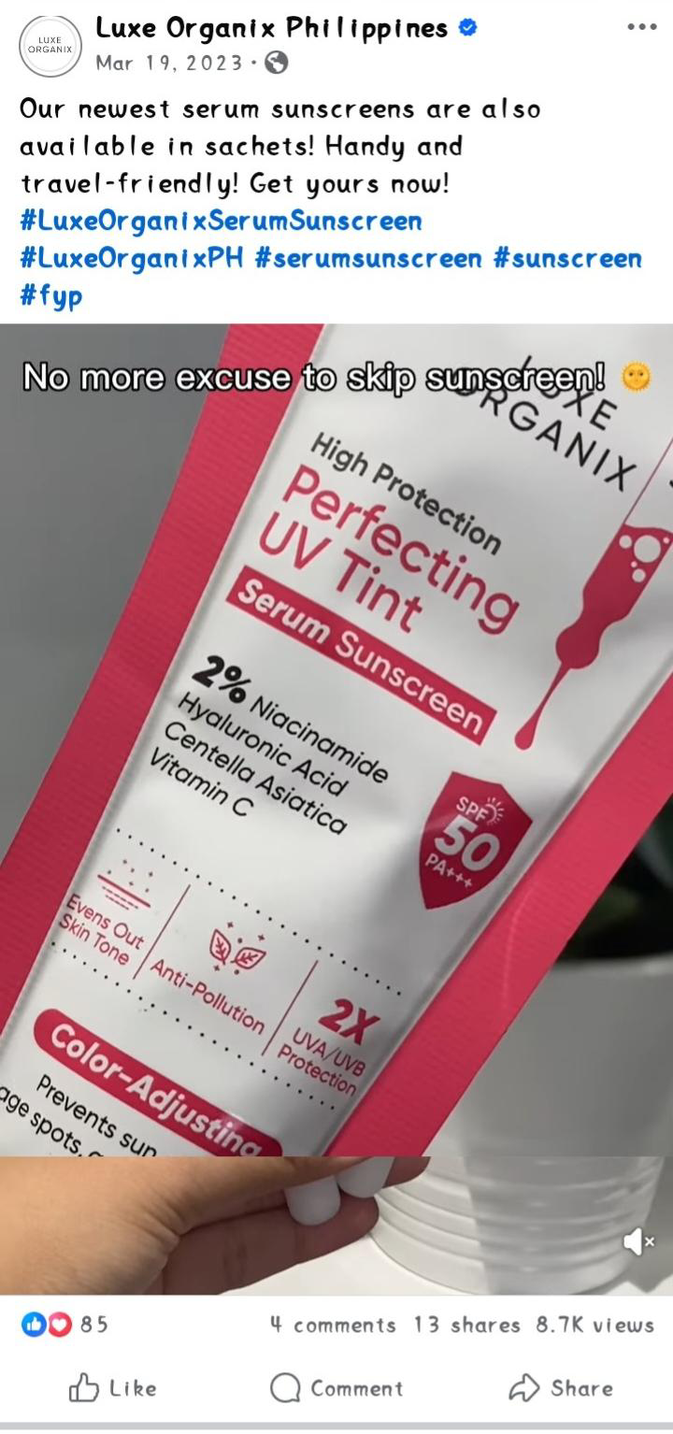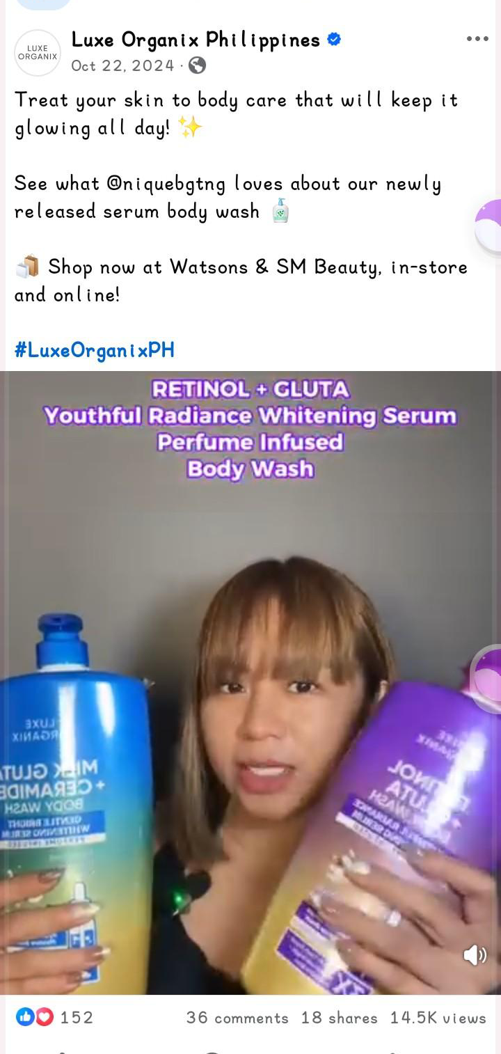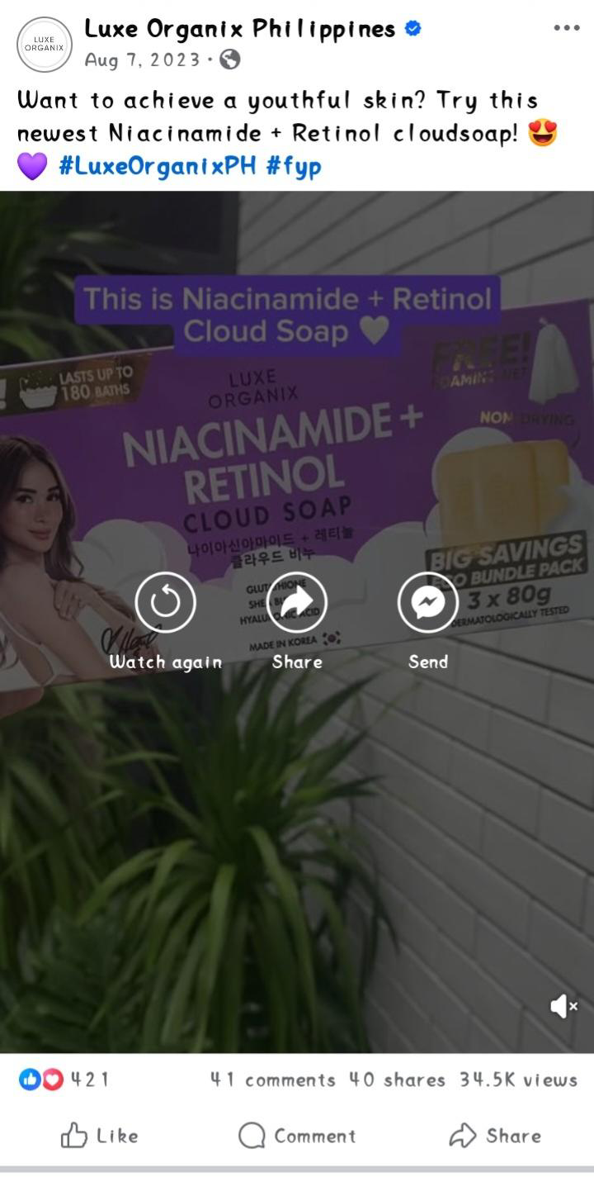

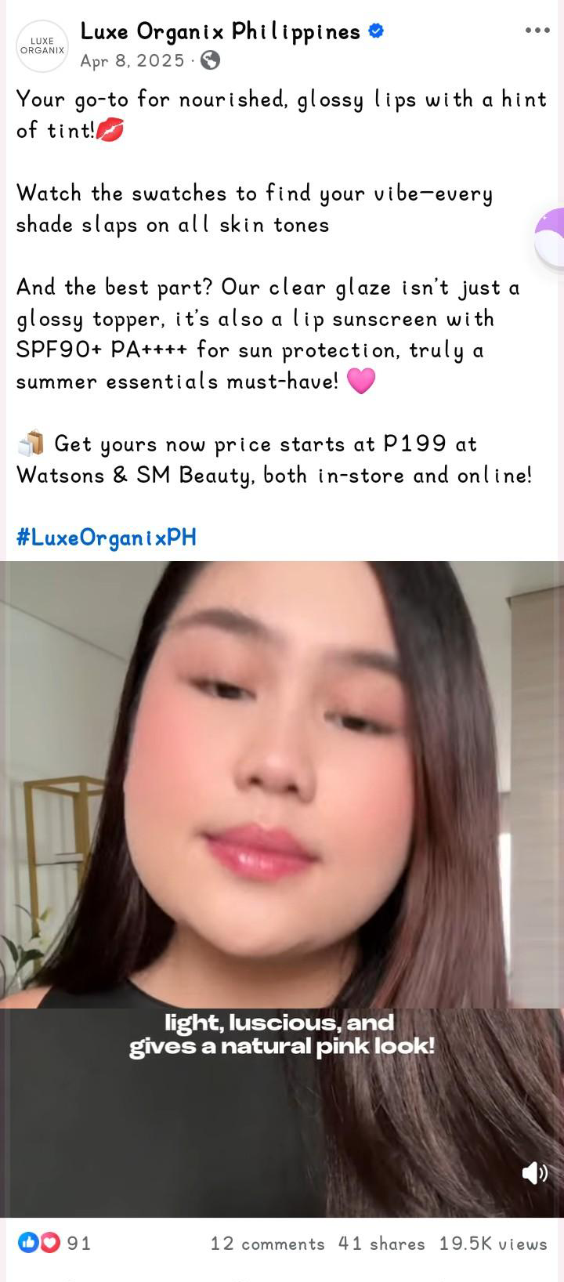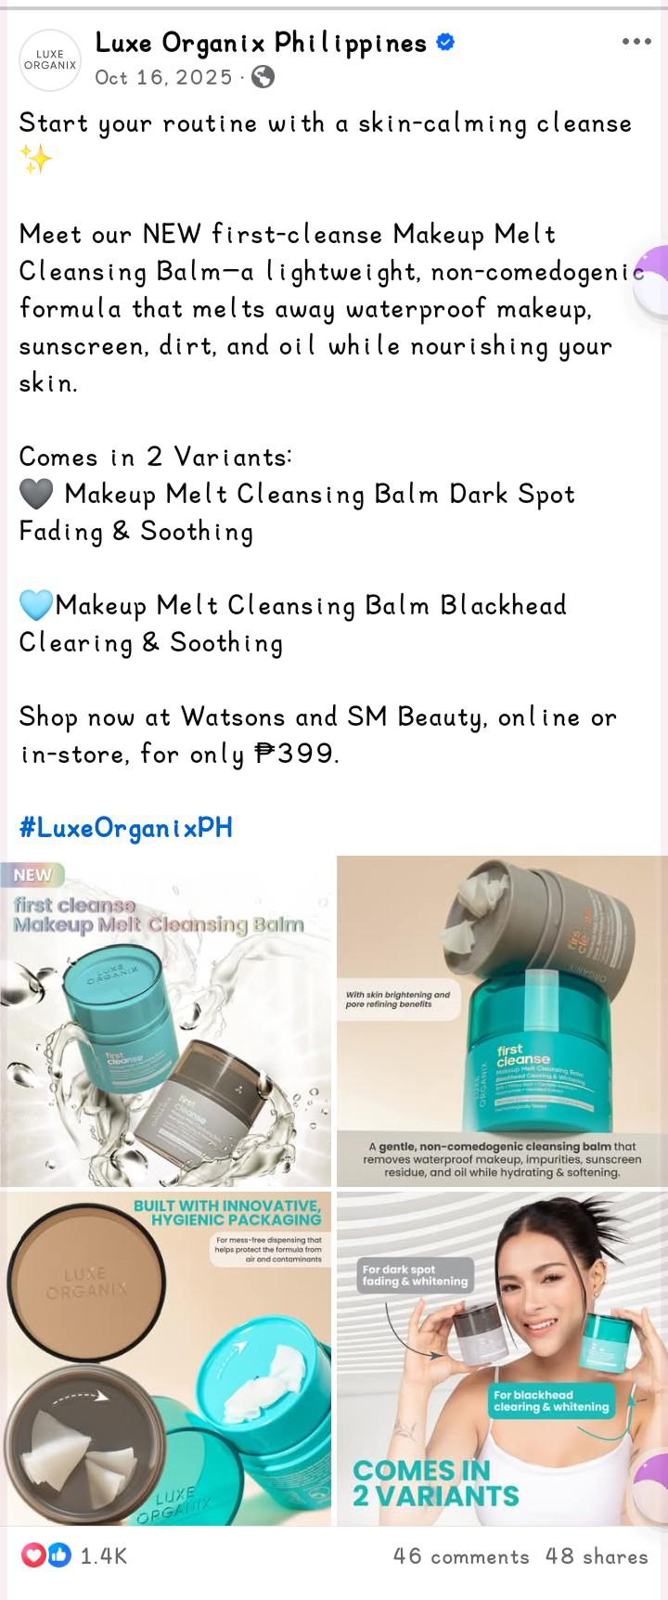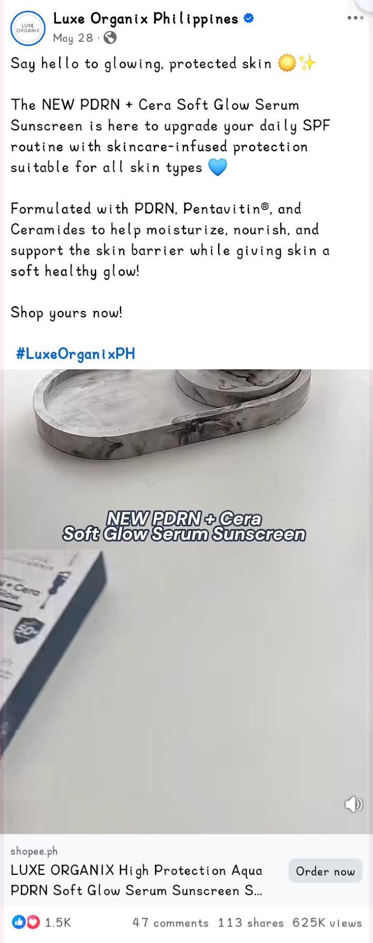
Figure 3
The Ordinary
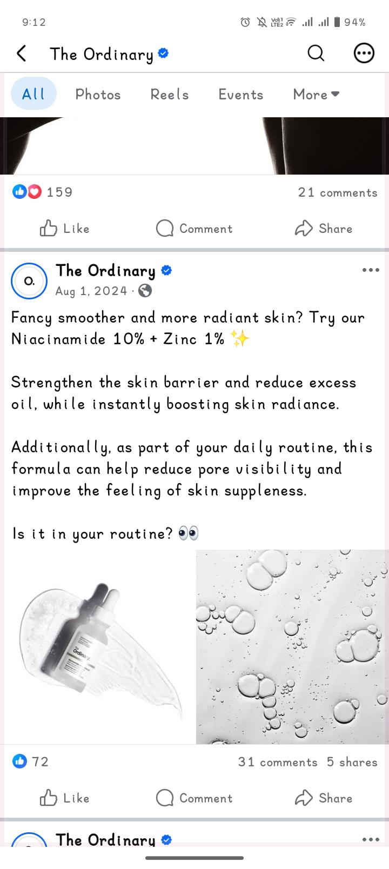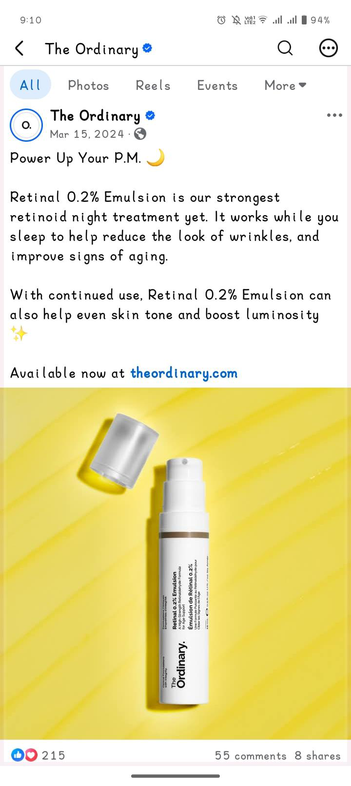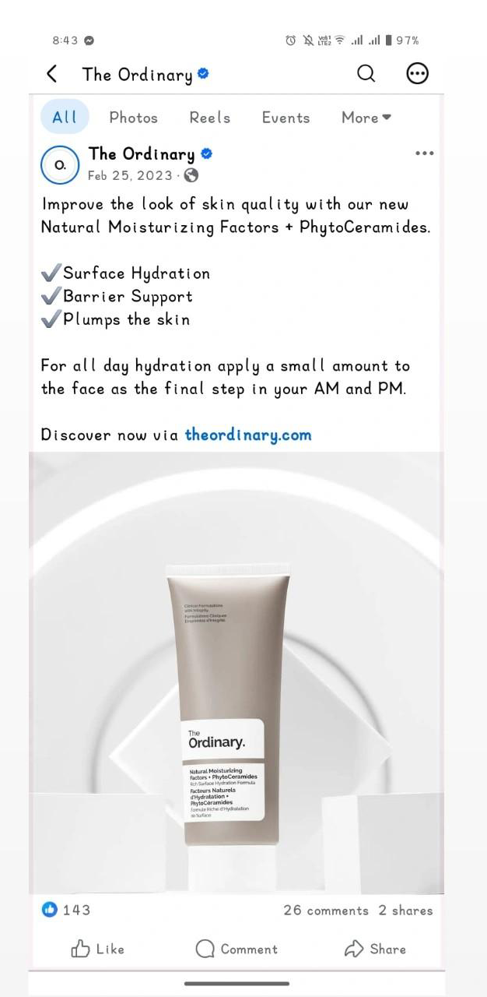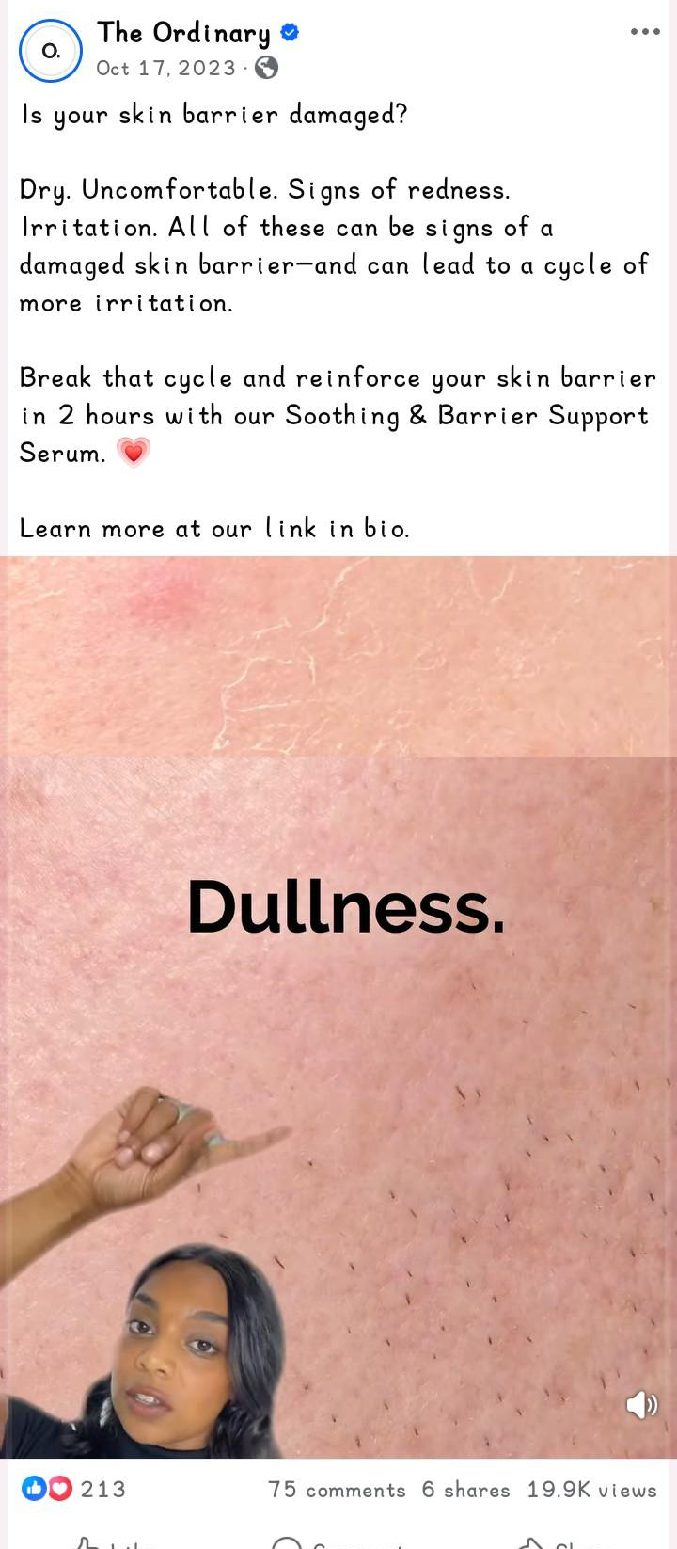
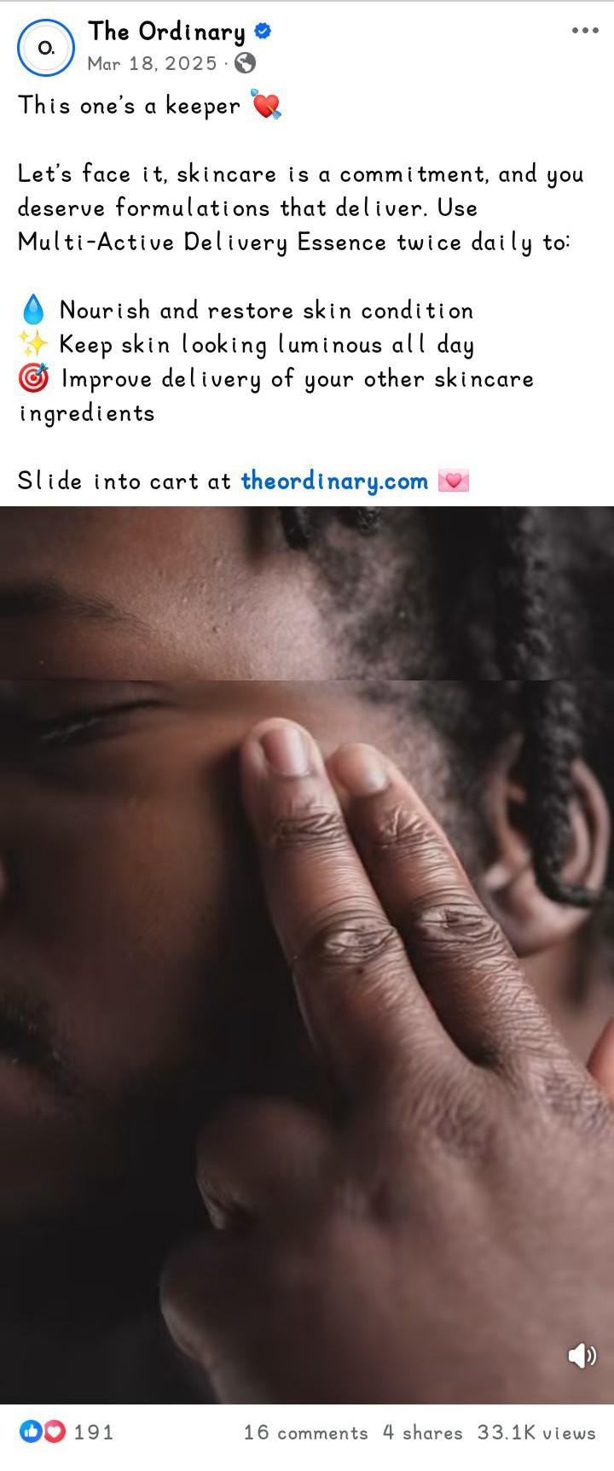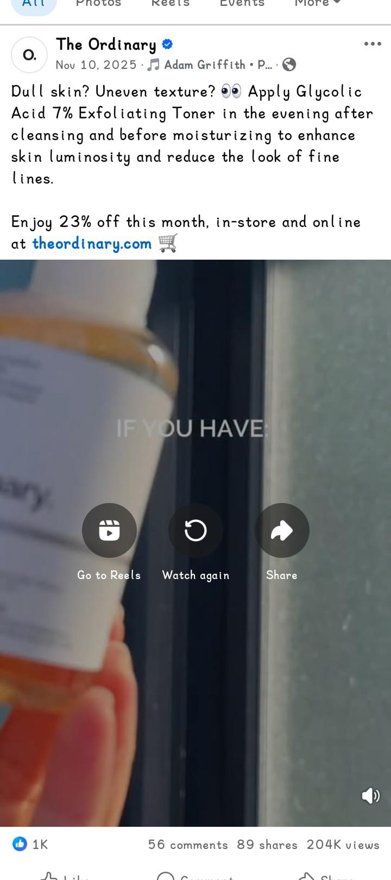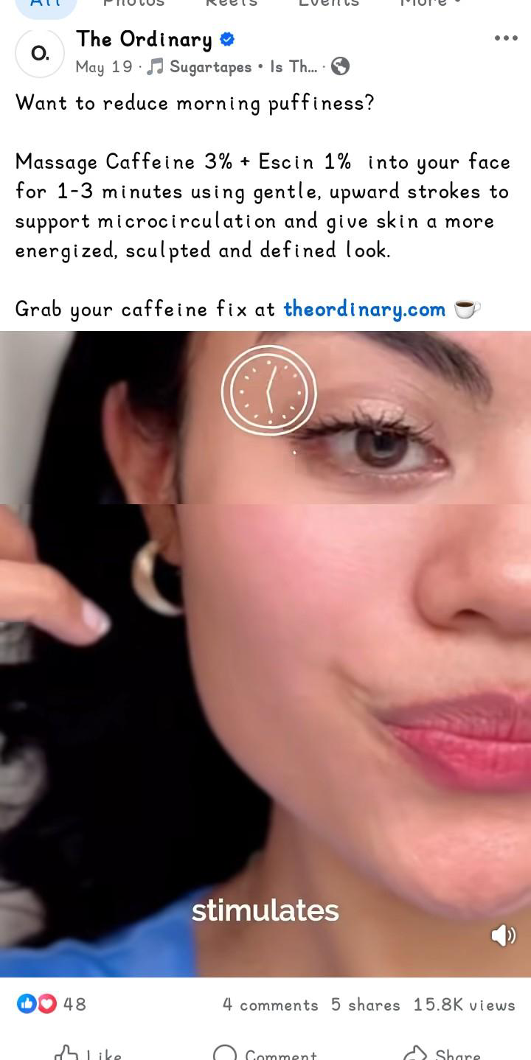
Figure 4
Myra
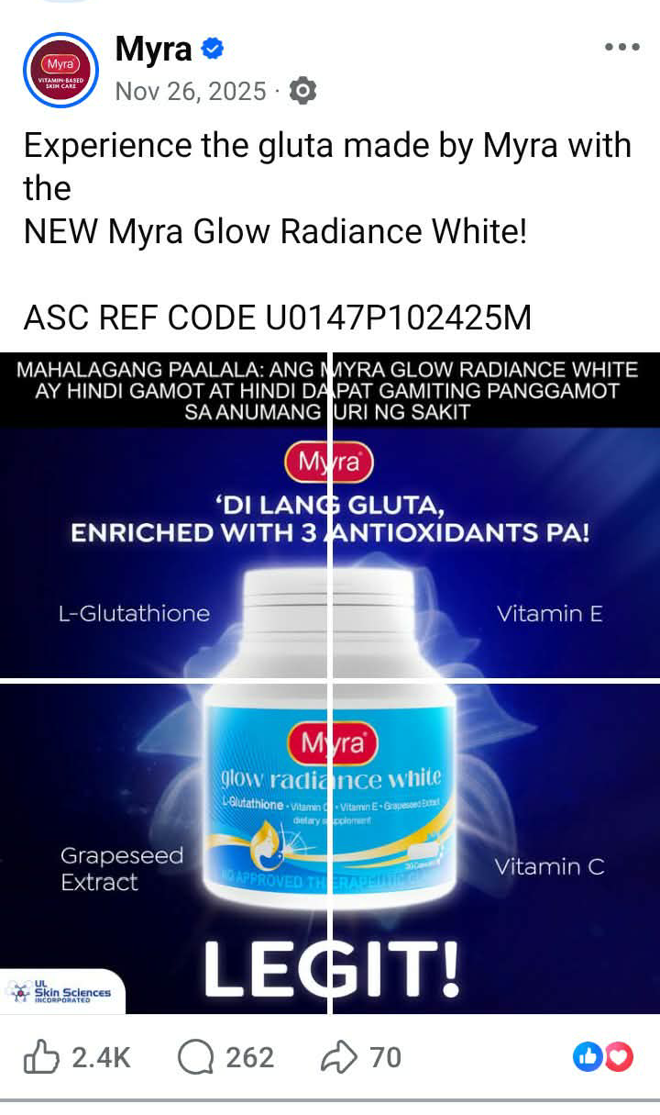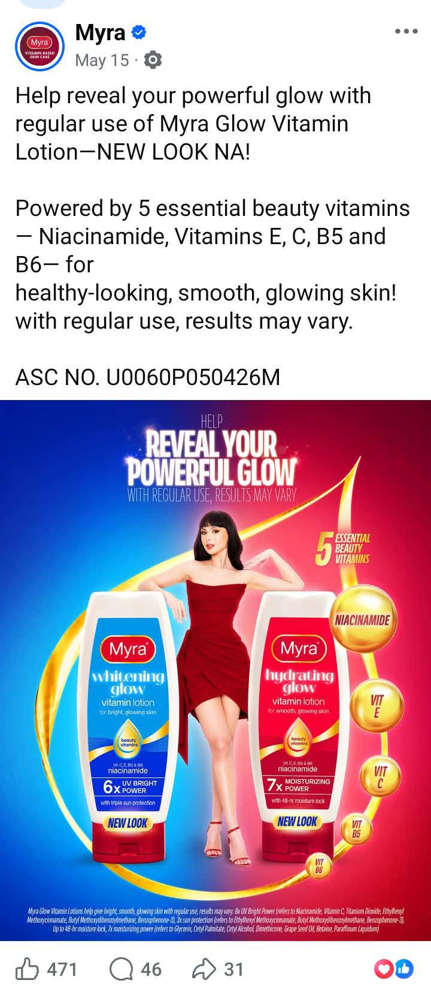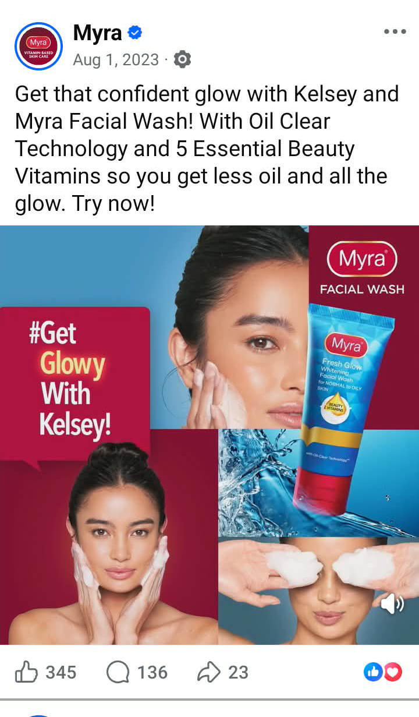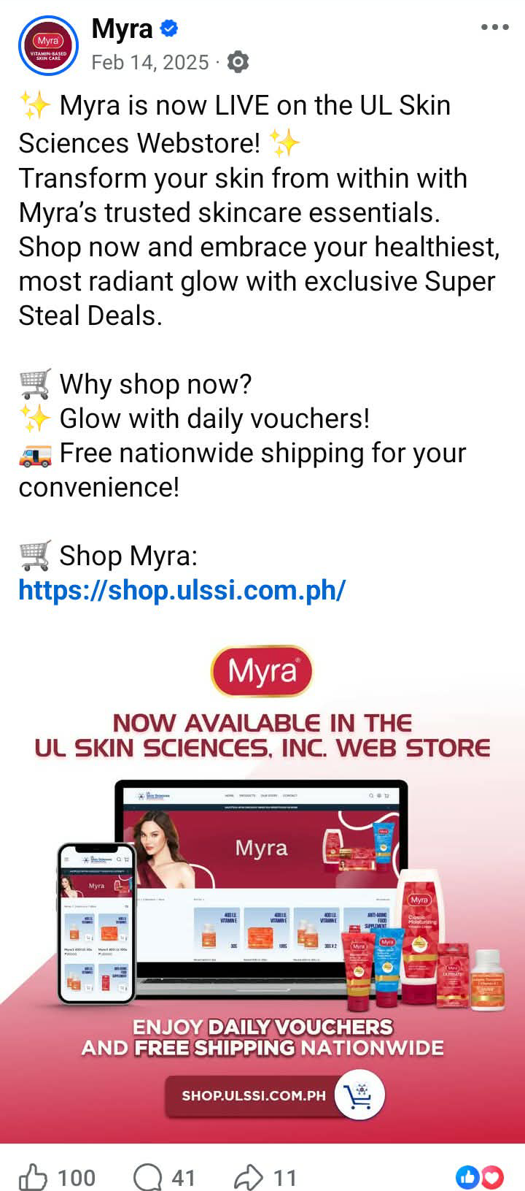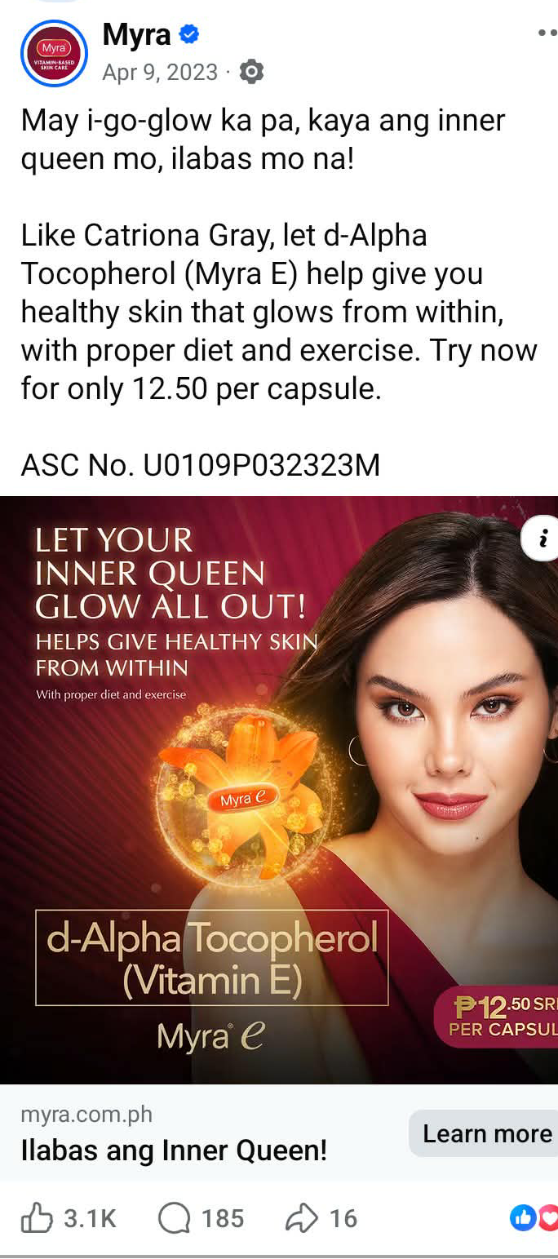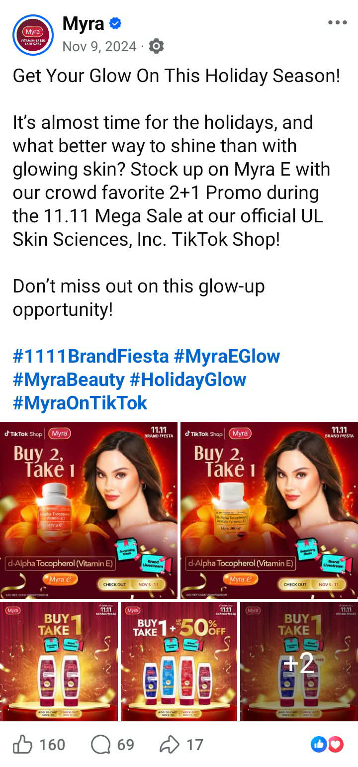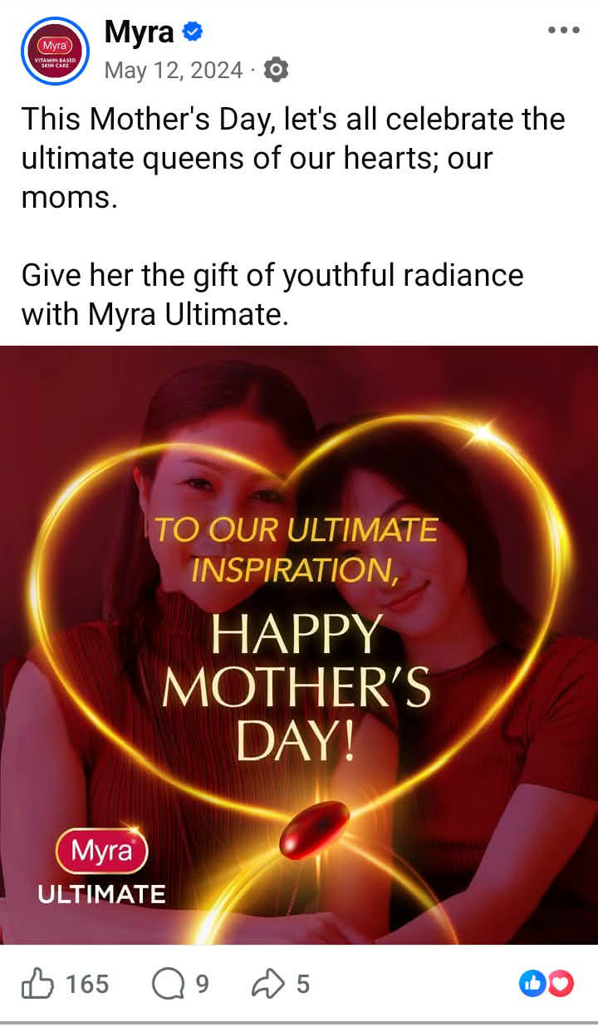
Figure 5
Pond’s
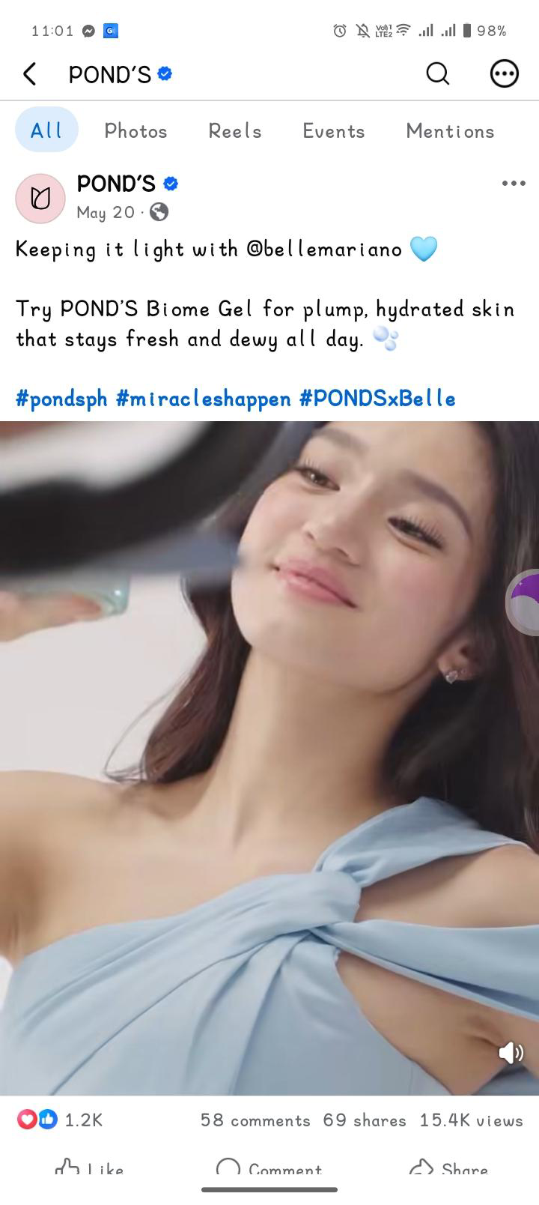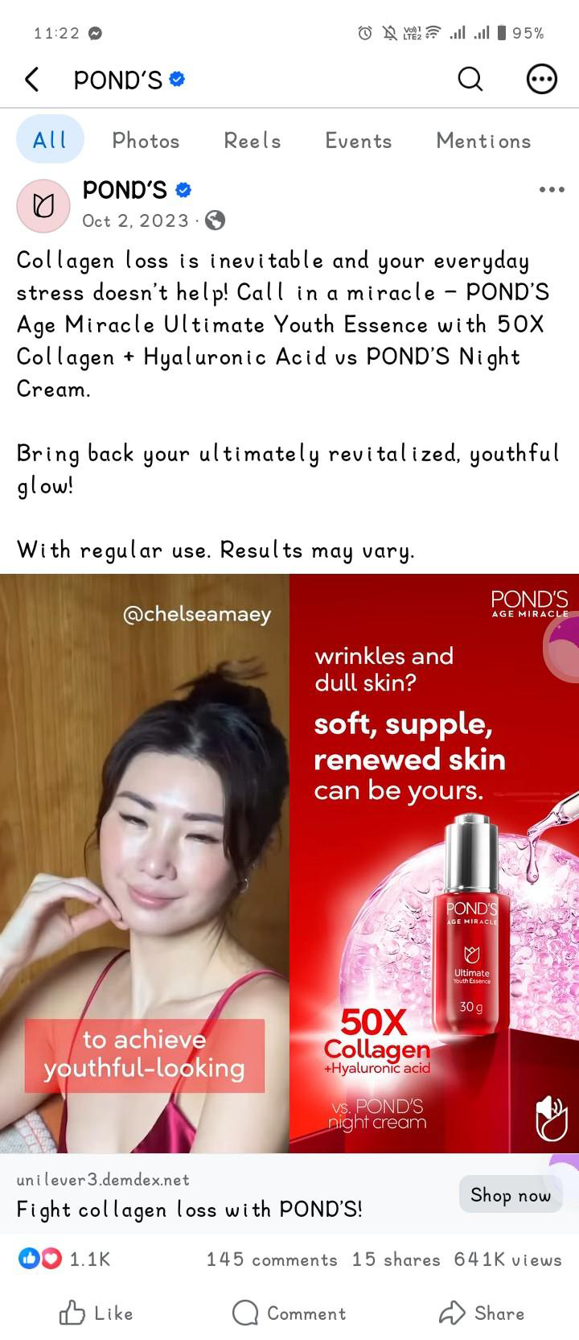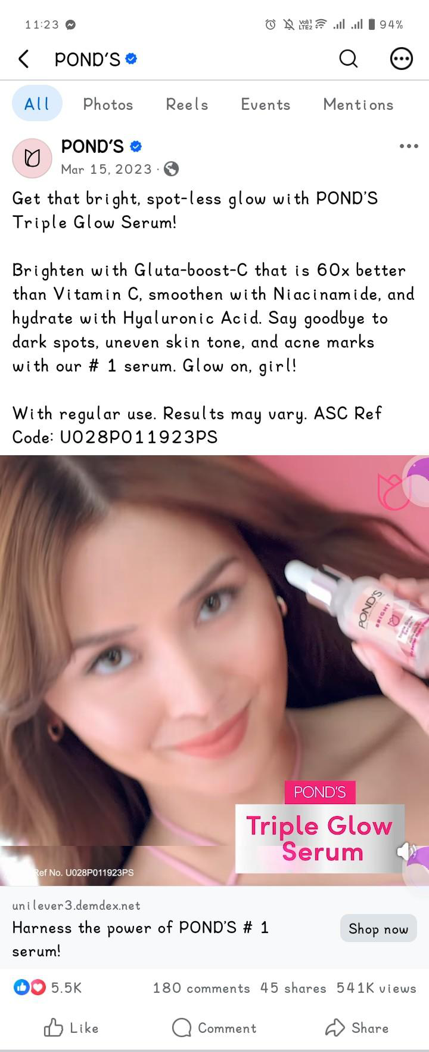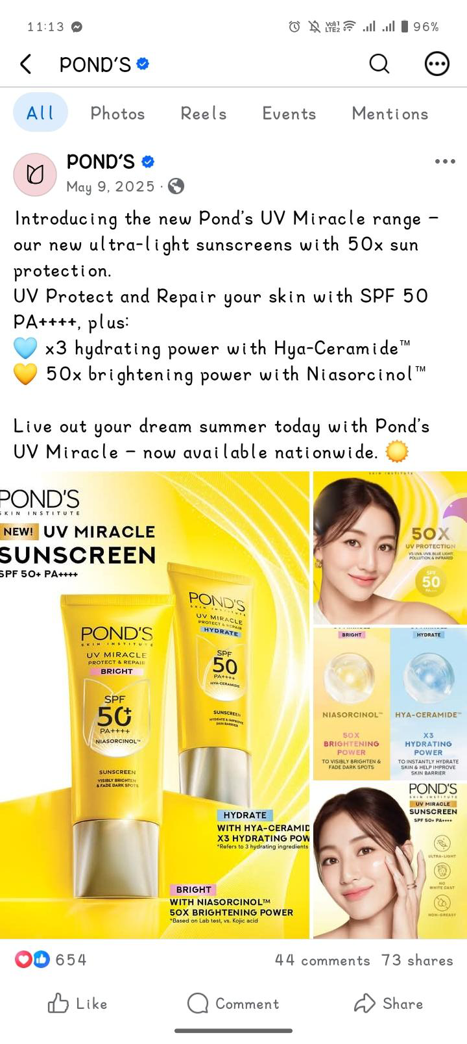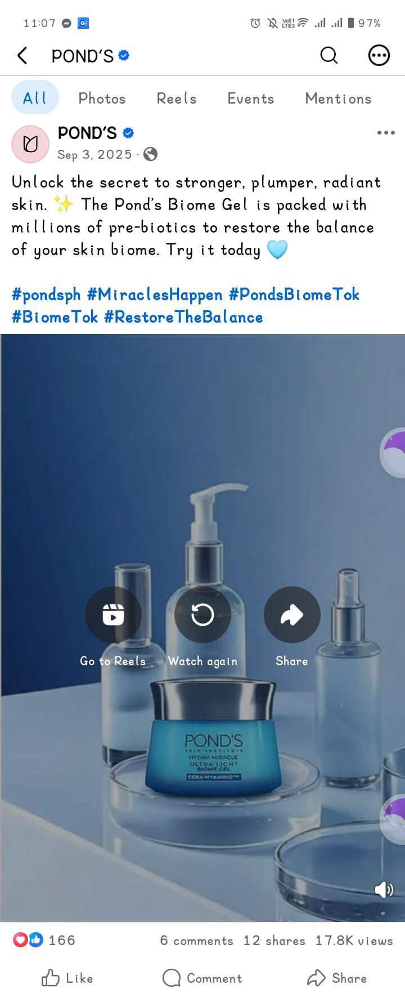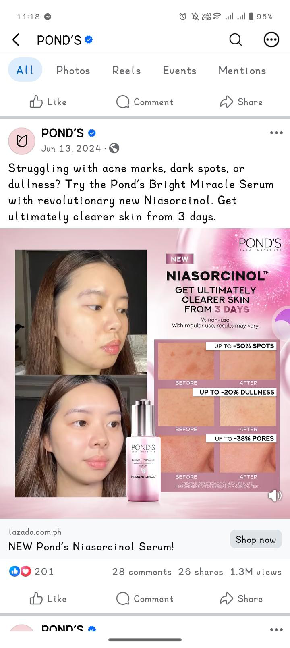

APPENDIX B: ANALYSIS OF RHETORICAL APPEALS

Table 1
Olay
Captions | Rhetorical Appeals | Interpretation
Don’t let the scorching heat dry your skin!  Check out our range of products with UV protection! Choose from Olay Regenerist Micro-sculpting Cream Moisturiser or Olay Regenerist Whip UV Cream! Both has SPF 30 that helps block DNA damaging rays to help protect skin  #OlayPhilippines | Logos | The caption uses logos by giving specific information about the products, particularly their SPF 30. It explains that the SPF 30 helps block DNA-damaging rays and protect the skin, giving a clear reason to consider the products.
Wrap your skin in love this holiday!  Unlock the secret to waking up with glowy, refreshed skin with our Night Regimen Holiday Gift Set.  Shop now at Watsons, S&R, Robinsons Department Store, Landmark Department Store, Shopee and Lazada.  #OlayPhilippines | Pathos | The caption uses pathos by creating feelings of love and care through “wrap your skin in love” and presenting the desirable experience of waking up with “glowy, refreshed skin.” These words make the product feel more appealing and enjoyable to use.
IT’S OUR BIGGEST SALE EVER!  Don’t miss the hottest deals on Olay best sellers and favorites including the NEW Olay Retinol Max range.  Shop these deals at your nearest Watsons and SM Beauty Department Stores or checkout at Watsons Online. | Pathos | The caption uses pathos by using exciting and urgent words such as “biggest sale ever” and “hottest deals.” These words create excitement and encourage consumers not to miss the sale.
Shop now and win amazing prizes with every minimum spend on your favorite Olay products!  Don’t miss out! Add to Cart now:https://s.lazada.com.ph/s.PFOQp  Available only on Lazada.  Terms and conditions apply. | Pathos | The caption uses pathos by highlighting “win amazing prizes” and “Don’t miss out!” These phrases create excitement and a sense of urgency, encouraging consumers to take advantage of the offer.
Feel SUPER with the all-new OLAY SUPER SERUM. Get the power of 5 serum benefits in just one bottle! Launching this July 1, 2025, at Watsons and Tiktok Shop.  #OlaySuperSerum | Logos | The caption uses logos by giving specific information about the product, particularly that it provides five serum benefits in one bottle. This information gives consumers a clear reason to consider the product.
Say hello to younger- looking skin with Olay Total Effects! Your all-in-one solution for the 7 signs of aging.  Get up to 50% off + free shipping only this September 28-30!  Don’t miss out! Add to cart now!  https://www.tiktok.com/@olayphilippines | Logos | The caption uses logos by giving specific information about the product, particularly that it is an all-in-one solution for the “7 signs of aging.” This gives consumers a clear product benefit to consider.
Step into your #SuperEra with Olay Shopee Brand Day this Feb 24.  Enjoy up to 50% off, free shipping, vouchers, and exclusive gifts when you shop the iconic Total Effects Day & Night Cream and SUper Serum Day & Night Bundles.  Shop here:  https://shopee.ph/pgolayoofficialstore | Pathos | The caption uses pathos through expressions such as “#SuperEra” and “exclusive gifts,” which present the shopping event as exciting and special. The promotional offers further appeal to the audience’s desire to enjoy additional benefits when shopping.
Table 2
Luxe Organix
Caption | Rhetorical Appeals | Interpretation
Our newest serum sunscreen is also available in sachets! Handy and travel-friendly! Get yours now!  #LuxeOrganixxSerumSunscreen  #LuxeOrganixPH #serumsunscreen #sunscreen #fyp | Logos | The caption uses logos by providing practical information about the product’s availability in sachets and its portability. These features explain how the product may be convenient for consumers, giving them a practical reason to consider it.
Want to achieve a youthful skin? Try this newest Niacinamide + Retinol cloudsoap!  #LuxeOrganixPH #fyp | Pathos | The caption uses pathos by presenting youthful skin as a desirable result. The phrase “achieve a youthful skin” appeals to the audience’s desire to maintain a younger-looking appearance, making the product more emotionally appealing.
The 1st ever sunscreen stick from Luxe Organix is finally out!  Introducing our newest Zero Shine Invisible Screen Daily Sun Stick: a lightweight, non-sticky SPF 50 PA+++ sunscreen for everyday and on-the-go use, keeping you UV protected the entire day!  - With Green Tea Extract, Licorice Extract, & Anti Sebum p  -Has SPF50 PA+++ 2X UVA/UVB protection  - Zero tugging and looks seamless  - Has soft, cloud matte finish  - Helps control sebum to keep you shine free  - Helps brighten skin  - Quick absorbing  Shop now in Watsons stores & online!  #LuxeOrganixPH #WatsonsPH #SMBeauty | Logos | The caption uses logos by presenting specific information about the sunscreen, including its SPF rating, ingredients, and stated features. These details explain the product’s protective and skincare functions and give the audience information to consider when evaluating it.
Treat your skin to body care that will keep it glowing all day!  See what @niquebgtng loves about our newly released serum body wash Shop now at Watsons & SM Beauty, in-store and online!  #LuxeOrganixPH | Pathos | The caption uses pathos by presenting glowing skin as a desirable result. This creates an appealing image of how consumers may want their skin to look.
Your go-to for nourished, glossy lips with a hint of tint!  Watch the swatches to find your vibe—every shade slaps on all skin tones And the best part? Our clear glaze isn’t just a glossy topper, it’s also a lip sunscreen with SPF90+ PA++++ for sun protection, truly a summer essentials must-have!  Get yours now price starts at P199 at Watsons & SM Beauty, both in-store and online!  #LuxeOrganixPH | Logos | The caption uses logos by providing specific information about the product’s sun protection and starting price. These details communicate its stated function and cost, giving the audience practical information about the product.
Start your routine with a skin-calming cleanse  Meet our NEW first-cleanse Makeup Melt Cleansing Balm—a lightweight, non-comedogenic formula that melts away waterproof makeup, sunscreen, dirt, and oil while nourishing your skin.  Comes in 2 Variants:  Makeup Melt Cleansing Balm Dark Spot Fading & Soothing  Makeup Melt Cleansing Balm Blackhead Clearing & Soothing  Shop now at Watsons and SM Beauty, online or in-store, for only ₱399.  #LuxeOrganixPH | Logos | The caption uses logos by explaining the cleansing balm’s formulation, functions, available variants, and price. These details provide product-related information that helps the audience understand what the product is intended to do.
Say hello to glowing, protected skin  The NEW PDRN + Cera Soft Glow Serum Sunscreen is here to upgrade your daily SPF routine with skincare-infused protection suitable for all skin types  Formulated with PDRN, Pentavitin®, and Ceramides to help moisturize, nourish, and support the skin barrier while giving skin a soft healthy glow!  Shop yours now!  #LuxeOrganixPH | Logos | The caption uses logos by giving specific information about the product’s ingredients and benefits. These details explain how the serum sunscreen helps moisturize, nourish, and support the skin barrier.

Table 3
The Ordinary
Caption | Rhetorical Appeal | Interpretation
Improve the look of skin quality with our new Natural Moisturizing Factors + PhytoCeramides.  Surface Hydration  Barrier Support  Plumps the skin  For all day hydration apply a small amount to the face as the final step in your AM and PM.  Discover now via theordinary.com | Logos | The caption uses specific product benefits to provide information about how the product can help improve the skin.
Is your skin barrier damaged?  Dry. Uncomfortable. Signs of redness. Irritation. All of these can be signs of a damaged skin barrier—and can lead to a cycle of more irritation.  Break that cycle and reinforce your skin barrier in 2 hours with our Soothing & Barrier Support Serum.  Learn more at our link in bio. | Logos | The caption uses a specific time and product benefit to show what the serum can do for the skin.
Power Up Your P.M.  Retinal 0.2% Emulsion is our strongest retinoid night treatment yet. It works while you sleep to help reduce the look of wrinkles, and improve signs of aging.  With continued use, Retinal 0.2% Emulsion can also help even skin tone and boost luminosity  Available now at theordinary.com | Logos | The caption uses logos by identifying the product’s concentration and describing its stated benefits, including reducing the appearance of wrinkles and improving skin tone. These details provide product-related information about its intended effects.
Fancy smoother and more radiant skin? Try our Niacinamide 10% + Zinc 1%  Strengthen the skin barrier and reduce excess oil, while instantly boosting skin radiance.  Additionally, as part of your daily routine, this formula can help reduce pore visibility and improve the feeling of skin suppleness.  Is it in your routine? | Logos | The caption provides specific product information through the ingredient concentrations and the stated benefits for the skin. Although the phrase “smoother and more radiant skin” appeals to the audience’s desire for an improved appearance, the product information and benefits provide the stronger basis for classifying the dominant appeal as Logos.
This one’s a keeper  Let’s face it, skincare is a commitment, and you deserve formulations that deliver. Use Multi-Active Delivery Essence twice daily to:  - Nourish and restore skin condition  - Keep skin looking luminous all day  - Improve delivery of your other skincare ingredients  Slide into cart at theordinary.com | Logos | The caption uses specific product functions and benefits to show what the product can do for the skin.
Dull skin? Uneven texture? Apply Glycolic Acid 7% Exfoliating Toner in the evening after cleansing and before moisturizing to enhance skin luminosity and reduce the look of fine lines.  Enjoy 23% off this month, in-store and online at theordinary.com | Logos | The caption uses logos by identifying the product’s concentration, explaining when it should be applied, and stating its intended benefits. These details provide information about both product use and its claimed effects.
Want to reduce morning puffiness?  Massage Caffeine 3% + Escin 1% into your face for 1-3 minutes using gentle, upward strokes to support microcirculation and give skin a more energized, sculpted and defined look.  Grab your caffeine fix at theordinary.com | Logos | The caption uses logos by providing specific application instructions, including the duration and technique, along with the stated purpose of supporting microcirculation. These details explain how the product is intended to be used and what it is claimed to do.

Table 4
Myra
Caption | Rhetorical Appeal | Interpretation
May i-go-glow ka pa, kaya ang inner queen mo, ilabas mo na! ​  ​  Like Catriona Gray, let d-Alpha Tocopherol (Myra E) help give you healthy skin that glows from within, with proper diet and exercise. Try now for only 12.50 per capsule. ​  ​  ASC No. U0109P032323M | Pathos | The caption uses pathos by presenting healthy and glowing skin as a desirable result. This appeals to the audience’s desire for attractive and healthy-looking skin.
Get that confident glow with Kelsey and Myra Facial Wash! With Oil Clear Technology and 5 Essential Beauty Vitamins so you get less oil and all the glow. Try now! | Logos | The caption uses logos by providing specific information about the product’s technology and ingredients. These details give factual information about the product and its benefits.
This Mother's Day, let's all celebrate the ultimate queens of our hearts; our moms.  Give her the gift of youthful radiance with Myra Ultimate. | Pathos | The caption uses pathos by connecting the product with feelings of love and appreciation for mothers. Presenting the product as a gift associated with youthful radiance appeals to the audience’s emotions and desire to show care.
Get Your Glow On This Holiday Season!  It’s almost time for the holidays, and what better way to shine than with glowing skin? Stock up on Myra E with our crowd favorite 2+1 Promo during the 11.11 Mega Sale at our official UL Skin Sciences, Inc. TikTok Shop!  Don’t miss out on this glow-up opportunity!  #1111BrandFiesta #MyraEGlow #MyraBeauty #HolidayGlow #MyraOnTikTok | Pathos | The caption uses pathos by presenting glowing skin and the special promotion as desirable and exciting. These expressions appeal to the audience’s desire to look good and enjoy the promotion.
Myra is now LIVE on the UL Skin Sciences Webstore!  Transform your skin from within with Myra’s trusted skincare essentials. Shop now and embrace your healthiest, most radiant glow with exclusive Super Steal Deals.  Why shop now?  Glow with daily vouchers!  Free nationwide shipping for your convenience!  Shop Myra: https://shop.ulssi.com.ph/ | Ethos | The caption uses ethos through the phrase “trusted skincare essentials,” which explicitly presents the brand’s products as trustworthy. Although the caption also highlights discounts and other promotional benefits, this wording provides a direct basis for identifying an appeal to credibility.
Experience the gluta made by Myra with the  NEW Myra Glow Radiance White!  ASC REF CODE U0147P102425M | Pathos | The caption uses pathos by presenting a glowing and radiant appearance as a desirable outcome through the product name “Myra Glow Radiance White.” These expressions appeal to the audience’s desire for improved-looking skin. The phrase “made by Myra” identifies the brand but does not, by itself, clearly establish trustworthiness or credibility.
Help reveal your powerful glow with regular use of Myra Glow Vitamin Lotion—NEW LOOK NA!  Powered by 5 essential beauty vitamins— Niacinamide, Vitamins E, C, B5 and B6— for  healthy-looking, smooth, glowing skin! with regular use, results may vary.  ASC NO. U0060P050426M | Logos | The caption uses logos by providing specific information about the ingredients in the product. These details give factual information about what the product contains and its stated benefits.
Table 5
Pond’s
Caption | Rhetorical Appeal | Interpretation
Get that bright, spot-less glow with POND’S Triple Glow Serum!  Brighten with Gluta-boost-C that is 60x better than Vitamin C, smoothen with Niacinamide, and hydrate with Hyaluronic Acid. Say goodbye to dark spots, uneven skin tone, and acne marks with our # 1 serum. Glow on, girl!  With regular use. Results may vary. ASC Ref Code: ﻿﻿U028P011923PS | Logos | The caption uses logos by providing specific information about the product’s ingredients and their claimed functions. The reference to Gluta-boost-C, Niacinamide, and Hyaluronic Acid gives details about how the serum is intended to brighten, smoothen, and hydrate the skin.
Collagen loss is inevitable and your everyday stress doesn’t help! Call in a miracle – POND’S Age Miracle Ultimate Youth Essence with 50X Collagen + Hyaluronic Acid vs POND’S Night Cream.  Bring back your ultimately revitalized, youthful glow!  With regular use. Results may vary. | Logos | The caption uses logos by highlighting the product’s stated formulation, particularly “50X Collagen + Hyaluronic Acid.” Although the language also appeals to the desire for youthful-looking skin, the formulation provides the main informational basis for the classification.
Struggling with acne marks, dark spots, or dullness? Try the Pond's Bright Miracle Serum with revolutionary new Niasorcinol. Get ultimately clearer skin from 3 days. | Logos | The caption uses logos by providing specific information about the product, particularly the “revolutionary new Niasorcinol” and the claim of achieving clearer skin from 3 days. These details present a specific ingredient and a time-based product claim.
Introducing the new Pond’s UV Miracle range – our new ultra-light sunscreens with 50x sun protection.  UV Protect and Repair your skin with SPF 50 PA++++, plus:  x3 hydrating power with Hya-Ceramide™  50x brightening power with Niasorcinol™  Live out your dream summer today with Pond’s UV Miracle – now available nationwide. | Logos | The caption uses logos by providing specific information about the product’s sun protection and benefits, particularly its SPF 50 PA++++ rating, 3x hydrating power, and 50x brightening power. These details give the audience information about the product’s features and claimed benefits.
Unlock the secret to stronger, plumper, radiant skin. The Pond’s Biome Gel is packed with millions of pre-biotics to restore the balance of your skin biome. Try it today  #pondsph #MiraclesHappen #PondsBiomeTok #BiomeTok #RestoreTheBalance | Logos | The caption uses logos by providing specific information about the product’s formulation and function. The reference to “millions of pre-biotics” and their role in restoring the balance of the skin biome gives information about how the product is intended to work.
Keeping it light with @bellemariano  Try POND’S Biome Gel for plump, hydrated skin that stays fresh and dewy all day.  #pondsph #miracleshappen #PONDSxBelle | Pathos | The caption uses pathos by presenting “plump,” “hydrated,” “fresh,” and “dewy” skin as desirable results. These expressions appeal to the audience’s aspirations for an attractive, healthy-looking appearance.

APPENDIX C: ANALYSIS OF DIRECTIVE SUBTYPES

Table 6
Olay
Call-to-action | Directive Subtypes | Interpretation
Check out our range of products with UV protection! Choose from Olay Regenerist Micro-sculpting Cream Moisturiser or Olay Regenerist Whip UV Cream! | Order | The CTA directly instructs consumers to check out the products and choose from the available Olay products.
Shop now at Watsons, S&R, Robinsons Department Store, Landmark Department Store, Shopee and Lazada. | Order | The CTA directly instructs consumers to shop for the product and provides the locations where they can purchase it.
Shop these deals at your nearest Watsons and SM Beauty Department Stores or checkout at Watsons Online. | Order | The CTA directly instructs consumers to shop for the deals in physical stores or check out online.
Shop now and win amazing prizes… Don’t miss out! Add to Cart now. | Order | The CTA directly instructs consumers to shop, take advantage of the offer, and add the products to their cart.
Get the power of 5 serum benefits in just one bottle! | Order | The CTA encourages consumers to obtain the product by highlighting the five serum benefits offered in one bottle.
Don’t miss out! Add to cart now! | Order | The CTA directly instructs consumers to add the product to their cart and encourages them not to miss the offer.
Shop Here. | Order | The CTA directly instructs consumers to access the provided shopping link to shop for the featured Olay products.

Table 7
Luxe Organix
Call-to-action | Directive Subtypes | Interpretation
Get yours now! | Order | The CTA directly instructs consumers to get the advertised serum sunscreen.
Try this newest Niacinamide + Retinol cloudsoap! | Suggestion | The CTA suggests trying the new Niacinamide + Retinol cloudsoap as an option for consumers seeking youthful-looking skin.
Shop now in Watsons stores & online! | Order | The CTA directly instructs consumers to purchase the advertised sunscreen through Watsons stores or online.
Shop now at Watsons & SM Beauty, in-store and online! | Order | The CTA directly instructs consumers to purchase the advertised serum body wash at Watsons or SM Beauty, either in-store or online.
Get yours now | Order | The CTA directly instructs consumers to obtain the advertised lip product from Watsons or SM Beauty.
Shop now at Watsons and SM Beauty, online or in-store | Order | The CTA directly instructs consumers to purchase the advertised cleansing balm through Watsons or SM Beauty, either online or in-store.
Shop yours now! | Order | The CTA directly instructs consumers to purchase the advertised serum sunscreen.

Table 8
The Ordinary
Call-to-action | Directive Subtypes | Interpretation
Discover now via theordinary.com | Order | The CTA directly instructs the audience to explore the product through the website.
Learn more at our link in bio. | Order | The CTA directly instructs the audience to learn more about the product through the provided link.
Power Up Your P.M. | Suggestion | The CTA suggests enhancing the audience’s nighttime skincare routine with the product.
Try our Niacinamide 10% + Zinc 1%. | Suggestion | The CTA suggests trying the product as an option for the audience’s skincare routine.
Slide into cart at theordinary.com | Order | The CTA directly instructs the audience to add the product to their cart through the website.
Apply Glycolic Acid 7% Exfoliating Toner in the evening after cleansing and before moisturizing | Order | The CTA directly instructs the audience to apply the toner in the evening, after cleansing and before moisturizing.
Grab your caffeine fix at theordinary.com | Order | The CTA directly instructs the audience to obtain the product through the website.
Table 9
Myra
Call-to-action | Directive Subtypes | Interpretation
Try now for only 12.50 per capsule. | Suggestion | The CTA suggests trying the product and provides its price per capsule
Try now! | Suggestion | The CTA suggests trying Myra Facial Wash.
Give her the gift of youthful radiance with Myra Ultimate. | Suggestion | The CTA suggests giving Myra Ultimate as a gift to the consumer’s mother.
Stock up on Myra E with our crowd favorite 2+1 Promo during the 11.11 Mega Sale at our official UL Skin Sciences, Inc. TikTok Shop! Don’t miss out on this glow-up opportunity! | Order | The CTA directly instructs consumers to stock up on Myra E and highlights the promotional opportunity.
Shop now and embrace your healthiest, most radiant glow with exclusive Super Steal Deals.” / “Shop Myra | Order | The CTAs directly instruct consumers to shop for Myra products and take advantage of the available deals.
Experience the Gluta made by Myra with the NEW Myra Glow Radiance White! | Suggestion | The CTA suggests experiencing the newly introduced Myra Glow Radiance White product.
Help reveal your powerful glow with regular use of Myra Glow Vitamin Lotion—NEW LOOK NA! | Suggestion | The CTA encourages consumers to use Myra Glow Vitamin Lotion regularly to help reveal their glow.

Table 10
Pond’s
Call-to-action | Directive Subtypes | Interpretation
Brighten with Gluta-boost-C that is 60x better than Vitamin C, smoothen with Niacinamide, and hydrate with Hyaluronic Acid. Say goodbye to dark spots, uneven skin tone, and acne marks with our #1 serum. Glow on, girl! | Order | The CTAs directly instruct consumers to brighten, smoothen, and hydrate their skin and encourage them to address skin concerns by using the advertised serum.
Call in a miracle – POND’S Age Miracle Ultimate Youth Essence with 50X Collagen + Hyaluronic Acid vs POND’S Night Cream. Bring back your ultimately revitalized, youthful glow! | Order | The CTAs directly instruct consumers to use POND’S Age Miracle Ultimate Youth Essence to achieve a revitalized and youthful-looking appearance.
Try the Pond's Bright Miracle Serum with revolutionary new Niasorcinol. Get ultimately clearer skin from 3 days. | Suggestion | The CTAs encourage consumers to try Pond’s Bright Miracle Serum and highlight the clearer-skin benefit stated in the advertisement.
Live out your dream summer today with Pond’s UV Miracle. | Suggestion | The CTA presents Pond’s UV Miracle as an option for consumers who want to enjoy their desired summer experience.
Try it today. | Suggestion | The CTA encourages consumers to try Pond’s Biome Gel and presents the product as an option for their skincare routine.
Try POND’S Biome Gel for plump, hydrated skin that stays fresh and dewy all day. | Suggestion | The CTA recommends trying POND’S Biome Gel and highlights the skin benefits stated in the advertisement.

APPENDIX D: ANALYSIS OF THE CONSTRUCTION OF PERSUASIVE MEANING

Table 11
Skincare Brands | Rhetorical Appeal + Directive Subtypes | Discussion
OLAY | Logos + Order,  Pathos + Order | The combinations consisted of four Pathos + Order and three Logos + Order. Pathos + Order used emotional expressions with direct instructions, while Logos + Order combined product-related information with direct instructions. These combinations helped make the advertisements appealing while encouraging consumers to take action.
LUXE ORGANIX | Logos + Order,  Pathos + Order, and  Pathos + Suggestion | The combinations consisted of five Logos + Order, one Pathos + Order, and one Pathos + Suggestion. Logos + Order was the most common combination, using product-related information with direct instructions. Meanwhile, Pathos + Order and Pathos + Suggestion appealed to consumers’ desired skin results to encourage action or invite them to consider a product. These combinations show how product information and emotional appeal contributed to persuasive meaning.
THE ORDINARY | Logos + Order,  Logos + Suggestion | The combinations consisted of five Logos + Order and two Logos + Suggestion. Logos + Order combined product-related information with direct instructions, while Logos + Suggestion presented actions that consumers could consider. These combinations helped communicate information about the products while encouraging consumers to use or explore them.
MYRA | Logos + Suggestion,  Pathos + Suggestion,  Ethos + Suggestion, and  Pathos + Order | The combinations consisted of two Logos + Suggestion, three Pathos + Suggestion, one Ethos + Suggestion, and one Pathos + Order. Pathos + Suggestion was the most common combination, appealing to consumers’ feelings and desired appearance while inviting them to consider a product. Logos + Suggestion presented product-related information as a reason to consider an action, while Ethos + Suggestion emphasized brand credibility. Pathos + Order used emotional appeal with a more direct instruction. These combinations show how Myra used different appeals to encourage consumer action.
POND’S | Logos + Order  Pathos + Suggestion, and  Logos + Suggestion | The combinations consisted of two Logos + Order, three Logos + Suggestion, and one Pathos + Suggestion. Logos + Suggestion was the most common combination, presenting product-related information while inviting consumers to consider an action. Logos + Order used product-related information with direct instructions, while Pathos + Suggestion appealed to consumers’ desired appearance and invited them to consider the advertised product. These combinations show how product information and emotional appeal contributed to the construction of persuasive meaning.

