The discourse of digital activism: a linguistic analysis of calls for action concerning the Fashion Revolution

[published in Applied Linguistics, 2024)

Barbara De Cock¹, Laetitia Aulit¹, Sara Cigada², Sara Greco³, Ewa Modrzejewska⁴, Rudi Palmieri⁵
1.Institut Langage et Communication, Université catholique de Louvain, Belgium
2. Faculty of Linguistic Sciences and Foreign Literatures, Università Cattolica del Sacro Cuore, Italy
3. Institute of Argumentation, Linguistics and Semiotics, Faculty of Communication, Culture and Society, USI - Università della Svizzera italiana, Switzerland
4. Institute of Applied Polish Studies, University of Warsaw, Poland
5. Language, Data and Society Research Centre & Department of Communication and Media, University of Liverpool, UK

Corresponding author contact details: Barbara De Cock, Place Mercier 31, L3.03.33, 1348 Louvain-la-Neuve, Belgium, barbara.decock@uclouvain.be

Introduction: Fashion Revolution as case study of digital activism concerning sustainability
On 24 April 2013, the Rana Plaza factory collapsed in Bangladesh, killing over a thousand people and leaving more than two thousand injured (St Clair 2018: 218). The building hosted subcontractors for big fashion brands in the West. This event brought the (un)sustainability of the fashion industry system and the opaqueness of the supply chain to the public attention. In the aftermath of the accident, the activist organization Fashion Revolution was founded to raise awareness and advocate for the social (and environmental) sustainability of the fashion industry. Since then, Fashion Revolution organizes a yearly Fashion Revolution Week to commemorate the Rana Plaza accident. This is an international event, hence involving communication in a variety of languages. The Fashion Revolution Week boasts a wide array of initiatives, including online campaigns, to which mainly Instagram and Twitter¹ users – be they activists, organizations, brands, the broader public – are invited to participate using the hashtags #FashionRevolution, #whomademyclothes and, since 2020, #WhatsInMyClothes.
Multi-party participation to this online campaign results in a complex conversation around sustainability issues in the fashion industry (see also Greco & De Cock 2021, Greco et al. 2023) on sustainable fashion discourses, which involves digital activism to promote actions that could change the production and consumption of fashion. The literature about digital activism (in sociology and communication) acknowledges that one of the main functions of digital activism is discursive, as activists change “the issues that are discussed” in society (van Dyke & Taylor 2019: 487) and “drive discourse in particular directions” (Kuo 2018: 497). Irrespective of the importance of discourse in digital activism, however, little is said about how activists discursively achieve the goal of changing people’s focus on one or the other issue, and motivate them to take action (get more information, talk about a new topic, join digital campaigns, etc.). Bennett and Segerberg (2012) call this connective action. At the core of the logic of connective action “is the recognition of digital media as organizing agents” (Bennett and Segerberg 2012: 752). Highfield (2016: 103) notes that, in connective action, “political engagement is also personalized and digitally mediated”, meaning that social media offer the opportunity to aggregate actors with different goals and interests in the campaigns to act together. To our best knowledge, research on the linguistic, discursive and argumentative structure of digital activists’ calls for action is not yet developed, although these calls for action are clearly discursively formulated. The present paper bridges this gap by taking into account the international, hence multilingual, nature of the digital activism concerning Fashion Revolution.

Against this background, in line with van Dijk’s (2023: 154) observation about the fact that the study of social movements would require “more precise theoretical and methodological concepts” grounded in discourse studies, our paper proposes a discursive analysis of such calls for action to change the fashion system, focusing on Twitter activism in relation to the April 2020 Fashion Week. Our analysis is based on a dataset of tweets collected in 2020, which was a particularly significant year for digital activism. Indeed, due to the outbreak of the Covid-19 pandemic, most of the activities related to Fashion Revolution were carried out online, though quite some digital activism was generated also in previous years. ,
Our focus on connective action in online activism contributes to a field that has been treated only scantily in linguistics, namely the analysis of sensibilization campaigns which aim to encourage a complex audience constituted by different actors (citizens, small brands, etc.) to change their behavior. Specific of these campaigns is that the authors of the calls to action have very limited, if any, institutional power to impose a concrete behavior on business companies, and, therefore, must rely exclusively on discursive persuasion. The increasing participation in digital activism on fashion sustainability (with numbers of followers of Fashion Revolution in the field progressively growing)² signals a certain degree of effectiveness of these digital campaigns. It becomes thus interesting to better understand how such discursive persuasion endeavors work: Who is presented as the entity that has to carry out the action? Which action is being called for? What are the different linguistic forms used to incite to action? Is a motivation in the form of an argument given for this call for action? What type of action and what kind of sustainability is being called for? We address these questions with an onomasiological perspective (Gobber and Morani 2014: 86), rather than focusing on a specific structure such as the imperative. We then start from the idea of deonticity and look into different structures that can express this with different degrees of intensity of the illocutionary force (Caffi 2007), including modal verbs and lexical expressions of necessity, and taking into account language-specific features.
Some existing studies that have analyzed other types of situations where the author tries to convince to adopt a certain behavior without having the power to impose it. In an analysis of prevention campaigns on HIV towards men having sex with men (Avila and Gras 2014), the authors highlight that, in the absence of a position to impose a certain action, the arguments to convince the public are even more crucial. Similarly, in an analysis of online comments to blogs in which the commenters wish to bring about social change (González Arias and Satt Román 2016), the authors show the importance of the reason or cause from which a deontic content derives (Lyons 1977). Due to the importance of giving reasons in order to change behavior in these situations, we will analyze whether an argumentation is explicitly formulated to support the deontic structures, taking into account whether a specific type of sustainability is being referred to as the reason to move towards more sustainable fashion. In doing so, we will contribute to fleshing out how argumentation is used in order to promote behavioral change in the variety of actors potentially contributing to connective action in digital activism.

Theoretical framework: deontic structures as calls for action and their argumentative support
In line with the goal of this paper, in the deontic structures we look into, we focus particularly on the modal agent, that is “the person expected to carry out the action” (Verstraete 2005: 1410). As pointed out before, Fashion Revolution started after a catastrophe that was clearly linked to the production chain of big brands, who could then be expected to be represented as the modal agent in activism on sustainable fashion. However, as we will see, a wide variety of actors appear in this campaign. Furthermore, some utterances also make the modal source of the call for action explicit. Figure 1 offers a schematic representation of the position of modal source and modal agent in our analysis of deontic structures as calls for action.

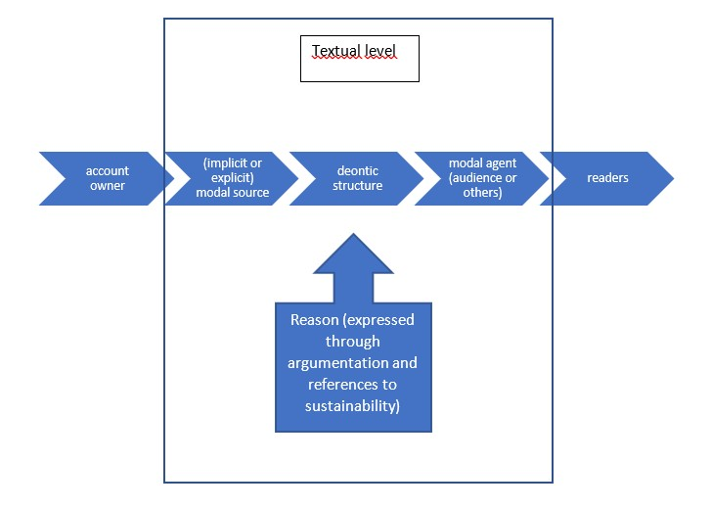
Figure 1. Schematic representation of deontic structures as calls for action
In (1) we (i.e. Fashion Revolution) is the modal source launching a call for action to the reader (YOU), who is portrayed as a modal agent. The relevant parts of the tweets are marked in bold by us.
- Day 6 of #FashionRevolution Week and we’re asking YOU to add your signature to our Manifesto. It’s our 10-point vision for an industry that stands on justice, respect, equality and environmental stewardship. https://www.fashionrevolution.org/manifesto/ [picture]
The concept of modal agent allows us to deal with the variety of syntactic functions that the modal agent can fulfill in deontic structures, such as object (you in (1)), prepositional complement (from fashion brands in (2)), subject. Moreover, in (2), while the modal agent is made explicit, the modal source is not.
(2) Who made my clothes? Where are my clothes made? What’s in my clothes?
For credible transparency detailed answers from fashion brands are required.
#fashionrevolution
The modal agent is of course not always expressed. Indeed, it has been pointed out that indeterminate deontic meanings are less face-threatening than more directly formulated alternatives (Brown and Levinson 1987: 191–192). The literature on deonticity and, more generally, modality is of course vast (see among others Nuyts 2005 for an overview). Among these proposals, we follow the traditional distribution of deontic concepts, based on semantic criteria and presented among others in Palmer (2001), which subdivides them in expressions of obligation, permission, and prohibition. The calls for action focused on in this study are typically formulated as a form of obligation, as we will show in the analysis.
To understand whether a motivation is given in the calls for action made by activists, we connect the analysis of deontic structures to a basic argumentation analysis, informed by previous studies on modality and argumentation (Rocci 2017). More specifically, the following possibilities are distinguished: (a) tweets that contain an explicitly formulated argumentation, including an expressed standpoint and at least one reason supporting it; (b) tweets with an external linked document that contains a standpoint not justified directly in the post, but very likely to be reasserted and supported in the linked source. This is a frequent situation given the limited number of characters allowed by Twitter (see Schäfer and Stede 2021); (c) tweets that only present a potential standpoint, i.e. they express an opinion which however is not supported by arguments (though this may be due to the fact that these are already known within the relevant community and thus have become a shared premise); and (d) tweets that are non-argumentative, because their content clearly does not contain an opinion, or because we lack sufficient contextual information to demonstrate the presence of arguments, or because the text of the tweet is too obscure to allow a clear interpretation. Whereas a standpoint (supported or unsupported) is present, we distinguish between prescriptive standpoints (asserting that a certain type of action must or should be done), evaluative standpoints (such as, for example, “the fashion system is not sustainable”), and descriptive standpoints (such as “clothing consumption is increasing constantly”); for this distinction, see van Eemeren (2017: 17).

Corpus
For our analysis, we collected a corpus of tweets containing the hashtag #FashionRevolution (both capitalized and non-capitalized spellings), produced between 1 January and 26 April 2020, the end of the 2020 Fashion Revolution Week. This rallying hashtag (Karamalak and Cantoni 2021) clearly connects to digital activism. Twitter was chosen because online activism on this social network plays an important role in many sustainability campaigns, which was reinforced in 2020 by the impact of the Covid-19 pandemic. The tweets were obtained with the help of the Centre de Traitement Automatique du Langage of the Université catholique de Louvain (for further information, see Naets 2018). During the selected period, 659 tweets with #FashionRevolution were published, out of which we selected those that contain a deontic structure. These represent 274 tweets, showing the importance of this kind of constructions (41,5%) in the online discourse concerning fashion revolution, in spite of the relatively small size of the overall dataset. Tweets containing publicity for sustainable fashion items or mere announcements were excluded from our final dataset.

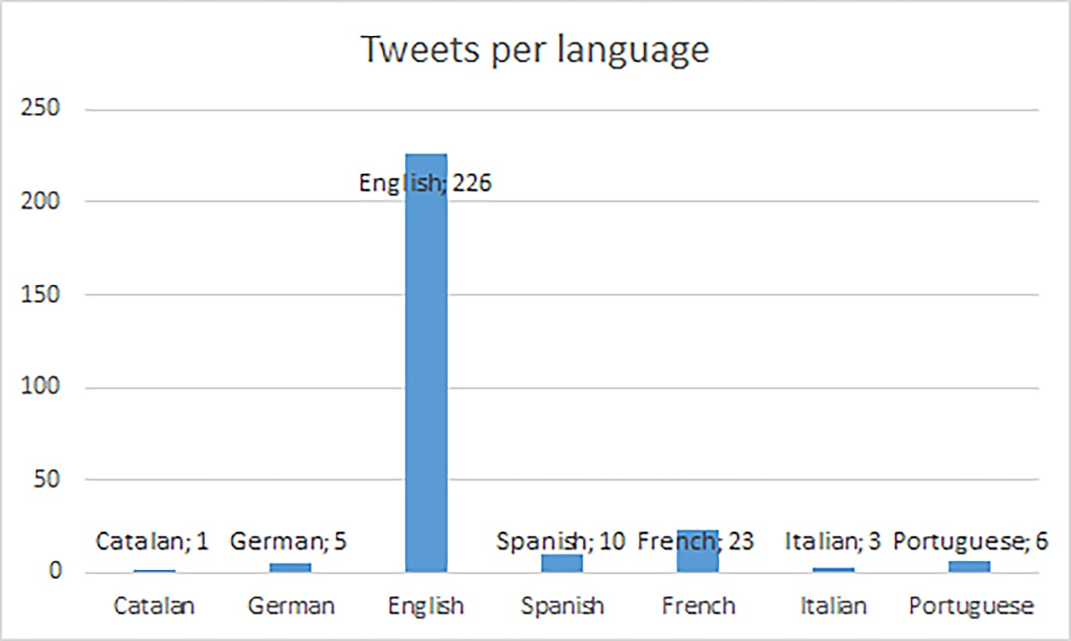
Figure 2: Distribution of tweets per language

Figure 2 shows the different languages in the corpus, with an overwhelming dominance of English. Given the variety of account owners who publish messages (see: the section below), the content of the posts vary expressions of opinions to transmission of factual data or mere publicity advertising for goods. References to non-public figures have been anonymized. We report the examples as they have been published, which may include non-standard language use. Translations are ours. We do not reproduce graphic elements, such as special graphic arrangements, pictures or links included in the tweet but we do mention between brackets when a picture or link was present in the original tweet. The study of visual elements is beyond the scope of this study since we focus on the formulation of the call for action. Yet, a multimodal analysis would merit a study in its own right. The messages were annotated for various analytical categories (cf. infra). After an initial joint annotation, each annotator analyzed a specific category in two rounds. Annotations made by one annotator were revised by at least a second one in the team. Moreover, ambiguous cases were discussed by all co-authors.

Analysis of calls for action
In order to understand how the involvement in the Fashion Revolution campaign as a form of connective action in which different actors participate is discursively fostered and justified, we analyze in more detail the different aspects of the calls for action. In the first place, we look into the account owners and which (categories of) owners formulate the calls for action. Understanding who is formulating the call is an important preliminary step for the linguistic analysis, as it connects the analysis of deontic structures to the specific communicative situation considered. We then look into who is presented as a modal agent (viz. which actor is expected to undertake the action), taking into account also whether the modal source is effectively present in the message. In order to do so, we pay particular attention to how the deontic structure formulates the relationship between modal source and modal agent and we consider whether this call for action is justified with an argument or whether a reason is suggested through a more general reference to sustainability. Finally, we analyze which types of action are called for, in order to show the specific focus of the campaign.

Who drives the sustainable fashion discourse?
We categorize the account owners along 7 groups (see Figure 3), which we have defined empirically from our dataset. The boundaries between the categories may be conventional because the owners often play different social roles, e.g. individuals may be mainly activists but also run a blog. In such cases, the main criterion for the annotation of the category was self-identification in the Twitter biography of the account since it indicates how the individual views its own presence on Twitter. When no modal source is made explicit in the message, the account owner is interpreted to be the modal source of the call for action.
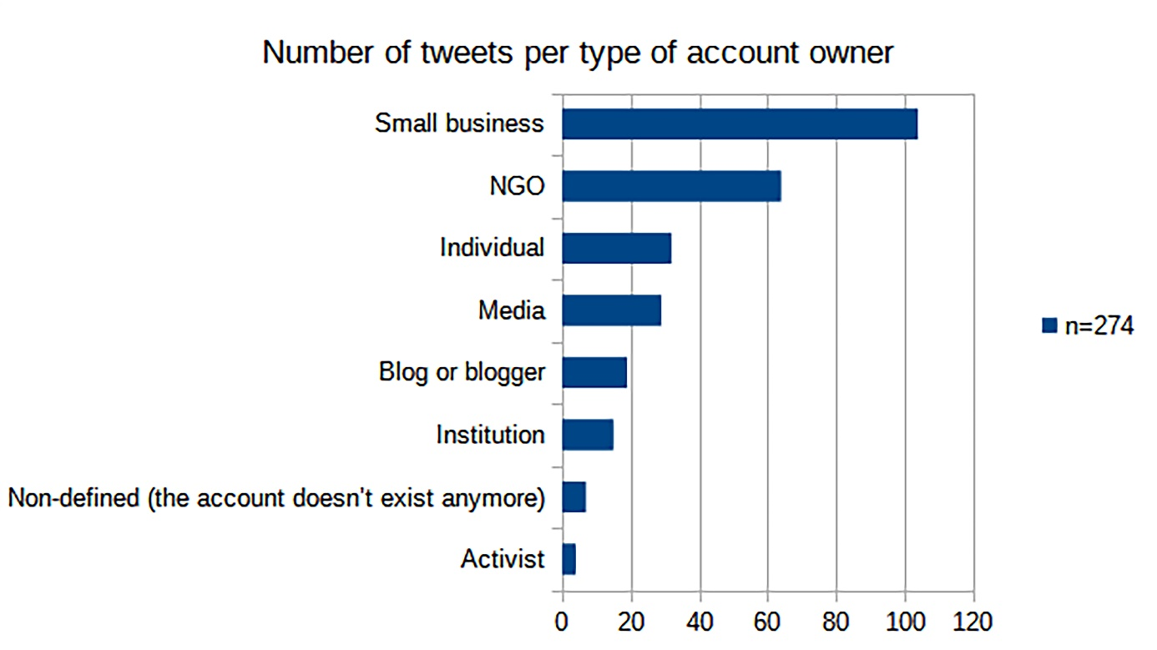
Figure 3: Number of tweets per type of account owner

In our corpus, the issue of fashion sustainability is driven mainly by small businesses (38%). These accounts are mainly local entrepreneurs, eco and slow fashion retailers or advisers. During Fashion Week, they use kairos – defined in rhetorical studies as the most favorable time to do something, in accordance with the etymological meaning of this term in ancient Greek (Kinneavy and Eskin 2000) – to boost their business mission statement while contributing to the campaign (for a broader discussion on multiple goals related to connective action in online activism and the role of small brands, see Greco et al. 2023). The second most represented category of account owners are NGOs (23%); more than half of those tweets (38 out of 64) come from accounts of the Fashion Revolution movement itself, which initiated this campaign.
Since a vast number of accounts identify themselves as interested in eco issues or/and sustainable and slow fashion topics, it seems that Fashion Revolution tweets are disseminated mainly by organizations and individuals who are already aware of the problem. Moreover, whether they are small businesses or NGOs, the entities who call for change in the fashion industry do not seem to have the power to impose anything on their audience, because of the digital communicative context in which such calls for action are formulated.

Who has to carry out actions towards more sustainability? Modal agents
A first significant result is that only 13,5% of the calls for action (37 out of 274 tweets) include an explicit description of the modal agent, such as las Marcas ‘the Brands’ in (3), indicating who should act, according to the activists. This is a low result for a campaign that originated in reaction to the Rana Plaza disaster, where rather concrete actors could be considered as co-responsible.
(3) @La_Segunda Para terminar con el modelo de #FastFashion, las Marcas deben replantearse sus formas de hacer negocio -no sólo reaccionar a temdemcias -. Tienen poder de transformar la moda, en una fuerza para bien socioambientalmente #FashionRevolution [link to journal article]
‘@La_Segunda In order to put an end to the @FastFashion model, the brands must reconsider the ways they do business - not only react to trends-. They have the power to transform fashion into a force for the better, from a socio-environmental perspective #FashionRevolution’
In 237 out of 274 utterances (86,5%), however, the modal agent is left rather vague, in such a way that the call for action can be interpreted as potentially referring to anyone, thus suggesting that the campaign aims to change the fashion production process through intermediary action: increasing awareness of customers is supposed to ultimately have an effect on the fashion industry. These strategies, in which the modal agent is left vague, mainly rely on deictic forms, such as 1st person plural references in (4) or 2nd person forms, for instance through an imperative as in (5). The choice for a vague actor ties in with an overall campaign mode wherein no specific actor is being called to action.
(4) We make the fabrics & clothes for the industry based in India. It is sad that so many workers lost their lives. This week we should all unite & stand together not only for bangladesh but also for all the workers developing countries #FashionRevolutionWeek #FashionRevolution

(5) FASHION REVOLUTION. JOUR 7
Signez notre manifeste (lien en bio)
Demandez aux marques #whomademyclothes
(…) #fashionrevolution
(…) [link] [picture] (@FashRev)
‘FASHION REVOLUTION. DAY 7
Sign our manifesto (link in bio)
Ask brands #whomademyclothes
(…)#fashionrevolution
(…) [link] [picture] (@FashRev)’
The 2nd person singular messages that are not imperatives, such as (6), often oscillate between various possible addressees. While uses of the 2nd person singular form can range from merely deictic to more generalizing (as pointed out by Kluge [2012] in a comparative study of French and Spanish), the range of possible addressees is even broader in English, since you can refer to singular or plural and express informal or formal address (Maggioni 2022).³ Moreover, the context of Twitter, where virtually anyone could be a reader, contributes to the difficulties of interpreting 2nd person forms that are unmarked for number or politeness. Except when tweets are posted in reply to another message, include a tag to account that can be interpreted as addressee, or mark the addressee in another form, messages can address a very broad audience, in this case defined as the buyers of clothes. While a certain type of stakeholder is then defined as modal agent, its potential reference remains vague and as such contributes to a potentially very broad interpretation.
(6) Every worker deserves a #livingwage How does your favorite brand stack up? When you buy fair trade, you know that workers have good, safe conditions and are paid a fair wage. #fairtrade #socialjustice #whomademyclothes #bethechange #fashionrevolution [picture]
As said above, only a limited number of tweets make the intended actor for change highly explicit. Among these, 15 portray the fashion industry as a whole as an important actor and 17 specifically present the fair fashion industry or brands as important actors. The fairly even distribution of fashion industry vs. fair fashion industry mirrors a more general tension concerning sustainability, namely whether dedicated brands are the solution to the problem or rather the whole industry should change its production model. 7 tweets explicitly portray the Fashion Revolution movement itself as the actor for change, again suggesting that the big players are not presented as the main drivers of change
In addition, a series of calls for action or for change in attitude appear with other explicitly mentioned actors for change that are mentioned only once or twice in our corpus, such as a specific city, but also isolated occurrences of workers, graduates or teenagers.
These results show that the responsibility for the sustainable fashion change is mainly attributed to the social media audience, which remains to a great extent undefined and unspecified. While this is in line with typical modes of campaign communication, it creates low accountability for actually carrying out the actions (see also Greco and De Cock 2021; Greco 2022). Moreover, we have shown that the account owners who usually call for change do not have the power to impose anything on their audience, as they are mainly small businesses and NGOs, as well as individuals and media. This lack of impositive force may precisely motivate the choice for a campaign that attempts to convince a wider (but maybe less defined) audience, rather than specific actors. We detail below how the calls for action in positions of low impositive force are expressed.

Deontic structure of the call for action in positions of low impositive force: imperatives in English and French
Through a more detailed analysis of the deontic structures, we now turn to consider how the modal source and agent are represented (or not) and especially how much impositively the call for action is formulated. We look into the imperative and other deontic structures in English and French respectively, the two most used languages in our corpus, before proceeding to the analysis of the other languages.
Out of the 274 tweets with a call for action, 215 tweets contain an imperative form. Imperatives represent then the main expression of deonticity, with some differences according to languages (82% of the tweets in English contain an imperative; 80% in Spanish; 60% in French; 0% in German, which has only 1 tweet in our data). In line with the overall dominance of English, 187 of the tweets with an imperative are in English (see Figure 4 for further detail). Figures concern the overall number of tweets containing at least one imperative form and not the overall number of imperatives. Indeed, some tweets contain more than one imperative or an imperative combined with another deontic structure.
The overall high frequency of the imperative, a very impositive form, creates a strong call for action because the imperative is formulated towards the reader as the modal agent and moreover presents the action as an obligation. As the modal source is not explicit, we then interpret it as coinciding with the account owner.

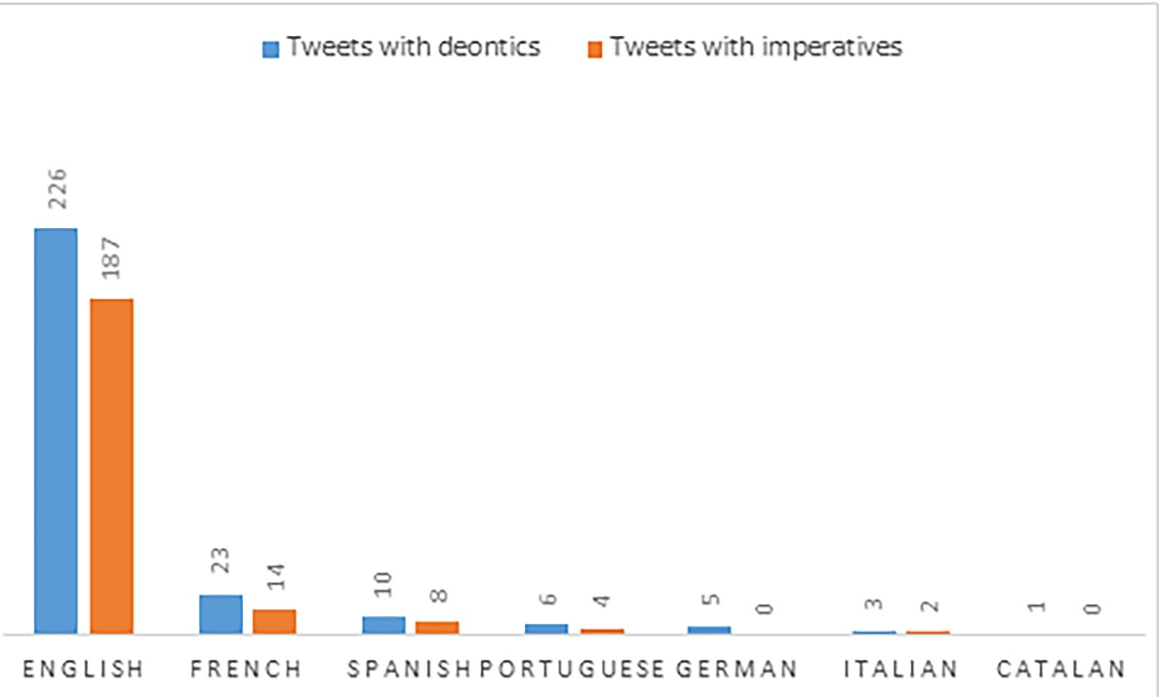
Figure 4: Presence of deontics and imperatives in the tweets, classified per language]

The positive imperative dominates by far, e.g. in English 182 tweets contain a positive form and only 5 a negative form. In only a few cases is the deontic force attenuated into a polite request by adding please (7), which also calls for attention, while one tweet contains the French abbreviation RSVP (“répondez s’il vous plaît”), that expresses both imperative and polite request in a loan lexicalised structure.
(7) If you're looking for Spring dresses, please support brands that care about the people who make them!
Women's dresses [link]
Girls' dresses [link]
15% off reg. price w/code ETHICALFASHION now thru 4/30
#FashionRevolution #WhoMadeMyClothes [picture]
English forms address the reader in a direct way. As for the grammatical person, English tweets display in general the second person you, whose number is currently unmarked though originally plural (Maggioni 2022). As mentioned above, this morphological unmarkedness often makes the interpretation of the modal agent ambiguous. However, other elements in the context can help to narrow down the interpretation. Thus, in (8) the presence of yourself clearly shows that the singular is meant, while teens in (9) points towards a plural interpretation. In (8) we see moreover that the imperative is prepared by questions, which already suggest that consumers should take action.
(8) Have you ever asked yourself this question? The answer is most likely exploited women that live in poverty. So ask yourself this - How can I support businesses that treat their staff fairly and ethically? Do some research and tweet your suggestions #fashionrevolution #DC20 [picture]

(9) Fashion conscious teens. Fashion is completely made up. It’s major social function is to highlight class division and express allegiance to various subcultures. Wear whatever the hell you want as often as you can, and donate to ethical resale outlets.
#FashionRevolution
The 1st person plural imperatives, as in (10), are much rarer. While in a 2nd person imperative, the modal agent is entirely dissociated from the speaker, in a 1st person plural imperative the speaker is both modal source and part of the modal agent, thus reducing the potential face-threat of the imperative (De Cock 2014). This is particularly interesting in the case of (inciting to) digital activism, where the modal source has no power to oblige the modal agent to act but rather has to encourage or convince the modal agent.
(10) Lets make everyday Earth day.
dont forget about #FashionRevolution week #iamthechange [picture]
The imperative is the most represented deontic structure also in French, with 12 positive and 2 negative imperatives, even if with a lower relative frequency than in English. Positive forms manifest 2nd (vous, 8 verbs related to getting informed) but also 1st person plural (nous, 1 verb related to getting informed and 2 verbs related to activism). Even if the 2nd person plural may also be interpreted as a polite form for addressing a singular interlocutor, the context makes the plural interpretation more relevant. Whereas the modal agent is entirely dissociated from the source in the 2nd person, the first plural person has an inclusive function and shows the typical “pedagogical” attitude of the French expert (cf. Cigada 2014: 46 and 134–135), in which modal agent and modal source coincide (11).
(11) Ahhh la création, l'innovation... elle sont souvent source de destruction massive... Informons-nous sur la provenance des matières et sur la manière dont elles sont produites !
#fashrev #fashionrevolution #thinkbeforebuying #reflechiscestgratuit #anotherfashion #lifebeforefashion [picture]
‘Ahhh creation, innovation… they are often a source of massive destruction… Let’s inquire about the origin of the materials and the way they are produced!
#fashrev #fashionrevolution #thinkbeforebuying #thinkitsfree #anotherfashion #lifebeforefashion’
Upon closer analysis, we see that negative imperatives do not express prohibition, which would not be unimaginable in this kind of campaign e.g. in an attempt to reduce unsustainable production or shopping habits. Rather, such negative imperatives show some degree of lexicalisation and have the pragmatic function of a kind invitation, thus again reducing impositive force. This is the case for the 5 English negative imperatives, and for the 2 negative forms in French, which moreover contain vous in a lexicalised politeness strategy with a honorific 2nd person singular form, i.e. a variant for polite address to a singular interlocutor (12).
(12) Dans le cadre de la #FashionRevolutionWeek , nous avons co-écrit un article en toute transparence sur notre chaîne de production. N'hésitez pas à y faire un tour et réagir ;)
‘In the context of the #FashionRevolutionWeek, we have co-written an article with full transparency about our production chain. Do not hesitate to have a look and react ;)’

Other deontic structures in English and French
Even though the imperative is the most frequent deontic structure, others occur as well, like modal verbs and adjectives expressing deontic meanings. This variety was also observed in other contexts of non-impositive attempts to change behavior, namely expressions for social regulation in comments to blogs (González Arias and Satt Román 2016) and in prevention campaigns of Covid-19 (Silva Oliveira 2021). These deontic verbs and adjectives entail different configurations of modal source and agent, often leaving both rather vague.
In English, 61 tweets contain such other deontics though they sometimes appear in combination with an imperative. These concern lexical items, such as verbs (need, should, cannot, must, haven’t to) and the verbal adjective with -able suffix. In these cases, the modal agent may be less clearly identifiable than with the imperatives. The most frequent of these forms is the modal verb need (20 occurrences). Other forms such as should (5 occurrences), can’t/cannot (3 occurrences) and must (one occurrence as a verbal determinant) are less represented. While need allows to leave the modal agent implicit (13), thus attributing responsibility to potentially anybody, most need forms are expressed with a 1st person plural subject (14), which plays the role of modal agent, referring inclusively (Siewierska 2004) to the speaker and the addressees. The adverb still reinforces the urgency.
(13) Today is the anniversary of Rana Plaza disaster in Bangladesh - the factory collapsed killing 1100+ people. Fast fashion is sold at a low cost in the U.K. by compromising workers rights, pay and working conditions in the supply chain this needs to change #FashionRevolution [picture]

(14) 1/2 If self-isolating feeling ok maybe it's a good opportunity to learn crafting skills. Whenever #corona settles we'll still need to fight #ClimateCrisis help lives of vulnerable so let's use this to learn to make, repair or upcycle our clothes? @Fash_Rev #fashionrevolution
While negative imperatives are not used to prohibit or dissuade, as shown above, but to formulate an invitation, the expression of prohibition or dissuasion to perform undesirable behavior seems to be expressed by other structures which leave the modal agent not expressed and, as such, are much less impositive. Particularly the verbal adjective with the suffix -able and a negative prefix (e.g. unbelievable) or negation adverb (e.g. not disposable) creates a regular structure meaning “that cannot be V-ed”, representing a prohibition, since a reason is given why the disposing of clothes is not desirable (valuing the people who make them). The modal agent is not expressed and has to be interpreted in a universal way (15). This is further underlined by the use of an inclusive we in the expression of the cause, suggesting that the account owner and the audience share the same values.
(15) Repost @Fash_Rev: Reminder: Clothes aren’t disposable, because we value the people who make them, and because #LovedClothesLast.
Embroidery by @EvaKittelsen #FashionRevolution [picture]
Moreover, there are other more complex strategies, which in some cases show some degree of systematicity, like references to time, as in (16), which assigns modal agency to anybody. There are 9 occurrences in English and a similar structure is attested both in French and Portuguese. Deonticity may also be expressed by abstract nouns, in English (17), reinforced by the presence of imperatives in the tweet (check out, share, ask), but also in French.
(16) It's Fashion Revolution week, and we are so here for it. It's time to ask: Who made my clothes? Who made my products? How were they made? I feel like, more than ever, this pandemic is bringing to light its importance. #sustainableshopping #ethicalshopping #fashionrevolution

(17) Every year since #FashionRevolution started the call for a fairer, more sustainable and transparent fashion industry has been growing.
Now the 2020 FashRevWeek has started - check out the online events, share stories and ask the brands #WhoMadeMyClothes [link to announcement]
We furthermore find verbs like require, demand, encourage, call, and the structure it is important to, expressing different degrees of obligation, showing again how account owners can vary the impositive force when trying to convince their audience. As has been shown, English tweets are direct and quite simple from a linguistic point of view. In just two cases we found more elaborate deontic structures, such as the optative form (may we+infinitive) in (18) with an almost lyric sense-effect:
(18) Nothing should go back to normal. Normal wasn't working.
If we go back to the way things were, we will have lost the lesson.
May we rise up and do better.
~ Chris Kidd via @LinkedIn #FashionRevolution #EarthDay

In (19), we find a conversive, displaying deonticity in the perspective of those who have a right, presenting “your favorite brand/fair trade” as the modal agent to attain social sustainability.
(19) Every worker deserves a #livingwage How does your favorite brand stack up? When you buy fair trade, you know that workers have good, safe conditions and are paid a fair wage. #fairtrade #socialjustice #whomademyclothes #bethechange #fashionrevolution [picture]
In French, we counted 9 tweets containing other deontic structures (which generally occur in a tweet where there is no imperative form included), namely modal verbs devoir ‘have to’, demander ‘ask’, inciter ‘incite’, inviter ‘invite’ and the adjective nécessaire ‘necessary’. (20) with devoir represents a rare case where both deontic agent (l’industrie de la mode ‘the fashion industry’) and deontic source (quoted speaker Dana Thomas) are made explicit.
(20) Dana Thomas : "L’industrie de la mode doit changer et repenser son système." (via @marieclaire_fr) [link]#slowfashion #fashionrevolution
‘Dana Thomas: “The fashion industry must change and rethink its system.” (via @marieclaire_fr) [link]#slowfashion #fashionrevolution’
We find a more indirect strategy in example (21), where nécessaire qualifies the abstract noun mobilisation: both modal source and agent are implicit, but the reader can easily infer that mobilization involves anybody. The adjective is intensified by an adverbial form (plus que jamais) and, at the visual level, by the used of upper-case characters in the tweet (García Aguiar 2019):
(21) 7 ANS APRÈS LA CATASTROPHE DU RANA PLAZA, LA MOBILISATION RESTE PLUS QUE JAMAIS NÉCESSAIRE
EN MÉMOIRE DE TOUS CEUX QUI NE SONT PLUS LÀ…[link Instagram]
‘/DO YOU KNOW WHO MADE YOUR CLOTHES?/
#whomademyclothes #fashionrevolution
‘7 YEARS AFTER THE RANA PLAZA DISASTER, MOBILIZATION REMAINS MORE NECESSARY THAN EVER.
IN MEMORY OF ALL THOSE WHO ARE NO LONGER THERE…[link Instagram]
‘/DO YOU KNOW WHO MADE YOUR CLOTHES?/’

Deontic strategies in other languages
Romance languages other than French are far less represented in our corpus. Out of the 10 Spanish tweets, 8 contain an imperative form, mostly in the informal 2nd person singular (e.g. inscríbete ‘register’, participa ‘participate’), which we did not find in the French data. There are 2 negative lexicalised forms no te pierdas ‘don’t miss’ and the equivalent plural honorific form (22). Thus, in terms of positive vs. negative imperatives, the tendency is similar to what we found for French and again these negative imperatives do not express prohibition or dissuasion from undesirable behavior, but invitations. The campaign then focuses on trying to impose desirable behavior, not on trying to prohibit or reduce behavior that is harmful to sustainability.
(22) Mañana comienzan las actividades digitales de la Semana de Fashion Revolution! No se lo pierdan! #FashionRevolution [picture]
‘Tomorrow the digital activities of Fashion Revolution Week start!
Don’t miss it! #FashionRevolution’
We also find an impersonal form (hace falta ‘it is needed’), the deontic verbs necesitar ‘to need’ and deber ‘have to’, with explicit modal agent and implicit modal source, as in (3). Similar results are found in Italian, where tweets contain a positive (segui ‘follow’) and a negative (non mancare ‘don’t miss’) 2nd person singular, as well as deontic verb dovere ‘have to’, in the conditional form (dovrebbe) expressing a sort of mitigated duty in an impersonal way.
For Brazilian Portuguese, the 2nd person singular imperative form leia ‘read’ occurs twice. Furthermore, deonticity is expressed twice by precisamos ‘we need’, and once by the verbal form exige ‘requires’ (23). In this example, the abstract noun busca ‘search’ as subject hides the modal source while the modal agent is explicit, namely diversos atores ‘different actors’.
(23) #FashionRevolution | A busca é constante e exige a ação de diversos atores – e também uma boa dose de luta, coragem, perseverança e amor. [link]
‘#FashionRevolution | The search is constant and requires the action of different actors – and also a good dose of fight, courage, perseverance and love.’
The only German tweet uses the adjective wichtig ‘important’. The modal source is explicit and the modal agent is made explicit by the possessive unsere ‘our’ (24).
(24)“Es ist genauso wichtig, unsere Kleidung zu flicken wie kaputte Systeme zu reparieren", so die Gründerin der #FashionRevolution [link]
‘”It is as important to mend our clothes as to repair broken systems”, says the founder of #FashionRevolution’

As shown, a wide variety of deontic structures is then observed. General tendencies are that, despite their lack of impositive force, the activists who act as modal source predominantly use an imperative form directed to their audience (presented as vague modal agent, leaving room for a universal interpretation) to involve them in the call for action to change the fashion industry. In spite of the wish of Fashion Revolution to change current behavior, few prohibitions are being formulated and, rather, people are incited to undertake specific kinds of actions.

Argumentation to strengthen the call for action
The modal analysis discussed in the previous sections revealed the presence of numerous tweets soliciting actions, often by means of imperatives. This happens in a context where the account owners do not have the power of enforcing a given behavior on the modal agents and yet, as discussed in the Introduction, they seem to be successful in getting more attention on the topic . For this reason, we complement the deontic analysis with a basic argumentative analysis in order to verify whether the need to justify a call for action was present.
Our findings reveal that argumentation is present in a significant number of tweets (see Figure 5).

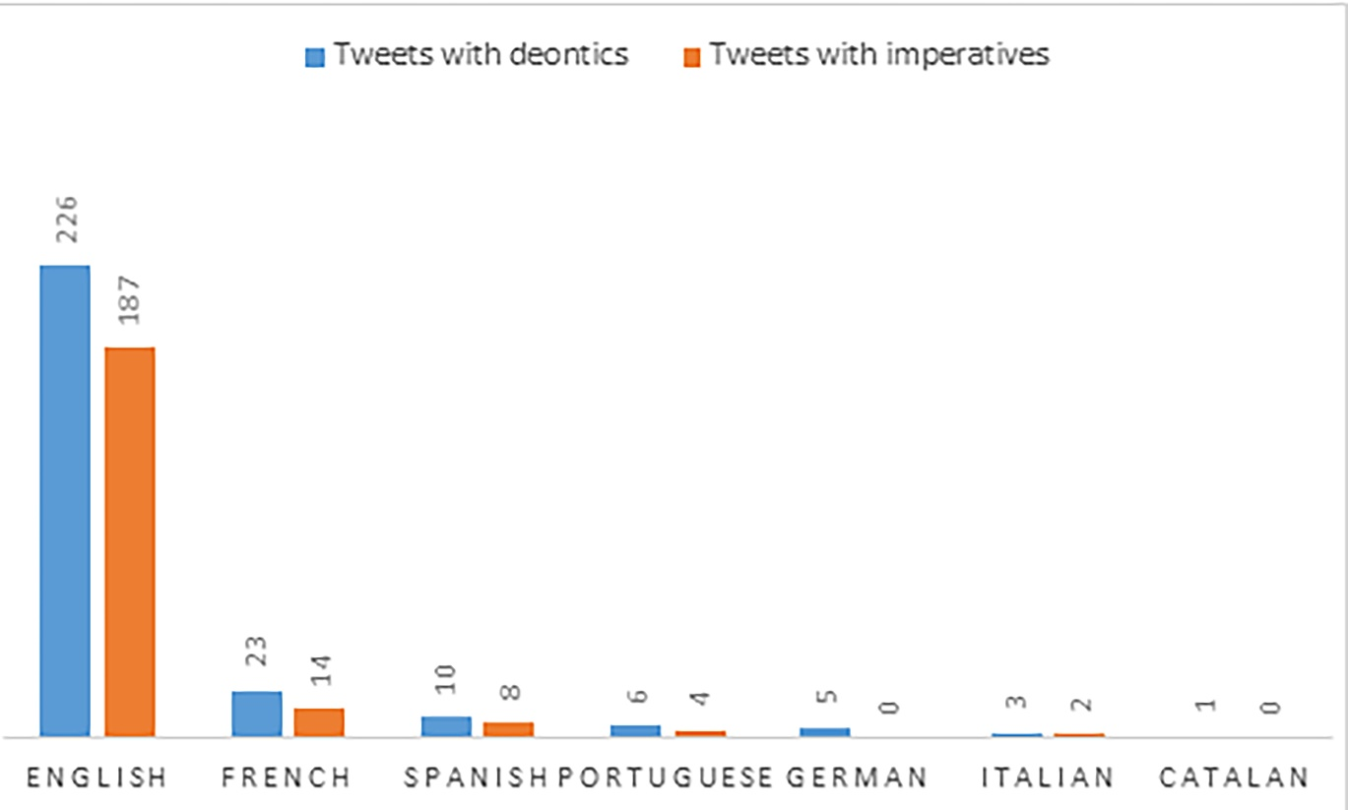
Figure 5: Types of argumentation in the tweets

More precisely, 39% (106) of tweets clearly contain argumentation, as they include a standpoint affirming the call for action supported by one or more arguments as for example in (25).
(25) [argument] #fashionrevolution has been supporting the movement towards a more ethical and sustainable fashion industry for the past 7 years following the Rana Plaza garment factory disaster in 2013. [standpoint] Head over to our FB to find out ways that YOU (yes, from home!) can help make a difference! [picture]
The large presence of argumentation suggests that account owners feel the need to justify their calls for action. Not surprisingly given the theme of the considered campaign, 89 of the 106 (81%) cases of explicit argumentation include sustainability topics in the argument, thus clarifying the reason for action. In particular, we coded 22 arguments as referring to environmental issues (e.g. climate crisis, waste and need for recycling, pollution etc.), 17 to social issues (workers exploitation, safety conditions, as well as gender-based discrimination, violence, and child labor), 11 to both environmental and social issues and 39 about a generic concept of sustainability (e.g. an unspecified concept of ethical fashion).
In addition to explicitly argumentative tweets, we found 21% (58) of tweets that contain a standpoint and a link to an external document or website that features argumentation. The association between an explicit standpoint and external arguments has been considered before as a form of argumentation typical of Twitter (Schäfer and Stede 2021: 50).
Given the limited number of characters allowed by Twitter as a platform, the presence of a large number of messages directly or indirectly containing argumentation is per se a result that goes against views of Twitter as a space that does not allow for argumentation (see also Balabanova et al. 2023). In fact, it confirms the need to justify calls for action by account owners (such as entrepreneurs and retailers) who do not have the power to impose their calls for action.
101 tweets included an unjustified claim, which was not supported by explicit argumentation. Even though strictly speaking a claim that is not supported by argumentation is not a standpoint, in this specific context we might interpret these claims, in a perspective of intertextuality, as repeating or amplifying standpoints expressed elsewhere and justified by argumentation. In fact, once again, the limited number of characters and the “fast-paced” nature of Twitter (Schäfer and Stede 2021: 46) might explain why senders focus on a claim without supporting it with arguments. If we interpret these unfounded claims within the context of the Fashion Revolution Week, they might invite people to find more information on the broader communication campaign on Twitter and beyond, which would provide supporting arguments.
Finally, only 9 tweets were eliminated from the analysis as their content cannot be reconstructed as clearly including argumentation (see Theoretical framework), meaning that the combined analysis of the members of the team could not clearly reconstruct either a justified claim (standpoint) or at least a claim that, as explained above, could be or has been already argumentatively discussed.
As a second step, drawing on van Eemeren (2017) we classified the type of standpoint in the considered tweets (excluding the 9 tweets that were not related to argumentation). We noted that the vast majority (235 or 85,7%) include a prescriptive standpoint, while only 26 (9,4%) include an evaluative standpoint and 4 (1,5%) a descriptive standpoint. The prescriptive standpoints are frequent as they correspond to calls for action. The evaluative standpoints tend to concern either a negative evaluation of the current fashion (26, see the standpoint “The fashion industry is one of those that most contaminates, in addition to being responsible of a big part of the global emissions”) or a positive evaluation of the involvement in the Fashion Revolution week, creating the case for change. Indirectly, this evaluation may provide the basis for a call for action in the context of the Fashion Revolution campaign.
(26) La indústria de la moda és una de les que més contamina, a més de ser responsable de gran part de les emissions globals. Les rebaixes són només una fase més, amb la condició que la gent consumeixi encara que no ho necessiti. #CrisiClimàtica #FashionRevolution #WhoMadeMyClothes)
‘The fashion industry is one of those that most contaminates, in addition to being responsible of a big part of the global emissions. Sales periodes are no more than another phase, with the condition that people consume even if they do not need. #Climatecrisis #FashionRevolution #WhoMadeMyClothes’
In sum, our basic argumentative analysis confirms the fact that the calls for action expressed through deontics, and often associated to prescriptive standpoints, are justified by explicit argumentation or by a connection to external argumentation in the majority of cases.

Type of action to reach fashion sustainability
Understanding what types of actions are called for is important to complete our analysis of how participation (and which kind of participation) is encouraged during the Fashion Revolution week. The different typologies were established inductively through the analysis, taking into account different ways of being an activist online and offline. 137 out of 274 utterances call for action to attend (in person or online) activities organized as part of the Fashion Revolution Week, as in (27).
(27) See you there! It's a great week to get involved, there's so much planned for #FashionRevolution and we can't wait to chat all about it hope you've been well? (@EthicalHour)
This type of action has been classified as a call for ‘(digital) activism’, along with calls for action in which deontic constructions such as ask yourself, signez notre manifeste ‘sign our manifesto’, come join us, etc. are used. In these cases, the actions invite to reflect on the Fashion Revolution issues and participate in specific events or in the general campaign.
In addition to this, we selected three other main types of action, namely a) the call to 'inform' or get informed, b) the call to 'change', c) and the call to action on 'fashion behavior'. The call to inform or get informed concerns the invitation to visit a web page, to check out (28) or to have a read, for example. Through these calls, the modal agent is invited to learn more about the Fashion Revolution (issues) and the ways to improve fashion. This message also showcases the hybrid position of many small businesses that are at the same time activists and owner of a commercial activity, as in (28) where the tweet leads to an extensive blog post on sustainable fashion with a very short link to own sustainable products.
(28) Why do we need a #FashionRevolution? Have a read of my new blog post and check out my new wearable art work Supply Chain: [link][picture]
Finally, we distinguish between calls for change, formulated in more general terms, and calls for action on fashion behavior, formulated in more concrete terms. While the former type of call is limited to raising awareness of the necessity of changing things (29), the latter proposes concrete ways to make this change, for example by “buying less and better quality, thrifting or renting, and shopping your wardrobe” in (30), which are examples of politically motivated consumerism (both supported by explicit argumentation).
(29) Did you know?
The dyeing & finishing phase of textiles production can require as much as 200 tons of water per ton of textile produced.
The fast fashion industry isn't sustainable for workers, but it's also not sustainable for our planet. We must do better. #FashionRevolution [picture]

(30) Did you know that when you buy different sizes of the same garment your returns probably go to the landfill or get destroyed? Reduce consumption by buying less & better quality, thrifting or renting & shopping your #wardrobe. #ethicalfashion #sustainableliving #FashionRevolution [link]
The general results show that in an almost equal number of tweets, account owners inform citizens, or call them to inform themselves (79 tweets, 28.8%) or encourage to engage in online actions (74 tweets, 27%). This signals a focus on digital activism rather than on real-life actions, although it could be mainly due to the Covid-19 pandemic. Only 18% of the utterances refer to fashion behavior and 7% indicate a need for change.
It is worth noting that the tweets focused on the Fashion Revolution campaign, namely the need to change the fashion industry and to raise awareness to improve workers' conditions, are more related to social sustainability, while the tweets related to individual actions are more about environmental sustainability. This difference reflects the typical nature of connective action, in which individuals are asked not only to act collectively (as in social movement protests), but also to participate in change individually according to different goals (Highfield 2016: 103–104). Finally, almost 20% of the tweets did not mention any kind of action. Interestingly, we may say that a large number of calls for actions are related to digital activities, which may be surprising for a campaign that ultimately wishes to promote behavioral change. Future research may establish whether this is related to April 2020 and the first lockdown in the Covid-19 pandemic or whether this is a general feature of connective action. Contrastingly, there is no clear tendency regarding the type of action and the account owners. All actions called for fall within the scope of cause-oriented participation, rather than political sphere-oriented participation, which is a type of participation also associated with environmental influencers (Dekoninck and Schmuck 2023).

Conclusions
This paper contributes to research on connective action in digital activism, with a focus on the Fashion Revolution Week campaigns for a more sustainable fashion system. While activism is not a new phenomenon, digital activism has just passed its infancy and has been described as a “raucous teenager” (George and Leidner 2019: 16). It has already been noted that the type of action in digital activism is partially different from the standard activist action, in it being a connective action in which individuals use social media to intertwine their individual goals with collective goals. However, linguistic research on how connective action is initiated and supported discursively was not yet present. Yet, it is important to delve into the discourse motivating connective action in order to better understand a phenomenon in which activists’ discourse seems to be managing to actually involve more and more people to engage in the campaigns and discuss the sustainability of the fashion system. Arguably, it is valuable to understand what kind of discourse, even though deprived of impositive power, can still motivate people to engage in (connective) action. Moreover, some of the findings might be further elaborated in a perspective of communication design (Aakhus, 2007) to reflect on how to improve public or activist campaigns on important topics such as reducing violence and hate speech, increasing sustainability in different domains, and so on.
Our analysis focused on a successful case of digital activism, if we consider the increasing interest in sustainable fashion and the increasing number of followers of the Fashion Revolution accounts worldwide. Despite existing criticism about digital activism, sometimes pejoratively labeled as “clicktivism” or “slacktivism” (Dennis 2019: 185), it has been recognized that digital activism is related to change and awareness raising on new issues, offering an opportunity for “discursive engagement” (Dennis 2019: 185). For this reason, it is important to define how the engagement in connective action and the increase in awareness are generated discursively and what linguistic strategies support it in campaign types where the author does not have impositive force on the audience, and where the formulation of the desired change in the deontic content and its reason is crucial. This paper contributed to fill this gap, showing what types of actors are put forward, through what deontic structures the call for actions are formulated, what kind of argumentation is given, and what type of action and kind of sustainability is being called for. Our analysis moreover fully takes into account the international nature of Fashion Revolution, by including tweets in various languages.
The most important features revealed by our analysis are the following:
A wide variety of actors call for change in the Fashion Revolution, including the founding organization Fashion Revolution but also other NGOs and a relatively high number of small businesses, which use the Fashion Revolution Week rhetorically as a kairos. What all these organizations have in common is that they do not have impositive force. They need therefore to discursively persuade people to undertake the prescribed actions, many of which are related to changing one’s behavior in fashion consumption and/or to getting informed. The latter are motivated by the need of awareness raising and the assumption that such awareness raising will lead to behavioral changes. These are typically individual actions that go hand in hand with the collective initiative of the Fashion Revolution Week, which is characteristic of digital connective action.
Linguistically, we observe a significant presence of deontics, mainly in the form of imperatives, which clearly present a modal agent, while fewer structures clearly include the modal source. The modal agent portrayed often refers to the addressee(s) or is left vague, depending also on specific linguistic structures such as the unmarkedness of singular/plural in the English second person. While this implies a lot of potential actors, possibly mobilizing many, one could consider that this also diffuses the responsibility of some major players. Only a small amount of messages clearly portray (parts of the) fashion industry as the modal agent. This may tie in with the activist approach that mainly tries to mobilise individuals. On the other hand, this also means that the responsibility is mainly put on the shoulders of the consumers and that the big players, who can bring about systemic change, are in the end not often presented as the actors that should undertake concrete action. Future research may investigate other strategies through which activists address big fashion brands, such as campaigns like #PayYourWorkers or #PayUp (Greco, 2023).
Argumentatively, the calls for action are often formulated as prescriptive standpoints, which can be either supported by explicit arguments or by links to external documents, or again remain unsupported and only invite people to refer to the general context of the Fashion Revolution Week to derive some good reasons to act. Both social and environmental sustainability are being referred to in the argumentation as reason, but the type of sustainability is often left implicit or rather general, leading again to some vagueness as to which action by whom is needed.
Obviously, our study has some limitations. First, we only considered Twitter, while the Fashion Revolution Week also “happens” on other social media platforms, particularly Instagram. Second, we only considered 2020. While, as said above, this is interesting for the specific conditions related to the Covid-19 pandemic that made digital activism particularly important, one could argue that, in the preceding and following years, a different weight will be given to offline actions such as protests and others. This remains to be verified in further research.
By means of the discursive and linguistic analysis proposed, we can now substantiate what it means to call for a “Revolution” in fashion through digital activism in the Fashion Revolution Week.

Endnotes
1. We use the term ‘Twitter’ here, because data was collected before Twitter was named X in the summer of 2023.
2. Fashion Revolution impact reports are available at: https://www.fashionrevolution.org/impact/ (last visited: September 2023).
3. As Maggioni (2022) points out, some varieties of English do have more specific plural references but these are not observed in our corpus.

Acknowledgements
The authors thank the anonymous reviewers for their helpful suggestions. The authors furthermore gratefully acknowledge the support of COST Action CA17132 ‘European Network for Argumentation and Public Policy Analysis’ (www.publicpolicyargument.eu). Laetitia Aulit was funded by the Fonds Spéciaux de Recherche of the Université catholique de Louvain, project title: “Atténuation et intensification pour la prise de position dans des situations de controverse: le cas de trois débats sociétaux espagnols dans le discours oral et dans les nouveaux médias”. The authors thank the Centre de traitement automatique du langage of the Université catholique de Louvain, and especially Hubert Naets, for downloading the tweets, as well as Laura Aguiar De Souza Penha Marion and Neus Nogué Serrano for assistance with the Portuguese resp. Catalan examples.

References

Aakhus, M. 2007. ‘Communication as design,’ Communication Monographs 74(1): 112-117.
- Avila, R. and P. Gras. 2014. ‘“No sin él”: análisis crítico del discurso de las campañas de prevención del VIH dirigidas a hombres que tienen sexo con hombres en España (2006–2011),’ Discurso y Sociedad 8(2): 137–181.
- Balabanova, E., Palmieri, R. and Z. Liu. 2023. ‘Twitter (X), Fast Fashion and Backlash: Argumentation and Ethics on Social Media,’ Business and Professional Communication Quarterly, 0(0). https://doi.org/10.1177/23294906231208411
- Bennett, W. L. and A. Segerberg. 2012. ‘The logic of connective action,’ Information, Communication & Society 15(5): 739–768. DOI: 10.1080/1369118X.2012.670661.
- Brown, P. and S. C. Levinson. 1987. Politeness: Some Universals in Language Usage. Cambridge: Cambridge University Press.
- Caffi, C. 2007. Mitigation. Amsterdam: Elsevier.
- Cigada, S. 2014. Les procédés du discours argumentatif en français. Sainte-Luce-sur-Loire: Bookelis.
- De Cock, B. 2014. ‘Verbos deónticos en primera persona: un corpus general frente a un corpus parlamentario,’ Círculo de Lingüística Aplicada a la Comunicación 59: 16–34.
- Dekoninck, H. and D. Schmuck. 2023. ‘The “greenfluence”: Following environmental influencers, parasocial relationships, and youth’s participation behavior,’ New Media & Society, (online first). DOI: 10.1177/14614448231156131.
- Dennis, J. 2019. Beyond Slacktivism: Political Participation on Social Media. Cham: Palgrave Macmillan.
- Ditty, S. 2020. Why we still need a Fashion Revolution. Fashion Revolution White Paper. [Online] https://www.fashionrevolution.org/why-do-we-need-a-fashion-revolution/ (last accessed: 08.02.2022).
- Eemeren, F. H., van. 2017. Prototypical Argumentative Patterns. Exploring the Relationship Between Argumentative Discourse and Institutional Context. Amsterdam/Philadelphia: John Benjamins.
- García Aguiar, L. C. 2019. ‘Mensajes condensados en 280 caracteres: Twitter’ in Robles Ávila S. & Moreno-Ortiz A. (eds.), Comunicación mediada por ordenador: La lengua, el discurso y la imagen: 207–233. Madrid: Cátedra.
- George, J. J. and D. E. Leidner. 2019. ‘From clicktivism to hacktivism: Understanding digital activism,’ Information and Organization 29(3), online first. doi:10.1016/j.infoandorg.2019.04.001.
- Gobber, G. and M. Morani. 2014. Linguistica Generale. Milan: McGraw-Hill.
- González Arias, C. and J. Satt Román. 2016. ‘Modalidad deóntica como expresión de la regulación social en el discurso político ciudadano en las cadenas de comentarios en blogs de periodismo.’ Ibérica 32: 201-220.
- Greco, S. 2023. ‘Twitter activists’ argumentation by means of sub-discussions: Theory, method and illustration on the controversy surrounding sustainable fashion,’ Argumentation 37: 1–23. DOI:10.1007/s10503-022-09579-1.
- Greco, S. and B. De Cock. 2021. ‘Argumentative misalignments in the controversy surrounding fashion sustainability,’ Journal of Pragmatics 174: 55–67. DOI:10.1016/j.pragma.2020.12.019.
- Greco, S., C. Mercuri, B. De Cock and R. Schär. 2023 (online first). ‘Arguing through best practice: the role of argumentation from example in activists’ social media posts on sustainable fashion,’ Discourse Studies, 25(4), 530–548. https://doi.org/10.1177/1461445623116342.
- Highfield, T. 2016. Social Media and Everyday Politics. Cambridge (UK): Polity Press.
- Karamalak, O. and L. Cantoni. 2021. ‘Rallying hashtags as a tool for societal change in fashion’ in Sádaba, T. et al. (eds.): Fashion Communication: 237–249. Cham: Springer. DOI:10.1007/978-3-030-81321-5_18
- Kinneavy, J. L. and C. R. Eskin. 2000. ‘Kairos in Aristotle’s Rhetoric,’ Written Communication 17(3): 432–444. DOI: 10.1177/0741088300017003005.
Kluge, B. 2012. Referential ambiguity in interaction. Establishing generic reference of second person singular pronouns in the Romance languages. Unpublished habilitation thesis Universität Bielefeld.
Kuo, R. 2018. ‘Racial justice activist hashtags: Counterpublics and discourse circulation,’ New media & Society 20(2): 495-514. DOI: 10.1177/1461444816663485
Lyons, J. 1977. Semantics. 2 vol. London/New York/Melbourne: Cambridge University Press.
- Maggioni, M. L. 2022. ‘Coping with ‘you’ and ‘they’ in early-21st-century English’ in Gilardoni, S. (ed.): Apprendere e Insegnare le Lingue: la Ricerca nella Didattica: 185–200. Brescia: Morcelliana.
- Naets, H. 2018. ‘Techniques de collecte et d’archivage des tweets: Partage de pratiques et d’outils’ in Aurore F. et al. (eds.), Pérenniser l’éphémère. Archivage et Médias Sociaux. Series Publications des Archives de l’UCL: 215–237. Louvain-la-Neuve: Academia Eds.
- Nuyts, J. 2005. ‘The modal confusion: On terminology and the concepts behind it’ in Klinge, A., H. Høeg Müller (eds.): Modality: Studies in Form and Function: 5–38. London: Equinox.
- Palmer, F. R. 2001. Mood and Modality (Cambridge Textbooks in Linguistics). Cambridge: Cambridge University Press.
- Rocci, A. 2017. Modality in Argumentation. A Semantic Investigation of the Role of Modalities in the Structure of Arguments with an Application to Italian Modal Expressions. Cham: Springer.
- Schäfer, R. and M. Stede. 2021. ‘Argument mining on Twitter: A survey,’ Information Technology 63(1): 45–58.
- Siewierska, A. 2004. Person. Cambridge: Cambridge University Press.
Silva Oliveira, A. 2021. ‘A modalidade deôntica no discurso da saúde: uma análise dos valores semânticos deônticos no tratamento e prevenção contra o coronavírus,’ Revista Humanidades e Inovação 8(36): 375–386
- St Clair, K. 2018. The Golden Thread: How Fabric Changed History. London: John Murray.
- van Dijk, T. A. 2023. ‘Analyzing frame analysis: A critical review of framing studies in social movement research’, Discourse Studies 25(2): 153–178. DOI:10.1177/14614456231155080
- van Dyke, N. and V. Taylor. 2019. ‘The cultural outcomes of social movements’ in D. A. Snow et al. (eds.), The Wiley Blackwell companion to social movements, 2nd edition: 482-498: New York: Wiley. DOI:10.1002/9781119168577.ch27
- Verstraete, J.-C. 2005. ‘Scalar quantity implicatures and the interpretation of modality: problems in the deontic domain,’ Journal of Pragmatics 37: 1401–1418.

