PERSUASIVE LANGUAGE IN CALL-TO-ACTION PHRASES OF FACEBOOK SKINCARE PRODUCT ADVERTISEMENTS

A Thesis
Presented to the Faculty of
Department of English
College of Arts and Sciences
Pampanga State Agricultural University
Magalang, Pampanga

In Partial Fulfillment
of the Requirements for the Degree
BACHELOR OF ARTS IN ENGLISH LANGUAGE STUDIES

By

AHLAI JEHZIEL M. VELASQUEZ
October 2026

INTRODUCTION

Background of the study

Social media has become one of the most powerful tools in modern marketing, with Facebook standing as one of the largest digital advertising platforms worldwide. As of 2025, Facebook remains one of the most widely used social networking platforms globally, with approximately 3 billion monthly active users (Statista, 2026). This makes it a highly influential space where brands can reach vast and diverse audiences. In this digital environment, the beauty industry increasingly relies on online advertising to promote products, build brand identity, and influence consumer actions. One of the most commonly used persuasive tools in these advertisement captions is the use of call-to-action (CTA) strategies, which are designed to direct users toward immediate engagement such as purchasing, trying, or learning more about a product. Through these short but powerful expressions, skincare brands strategically communicate persuasive messages that combine emotional appeal, urgency, and consumer motivation within a highly competitive digital marketplace.

Digital communication, enabled by modern technologies, extends traditional forms of human interaction by combining elements such as voice, images, sounds, and symbols. These are processed and transmitted through tools like computers, mobile phones, networks, and software. This is commonly experienced through the use of internet-enabled mobile devices for communication, browsing, transactions, and entertainment (Abubakar et al., 2023).

According to Moorthi (2025), social media advertising is a form of digital marketing that utilizes platforms such as LinkedIn, YouTube, Facebook, X, TikTok, and Instagram to distribute paid promotional content to specific audiences. It enables businesses to quickly convey their value proposition, strengthen brand recall, and reach highly targeted groups through data-driven personalization. Moreover, compared to traditional advertising methods, it is considered cost-efficient and capable of generating a strong return on investment. In addition, although social media advertising can be difficult to navigate, when properly managed, it becomes a powerful tool that enables businesses to surpass their marketing objectives (McCormick, 2026).

The beauty and personal care market in the Philippines continues to experience steady growth despite changing consumer preferences, economic conditions, and increasing competition among local and international brands. According to Euromonitor International (2025), rising awareness of personal grooming and the emergence of beauty-related technological innovations continue to sustain demand in the sector. Furthermore, skincare represents a key segment of the beauty and personal care industry and has become increasingly prevalent among individuals in the Philippines due to growing awareness of self-care and personal grooming practices.

A call to action (CTA) is a marketing concept that directs consumers toward a specific next step that marketers want them to take. It can appear in various forms, including direct prompts such as buttons labeled “Buy Now” (Kenton, 2025). CTA phrases are often used as persuasive tools in advertising to encourage immediate consumer response through concise and directive language. In advertising discourse, persuasive communication may also involve rhetorical strategies such as emotional appeal, logical reasoning, and credibility, which are commonly discussed in relation to Aristotle’s rhetorical triangle. To further understand how social media advertising functions in influencing consumers, several studies have examined its impact on consumer behavior, persuasive strategies.

Implications of social media advertising to consumers
Recent studies consistently show that social media advertising significantly influences consumer purchasing behavior and shapes attitudes toward advertised products. Social media has also transformed the beauty industry by enabling brands to integrate marketing, consumer engagement, and product promotion within digital platforms. According to Giddings (2025), social media allows beauty brands to interact directly with consumers and influence their purchasing decisions through targeted and engaging content. This highlights how platforms such as Facebook serve as effective spaces for promoting skincare products and delivering persuasive advertising messages, particularly through caption-based call-to-action (CTA) phrases.
Both Srivastava (2026) and Sujinamol (2026) examined the influence of social media advertising on consumer purchasing behavior, though they differed in focus and methodology. Srivastava (2026) found that consumers are frequently exposed to social media advertisements and generally exhibit positive attitudes toward them, with exposure significantly influencing purchasing behavior. Meanwhile, Sujinamol (2026) identified informativeness and credibility as key determinants of consumer response, along with demographic factors such as age, education, and income.
Overall, social media advertising plays a strong role in shaping consumer behavior by increasing exposure, improving attitudes toward products, and influencing purchasing decisions. These effects are strengthened by credibility, informativeness, personalization, and audience targeting, which enhance how consumers interpret advertising messages.
Building on these findings, one of the most direct mechanisms through which advertisements trigger consumer response is the use of caption-based call-to-action (CTA) phrases.

Captions and persuasive strategies in social media advertising
Recent studies emphasize that call‑to‑action (CTA) strategies are essential in encouraging immediate consumer engagement. Nguyen (2025) found that direct requests create clarity and urgency, while indirect requests may reduce effectiveness depending on cultural context. Similarly, Arakelyan and Aleksanyan (2025) highlighted that effective CTAs are characterized by brevity, imperative mood, and strong action verbs. These features make CTA phrases highly directive and easy to interpret, which increases the likelihood of audience compliance.
Furthermore, Saad and Ismael (2025) demonstrated that cosmetic advertising combines rhetorical appeals and Speech Act Theory. Their findings show that directive speech acts (commands, requests, suggestions) are commonly used to prompt action, while commissive acts (promises) establish expectations about product outcomes. These linguistic strategies enhance persuasion by combining emotional appeal, credibility, and logical reasoning.
In addition to CTA strategies, previous studies also highlight that advertising messages are shaped through linguistic features such as personalization, emotive language, and direct address (Ardyanti et al., 2025; Darmawan & Indah, 2025). These features strengthen persuasion by creating emotional connection and audience engagement. Taken together, these studies suggest that CTA strategies function as direct communicative acts that combine linguistic clarity, emotional appeal, and rhetorical persuasion to influence consumer behavior.
Building on these insights, scholars have increasingly applied Aristotle’s rhetorical triangle to analyze how short caption‑based messages in social media advertisements construct persuasive meaning. Aristotle’s model of persuasion, composed of ethos (credibility), pathos (emotion), and logos (reason), continues to serve as a foundational framework for understanding how brands shape audience perception and behavior (Stanford Encyclopedia of Philosophy, 2022).
In the context of advertising, recent studies have used Aristotle’s rhetorical triangle to examine how ethos, pathos, and logos operate in digital and traditional media. Talaue (2022) applied Aristotle’s rhetorical triangle to advertisements targeting Saudi Arabian college student consumers and found that ethos, as the appeal to brand credibility, emerged as the most influential persuasive strategy, supported by pathos and logos. In addition, De Castro and Martinez (2025) showed that Facebook bank advertisements similarly rely on ethos and pathos‑based strategies to engage Filipino audiences, indicating that Aristotle’s framework is applicable to the Philippine digital advertising landscape. Taken together, these studies demonstrate that Aristotle’s rhetorical appeals are not only relevant in cross‑cultural advertising contexts but also in Philippine social media ads, which provides a solid basis for analyzing how ethos, pathos, and logos are realized in Facebook skincare advertisement captions, particularly within short CTA phrases.
Parallel to this rhetorical analysis, Speech Act Theory offers a linguistic lens for understanding how short utterances in advertising function as social actions rather than merely as statements. Searle (1975), in his taxonomy of illocutionary acts, identifies directives as one category of illocutionary acts through which speakers attempt to get hearers to perform an action. This is particularly relevant to advertising CTAs because expressions such as “try,” “buy,” and “shop” are intended to encourage consumers to take a particular action. Building on this perspective, Yule (1996) discusses directive speech acts in terms of command, order, request, and suggestion, which provide the specific categories used in the present study to classify CTA phrases. The definitions of these four directive subtypes are adopted from Anggraini and Afriana (2023), who apply Yule’s framework in their analysis of directive speech acts.
Recent studies such as Prasetya and Ramdhani (2023) found that directive speech acts such as “try,” “buy,” and “drink” serve as persuasive prompts, while representative statements provide product information. Similarly, Kencana (2025) demonstrated that directive utterances function as calls to action that guide audience behavior, while representative acts reinforce product claims. Together, these studies suggest that Facebook skincare captions likewise integrate Aristotelian appeals (ethos, pathos, logos) and speech act functions, especially directives, to influence consumer response.
Overall, social media advertising operates through a combination of behavioral influence, emotional engagement, and directive communication. Taken together, studies on Aristotle’s rhetorical framework and speech act-based analyses indicate that persuasive advertising integrates rhetorical appeals with directive communication to shape audience interpretation and behavior. However, limited attention has been given to the integration of Aristotle’s rhetorical appeals—ethos, pathos, and logos—with Yule’s directive framework in examining CTA phrases as a distinct linguistic unit in Facebook skincare advertisements, particularly in identifying how specific directive subtypes work together with rhetorical appeals to construct persuasive meaning.
Therefore, this study aims to analyze how persuasive meaning is constructed through CTA phrases in Facebook skincare advertisement captions. Aristotle’s rhetorical framework will be used to examine ethos, pathos, and logos, while Yule’s (1996) framework of directive speech acts will be used to identify the directive subtypes of command, order, request, and suggestion. The operational definitions of these directive subtypes will be adopted from Anggraini and Afriana (2023).

Statement of the Problem
Existing studies have examined various aspects of social media advertising, including linguistic features, stylistic analysis, and persuasive strategies. However, limited attention has been given to the integration of Aristotle’s rhetorical appeals and directive speech acts, particularly the directive subtypes embedded in call-to-action (CTA) phrases in Facebook skincare advertisement captions. In particular, short directive expressions, which function as key carriers of persuasive intent, remain underexplored as a distinct unit of analysis. Moreover, previous research has often treated advertising language as a whole, with less emphasis on CTA phrases as a specific linguistic component that directly prompts audience response. This gap suggests a need to examine how persuasion operates at the level of CTA expressions through both rhetorical appeals and directive subtypes.
In response to this gap, this study aims to examine the rhetorical appeals and directive subtypes of CTA phrases found in the captions of Facebook advertisements of selected skincare brands, namely Luxe Organix, Olay, The Ordinary, Pond’s, and Myra, and how these elements contribute to the construction of persuasive meaning in advertising discourse.

General Research Question
This study generally aims to analyze how persuasive meaning is constructed in the call-to-action (CTA) phrases of Facebook skincare advertisement captions.
Specifically, it seeks to answer the following:
- What rhetorical appeals are used in the CTA phrases of selected Facebook skincare advertisements?
- What directive subtypes are present in the CTA phrases of selected Facebook skincare advertisements?
- How do directive subtypes and rhetorical appeals contribute to the construction of persuasive meaning in the CTA phrases of selected Facebook skincare advertisements?

Research Framework

This study will be anchored in Aristotle’s rhetorical framework, specifically the three means of persuasion: ethos, pathos, and logos. As discussed in the Stanford Encyclopedia of Philosophy (2022), these three means of persuasion operate through different aspects of persuasive communication: ethos refers to the speaker’s credibility or authority, pathos appeals to the emotions of the audience, and logos relies on logical reasoning or argument. In advertising discourse, these appeals will be treated as persuasive strategies that shape how messages influence audience perception and behavior. Within this framework, call-to-action (CTA) phrases in Facebook skincare advertisement captions will be analyzed as condensed persuasive units that directly guide audience response. Although brief in form, CTA phrases such as “Shop now,” “Try it today,” and “Discover your glow” will be regarded as strategically constructed linguistic forms that contribute to persuasive meaning through rhetorical appeals. In this study, these appeals will be examined to determine how advertising language constructs credibility, emotional engagement, and logical motivation within CTA expressions.
In addition to Aristotle’s rhetorical framework, this study will be grounded in Speech Act Theory proposed by Searle (1975), which explains that utterances perform actions through language. Searcle classifies illocutionary acts into five categories: assertives, directives, commissives, expressives, and declarations. Among these, this study focuses specifically on directive speech acts because call-to-action (CTA) phrases are intended to encourage or influence consumers to perform a particular action.
For the classification of directive subtypes, this study follows Yule’s (1996) framework, which identifies four types of directive speech acts: command, order, request, and suggestion. The definitions and explanations of these four subtypes are adopted from Anggraini and Afriana (2023), who apply Yule’s framework in their analysis of directive speech acts.
According to Anggraini and Afriana (2023), command refers to a directive that directly instructs the hearer to perform an action, particularly when the speaker has authority or influence over the hearer; order refers to a directive that directly tells the hearer to perform an action without necessarily involving a dominant power relationship between the speaker and hearer; request refers to a directive that asks the hearer to perform an action in a less forceful or more polite manner; and suggestion refers to a directive that proposes a possible action or course of action while allowing the hearer the option to accept or reject it. These definitions serve as the operational criteria for classifying the CTA phrases according to their directive subtype.
Accordingly, Aristotle’s rhetorical framework is used to identify the rhetorical appeals—ethos, pathos, and logos—present in the CTA phrases by examining the phrases together with their original Facebook advertisement captions. Meanwhile, Yule’s (1996) directive framework, with the subtype definitions adopted from Anggraini and Afriana (2023), is used to identify and classify the directive subtypes present in the CTA phrases. This allows the study to examine both the persuasive appeal used by the advertisement and the manner in which the CTA directs consumers toward a desired action.
Overall, this study proposes that persuasive meaning in Facebook skincare advertisement captions is constructed through the interaction of rhetorical appeals and directive subtypes. By integrating Aristotle’s rhetorical framework and Yule’s (1996) directive framework, the study examines CTA phrases as persuasive linguistic devices that both appeal to consumers and encourage them to perform particular actions. Through this integration, the study seeks to explain how ethos, pathos, and logos, together with command, order, request, and suggestion, contribute to the construction of persuasive meaning in Facebook skincare advertising discourse.

Figure 1
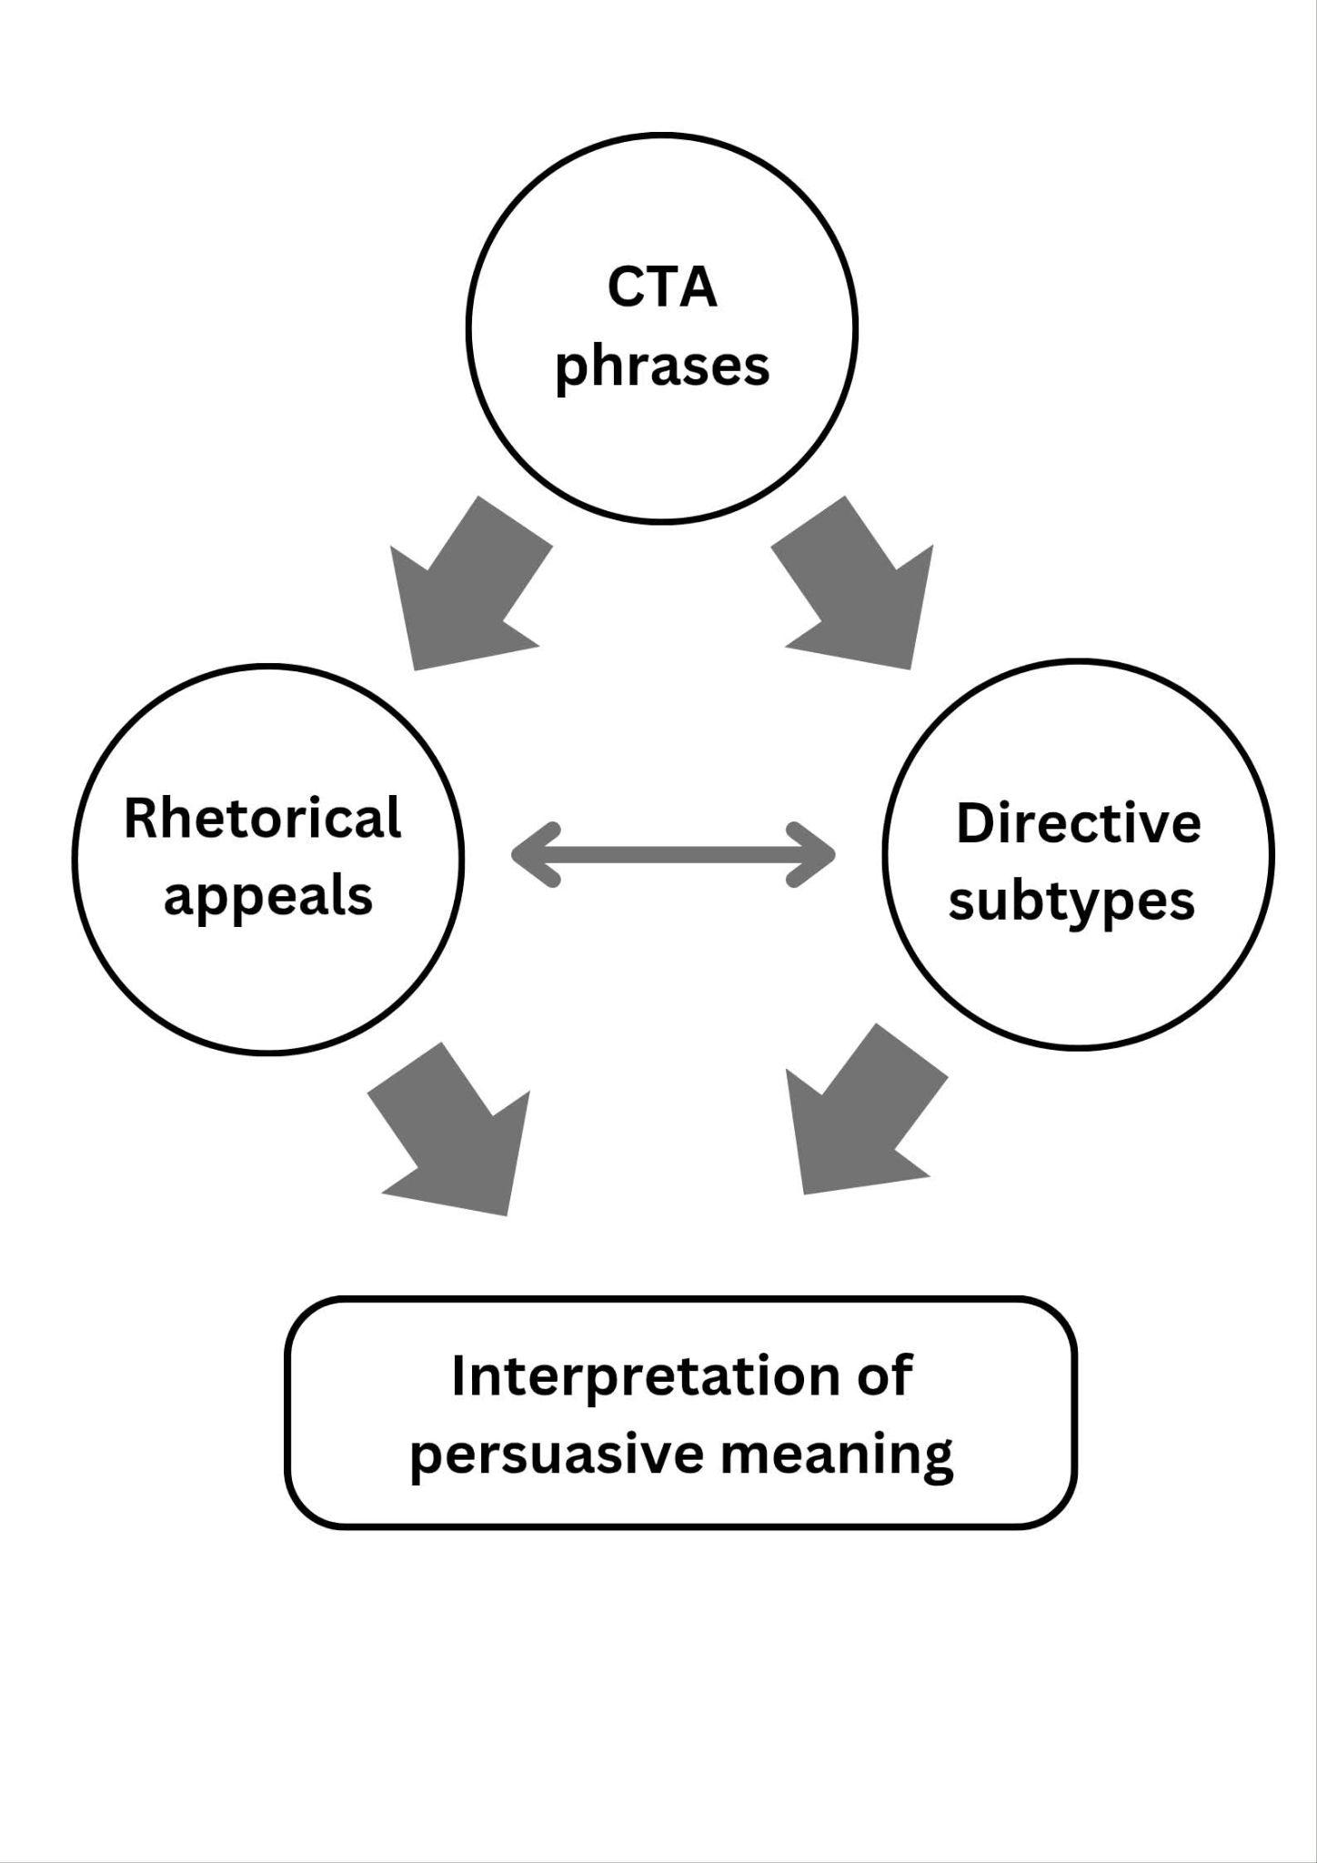
Conceptual Framework

The conceptual framework of the study will illustrate how persuasive meaning will be constructed through the analysis of call-to-action (CTA) phrases in Facebook skincare advertisement captions. In this framework, CTA phrases are positioned at the top as the unit of analysis, serving as the primary source of data for the study. The CTA phrases will be examined through two analytical lenses: Aristotle’s rhetorical appeals and directive subtypes based on Speech Act Theory.
The first analytical lens is Aristotle’s rhetorical framework, which explains persuasion through ethos, pathos, and logos. These rhetorical appeals will be used to identify the persuasive strategies embedded in the CTA phrases by examining how advertisers establish credibility, evoke emotions, and present logical reasoning to influence consumers.
The second analytical lens focuses on the directive subtypes of the CTA phrases. Within the perspective of Speech Act Theory, Searle (1975) provides the theoretical basis for directive speech acts, while Yule (1996) provides the classification of directive subtypes used in this study. Accordingly, the CTA phrases will be classified into command, order, request, and suggestion. The operational definitions of these four directive subtypes will be adopted from Anggraini and Afriana (2023). These subtypes will be used to determine the different ways advertisers linguistically encourage consumers to perform a desired action.
The arrows from the CTA phrases toward the rhetorical appeals and directive subtypes indicate that the same CTA phrases are examined using both analytical lenses. The rhetorical appeals identify how the CTA persuades, while the directive subtypes identify how the CTA directs or encourages consumers to act. The two analytical dimensions are therefore examined together rather than independently.
At the bottom of the framework, interpretation represents the analysis of the combined findings from the rhetorical appeals and directive subtypes. Through this interpretation, the study explains how the persuasive appeal and the directive function of a CTA phrase work together to construct persuasive meaning. Thus, the interpretation does not represent another category of analysis but serves as the result of examining the CTA phrase through both analytical lenses.
Overall, the conceptual framework illustrates that CTA phrases serve as the unit of analysis, rhetorical appeals and directive subtypes serve as the analytical lenses, and interpretation represents the resulting explanation of how these elements contribute to the construction of persuasive meaning in Facebook skincare advertisement captions.

Significance of the study

The findings of the study will be beneficial to the following: beauty product brands, students, Facebook advertiser and marketers, future researcher.
Beauty Product Brands. The findings will highlight how CTA phrases are constructed to convey persuasive meanings, enabling brands to align their messaging with rhetorical and linguistic strategies identified in skincare advertising discourse.
ELS Students. The findings will benefit the English Language Studies (ELS) students by enhancing their understanding of how persuasive techniques are used in advertising language, particularly in call-to-action phrases. It also may help them develop their skills in discourse analysis and critical interpretation of digital texts.
Facebook Advertisers and Marketers. The findings will provide insights into the use of persuasive language in beauty advertisement CTAs, particularly in terms of rhetorical strategies and directive subtypes. This may help advertisers and marketers better understand how rhetorical appeals and directive language are used in call-to-action phrases.
Future Researchers. The findings will serve as baseline data and a methodological reference for further studies on digital advertising discourse, particularly in the analysis of persuasive language across different platforms and product categories.

Scope and Limitations

This study focuses on the analysis of call-to-action (CTA) phrases used in Facebook advertisement captions posted on the official Facebook pages of selected skincare brands. Specifically, the study examines CTA phrases from five skincare brands—Luxe Organix, Olay, The Ordinary, Pond’s, and Myra—which were selected based on their established presence, recognition, and relevance in the skincare industry, as supported by BusinessMirror (2022), Teehankee (2016), Mananquil (2009), Jamora-Garceau (2023), and Vogue Business Custom Insights Team (2023).
The study covers Facebook advertisement captions published from 2023 to 2026. For each selected brand, Facebook advertisements were selected from two periods within each year: January to June and July to December. One advertisement containing CTA phrases was selected from each half-year period, whenever available. Among the available advertisements within each half-year period, the advertisement with the highest number of likes or reactions was prioritized for selection. This criterion was used to identify advertisements with greater audience interaction while maintaining the study’s focus on the linguistic analysis of CTA phrases rather than measuring advertising effectiveness. The CTA phrases identified from these advertisements served as the primary data for analysis. A total of 34 CTA phrases were included in the final corpus because no Pond’s advertisement posts were available from July to December 2024. The study examines how persuasive meaning is constructed through Aristotle’s rhetorical appeals (ethos, pathos, and logos) and directive speech acts based on Searle’s (1975) Speech Act Theory and Yule’s (1996) classification of directive subtypes (command, request, suggestion, and order).
The study is limited to textual CTA phrases written in English or predominantly in English to ensure consistency in linguistic analysis. It focuses exclusively on CTA phrases found in Facebook advertisement captions. Although audience engagement indicators such as likes and reactions are considered in selecting advertisements, they are not included as part of the linguistic analysis. The study excludes visual elements such as images and videos, hashtags, emojis, comments, shares, and other engagement metrics. Consumer interpretations, purchasing behavior, and advertising effectiveness are likewise excluded, as the study is limited to the linguistic analysis of persuasive language.
Furthermore, advertisements published outside the 2023–2026 timeframe are excluded. Likewise, non-skincare advertisements, CTA phrases that are not written in English or predominantly in English, and captions that do not contain identifiable CTA phrases are excluded from the analysis.

Definition of Terms

This section presents the operational definitions of the key terms used in the study. These definitions guide the identification, classification, and interpretation of call-to-action (CTA) phrases in Facebook skincare advertisement captions.
Call-to-Action (CTA) Phrases. These are short, directive expressions used in advertisements (e.g., "Buy Now," "Shop Today") that encourage an immediate response from the audience. In this study, CTA phrases are operationally defined as the primary linguistic units extracted from the Facebook advertisement captions of selected skincare brands. When an advertisement contains multiple CTA expressions, these are treated as one combined CTA data item. They serve as the main data for analysis and are identified based on their persuasive function in encouraging product-related actions such as purchasing, trying, or exploring skincare products.
Directive Speech Acts. These refer to utterances used by speakers or writers to make the hearer perform a particular action. Based on Searle’s (1975) Speech Act Theory, directives are speech acts that express the speaker’s intention to get the hearer to do something. In this study, directive speech acts are operationally defined as the illocutionary acts performed by CTA phrases to encourage consumers to respond to skincare advertisements.
Directive Subtypes. These refer to the categories used to classify directive speech acts according to the intended action expected from the audience. Based on Searle’s (1975) concept of directive speech acts and Yule’s (1996) classification of directives, this study uses four directive subtypes: command, order, request, and suggestion. Following Anggraini and Afriana (2023), these subtypes are operationally defined as follows:
Command. This refers to a directive speech act that is usually fulfilled when the speaker has a dominating position or power over the hearer (Yule, 1996, as cited in Anggraini & Afriana, 2023). In this study, commands are identified when CTA phrases explicitly tell consumers to take an action related to a skincare product.
Order. This refers to a directive speech act intended to ask someone to perform an action without a dominant power relationship between the speaker and the hearer (Yule, 1996, as cited in Anggraini & Afriana, 2023). In this study, orders are identified when CTA phrases present a direct instruction for consumers to take an action toward skincare products.
Request. This refers to a polite directive speech act that asks someone to perform an action, which may or may not be carried out by the hearer (Yule, 1996, as cited in Anggraini & Afriana, 2023). In this study, requests are identified when CTA phrases encourage consumers to engage with skincare products through a polite or less direct expression.
Suggestion. This refers to a directive speech act that gives the hearer the option to accept or reject the proposed action (Yule, 1996, as cited in Anggraini & Afriana, 2023). In this study, suggestions are identified when CTA phrases encourage consumers to consider trying, exploring, or purchasing skincare products.
Persuasive Language. This refers to the use of linguistic features intended to influence audience attitudes, perceptions, or actions. In this study, persuasive language is operationally defined as the use of rhetorical appeals and directive subtypes within CTA phrases to encourage consumer response in Facebook skincare advertisement captions.
Rhetorical Appeals. These refer to the persuasive strategies used in communication to influence an audience through credibility, emotion, and reasoning. Based on Aristotle’s rhetorical framework, the three rhetorical appeals are ethos, pathos, and logos (Stanford Encyclopedia of Philosophy, 2022). In this study, rhetorical appeals are used to identify the dominant persuasive basis expressed in the Facebook advertisement captions of selected skincare products.
Ethos. This refers to an appeal based on the speaker’s or source’s credibility, character, or trustworthiness (Stanford Encyclopedia of Philosophy, 2022). In this study, ethos is identified when the advertisement presents the brand or product as trustworthy, reliable, or credible.
Pathos. This refers to an appeal that influences the audience by evoking emotions or feelings (Stanford Encyclopedia of Philosophy, 2022). In this study, pathos is identified when the advertisement uses emotional or desirable expressions that appeal to consumers’ feelings, wants, or aspirations.
Logos. This refers to an appeal based on reasoning, evidence, or information that supports a claim (Stanford Encyclopedia of Philosophy, 2022). In this study, logos are identified when the advertisement provides specific product information, features, ingredients, benefits, or other details that give consumers a reason to consider the product.
Skincare Advertisements. These refer to promotional Facebook posts that advertise skincare products. In this study, skincare advertisements are operationally defined as the selected Facebook advertisement captions from Luxe Organix, Olay, The Ordinary, Pond’s, and Myra that contain CTA phrases and serve as the corpus of analysis.

METHODOLOGY

This section explains the research design, where the study will be conducted, how the data will be collected, and how the data will be selected. These methods are based on the research questions and the limitations of the study.

Research Context

This study is situated within the context of digital advertising on the social media platform Facebook, where skincare brands promote their products through advertisement captions. Facebook serves as a widely used marketing platform that enables brands to communicate persuasive messages to audiences through short, text-based promotional content.
Within this context, call-to-action (CTA) phrases are incorporated into advertisement captions as concise linguistic expressions that encourage audience interaction and potential consumer action. These short, directive expressions function as important elements in persuasive communication by guiding audiences toward a desired response. In skincare advertising, CTA phrases often highlight themes such as beauty, self-improvement, product benefits, and urgency, making them valuable linguistic data for examining how persuasive language is constructed.
The study focuses on CTA phrases collected from advertisement captions posted on the official Facebook pages of selected skincare brands, specifically Luxe Organix, Olay, The Ordinary, Pond’s, and Myra. These brands were selected based on their established presence, recognition, and relevance in the skincare industry, as supported by BusinessMirror (2022), Teehankee (2016), Mananquil (2009), Jamora-Garceau (2023), and Vogue Business Custom Insights Team (2023). The study covers Facebook advertisements published from 2023 to 2026. For each selected brand, one advertisement from January to June and one advertisement from July to December will be selected for each year within the specified period, whenever available. The final data period covers advertisements published from January to June 2026. The CTA phrases contained in these advertisements will serve as the corpus of the study.
By examining these CTA phrases within the context of Facebook advertising, the study aims to analyze how persuasive meaning is constructed through Aristotle’s rhetorical appeals (ethos, pathos, and logos) and directive speech acts based on Searle’s (1975) concept of directive speech acts and Yule’s (1996) classification of directive subtypes, namely commands, orders, requests, and suggestions. This context provides an appropriate setting for exploring how persuasive language is employed in short, text-based promotional content.

Research Design

This study employs a qualitative research design, specifically a discourse analysis approach, to examine how persuasive language is constructed in call-to-action (CTA) phrases used in Facebook skincare advertisement captions. Qualitative research is appropriate for this study because it focuses on the interpretation of language, meaning, and communicative function rather than numerical measurement, allowing for a deeper understanding of real-world communication (Tenny et al., 2022).
Discourse analysis is appropriate for this study because it examines language as it is used in real communicative contexts. In this study, discourse is understood as language-in-use within a specific social and communicative setting, following Brown and Yule (1983), who define discourse as language used for communication and interpreted within context, and Gee (2014), who emphasizes discourse as language-in-use that performs social actions. From these perspectives, discourse is understood not by length or structure alone but by communicative function. Thus, even short linguistic units such as call-to-action (CTA) phrases may be analyzed as discourse because they perform persuasive and communicative functions within Facebook advertising interactions.
Within this framework, CTA phrases are treated as action-oriented components of advertising discourse that are used to influence audience behavior and engagement. They operate within a digital marketing environment where language is purposeful, strategic, and designed to encourage consumer response. Accordingly, discourse analysis enables the study to examine not only the linguistic form of CTA phrases but also their communicative function and persuasive meaning within their advertising context.
The study is guided by two theoretical frameworks: Aristotle’s rhetorical appeals (ethos, pathos, and logos) and Speech Act Theory. Aristotle’s rhetorical framework is used to identify how persuasion is constructed through credibility, emotion, and logical reasoning, while Speech Act Theory is used to classify the directive speech acts manifested in CTA phrases. Following Searle’s (1975) concept of directive speech acts and Yule’s (1996) classification of directive subtypes, the CTA phrases will be analyzed according to commands, orders, requests, and suggestions.
The data will be collected from Facebook advertisement captions of five selected skincare brands, namely Luxe Organix, Olay, The Ordinary, Pond’s, and Myra. These brands were selected based on their established presence, recognition, and relevance in the skincare industry, as supported by BusinessMirror (2022), Teehankee (2016), Mananquil (2009), Jamora-Garceau (2023), and Vogue Business Custom Insights Team (2023).
For each selected brand, one Facebook advertisement published from January to June and one Facebook advertisement published from July to December will be selected for each year from 2023 to 2025, whenever available. For 2026, advertisements published from January to June will be considered. The CTA phrases contained in these selected advertisements will be extracted and analyzed. This sampling procedure provides representation across different periods while maintaining a manageable dataset for qualitative discourse analysis.

Research Process

The study will follow a systematic qualitative procedure consisting of data collection, data preparation, data analysis, and presentation of findings. The process is guided by discourse analysis, which treats language as language-in-use within a specific social and communicative context rather than as isolated linguistic forms.

a. Data Collection
The first stage involves the collection of call-to-action (CTA) phrases from the Facebook advertisement captions of the selected skincare brands, namely Luxe Organix, Olay, The Ordinary, Pond’s, and Myra.
The selected skincare brands were identified based on their established presence, recognition, and relevance in the skincare industry, as supported by BusinessMirror (2022), Teehankee (2016), Mananquil (2009), Jamora-Garceau (2023), and Vogue Business Custom Insights Team (2023). For each selected brand, Facebook advertisements published within two periods of each year—January to June and July to December—will be reviewed. One advertisement containing CTA phrases will be selected from each half-year period, whenever available. Among the available advertisements within each period, the advertisement with the highest number of likes or reactions will be prioritized for selection. This criterion will be used only for selecting advertisements and not for measuring advertising effectiveness. The CTA phrases contained in these selected advertisements will then be extracted for analysis.
The inclusion criteria are as follows:
- CTA phrases must be taken from the Facebook advertisement captions of the selected skincare brands.
- Advertisements must have been published from January 2023 to June 2026.
- One advertisement from January–June and one advertisement from July–December will be selected for each year, whenever available.
- CTA phrases must be written in English or predominantly in English.
- CTA phrases must function as directive expressions intended to encourage audience action and must be classifiable into the directive subtypes of commands, orders, requests, or suggestions.
Screenshots and textual copies of the advertisement captions will be collected as the primary data to ensure the authenticity and traceability of the discourse context.

b. Data Preparation
The extracted CTA phrases will be organized into a structured corpus. Each CTA phrase will be coded according to its corresponding brand, year of publication, advertisement source, rhetorical appeal, and directive subtype.
The collected data will then be reviewed to ensure that all CTA phrases satisfy the established inclusion criteria. Advertisements that do not contain identifiable CTA phrases, advertisements outside the 2023–2026 timeframe, non-skincare advertisements, and CTA phrases that are not written in English or predominantly in English will be excluded from the analysis.

c. Data Analysis
The study will employ qualitative discourse analysis to examine how persuasive meaning is constructed in the CTA phrases of Facebook skincare advertisement captions. CTA phrases will be analyzed as functional communicative units that perform persuasive purposes within advertising discourse.
Each CTA phrase will be analyzed using two complementary analytical frameworks.
1. Aristotle’s Rhetorical Appeals
Each CTA phrase will be examined to determine the dominant rhetorical appeal used in constructing persuasive meaning. The full advertisement caption will be considered as the basis for identifying the rhetorical appeal of the CTA phrase. The CTA phrase will remain the primary unit of analysis, while the information, claims, and wording found throughout the caption will be used to support the interpretation of its dominant appeal.
- Ethos – refers to persuasion through credibility, trustworthiness, or authority.
- Pathos – refers to persuasion through emotions, desires, or feelings.
- Logos – refers to persuasion through logic, reasoning, or factual information.
The identified rhetorical appeals will explain how advertisers construct persuasive meaning through CTA phrases based on the overall message of the advertisement caption.
2. Directive Subtypes Based on Speech Act Theory
Following Searle’s (1975) concept of directive speech acts and Yule’s (1996) classification of directive subtypes, each CTA phrase will be classified according to its directive subtype. The classification of each directive subtype will be based on the communicative function of the CTA phrase within its advertising context rather than on the action verb alone.
The directive subtypes include:
- Command- refers to a directive speech act that is usually fulfilled when the speaker has a dominating position or power over the hearer (Yule, 1996, as cited in Anggraini & Afriana, 2023).
- Order - refers to a directive speech act intended to ask someone to perform an action without a dominant power relationship between the speaker and the hearer (Yule, 1996, as cited in Anggraini & Afriana, 2023).
- Request - refers to a polite directive speech act that asks someone to perform an action, which may or may not be carried out by the hearer (Yule, 1996, as cited in Anggraini & Afriana, 2023).
- Suggestion - refers to a directive speech act that gives the hearer the option to accept or reject the proposed action (Yule, 1996, as cited in Anggraini & Afriana, 2023).
Following Anggraini and Afriana (2023), these directive subtypes will be used to identify how CTA phrases express different intended actions and how advertisers linguistically encourage consumers to respond to skincare advertisements.
After the rhetorical appeals and directive subtypes have been identified, the findings will be interpreted to explain how these two analytical dimensions contribute to the construction of persuasive meaning in CTA phrases from Facebook skincare advertisement captions.

d. Presentation of Results
The findings will be presented according to the three research questions of the study. Part I will present the rhetorical appeals identified in the CTA phrases, including logos, pathos, and ethos. The full advertisement captions will be considered as the basis for identifying the dominant rhetorical appeal, while the CTA phrases will serve as the primary units of analysis. Tables will be used to present the distribution of the identified rhetorical appeals, followed by descriptive discussions and examples from the selected Facebook skincare advertisement captions.
Part II will present the directive subtypes identified in the CTA phrases based on command, order, request, and suggestion. The results will be presented in a table showing the distribution of the directive subtypes, followed by an analysis and discussion of the linguistic expressions used in the CTA phrases.
Part III will examine the combinations of rhetorical appeals and directive subtypes to explain how they contribute to the construction of persuasive meaning in the CTA phrases. The findings will be presented through a table of the identified combinations, followed by descriptive analysis and discussion supported by examples from the advertisement captions.

Research Corpus

This study will utilize a corpus of call-to-action (CTA) phrases extracted from the Facebook advertisement captions of selected skincare brands. The corpus will consist of CTA phrases obtained from the official Facebook pages of Luxe Organix, Olay, The Ordinary, Pond’s, and Myra.
The selected skincare brands were chosen based on their established presence, recognition, and relevance in the skincare industry, as supported by BusinessMirror (2022), Teehankee (2016), Mananquil (2009), Jamora-Garceau (2023), and Vogue Business Custom Insights Team (2023). For each selected brand, Facebook advertisements published within two periods of each year—January to June and July to December—will be reviewed. One advertisement containing CTA phrases will be selected from each half-year period, whenever available. Among the available advertisements within each period, the advertisement with the highest number of likes or reactions will be prioritized for selection. This criterion will be used only to determine the advertisement sample and not to measure advertising effectiveness. The CTA phrases contained in these selected advertisements will comprise the research corpus.
The corpus serves as the primary linguistic data for qualitative discourse analysis. The collected CTA phrases will be analyzed using Aristotle’s rhetorical appeals (ethos, pathos, and logos) and the directive subtypes of Speech Act Theory, following Searle’s (1975) concept of directive speech acts and Yule’s (1996) classification of directive subtypes (command, request, suggestion, and order). For the analysis of rhetorical appeals, the CTA phrase will serve as the primary unit of analysis, while the full advertisement caption will be considered as the basis for identifying the dominant rhetorical appeal. The textual elements of the caption, such as product information, claims, benefits, emotional expressions, and statements related to credibility, will be considered in determining the dominant appeal. In this study, the corpus will be treated as discourse-in-use, recognizing that each CTA phrase performs a persuasive communicative function within the context of Facebook skincare advertising.

Inclusion Criteria
The following criteria will be used in selecting CTA phrases for the corpus:
- CTA phrases must be extracted from the Facebook advertisement captions of the selected skincare brands.
- Advertisements must have been published from January 2023 to June 2026.
- For each selected brand, one advertisement from January–June and one advertisement from July–December will be selected for each year from 2023 to 2025, whenever available, while advertisements from January–June will be considered for 2026.
- Advertisements selected within each half-year period must have the highest number of likes or reactions among the available advertisements.
- CTA phrases must be written in English or predominantly in English.
- CTA phrases must function as directive expressions intended to encourage audience action and must be classifiable under the directive subtypes of commands, orders, requests, or suggestions.

Exclusion Criteria
The following will be excluded from the corpus:
- Advertisements published outside the January 2023–June 2026 timeframe.
- Advertisements that do not promote skincare products.
- CTA phrases that are not written in English or predominantly in English.
- Captions that do not contain identifiable CTA phrases.
- CTA phrases that do not function as directive expressions.

Ethical Considerations
This study will analyze call-to-action (CTA) phrases extracted from the Facebook advertisement captions of selected skincare brands. Since the data consist solely of publicly accessible advertising content, no human participants will be involved, and no personal or private information will be collected.
The study will adhere to ethical research standards by using the collected data exclusively for academic purposes. The researcher will preserve the original wording of all CTA phrases and will not alter, fabricate, or misrepresent any advertisement content. Proper acknowledgment of sources and adherence to academic integrity will be observed throughout the collection, analysis, and presentation of the findings.

RESULT, ANALYSIS AND DISCUSSION

This chapter presents the results, analysis, and discussion of the rhetorical appeals and directive subtypes identified in the call-to-action (CTA) phrases of Facebook skincare advertisement captions. The chapter is organized into three parts, each corresponding to a research question. Part I presents the rhetorical appeals used in the CTA phrases. Part II examines the directive subtypes present in the CTA phrases. Part III discusses how the directive subtypes and rhetorical appeals contribute to the construction of persuasive meaning.

PART I: RHETORICAL APPEALS USED IN THE CTA PHRASES
The coding identified three rhetorical appeals across the 34 call-to-action (CTA) phrases from the selected Facebook skincare advertisement captions. These appeals were classified as logos, pathos, and ethos based on Aristotle's rhetorical framework. In identifying the dominant rhetorical appeal, the full advertisement caption was examined to determine the textual elements that indicated the appeal, while the CTA phrase served as the primary unit of analysis. Table 1 presents the distribution of rhetorical appeals across the five selected skincare brands.
Table 1
Distribution of Rhetorical Appeals Across the Selected Skincare Brands
Skincare Brands | Logos | Pathos | Ethos | Total
OLAY | 3 | 4 | 0 | 7
LUXE ORGANIX PH | 5 | 2 | 0 | 7
THE ORDINARY | 6 | 1 | 0 | 7
MYRA | 2 | 3 | 2 | 7
POND’S | 5 | 1 | 0 | 6
Total | 21 | 11 | 2 | 34

Table 1 presents the overall distribution of rhetorical appeals identified in the CTA phrases. Logos was the most frequently identified appeal, with 21 instances, followed by pathos with 11 instances and ethos with 2 instances. The Ordinary had the highest number of logos-based CTA phrases, with six instances, while Olay had four pathos-based CTA phrases. Ethos was identified only in two CTA phrases from Myra. Overall, the distribution shows that all three rhetorical appeals were present in the selected CTA phrases, with logos occurring most frequently.
A closer examination of the logos category shows that it was commonly indicated by product-related information presented in the full advertisement captions. The Ordinary had the highest number of CTA phrases classified as logos, with six instances, followed by Luxe Organix and Pond’s, with five instances each. Olay had three logos-based CTA phrases, while Myra had two. The captions supporting these CTA phrases commonly presented information such as product ingredients, features, numerical information, stated benefits, and prices. For instance, Olay's caption containing the CTA phrase “5 serum benefits in just one bottle” presented a specific number of benefits associated with the product. Similarly, Luxe Organix captions provided information about ingredients, sun protection, product functions, and prices. These textual elements in the captions provided a basis for classifying the CTA phrases as logos because they presented product-related information that appealed to reason and specific details.
Pathos was the second most frequently identified rhetorical appeal, with 11 instances. It appeared most frequently in Olay, with four instances, followed by Myra with three and Luxe Organix with two. The Ordinary and Pond’s each had one pathos-based CTA phrase. The full captions containing these CTA phrases commonly presented desirable skin conditions, emotional associations, promotional excitement, or a sense of urgency. For example, Olay used expressions such as “wrap your skin in love,” “glowy, refreshed skin,” “win amazing prizes,” and “Don't miss out!” Luxe Organix also used the phrase “achieve a youthful skin,” which presents youthful-looking skin as a desirable result. These textual elements provided the basis for classifying the CTA phrases as pathos because they appealed to the audience's desires and emotions.
Ethos was the least frequently identified rhetorical appeal, with two instances, both found in Myra's CTA phrases. These included “trusted skincare essentials” and “made by Myra.” The full captions associated with these CTA phrases emphasized trust and the brand's association with the advertised skincare products. These textual elements provided the basis for classifying the CTA phrases as ethos because they conveyed credibility and trustworthiness.
Overall, the findings show that logos, pathos, and ethos were all identified in the CTA phrases based on the textual elements present in their full advertisement captions. Logos was the dominant rhetorical appeal, followed by pathos, while ethos appeared least frequently. The findings suggest that the selected Facebook skincare advertisements constructed persuasive meaning through product-related information, desirable outcomes and emotional associations, and expressions of brand credibility. Thus, the findings answer the first research question by showing that all three of Aristotle’s rhetorical appeals were present in the CTA phrases, with logos occurring most frequently.

PART II: DIRECTIVE SUBTYPES PRESENT IN THE CTA PHRASES
The coding considered four directive subtypes in the 34 call-to-action (CTA) phrases from the selected Facebook skincare advertisement captions: command, order, request, and suggestion. These directive subtypes were classified based on the operational categories used in the study. Table 3 presents the distribution of directive subtypes across the five selected skincare brands.
Table 2
Distribution of Directive Subtypes Across the Selected Skincare Brands
Skincare Brands | Command | Order | Request | Suggestion | Total
OLAY | 7 | 0 | 0 | 0 | 7
LUXE ORGANIX PH | 6 | 0 | 0 | 1 | 7
THE ORDINARY | 5 | 0 | 0 | 2 | 7
MYRA | 7 | 0 | 0 | 0 | 7
POND’S | 6 | 0 | 0 | 0 | 6
Total | 31 | 0 | 0 | 3 | 34

Table 2 presents the overall distribution of the four directive subtypes included in the analysis. Command was the most frequently identified directive subtype, with 31 instances, followed by suggestion with 3 instances. No instances of order or request were identified in the 34 CTA phrases. Command was present across all five selected skincare brands, while suggestions appeared only in Luxe Organix PH and The Ordinary.
A closer examination of the command category shows that it was identified in 31 CTA phrases across the five brands. Olay and Myra each had seven command-based CTA phrases, while Luxe Organix and Pond’s had six each. The Ordinary had five. The command CTAs commonly used direct action verbs such as “shop,” “get,” “try,” “check out,” “choose,” “add,” “discover,” “learn,” “apply,” and “stock up.” For example, Olay used “Shop now at Watsons, S&R, Robinsons Department Store, Landmark Department Store, Shopee and Lazada,” directly telling the audience to shop for the featured products. Similarly, Luxe Organix used “Get yours now!” and “Shop now in Watsons stores & online!” to direct the audience toward obtaining or purchasing the products. These expressions communicate a specific action for the audience to perform. Based on the directive categories used in the study, these CTA phrases were classified as commands because they directly instruct the audience to carry out an action.
Suggestion was identified in only three CTA phrases. One instance was found in Luxe Organix through “Try this newest Niacinamide + Retinol cloudsoap!” and two instances were found in The Ordinary through “Power Up Your P.M.” and “Try our Niacinamide 10% + Zinc 1%.” These expressions encourage the audience to consider or try the featured products rather than presenting the action as a direct requirement. For example, “Try this newest Niacinamide + Retinol cloudsoap!” presents the product as an option for those seeking youthful-looking skin. Similarly, “Try our Niacinamide 10% + Zinc 1%” encourages the audience to consider the product as part of their skincare routine. These CTA phrases were therefore classified as suggestions because they recommend or encourage an action for the audience.
No instances of order or request were identified in the analyzed CTA phrases. Although both subtypes were included in the directive classification used in the study, none of the selected captions contained CTA expressions that met the criteria for these categories. The absence of these two subtypes indicates that the directive language in the selected advertisements was concentrated on direct commands and, to a much smaller extent, suggestions.
Overall, the findings show that command was the dominant directive subtype, with 31 of the 34 CTA phrases, while suggestion occurred only 3 times. Order and request were not identified in the dataset. This distribution shows that the selected Facebook skincare advertisements primarily used direct action-oriented language to encourage the audience to perform actions such as shopping, trying, getting, applying, or discovering the featured products. Suggestions were used less frequently to present products as options for the audience to consider. Thus, the findings answer the second research question by showing that while four directive subtypes were considered in the analysis, only command and suggestion were present in the selected CTA phrases.

PART III: CONSTRUCTING PERSUASIVE MEANING
The analysis examined how rhetorical appeals and directive subtypes were combined in the 34 call-to-action (CTA) phrases from the selected Facebook skincare advertisement captions. The findings show that the CTA phrases contained different combinations of rhetorical appeals and directive subtypes, with some combinations occurring more frequently than others. Table 4 presents the distribution of these combinations across the five selected skincare brands.
Table 3
Distribution of Rhetorical Appeal and Directive Subtype Combinations
Skincare Brands | Logos +  Command | Pathos + Command | Ethos + Command | Logos + Suggestion | Pathos + Suggestion | Total
OLAY | 3 | 4 | 0 | 0 | 0 | 7
LUXE ORGANIX | 5 | 1 | 0 | 0 | 1 | 7
THE ORDINARY | 5 | 0 | 0 | 1 | 1 | 7
MYRA | 2 | 3 | 2 | 0 | 0 | 7
POND’S | 5 | 1 | 0 | 0 | 0 | 6
Total | 20 | 9 | 2 | 1 | 2 | 34

Table 3 shows that Logos + Command was the most frequent combination, occurring in 20 of the 34 CTA phrases. This was followed by Pathos + Command, with 9 occurrences, and Ethos + Command, with 2 occurrences. Logos + Suggestion occurred once, while Pathos + Suggestion occurred twice. The distribution shows that command was commonly paired with the three rhetorical appeals, while suggestion was used less frequently and was paired only with logos and pathos.
The most common combination, Logos + Command, shows how product-related information can be presented together with a direct instruction to act. This combination appeared 20 times across the five brands. For example, Olay used CTA phrases such as “Get the power of 5 serum benefits in just one bottle!” where the product information provides a reason for considering the product while the command directs the audience toward the advertised action. Similar patterns were found in Luxe Organix PH, The Ordinary, and Pond’s, where product features, ingredients, benefits, or other specific information were presented alongside direct actions such as “shop,” “get,” “try,” or “discover.” In this combination, the rhetorical appeal provides information that supports the promotional message, while the command gives the audience a specific action to perform.
The second most frequent combination was Pathos + Command, which occurred 9 times. This combination connects emotional or desirable associations with a direct action. For example, Olay used expressions related to “glowy, refreshed skin,” “win amazing prizes,” and not missing out on promotions, while the accompanying CTA phrases directed the audience to shop, add the product to the cart, or take action. Myra also used expressions associated with youthful radiance, healthy-looking skin, and emotional appeal together with commands such as “Try now!” and “Give her the gift of youthful radiance.” These combinations construct persuasive meaning by presenting a desirable feeling, experience, or outcome and then directing the audience toward an action related to the product.
Ethos + Command appeared twice, both in Myra's CTA phrases. The captions used expressions such as “trusted skincare essentials” and “made by Myra,” which establish an association with the brand's credibility or trustworthiness. These appeals were paired with direct commands, allowing the brand-related credibility presented in the caption to accompany an action directed toward the product. Thus, the persuasive meaning in these CTA phrases is constructed through the connection between brand credibility and a specific action.
The less frequent combinations were Logos + Suggestion and Pathos + Suggestion. Logos + Suggestion appeared once in The Ordinary, while Pathos + Suggestion appeared twice, in Luxe Organix PH and The Ordinary. Unlike commands, these CTA phrases encourage the audience to consider or try an action without presenting it as a direct instruction. For example, “Try this newest Niacinamide + Retinol cloudsoap!” combines a desirable outcome related to youthful-looking skin with a suggestion to try the product. Similarly, “Try our Niacinamide 10% + Zinc 1%” combines product-related information with a suggestion. These combinations show that persuasive meaning can also be constructed through a less direct form of action, where the advertisement presents a reason or desirable outcome and encourages the audience to consider the product.
Overall, the findings show that persuasive meaning in the selected Facebook skincare advertisements was constructed through the combination of rhetorical appeals and directive subtypes. Logos was most often paired with command, followed by pathos and ethos with command, while suggestions occurred less frequently. The rhetorical appeals provided the informational, emotional, or credibility-related basis of the promotional message, while the directive subtypes guided the audience toward an action or encouraged them to consider one. Therefore, the findings indicate that the CTA phrases constructed persuasive meaning by presenting a basis for the promotional message and linking it to an intended or suggested action for the audience.

CONCLUSION AND RECOMMENDATIONS

This study investigated persuasive language in call-to-action (CTA) phrases of selected skincare product advertisements on Facebook. It analyzed 34 CTA phrases from the official Facebook pages of Luxe Organix, Olay, The Ordinary, Pond’s, and Myra. The study examined the rhetorical appeals used in the CTA phrases and the directive subtypes present in them, based on Aristotle’s rhetorical appeals and Searle’s (1975) Speech Act Theory with Yule’s (1996) classification of directive subtypes. The findings were interpreted to explain how rhetorical appeals and directive subtypes contribute to the construction of persuasive meaning in Facebook skincare advertisements.
Conclusion
The findings revealed that logos was the most frequently identified rhetorical appeal, with 21 occurrences, followed by pathos with 11 and ethos with 2. Logos were mainly expressed through product information, benefits, ingredients, features, and other factual or practical details. Pathos was expressed through desirable skin outcomes, emotional associations, promotional excitement, and urgency, while ethos was reflected in expressions related to trust and brand credibility. These findings show that the selected Facebook skincare advertisements primarily used informational and benefit-oriented language as the basis of their persuasive messages.
For the directive subtypes, command was the most frequently identified subtype, occurring in 31 of the 34 CTA phrases, while suggestion occurred only three times. No examples of order or request were identified. The frequent use of command was reflected in direct action-oriented expressions such as “shop,” “get,” “try,” “check out,” and “discover.” These expressions communicated the action that the advertisements intended to direct or encourage the audience to consider.
The analysis of the combinations of rhetorical appeals and directive subtypes showed that logos combined with command was the most frequent pattern, with 20 occurrences, followed by pathos combined with command with 9, ethos combined with command with 2, logos combined with suggestion with 1, and pathos combined with suggestion with 2. These patterns indicate that persuasive meaning was constructed by connecting the basis of the promotional message with an intended or suggested action. The rhetorical appeals provided the informational, emotional, or credibility-related basis of the message, while the directive subtypes expressed the intended action or encouraged the audience to consider an action.
Overall, the findings indicate that persuasive meaning in the selected Facebook skincare advertisements was mainly constructed through the use of informational rhetorical appeals and direct action-oriented language. Logos provided much of the informational basis of the promotional messages, while commands commonly expressed the intended action. The combination of these features allowed the CTA phrases to present a persuasive basis and connect it with an intended or suggested action. Thus, the CTA phrases functioned as important linguistic elements in the construction of persuasive meaning in Facebook skincare advertisements.
Recommendations
Based on the findings of the study, skincare advertisers and content creators may continue to use clear product-related information in their Facebook advertisements, particularly information about product benefits, features, ingredients, and functions. Since logos was the most frequently identified rhetorical appeal, informative language may be used to provide a clear basis for the promotional message before presenting a CTA.
Skincare brands may also consider varying their use of rhetorical appeals and directive subtypes. Although command was the dominant directive subtype in the data, the use of suggestions may provide an alternative way of encouraging audience action. The use of pathos and ethos may also be considered when appropriate to create emotional associations or communicate credibility within promotional messages.
Future researchers may expand the corpus by including more skincare brands and a larger number of Facebook advertisements. They may also examine advertisements from other social media platforms, such as Instagram or TikTok, to determine whether similar patterns of rhetorical appeals and directive subtypes occur across different platforms.
Future studies may also examine other linguistic features that were not covered in the present study, such as politeness, modality, lexical choices, or other speech act categories. Researchers may also investigate audience responses or consumer behavior if they intend to examine the effectiveness of persuasive language in advertisements. These areas may provide further insight into how persuasive language is used and received in digital advertising.

REFERENCES

Abubakar, J., Ruqayya, R., & Bashir, A. S. (2023). Digital communication.
ResearchGate. https://share.google/EC0fhobJadzjqEeAK

Anggraini, M., & Afriana. (2023). Types of directive speech acts in “Fall” Movie 2022. Journal of Language Teaching and Learning, Linguistics and Literature, Vol. 11, No. 2(2548–4192), 1132–1143. https://doi.org/10.24256/ideas.v11i2.4250

Arakelyan, H., & Aleksanyan, A. (2025). LINGUISTIC PECULIARITIES OF CALL-TO-ACTION PHRASES IN DIGITAL DISCOURSE. Foreign Languages in Higher Education, 29(2(39)), 5–20. https://doi.org/10.46991/flhe.2025.29.2.005

Ardyanti, E., Duwila, S. A., & Astutik, A. (2025). CONSTRUCTING BEAUTY: A LINGUISTIC FEATURES ANALYSIS OF KOREAN SKINCARE ADVERTISEMENTS. Journal of Gender Equality and Social Inclusion (Gesi), 4(2), 57–68. https://doi.org/10.38156/gesi.v4i2.208

Brown, G., & Yule, G. (1983). DISCOURSE ANALYSIS. Cambridge University Press. https://carrerainglesuce.wordpress.com/wp-content/uploads/2019/05/discourse_analysis_by_gillian_brown_geor.pdf

Business Mirror. (2022). Luxe Organix shares two important announcements to treat customers. BusinessMirror. https://businessmirror.com.ph/2022/11/02/luxe-organix-shares-two-important-announcements-to-treat-customers/

Darmawan, R., & Indah, R. N. (2025). STYLISTIC ANALYSIS OF PERSUASIVE TECHNIQUES IN MALE SKINCARE ADVERTISING ON INSTAGRAM. LINGUISTIK Jurnal Bahasa Dan Sastra, 10(4), 445–456. https://doi.org/10.31604/linguistik.v10i4.445-456

De Castro, G., & Martinez, S. M. (2025). Rhetorical Appeals across Selected Philippine Bank Advertising on Facebook. Southern Semiotic Review, 22. https://doi.org/10.33234/ssr.22.13

Euromonitor International. (2025). Beauty and personal care in the Philippines. https://www.euromonitor.com/beauty-and-personal-care-in-the-philippines/report?id=421071&recid=1951822385765&utm_source=chatgpt.com

Giddings, A. (2025). The Role of Social Media in Beauty Marketing: Insights from Kidfluencers, Brand Withdrawal, and Consumers’ Attitudes. Scholars Archive - University at Albany (University at Albany, State University of New York). https://scholarsarchive.library.albany.edu/honorscollege_business/70

Gee, J. P. (2014). An introduction to discourse analysis. https://doi.org/10.4324/9781315819679

Jamora-Garceau, T. (2023). Award-winning clean beauty brands under one roof. Philstar.com. https://www.philstar.com/lifestyle/2023/12/08/2317173/award-winning-clean-beauty-brands-under-one-roof

Kencana, D. S. S. (2025). An analysis of representative and directive speech acts in NIVEA’s advertising discourse on Instagram. Prasasti/UNS Journal of Language Studies, 10(2), 184. https://doi.org/10.20961/prasasti.v10i2.97398

Kenton, W. (2025). What a call to action (CTA) is and how it works. https://share.google/s4l7LqDgUSalTgGvu

Mananquil, R. (2009). On golden Pond’s. Philstar.com. https://www.philstar.com/lifestyle/fashion-and-beauty/2009/12/23/534716/golden-ponds?

McCormick, K., & McCormick, K. (2026). Social media advertising in 2026: Costs, types, tips & top channels. WordStream. https://share.google/fl9hXfbriNZC8D8oe

Moorthi, V., & Moorthi, V. (2025). What is Social Media Advertising? A Beginner’s Guide. Sprinklr. https://share.google/GZGUJ6XHUG2gJx1wl

Nguyen, S. D. (2025). Interpreting creative call to action messages in advertising discourse using requestive strategies. Journal of Media & Management, Volume 7(4): 8-8, 8. https://doi.org/10.47363/JMM/2025(7)190

Prasetya, D. A., & Ramdhani, I. S. (2023). Analysis of speech acts in the advertising language of yakult beverage products on television. AURELIA Jurnal Penelitian Dan Pengabdian Masyarakat Indonesia, 2(1), 552–554. https://doi.org/10.57235/aurelia.v2i1.218

Saad, I. T., & Ismael, A. A. (2025). The Art of Selling Beauty: Analyzing persuasive strategies and speech acts in social media cosmetics advertising. Tasnim International Journal for Human Social and Legal Sciences, 4(4), 483–509. https://doi.org/10.56924/tasnim.14.2025/23

Searle, J. R. (1975). A taxonomy of illocutionary acts: Vol. VII (pp. 344–369). https://doi.org/10.1017/cbo9780511609213.003

Srivastava, N. (2026). Consumer attitude towards social media advertising and its impact on buying behaviour. International Journal of Innovations in Science Engineering and Management., 179–184. https://doi.org/10.69968/ijisem.2026v5i1179-184

Stanford Encyclopedia of Philosophy. (2022). Aristotle’s rhetoric. https://share.google/ItMEB6Cu60yuw0QVd

Statista. (2026). Most used social networks 2025, by number of users. https://share.google/uNNWMR0oxQ6flNhQD

Sujinamol P. (2026). IMPACT OF SOCIAL MEDIA ADVERTISING ON CONSUMER BUYING DECISIONS. ShodhSamajik Journal of Social Studies, 3(1), 56–63. https://doi.org/10.29121/shodhsamajik.v3.i1.2026.76

Talaue, G. M. (2022). Aristotle’s rhetorical triangle as applied to advertisements: it’s impact to Saudi Arabian college student consumers. International Journal of Applied Management Theory and Research, 4(1), 1–18. https://doi.org/10.4018/IJAMTR.300280

Teehankee, P. (2016). Be your ‘best beautiful.’ Philstar.com. https://www.philstar.com/other-sections/newsmakers/2016/11/11/1641397/be-your-best-beautiful

Tenny, S., Brannan, J. M., & Brannan, G. D. (2022). Qualitative Study. StatPearls - NCBI Bookshelf. https://share.google/IFanouegVEjbWB3Fb

Vogue Business Custom Insights Team. (2023). The Vogue Business Beauty Index: The Ordinary, Charlotte Tilbury and Kiehl’s top the leaderboard. Vogue. https://www.vogue.com/article/the-vogue-business-beauty-index-the-ordinary-charlotte-tilbury-and-kiehls-top-the-leaderboard

Yule, G. (1996). Pragmatics. Oxford University Press. https://books.google.com.ph/books?id=9trRnQEACAAJ&lpg=PP1&pg=PR4#v=onepage&q&f=false

APPENDICES

APPENDIX A: SCREENSHOTS OF THE SELECTED FACEBOOK SKINCARE ADVERTISEMENTS

A.1 OLAY
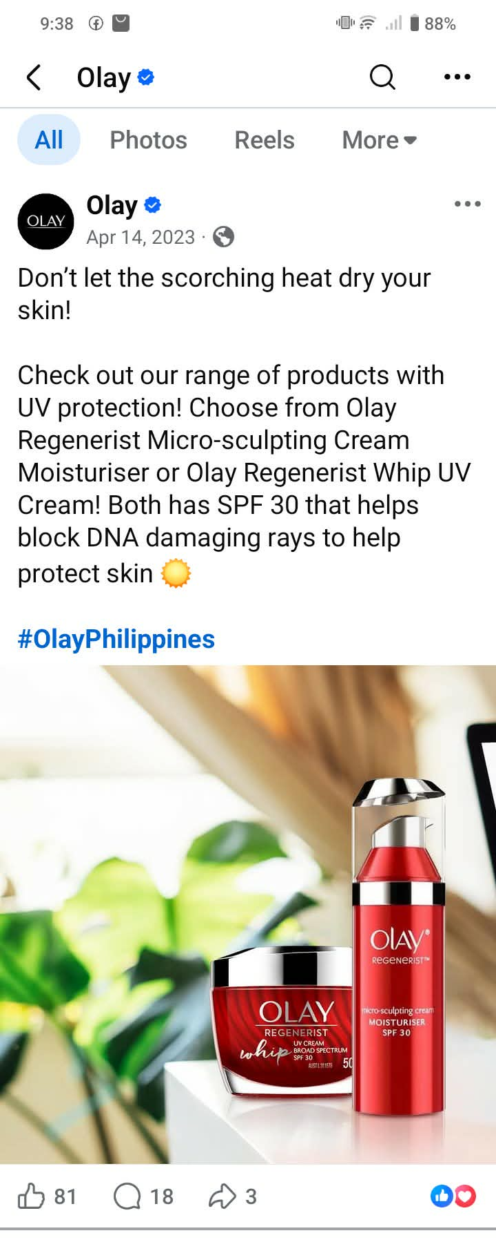
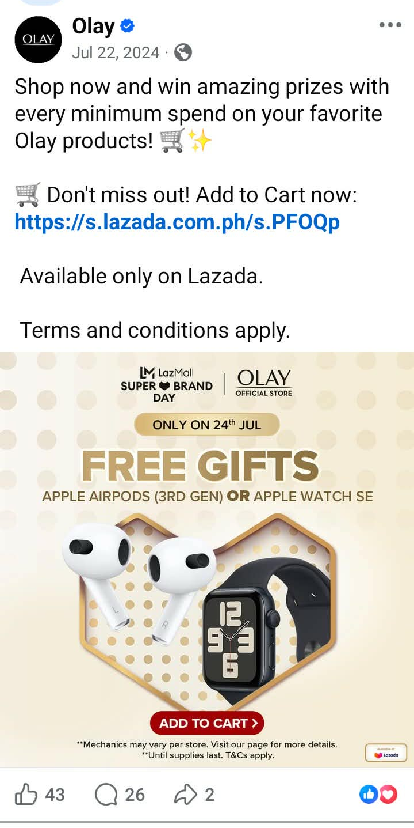
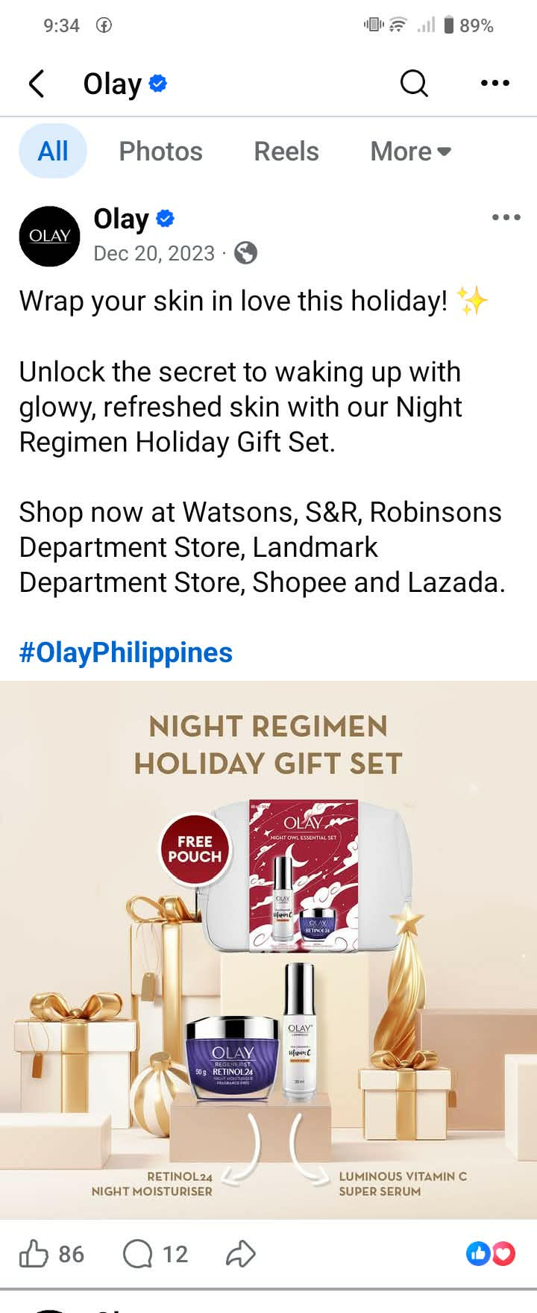
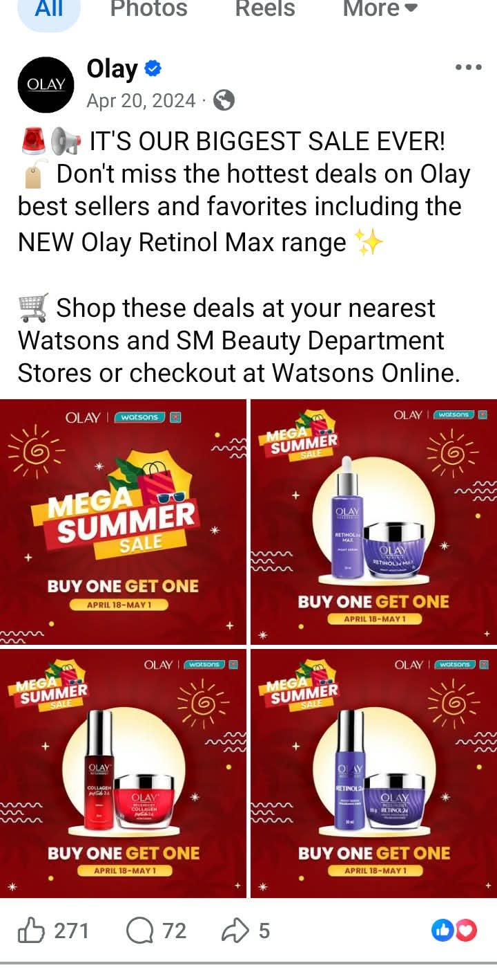
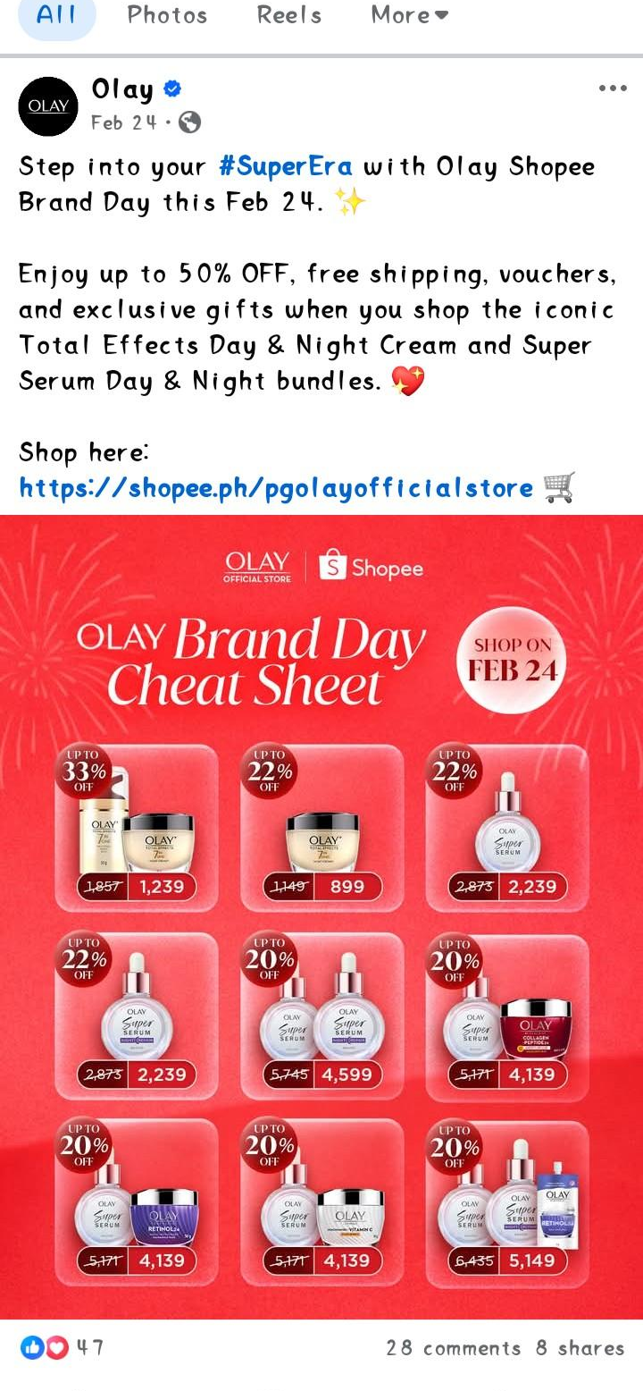
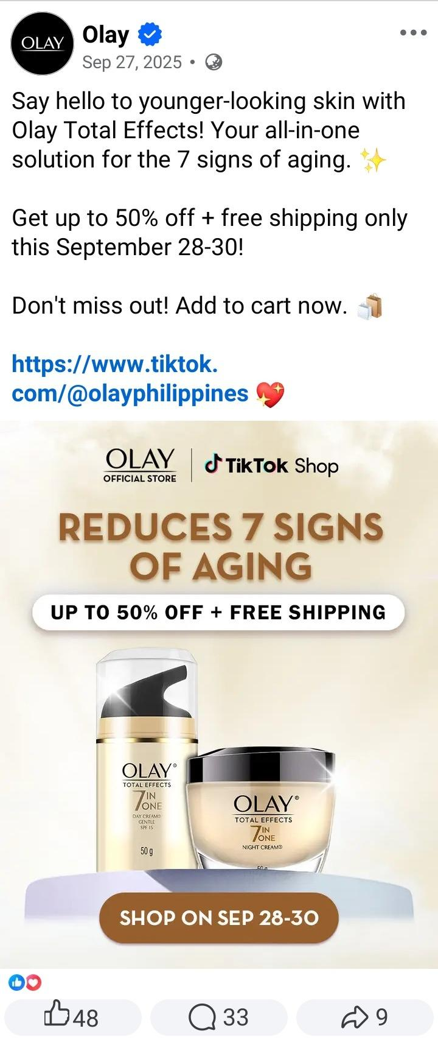
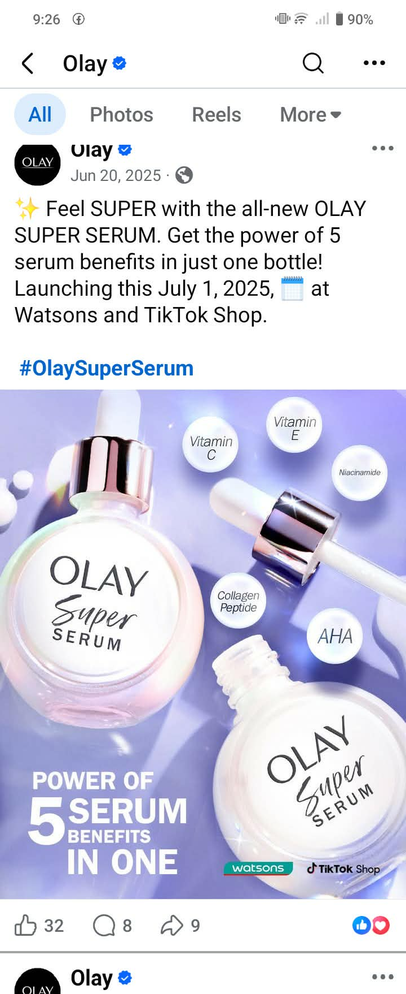
A.2 LUXE ORGANIX
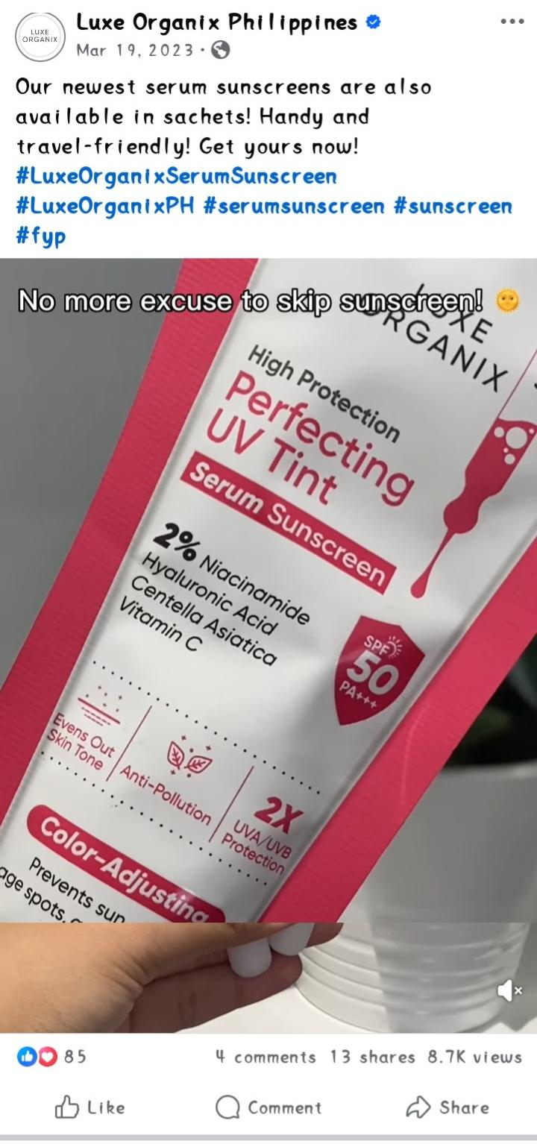
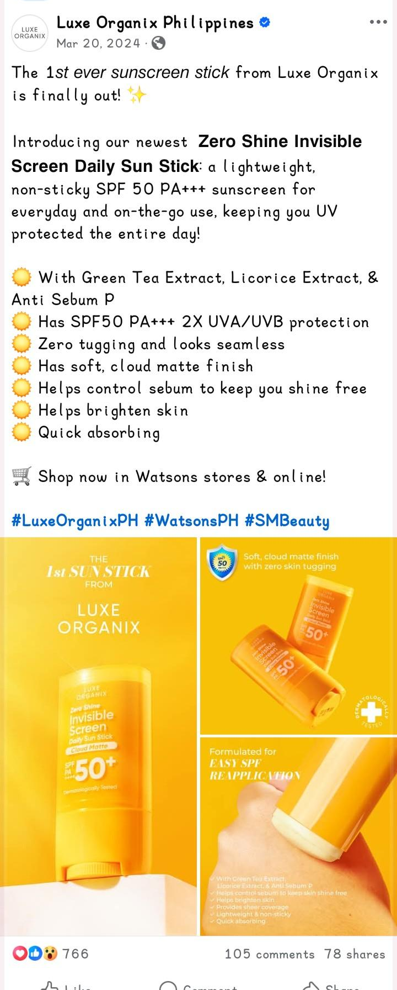
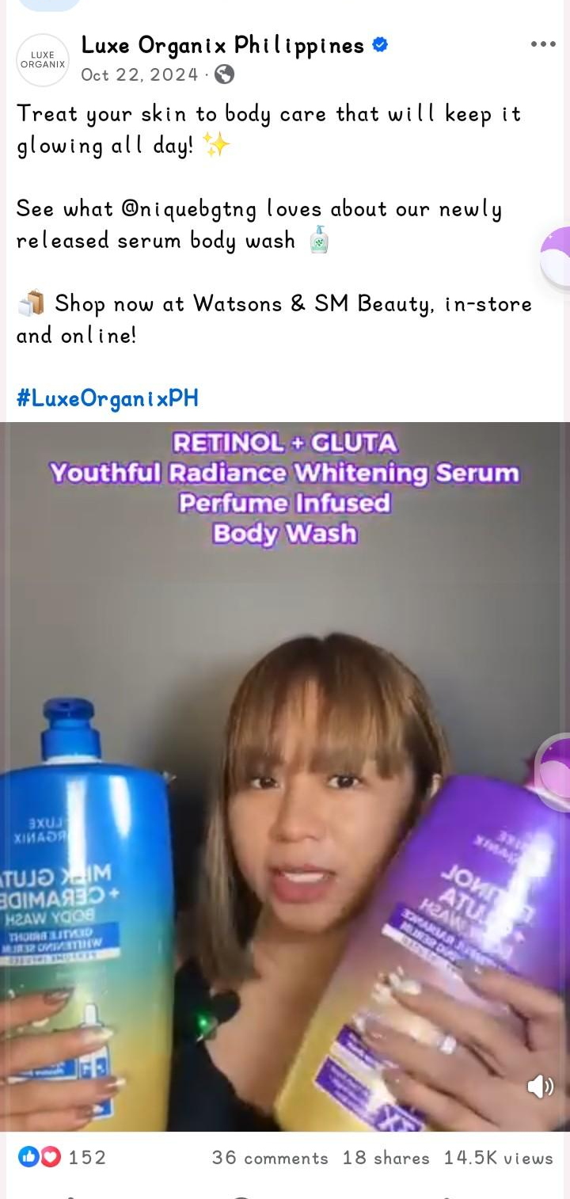
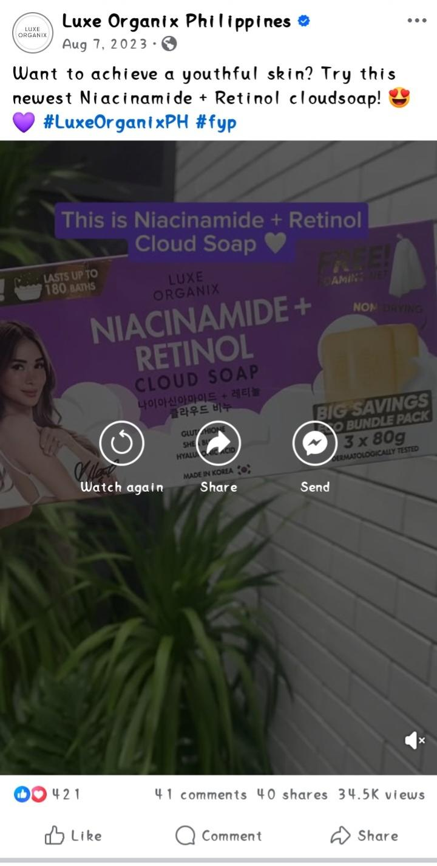

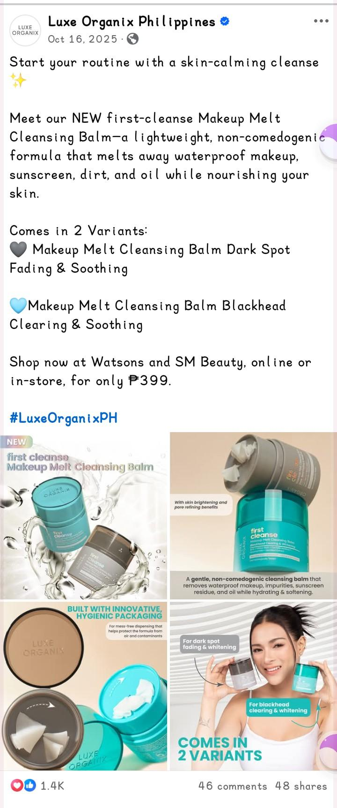
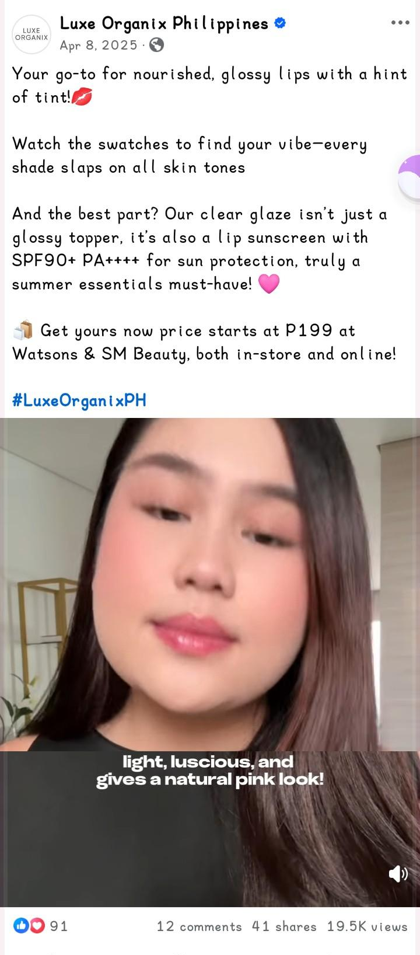

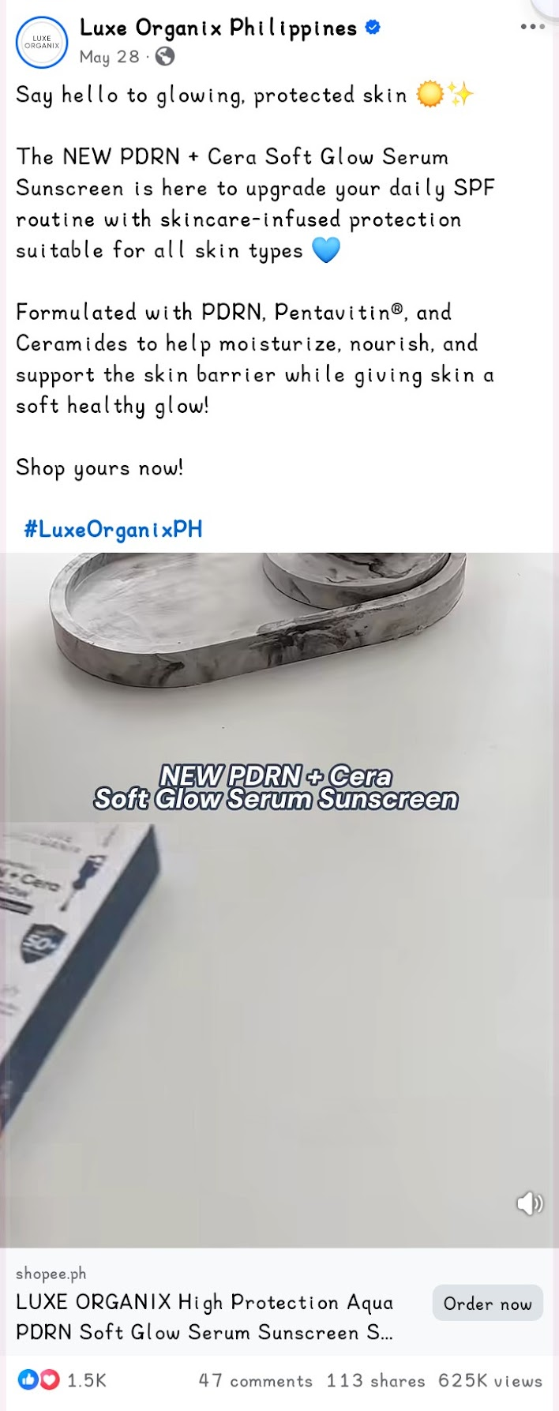

A.3 THE ORDINARY

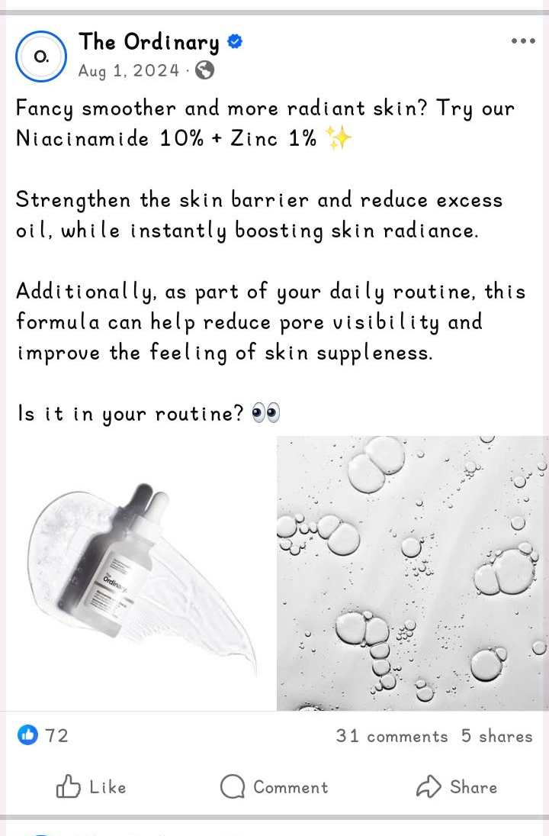
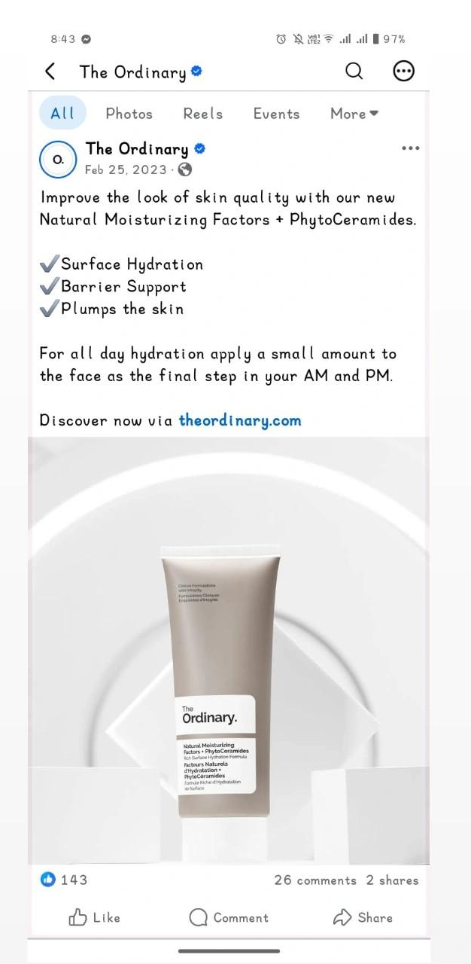
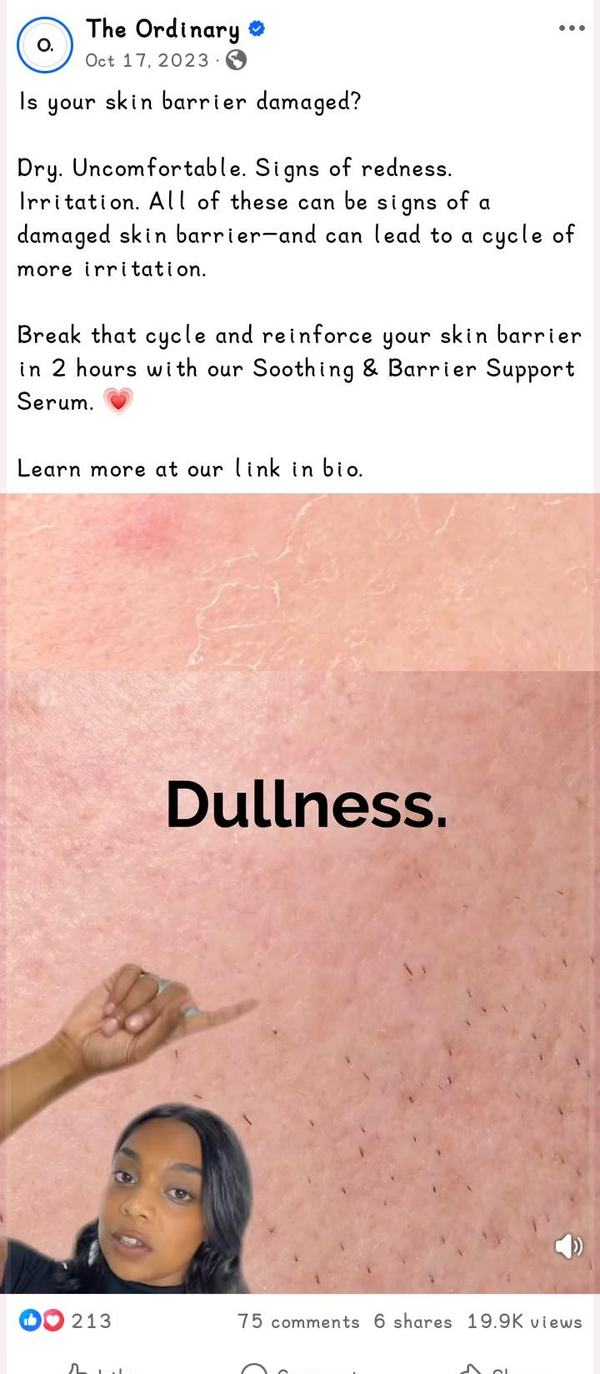
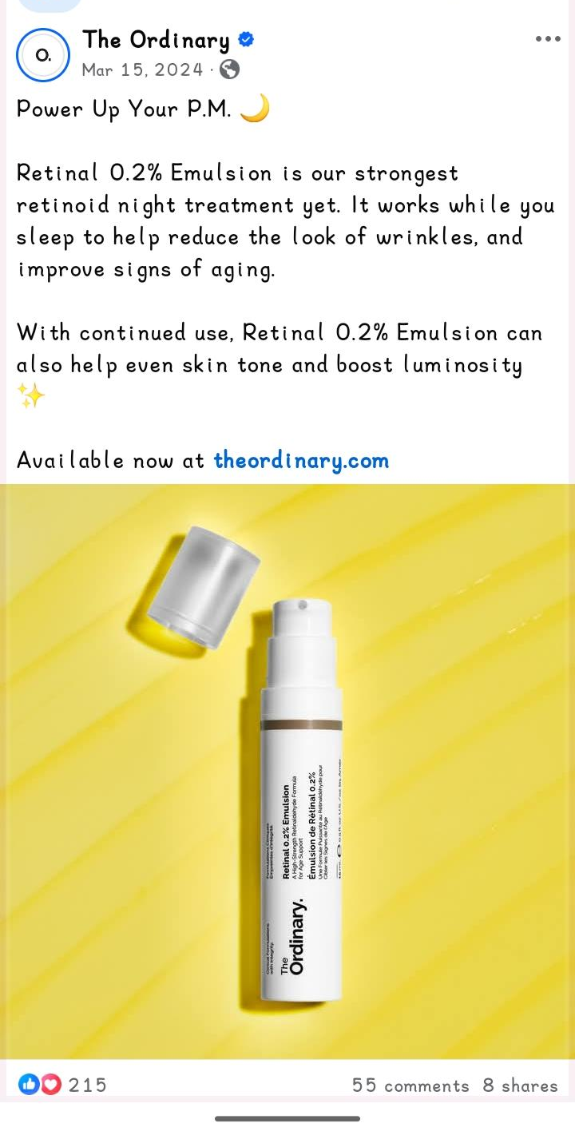

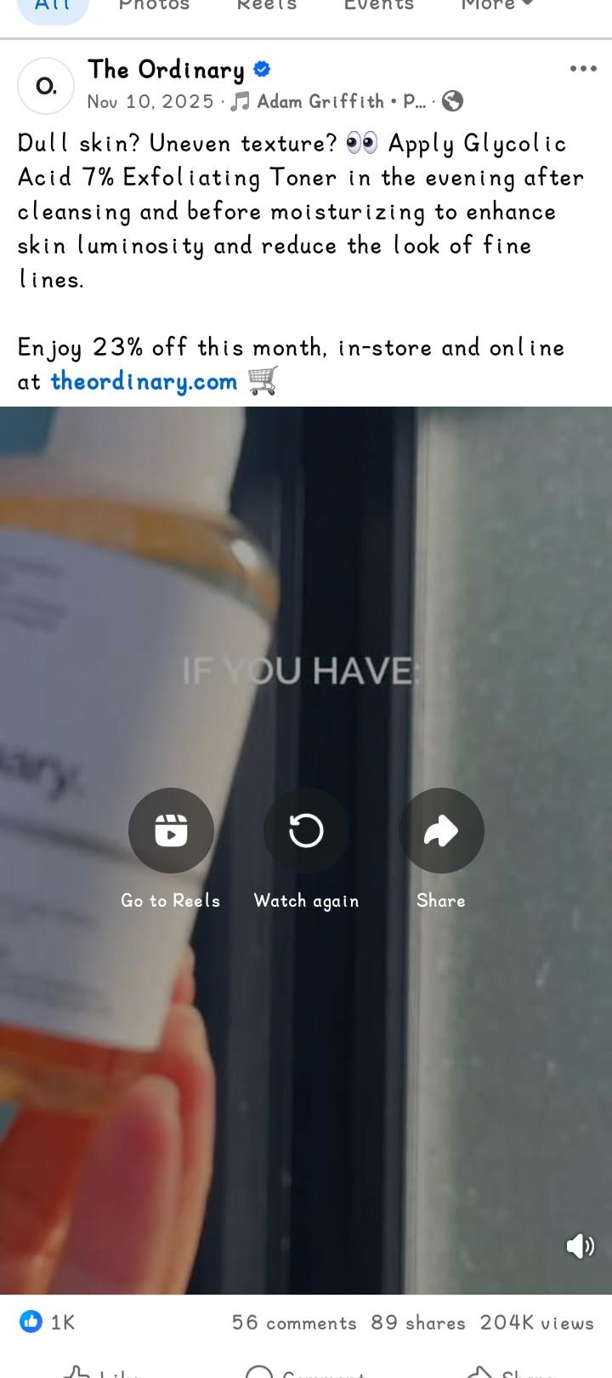
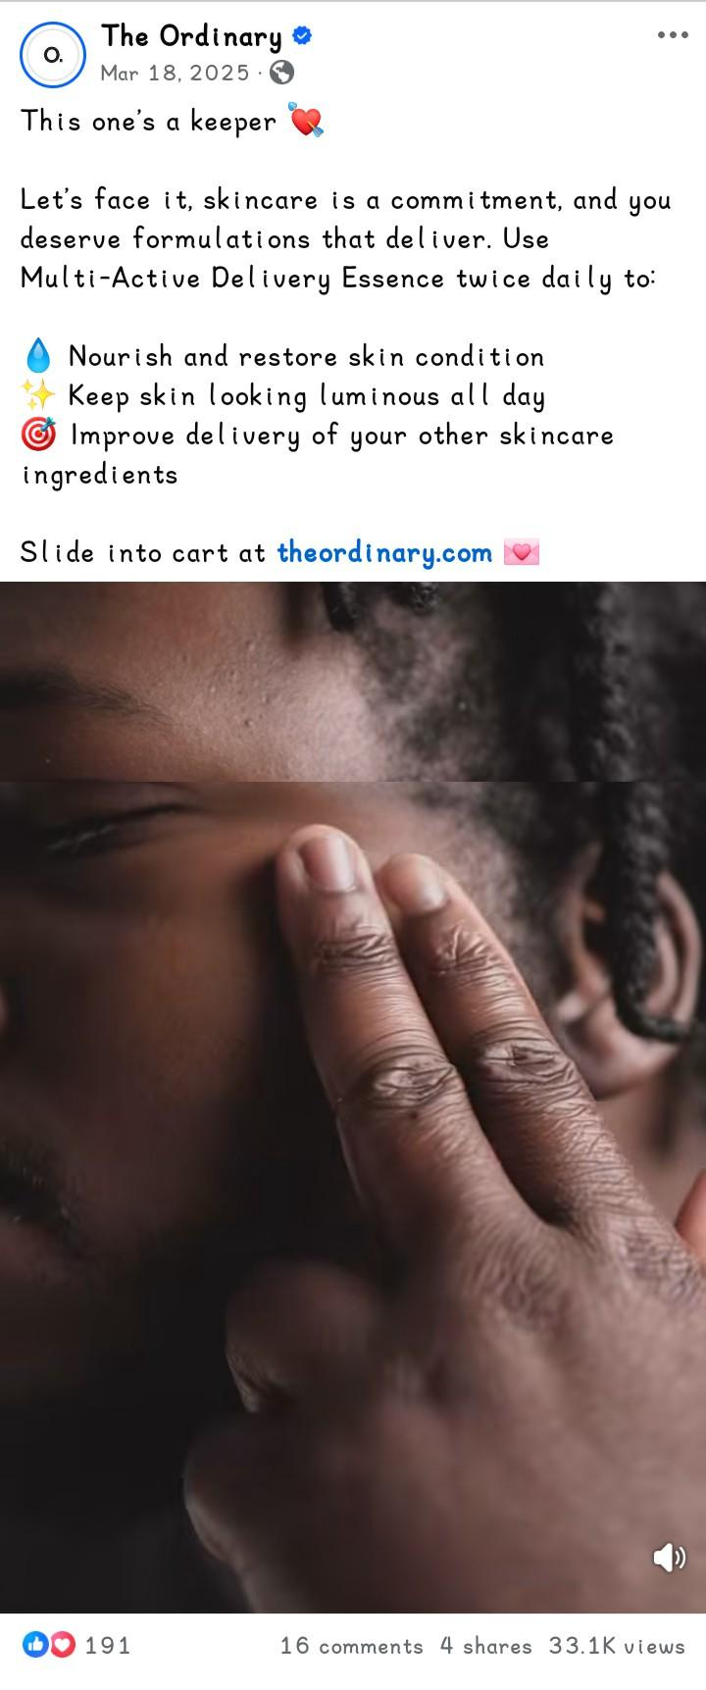
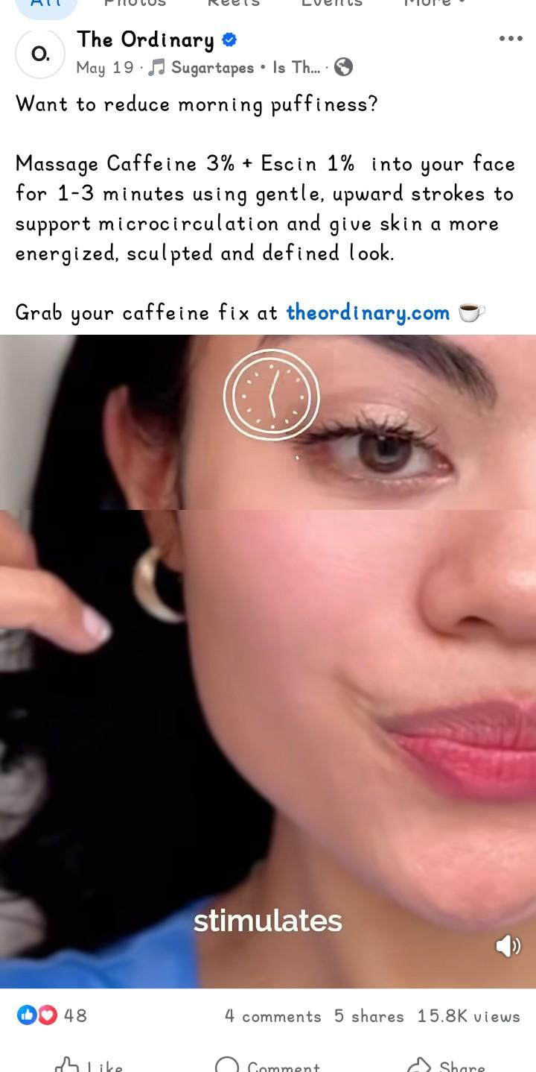
A.4 MYRA

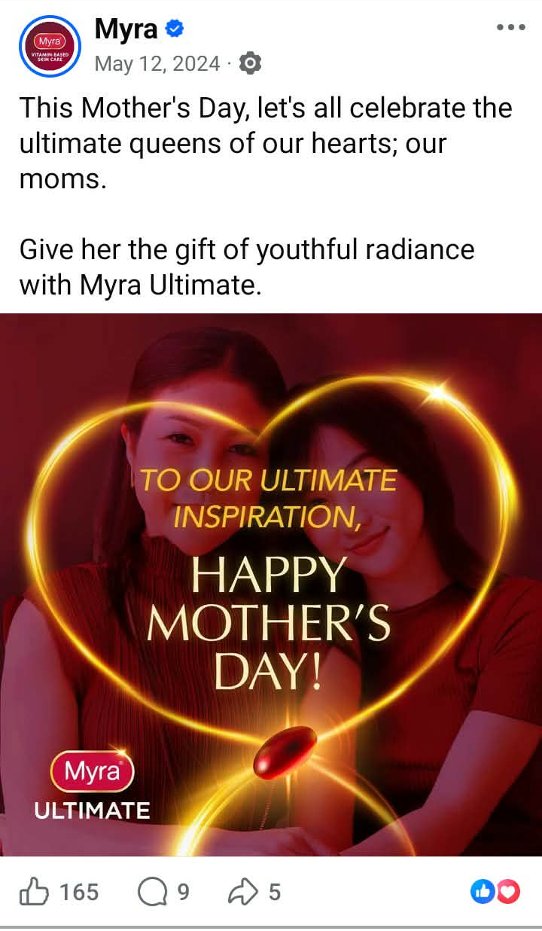
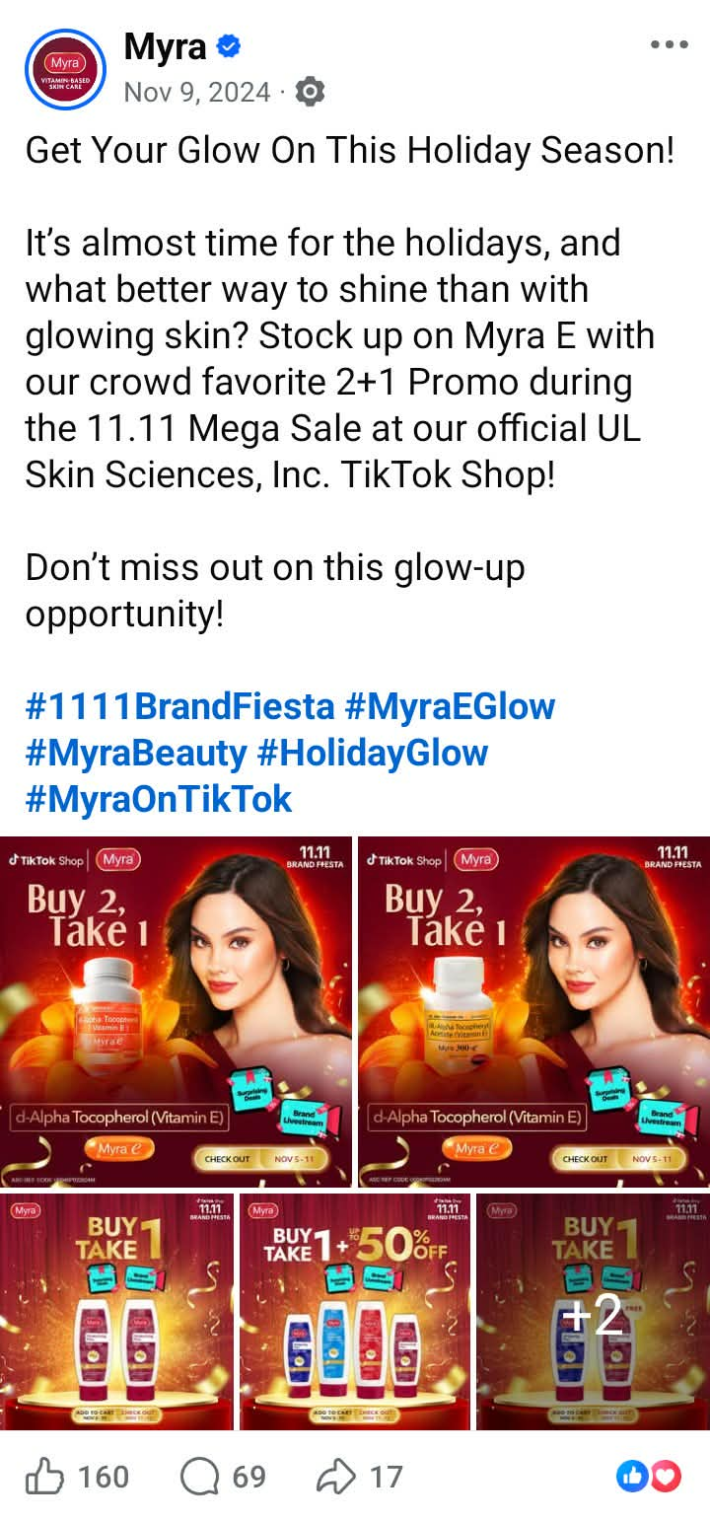
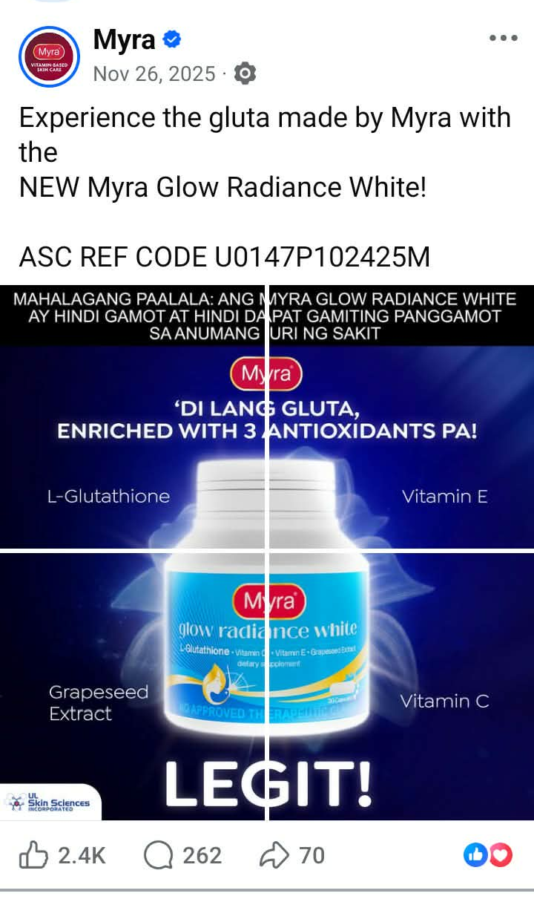
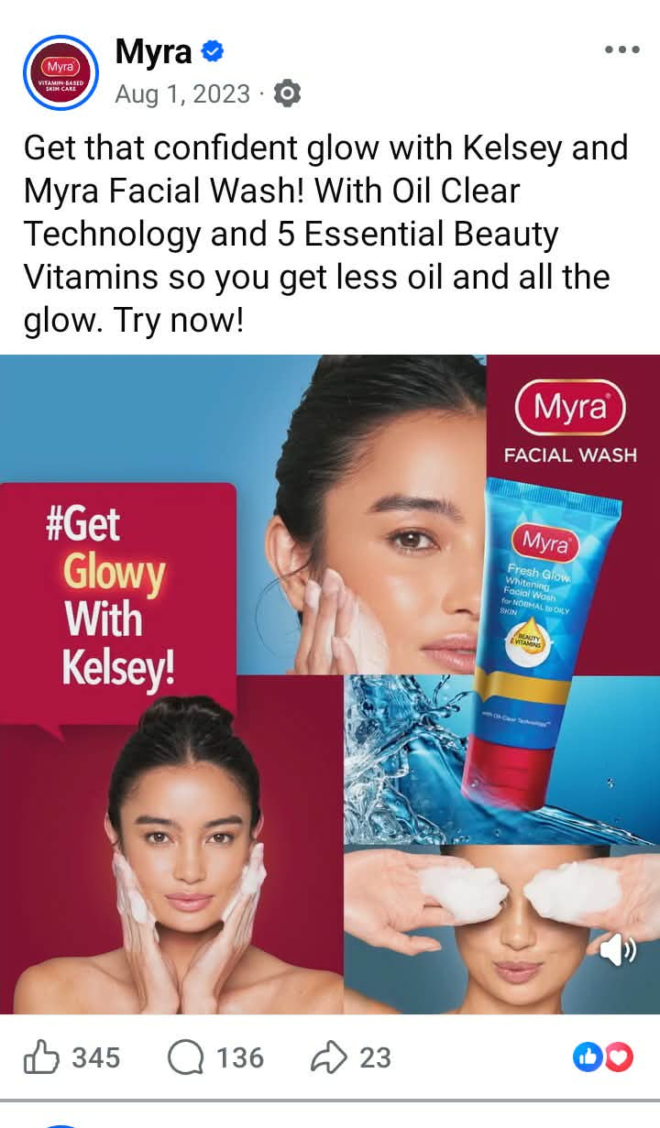
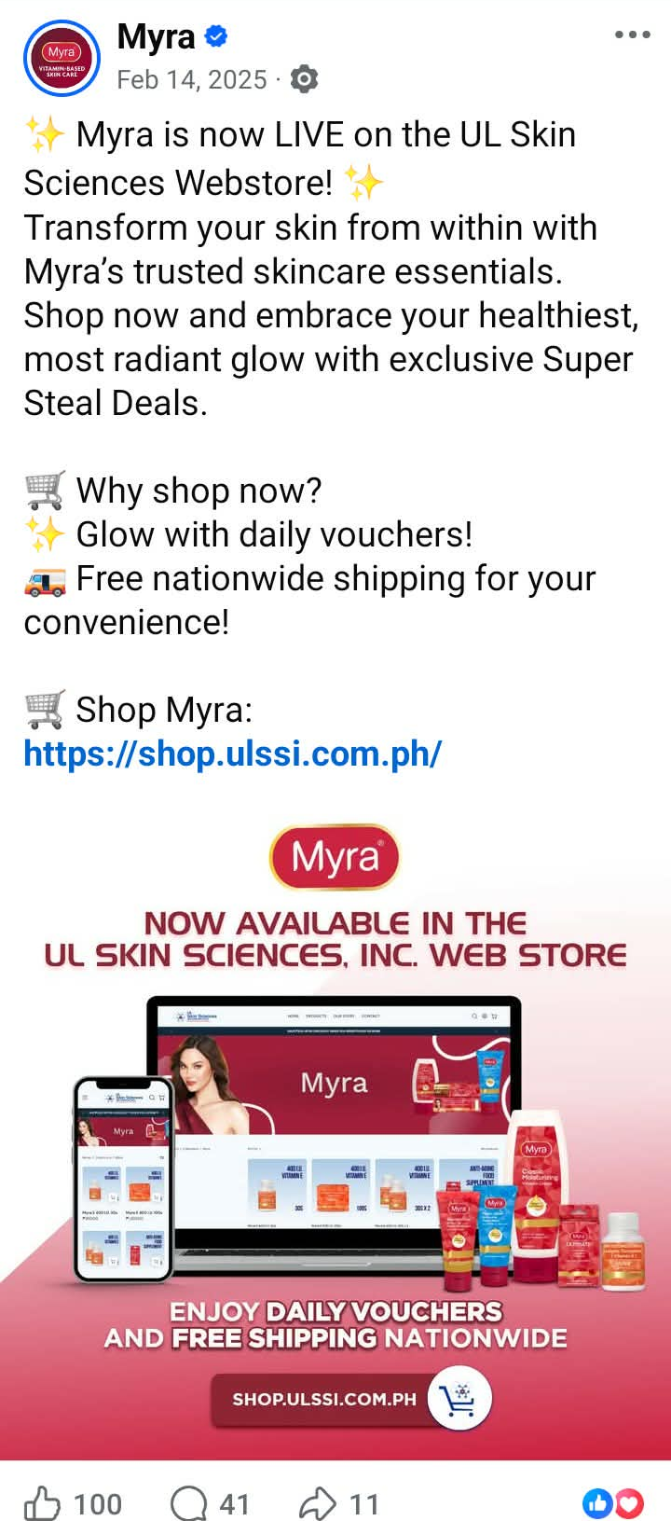
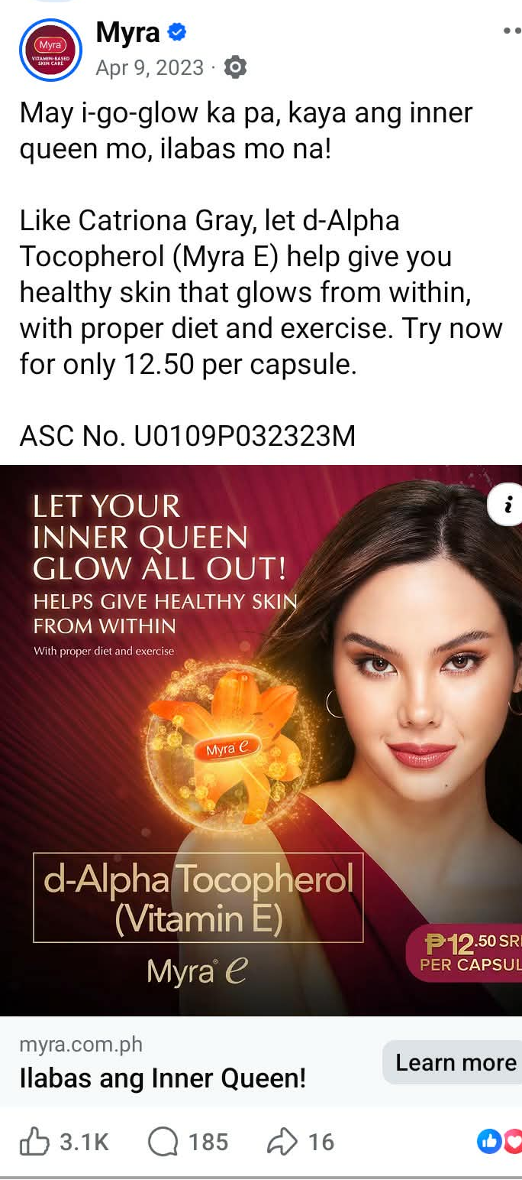
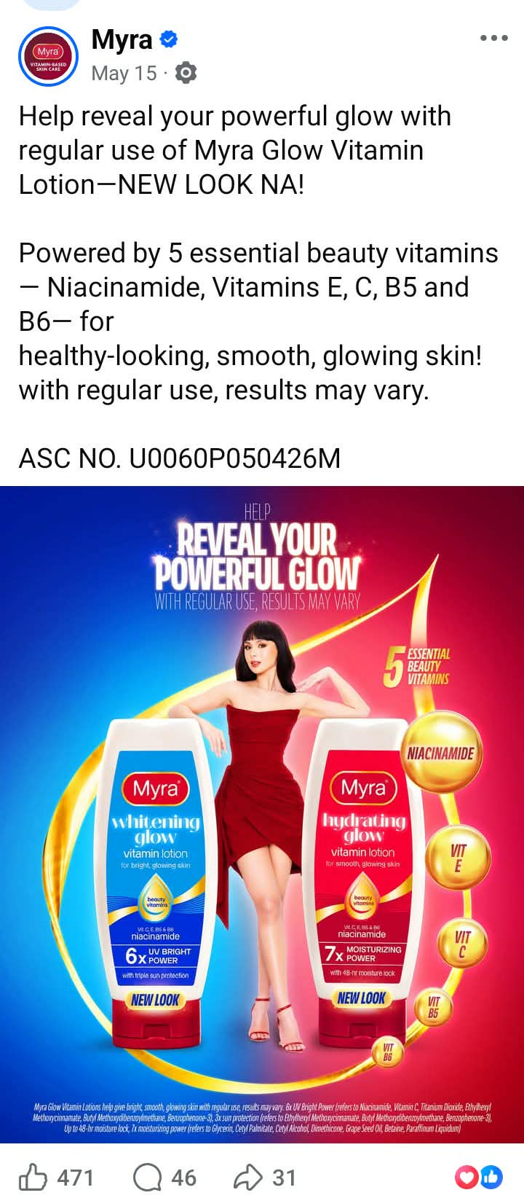
A.5 POND’S

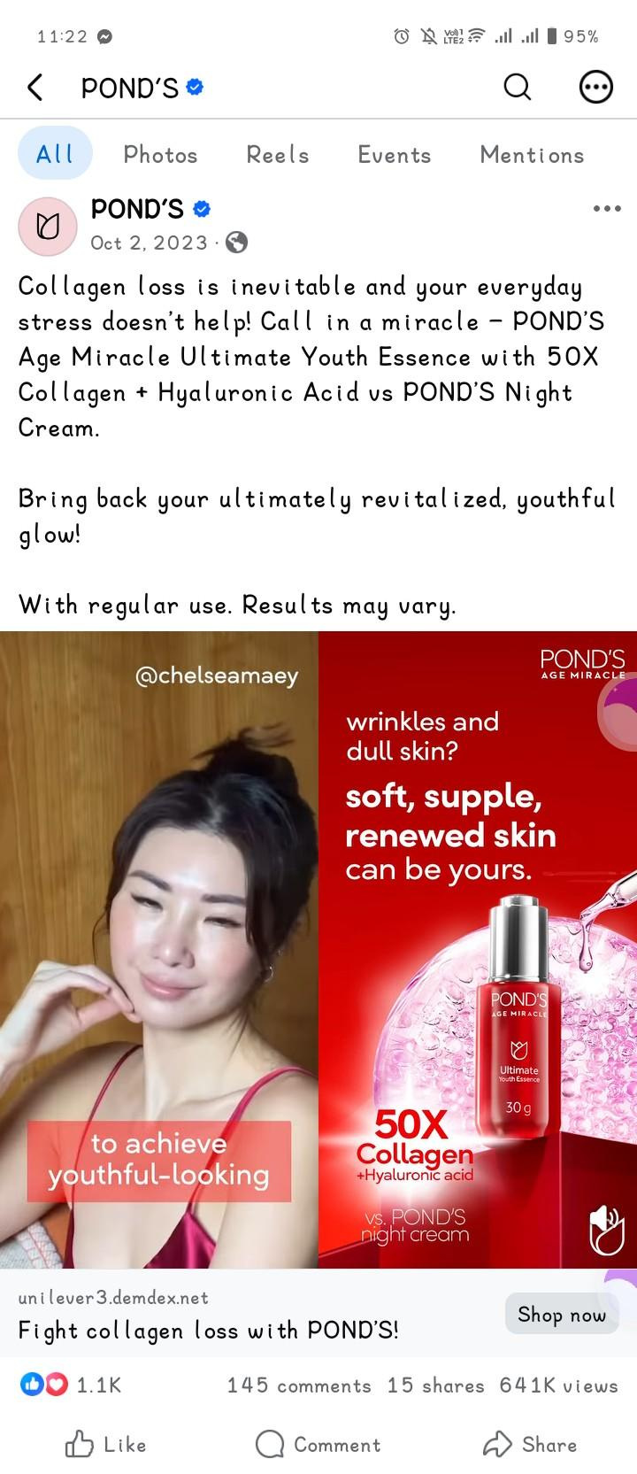
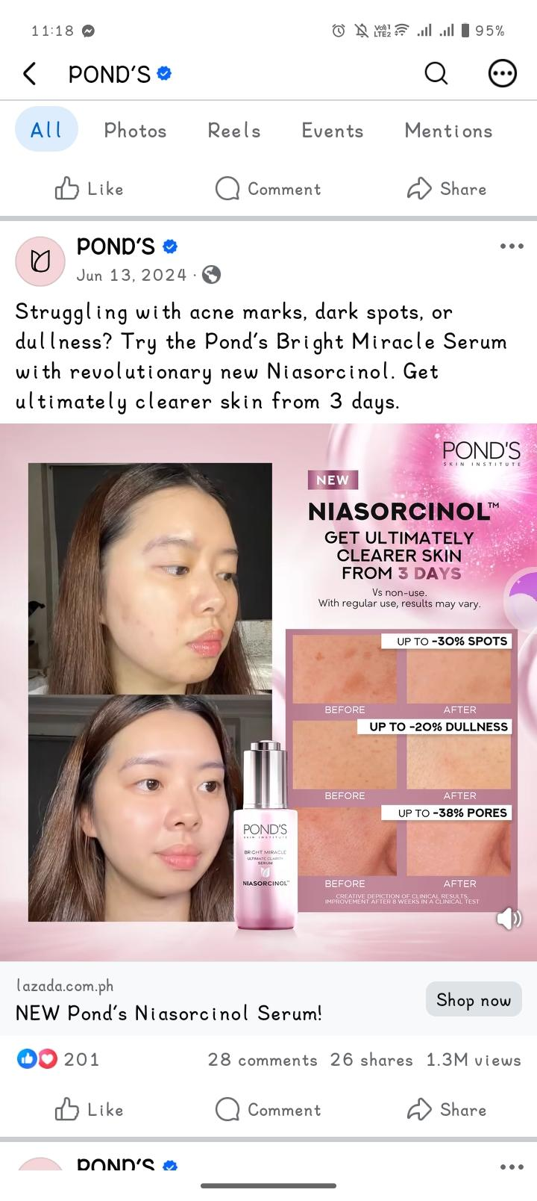
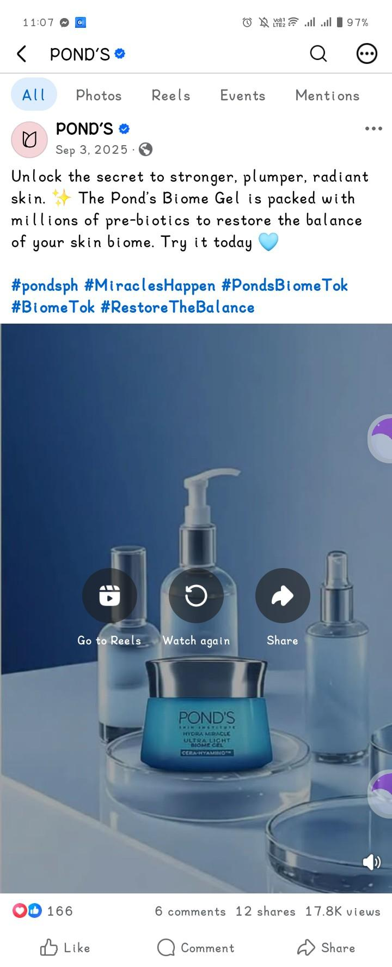
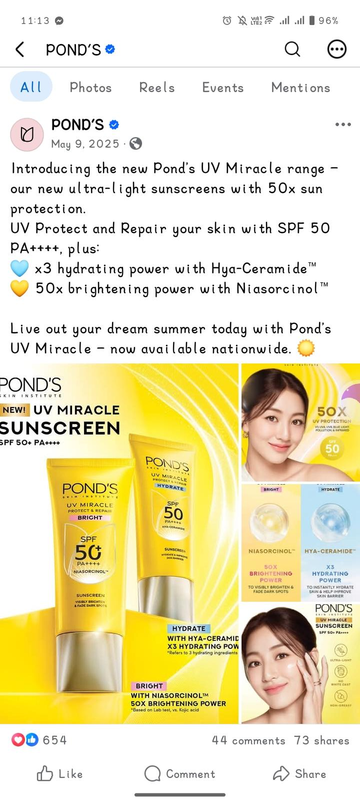
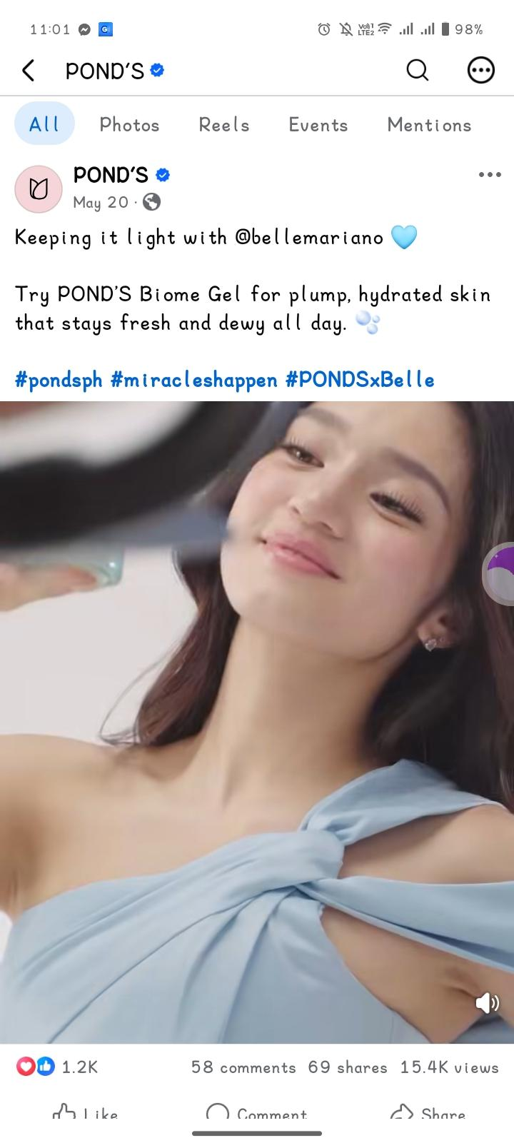
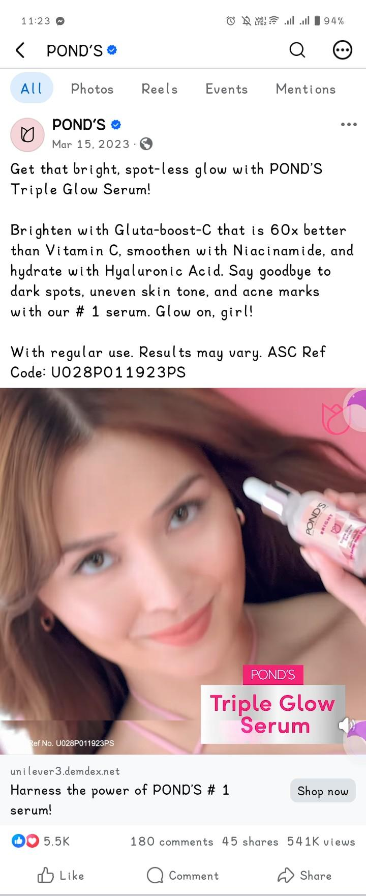
APPENDIX B: ANALYSIS OF RHETORICAL APPEALS

B.1 OLAY

Captions | Rhetorical Appeals | Interpretation
Don’t let the scorching heat dry your skin!  Check out our range of products with UV protection! Choose from Olay Regenerist Micro-sculpting Cream Moisturiser or Olay Regenerist Whip UV Cream! Both has SPF 30 that helps block DNA damaging rays to help protect skin  #OlayPhilippines | Logos | The caption uses logos by giving specific information about the products, particularly their SPF 30. It explains that the SPF 30 helps block DNA-damaging rays and protect the skin, giving a clear reason to consider the products.
Wrap your skin in love this holiday!  Unlock the secret to waking up with glowy, refreshed skin with our Night Regimen Holiday Gift Set.  Shop now at Watsons, S&R, Robinsons Department Store, Landmark Department Store, Shopee and Lazada.  #OlayPhilippines | Pathos | The caption uses pathos by creating feelings of love and care through “wrap your skin in love” and presenting the desirable experience of waking up with “glowy, refreshed skin.” These words make the product feel more appealing and enjoyable to use.
IT’S OUR BIGGEST SALE EVER!  Don’t miss the hottest deals on Olay best sellers and favorites including the NEW Olay Retinol Max range.  Shop these deals at your nearest Watsons and SM Beauty Department Stores or checkout at Watsons Online. | Pathos | The caption uses pathos by using exciting and urgent words such as “biggest sale ever” and “hottest deals.” These words create excitement and encourage consumers not to miss the sale.
Shop now and win amazing prizes with every minimum spend on your favorite Olay products!  Don’t miss out! Add to Cart now:https://s.lazada.com.ph/s.PFOQp  Available only on Lazada.  Terms and conditions apply. | Pathos | The caption uses pathos by highlighting “win amazing prizes” and “Don’t miss out!” These phrases create excitement and a sense of urgency, encouraging consumers to take advantage of the offer.
Feel SUPER with the all-new OLAY SUPER SERUM. Get the power of 5 serum benefits in just one bottle! Launching this July 1, 2025, at Watsons and Tiktok Shop.  #OlaySuperSerum | Logos | The caption uses logos by giving specific information about the product, particularly that it provides five serum benefits in one bottle. This information gives consumers a clear reason to consider the product.
Say hello to younger- looking skin with Olay Total Effects! Your all-in-one solution for the 7 signs of aging.  Get up to 50% off + free shipping only this September 28-30!  Don’t miss out! Add to cart now!  https://www.tiktok.com/@olayphilippines | Logos | The caption uses logos by giving specific information about the product, particularly that it is an all-in-one solution for the “7 signs of aging.” This gives consumers a clear product benefit to consider.
Step into your #SuperEra with Olay Shopee Brand Day this Feb 24.  Enjoy up to 50% off, free shipping, vouchers, and exclusive gifts when you shop the iconic Total Effects Day & Night Cream and SUper Serum Day & Night Bundles.  Shop here:  https://shopee.ph/pgolayoofficialstore | Pathos | The caption uses pathos by using appealing and exciting words such as “#SuperEra,” “exclusive gifts,” and “iconic.” These words create excitement and make the promotion and products more appealing to consumers.

For Olay, pathos was the most frequently identified rhetorical appeal, appearing in four of the seven advertisements, while logos appeared in three. No advertisement was classified as ethos. The use of pathos was evident in captions that emphasized emotions, excitement, and urgency, such as “wrap your skin in love,” “biggest sale ever,” “hottest deals,” and “exclusive gifts.” Meanwhile, logos were used in advertisements that presented specific product information, such as SPF 30, five serum benefits, and the seven signs of aging. This result shows that Olay advertisements relied slightly more on emotional appeal while also using product information to support their promotional messages.

B.2 LUXE ORGANIX

Caption | Rhetorical Appeals | Interpretation
Our newest serum sunscreen is also available in sachets! Handy and travel-friendly! Get yours now!  #LuxeOrganixxSerumSunscreen  #LuxeOrganixPH #serumsunscreen #sunscreen #fyp | Logos | The caption uses logos by giving practical information about the product, particularly that it is available in sachets and is handy and travel-friendly. This gives consumers a clear reason to consider the product.
Want to achieve a youthful skin? Try this newest Niacinamide + Retinol cloudsoap!  #LuxeOrganixPH #fyp | Pathos | The caption uses pathos by presenting youthful skin as a desirable result. The phrase “achieve a youthful skin” appeals to the audience’s desire to maintain a younger-looking appearance, making the product more emotionally appealing.
The 1st ever sunscreen stick from Luxe Organix is finally out!  Introducing our newest Zero Shine Invisible Screen Daily Sun Stick: a lightweight, non-sticky SPF 50 PA+++ sunscreen for everyday and on-the-go use, keeping you UV protected the entire day!  - With Green Tea Extract, Licorice Extract, & Anti Sebum p  -Has SPF50 PA+++ 2X UVA/UVB protection  - Zero tugging and looks seamless  - Has soft, cloud matte finish  - Helps control sebum to keep you shine free  - Helps brighten skin  - Quick absorbing  Shop now in Watsons stores & online!  #LuxeOrganixPH #WatsonsPH #SMBeauty | Logos | The caption uses logos by providing specific information about the sunscreen, including its SPF 50 PA+++ protection, ingredients, and product features. These details give consumers clear reasons to consider the product.
Treat your skin to body care that will keep it glowing all day!  See what @niquebgtng loves about our newly released serum body wash Shop now at Watsons & SM Beauty, in-store and online!  #LuxeOrganixPH | Pathos | The caption uses pathos by presenting glowing skin as a desirable result. This creates an appealing image of how consumers may want their skin to look.
Your go-to for nourished, glossy lips with a hint of tint!  Watch the swatches to find your vibe—every shade slaps on all skin tones And the best part? Our clear glaze isn’t just a glossy topper, it’s also a lip sunscreen with SPF90+ PA++++ for sun protection, truly a summer essentials must-have!  Get yours now price starts at P199 at Watsons & SM Beauty, both in-store and online!  #LuxeOrganixPH | Logos | The caption uses logos by providing specific information about the product, particularly its SPF90+ PA++++ sun protection and starting price of P199. These details give consumers clear information about the product.
Start your routine with a skin-calming cleanse  Meet our NEW first-cleanse Makeup Melt Cleansing Balm—a lightweight, non-comedogenic formula that melts away waterproof makeup, sunscreen, dirt, and oil while nourishing your skin.  Comes in 2 Variants:  Makeup Melt Cleansing Balm Dark Spot Fading & Soothing  Makeup Melt Cleansing Balm Blackhead Clearing & Soothing  Shop now at Watsons and SM Beauty, online or in-store, for only ₱399.  #LuxeOrganixPH | Logos | The caption uses logos by providing specific information about what the cleansing balm does, including removing makeup, sunscreen, dirt, and oil. It also provides information about its variants and price.
Say hello to glowing, protected skin  The NEW PDRN + Cera Soft Glow Serum Sunscreen is here to upgrade your daily SPF routine with skincare-infused protection suitable for all skin types  Formulated with PDRN, Pentavitin®, and Ceramides to help moisturize, nourish, and support the skin barrier while giving skin a soft healthy glow!  Shop yours now!  #LuxeOrganixPH | Logos | The caption uses logos by giving specific information about the product’s ingredients and benefits. These details explain how the serum sunscreen helps moisturize, nourish, and support the skin barrier.

For Luxe Organix, **logos was the most frequently identified rhetorical appeal, appearing in five of the seven advertisements, while pathos appeared in two.** No advertisement was classified as ethos. The use of logos was mainly shown through specific product information, such as **SPF protection, ingredients, product features, benefits, variants, and prices**. For example, the advertisements highlighted SPF 50 PA+++, SPF 90+ PA++++, product ingredients, and the functions of the cleansing balm. Meanwhile, pathos was used in advertisements that presented **youthful and glowing skin** as desirable outcomes, appealing to consumers’ desire for an improved appearance. This result shows that Luxe Organix relied more on product-related information and benefits than on emotional appeal in its advertisements.
B.3 THE ORDINARY

Caption | Rhetorical Appeal | Interpretation
Improve the look of skin quality with our new Natural Moisturizing Factors + PhytoCeramides.  Surface Hydration  Barrier Support  Plumps the skin  For all day hydration apply a small amount to the face as the final step in your AM and PM.  Discover now via theordinary.com | Logos | The caption uses specific product benefits to provide information about how the product can help improve the skin.
Is your skin barrier damaged?  Dry. Uncomfortable. Signs of redness. Irritation. All of these can be signs of a damaged skin barrier—and can lead to a cycle of more irritation.  Break that cycle and reinforce your skin barrier in 2 hours with our Soothing & Barrier Support Serum.  Learn more at our link in bio. | Logos | The caption uses a specific time and product benefit to show what the serum can do for the skin.
Power Up Your P.M.  Retinal 0.2% Emulsion is our strongest retinoid night treatment yet. It works while you sleep to help reduce the look of wrinkles, and improve signs of aging.  With continued use, Retinal 0.2% Emulsion can also help even skin tone and boost luminosity  Available now at theordinary.com | Logos | The caption uses specific skin benefits to explain the intended effects of the product.
Fancy smoother and more radiant skin? Try our Niacinamide 10% + Zinc 1%  Strengthen the skin barrier and reduce excess oil, while instantly boosting skin radiance.  Additionally, as part of your daily routine, this formula can help reduce pore visibility and improve the feeling of skin suppleness.  Is it in your routine? | Pathos | The caption uses desirable skin results to appeal to the audience’s desire for better-looking skin.
This one’s a keeper  Let’s face it, skincare is a commitment, and you deserve formulations that deliver. Use Multi-Active Delivery Essence twice daily to:  - Nourish and restore skin condition  - Keep skin looking luminous all day  - Improve delivery of your other skincare ingredients  Slide into cart at theordinary.com | Logos | The caption uses specific product functions and benefits to show what the product can do for the skin.
Dull skin? Uneven texture? Apply Glycolic Acid 7% Exfoliating Toner in the evening after cleansing and before moisturizing to enhance skin luminosity and reduce the look of fine lines.  Enjoy 23% off this month, in-store and online at theordinary.com | Logos | The caption uses specific skin benefits to explain what the product is intended to do.
Want to reduce morning puffiness?  Massage Caffeine 3% + Escin 1% into your face for 1-3 minutes using gentle, upward strokes to support microcirculation and give skin a more energized, sculpted and defined look.  Grab your caffeine fix at theordinary.com | Logos | The caption uses specific usage details and a stated purpose to provide information about how the product should be applied.
For The Ordinary, logos was the most frequently identified rhetorical appeal, appearing in six of the seven advertisements, while pathos appeared in only one. No advertisement was classified as ethos. The use of logos was mainly shown through specific product benefits, ingredients, usage instructions, and stated effects, such as improving skin texture, supporting the skin barrier, reducing the appearance of wrinkles, and enhancing skin luminosity. For example, the advertisements provided details about Retinal 0.2% Emulsion, Glycolic Acid 7%, and Caffeine 3% + Escin 1% to explain their intended benefits and use. Meanwhile, pathos appeared in the advertisement for Niacinamide 10% + Zinc 1%, which presented smoother and more radiant skin as a desirable result. This result shows that The Ordinary relied strongly on informational and product-based appeal through logos.

B.4 MYRA

Caption | Rhetorical Appeal | Interpretation
May i-go-glow ka pa, kaya ang inner queen mo, ilabas mo na! ​  ​  Like Catriona Gray, let d-Alpha Tocopherol (Myra E) help give you healthy skin that glows from within, with proper diet and exercise. Try now for only 12.50 per capsule. ​  ​  ASC No. U0109P032323M | Pathos | The caption uses pathos by presenting healthy and glowing skin as a desirable result. This appeals to the audience’s desire for attractive and healthy-looking skin.
Get that confident glow with Kelsey and Myra Facial Wash! With Oil Clear Technology and 5 Essential Beauty Vitamins so you get less oil and all the glow. Try now! | Logos | The caption uses logos by providing specific information about the product’s technology and ingredients. These details give factual information about the product and its benefits.
This Mother's Day, let's all celebrate the ultimate queens of our hearts; our moms.  Give her the gift of youthful radiance with Myra Ultimate. | Pathos | The caption uses pathos by connecting the product with feelings of love and appreciation for mothers and presenting youthful radiance as a desirable result.
Get Your Glow On This Holiday Season!  It’s almost time for the holidays, and what better way to shine than with glowing skin? Stock up on Myra E with our crowd favorite 2+1 Promo during the 11.11 Mega Sale at our official UL Skin Sciences, Inc. TikTok Shop!  Don’t miss out on this glow-up opportunity!  #1111BrandFiesta #MyraEGlow #MyraBeauty #HolidayGlow #MyraOnTikTok | Pathos | The caption uses pathos by presenting glowing skin and the special promotion as desirable and exciting. These expressions appeal to the audience’s desire to look good and enjoy the promotion.
Myra is now LIVE on the UL Skin Sciences Webstore!  Transform your skin from within with Myra’s trusted skincare essentials. Shop now and embrace your healthiest, most radiant glow with exclusive Super Steal Deals.  Why shop now?  Glow with daily vouchers!  Free nationwide shipping for your convenience!  Shop Myra: https://shop.ulssi.com.ph/ | Ethos | The caption uses ethos by describing Myra’s products as “trusted skincare essentials,” which presents the products as reliable and worthy of trust.
Experience the gluta made by Myra with the  NEW Myra Glow Radiance White!  ASC REF CODE U0147P102425M | Ethos | The caption uses ethos by emphasizing that the product is “made by Myra,” associating the product with the brand and its reliability.
Help reveal your powerful glow with regular use of Myra Glow Vitamin Lotion—NEW LOOK NA!  Powered by 5 essential beauty vitamins— Niacinamide, Vitamins E, C, B5 and B6— for  healthy-looking, smooth, glowing skin! with regular use, results may vary.  ASC NO. U0060P050426M | Logos | The caption uses logos by providing specific information about the ingredients in the product. These details give factual information about what the product contains and its stated benefits.

For Myra, pathos was the most frequently identified rhetorical appeal, appearing in three of the seven advertisements, followed by logos with two and ethos with two. Pathos was mainly used by presenting glowing, youthful, and attractive skin as desirable outcomes, as well as by connecting the products with feelings of love and appreciation, particularly in the Mother’s Day advertisement. Logos were used through specific product information, such as Oil Clear Technology, five essential beauty vitamins, and the ingredients of Myra Glow Vitamin Lotion. Meanwhile, ethos was identified through expressions that emphasized the brand’s credibility, such as “trusted skincare essentials” and “made by Myra.” This result shows that Myra used a combination of emotional appeal, product information, and brand credibility, with pathos occurring most frequently.

B.5

Caption | Rhetorical Appeal | Interpretation
Get that bright, spot-less glow with POND’S Triple Glow Serum!  Brighten with Gluta-boost-C that is 60x better than Vitamin C, smoothen with Niacinamide, and hydrate with Hyaluronic Acid. Say goodbye to dark spots, uneven skin tone, and acne marks with our # 1 serum. Glow on, girl!  With regular use. Results may vary. ASC Ref Code: ﻿﻿U028P011923PS | Logos | The caption uses logos by providing specific information about the product’s ingredients and their claimed functions. The reference to Gluta-boost-C, Niacinamide, and Hyaluronic Acid gives details about how the serum is intended to brighten, smoothen, and hydrate the skin.
Collagen loss is inevitable and your everyday stress doesn’t help! Call in a miracle – POND’S Age Miracle Ultimate Youth Essence with 50X Collagen + Hyaluronic Acid vs POND’S Night Cream.  Bring back your ultimately revitalized, youthful glow!  With regular use. Results may vary. | Logos | The caption uses logos by providing specific information about the product, particularly its “50X Collagen + Hyaluronic Acid” formulation. This gives the audience factual product information and highlights the ingredients used in the product.
Struggling with acne marks, dark spots, or dullness? Try the Pond's Bright Miracle Serum with revolutionary new Niasorcinol. Get ultimately clearer skin from 3 days. | Logos | The caption uses logos by providing specific information about the product, particularly the “revolutionary new Niasorcinol” and the claim of achieving clearer skin from 3 days. These details present a specific ingredient and a time-based product claim.
Introducing the new Pond’s UV Miracle range – our new ultra-light sunscreens with 50x sun protection.  UV Protect and Repair your skin with SPF 50 PA++++, plus:  x3 hydrating power with Hya-Ceramide™  50x brightening power with Niasorcinol™  Live out your dream summer today with Pond’s UV Miracle – now available nationwide. | Logos | The caption uses logos by providing specific information about the product’s sun protection and benefits, particularly its SPF 50 PA++++ rating, 3x hydrating power, and 50x brightening power. These details give the audience information about the product’s features and claimed benefits.
Unlock the secret to stronger, plumper, radiant skin. The Pond’s Biome Gel is packed with millions of pre-biotics to restore the balance of your skin biome. Try it today  #pondsph #MiraclesHappen #PondsBiomeTok #BiomeTok #RestoreTheBalance | Logos | The caption uses logos by providing specific information about the product’s formulation and function. The reference to “millions of pre-biotics” and their role in restoring the balance of the skin biome gives information about how the product is intended to work.
Keeping it light with @bellemariano  Try POND’S Biome Gel for plump, hydrated skin that stays fresh and dewy all day.  #pondsph #miracleshappen #PONDSxBelle | Pathos | The caption uses pathos by presenting “plump, hydrated,” “fresh,” and “dewy” skin as desirable results. These expressions appeal to the audience’s desire for attractive and healthy-looking skin.

For Pond’s, logos was the most frequently identified rhetorical appeal, appearing in five of the six advertisements, while pathos appeared in one. No advertisement was classified as ethos. The use of logos was mainly shown through specific product ingredients, claimed benefits, formulations, and product features. For example, the advertisements highlighted Gluta-boost-C, Niacinamide, Hyaluronic Acid, 50X Collagen, SPF 50 PA++++, and millions of pre-biotics to provide information about the products and their intended effects. Meanwhile, pathos appeared in the Biome Gel advertisement, which described “plump, hydrated,” “fresh,” and “dewy” skin as desirable results. This result shows that Pond’s relied predominantly on logos by providing specific product information and claimed benefits in its advertisements.

APPENDIX C: ANALYSIS OF DIRECTIVE SUBTYPES

C.1 OLAY

Call-to-action | Directive Subtypes | Interpretation
Check out our range of products with UV protection! Choose from Olay Regenerist Micro-sculpting Cream Moisturiser or Olay Regenerist Whip UV Cream! | Command | The CTA directly tells consumers to check out the products and choose from the available Olay products.
Shop now at Watsons, S&R, Robinsons Department Store, Landmark Department Store, Shopee and Lazada. | Command | The CTA directly tells consumers to shop now and gives the places where they can buy the product.
Shop these deals at your nearest Watsons and SM Beauty Department Stores or checkout at Watsons Online. | Command | The CTA directly tells consumers to shop the deals in physical stores or checkout online.
Shop now and win amazing prizes… Don’t miss out! Add to Cart now. | Command | The CTA directly tells consumers to shop, not miss the offer, and add the products to their cart.
Get the power of 5 serum benefits in just one bottle! | Command | The CTA directly tells consumers to get the product and its five serum benefits in one bottle.
Don’t miss out! Add to cart now! | Command | The CTA directly tells consumers not to miss the offer and to add the product to their cart.
Shop Here. | Command | The CTA directly tells consumers to shop for the featured Olay products through the provided link.

For Olay, all seven advertisements were classified as command, with no instances of order, request, or suggestion. The CTAs consistently used direct expressions such as “Check out,” “Choose from,” “Shop now,” “Get,” “Add to cart,” and “Shop here” to tell consumers what action to take. These commands were mainly directed toward purchasing, checking available products, or accessing the advertised offers. This result shows that Olay relied consistently on direct commands to encourage consumers to respond to its advertisements.

C.2 LUXE ORGANIX

Call-to-action | Directive Subtypes | Interpretation
Get yours now! | Command | The CTA directly instructs consumers to get the serum sunscreen.
Try this newest Niacinamide + Retinol cloudsoap! | Suggestion | The CTA recommends trying the new cloudsoap and presents it as an option for consumers who want youthful-looking skin.
Shop now in Watsons stores & online! | Command | The CTA directly tells consumers to shop for the sunscreen at Watsons stores or online.
Shop now at Watsons & SM Beauty, in-store and online! | Command | The CTA directly tells consumers to shop for the serum body wash at Watsons and SM Beauty.
Get yours now | Command | The CTA directly instructs consumers to get the lip product from Watsons or SM Beauty.
Shop now at Watsons and SM Beauty, online or in-store | Command | The CTA directly tells consumers to shop for the cleansing balm at Watsons and SM Beauty.
Shop yours now! | Command | The CTA directly instructs consumers to purchase the serum sunscreen.

For Luxe Organix, six of the seven advertisements were classified as command, while one was classified as suggestion. The command CTAs directly instructed consumers to take actions such as “Get yours now,” “Shop now,” and “Shop yours now.” In contrast, the CTA “Try this newest Niacinamide + Retinol cloudsoap!” was classified as a suggestion because it recommends trying the product as an option for consumers. This result shows that Luxe Organix predominantly used direct commands, with suggestions used in one advertisement to present the product as an option.

C.3 THE ORDINARY

Call-to-action | Directive Subtypes | Interpretation
Discover now via theordinary.com | Command | The CTA directly instructs the audience to discover the product through the website.
Learn more at our link in bio. | Command | The CTA directly instructs the audience to learn more about the product through the provided link.
Power Up Your P.M. | Suggestion | The CTA encourages the audience to improve or enhance their nighttime skincare routine with the product.
Try our Niacinamide 10% + Zinc 1%. | Suggestion | The CTA encourages the audience to try the product as an option for their skincare routine.
Slide into cart at theordinary.com | Command | The CTA directly tells the audience to add the product to their cart through the website.
Apply Glycolic Acid 7% Exfoliating Toner in the evening after cleansing and before moisturizing | Command | The CTA directly instructs the audience to apply the product at a specific time and as part of their skincare routine.
Grab your caffeine fix at theordinary.com | Command | The CTA directly encourages the audience to obtain the product through the website.

For The Ordinary, five of the seven advertisements were classified as command, while two were classified as suggestion. The command CTAs included expressions such as “Discover now,” “Learn more,” “Slide into cart,” “Apply,” and “Grab your caffeine fix,” which directly encouraged the audience to take a specific action. Meanwhile, “Power Up Your P.M.” and “Try our Niacinamide 10% + Zinc 1%” were classified as suggestions because they encourage consumers to consider incorporating or trying the products as options for their skincare routine. This result shows that The Ordinary mainly used commands, although suggestions were also present in some advertisements.

C.4 MYRA

Call-to-action | Directive Subtypes | Interpretation
Try now for only 12.50 per capsule. | Command | The CTA directly instructs the audience to try the product while also providing its price per capsule
Try now! | Command | The CTA directly instructs the audience to try the Myra Facial Wash.
Give her the gift of youthful radiance with Myra Ultimate. | Command | The CTA directly instructs the audience to give Myra Ultimate as a gift to their mother.
Stock up on Myra E with our crowd favorite 2+1 Promo during the 11.11 Mega Sale at our official UL Skin Sciences, Inc. TikTok Shop! Don’t miss out on this glow-up opportunity! | Command | The CTAs directly instruct the audience to stock up on Myra E and not miss the promotional opportunity.
Shop now and embrace your healthiest, most radiant glow with exclusive Super Steal Deals.” / “Shop Myra | Command | The CTAs directly instruct the audience to shop for Myra products and encourage them to take advantage of the available deals.
Experience the gluta made by Myra with the NEW Myra Glow Radiance White! | Command | The CTA directly instructs the audience to experience the new Myra Glow Radiance White product.
Help reveal your powerful glow with regular use of Myra Glow Vitamin Lotion—NEW LOOK NA! | Command | The CTA directly instructs the audience to use Myra Glow Vitamin Lotion regularly to help reveal their glow.

For Myra, all seven advertisements were classified as command, with no instances of order, request, or suggestion. The CTAs directly instructed consumers to perform actions such as “Try now,” “Give her the gift,” “Stock up,” “Shop now,” “Experience,” and “Help reveal.” These expressions encouraged consumers to try, purchase, use, or engage with the advertised products. This result shows that Myra consistently used direct commands to encourage consumer action across its selected advertisements.
C.5 POND’S

Call-to-action | Directive Subtypes | Interpretation
Brighten with Gluta-boost-C that is 60x better than Vitamin C, smoothen with Niacinamide, and hydrate with Hyaluronic Acid. Say goodbye to dark spots, uneven skin tone, and acne marks with our #1 serum. Glow on, girl! | Command | The CTAs directly instruct the audience to brighten, smoothen, and hydrate their skin and to say goodbye to dark spots, uneven skin tone, and acne marks through the use of the product.
Call in a miracle – POND’S Age Miracle Ultimate Youth Essence with 50X Collagen + Hyaluronic Acid vs POND’S Night Cream. Bring back your ultimately revitalized, youthful glow! | Command | The CTAs directly instruct the audience to call in a miracle and bring back a revitalized, youthful glow through the use of POND’S Age Miracle Ultimate Youth Essence.
Try the Pond's Bright Miracle Serum with revolutionary new Niasorcinol. Get ultimately clearer skin from 3 days. | Command | The CTAs directly instruct the audience to try the Pond’s Bright Miracle Serum and get clearer skin through its use.
Live out your dream summer today with Pond’s UV Miracle. | Command | The CTA directly instructs the audience to live out their dream summer with Pond’s UV Miracle.
Try it today. | Command | The CTA directly instructed the audience to try the Pond’s Biome Gel today.
Try POND’S Biome Gel for plump, hydrated skin that stays fresh and dewy all day. | Command | The CTA directly instructs the audience to try POND’S Biome Gel to achieve plump, hydrated, fresh, and dewy skin.

For Pond’s, all six advertisements were classified as command, with no instances of order, request, or suggestion. The CTAs directly encouraged consumers to perform actions through expressions such as “Brighten,” “smoothen,” “hydrate,” “Call in a miracle,” “Try,” “Get,” “Live out,” and “Bring back.” These commands focused on using the products to achieve the stated skincare results. This result shows that Pond consistently used direct commands to encourage consumers to take action toward the advertised skincare products.

APPENDIX D: ANALYSIS OF THE CONSTRUCTION OF PERSUASIVE MEANING

Skincare Brands | Rhetorical Appeal + Directive Subtypes | Discussion
OLAY | Logos + Command  Pathos + Command  Pathos + Command  Pathos + Command  Logos + Command  Logos + Command  Pathos + Command | The combinations consisted of four Pathos + Command and three Logos + Command. Pathos + Command used emotional expressions with direct instructions, while Logos + Command used product information with direct instructions. These combinations helped make the advertisements appealing while also encouraging consumers to take action.
LUXE ORGANIX | Logos + Command  Pathos + Suggestion  Logos + Command  Pathos + Command  Logos + Command  Logos + Command  Logos + Command | The combinations consisted of five Logos + Command, one Pathos + Command, and one Pathos + Suggestion. Logos + Command was the most common combination, using product information and direct instructions. Pathos + Command and Pathos + Suggestion used desirable skin results to encourage consumers to respond. These combinations show that the advertisements mainly used product information and direct commands to create persuasive meaning.
THE ORDINARY | Logos + Command  Logos + Command  Logos + Suggestion  Pathos + Suggestion  Logos + Command  Logos + Command  Logos + Command | The combinations consisted of five Logos + Command, one Logos + Suggestion, and one Pathos + Suggestion. Logos + Command combined product information with direct instructions, while the suggestion combinations presented the products as options for consumers. These combinations helped provide reasons to consider the products while encouraging consumers to take action.
MYRA | Pathos + Command  Logos + Command  Pathos + Command  Pathos + Command  Ethos + Command  Ethos + Command  Logos + Command | The combinations consisted of two Logos + Command, three Pathos + Command, and two Ethos + Command. Pathos + Command was the most common combination and used emotional appeal with direct instructions. Logos + Command provided product information, while Ethos + Command emphasized brand credibility. These combinations helped make the advertisements appealing, informative, and trustworthy while encouraging consumer action.
POND’S | Logos + Command  Logos + Command  Logos + Command  Logos + Command  Logos + Command  Pathos + Command | The combinations consisted of five Logos + Command and one Pathos + Command. Logos + Command combined product information with direct instructions, while Pathos + Command used desirable skin results with a direct call to action. These combinations mainly provided product information while encouraging consumers to try or use the products.

