# The Battle of Neighbourhoods

IBM data Science Capstone project

KM Fong

12/2019

1. **Introduction**

Canada is one of the most popular places for immigration for Hong Kong citizens. The Chinese Canadian population has been growing since 1960s due to the changes in immigration law and political issues in Hong Kong. The Chinese has established many shops and restaurants to cater their population. As the capital of the province of Ontario, many immigrants favor Toronto as their port of entry. In this project, we would be finding the neighborhood with the best Chinese restaurants in Toronto. This would be valuable for newcomers joining the community who prefer to have Chinese food.

**1.1 Data**

For this project we need the following data:

Table 1. Data collection

|  |  |  |  |
| --- | --- | --- | --- |
| Data | Content | Source | Description |
| Toronto city data | contains list Boroughs, Neighborhoods along with their latitude and longitude | http://cocl.us/Geospatial_data,  https://en.wikipedia.org/wiki/List_of_postal_codes_of_Canada:_M | The Wikipedia page includes the postcode, borough, and neighborhood. And geocodes will be obtained from the geospatial_data. After combination, we will use this data set to explore Chinese restaurants of Toronto city. |
| Foursquare API |  |  | By using this API we will get all the venues in each neighborhood. We can filter these venues to get only Chinese restaurants. |
| City of Toronto Neighborhood Shapes for mapping |  | https://www.google.com/maps/d/u/0/viewer?msa=0&mid=1uclm6-D3MSanesned1rQCnzJtws&ll=43.71277641798449%2C-79.49240235858218&z=10 | By using this data, we will get the Toronto neighborhood boundaries that will help us visualize choropleth map. (KML converted to geojson file) |

1. **Method**
   1. **Approach**

We will first collect the geospatial data of Toronto from <http://cocl.us/Geospatial_data>. Then FourSquare API would be assessed to identify all venues for each neighborhoods and borough. Then all Chinese restaurants would be filtered. Again, we would then search the rating, tips, likes for each restaurants using the Foursquare API. Data would then be sorted and then visualized according to the ranking.

* 1. **Libraries**

The following libraries would be included – Panads and Numpy for data manipulation, request module for using FourSquare API, geopy to obtain coordinates of Toronto, folium for data visualization on a map.

1. **Results**

Looking at the dataset, we can see the North York is the largest borough with the highest number of neighborhoods in Toronto

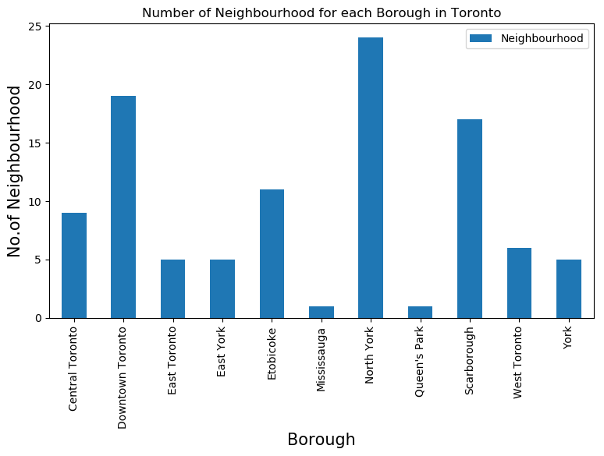

However, more Chinese restaurants situated in Scarborough.

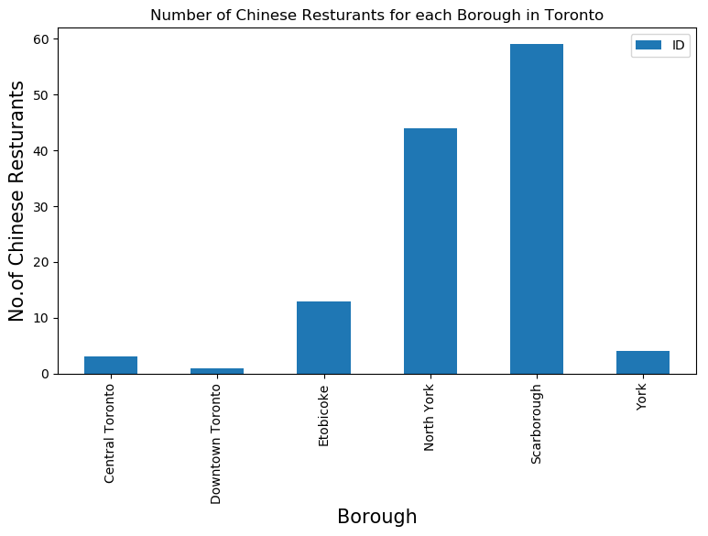

In Scarborough, L’Amoreaux West has the highest number of Chinese restaurants

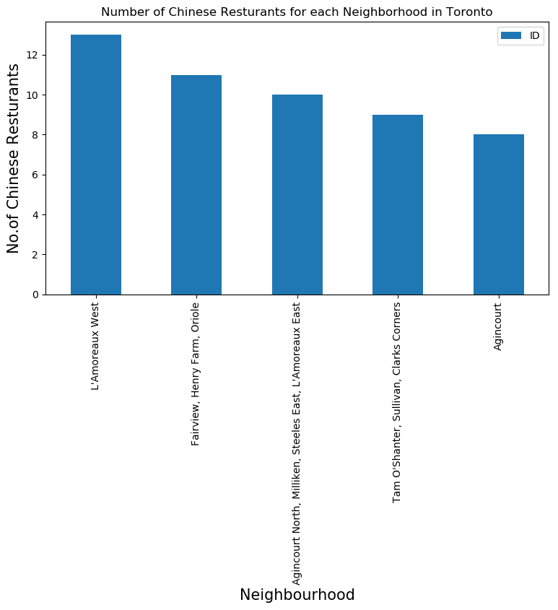

There are thirteen Chinese restaurants in L’Amoreaux West, namely Fishman Lobster Clubhouse Restaurant, D&R Wings, Asian Legend, Yin Ji Chang Fen, Sun’s Kitchen, Captain’s Catch, The Royal Chinese Restaurant, Sam’s Congee Delight, Congee Wong, Chinese Halal Restaurant, Omni Palace Noodle House, Grandeur Palace, Asian Legend.

Congee Wong is the restaurant who have the maximum Likes (60) and maximum tips (40), whereas Fishman Lobster ClubHouse has the maximum rating of 8.7.

Lastly, we would like to assess the average rating of Chinese restaurants of each neighborhood. Result are as follows:

|  |  |
| --- | --- |
| Neighborhood | Average Rating |
| Silver Hills, York Mills | 7.950000 |
| Fairview, Henry Farm, Oriole | 7.836364 |
| Bayview Village | 7.825000 |
| Hillcrest Village | 7.825000 |
| Humber Summit | 7.700000 |

Looking at each borough, North York has the highest average rating of Chinese restaurants

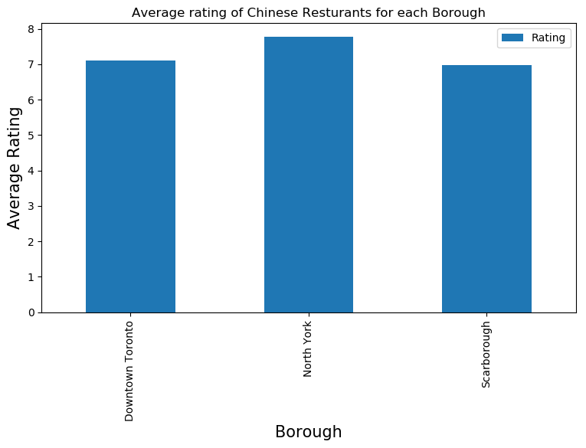

The following map showed neighborhoods with average rating of Chinese restaurants greater than 7.5

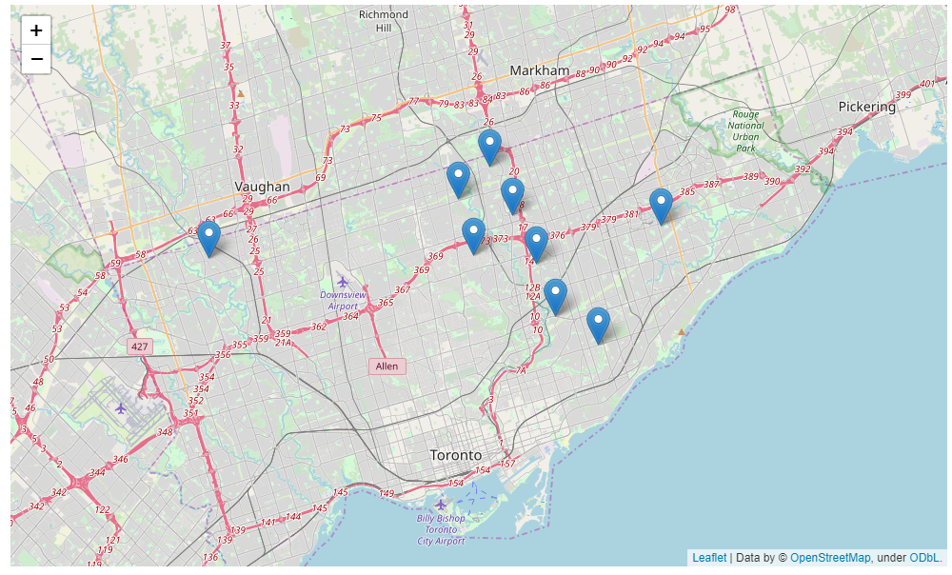

1. **Discussion**

Toronto is a city with plenty of Chinese restaurants available. More Chinese restaurants situated in Scarborough, but restaurants in North York have a higher average rating. Silver Hills/ York Mills is the neighborhood with the highest average rating of Chinese restaurants.

1. **Conclusion**

This study summarizes the location and rating of Chinese restaurants in Toronto. I would recommend people who enjoy Chinese food to visit North York