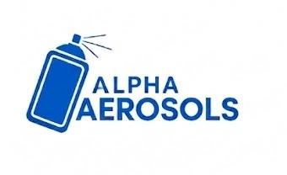 | Alpha Aerosols  Job Order Card | DOC #: AER-JOC-001  DATE: [Placeholder]  REVISION: 00
IMPORTANT: The machine CANNOT be started without this Job Card duly filled and signed by Planning, Production, Store and Quality.
1. JOB / ORDER DETAILS
Job Order No.: |  | Date:
Product / Can Size: |  | Order Quantity (Nos.):
Customer: |  | Shift:
Artwork / Design Ref.:

2. BILL OF MATERIALS (BOM) FOR THIS JOB
Sr. | Material Description | Material Code | Spec / Grade | Total Required Qty | Unit | Waste / Scrap % | Material Batch/Lot No.
1 | Aluminum Slug / Coil
2 | Internal Lacquer / Base Coat
3 | External Base Coat
4 | Printing Ink (per Artwork)
5 | Over-Varnish / Clear Coat
6 | Dome
7 | Neck / Valve Cup (if pre-fitted)
8 | Valve / Actuator / Cap (if applicable)
9 | Packaging – Trays / Cartons / Shrink
Note: Artwork/printing reference image to be attached per uploaded BOM artwork (ERP enhancement BOM-01/BOM-02).
3. CAN / PRODUCT SPECIFICATION
Can Type: |  | Can Diameter (mm):
Can Height (mm): |  | Neck Opening (mm):
Wall Thickness (mm): |  | Dome/Cone Thickness:
Internal Coating: |  | Base Coat Color:
External Print Colors: |  | Varnish Type:
Qty per Pallet/Carton: |  | Special Instructions:

4. QUALITY INSPECTION CHECKPOINTS
Sr. | Inspection Parameter | Specification | Result | Pass / Fail
1 | Leak Test
2 | Dome Height Check
3 | Wall Thickness Check
4 | Print Registration
5 | Coating DFT Check

5. APPROVAL / SIGN-OFF (Required before machine start)
Planning | Production | Store | Quality
Name: | Name: | Name: | Name:
Signature: | Signature: | Signature: | Signature:
Date: | Date: | Date: | Date:

