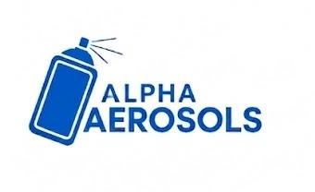 | Alpha Aerosols | SOP #: AER-PL-001  DATE: June 2026  REVISION: 00
Standard Operating Procedure (SOP)
Planning and Procurement Department

Title: Order Receipt and Review
Effective Date: June 2026
Purpose: To ensure every Sales Order is verified and entered into the schedule before planning begins.
Scope: All Sales Orders received for the Aerosol Plant.
Responsibility: Planning and Procurement Lead; Sales and Commercial Team

Procedure:
- Receive the Sales Order
  - Collect the Sales Order by email, ERP system, or physical document.
  - Check that product code, quantity, required delivery date, and specs are present.
- Check Finished Goods Inventory
  - Review current finished goods stock in the ERP system.
  - Available stock may partially or fully cover the order, reducing production needed.
- Check Production Feasibility
  - Confirm the plant can produce the required quantity by the requested delivery date.
  - Confirm raw materials are either in stock or can be procured in time.
- Confirm or Adjust the Delivery Date
  - If feasible: add to the Master Production Schedule and confirm the date to sales.
  - If not feasible: propose a revised date to the Production Manager with a reason.
- Update the Sales Order Log
  - Record the order with status: Received, Planned, In Production, or Dispatched.
  - Update the status each time the order moves to the next stage.

Created by: | Reviewed by: | Approved by:

