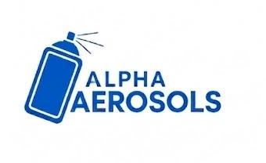 | Alpha Aerosols | SOP #: AER-PL-003  DATE: June 2026  REVISION: 00
Standard Operating Procedure (SOP)
Planning and Procurement Department

Title: Procurement Requisition to Supply Chain Manager
Effective Date: June 2026
Purpose: To communicate material needs to the Supply Chain Manager so Purchase Orders are placed on time.
Scope: All procurement requisitions raised by the Planning department for the Aerosol Plant.
Responsibility: Planning and Procurement Lead (raises requisition); Supply Chain Manager (places PO)

Procedure:
- Prepare the Requisition
  - For each material: note the code, description, quantity, and unit of measure.
  - Add the required delivery date at the plant and the priority level (P1 to P4).
  - Reference the Sales Order or production plan the material is being ordered for.
- Submit Based on Urgency
  - P1 and P2 materials: submit to the Supply Chain Manager on the same day.
  - P3 and P4 materials: submit as part of the weekly planning cycle.
- Confirm Acknowledgement
  - Supply Chain Manager must confirm the Purchase Order plan within one working day.
- Track Progress
  - Track all requisitions against confirmed POs via ERP and daily inventory report.
  - Follow up on any requisition where a PO has not been placed by the expected date.
- Escalate if Not Actioned
  - For P1: if not actioned within 4 hours, escalate to the Production Manager.
  - For P2: if not actioned by end of working day, escalate to the Production Manager.

Created by: | Reviewed by: | Approved by:

