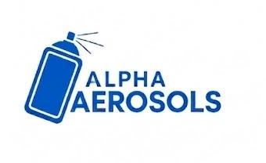 | Alpha Aerosols | SOP #: AER-PL-005  DATE: June 2026  REVISION: 00
Standard Operating Procedure (SOP)
Planning and Procurement Department

Title: Material Prioritization
Effective Date: June 2026
Purpose: To ensure the most critical materials are always acted on first when multiple orders are active.
Scope: All material procurement requisitions raised for the Aerosol Plant.
Responsibility: Planning and Procurement Lead

Procedure:
- P1 — Critical: Act Immediately
  - Stock is at zero or below the minimum safety stock level.
  - Production will stop within 24 hours if this material is not received.
  - Notify Supply Chain Manager immediately. Escalate to Production Manager in 4 hours.
- P2 — Urgent: Act Within 24 Hours
  - Stock covers less than 3 days of production at the current run rate.
  - Raise the same day. PO must be placed within 24 hours. Monitor delivery daily.
- P3 — Routine: Weekly Cycle
  - Stock is adequate but replenishment is needed within the normal lead time.
  - Include in the weekly requisition batch. No urgent action needed.
- P4 — Strategic: Discuss Before Acting
  - An opportunity exists to buy ahead, in bulk, or at a lower price.
  - Get approval from the Production Manager before committing to extra quantity.
- General Rules
  - Always state the priority level on every requisition submitted to Supply Chain.
  - Recheck P1 and P2 status daily until goods are received at the plant.
  - If a material's situation changes between cycles, re-prioritize and resubmit.

Created by: | Reviewed by: | Approved by:

