**Flexbox**

display: flex;

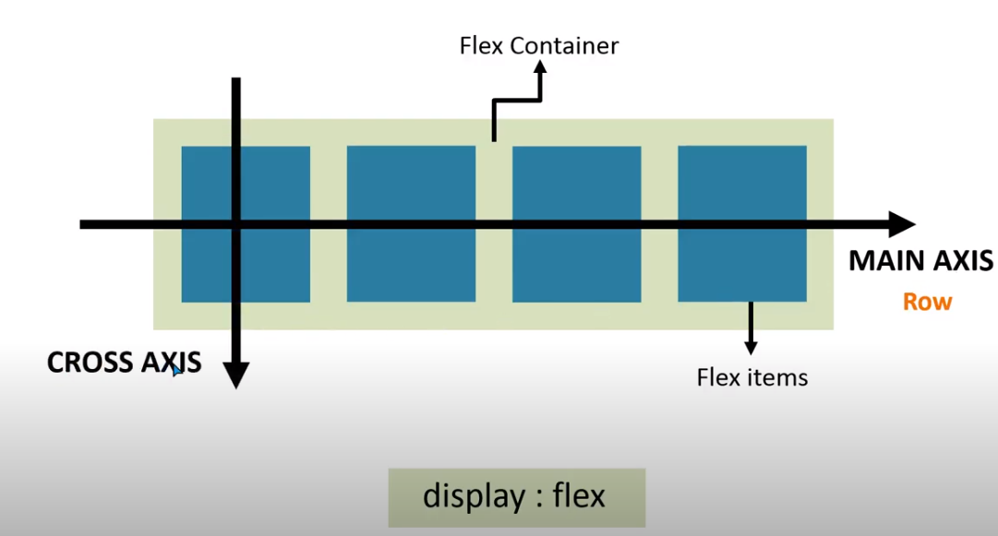

Property of Flex

1. flex-direction
2. flex-wrap
3. flex-flow
4. flex-grow
5. flex-shrink
6. flex-basis
7. flex
8. justify-content
9. align-content
10. align-items
11. align-self
12. order
13. flex-direction
    1. row

.container {

        display: flex;

        flex-direction: row;

}

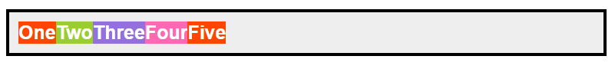

* 1. row-reverse

.container {

        display: flex;

        flex-direction: row-reverse;

}

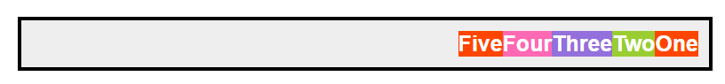

* 1. column

.container {

        display: flex;

        flex-direction: column;

}

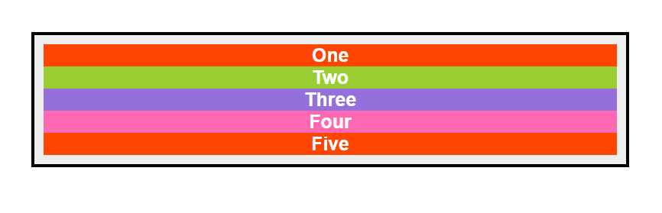

* 1. column-reverse

.container {

        display: flex;

        flex-direction: column;

}

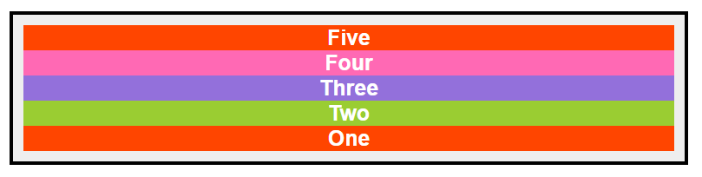

1. flex-wrap

.container {

width: 500px;

        display: flex;

flex-direction: row;

 }

* 1. nowrap

.container {

width: 500px;

     display: flex;

flex-direction: row;

flex-wrap: nowrap;

 }

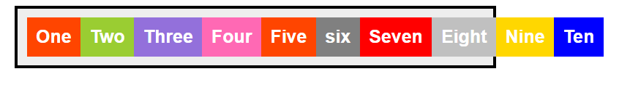

* 1. wrap

.container {

width: 500px;

     display: flex;

flex-direction: row;

flex-wrap: wrap;

 }

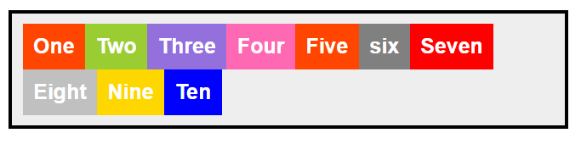

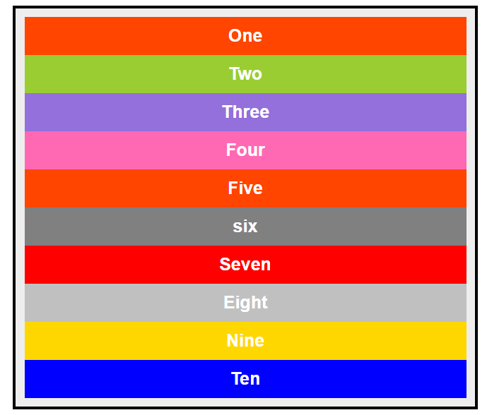

* 1. wrap-reverse

.container {

width: 500px;

      display: flex;

flex-direction: row;

flex-wrap: wrap-reverse;

 }

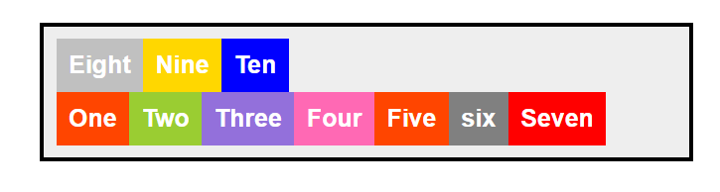

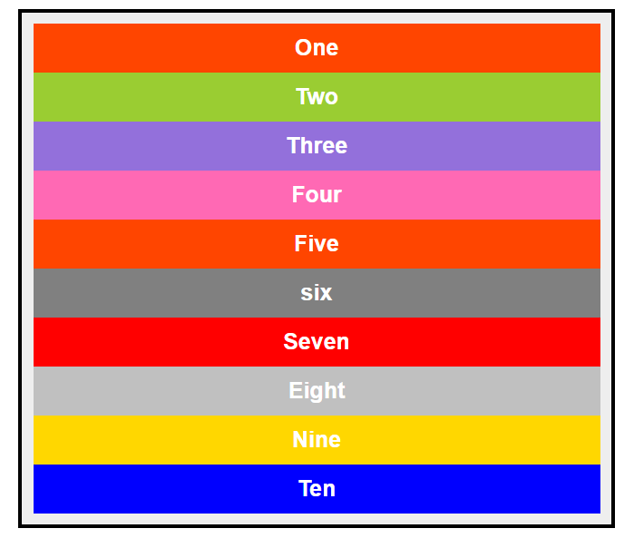

1. flex-flow

This is short hand of flex direction and flex wrap

Flex-flow: <flex-direction> <flex-warp>

.container {

        background: #eee;

        width: 400px;

        margin: 50px auto 0;

        padding: 10px;

        border: 3px solid #000;

        display: flex;

        /* flex-direction: row;

        flex-wrap: wrap; */

        flex-flow: column wrap;

      }

1. justify-content

It is use for horizontally alignment

* 1. flex-start

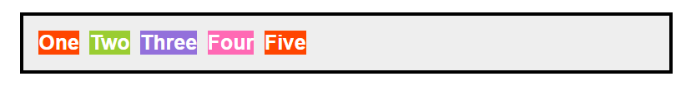

* 1. flex-end

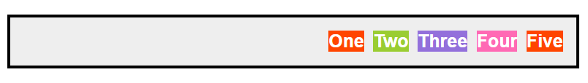

* 1. center

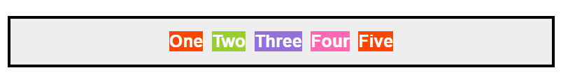

* 1. space-around

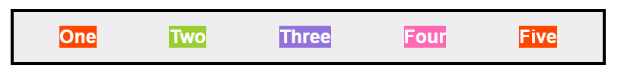

* 1. space-between

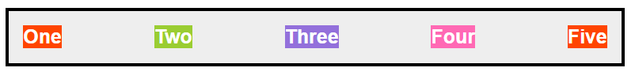



* 1. space-evenly

