Connor Knowles

12/13/24

Database Design

Final Project

Logical Data Requirements

My project is an NFL database. It contains the entities COACH, GAME, LEAGUE_STATS, PENALTY, PLAY, PLAYER, PLAYER_STATS, REFEREE, SCORE, STADIUM, STATISTIC, TEAM, & TEAM_STATS.

* There are individual NFL teams. A given team has a name which uniquely identifies it. We record the team’s division and coach, as well as the stadium ID and coach ID which reference the home stadium and coach respectively
* Players play in the NFL. Each player has a unique ID, as well as a (not-always unique) name. We record the player’s position, age, and team, the latter of which references the player’s team
* A coach coaches a specific team. They have a unique ID. We will record their name, age, experience, and the team in which they coach.
* The score tells us about a scoring play It has an ID which uniquely identifies it. The number of points scored is recorded. We also record the team which scored which references a team and a game ID, which references the game that is being played
* A play tells us what has happened on a specific play. It contains a uniquely-identifying ID. The time remaining of the game is also recorded. The description of the play is logged, as well as the quarter. We record the game ID, which references the game in which the play happened. We also record the penalty ID, which may reference penalty if the result of the play is a penalty.
* A game is an individual game between two football teams. It is identified uniquely by its ID. The date of the game is also stored. It contains references to both the home and away teams in which play in the game, as well as the stadium ID, which references the stadium in which it’s being played.
* The stadium is the place where games are played in. It has a unique ID identifier. The location, capacity, and name of the stadium are also stored as values. It contains a reference to the team which calls the stadium home
* A penalty is the result of a play in which a flag is thrown. It is uniquely identified by its ID. It contains the name of the penalty (pass interference, offsides, etc.). It also has a description of the penalty (The defender interfered with the receiver, hit on a defenseless receiver, etc.) and the amount of yards lost due to the penalty. It contains a reference to the player who was flagged for the penalty and a reference to the referee who called the penalty.
* A referee is somebody who oversees a game of football in order to ensure the rules aren’t being broken. They are identified by their unique ID. Their first name and last name are also recorded, as well as their experience (time spent) being a referee
* A statistic is an event which happens in a football game, be it a touchdown, a sack, an incompletion, etc. It is identified uniquely by its ID. The statistic has a name (incompletion, catch, etc.) and a description of the statistic recorded.
* Team Stats are the result of the total team’s stats. They are identified by their ID. They contain a reference to statistic, to their respective team, and to the total league stats.
* League Stats are the result of all the individual team’s stats. It contains the unique identifier ID. It stores the season’s year and total games played. It also stored the total points and total penalties acquired in that particular year.
* Player stats are the result of an individual player’s stats. It’s identified by a unique ID. It contains a reference to the both the statistic table and the player in which the stats are referencing.

ER Diagram

Relational Schema

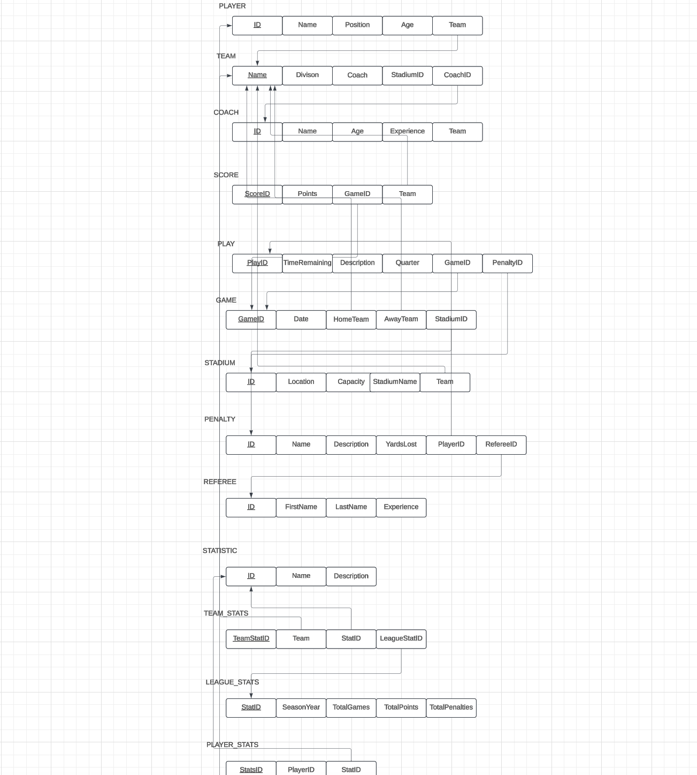

SQL (DDL)

CREATE TABLE ck195147.TEAM

(

[Name] VARCHAR(35) CONSTRAINT PK_TEAM_NAME PRIMARY KEY,

Divison VARCHAR(10) NOT NULL,

Coach VARCHAR(40)

)

CREATE TABLE ck195147.COACH

(

ID INT PRIMARY KEY,

[Name] VARCHAR(40),

Age INT,

Experience INT,

Team VARCHAR(35),

);

CREATE TABLE ck195147.OFF_COOR

(

ID INT CONSTRAINT PK_OFF_COOR_ID PRIMARY KEY,

FOREIGN KEY (ID) REFERENCES COACH(ID)

);

CREATE TABLE ck195147.DEF_COOR

(

ID INT CONSTRAINT PK_DEF_COOR_ID PRIMARY KEY,

FOREIGN KEY (ID) REFERENCES COACH(ID)

);

CREATE TABLE ck195147.STADIUM

(

ID INT CONSTRAINT PK_STADIUM_ID PRIMARY KEY,

StadiumName VARCHAR(50) NOT NULL,

[Location] VARCHAR(50),

Capacity INT,

Team VARCHAR(35) UNIQUE,

FOREIGN KEY (Team) REFERENCES ck195147.TEAM([Name])

);

CREATE TABLE ck195147.LEAGUE_STATS

(

StatID INT PRIMARY KEY,

SeasonYear INT,

TotalGames INT,

TotalPoints INT,

TotalPenalties INT

);

CREATE TABLE ck195147.STATISTIC

(

ID INT CONSTRAINT PK_STATISTIC_ID PRIMARY KEY,

[Name] VARCHAR(50) NOT NULL,

[Description] TEXT

);

CREATE TABLE ck195147.PLAYER

(

ID INT CONSTRAINT PK_PLAYER_ID PRIMARY KEY,

[Name] VARCHAR(40),

Position VARCHAR(20),

Age INT,

Team VARCHAR(35),

FOREIGN KEY (Team) REFERENCES ck195147.TEAM([Name])

);

CREATE TABLE ck195147.PLAYER_STATS

(

StatsID INT CONSTRAINT PK_PLAYER_STATS_ID PRIMARY KEY,

PlayerID INT,

StatID INT,

FOREIGN KEY (PlayerID) REFERENCES ck195147.PLAYER(ID),

FOREIGN KEY (StatsID) REFERENCES ck195147.STATISTIC(ID)

);

CREATE TABLE ck195147.TEAM_STATS

(

TeamStatID INT PRIMARY KEY,

Team VARCHAR(35),

StatID INT,

FOREIGN KEY (Team) REFERENCES ck195147.TEAM([Name]),

FOREIGN KEY (StatID) REFERENCES ck195147.STATISTIC(ID)

);

CREATE TABLE ck195147.PENALTY

(

ID INT CONSTRAINT PK_PENALTY PRIMARY KEY,

[Name] VARCHAR(50),

[Description] TEXT,

YardsLost INT

);

CREATE TABLE ck195147.SCORE

(

ScoreID INT CONSTRAINT PK_SCOREID PRIMARY KEY,

GameID INT,

Team VARCHAR(35),

Points INT,

FOREIGN KEY (GameID) REFERENCES ck195147.GAME(GameID),

FOREIGN KEY (Team) REFERENCES ck195147.TEAM([Name])

);

CREATE TABLE ck195147.GAME

(

GameID INT CONSTRAINT PK_GAMEID PRIMARY KEY,

HomeTeam VARCHAR(35),

AwayTeam VARCHAR(35),

[Date] DATE,

StadiumID INT,

FOREIGN KEY (HomeTeam) REFERENCES ck195147.TEAM([Name]),

FOREIGN KEY (AwayTeam) REFERENCES ck195147.TEAM([Name]),

FOREIGN KEY (StadiumID) REFERENCES ck195147.STADIUM(ID)

)

CREATE TABLE ck195147.REFEREE

(

ID INT CONSTRAINT PK_REFID PRIMARY KEY,

FirstName VARCHAR(40),

LastName VARCHAR(40),

Experience INT

);

CREATE TABLE ck195147.PLAY

(

PlayID INT CONSTRAINT PK_PLAYID PRIMARY KEY,

GameID INT,

[Description] TEXT,

[Quarter] INT,

TimeRemaining TIME,

PenaltyID INT,

FOREIGN KEY (GameID) REFERENCES ck195147.GAME(GameID),

FOREIGN KEY (PenaltyID) REFERENCES ck195147.PENALTY(ID)

);

ALTER TABLE ck195147.TEAM_STATS

DROP COLUMN Value;

ALTER TABLE ck195147.COACH

ADD CONSTRAINT FK_COACH_TEAM FOREIGN KEY (Team) REFERENCES ck195147.TEAM([Name]);

ALTER TABLE ck195147.COACH

ADD CONSTRAINT unique_team_coach UNIQUE (Team);

ALTER TABLE ck195147.PLAY

ALTER COLUMN TimeRemaining VARCHAR(50);

ALTER TABLE ck195147.PLAY

DROP CONSTRAINT FK__PLAY__PenaltyID__54EB90A0;

ALTER TABLE ck195147.PLAY

ADD CONSTRAINT FK__PLAY__PenaltyID__54EB90A0

FOREIGN KEY (PenaltyID) REFERENCES ck195147.PENALTY(ID)

ON DELETE SET NULL;

ALTER TABLE ck195147.TEAM

ADD StadiumID INT;

ALTER TABLE ck195147.TEAM

ADD CONSTRAINT FK_TEAM_STADIUM

FOREIGN KEY (StadiumID) REFERENCES ck195147.STADIUM(ID);

ALTER TABLE ck195147.PENALTY

ADD PlayerID INT;

ALTER TABLE ck195147.PENALTY

ADD CONSTRAINT FK_PENALTY_PLAYER

FOREIGN KEY (PlayerID) REFERENCES ck195147.PLAYER(ID);

ALTER TABLE ck195147.PENALTY

ADD RefereeID INT;

ALTER TABLE ck195147.PENALTY

ADD CONSTRAINT FK_PENALTY_REFEREE

FOREIGN KEY (RefereeID) REFERENCES ck195147.REFEREE(ID);

ALTER TABLE ck195147.TEAM

ADD CoachID INT;

ALTER TABLE ck195147.TEAM

ADD CONSTRAINT FK_Team_Coach FOREIGN KEY (CoachID) REFERENCES ck195147.COACH(ID);

ALTER TABLE ck195147.TEAM_STATS

ADD LeagueStatID INT;

ALTER TABLE ck195147.TEAM_STATS

ADD CONSTRAINT FK_TEAM_STATS_LEAGUE_STATS

FOREIGN KEY (LeagueStatID) REFERENCES ck195147.LEAGUE_STATS(StatID);

SQL (DML)

I mainly used the API to input my data, so it’s JSON, not SQL. Sorry. Here is the JSON I used

Team:

[

{

"name": "DEN",

"division": "AFC WEST",

"coach": "JOSH MCDANIELS",

"coachID": 5,

"stadiumID": 5

},

{

"name": "MIA",

"division": "AFC EAST",

"coach": "TONY SPARANO",

"coachID": 7,

"stadiumID": 14

},

{

"name": "NE",

"division": "AFC EAST",

"coach": "BILL BELICHICK",

"coachID": 8,

"stadiumID": 1000

},

{

"name": "PIT",

"division": "AFC NORTH",

"coach": "MIKE TOMLIN",

"coachID": 2,

"stadiumID": 2

},

{

"name": "TEN",

"division": "AFC SOUTH",

"coach": "JEFF FISHER",

"coachID": 1,

"stadiumID": 1

}

]

Coach:

[

{

"name": "JEFF FISHER",

"id": 1,

"experience": 24,

"team": "TEN",

"age": 51

},

{

"name": "MIKE TOMLIN",

"id": 2,

"experience": 3,

"team": "PIT",

"age": 37

},

{

"name": "JOSH MCDANIELS",

"id": 5,

"experience": 1,

"team": "DEN",

"age": 38

},

{

"name": "TONY SPARANO",

"id": 7,

"experience": 2,

"team": "MIA",

"age": 49

},

{

"name": "BILL BELICHICK",

"id": 8,

"experience": 10,

"team": "NE",

"age": 57

}

]

Stadium:

[

{

"location": "Nashville",

"stadiumName": "Nissan Stadium",

"capacity": 65000,

"stadiumID": 0,

"team": "TEN"

},

{

"location": "Pittsburgh",

"stadiumName": "Heinz Field",

"capacity": 69323,

"stadiumID": 0,

"team": "PIT"

},

{

"location": "Denver",

"stadiumName": "Mile High",

"capacity": 65000,

"stadiumID": 0,

"team": "DEN"

},

{

"location": "Miami",

"stadiumName": "HardRock Stadium",

"capacity": 61000,

"stadiumID": 0,

"team": "MIA"

},

{

"location": "Foxborough",

"stadiumName": "Gillette Stadium",

"capacity": 71000,

"stadiumID": 0,

"team": "NE"

}

]

LeagueStats:

[

{

"statID": 101,

"seasonYear": 2009,

"totalGames": 35,

"totalPoints": 2000,

"totalPenalties": 40

}

]

Statistic:

[

{

"description": "23-yard tocuhdown pass",

"name": "Pass",

"id": 1

},

{

"description": "99-yard run play",

"name": "Pass",

"id": 2

},

{

"description": "3-yard touchdown run",

"name": "Run",

"id": 3

},

{

"description": "92-yard kickoff returned for touchdown",

"name": "Kickoff",

"id": 4

},

{

"description": "QB tackled in own endzone",

"name": "Safety",

"id": 5

}

]

Player:

[

{

"position": "WR",

"name": "Tyreek Hill",

"id": 10,

"team": "MIA",

"age": 31

},

{

"position": "QB",

"name": "Russell Wilson",

"id": 12,

"team": "PIT",

"age": 36

},

{

"position": "QB",

"name": "Drake Maye",

"id": 16,

"team": "NE",

"age": 21

},

{

"position": "QB",

"name": "Josh Allen",

"id": 24,

"team": "TEN",

"age": 23

},

{

"position": "DT",

"name": "Jeffery",

"id": 29,

"team": "TEN",

"age": 27

}

]

PlayerStats:

[

{

"statID": 1,

"statsID": 1,

"playerID": 12

},

{

"statID": 2,

"statsID": 2,

"playerID": 10

},

{

"statID": 3,

"statsID": 3,

"playerID": 16

},

{

"statID": 4,

"statsID": 4,

"playerID": 24

},

{

"statID": 5,

"statsID": 5,

"playerID": 29

}

]

TeamStats:

[

{

"teamStatID": 1,

"statID": 1,

"team": "TEN",

"leagueStatID": 101

},

{

"teamStatID": 2,

"statID": 2,

"team": "DEN",

"leagueStatID": 101

},

{

"teamStatID": 3,

"statID": 3,

"team": "PIT",

"leagueStatID": 101

},

{

"teamStatID": 4,

"statID": 4,

"team": "MIA",

"leagueStatID": 101

},

{

"teamStatID": 5,

"statID": 5,

"team": "DEN",

"leagueStatID": 101

}

]

Penalty:

[

{

"refereeId": 2,

"playerId": 12,

"description": "Offense grabbed facemask",

"name": "Facemask",

"id": 13,

"yardsLost": 15

},

{

"refereeId": 5,

"playerId": 24,

"description": "Offense grabbed facemask",

"name": "Facemask",

"id": 19,

"yardsLost": 15

},

{

"refereeId": 5,

"playerId": 24,

"description": "offense inteferred with pass",

"name": "Pass Interference",

"id": 27,

"yardsLost": 10

},

{

"refereeId": 1,

"playerId": 29,

"description": "QB was hit too hard",

"name": "Offsides",

"id": 101,

"yardsLost": 10

},

{

"refereeId": 3,

"playerId": 16,

"description": "Place at spot of foul, loss of downs",

"name": "Intentional grounding",

"id": 232,

"yardsLost": 15

}

]

Score:

[

{

"gameID": 23,

"scoreID": 12,

"points": 7,

"team": "TEN"

},

{

"gameID": 23,

"scoreID": 19,

"points": 3,

"team": "PIT"

},

{

"gameID": 23,

"scoreID": 23,

"points": 45,

"team": "TEN"

},

{

"gameID": 23,

"scoreID": 26,

"points": 7,

"team": "PIT"

},

{

"gameID": 23,

"scoreID": 31,

"points": 2,

"team": "PIT"

}

]

[

{

"date": "2009-04-23",

"gameID": 23,

"homeTeam": "TEN",

"awayTeam": "PIT",

"stadiumID": 1

}

]

Referee:

[

{

"id": 1,

"firstName": "Johnny",

"lastName": "Bartholomew",

"experience": 23

},

{

"id": 2,

"firstName": "Jack",

"lastName": "Sparrow",

"experience": 1

},

{

"id": 3,

"firstName": "Kenny",

"lastName": "Powers",

"experience": 3

},

{

"id": 4,

"firstName": "Jack",

"lastName": "Daniels",

"experience": 7

},

{

"id": 5,

"firstName": "Billy",

"lastName": "Bob",

"experience": 35

}

]

Play:

[

{

"description": "Penalty (Intentional Grounding)",

"gameID": 23,

"playID": 120,

"quarter": 2,

"penaltyID": 232,

"timeRemaining": "12:23:23.0000000"

},

{

"description": "40-yard touchdown",

"gameID": 23,

"playID": 125,

"quarter": 3,

"penaltyID": **null**,

"timeRemaining": "11:72:93"

},

{

"description": "31-yard touchdown run",

"gameID": 23,

"playID": 130,

"quarter": 3,

"penaltyID": **null**,

"timeRemaining": "11:72:93"

},

{

"description": "-4 yard sack",

"gameID": 23,

"playID": 151,

"quarter": 2,

"penaltyID": **null**,

"timeRemaining": "03:24:23"

},

{

"description": "Incompletion",

"gameID": 23,s

"playID": 153,

"quarter": 1,

"penaltyID": **null**,

"timeRemaining": "09:23:12"

}

]

Java Spring Boot API

Link to my Github repository: https://github.com/cknowles01/DatabaseDesignFinalProject

An example of a functional requirement I have is that a team must have a coach. This means that every single team needs to have a head coach. You’ll get an error if you pass in an invalid coachID.