First report as of 4th October 2026
Corneille Ntihabose

First Code
The code below shows information about patients’ dataset.
patients <- read.csv("data/patients.csv")
head(patients)
id age sex region systolic_bp diabetes
1 1 54 F North 128 no
2 2 61 M North 141 yes
3 3 47 F South 119 no
4 4 72 M East 150 yes
5 5 38 F West 112 no
6 6 59 M South 134 no

A first chart
The chart below is about the distribution of age for patients:
hist(patients$age,
main = "Age distribution of practice patients",
xlab = "Age (years)",
col = "steelblue")
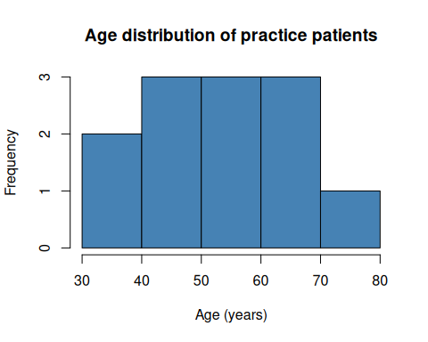

My overall comments
- Most of the patients are aged between 40 and 70 years’old.
- Student learnt how to add one Markdown feature ( bold, italics, or a list)
- I am adding a few sentences here to show that I know how to use one Markdown feature
- I will also add a small calculation here.
- Then, after the result, I will commit and sync this work.
20+80
[1] 100
str(patients)
'data.frame': 12 obs. of 6 variables:
$ id : int 1 2 3 4 5 6 7 8 9 10 ...
$ age : int 54 61 47 72 38 59 65 43 50 68 ...
$ sex : chr "F" "M" "F" "M" ...
$ region : chr "North" "North" "South" "East" ...
$ systolic_bp: int 128 141 119 150 112 134 145 123 130 148 ...
$ diabetes : chr "no" "yes" "no" "yes" ...

