**Repository Link : https://github.com/ckochh2/HCI-HW3.git**

**Answer 1.** Fitts's Law provides a model of human movement, established in 1954 by Paul Fitts, which can accurately predict the amount of time taken to move to and select a target. Although originally developed according to movement in the physical world, in human-computer interaction Fitts's Law is typically applied to movement through the graphical user interface using a cursor or other type of pointer.

**Fitts's Law 1954:** For a given target acquisition task, e.g. move the mouse to a certain point in the UI of an application and select it, Fitts's law describes how the distance from start point to the target and the width of the target influence the index of difficulty (ID) of the task. The original 1954 paper by [Paul Fitts](https://en.wikipedia.org/wiki/Paul_Fitts) proposed a metric to quantify the difficulty of a target selection task. The metric is Fitts's *index of difficulty* (*ID*, in bits):

ID = log2 (2D/W)

where **D** is the distance, **W** is the target's width, and the resulting **ID** is the **Index of Difficulty**.

Fitts also proposed an *index of performance* (*IP*, in bits per second) as a measure of human performance.

In Fitts's words, "The average rate of information generated by a series of movements is the average information per movement divided by the time per movement".

IP = ID/MT which is also known as Throughput

Researchers after Fitts began the practice of building linear regression equations and examining the correlation (*r*) for goodness of fit. The equation expresses the relationship between *MT* and the *D* and *W* task parameters:

MT = a + b * ID = a + b log2 (2D/W)

Where:

*MT* is the average time to complete the movement

a and b are constants that depend on the choice of input device and are usually determined empirically by regression analysis

Fitts's Law is applied to the design of interactive objects in graphical displays. As the size of an object increases the selection time goes down and as the distance between the user's starting point and the object decreases so does the time taken to make the selection. Conversely, small objects, placed far away from the user's starting position take longest to select. Therefore, designers should aim to make objects as close to one another when they are used in the same sequence chain. They should also try to make the interactive elements of the screen as large as is sensible with the amount of space available. Small objects spread apart take the longest time to select; avoid this combination of design features as much as possible.

**Answer 2)** **REPORT:** Fitts’s law experiment for aimed movement.

**2.a) Input Modality:** The input modality that has been chosen for the experiment is a trackpad.

**2.b) Fitts’s Law Experiment Apparatus:** Developed an interactive apparatus to test Fitts Law. The test follows ISO 9241-9:2000 standard for designing the experimental tasks (i.e. multi-directional tapping task). This paradigm has the advantage of controlling for the effect of direction.

**Basic Setup:** The test setup allows a user to go through 6 rounds of 15 taps each, with 2 different widths and 3 different distances to allow for the continuous insertion of test data for different conditions. The target to be hit is marked with Black color and all other circles are represented in red color. The setup is done is such a way that the point moves in opposite direction. When the circle highlighted in black is hit the distance between consecutive click and movement time is calculated.

In the end of the experiment apparatus user can find two buttons:

Button1: **Download Data Set:** Generates a link for downloading CSV file where we have a data dump as required in question generating width, distance, distance between 2 consecutive clicks and movement time.

Button2: **Download Attributes:** Generates a link for downloading CSV file where we have Index of difficulty, movement time and throughput for each of the rounds to further help in generation of graphs.

**2.c) Target and Conditions are mentioned as below:**

Target Width: 10 and 20

Movement Distances: 100,150,200

**2.d) Implementation:** The programming language that has been used to develop this apparatus is JavaScript with D3 libraries. For calculating the Shannon formula simple mathematical functions are being used. We have used CSV file to store the data generated from JavaScript. And for Data Analysis we have used Python to read the CSV file and generate graphs and get regression coefficient, MT over ID graph and Throughput over ID graph.

**Data Analysis over the collected Data:** Data can be retrieved from the CSV file generated for both the users by clicking the download button.

**2. e ) Shannon formulation of the Fitt’s Law :**

**ID = Log2 (D/W +1)**

**2. f) The data is collected from two user.**

**2 g) Regression Coefficient:**

Used linear regression of movement time and the effective index of difficulty to measure the goodness of fit (to decide whether Fitts' law indeed applies) and to verify that the intercept (a) is small.

Least-squares linear regression is used to find the intercept (*a*) and slope (*b*) parameters of the Fitts' law equation

**MTi = b*IDi + a which is equivalent to y = mx + c**

**Slope i.e. b = 144.068611296**

**Intercept at y-axis i.e. a = 725.608311013 ms**

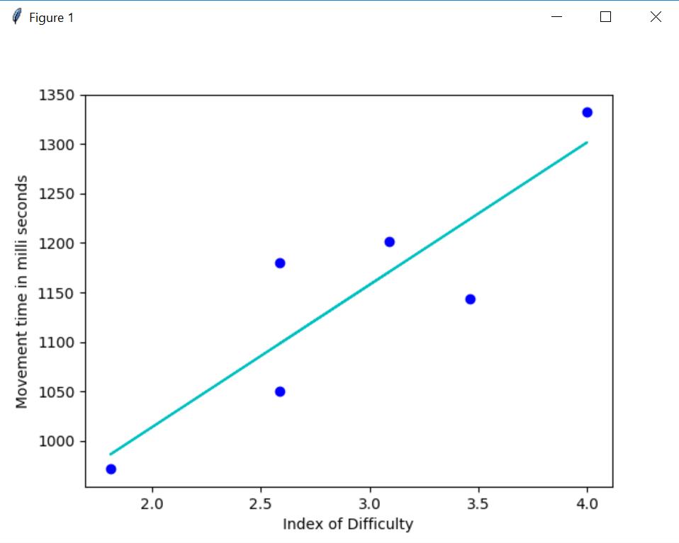

**Fig2.g: Time in ms over ID. Only parameter combinations (distance and width) with average of 2 user’s data is shown to calculate the regression coefficient.**

**2.h : Movement Time over Index of Difficulty:**

Movement time refers to the time subjects spend moving the pointing device.



**Fig2.h: Time in ms over ID. Only parameter combinations (distance and width) with average of 2 user’s data is shown.**

**DATA ANALYSIS:** The data is collected for two users having same set of target and conditions. The movement time is taken as the average for their respective Index of Difficulty.

The above graph is obtained from the data set and least square linear regression line indicates the linear fit that matches the pattern of a set of paired data as closely as possible from which we derived the Regression coefficient’s a and b above.

The above graph aligns to the Fitt’s law because with fixed target size if the distances increases i.e. if the index of difficulty increases the time taken for doing the task also increases.

Also the given above graph illustrate a good example in case the ID is 2.58 but the movement time shows a big difference. This indicates the index of difficulty depend greatly on the target size and amplitude.

For distance = 50, width =10 , ID is 2.58 and Movement Time = 1216 ms and

For distance = 100, width =20 , ID is 2.58 and Movement Time = 1017 ms

From the above 2 given figures we see the ID is same but movement time is different and that what aligns to the Fitt’s law that indicates as the size of an object increases the selection time goes down and as the distance between the user's starting point and the object decreases so does the time taken to make the selection. Conversely, small objects, placed far away from the user's starting position take longest to select.

**2.i) Throughput over Index of Difficulty:** Throughput and its distribution can be one of the indicators of a device's performance. As the below formula indicates with increase in the movement time to hit the target, the throughput i.e. the performance will decrease

Throughput is calculated as : TP = ID/MT

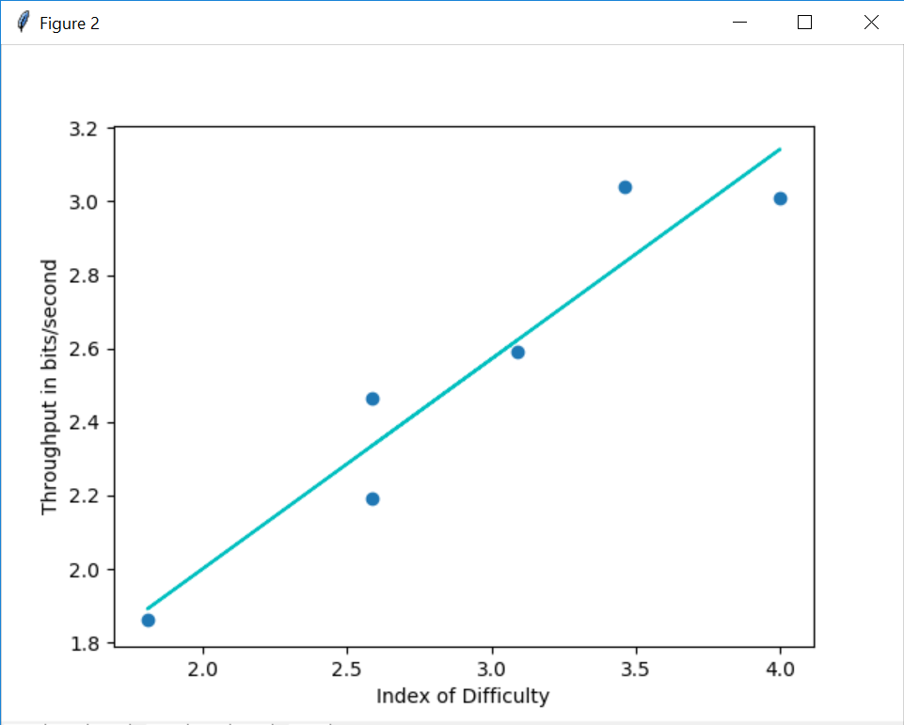

**Fig2.i: Throughput over ID indicating the average performance of both the users.**

**DATA ANALYSIS:** Throughput is computed as **ID/movement time** and therefore has the unit **bits/second**. Throughput and its distribution can be one of the indicators of performance.

From the mathematical equation we conclude that :

TP = ID / MT

And MT = a + b*ID

If the intercept is 0 i.e. a =0 than TP = 1/b

That is if the slope reduces Throughput i.e. TP increases.

Following this idea we can observe in our graph: Three points marked in an arrow that fit in the regression model with a substantial intercept, and between each of these and the origin consider a dotted line. The steepness of the dotted lines considered is a function of how far to the right of the origin each data point is – the larger the ID, the lower the slope of the considered dotted lines and hence the higher the point throughput.