Submitted to: Digital Engineering and Digital Twin (DEDT (open access, free of APC)
Digital engineering and digital twin technologies increasingly demand a lifecycle-consistent structure that links model development, system verification, and operational decision-making. Three Complementary Uses of the EFSUT Methodology: Model Development, System Testing, and Decision Support in ParaDEVS
By
Bernard P. Zeigler
RTSync Corporation and University of Arizona, Tucson, USA
zeigler@rtsync.com
Abstract
The Experimental Frame–System Under Test (EFSUT) methodology, originating in DEVS theory, provides a rigorous foundation for linking stakeholder questions, model structure, system implementation, and decision‑oriented analytics. Although widely referenced in modeling and simulation research, the methodology’s distinct roles across the digital‑engineering lifecycle have not been formally articulated. This paper clarifies three complementary uses of EFSUT that together support the development, verification, and operational employment of digital twins and multiresolution model families.
First, we show how EFSUT functions as a model‑development discipline, enabling the construction of coherent, multilevel, multiformalism model families aligned with a derivability‑ordered partial order of experimental frames. This ensures traceability from stakeholder questions to model abstraction levels and supports the creation of interoperable digital‑twin components.
Second, we demonstrate how EFSUT serves as a test‑engineering framework for verifying system implementations. By deriving admissible inputs, observables, and validation scenarios directly from experimental frames, EFSUT enables lifecycle‑consistent virtual testing, regression verification, and cross‑resolution consistency checks—capabilities central to digital‑engineering workflows.
Third, we show how EFSUT supports decision‑oriented digital‑twin applications when combined with fast tree expansion in paratemporal simulation (referred to as ParaDEVS) (Zeigler 2024), for branching, uncertainty‑aware simulation. In this role, EFSUT structures scenario exploration, tail‑risk metrics, and evidence‑to‑action workflows, enabling transparent, auditable decision support across operational contexts.
Together, these three types of uses position EFSUT as a unifying methodological scaffold for digital engineering and digital twin development, spanning model creation, system verification, and decision‑based deployment. This article presents concepts, practical workflows, and examples to show how EFSUT strengthens digital‑engineering practice throughout the product lifecycle. Finally, we conclude by discussing how research along these lines is a promising direction. Future work can explore automated experimental frame derivation and integration with MBSE toolchains. Research is also needed for formal verification of frame–model applicability and scalable ParaDEVS‑based decision pipelines
.
- Introduction

Digital engineering and digital twin technologies increasingly demand a lifecycle-consistent structure that links model development, system verification, and operational decision-making. The shift from isolated "silos" to an integrated "digital thread" is a major focus as engineering organizations look to modeling and simulation to maintain lifecycle consistency. As such organizations expand their reliance on model-centric processes, the absence of a unifying methodological backbone often leads to fragmentation: models are built in isolation, testing workflows are improvised for each project, and decision-support analyses are constructed ad hoc (Fundamentals for Digital Engineering, 2018; U.S. Department of Defense, 2018). These disconnected practices undermine traceability, reduce confidence in simulation-based evidence, and limit the reusability of digital-twin components across the system lifecycle (Bersbach et al., 2022; Zeigler et al., 2023; Zhuang et al., 2022; Törngren et al., 2020; Liu et al., 2023).
The Experimental Frame–System Under Test (EFSUT) perspective offers a principled alternative. Rooted in the Theory of Modeling and Simulation (Zeigler 1976, Zeigler et al. 2000, Zeigler et al. 2018), EFSUT provides a coherent scaffold that ties stakeholder questions to observational regimes, model abstraction levels, test conditions, and decision-oriented outputs. Rather than treating modeling, testing, and decision support as separate activities, EFSUT organizes them within a single conceptual structure, ensuring that every simulation or analysis is grounded in explicit assumptions and traceable to stakeholder intent.
Experimental Frames (EFs) were introduced as formal specifications of the observational and contextual conditions under which models operate (Zeigler 1976). The basic concepts underpinning the EFSUT methodology were developed with the theoretical framework of the organization of partial models—families of models each valid under specific frames (Zeigler 1978). This theory established EFs as the structuring principle for determining applicability of frames to models in relation to model simplification processes such as order reduction and abstraction. A subsequent ecosystem study demonstrated how frames form a partial order under a defined derivability relation, aligning model abstraction levels with the simulation experimental demands of frames (Zeigler 1979).. Later work by Traoré and Muzy (2006) formalized EFs as manipulable, hierarchical entities with behavioral semantics, enabling automated reasoning and compatibility checks. Recent advances (Zeigler 2023) positioned EFs as semantic anchors for model discovery, reuse, and curation creating an architecture where EFs bridge stakeholder objectives and model capabilities, supporting automated configuration of simulation workflows.
This paper clarifies three distinct uses of the EFSUT methodology that together support lifecycle-consistent digital engineering and digital-twin practice:
- Model Development: using EFSUT to structure multiresolution model families aligned with observational commitments.
- System Testing: deriving test harnesses, admissible inputs, and validation scenarios directly from experimental frames.
- Decision Support: integrating EFSUT with ParaDEVS to enable branching simulations, uncertainty quantification, and evidence-based reasoning.
By articulating these complementary roles, the paper positions EFSUT as a unifying methodological scaffold capable of strengthening digital-engineering workflows from initial requirements through operational decision-making.

2. Overview of EFSUT Framework
This section describes the methodological approach used to formalize the three complementary uses of the EFSUT framework. The method integrates theoretical analysis, structural modeling, and cross‑domain exemplification.
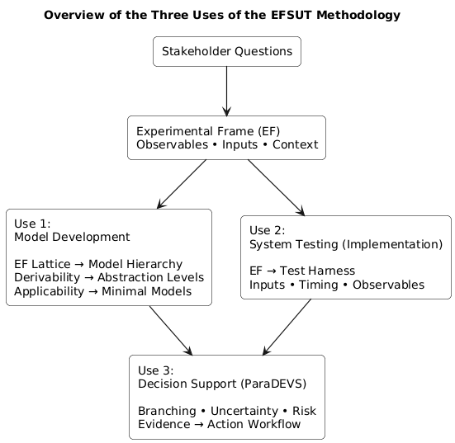
Figure 1 shows how stakeholder questions flow into experimental frames (EF), which then branch into three distinct uses: (1) model development via EF‑driven model hierarchies, (2) system testing via EF‑derived test harnesses, and (3) decision support via ParaDEVS‑based scenario exploration. All three uses remain anchored in the same EF definitions, ensuring lifecycle‑consistent digital‑engineering practice.
Figure 1 Overview of Uses of EFSUT Methodology: three distinct uses of the EFSUT methodology together support lifecycle consistent digital engineering and digital twin practice: Model Development, System Testing, and Decision Support.

2.1 Conceptual Decomposition of EFSUT
We begin by decomposing the EFSUT methodology into its core components:
- Experimental Frames (EFs): formal specifications of observational regimes, admissible inputs, and measurable outputs.
- System Under Test (SUT): the model, implementation, or digital‑twin component evaluated under an EF.
- Decision Metrics: the mapping from raw outputs to decision‑oriented observables.
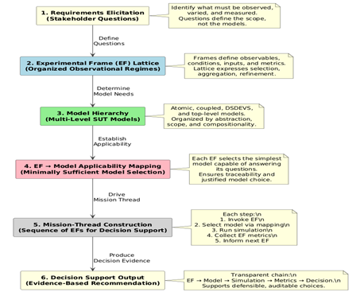
This decomposition provides the basis for distinguishing the three uses of EFSUT.
Figure 2 EFSUT Development Stages
Figure 3 Illustrating the EFSUT development pipeline

Next, we briefly overview the EFSUT development process. Figure 2 displays the EFSUT development pipeline, showing how each phase feeds the next: Requirements → EF Partial order → Model Hierarchy → Applicability → Mission Thread → Decision. Each arrow represents a justified transition, and each box enforces minimality, traceability, and compositional clarity.
Overview of the EFSUT Methodology
The EFSUT methodology is a structured approach for building, selecting, and deploying models in support of defensible decision-making. In the following we provide an informal overview of the methodology while the full definition will be available in (Zeigler in preparation) Each stage of the development corresponds to a distinct phase in the transformation from stakeholder questions to simulation-backed recommendations, with traceability and minimality enforced throughout. Referring to Figure 2, we briefly describe the phases:
1. Requirements Elicitation (Stakeholder Questions)
The process begins not with models, but with questions. Stakeholders articulate what they need to know—what must be observed, what decisions must be supported. These questions define the observational commitments, not the modeling assumptions
2. Experimental Frame (EF) Partial order
Each question induces an Experimental Frame (EF)—a formal specification of inputs, outputs, and validity conditions. These frames are organized into a partial order, expressing the derivability relationship where informally, one frame is derivable from another if the behavioral data associated with the first can be derived from the second. Roughly, this means that the first frame is less demanding in its data demands than the second. of refinement, aggregation, and selection. The partial order structure allows the system to determine which models are needed and how frames relate to one another.
3. Model Family
For each EF, the methodology selects (or constructs if not available) a minimally sufficient model capable of satisfying the frame’s requirements. These models are organized into a family of models, structured by abstraction level, scope, and compositionality.
4. EF → Model Applicability Mapping
This is the heart of EFSUT: each EF is related to the models that can answer its motivated questions. This mapping ensures that every model is traceable to its observational justification and the subset of models provides a basis for choosing a model to simulate based on the accuracy/computational complexity tradeoff.
5. Mission-Thread Construction
A mission thread is a sequence of EF–Model pairs, each step:
- Selects the model via applicability mapping
- Executes the model
- Evaluates the output
- Informs the next EF
- Continue until decision criteria are satisfied
This produces a transparent decision chain, where each inference is grounded in simulation and justified by minimal modeling. This structured approach to decision support is built from EF-driven model execution.
6. Decision Support Output
The output is a defensible recommendation supported by EF definitions, model applicability, simulation results, and mission-thread traceability. This process guarantees that decisions are model-justified, frame-aware, and always traceable to their data and modeling sources.
2.1.2 Construction of EF Partial orders
We construct EF partial orders using the derivability relation mentioned above. defined by selection (variable or spatial subset), The partial order structure is used to identify model abstraction levels, test coverage requirements, and decision-relevant observables.
3.3 Mapping EF Partial orders to Model Families
For each EF, we identify the minimally sufficient model capable of answering its questions. This process results in a model familty that is aligned with the EF partial order. The family may contain models at various levels of resolution and computational complexity. The applicability relation determines which models are appropriate for each frame.
3.4 Deriving Test Harnesses from EFs
To formalize EFSUT’s role in system testing, we derive a set of admissible input sequences, establish specific timing constraints, identify expected observables, and define validation criteria directly from the EF definitions. This comprehensive approach ensures that testing remains traceable to stakeholder intent and is consistent across all implementations.
3.5 ParaDEVS‑Based Decision Support
For decision-oriented applications, we integrate the EF partial order with ParaDEVS to support branching scenario exploration, uncertainty quantification and sensitivity analyses. This method ensures that decision metrics are grounded in explicit experimental frames and model outputs.
3. Case Illustrations
3.6 Cross-Domain Demonstration
To highlight the versatility of the EFSUT methodology, we present representative case studies from three distinct domains. Each example illustrates how experimental frames can be systematically applied to support model construction, validation, and integration, showcasing the method’s adaptability and effectiveness across various fields of engineering and science.
- Ecological Multiresolution Modeling: The EFSUT approach is employed to coordinate models at multiple spatial and temporal resolutions, such as linking detailed individual-based models of species behavior with aggregate population dynamics models. Experimental frames are used to formalize observation scales, define relevant environmental scenarios, and ensure consistency between fine-grained and coarse-grained representations. This creates a family of models that can to answer questions at different abstraction levels while maintaining traceability and coherence.
- Naval Swarm Engagement Modeling: In this context, the methodology guides the development of simulation models for coordinated operations among fleets of autonomous vehicles or vessels. Experimental frames specify engagement scenarios, operational constraints, and metrics of interest (such as survivability or mission effectiveness). Model hierarchies constructed under these frames allow for rapid reconfiguration and validation of tactics, supporting both high-fidelity simulations and abstracted decision-support tools within the same workflow.
- Financial Hybrid DEVS OU-Factor Modeling: The EFSUT process is applied to hybrid discrete event/continuous models that capture the stochastic evolution of financial assets, for example using the Ornstein-Uhlenbeck (OU) process to represent mean-reverting factors. Experimental frames define market conditions, regulatory policies, and performance criteria, enabling systematic evaluation of trading strategies or risk management solutions. The approach supports composability and reuse, facilitating integration with larger financial analysis toolchains.
Collectively, these case studies underscore the generality and broad applicability of the EFSUT methodology. By explicitly linking stakeholder objectives, experimental frames, model hierarchies, and validation mechanisms, the approach provides a unifying framework for simulation-based engineering across ecological, defense, and financial domains.
Use Case 1. Ecological Multiresolution Modeling
The ecological system example presented here illustrates the first and foundational use of the EFSUT methodology: constructing a family of models from the bottom up by progressively introducing Experimental Frames (EFs) and selecting the minimal DEVS models capable of satisfying them.
In the EFSUT framework, model construction does not begin with a fully articulated system model. Instead, it begins with a question, which determines the minimal observational commitments required to answer it. These commitments are formalized as Experimental Frames, and each EF induces the construction (or selection) of the simplest DEVS model that can satisfy its observational and behavioral requirements. As additional questions arise, new EFs are introduced, placed within the EF partial order, and paired with correspondingly richer models. In this way, the model family grows incrementally, justifiably, and traceably, with each step grounded in the mission-driven logic of the EFSUT methodology.
Zeigler (1979) demonstrated the application of EF theory in multilevel, multiformalism modeling, using predator–prey mite experiments as a concrete case. Briefly described, the experimental universe consisted of small number of oranges embedded in a larger array of rubber balls, where the oranges constitute cells of food source and balls constitute empty cells that must be traversed in search of food. Populated by mite species, some of which prey on others, this universe becomes a microscopic representation of a complex ecological system. There are multiple scientific questions for such a universe that no single model can answer. Instead, a structured family of models—each aligned with a specific experimental frame—is required. The frames organize questions that motivate model development, how frames are organized by demands on data acquisition, and how models relate to frames. The entire modeling enterprise becomes coherent when these relationships are made explicit. Three diagrams (Frame Partial Order, Frame–Model Partial order, Best‑Model Table) help visualize make this structure.
Experimental Frames: Organizing Questions and Observations
In Figure 4, each experimental frame, EF specifies the conditions under which a system is observed and the variables that can be measured. Frames encode the scientific questions being asked.
In the ecosystem example, frames vary along two axes:
• Spatial scope: global (all cells) vs. local (subset of cells)
• Level of abstraction (resolution): continuous counts vs. aggregated totals vs. state occupancy counts
For example, the most detailed frame, E_global, observes food, prey, and predator counts in every cell. More abstract frames observe only totals, or even just discrete occupancy categories. Each frame defines a set of possible data sets and determines which questions can be meaningfully posed. The Frame Hierarchy Diagram shows how these frames are organized into planes of abstraction.

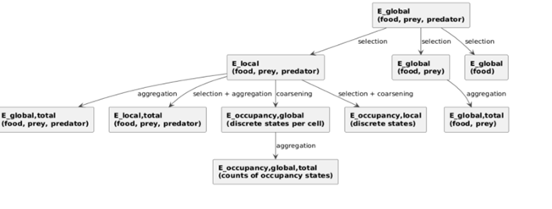
Figure 4 Experimental Frame Partial Order for Ecological System Example
Figure 4 shows how to integrate multiple models into a coherent architecture by aligning them with the frames they serve. Instead of treating models as competing alternatives, we organize them into a structured, interoperable family, each justified by the observational constraints of its frame. This approach exploits multiresolution modeling and compositional simulation to support model‑based systems engineering.

The Derivability Relation: Structuring the Frame Hierarchy
As indicated above, frames are partially ordered by the derivability relation (≤). The ecology system application more particularly illustrates the constructive definition, EF1 is derivable from EF2 if the data observable in EF1 can be obtained from the data in EF2 by applying one or more of the following operations:
- Selection — This operation involves identifying and extracting a specific subset of variables or cells from the broader data set, allowing development to focus on particular aspects of the system under study.
- Aggregation — This process consists of combining or summing values of variables across multiple cells, resulting in a consolidated total that represents the overall state or quantity for the selected region.
- Coarsening — This method entails transforming continuous numerical counts into discrete, categorical groupings, simplifying the data by assigning it to specific categories rather than maintaining fine-grained measurements.
These operations always reduce information, so derivability flows from more detailed (highly resolved) to more abstract frames. This creates a partial order: global continuous frames at the top, occupancy‑total frames at the bottom. Figure 4 captures this structure and shows how resolution decreases, or abstraction increases, as you move downward.
The Applicability Relation: Matching Models to Frames
Each model is constructed at a specific level of resolution and expressed in a particular formalism (differential equations, discrete event, or hybrid) (Zeigler et al 2018). A model accommodates a frame if it can answer all questions posed within that frame without requiring information the frame does not provide. We often use the converse relation; a frame is applicable to a model if the model accommodates the frame. The Frame–Model Partial order shows both hierarchies together
This yields a second hierarchy:
- The Base Model, formulated using differential equations and the DEVS formalism, is designed to answer questions that require the highest level of spatial detail, and therefore accommodates only the most highly resolved frames such as E_global and E_local.
- The Lumped Model, which employs discrete event methods, is specifically constructed to address frames that aggregate totals across the entire system or local regions, such as E_global,total, providing a summarized representation rather than detailed spatial information.
- The Occupancy Model, also based on discrete event formalism, is tailored to frames that capture the occupancy status of individual cells throughout the system, such as E_occupancy,global, where each cell’s state is represented as a discrete variable.
- The Random Phase–Space (RPS) Model, constructed with differential equations, applies to the most abstract frames, specifically occupancy-total frames like E_occupancy,global,total, where only the aggregated counts of occupancy states are represented, omitting any detail about individual cells.
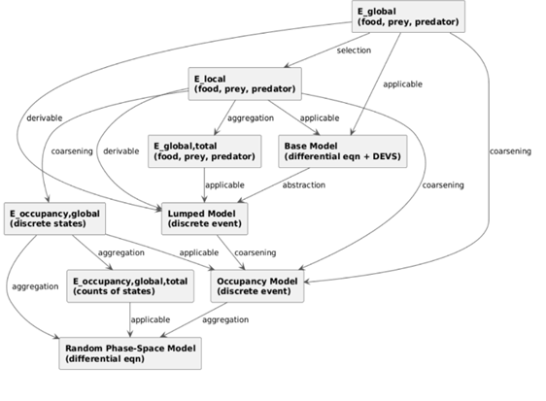
Figure 5 Derivability and Applicability relations juxtaposed

Applicability flows from more abstract models to more abstract frames, mirroring the derivability structure with the Best‑Model Table (Table 1) identifying the minimally sufficient model for each frame.
In the Frame-Model Partial order, frames are located on the left and models on the right. On the left, frames are ordered from most highly resolved (top) to most abstract (bottom):
The arrangement of frames and models follows a logical progression from the most detailed representations to the most abstract. At the top of the hierarchy, the frame labeled E_global provides full spatial detail, capturing the entire system at its most granular level. Just beneath this, E_local focuses on a subset of cells, narrowing the spatial resolution to specific regions within the system. Moving further down, E_global,total aggregates totals across the entire system, offering a simplified, summarized view. The E_occupancy,global frame introduces discrete states per cell, representing the occupancy of each cell individually. Finally, at the most abstract level, E_occupancy,global,total records only the counts of occupancy states across the system, summarizing the discrete states without reference to individual cells.
Correspondingly, models are organized from the most detailed to the most abstract. The Base Model, utilizing differential equations and the DEVS formalism, is capable of accommodating the highest resolution frames, such as E_global and E_local, answering questions that require full spatial detail. The Lumped Model, based on discrete event approaches, is suited for frames related to aggregated totals, like E_global,total. The Occupancy Model, which also employs discrete event formalism, addresses frames with discrete occupancy states, such as E_occupancy,global. The Random Phase–Space (RPS) Model, constructed with differential equations, is matched to the most abstract frame, E_occupancy,global,total, where counts of occupancy states are sufficient and no further detail is needed.
The applicability relation is shown by arrows which show which models can answer which frames’ questions.
• The Base Model is specifically designed to handle only the frames with the highest level of spatial detail, ensuring that questions requiring full system granularity can be answered accurately.
• The Lumped Model is suited for frames that aggregate data across the whole system or specific local regions, providing summarized results for totals at the global or local scale.
• The Occupancy Model is tailored to address frames that represent the status of individual cells throughout the system, focusing on the occupancy state of each cell as a discrete variable.
• The Random Phase–Space (RPS) Model is applicable exclusively to the most abstract occupancy-total frame, where only aggregate counts of occupancy states are considered and individual cell details are omitted.
Table 1. Application of Best Models to Experimental Frames

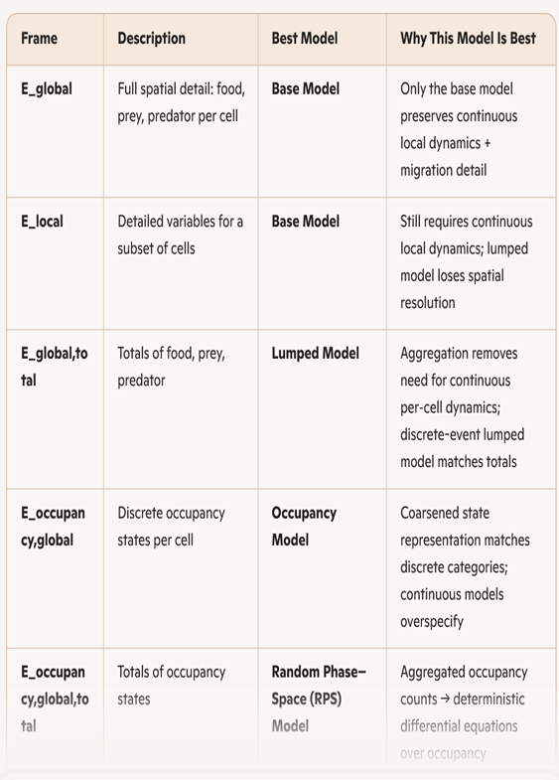Table 1 illustrates the applicability relation as employed to select the “best models for each frame, where “best” means: for each frame the preferred model is the most abstract one that fully answers the frame’s questions, provides no unnecessary detail, and is computationally minimal.

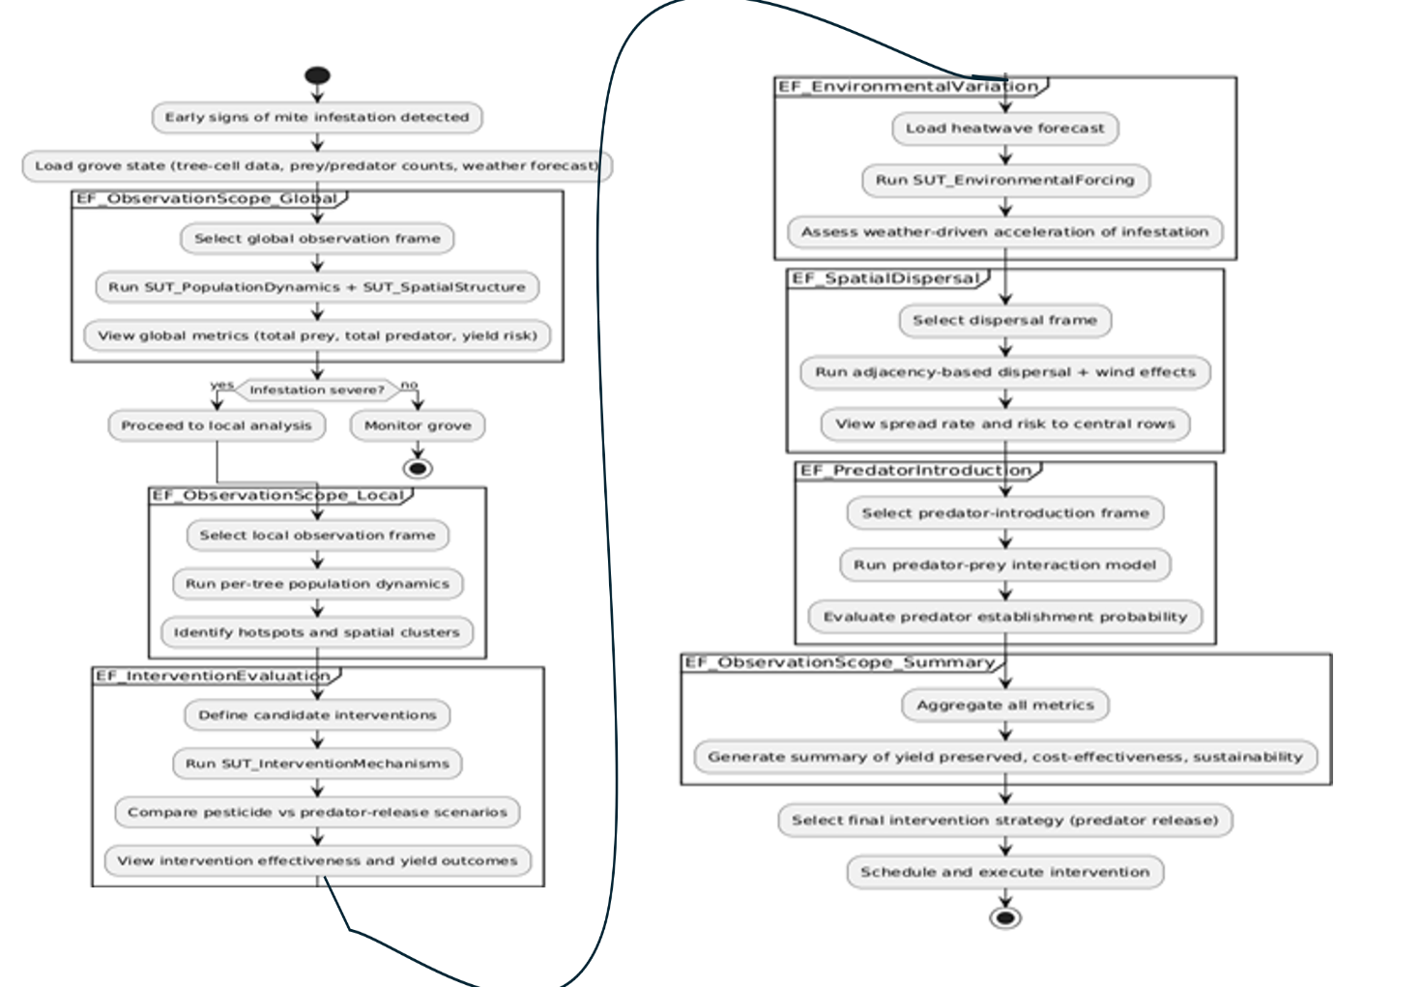
Figure 6 presents the decision process (mission thread) developed on the basis of ecological modeling and simulation of the form illustrated above. The components are outlined as follows:
Figure 6 Experimental Frame-based Mission Thread for Ecology-aware Agriculture
Questions formulated within stakeholder requirements:
Information Required by Farmers:
- A clear and timely assessment of the severity of mite infestation across the orchard, enabling farmers to detect early signs of outbreaks and monitor the progression of pest populations over time.
- Reliable identification of specific trees or regions within the grove that are at the highest risk of mite damage, so that targeted actions can be implemented to prevent severe losses.
- An evaluation of how varying weather conditions, such as temperature and humidity, may influence the development and spread of mite outbreaks, supporting farmers in making weather-informed management decisions.
- Guidance on the determination of optimal intervention strategies, including when and how to apply treatments or introduce biological controls, to effectively mitigate mite infestations with minimal resource expenditure.
- Comprehensive analysis of the impacts that mite management decisions have on crop yield, as well as associated costs, so that farmers can balance economic sustainability with effective pest control.
Experimental Frames:
- Global frame: Focuses on capturing trends across the entire grove. This frame addresses broad, overall questions such as understanding whether there is a significant outbreak affecting the whole system or detecting large-scale changes in mite or predator populations.
- Local frame: Concentrates on identifying hotspots at the level of individual trees. This frame is used when farmers need to pinpoint which specific trees or regions within the orchard are most affected, supporting targeted interventions.
- Intervention frame: Designed for comparing different management strategies. This frame enables evaluation of various treatments or control methods, helping determine which intervention is most effective or efficient for controlling mite populations.
- Environmental frame: Examines how weather conditions, such as temperature and humidity, affect mite and predator dynamics. It allows farmers to assess the influence of environmental variations on outbreak development or suppression.
- Dispersal frame: Addresses the dynamics of how mites spread from tree to tree. This frame helps answer questions about the speed and pattern of pest dispersal across the orchard, supporting decisions on containment measures.
- Predator introduction frame: Focuses on the success of biological control efforts. It evaluates whether introducing natural predators is effective in reducing mite populations and helps predict the outcomes of such biocontrol strategies.
- Decision metrics frame: Integrates information on yield, costs, and sustainability. This frame supports high-level decision making by analyzing the overall impact of pest management choices on crop productivity and economic outcomes.
Models for System Under Test (SUT) that can:
- Mite and predator dynamics: model the population dynamics of both pests and their natural enemies, capturing how their numbers change over time under different scenarios.
- Weather effects: incorporate the impact of environmental factors, such as temperature and humidity, on the development, survival, and spread of mites and predators.
- Tree-to-tree dispersal: track how mites move between individual trees, enabling detailed analysis of spatial spread and the identification of potential outbreak centers.
- Intervention application: allow simulation of various management actions, including chemical treatments or biological controls, to assess their effectiveness and optimize application timing.
- Yield outcomes: provide feedback on crop yield under different pest management strategies, helping farmers evaluate the economic and practical impacts of their decisions.

Mission Thread (Workflow)
How the Farmer Uses the Experimental Frames:
- Global frame: Helps the farmer assess the overall severity of the outbreak. By examining the situation at the orchard-wide level, the farmer can determine if the issue is minor or requires urgent, broad-scale action—essentially answering the question, “Is this outbreak serious?”
- Local frame: Focuses on identifying specific areas within the orchard where mite populations are concentrated. This frame enables the farmer to pinpoint hotspots and prioritize monitoring or treatments where they are most needed—answering, “Where are the hotspots?”
- Intervention frame: Allows the farmer to compare different management strategies, such as chemical sprays or biological control, to determine which is most effective for the current outbreak. This frame addresses the question, “Which strategy works best?”
- Environmental frame: Considers how changing environmental factors, such as an impending heatwave, might alter the dynamics of the outbreak or the effectiveness of interventions. The farmer uses this frame to anticipate and adapt to environmental changes—exploring, “How will the heatwave change things?”
- Dispersal frame: Examines how quickly and in what pattern mites are likely to move from tree to tree. This helps the farmer predict the potential spread of the outbreak and informs decisions regarding containment measures—answering, “How fast will it spread?”
- Predator introduction frame: Evaluates the likely success of releasing natural enemies (predators) to control the mite population. This frame helps the farmer anticipate whether biocontrol efforts will be effective—answering, “Will biocontrol succeed?”
- Summary frame: Synthesizes insights from all the frames to help the farmer develop the most effective overall management plan. By considering all factors, the farmer can decide on the best course of action—answering, “What’s the best overall plan?”

Decision Making (Outcome)
- The stakeholder (farmer) can employ the decision structure (mission thread) in Figure 6 to make decisions. As an example, a farmer might decide to release predator mites before an anticipated heatwave, using evidence from model predictions to stabilize the grove and prevent further spread of the outbreak. This proactive action is supported by transparent reasoning and measurable outcomes. The benefits of the decision process are summarized as:
- Transparent, traceable steps from farmer’s needs to model evidence: The decision structure outlined in Figure 6 enables the farmer to follow a clear, logical workflow. Each step in the process—from identifying the farmer's specific needs and questions to gathering and interpreting model-based evidence—is documented and easy to follow. This transparency ensures that every decision made can be traced back to its origin, providing accountability and clarity throughout the management process.
- Clear metrics: severity, spread, intervention effectiveness, predator success, yield preserved, cost–benefit: The decision structure emphasizes the use of well-defined metrics to assess all aspects of the mite outbreak. These metrics include the overall severity of the situation, how quickly and widely the mites are spreading, the effectiveness of various intervention strategies, the success rate of introduced predators, the amount of crop yield preserved, and a thorough analysis of the costs versus the benefits of each action. By systematically evaluating these criteria, the farmer gains a comprehensive understanding of the problem and potential solutions.
In summary, by following this structured process the farmer can make decisions with confidence. Each choice is grounded in solid evidence and thorough analysis, minimizing uncertainty and maximizing the likelihood of successful outcomes.

Introduction to the Response-Time Example
To make the EFSUT methodology concrete, this paper develops a simple
but representative response-time example. The purpose of the example is
not to showcase a sophisticated system, but to illustrate—using the smallest
possible model—the full chain from stakeholder Question to derived Exper-
6
imental Frames, to applicable Models, and finally to interpretable Results.
This example serves as a running thread through the paper, while its com-
plete DEVS specification is provided in the Appendix for reference.
The motivating Question is straightforward:
Does the system produce output Y within a specified time bound
Tmax after receiving input X?
Although simple, this question captures a pattern that appears across many
domains—communication latency, sensor response, actuator delay, and more
generally any requirement that constrains the time between stimulus and
response. Because the question is so common, it provides an ideal setting
for demonstrating how EFSUT structures the testing process.
From this Question, we derive a family of Experimental Frames that dif-
fer in how much they observe and how strictly they constrain the test. At the
most inclusive level, a full I/O frame records all inputs and outputs without
imposing any time bound. A more specific response-time frame emits a sin-
gle input at time zero and waits up to Tmax for the corresponding output. A
still more restrictive pass/fail frame coarsens the observation by discarding
the measured delay and reporting only whether the system met the time
requirement. These frames form a small derivability lattice, illustrating how
EFSUT organizes tests according to the observational commitments they
impose.
On the model side, we consider three simple DEVS atomic models that
represent different timing behaviors: a deterministic delay model, a stochas-
tic delay model, and an unbounded model that may accept input but never
respond. These models share the same interface but differ in their internal
timing assumptions. This allows us to demonstrate two key EFSUT rela-
tions: applicability, which determines whether a frame can be meaningfully
interpreted on a model, and morphism, which relates models across abstrac-
tion levels. For example, the deterministic model is an exact special case of
the stochastic one, while the unbounded model has no useful morphisms to
the others.
By combining these frames and models, the response-time example il-
lustrates the full EFSUT chain:
Q −→ E −→ M −→ R,
showing how a stakeholder concern is transformed into a structured test,
how models are selected and interpreted under that test, and how results are
made traceable back to the original question. The example is intentionally
7
minimal, but it captures the essential ideas that scale to more complex
systems, including hybrid, multiformalism, and mission-level models. The
formal DEVS definitions of the frames and models appear in the Appendix,
while the main text focuses on the conceptual and methodological insights
they support.
5 Relations Organizing Frames and Models in the
EFSUT Methodology
The EFSUT methodology extends the DEVS formalism by introducing three
relations—Derivability, Applicability, and Morphism—that organize the space
of Experimental Frames (EFs) and Models (SUTs). These relations provide
the structural foundation for transforming a stakeholder Question into a
well-defined test and for interpreting model behavior within that test. This
section formalizes each relation and illustrates its role using the response-
time example developed earlier.
[Experimental Frame] An Experimental Frame E is a DEVS-coupled
model specifying the admissible input segments, observable outputs, ter-
mination conditions, and interpretation rules under which a System Under
Test (SUT) is evaluated.
[Model] A Model M is a DEVS atomic system M = ⟨X, S, Y, δint, δext, λ, ta⟩

In the response-time example, derivability yields the hierarchy:
ERT passfail ≤ ERT ≤ EfullIO.
This ordering reflects the refinement of the original Question into in-
creasingly specific tests. The most inclusive frame EfullIO records all I/O
behavior without constraints. The frame ERT restricts the test to a single
input X, a single output Y , and a bounded observation window Tmax. Fi-
nally, ERT passfail coarsens the observable by discarding the numeric response
time.
5.2 Applicability: Determining Which Models Can Be Tested
[Applicability] An Experimental Frame E is applicable to a Model M if the
EF’s admissible input segments, output map, and validity conditions can
be meaningfully interpreted on M . This requires compatible input/output
ports and interpretable EF semantics.
In the response-time example, all three models—the deterministic delay
model M1, the stochastic delay model M2, and the unbounded delay model
M3—share the same input/output ports as all three frames. Thus:
EfullIO, ERT, ERT passfail are applicable to M1, M2, M3.
However, applicability does not imply that the model satisfies the Ques-
tion. Under the bounded-time frames:
• M1 may pass or fail depending on whether d ≤ Tmax,
• M2 may pass or fail probabilistically,
• M3 always fails, because it never produces output.
5.3 Morphism: Relating Models Across Abstraction Levels
[Model Morphism] Let M and M ′ be DEVS models. A morphism M → M ′
is a structure-preserving mapping that ensures the behavior of M ′ simulates
or approximates the behavior of M at a specified level of abstraction.
In the response-time example:
M1 → M2 (σ = 0, μ = d),
meaning that the deterministic delay model is an exact special case of
the stochastic delay model. Conversely:
10
M2 99K M1,
when the stochastic delay is approximated by a representative determin-
istic value (e.g., mean or worst-case delay). No useful morphisms involve
M3, whose behavior (never responding) is qualitatively different.
5.4 The EFSUT Chain
The three relations coordinate the entire development and testing workflow:
Q −→ E −→ M −→ R.
Each arrow is justified by the relations defined above. This chain ensures
that simulation results are traceable to the original Question, grounded in
a well-defined EF, and interpreted in the context of the model’s structural
relationships. This is the core value of EFSUT: it makes the entire modeling
and testing process explicit, organized, and defensible

The HelloWorld mission thread is a deliberately simple but fully representative example of this process. The mission objective—verify that Bob replies “Hi” after Alice sends “Hello”—cannot be answered in a single leap. Instead, the EFSUT methodology decomposes the objective into a sequence of frame-driven modeling tasks, each of which constructs or selects the minimal model needed to answer a specific question:
- EFHelloSent → M_HelloSender Construct the minimal model that can confirm whether Alice sends “Hello“
- EFHiReceived → M_HiResponder Construct the minimal model that can confirm whether Bob replies “Hi”.
- EFBase → M_HelloWorld Construct the coupled model that can confirm the causal relationship between the two events.
This progression is not arbitrary—it is the canonical EFSUT pattern for model construction. Each step:
- introduces a new EF only when required by the mission thread,
- inserts it into the EF partial order in a principled way,
- constructs the minimal DEVS model capable of satisfying that EF, and
- validates the model under that EF before proceeding.
By the end of the mission thread, the modeler has not only answered the mission question but has also constructed a complete, well-organized model family—from simple atomic models to a fully coupled system—together with the EF partial order that justifies and governs their use.
Thus, this mission-thread example is more than a demonstration of DEVS execution; it is a concrete, step-by-step instantiation of EFSUT Use Case #1: Model Construction, showing how the methodology builds models only as needed, only to the required level of detail, and always under explicit EF control.
A mission thread is a guided sequence of questions, each tied to an Experimental Frame (EF), where each question selects the simplest model capable of answering it. The thread ends when the mission objective is satisfied.
For HelloWorld, the mission objective is:
Verify that Bob replies “Hi” after Alice sends “H”.
This requires progressively richer frames and models.

Mission Thread Overview
Step | Mission Question | EF Used | Model Used | Output
1 | Did Alice send “H”? | EFHelloSent | M_HelloSender | Time of H
2 | Did Bob reply “Hi”? | EFHiReceived | M_HiResponder | Time of Hi
3 | Did Bob reply after Alice sent? | EFBase | M_HelloWorld | Causal confirmation
The mission thread moves from simple → complex, using the minimal EF and model at each step.

Step-by-Step Mission Thread

Step 1 — Frame: EFHelloSent
Mission Question: “Did Alice send Hello?”
Why this EF? It observes only Hello_out, so it is the minimal frame that can answer the question.
Model selected: M_HelloSender (simplest model that produces H)
Execution:
- Run the model under EFHelloSent
- Observe the time and occurrence of Hello_out
Result:
- Alice sent “Hello” at time $t_{H}$
Mission thread update: We now know the send event, but not the reply.

Step 2 — Frame: EFHiReceived
Mission Question: “Did Bob reply Hi?”
Why this EF? It observes only Hi_out, so it is the minimal frame that can answer the question.
Model selected: M_HiResponder (simplest model that produces Hi when triggered)
Execution:
- Run the model under EFHiReceived
- Observe the time and occurrence of Hi_out
Result:
- Bob replied “Hi” at time $t_{Hi}$
Mission thread update: We now know the reply event, but not whether it followed the send.

Step 3 — Frame: EFBase
Mission Question: “Did Bob reply after Alice sent Hello?”
Why this EF? It observes both Hello_out and Hi_out and their temporal relation. This is the least frame that can answer the causal question.
Model selected: M_HelloWorld (coupled model: Alice → Bob)
Execution:
- Run the full model under EFBase
- Observe the sequence:
  - Alice outputs Hello_out
  - Bob receives H_in
  - Bob outputs Hi_out
Result:
- Verified: $t_{H}<t_{Hi}$
- Verified: Bob’s reply is causally triggered by Alice’s send
Mission thread complete.

- Another Use-case Illustration: Ecological multiresolution model family
Appendix A provides more details on the underlying structures
4. Use Case 2: EFSUT for Testing System Implementations
4.1 EF‑Derived Test Harnesses
• Admissible inputs, timing constraints, observables
• Automated scenario generation
4.2 Virtual Testing and Verification
• Regression testing
• Cross‑resolution consistency checks
• Validation against EF‑defined observables
4.3 Integration with MBSE Workflows
• Requirements → EF → SUT traceability
• Support for digital‑thread verification
- Use-case Illustration: NavalSwarm multilevel–multiformalism architecture

5. Use Case 3: EFSUT for Decision Support Using ParaDEVS
5.1 Decision‑Oriented Experimental Frames
• Defining metrics, observables, and decision contexts
• Mapping questions to model resolutions
5.2 ParaDEVS for Scenario Exploration
• Branching trajectories
• Stochastic and event‑driven uncertainty
5.3 Evidence‑to‑Action Workflow
• Tail‑risk metrics (VaR, ES)
• Sensitivity measures and scenario comparisons
• Transparent, auditable decision support

• Use-case Illustration: Financial hybrid DEVS OU‑factor model family

6. Discussion: Cross‑Cutting Benefits Across the Digital‑Engineering Lifecycle
• Unified structure from design to operation
• Enhanced traceability and auditability
• Support for digital‑thread and digital‑twin integration
• Improved stakeholder alignment
2. Related Work
Research on Experimental Frames (EFs) and their role in modeling and simulation has a long lineage, originating in Zeigler’s foundational work on the Theory of Modeling and Simulation (TMS). Early formulations established the EF as the formal mechanism for specifying the observational, experimental, and contextual conditions under which a model is exercised (Zeigler 1976). This concept was later extended to support the organization of partial models—families of models that each answer only a subset of questions about a complex system (Zeigler 1978). In this early view, EFs serve as the structuring principle that determines which questions are answerable by which models, and how models relate through derivability, abstraction, and simplification.
The EF concept matured significantly in the context of multilevel and multiformalism modeling. Zeigler’s ecosystem case study (Zeigler 1979) demonstrated how frames can be organized into a derivability partial order, enabling systematic transitions from detailed spatially resolved models to aggregated or occupancy‑based abstractions. This work established the methodological pattern—still central today—of aligning model abstraction levels with the observational commitments encoded in EFs.
Subsequent research expanded the EF formalism to support model reuse, composability, and automated reasoning. Traoré and Muzy (2006) formalized the duality between models and their contexts, showing that EFs can be treated as first‑class specifications with their own hierarchy, structure, and behavioral semantics. Their work introduced the idea that EFs can be symbolically manipulated, verified, and matched to models, enabling automated assessment of applicability and compatibility. This line of research also clarified the distinction between generation and acceptance modes of EF operation, a distinction that remains important for digital‑twin experimentation.
Parallel efforts in model reuse and curation emphasized the need for EF‑driven discovery and composition. Zeigler’s methodology for characterizing simulation models for discovery and reuse (Zeigler 2023) argued that EFs provide the semantic key for retrieving, validating, and integrating legacy models. This work introduced the notion of EF‑based model curation, where models are annotated with their intended use, assumptions, and applicability constraints to support automated selection and composition in large repositories.
The Simulation Model Reuse and Composition (SMRC) architecture (Zeigler 2023) further demonstrated how EFs can be embedded into ontologies and workflows that support model discovery, configuration, and execution. In this architecture, EFs serve as the bridge between stakeholder objectives and model capabilities, enabling automated configuration of simulation instances that satisfy intended‑use constraints.
More recent work has explored EF‑driven validation and compatibility checking. Foures, Albert, and Nketsa (2013) proposed a formal compatibility framework in which EFs and models are represented as I/O automata, enabling the use of model checking to assess whether a model satisfies the behavioral constraints of a frame. Their work introduced quantitative and qualitative metrics for simulation validity, including coverage, confidence, and structural compatibility. This approach demonstrated that EFs can serve not only as experimental specifications but also as formal validation artifacts.
In the domain of software and cyber‑physical systems, EFs have been used to structure quality evaluation and virtual testing. Cao et al. (2015) extended DEVSML to support EF specification for software reliability and performance evaluation, showing how EF‑driven generators, acceptors, and Metrics Computers can automate early‑phase quality assessment. Their work illustrates the growing relevance of EFs in digital engineering workflows where simulation‑based evaluation must be repeatable, traceable, and aligned with stakeholder concerns.
Finally, the EFSUT methodology itself (Zeigler in preparation) builds on this lineage by explicitly linking stakeholder questions → Experimental Frames → System Under Test → Metrics Computer outputs. This pipeline operationalizes the EF concept for modern digital‑engineering contexts, ensuring that every model execution is traceable to stakeholder intent and that model abstraction levels are justified by the observational commitments of the frame.
Together, these contributions establish a functional foundation for the present work. They demonstrate that EFs are not merely simulation artifacts but central organizing structures for model development, reuse, validation, and decision support. The EFSUT methodology extends this tradition by unifying these roles into a single lifecycle‑spanning framework suitable for digital engineering and digital‑twin ecosystems.

7. Conclusion
The EFSUT methodology offers a unifying structure for digital engineering and digital twin development by explicitly linking stakeholder questions, model abstraction levels, system implementations, and decision‑oriented analytics. Across the digital‑engineering lifecycle—design, development, verification, operation, and sustainment—EFSUT provides a disciplined way to specify observational regimes, derive appropriate models, and ensure that every simulation or test is grounded in clearly articulated experimental conditions. This explicitness is essential for building trustworthy digital twins whose behavior can be traced back to well‑defined assumptions and validated against consistent criteria.
As a model‑development discipline, EFSUT enables the construction of coherent multiresolution model families aligned with a derivability‑ordered partial order of experimental frames. This ensures that digital‑twin components are not isolated artifacts but members of a structured, interoperable architecture. Such model families support multilevel fidelity, multiformalism integration, and lifecycle reuse—capabilities increasingly required in aerospace, defense, manufacturing, and other engineering domains.
As a test‑engineering framework, EFSUT provides a principled basis for generating test harnesses, admissible input sequences, and validation scenarios directly from experimental frames. This strengthens digital‑thread verification by ensuring that system implementations are evaluated under the same observational regimes that motivated their design. The result is improved traceability, reproducibility, and confidence in both virtual testing and physical system verification.
As a decision‑support methodology, EFSUT integrates naturally with ParaDEVS to support branching simulations, uncertainty quantification, and evidence‑based reasoning. By grounding decision metrics in explicit experimental frames, the methodology ensures that digital‑twin outputs remain interpretable, auditable, and aligned with stakeholder needs. This is particularly important as digital twins increasingly serve operational roles in monitoring, prediction, and real‑time decision‑making.
Taken together, these three uses demonstrate that EFSUT is not merely a modeling construct but a lifecycle‑spanning methodological scaffold for digital engineering. It provides the conceptual clarity and structural discipline needed to integrate multiresolution models, virtual testing workflows, and decision‑oriented analytics into a coherent digital‑twin ecosystem.
Research along these lines is a promising direction. As digital engineering continues to evolve toward greater automation, interoperability, and operational relevance, the need for explicit experimental frames, traceable model hierarchies, and structured decision workflows will only grow. Future work can explore automated EF derivation, integration with MBSE toolchains, formal verification of EF–model applicability, and scalable ParaDEVS‑based decision pipelines. Advancing these capabilities will strengthen the foundations of digital‑twin practice and help realize the vision of transparent, trustworthy, and lifecycle‑consistent digital engineering.

Appendix A
DEVSISO-EF.pdf
1 Applicability: Experimental Frames and Behavioral Inclusion
To ensure that models are not only structurally valid but behaviorally appropriate for their intended
use, each published model must declare at least one Applicability triple:
• Experimental Frame (EF): A formal specification of the experimental context, including
input/output ports, input generators, observation functions, and conformance predicates.
• Model: The atomic or coupled DEVS model artifact.
• Applicability Claim: A signed artifact asserting that the model’s I/O behavior satisfies
the EF’s specification.
1.1 Formal Definition
Let an EF be defined as:
E = ⟨XE, YE, G,O, C,H⟩
where:
• XE, YE: Typed input/output ports with declared units.
• G: Input generators (e.g., deterministic, stochastic).
• O: Observation map from raw traces to metrics or signals.
• C: Conformance predicates (e.g., STL formulas).
• H: Time horizon or stop condition.
A model’s I/O behavior under generator g ∈ G is denoted Tr(M, g), and the model’s behavior
relation is:
RM =
[
g∈G
Tr(M, g)
The EF induces an admissible behavior set:
RE = {τ | τ is produced under g ∈ G, O(τ ) |= C}
An EF is applicable to a model iff:
RE ⊆ RM
This formalizes the notion that the model can generate all behaviors specified by the EF [9, 2].
1.2 Verification Methods
Applicability claims must include evidence demonstrating RE ⊆ RM. Three verification tiers are
defined:
2
Empirical Verification (Level 1) Execute the model under EF-defined generators and verify
that observed traces satisfy all predicates [1]. Evidence includes trace hashes, seeds, and coverage
metrics. Recommended for deterministic or bounded stochastic models.
Contract-Based Verification (Level 2) Use assume–guarantee contracts to formalize the relationship
between EF assumptions and model guarantees [7, 4]. Contracts must be machinecheckable
and support modular verification.
Formal Verification (Level 3) Apply model checking or reachability analysis to prove behavioral
inclusion [5, 6]. STL predicates are used for continuous/hybrid systems. Requires abstraction
of QSS dynamics and declared error bounds.
1.3 Numeric Tolerances
All comparisons must respect EF-declared tolerances. When unspecified, defaults are:
• Absolute value tolerance: 10−6
• Time tolerance: 10−9
These tolerances ensure reproducibility and consistency across simulation engines [3].
1.4 Hybrid and QSS Considerations
For QSS-based models, EF predicates may be expressed in Signal Temporal Logic (STL), and
satisfaction is checked using piecewise-affine interpolation between quantized events [6].
1.5 Composition and Closure
Applicability claims should be composable. If M = couple(Mi) and E = compose(Ei), then:
∀i,Ei ⪯ Mi ⇒ E ⪯ M
This aligns with closure under coupling in DEVS theory [9].
1.6 Artifact Requirements
Each model release must include:
• At least one EF artifact.
• At least one signed applicability claim.
• Evidence supporting the claim (empirical traces, contracts, or proofs).
Claims must be versioned, signed (e.g., via Sigstore), and include validity ranges for parameters
and environmental assumptions [8].
1.7 Governance and Lifecycle
• Applicability claims are invalidated by breaking changes to the model or EF.
• CI pipelines must re-verify claims on model updates.
• Documentation must include rationale, interpretation, and limitations [?
Appendix B Use Case for Model Construction

3. HelloWorld base model and EF partial order
We use a minimal DEVS “HelloWorld” conversation as the base model and construct the EF partial order as Zeigler prescribes.

3.1 Base DEVS model (informal)
- Real system: Alice sends “H” to Bob; Bob must reply with “Hi”.
- Base Model $M_{\text{Base}}$:
  - Atomic models:
    - Alice: generates output “H” once.
    - Bob: upon receiving “H”, outputs “Hi”.
  - Coupling: Alice → Bob.

3.2 Experimental frames
- EFEmpty:
  - No inputs, no outputs observed.
  - Represents the trivial frame at the bottom of the partial order.
- EFHelloSent:
  - Observes Alice’s output “H” (and possibly its timing).
  - Ignores Bob’s response.
- EFHiReceived:
  - Observes Bob’s output “Hi” (and possibly its timing).
  - May or may not observe the incoming “H” explicitly, depending on design.
- EFBase:
  - Observes both “H” and “Hi” and their temporal relation.
  - This is the “full” frame for the Base Model.

3.3 Partial order structure
We define the partial order “is derivable from” ($≤$) as:
- Bottom:
  - $EF_{\text{Empty}}≤EF_{\text{HelloSent}}$
  - $EF_{\text{Empty}}≤EF_{\text{HiReceived}}$
- Intermediate:
  - $EF_{\text{HelloSent}}≤EF_{\text{Base}}$
  - $EF_{\text{HiReceived}}≤EF_{\text{Base}}$
- Top:
  - $EF_{\text{Base}}$is the least upper bound (join) of $EF_{\text{HelloSent}}$and $EF_{\text{HiReceived}}$.
Data mappings $D↦D^{'}$correspond to “forgetting” parts of the observation (e.g. projecting from full conversation logs to only “H” events or only “Hi” events).

References
Albert, V., Foures, D. & Nketsa, A. (2014) ‘Formal compatibility of experimental frame concept and FD‑DEVS model’, Proceedings of the 9th International Conference on Modeling, Optimization & Simulation (MOSIM).
Boniol, F. & Wiels, V. (2014) The Landing Gear System Case Study. Toulouse: ONERA/LAAS.
Cao, B., Huang, L. & Hu, J. (2015) ‘Experimental frame design using E‑DEVSML for software quality evaluation’, Proceedings of SEKE 2015, pp. 1–7.
Foures, D., Albert, V. & Nketsa, A. (2013) ‘Simulation validation using the compatibility between simulation model and experimental frame’, SummerSim 2013, pp. 1–10.
Traoré, M.K. (2004) ‘A methodology to capture the dual relationship between simulation models and their context’, Proceedings of the 2004 Winter Simulation Conference, pp. 1–9.
Traoré, M.K. & Muzy, A. (2006) ‘Capturing the dual relationship between simulation models and their context’, Proceedings of the 2006 European Simulation and Modelling Conference, pp. 1–10.
Mama Diakité, Mamadou Kaba Traoré, FORMAL APPROACH TO DIGITAL TWIN SPECIFICATION
Zeigler, B.P. (1976) Theory of Modeling and Simulation. New York: Wiley.
Zeigler, B.P. (1978) ‘Structuring the organization of partial models’, International Journal of General Systems, 4(2), pp. 81–88.
Zeigler, B.P. (1979) ‘Multilevel multiformalism modeling: an ecosystem example’, in Theoretical Systems Ecology. New York: Academic Press, pp. 17–54.
Zeigler, B.P. (1984) Multifacetted Modelling and Discrete Event Simulation. London: Academic Press.
Zeigler, B.P. & Barto, A. (1977) ‘Toward a formal theory of adaptive systems’, Journal of Cybernetics, 7(2), pp. 1–20.
Zeigler, B.P. & Nutaro, J. (2016) ‘Towards a framework for computational representation of intended use’, Journal of Simulation, 10(2), pp. 1–15.
Zeigler, B.P. & Sarjoughian, H. (2013) Guide to Modeling and Simulation with MS4 Me. Tucson: RTSync Corp.
Zeigler, B.P., Muzy, A. & Kofman, E. (2018) Theory of Modeling and Simulation, 3rd edn. London: Academic Press.
Zeigler, B.P. (2023) ‘A methodology to characterize simulation models for discovery and composition’, International Journal of Simulation and Process Modelling, Vol. 19, No. 1-2, p 3-13.
Zeigler, B.P. (2024), Discrete Event Systems Theory for Fast Stochastic Simulation via Tree Expansion. Systems 12, 80. https://doi.org/10.3390/systems12030080
Zeigler, B.P. (2026) “EFSUT Methodology: From Requirements to MS4 Me Implementation”, work in preparation.
[2] Raphael Chreyh. An internet-based repository for devs models and their experimental frames.Master’s thesis, Carleton University, 2006.
[3] Alexandre Donz´e and Oded Maler. Systematic simulation using sensitivity analysis. In HSCC, pages 174–189, 2007.
[4] Joshua B. Graebener, Anudeep Badithela, Ibrahim Incer, and Richard M. Murray. Reasoning over test specifications using assume–guarantee contracts. In NASA Formal Methods, pages 278–294, 2023.
[5] Ibrahim Incer, Alberto Sangiovanni-Vincentelli, Chih-Hong Lin, and Eunkyoung Kang. Quotient for assume–guarantee contracts. In MEMOCODE, pages 1–10, 2018.
[6] Oded Maler and Dejan Nickovic. Monitoring temporal properties of continuous signals. In FORMATS/FTRTFT, volume 3253 of LNCS, pages 152–166, 2004.
[7] Michael Sharf, Bj¨orn Besselink, Anders Molin, Qian Zhao, and Karl H. Johansson. Assume/guarantee contracts for dynamical systems: Theory and computational tools. arXiv
preprint arXiv:2012.12657, 2020.
[8] Leanware Editorial Team. Best practices for application and software development in 2025.https://leanware.com/insights, 2025.

Blackburn, Mark R. and Timothy D. West 2023 Fundamentals of Digital Engineering
https://doi.org/10.1002/9781394203314.ch1Digital Object Identifier (DOI)
U.S. Department of Defense (2018). Digital Engineering Strategy.
Bersbach, D., et al. (2022). Digital Twins need Digital Threads for success.
Zeigler, B.P., et al. (2023). Digital Test and Evaluation: Validation of System Models as a Key Enabler.
Zhuang, X., et al. (2022). Challenges of Digital Twin in High Value Manufacturing.
Törngren, M., et al. (2020). A Systematic Digital Engineering Approach to Verification & Validation of Autonomous Ground Vehicles in Off-Road Environments.
Liu, Y., et al. (2023). Digital Twin approaches and applications.

The following terms refer to the fundamental ways a CPU communicates with hardware devices and how those devices signal back to the processor.
1. PIO (Programmed I/O) Endpoints
PIO is a method where the CPU uses a special set of instructions (like IN and OUT in x86) to transfer data to or from a device's registers.
- How it works: The CPU has a separate address space specifically for I/O ports (0 to 65535).
- In the diagram: The PIC (Programmable Interrupt Controller) is labeled with "legacy PIO," meaning the CPU interacts with it by sending commands to specific port addresses rather than memory addresses.
2. MMIO (Memory-Mapped I/O) Endpoints
MMIO is the modern standard for device communication. Instead of a separate I/O space, device registers are mapped directly into the system's main RAM address space.
- How it works: When the CPU writes to a specific "memory address," it isn't actually writing to RAM; it is sending data to a hardware device (like a GPU or Network Card).
- In the diagram: The MemoryMap component handles these "MMIO slots." This allows the Processor to talk to the DiscreteDevice using standard memory load/store instructions.
3. Timers
Timers are hardware components that count clock cycles and trigger actions at specific intervals.
- Purpose: They are essential for multitasking. A timer can "interrupt" the CPU to tell it to switch from one task to another (preemptive multitasking).
- In System Design: Within a simulation, a timer would likely be a source that periodically injects "Tick" events into the Router or Processor to keep the simulation time moving forward.
4. IRQ (Interrupt Request) Sources
An IRQ is a signal sent by a device to the CPU to get its immediate attention.
- How it works: Instead of the CPU constantly checking if a device has data (polling), the device "interrupts" the CPU.
- The Pipeline: In the diagram, the flow follows this hardware logic:
  - Source: The DiscreteDevice generates an IRQ.
  - Routing: That signal goes to the IOAPIC (Interrupt Controller).
  - Delivery: The IOAPIC routes it to a specific LocalAPIC (per-core), which finally interrupts the Processor.

EFSUT-Driven DEVS Modeling for Processor–Device Digital Twins
Author: Bernard
Affiliation: —
Keywords: EFSUT, DEVS, SES, Digital Twin, Processor Modeling, Device Modeling, Simulation Architecture

Abstract
Digital-twin development for computing systems requires modeling workflows that are traceable, compositional, and aligned with lifecycle needs. This paper presents a methodology that integrates the EFSUT conceptual framework with DEVS-based executable models to support the design and analysis of processor–device interactions. EFSUT (Entities, Functions, Structure, Usage, Time) provides a disciplined front-end for identifying stakeholder questions and the minimal model structures required to answer them. A pruned Entity Structure (SES) formalizes these relationships, yielding ten Entity–Function/Model (EF/Model) pairings. Each pairing is automatically transformed into a DEVS coupled model using the StreamlinedDEVSJava architecture, which includes processor, device, routing, and memory-fabric components. A scenario-driven test suite operationalizes each EF as a simulation experiment, ensuring continuous verification and validation. The methodology is demonstrated through an MMIO-write routing example. The paper concludes by positioning the EFSUT–DEVS workflow within digital-twin methodology, emphasizing traceability, compositionality, and lifecycle alignment.

1. Introduction
Modern computing systems—particularly multi-core processors interacting with heterogeneous devices—exhibit complex behaviors that challenge traditional modeling approaches. Designers must reason about memory-mapped I/O, interrupt routing, simulated RAM regions, instruction-stream checks, and device-timer interactions. These behaviors are dynamic, interconnected, and sensitive to timing, making them ideal candidates for discrete-event modeling.
However, simulation efforts often suffer from two recurring problems:
(1) ad-hoc model construction, where components are added without a clear rationale, and
(2) lack of traceability, where it is unclear which stakeholder questions a model actually answers.
To address these issues, we integrate the EFSUT methodology—a conceptual framework for structuring modeling problems—with DEVS (Discrete Event System Specification), a formalism for modular, hierarchical simulation [Zeigler et al., DEVS Theory]. EFSUT provides the front-end reasoning, while DEVS provides the executable back-end.
This paper demonstrates the methodology using a processor–device case study. The contributions are:
- A formal EFSUT analysis of processor–device interactions.
- A pruned SES that yields ten EF/Model pairings.
- Auto-generated DEVS coupled models using StreamlinedDEVSJava.
- A scenario-driven test suite derived directly from EFSUT.
- A demonstration of the methodology using an MMIO-write routing example.
- A discussion of how this workflow aligns with digital-twin methodology.
The result is a modeling pipeline that is explicit, auditable, and suitable for digital-twin engineering.

2. Background and Related Work

2.1 DEVS and Modular Simulation
DEVS provides a mathematically rigorous framework for modeling discrete-event systems [Zeigler et al., DEVS Theory]. Its separation of atomic and coupled models supports modularity, compositionality, and hierarchical design. DEVS is widely used in digital-twin research due to its ability to represent heterogeneous components with precise timing semantics.

2.2 EFSUT Methodology
EFSUT (Experimental Frame-System Under Test) methodology is a conceptual modeling discipline that ensures every model is grounded in stakeholder intent. It is particularly effective in domains where multiple interacting subsystems must be represented at varying levels of fidelity.

2.3 Digital Twins in Computing Systems
Digital twins of computing systems—processors, memory fabrics, and devices—are increasingly used for performance analysis, architectural exploration, and cyber-physical integration [Digital Twin literature]. These twins require both conceptual clarity and executable precision, making EFSUT and DEVS a natural pairing.

3. EFSUT Methodology for Processor–Device Modeling
EFSUT decomposes the modeling problem into five lenses.

3.1 Entities (E)
Relevant entities include:
- Processor fabric (cores, router, memory map, interrupt controllers)
- Discrete devices (PIO/MMIO endpoints, timers, IRQ sources)
- Memory regions (physical RAM, simulated RAM, MMIO slots)
- Workloads (instruction streams, I/O patterns)
These entities form the EF categories in the canonical table.

3.2 Functions (F)
Functions describe the behaviors of interest:
- MMIO/PIO access
- Interrupt signaling
- Memory-slot creation and deletion
- Instruction-stream checks
- Device-timer expiration
- Conflict detection in MMIO regions

3.3 Structure (S)
The structural backbone is the StreamlinedDEVSJava architecture:
DiscreteDevice → Processor_StreamlinedDEVSJava → Router
Router → {MemoryMap, PIC, IOAPIC, LAPIC}
This structure is fixed, but different EF/Model pairings activate different pathways.

3.4 Usage (U)
Each EF corresponds to a scenario:
- A device performs an MMIO write
- A device generates an IRQ
- A device creates simulated RAM
- A core checks its instruction stream
These scenarios become unit tests.

3.5 Time (T)
DEVS sigma values govern:
- Device timers
- Routing delays
- MemoryMap slot updates
- Interrupt propagation
Time is integral to the modeling objectives.

4. Canonical EF/Model Table
EFSUT yields ten EF categories, each mapped to a minimal DEVS model structure.
Each row in the table represents a modeling question, the EF that encodes it, the minimal model required, and the modeling objective.

Question | EF / Model Pair | Modeling Objective
How does a device’s MMIO write propagate through the processor fabric? | EF\_MMIOWrite + Processor\_StreamlinedDEVSJava.Router + MemoryMap | Capture routing logic for EVENT\_KVM\_MMIO, including LAPIC/IOAPIC/MMIO-slot resolution and timing.
What happens when a device generates an IRQ under load? | EF\_IRQGeneration + DiscreteDevice + Processor\_StreamlinedDEVSJava (PIC + IOAPIC + LAPIC) | Evaluate interrupt delivery path, priority resolution, and timing of EVENT\_KVM\_INT propagation.
How does simulated RAM insertion affect memory access behavior? | EF\_SimulatedRAM + MemoryMap + DiscreteDevice | Validate MEM\_SIMULATE\_PHYSICAL and MEM\_RESTORE\_PHYSICAL transitions and ensure correct slot splitting/merging.
How do cores respond to instruction-stream checks during device activity? | EF\_IStreamCheck + Core + Router | Observe EVENT\_CHECK\_ISTREAM handling, core-level reaction, and follow-on MMIO/IO events.
How does a device’s timer expiration influence processor event flow? | EF\_DeviceTimers + DiscreteDevice + Processor.Router | Model timer countdown, expiration events, and their routing into the processor fabric.
How does PIO traffic interact with the processor’s routing logic? | EF\_PIOAccess + DiscreteDevice + Processor.Router + PIC | Validate EVENT\_KVM\_IO routing, PIO range checks, and optional echo behavior.
How does the processor behave when multiple devices register overlapping MMIO regions? | EF\_MMIOConflict + MemoryMap + Multiple DiscreteDevices | Detect and analyze slot overlap, ordering, and conflict resolution in MMIO registration.
How does the system behave during boot-phase device enumeration? | EF\_BootProbe + Processor + DiscreteDevice | Capture MMIO/PIO registration, IRQ probing, and early-phase event routing.
What is the timing impact of high-rate MMIO traffic on routing latency? | EF\_HighRateMMIO + Processor.Router + MemoryMap | Measure sigma-driven routing delays and event queue buildup under stress.
How does the processor respond to malformed or out-of-range MMIO accesses? | EF\_FaultInjection + Processor.Router + MemoryMap | Validate fallback routing, error signaling, and safe handling of invalid addresses.
This table is the conceptual backbone of the methodology.

5. Pruned SES for EF/Model Generation

5.1 SES Structure
The SES contains two aspects:
- EF ∈ {EF_MMIOWrite, EF_IRQGeneration, …}
- Model ∈ {M_RouterMemory, M_InterruptFabric, …}

5.2 Pruning Rules
Pruning rules enforce a one-to-one mapping:
EF_MMIOWrite → M_RouterMemory
EF_IRQGeneration → M_InterruptFabric
...

5.3 Resulting PES Set
The result is ten PES instances, each representing a fully determined modeling configuration.

6. Auto-Generated DEVS Models

6.1 StreamlinedDEVSJava Architecture
The architecture includes:
- Processor_StreamlinedDEVSJava
- DiscreteDevice
- Router
- MemoryMap
- PIC, IOAPIC, LAPIC

6.2 Code Generation Strategy
A base class (BaseEFModel) provides common wiring.
Each PES generates a subclass with the appropriate devices and couplings.

6.3 Example Generated Model
For EF_MMIOWrite:
DiscreteDevice("Device_MMIOWrite")
Processor_StreamlinedDEVSJava("Processor")
Couplings: Device.out → Processor.in → Router → MemoryMap

7. Scenario-Driven Test Suite

7.1 Test Generation from EFSUT
Each EF becomes a test case.

7.2 Test Harness Architecture
The harness provides:
- inject port
- observe port
- Device + Processor wiring

7.3 Unit Test Suite
Tests include:
- MMIO write
- PIO read
- IRQ routing
- Simulated RAM
- Instruction-stream check

7.4 Routing Path Diagrams
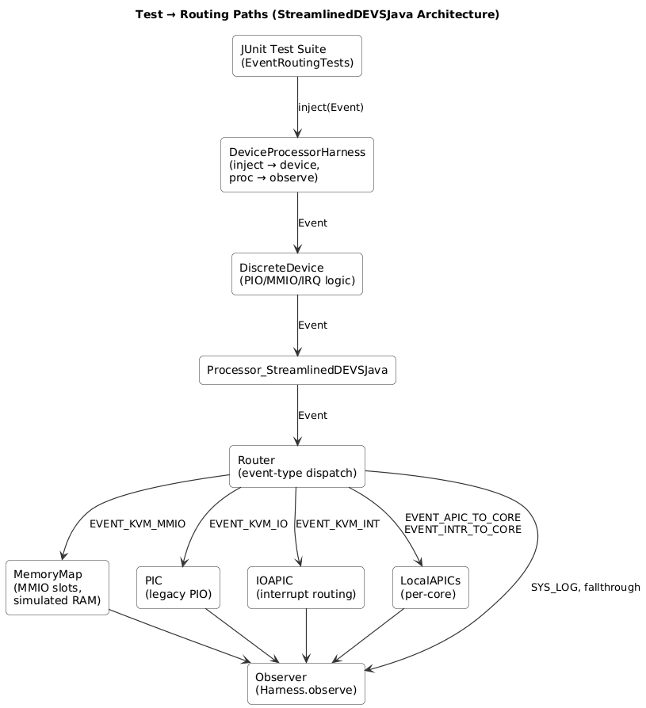

8. Case Study: MMIO-Write Routing

8.1 EF Definition
EF_MMIOWrite asks:
How does a device’s MMIO write propagate through the processor fabric?

8.2 EFSUT Mapping
- E: Device, Processor, Router, MemoryMap
- F: MMIO write handling
- S: Device → Processor → Router → MemoryMap
- U: Device performs MMIO write
- T: Immediate device output, routing within Δt

8.3 Generated DEVS Model
The pruned EF/Model pair selects M_RouterMemory.

8.4 Test Execution
The test injects:
Event e = new Event();
e.type = EVENT_KVM_MMIO;
e.kvmMmio.addr = 0xFEC00000L;
e.kvmMmio.bytes = 4;

8.5 Interpretation
The test confirms that the MemoryMap receives and processes the MMIO write.

9. Integration with Digital-Twin Methodology

9.1 Traceability
EFSUT ensures traceability from stakeholder questions to DEVS execution.

9.2 Compositionality
StreamlinedDEVSJava supports modular digital-twin components.

9.3 Minimality and Sufficiency
Pruned SES ensures no over-modeling.

9.4 Continuous Verification
The test suite provides ongoing validation.

9.5 Lifecycle Alignment
The methodology supports conceptual design, verification, and operational decision support.

10. Conclusion
This paper demonstrates how EFSUT and DEVS can be integrated into a coherent methodology for modeling processor–device interactions. EFSUT provides conceptual clarity, SES pruning ensures minimality, DEVS provides executable precision, and the test suite ensures continuous verification. The resulting workflow is traceable, compositional, and aligned with digital-twin engineering principles.
Future work includes automated code generation, multi-device scaling, ParaDEVS integration, and application to broader cyber-physical systems.

