Project Phase 1

Step 1.1: Conceptual & Logical Design:
1. Conceptual Design
The dataset used in this project contains detailed information about motor vehicle collisions in New York City. Each row represents a single collision event, along with information about location, time, number of injuries/fatalities, involved vehicle types, and contributing factors.
From the dataset, the following core entities were identified:
Entities
- Collision – The central event, containing the main details of each crash.
- Borough – A lookup entity storing unique borough names such as MANHATTAN, BROOKLYN, etc.
- Vehicle Type – Stores the description of each vehicle involved in a collision.
- Contributing Factor – Stores the human/vehicle/environment factors associated with each collision.
- Collision Vehicles (Bridge Entity) – Resolves the many-to-many relationship between collisions and vehicle types.
- Collision Factors (Bridge Entity) – Resolves the many-to-many relationship between collisions and contributing factors.
Relationships
- A borough can have many collisions, but each collision belongs to at most one borough.
- A collision can involve multiple vehicle types (vehicle_type_code1…5).
- A vehicle type can appear in multiple collisions.
- A collision can have multiple contributing factors (contributing_factor_vehicle_1…5).
- A factor can be associated with multiple collisions.
Because “vehicle types” and “factors” repeat across rows and multiple times per collision, they form many-to-many relationships. These are normalized using bridge tables.

2. Logical Design (Entities, Attributes, Keys)

BOROUGHS
- borough_id (Primary key)
- borough_name

COLLISIONS
- collision_id (Primary key)
- crash_date
- crash_time
- borough_id (Foreign key → boroughs.borough_id)
- zip_code
- latitude
- longitude
- location
- on_street_name
- off_street_name
- cross_street_name
- number_of_persons_injured
- number_of_persons_killed
- number_of_pedestrians_injured
- number_of_pedestrians_killed
- number_of_cyclist_injured
- number_of_cyclist_killed
- number_of_motorist_injured
- number_of_motorist_killed

VEHICLE_TYPES
- vehicle_type_id (Primary key)
- vehicle_type_desc

COLLISION_VEHICLES (Bridge Table)
- collision_id (FK → collisions.collision_id)
- vehicle_order (e.g., 1–5)
- vehicle_type_id (FK → vehicle_types.vehicle_type_id)
Primary Key: (collision_id, vehicle_order)

FACTORS
- factor_id (Primary Key)
- factor_desc

COLLISION_FACTORS (Bridge Table)
- collision_id (FK → collisions.collision_id)
- factor_order (1–5)
- factor_id (FK → factors.factor_id)
Primary Key: (collision_id, factor_order)

3. ERD Diagram
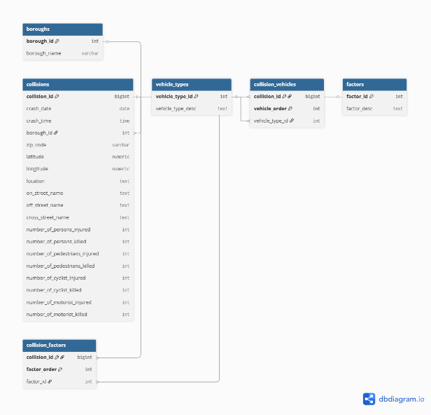
Structure (for reference):
- Boroughs 1 → ∞ Collisions
- Collisions 1 → ∞ Collision_Vehicles → ∞ Vehicle_Types
- Collisions 1 → ∞ Collision_Factors → ∞ Factors

4. 3NF Justification
The schema is designed to follow Third Normal Form (3NF) to eliminate redundancy and prevent data anomalies.
1NF Compliance
- All values are atomic.
- Repeating multivalued attributes (vehicle_type_code1…5, contributing_factor_vehicle_1…5) were removed and placed into separate bridge tables.
2NF Compliance
- Each non-key attribute depends fully on the primary key of its table.
- No partial dependencies exist because:
  - Collision details depend on collision_id.
  - Vehicle type descriptions depend only on vehicle_type_id.
  - Factor descriptions depend only on factor_id.
3NF Compliance
- There are no transitive dependencies.
- Borough names depend only on borough_id, not on collision_id.
- Vehicle type descriptions depend only on vehicle_type_id.
- Factor descriptions depend only on factor_id.
- All descriptive attributes are separated into their own lookup tables, preventing duplicated text.
How the design avoids anomalies
- Update anomaly: Changing a vehicle type or factor updates only one row in its lookup table.
- Insert anomaly: New vehicle types or factors can be added without creating a collision.
- Delete anomaly: Removing a collision does not delete vehicle types or factor descriptions.
Therefore, the schema meets all requirements of Third Normal Form (3NF).

