Case Study: Office Building Scenario
The case study models a single office building with solar panels installed in the rooftop, 15 electric vehicles charging at the building, a stationary battery storage system, and a grid connection with capacity limits. The simulation window is one day.

Building Energy Profile

Energy Consumption Data

Data Source
The energy consumption profile as stated in the previous chapter was derived from ELMAS dataset. A new timeseries was created with synthetic data.

Profile Characteristics
Figure 1.1 shows the hourly consumption pattern:
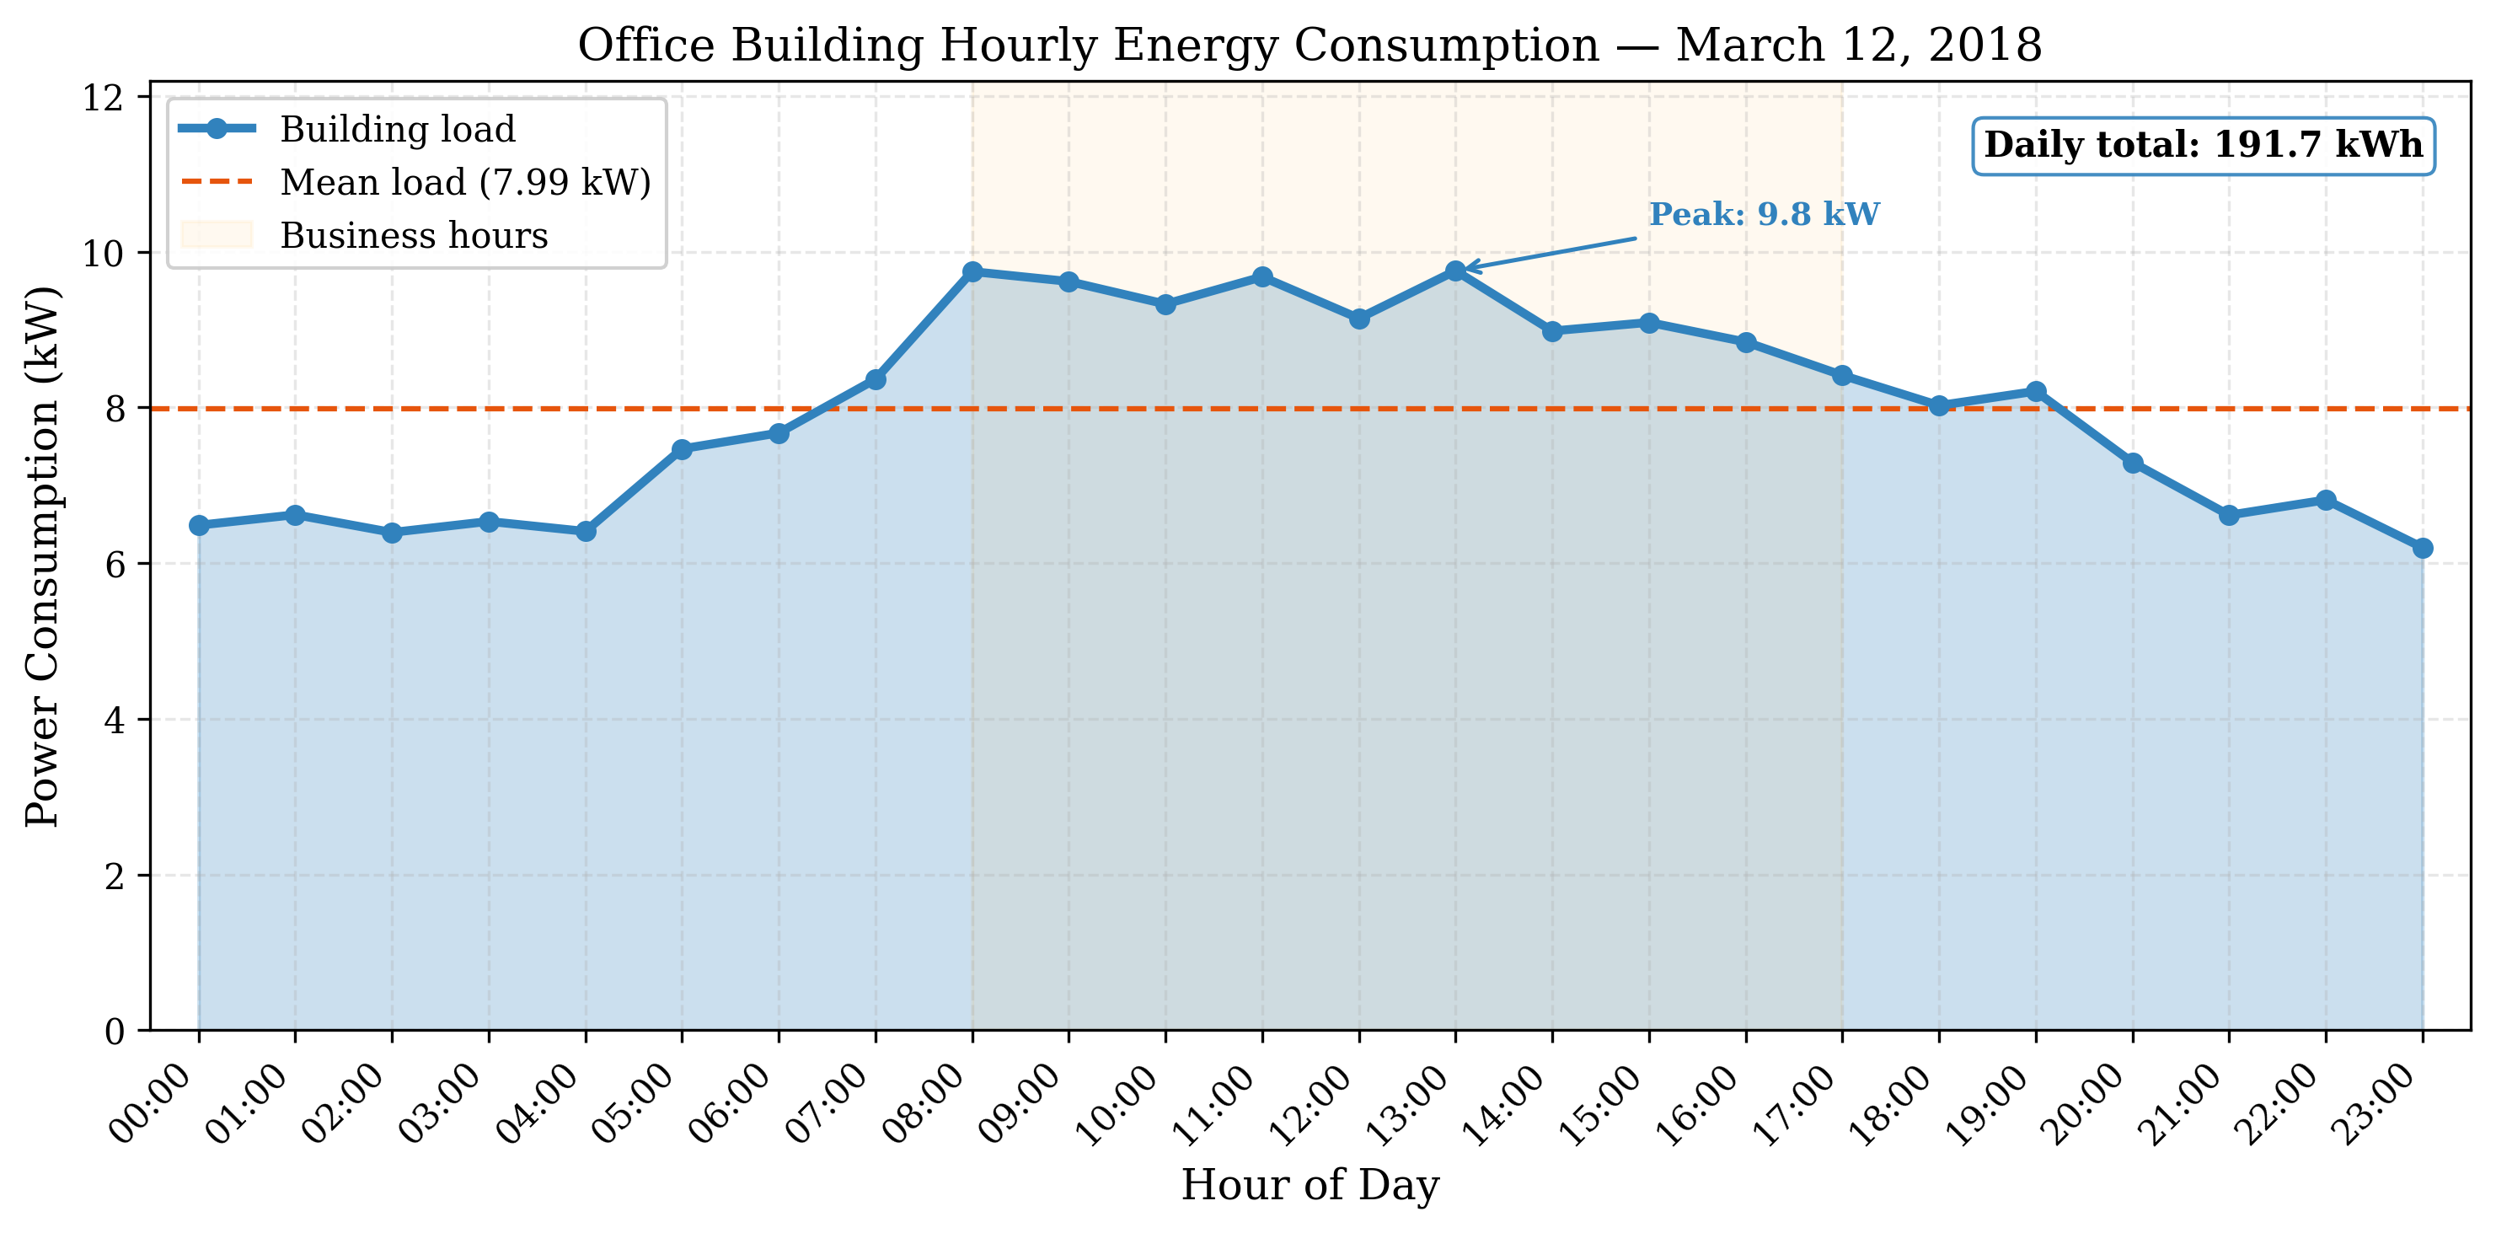
Office building hourly energy consumption profile
Annual statistics are a mean load of 6.73 kW, a peak load of 11.92 kW during business hours, an annual energy of 58,831 kWh, and a daily consumption of about 161 kWh (annual divided by 365).

Validation
The consumption profile comes from the ELMAS source data. The per-customer annual energy distribution, with mean 10,429 kWh and P75 = 58,831 kWh, reflects small to medium-sized office buildings. The 75th percentile is used to represent a medium-to-large office. The cluster shape has a clear working-hours peak and a low night baseline, which matches an office profile, and the added noise keeps the curve from looking overly smooth while preserving the annual total.

Solar PV System

System Parameters
Values of the rooftop solar PV system are:
Solar PV system specifications
Parameter | Value
Panel area | 150 m$​^{2}$
Panel efficiency | 20%
Peak power | 30 kW
Technology | Monocrystalline PERC (JA Solar DeepBlue 3.0 Pro)
Reference module | JAM54S31-405/MR (405 Wp, 20.7% efficiency)
No. of modules | 74
The manufacturer data (for the reference module) is from JA Solar DeepBlue 3.0 Pro (JAM54S31-405/MR) - a popular monocrystalline PERC half-cut cell panel type, rated at 405 Wp with a module efficiency of 20.7% (STC). We have installed 74 units, with a total approximate unit area of 144.5m$​^{2}≈$150m$​^{2}$ and still a peak system power of 29.97kW$≈$30kW.

Irradiance data
The solar irradiance data is derived from PVGIS (Photovoltaic Geographical Information System) . It is also the European Commission Joint Research Centre PVGIS database. Selected the location Paris, France (48.857°N, 2.352°E, 32 m elevation) and the PVGIS-SARAH3 radiation database. Module oriented to South (azimuth 0°) with a tilt of 37° (site-optimum). Selected March 12, 2018 as a representative Spring Day. Hourly data file is irradiance_pvgis.csv.

Solar Production profile
Hourly solar power production:
$$P_{solar}(t)=A_{panel}⋅η_{panel}⋅I(t)=150 {\text{m}}^{2}⋅0.20⋅I(t)$$
Profile is represented by:
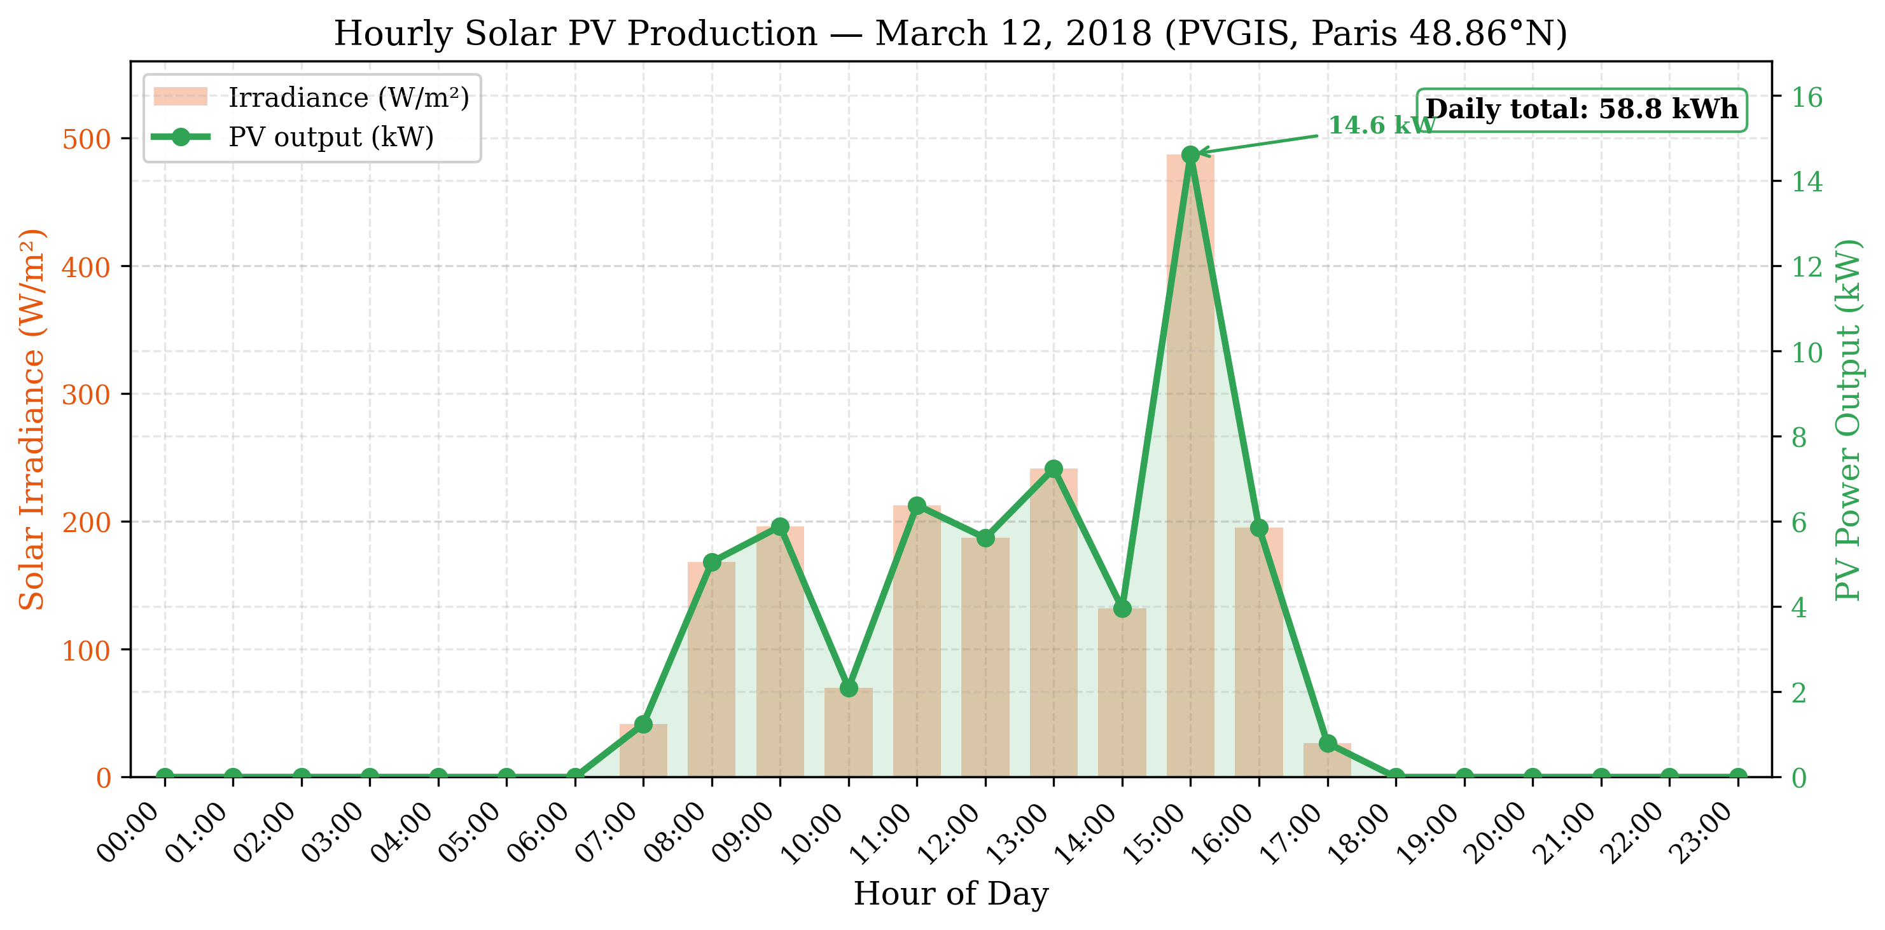
Hourly solar PV production profile (12th March 2018)
Maximum production at about 14.6 kW at 15:00 when maximum irradiance measured is 487 W/m$​^{2}$; Total daily production $≈$58.8kWh. Part of the building consumption for business hours is offset ($≈$7:00–17:00) and appears to be surplus at 15:00 as well. Additionally, the profile compliments the EV parking hours (6 AM - 6PM) aspect of the profile. There is also regularly variable irradiance due to intermittent cloud cover typically observed in Paris in Spring.

Justification for Selected date
March 12, 2018 was selected because it is a Spring day with midrange curtailment of net demand and midrange clouds accounted in Paris PVGIS data. This rule also helps avoid using extreme Summer or Winter days inappropriately; It also helps minimise further methodology errors. SARAH3 clouds for this date are well validated overall.

Building Battery Storage
The building contains a stationary battery storage system:
Building battery specifications
Parameter | Value
Capacity | 80 kWh
Efficiency | 95%
Initial SoC | 50%
Depth of discharge limit | 80%
Max charge rate | 50 kW
Max discharge rate | 50 kW
Chemistry | Lithium Iron Phosphate (LFP)
Reference product | BYD Battery-Box Premium HVM
The battery parameters represent a modular lithium iron phosphate (LFP) system using cobalt free LFP cells that have been certified by HTW Berlin at an efficiency of $≥$96%. Modular scalability can be achieved in 2.76 kW increments. The simulated configuration consists of the equivalent of four HVM 19.3 towers ($4×19.32=77.3$ kWh $≈80$ kWh), resulting in a total max charge/discharge power of approximately 50 kW.

Electric Vehicle Fleet

Subfleet Composition
The simulation allows for a fleet of 15 electric vehicles, which corresponds to an average-sized office building with 50-100 employees (assuming 15-30% EV adoption).

Sub-fleet Characteristics
Each EV has similar technical characteristics:
Electric Vehicle Characteristics
Parameter | Value
Battery capacity | 100 kWh
Reference vehicle | Tesla Model 3 Long Range
Max charge rate | 22 kW (Level 2 AC Charger)
Max discharge rate | 22 kW (V2G Capable)
Energy consumption | 0.18 kWh/km
Depth of discharge limit | 90%
Minimum SoC | 20%

Justification
In this case, we chose 100-kWh capacity to model current generation long-range EVs like the Tesla Model 3 and Hyundai Ioniq 5. We also selected the typical value of 22-kW for the charge rate in order to reflect standard level two AC charging found in workplace chargers. For this type of vehicle, a usage factor of 0.18 kWh/km was used. Lastly, a min SoC of 20% will prevent extreme discharges and minimize battery aging.

Mobility Patterns

Arrival and Departure Time Windows
The EV fleet follows normal workday timing:
EV mobility parameters
Parameter | Value
Arrive window | 06:00 - 09:00 AM
Departure Window | 04:00 PM - 08:00 PM
Parking Duration | 7 - 14 hours
Initial SOC Range | 20 - 30%
Desired SOC Range | 70 - 80%
The actual time each EV arrives or departs is randomly selected from the above defined time windows so as to represent real-world variation.

State Of Charge Requirements
The SOC when arriving typically ranges from 20 - 30%, indicating that the batteries would have lost some charge over their morning trip of approximately 30-50 km. Similarly, the target SOC for departing is set at a level that should provide sufficient charge to complete both trips plus an additional reserve of roughly 100-150 km.

Justification
This schedule matches most people who go to work and then leave to go home. The longer parking duration allows the owner flexibility regarding where they perform their daily charging. Regardless of how often the driver charges during the day, all drivers need to arrive with a full battery that can last through their afternoon commute.

Grid Parameters

Electricity Pricing

Realistic Wholesale Prices Used For Simulations
The simulations used wholesale day-ahead electricity prices published by the European Power Exchange (EPEX SPOT), the primary wholesale electricity exchange in Europe, on March 12th, 2018. Real wholesale prices were downloaded from two sources: (i) The transparency platform run by ENTSO-E [ENTSO-E TRANSPARENCY], which publishes wholesale energy prices across all EU markets; and (ii) The Fraunhofer ISE Energy Charts API [ENERGY CHARTS] that also provide energy charts for individual countries. As seen in Fig. 1.3, the day ahead price profile resembles those typically observed in most of Western Europe with both peaks and troughs. On this particular day, there was a large trough during the early morning hours (between 01:00 – 06:00 AM) when prices were very low. This occurred because it was night-time and thus overall electricity demand is very low while many thermal units are still producing electricity, especially since they are usually less expensive than gas fired units. However, as people begin to go to work, start their cars, etc., the demand increases rapidly, leading to steep increase in price until noon when the price begins to decrease again. At 18:00 – 19:00 PM (6 – 7 PM) prices reach their highest levels, primarily due to the fact that renewable resources have decreased significantly during the afternoon and evening periods as clouds become thicker and residential electrical usage for cooking and lighting becomes greater. Table 1.5 shows some statistics for the prices over each hourly time slot.
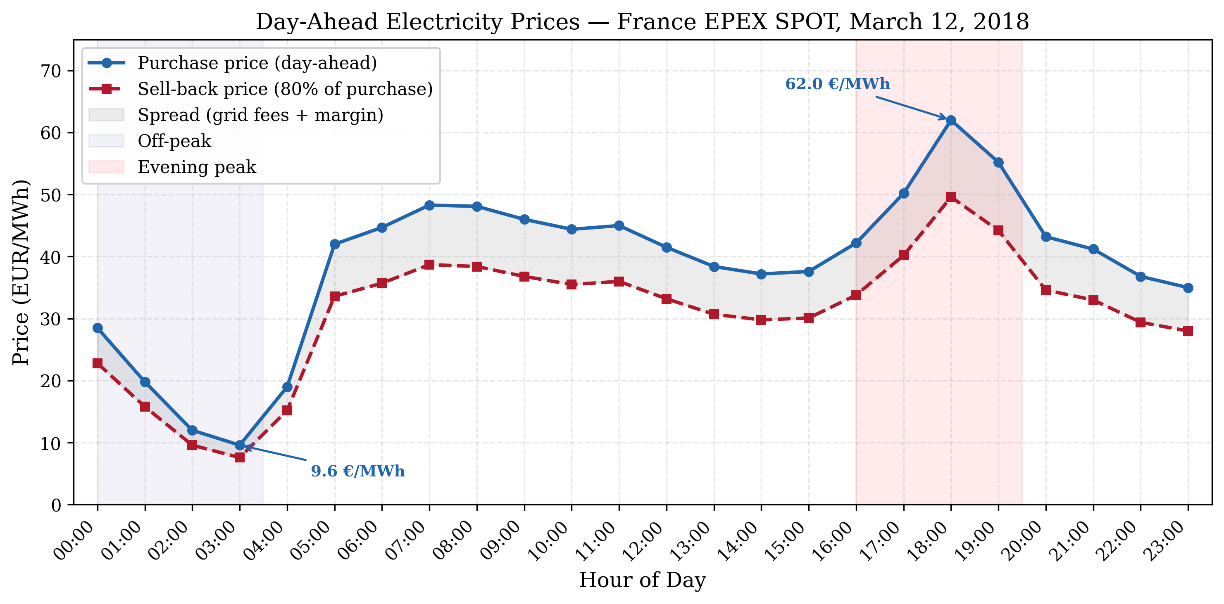
Hourly Electricity Purchase Price and Sell Back Price for France on March 12, 2018. Note: Data source: EPEX SPOT.
Hourly Average Day Ahead Price for Each Time Slot.
 |  | Purchase Price |  | Sell Back Price
1-5 Time Period | Time Slot | EUR/MWh | €/kWh | €/kWh | EUR/MWh
Night | 00:00 – 03:00 | 9.56 – 28.46 | $0.010−−0.028$ | $0.008−−0.023$ | 9.55 – 28.40
Morning Ramp | 04:00 – 07:00 | 19.04 – 48.34 | $0.019−−0.048$ | $0.015−−0.039$ | 18.98 – 47.83
Bus Hours | 08:00 – 11:00 | 44.41 – 48.05 | $0.044−−0.048$ | $0.036−−0.038$ | 44.33 – 47.91
Mid-day | 12:00 – 15:00 | 37.24 – 41.50 | $0.037−−0.042$ | $0.030−−0.033$ | 36.93 – 40.78
Evening Peak | 16:00 – 19:00 | 42.23 – 62.00 | $0.042−−0.062$ | $0.034−−0.050$ | 41.84 – 60.69
Night | 20:00 – 23:00 | 35.04 – 43.23 | $0.035−−0.043$ | $0.028−−0.035$ | 34.53 – 42.27
Average Daily Price | — | $\boxed{38.67}$ | $\boxed{0.039}$ | $\boxed{0.031}$ | $\boxed{38.64}$
All raw data needed to recreate these tables can be found in appendix [app:hourly_data].

Price Characteristics
As shown in Fig. 1.3, the wholesale price curve exhibits typical characteristics of wholesale pricing throughout the world; specifically, prices tend to follow a “trough-to-peak” structure where low prices occur during nighttime hours and higher prices occur during mid-morning to late-evening hours.
A common reason why prices drop at night is due to lower electricity demands caused by less commercial or household activity such as sleeping and/or reduced industrial activities; however, another important contributing factor is due to the types of generation used at night being generally cheaper than other times of the day (as thermal plants often produce electricity at night).
Another characteristic evident in Fig. 1.3 is the rapid spike in price between mid-morning to late-afternoon hours as demand increases and renewable resource output drops.
Finally, another notable characteristic of Fig. 1.3 is how quickly the price spikes up in the late afternoon hours as solar irradiance starts to decline (and thus solar output drops). Justification: V2G uses more training episodes because the action space is larger (three actions instead of two). The discount factor is set to $γ=1.0$ in V2G so later discharge opportunities are valued the same as near-term charging. The exploration rate $ϵ$ is lower to emphasize exploitation once the policy stabilizes.

Summary of Data Sources
Summary of Data Sources
Data Type | Source | Reference
Building consumption | ELMAS dataset (Office cluster #5)
Solar irradiance | PVGIS
Electricity prices | EPEX SPOT / ENTSO-E (France)
Solar PV modules | JA Solar DeepBlue 3.0 Pro
Building battery | BYD Battery-Box Premium HVM
EV specifications | Tesla Model 3
Charging standards | IEC 61851

Simulation Scenarios

Scenario 1: Charging Only (V2G Not Permitted)
Configuration: multi_ev_config.yml.
In this scenario we investigate unidirectional charging only using 15 EVs that can only take charge. We use two algorithms (simple and RL (Q-learning)), an 80 kW Grid Capacity Limit and No Discharge Allowed.
Objective: Establish Baseline Performance for Intelligent Charging without V2G.

Scenario 2: Enabled for V2G
Configuration: multi_ev_v2g_config.yml.
This scenario enables bidirectional functionality (both charge and discharging) with the same 15 EVs as before. The simple and RL algorithms are able to perform both a charge and a discharge action. The sell-back price is given at 80–90% of purchase price. Restrictions have also been put into place to prevent excessive discharging when preserving the desired state of charge.
Objective: Evaluate the impact of enabling V2G technology.

Metrics For Evaluation
Below are the metrics that will be used to evaluate performance of each solution.

Economic Metrics
Economic Metrics measure total daily cost (electricity purchased — V2G revenue), cost/kWh, and savings relative to Level 1 baseline.

Energy Metrics
Energy Metrics measure total grid consumption, renewable utilization (percentage of charging coming from solar energy), and V2G energy discharged to the grid.

Performance Metrics
Performance Metrics measure target achievement, average final SOC at departure, number of hours over capacity limit (grid violations), and number of times below minimum SOC (SOC violations).

Computational Metrics
Computational Metrics report execution time/simulation, training time/RL methods, and how scalability affects performance as a function of fleet size.

Implementation Details

Software Development Environment
The simulation was built using Python 3.x. The numerical part was implemented using NumPy, plots were produced using Matplotlib, and configuration files were managed with PyYAML.
Software dependencies
Library | Purpose
NumPy | Numerical computations
Matplotlib | Plotting
PyYAML | Configuration management

Code Structure
The code follows a modular design where central models represent the building, electric vehicles, and the grid. Unidirectional charging logic resides within MultiEVChargingSystem, while V2G logic resides within MultiEVV2GChargingSystem. Scripts multi_ev_simulator and multi_ev_v2g_simulator simulate charge-only and V2G scenarios respectively.

