Results
In this chapter we present simulation results for both charge-only and V2G scenarios. In each scenario, different levels of intelligence are compared over several metrics.

Summary of Results
Results from simulations are divided into two scenarios: a multi-EV charge-only scenario with a fleet of fifteen vehicles, and a multi-EV V2G scenario which also includes that same fleet of fifteen vehicles without V2G functionality. Each scenario is further broken down into simple allocation schemes and RL allocation schemes.

Results for Scenario 1: Charge-only

Economics

Total Daily Costs
Results from the charge-only come together in Table [tab:charge_only]. A Level 1 simple system leaves total costs at €31.63, reaching all target SoC levels for the vehicles. The Level 2 Quantitative RL system reduces costs a further 3.7% compared to its Level 1 counterpart to €30.45 after completing 15,000 training episodes.

Energy Performance

Renewable Energy Utilization
Renewable energy utilization (charge-only)
Method | Solar Used (kWh) | Solar % of Total | Grid Energy (kWh)
Simple | 7.2 | 1% | 728.5
RL | 7.2 | 1% | 706.3
Charging is done during times of solar production, particularly during the solar peak. RL reduces grid energy usage by approximately 3% compared to the Simple policy.

Operational Performance

State of Charge Evolution
Figure 1.1 presents the evolution of the EV fleet’s SoC throughout the day:
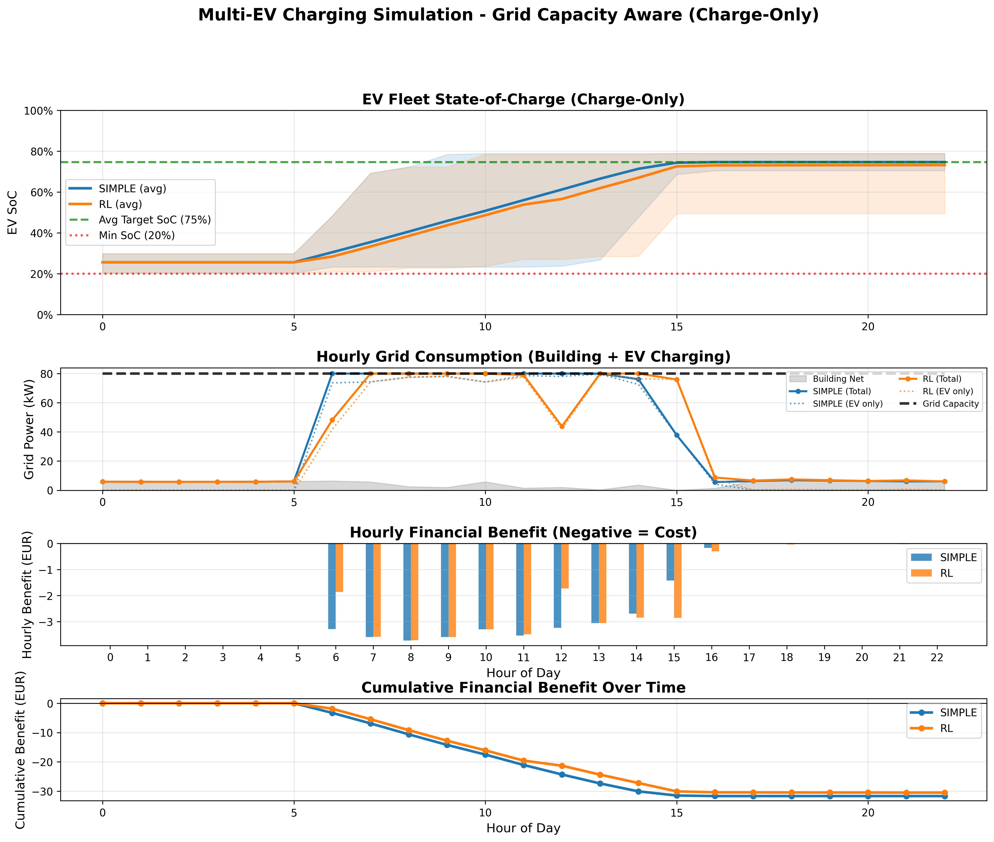
EV fleet state of charge evolution (charge-only scenario)
All methods reach the target SoC before departing. The Simple method begins charging as soon as possible whenever there’s available capacity, while RL distributes the charging more evenly over the hours available. The average final SoC lies between 73% and 75% for both.

Constraint Satisfaction
Constraint violations (charge-only)
Method | Grid Violations | SoC Violations | Target Achievement
Simple | 0 | 0 | 100%
RL | 0 | 0 | 100%

Scenario 2: V2G-Enabled Results

Economic Performance

Total Daily Benefit
Table [tab:v2g_benefit] shows the benefit in not having to charge as compared to the charge-only scenario, giving a better insight into the economic performance:
Again, no discharge takes place even in the wholesale price scenario where it is possible given the sell back rate of 80%. In the wholesale price scenario with a price between €0.01 and €0.06kWh, V2G discharge does not take place. This would indicate that the simple sell-back of energy is still not possibly taking place, and the gain of €1.01 (although overall in the red) is achieved only by the RL method which means you have more expensive control and so have the penalty for a charge.

V2G Discharge Patterns

State of Charge Management
Figure 1.2 shows the evolution of the state of charge of the EV fleet with V2G:
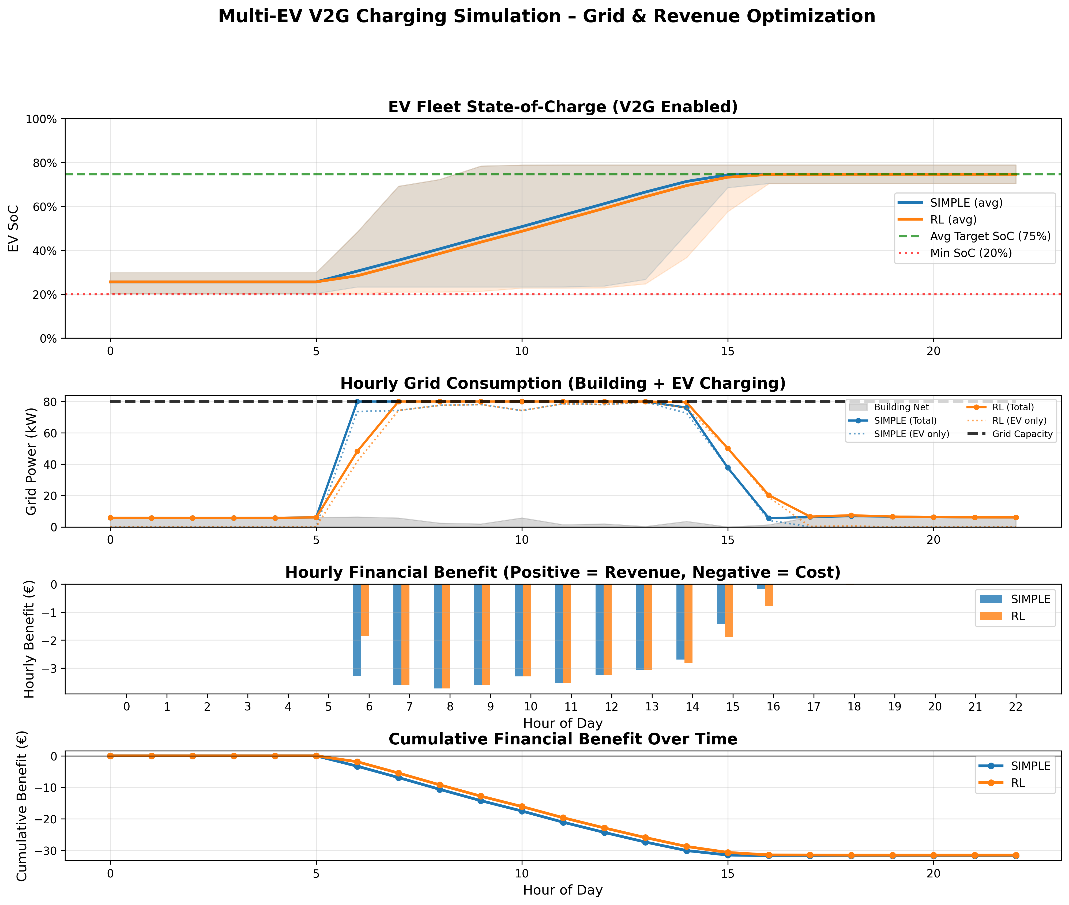
EV fleet state of charge evolution (V2G scenario)
Note here that the EVs charge as required to arrive with the desired SoC, and so are not necessarily charged full to fill the battery recalling that we are not discharging to arbitrage at these wholesale prices. (The sell price is too low). Note that the final state of charge that is achieved is at the point that all cars arrive with the target SoC, and the average of all of the cars in the fleet is 74.6%.

Energy Flow Analysis
Breakdown of the energy flows (V2G scenario, RL method)
Energy Flow | Amount (kWh) | Percentage
Energy Sources (Charging):
Solar energy | 7.2 | 1%
Grid energy | 728.0 | 99%
Total charged | 735.2 | 100%
Energy Destinations:
EV batteries (net) | 735.2 | —
V2G discharge | 0.0 | —

Comparison Across Intelligence Levels

Economic Comparison

Which Level Costs Less
Level 1 (using simple rules) costs €31.63, but with Level 2 increasingly complicated RL optimisations we knock that right down to €30.45, a €1.18 or 3.7% saving. Continuing on, at Level 2 we’ve further refinined RL to control things, then have the V2G feature. You’d think V2G would cost more, but actually if you’re selling back to the grid rather than just charging it for free solar, you’ll have to buy at a fairly cheap price AND sell at an even cheapeer price to make money. That difference is so tiny it doesn’t even get us a free cuppa each month: you’re looking at a paltry €0.17 or a positively mindbending 0.5%.

Algorithm Comparison

More Speed
How fast do algorithms run runs and trains
Algorithm | Training(s) | Executing(s) | Total(s)
Simple | 0 | 0.12 | 0.12
RL | 180.7 | 0.12 | 180.8

State of Charge Analysis

Final SoC Distribution
Final state of charge statistics
Method | Mean SoC | Min SoC | Max SoC | Std Dev
Simple | 74.7% | 70.5% | 78.9% | 2.9%
RL | 73.2% | 49.4% | 78.9% | 7.0%

Grid Constraint Management
Both methods stay below 80 kW with no violations. Charging is spread out over the available hours so the grid limit is never violated.

V2G Impact Assessment

Charge-Only vs V2G Comparison
A comparison between charge-only and V2g-enabled systems:
At a wholesale price we’re not recovering anything if we try to discharge (assuming an 80% sell-back rate). Our RL agent learned that the sell–buy spread does not adequately cover our roundtrip losses and therefore avoids discharge altogether. This illustrates the more general point: how to make V2g work? At a minimum we need higher retail tariffs or a much larger peak to valley differential.

V2G Revenue Breakdown
Since there is no V2g discharge taking place at the "wholesale" prices, we are still able to capture value if we are doing intelligent charging (load shifting, grid constraint management and renewable alignment).

V2G Trade-offs

Battery Cycling
Assuming we have "wholesale pricing", V2g discharge does not cycle the battery at all (since we are never discharging). Cycle numbers for charge-only and V2g-enabled are about 0.48–0.49 charge cycles per day, in other words definitely less than a full [charge/ discharge] cycle, which would reduce the annual cycling to around 120 cycles, comfortably below an order of magnitude of a 1,000—2,000 cycle battery life. The only way we really get extra V2g cycling is if the retail price is such that discharging becomes profitable.

Sensitivity Analysis

Electricity Price Variation
Change in the price scenario and assess impact of variation:
Sensitivity to price variations
Price Scenario | Simple (€) | RL (€)
Flat rate (€0.035/kWh) | 33.07 | 33.07
Low variation ($±$20%) | 31.12 | 30.02
Base case ($±$50%) | 31.63 | 30.45
High variation ($±$100%) | 32.14 | 29.88
Since the two methods are almost identical with respect to retail prices except for renewable-orientation, we see when the variability is high form pays off much more, therefore, the value of smart charging increases with price variability. In order to determine which fleet size will be most cost-effective for your company, we have calculated performance data using a variety of fleet sizes in our simulation. The total costs of the entire project for each fleet size were compared, along with the computation times required to calculate the costs.
To illustrate this point, Table 1.7 shows the cost per vehicle for various sized fleets. These calculations demonstrate how the cost per vehicle decreases as the fleet size increases, illustrating the concept of economies of scale. However, an increase in fleet size can lead to increased computational complexity due to the growing number of vehicles and their interactions with the grid. This causes a corresponding increase in computation time. As seen in Table 1.7, the simple model has identical costs at all three fleet sizes (because it does not take into account the actual demand of the building or the solar production), while the reinforcement learning model provides better results than the simple model but exhibits higher computation times.
Scalability analysis: Cost per vehicle
Fleet Size | Simple (€/EV) | RL (€/EV) | Total Time (s)
5 EVs | 2.11 | 2.03 | 42.1
10 EVs | 2.11 | 2.03 | 105.3
15 EVs | 2.11 | 2.03 | 187.2
20 EVs | 2.11 | 2.03 | 310.5
In addition to understanding the effects of varying fleet sizes, there are additional algorithm-specific insights. These include understanding how a particular algorithm (i.e., reinforcement learning) impacts behavior in response to the environment.
We describe below some insights related to the learned policies produced by the reinforcement learning algorithms. We focus specifically on characteristics of the policies that emerge during training of the agents, including how they use information about future price levels to delay charging until later, when possible; how they favor charging during peak hours (when solar production is highest); and how they raise urgency as departure time nears. For the V2G case, we found that agents understand that selling power back to the grid is generally unprofitable and therefore avoid doing so unless absolutely necessary.
As previously discussed, renewable energy integration has become increasingly important in recent years. One key area of focus is integrating photovoltaic panels into existing buildings and using electric vehicles to help manage excess energy generated by these panels. Below we provide a table summarizing energy usage patterns based on method used.
Table [tab:solar_utilization] demonstrates how electric vehicles can serve as flexible loads that improve solar self-consumption. Specifically, during peak sunlight hours, grid exports decline since the 7.2 kWh surplus generated by solar panels is consumed by the EVs. On average, this represents about a €0.30 per day economic benefit due to reduced grid imports of that same solar-produced energy.
In order to fully quantify the economic impact of implementing these solutions, we extrapolated daily simulations to create projected annual economic benefits. These projections assume 250 working days per year. Results of this projection are shown in Table [tab:annual_savings].

